Supplements

Genetic liability to insomnia in relation to cardiovascular disease: a Mendelian randomisation study

Shuai Yuan, Amy M. Mason, Stephen Burgess, Susanna C. Larsson

Supplementary Table 1. Detailed information on included traits in the present study
Supplementary Table 2. Detailed information on genetic instruments
Supplementary Table 3. Definition and sources of information for cardiovascular disease outcomes in UK Biobank
Supplementary Table 4. Associations of genetically predicted liability to insomnia with 9 individual cardiovascular diseases in UK Biobank in sensitivity analyses

Supplementary Figure 1. Associations of genetically predicted liability to depression with 9 individual cardiovascular diseases in UK Biobank
Supplementary Figure 2. Associations of genetically predicted liability to insomnia with 9 individual cardiovascular diseases after adjusting for depression in UK Biobank
Supplementary Figure 3. Associations of genetically predicted liability to insomnia with 9 individual cardiovascular diseases after adjusting for sleep duration in UK Biobank
Supplementary Figure 4. Associations of genetically predicted liability to insomnia with body mass index, smoking, alcohol drinking and type 2 diabetes mellitus
Supplementary Figure 5. Associations of genetically predicted liability to insomnia with 9 individual cardiovascular diseases after adjusting for body mass index, smoking and type 2 diabetes mellitus in UK Biobank

Supplementary Table 1. Detailed information on included traits in the present study

Traits | Data source | Sample size | Web link for data source
Insomnia | UK Biobank and 23andMe | 1 331 010 individuals (386 533 from UK Biobank and 944 477 from 23andMe) | https://ctg.cncr.nl/software/summary_statistics
Cardiovascular disease | UK Biobank | 367 643 individuals | https://www.ukbiobank.ac.uk/
Depression (SNPs) | UK Biobank, 23andMe and Psychiatric Genomics Consortium | 807 553 individuals (246 363 cases and 561190 non-cases) | https://datashare.is.ed.ac.uk/handle/10283/3203
Depression (summary-level) | UK Biobank and Psychiatric Genomics Consortium | 500 199 (170 756 cases and 329 443 non-cases) | https://datashare.is.ed.ac.uk/handle/10283/3203
Sleep duration | UK Biobank | 384 317 individuals | https://ctg.cncr.nl/software/summary_statistics
Body mass index | GIANT consortium | 694 649 individuals | https://zenodo.org/record/1251813#.Xbhf9pNKiqB
Smoking initiation | 29 studies | 1 232 091 individuals | https://conservancy.umn.edu/handle/11299/201564
Alcohol drinking | 29 studies | 941 280 individuals | https://conservancy.umn.edu/handle/11299/201564
Type 2 diabetes mellitus | DIAGRAM consortium | 898 130 individuals (74 124 cases and 824 006 non-cases) | https://www.diagram-consortium.org

DIAGRAM indicates DIAbetes Genetics Replication And Meta-analysis; GIANT, Genetic Investigation of ANthropometric Traits.
Supplementary Table 2. Detailed information on genetic instruments

rsID | Chr | Position | EA | NEA | EAF | Beta | SE | P-value
rs2089358 | 1 | 37194103 | C | T | 0.30 | 0.041 | 0.007 | 2.75E-10
rs11588755 | 1 | 57819204 | G | A | 0.48 | 0.035 | 0.006 | 5.14E-09
rs1937447 | 1 | 66358242 | G | C | 0.24 | 0.039 | 0.007 | 2.08E-08
rs1620977 | 1 | 72729142 | A | G | 0.27 | 0.052 | 0.007 | 2.27E-14
rs699844 | 1 | 74878253 | A | G | 0.92 | 0.060 | 0.011 | 4.11E-08
rs12030482 | 1 | 96961268 | A | T | 0.22 | 0.041 | 0.007 | 8.16E-09
rs6702604 | 1 | 107190062 | G | A | 0.42 | 0.037 | 0.006 | 1.30E-09
rs1289939 | 1 | 117944435 | C | T | 0.77 | 0.041 | 0.007 | 6.00E-09
rs5877 | 1 | 173878862 | T | C | 0.67 | 0.036 | 0.006 | 1.23E-08
rs11803128 | 1 | 190060095 | G | A | 0.35 | 0.041 | 0.006 | 6.85E-11
rs10800992 | 1 | 190900576 | T | C | 0.44 | 0.042 | 0.006 | 3.84E-12
rs623025 | 1 | 201765094 | C | T | 0.74 | 0.038 | 0.007 | 3.16E-08
rs11119409 | 1 | 210293333 | C | T | 0.41 | 0.035 | 0.006 | 1.19E-08
rs823247 | 2 | 2850540 | C | T | 0.52 | 0.037 | 0.006 | 5.25E-10
rs6734957 | 2 | 42813247 | G | T | 0.76 | 0.042 | 0.007 | 1.82E-09
rs56097173 | 2 | 44262449 | T | C | 0.68 | 0.040 | 0.006 | 2.69E-10
rs13010288 | 2 | 51824512 | G | T | 0.87 | 0.060 | 0.009 | 9.26E-12
rs1861412 | 2 | 58893065 | A | G | 0.43 | 0.038 | 0.006 | 1.67E-10
rs6545798 | 2 | 60521311 | T | A | 0.59 | 0.041 | 0.006 | 1.19E-11
rs1519102 | 2 | 66677816 | G | C | 0.31 | 0.037 | 0.006 | 1.90E-08
rs113851554 | 2 | 66750564 | T | G | 0.05 | 0.206 | 0.014 | 1.56E-51
rs75452188 | 2 | 67134426 | A | G | 0.88 | 0.052 | 0.009 | 1.58E-08
rs12991815 | 2 | 68071990 | C | G | 0.42 | 0.040 | 0.006 | 3.02E-11
rs11679943 | 2 | 77724624 | A | G | 0.35 | 0.037 | 0.006 | 3.16E-09
rs72820274 | 2 | 104412924 | A | G | 0.42 | 0.034 | 0.006 | 1.28E-08
rs62158170 | 2 | 114082175 | A | G | 0.79 | 0.066 | 0.007 | 1.20E-19
rs10928256 | 2 | 146458738 | T | C | 0.42 | 0.034 | 0.006 | 1.61E-08
rs6756610 | 2 | 147480394 | C | G | 0.63 | 0.037 | 0.006 | 1.14E-09
rs116466468 | 2 | 159137557 | T | C | 0.76 | 0.044 | 0.007 | 2.11E-10
rs4664299 | 2 | 160570033 | C | T | 0.77 | 0.041 | 0.007 | 4.95E-09
rs7571486 | 2 | 176473295 | G | A | 0.75 | 0.039 | 0.007 | 1.40E-08
rs55772859 | 2 | 208042581 | A | C | 0.31 | 0.042 | 0.006 | 4.82E-11
rs62213452 | 2 | 210380152 | T | G | 0.28 | 0.037 | 0.007 | 2.39E-08
rs34967082 | 2 | 215382654 | A | G | 0.41 | 0.035 | 0.006 | 4.34E-09
rs1530938 | 2 | 236900633 | A | G | 0.44 | 0.036 | 0.006 | 8.82E-10
rs7599697 | 2 | 239231477 | C | T | 0.64 | 0.037 | 0.006 | 5.00E-09
rs6808140 | 3 | 10581380 | T | C | 0.51 | 0.039 | 0.006 | 5.35E-11
rs7615602 | 3 | 18718055 | G | C | 0.73 | 0.040 | 0.007 | 2.59E-09
rs4858708 | 3 | 25154112 | T | A | 0.47 | 0.034 | 0.006 | 1.23E-08
rs35110063 | 3 | 43066558 | A | G | 0.43 | 0.039 | 0.006 | 8.82E-11
rs7625896 | 3 | 44062561 | A | G | 0.65 | 0.036 | 0.006 | 5.28E-09
rs10865954 | 3 | 49211989 | T | C | 0.33 | 0.042 | 0.006 | 1.92E-11
rs3774751 | 3 | 50209053 | G | T | 0.54 | 0.041 | 0.006 | 7.32E-12
rs1567084 | 3 | 71435955 | A | G | 0.50 | 0.033 | 0.006 | 2.14E-08
rs17025198 | 3 | 88001713 | A | G | 0.20 | 0.041 | 0.007 | 2.19E-08
rs1580173 | 3 | 107955515 | A | G | 0.56 | 0.033 | 0.006 | 2.28E-08
rs62264767 | 3 | 117642005 | A | C | 0.85 | 0.065 | 0.008 | 1.63E-14
rs492858 | 3 | 155432229 | C | T | 0.92 | 0.066 | 0.011 | 3.46E-09
rs2364921 | 3 | 158522463 | C | T | 0.53 | 0.034 | 0.006 | 2.13E-08
rs694786 | 3 | 173112907 | C | T | 0.54 | 0.044 | 0.006 | 1.97E-13
rs4260410 | 3 | 178469932 | T | C | 0.33 | 0.034 | 0.006 | 4.87E-08
rs2216427 | 3 | 180785697 | C | G | 0.65 | 0.035 | 0.006 | 1.60E-08
rs62301574 | 4 | 22050165 | G | C | 0.20 | 0.042 | 0.007 | 1.37E-08
rs16990210 | 4 | 34720226 | C | T | 0.15 | 0.046 | 0.008 | 1.97E-08
rs17005118 | 4 | 82288564 | A | G | 0.26 | 0.042 | 0.007 | 6.13E-10
rs72657797 | 4 | 90820809 | C | T | 0.82 | 0.056 | 0.008 | 1.52E-12
rs13135092 | 4 | 103198082 | G | A | 0.08 | 0.089 | 0.011 | 2.53E-16
rs4699157 | 4 | 106055212 | C | T | 0.04 | 0.081 | 0.015 | 3.98E-08
rs11722569 | 4 | 112822731 | T | C | 0.66 | 0.034 | 0.006 | 2.91E-08
rs13138995 | 4 | 148987430 | A | G | 0.39 | 0.034 | 0.006 | 1.97E-08
rs17223714 | 5 | 50492629 | A | G | 0.79 | 0.046 | 0.007 | 2.44E-10
rs12520974 | 5 | 61514611 | C | T | 0.52 | 0.036 | 0.006 | 1.69E-09
rs701394 | 5 | 80296487 | G | A | 0.36 | 0.036 | 0.006 | 6.83E-09
rs16903122 | 5 | 87693561 | T | C | 0.25 | 0.055 | 0.007 | 9.04E-16
rs35539975 | 5 | 91607148 | A | G | 0.78 | 0.042 | 0.007 | 4.49E-09
rs17083297 | 5 | 92995477 | C | A | 0.82 | 0.044 | 0.008 | 1.60E-08
rs12187443 | 5 | 102660400 | T | C | 0.67 | 0.040 | 0.006 | 1.64E-10
rs2431108 | 5 | 103947968 | C | T | 0.33 | 0.053 | 0.006 | 7.83E-17
rs152555 | 5 | 106849674 | G | A | 0.15 | 0.052 | 0.008 | 4.83E-10
rs17367725 | 5 | 107112116 | C | T | 0.65 | 0.036 | 0.006 | 9.29E-09
rs8180457 | 5 | 107209814 | C | T | 0.84 | 0.056 | 0.008 | 1.12E-11
rs55972276 | 5 | 135653737 | A | C | 0.14 | 0.073 | 0.009 | 4.19E-17
rs6888135 | 5 | 141254063 | A | C | 0.50 | 0.038 | 0.006 | 1.21E-10
rs4502882 | 5 | 153093998 | C | T | 0.34 | 0.039 | 0.006 | 7.96E-10
rs62383308 | 5 | 165460085 | G | A | 0.92 | 0.060 | 0.011 | 3.98E-08
rs6601080 | 5 | 179511043 | A | G | 0.68 | 0.035 | 0.006 | 2.21E-08
rs11756035 | 6 | 18843810 | C | G | 0.13 | 0.051 | 0.009 | 1.29E-08
rs138678612 | 6 | 30932223 | G | A | 0.02 | 0.117 | 0.020 | 1.41E-08
rs3131638 | 6 | 31475127 | G | A | 0.77 | 0.044 | 0.007 | 7.88E-10
rs10947428 | 6 | 33647058 | C | T | 0.21 | 0.068 | 0.007 | 9.06E-21
rs6457796 | 6 | 34828553 | C | T | 0.27 | 0.039 | 0.007 | 1.12E-08
rs10947690 | 6 | 37631768 | G | A | 0.26 | 0.047 | 0.007 | 4.04E-12
rs9394502 | 6 | 38452503 | C | T | 0.67 | 0.054 | 0.006 | 7.76E-18
rs10947987 | 6 | 41754370 | C | T | 0.56 | 0.033 | 0.006 | 4.08E-08
rs10944696 | 6 | 94498850 | G | A | 0.70 | 0.038 | 0.007 | 7.99E-09
rs2388840 | 6 | 99598756 | G | A | 0.42 | 0.037 | 0.006 | 1.37E-09
rs9373590 | 6 | 101212001 | A | T | 0.51 | 0.040 | 0.006 | 2.18E-11
rs314281 | 6 | 105400605 | C | T | 0.55 | 0.043 | 0.006 | 6.03E-13
rs728017 | 6 | 124292594 | G | A | 0.61 | 0.035 | 0.006 | 9.51E-09
rs62429521 | 6 | 140324582 | A | C | 0.15 | 0.051 | 0.008 | 1.78E-09
rs1147852 | 6 | 147980909 | A | G | 0.31 | 0.039 | 0.006 | 9.94E-10
rs4709655 | 6 | 163280204 | C | T | 0.88 | 0.054 | 0.009 | 3.09E-09
rs117152417 | 6 | 166411281 | G | A | 0.99 | 0.147 | 0.026 | 2.82E-08
rs6978112 | 7 | 1966841 | T | C | 0.41 | 0.034 | 0.006 | 2.11E-08
rs940780 | 7 | 3323848 | T | C | 0.36 | 0.038 | 0.006 | 8.50E-10
rs190073 | 7 | 10985188 | G | A | 0.59 | 0.034 | 0.006 | 2.86E-08
rs2030672 | 7 | 21687925 | C | G | 0.56 | 0.034 | 0.006 | 1.10E-08
rs521484 | 7 | 49894349 | G | A | 0.23 | 0.040 | 0.007 | 1.53E-08
rs6465151 | 7 | 88310899 | T | C | 0.11 | 0.056 | 0.009 | 1.90E-09
rs75932578 | 7 | 106844694 | C | T | 0.78 | 0.040 | 0.007 | 4.15E-08
rs670501 | 7 | 108625185 | T | C | 0.21 | 0.053 | 0.007 | 7.40E-13
rs8180817 | 7 | 114047542 | G | C | 0.57 | 0.049 | 0.006 | 1.83E-16
rs12666306 | 7 | 115082406 | A | G | 0.50 | 0.042 | 0.006 | 2.24E-12
rs17520265 | 7 | 119674508 | G | A | 0.97 | 0.091 | 0.016 | 2.87E-08
rs6967168 | 7 | 132672192 | G | T | 0.25 | 0.044 | 0.007 | 1.39E-10
rs2598293 | 7 | 133989882 | T | C | 0.48 | 0.035 | 0.006 | 2.48E-09
rs1731951 | 7 | 137075847 | T | A | 0.56 | 0.035 | 0.006 | 1.36E-08
rs28611339 | 8 | 10170037 | T | G | 0.13 | 0.058 | 0.009 | 8.46E-11
rs874168 | 8 | 30849450 | T | C | 0.53 | 0.034 | 0.006 | 7.95E-09
rs871994 | 8 | 35190619 | A | C | 0.44 | 0.035 | 0.006 | 5.50E-09
rs671985 | 8 | 60914783 | G | A | 0.55 | 0.038 | 0.006 | 2.79E-10
rs4588900 | 8 | 73890425 | A | G | 0.52 | 0.033 | 0.006 | 1.57E-08
rs17643634 | 8 | 91650818 | C | T | 0.84 | 0.060 | 0.008 | 1.34E-13
rs28552587 | 8 | 103356226 | A | G | 0.56 | 0.033 | 0.006 | 3.30E-08
rs10955647 | 8 | 114154187 | T | G | 0.53 | 0.033 | 0.006 | 1.84E-08
rs2737240 | 8 | 116657235 | A | G | 0.71 | 0.036 | 0.007 | 3.37E-08
rs10758593 | 9 | 4292083 | G | A | 0.60 | 0.036 | 0.006 | 4.90E-09
rs118166957 | 9 | 8858043 | T | C | 0.16 | 0.068 | 0.008 | 1.95E-16
rs10756571 | 9 | 14534505 | T | C | 0.69 | 0.036 | 0.006 | 1.80E-08
rs4090240 | 9 | 77118987 | C | T | 0.72 | 0.039 | 0.007 | 8.46E-09
rs7044885 | 9 | 81739348 | G | C | 0.56 | 0.041 | 0.006 | 5.67E-12
rs10761240 | 9 | 96361922 | G | A | 0.60 | 0.043 | 0.006 | 2.12E-12
rs1927902 | 9 | 120518991 | T | C | 0.25 | 0.053 | 0.007 | 1.15E-14
rs2792990 | 9 | 125621610 | C | G | 0.86 | 0.054 | 0.008 | 1.15E-10
rs6597649 | 9 | 133786652 | T | C | 0.40 | 0.033 | 0.006 | 3.05E-08
rs7040224 | 9 | 134886837 | A | G | 0.32 | 0.037 | 0.006 | 4.24E-09
rs72773790 | 9 | 139109080 | T | C | 0.67 | 0.037 | 0.006 | 3.71E-09
rs77641763 | 9 | 140265782 | T | C | 0.12 | 0.071 | 0.009 | 6.53E-15
rs12251016 | 10 | 21821918 | T | A | 0.34 | 0.039 | 0.006 | 3.89E-10
rs10825503 | 10 | 57177470 | T | G | 0.49 | 0.033 | 0.006 | 1.43E-08
rs224029 | 10 | 64519299 | C | T | 0.60 | 0.039 | 0.006 | 2.51E-10
rs11001276 | 10 | 76825638 | T | A | 0.26 | 0.038 | 0.007 | 2.52E-08
rs7475916 | 10 | 77771194 | G | C | 0.65 | 0.037 | 0.006 | 6.70E-09
rs214934 | 11 | 17193475 | T | A | 0.69 | 0.038 | 0.006 | 3.16E-09
rs72899452 | 11 | 45415577 | T | C | 0.06 | 0.074 | 0.012 | 1.00E-09
rs11605348 | 11 | 47606483 | G | A | 0.65 | 0.045 | 0.006 | 7.01E-13
rs12790660 | 11 | 57667222 | C | T | 0.32 | 0.040 | 0.006 | 4.49E-10
rs4592425 | 11 | 62697813 | T | G | 0.70 | 0.040 | 0.006 | 4.31E-10
rs524859 | 11 | 66041079 | G | A | 0.64 | 0.044 | 0.006 | 1.48E-12
rs566673 | 11 | 66401373 | G | T | 0.46 | 0.039 | 0.006 | 1.18E-10
rs56133505 | 11 | 72348039 | A | G | 0.54 | 0.041 | 0.006 | 5.59E-12
rs10898940 | 11 | 73455292 | A | C | 0.52 | 0.034 | 0.006 | 8.09E-09
rs667730 | 11 | 83277325 | T | C | 0.58 | 0.033 | 0.006 | 2.26E-08
rs2221119 | 11 | 88598444 | C | G | 0.44 | 0.036 | 0.006 | 2.00E-09
rs6589988 | 11 | 99126016 | G | A | 0.32 | 0.038 | 0.006 | 4.70E-09
rs1064939 | 11 | 118396331 | A | T | 0.98 | 0.130 | 0.020 | 2.16E-10
rs647905 | 11 | 121534938 | T | C | 0.54 | 0.033 | 0.006 | 2.87E-08
rs2286729 | 12 | 6873818 | A | G | 0.09 | 0.070 | 0.011 | 5.37E-11
rs1167132 | 12 | 43484487 | T | C | 0.39 | 0.035 | 0.006 | 8.73E-09
rs324017 | 12 | 57487814 | A | C | 0.29 | 0.039 | 0.007 | 1.61E-09
rs61921611 | 12 | 66367726 | C | T | 0.31 | 0.044 | 0.006 | 7.84E-12
rs7486418 | 12 | 84336911 | T | G | 0.66 | 0.041 | 0.006 | 6.84E-11
rs6606731 | 12 | 109982578 | A | T | 0.19 | 0.043 | 0.008 | 1.51E-08
rs4767645 | 12 | 118385788 | G | T | 0.54 | 0.037 | 0.006 | 6.47E-10
rs28582096 | 12 | 123856998 | G | A | 0.80 | 0.054 | 0.007 | 1.74E-13
rs9527083 | 13 | 53991125 | G | A | 0.33 | 0.076 | 0.006 | 1.61E-32
rs1031654 | 13 | 54382035 | C | A | 0.20 | 0.051 | 0.007 | 3.88E-12
rs7992992 | 13 | 54721699 | A | G | 0.13 | 0.051 | 0.009 | 1.15E-08
rs6562066 | 13 | 60532796 | T | C | 0.37 | 0.039 | 0.006 | 1.38E-10
rs9563886 | 13 | 61720066 | C | T | 0.39 | 0.034 | 0.006 | 3.08E-08
rs9540729 | 13 | 66947124 | A | T | 0.48 | 0.036 | 0.006 | 1.40E-09
rs11149313 | 13 | 85294881 | A | G | 0.73 | 0.040 | 0.007 | 2.38E-09
rs2389631 | 13 | 96932868 | C | A | 0.33 | 0.040 | 0.006 | 2.03E-10
rs1536053 | 13 | 111982291 | C | T | 0.68 | 0.038 | 0.006 | 6.04E-09
rs4981170 | 14 | 33412996 | G | A | 0.81 | 0.054 | 0.008 | 7.33E-13
rs12912299 | 15 | 38897857 | C | T | 0.51 | 0.043 | 0.006 | 4.42E-13
rs715338 | 15 | 57215867 | A | G | 0.58 | 0.041 | 0.006 | 7.85E-12
rs7168238 | 15 | 66709386 | C | G | 0.07 | 0.064 | 0.011 | 1.80E-08
rs1038093 | 15 | 74012409 | T | C | 0.63 | 0.039 | 0.006 | 2.47E-10
rs12917449 | 15 | 74331659 | C | A | 0.19 | 0.042 | 0.008 | 2.97E-08
rs176644 | 15 | 89913632 | T | G | 0.40 | 0.035 | 0.006 | 9.49E-09
rs4702 | 15 | 91426560 | G | A | 0.44 | 0.048 | 0.006 | 6.78E-16
rs7402939 | 15 | 99183876 | C | T | 0.62 | 0.036 | 0.006 | 5.19E-09
rs3184470 | 16 | 715164 | G | A | 0.65 | 0.038 | 0.006 | 9.73E-10
rs12924275 | 16 | 9191790 | T | C | 0.27 | 0.038 | 0.007 | 1.93E-08
rs830716 | 16 | 12323509 | C | G | 0.71 | 0.045 | 0.007 | 8.68E-12
rs66674044 | 16 | 19904344 | T | A | 0.14 | 0.060 | 0.009 | 2.18E-12
rs4788203 | 16 | 29978827 | G | A | 0.57 | 0.035 | 0.006 | 6.32E-09
rs1015438 | 16 | 51177517 | A | G | 0.19 | 0.058 | 0.008 | 2.51E-14
rs34214423 | 16 | 52303107 | A | C | 0.81 | 0.045 | 0.008 | 3.18E-09
rs4238755 | 16 | 52746089 | C | A | 0.74 | 0.043 | 0.007 | 2.30E-10
rs9931543 | 16 | 56128782 | T | C | 0.74 | 0.048 | 0.007 | 1.11E-12
rs3902952 | 16 | 61647589 | T | C | 0.19 | 0.048 | 0.008 | 2.55E-10
rs35322724 | 16 | 77137324 | A | C | 0.58 | 0.049 | 0.006 | 3.75E-16
rs62068188 | 17 | 2400876 | T | C | 0.83 | 0.049 | 0.008 | 1.18E-09
rs34490907 | 17 | 26933741 | C | G | 0.89 | 0.054 | 0.009 | 1.76E-08
rs7214267 | 17 | 43157709 | G | A | 0.42 | 0.044 | 0.006 | 5.09E-13
rs11650304 | 17 | 46035001 | C | G | 0.93 | 0.067 | 0.012 | 1.23E-08
rs4643373 | 17 | 47123423 | T | C | 0.70 | 0.041 | 0.007 | 1.58E-10
rs9889282 | 17 | 50259142 | C | A | 0.39 | 0.042 | 0.006 | 4.70E-12
rs8076183 | 17 | 61024696 | C | T | 0.55 | 0.038 | 0.006 | 2.75E-10
rs12454003 | 18 | 26315799 | G | C | 0.52 | 0.035 | 0.006 | 4.94E-09
rs12605642 | 18 | 31313965 | T | G | 0.49 | 0.035 | 0.006 | 2.13E-09
rs10502966 | 18 | 50748499 | G | A | 0.42 | 0.039 | 0.006 | 8.54E-11
rs60565673 | 18 | 52906830 | G | T | 0.38 | 0.043 | 0.006 | 1.59E-12
rs9964420 | 18 | 56824041 | A | C | 0.30 | 0.035 | 0.007 | 4.54E-08
rs12983032 | 19 | 5073447 | G | A | 0.66 | 0.043 | 0.006 | 1.07E-11
rs6510033 | 19 | 30710785 | G | A | 0.27 | 0.037 | 0.007 | 4.66E-08
rs429358 | 19 | 45411941 | T | C | 0.85 | 0.046 | 0.008 | 2.13E-08
rs908668 | 19 | 56134038 | T | C | 0.21 | 0.050 | 0.007 | 1.41E-11
rs6119267 | 20 | 31163914 | G | C | 0.31 | 0.060 | 0.006 | 2.32E-20
rs2867690 | 20 | 41972028 | T | C | 0.18 | 0.042 | 0.008 | 3.70E-08
rs910187 | 20 | 45841052 | G | A | 0.63 | 0.035 | 0.006 | 1.63E-08
rs6019663 | 20 | 47774512 | T | C | 0.29 | 0.040 | 0.007 | 6.47E-10
rs742760 | 20 | 50985290 | A | T | 0.82 | 0.043 | 0.008 | 2.48E-08
rs76145129 | 20 | 62670427 | G | T | 0.88 | 0.050 | 0.009 | 2.73E-08
rs2838787 | 21 | 46539725 | G | A | 0.61 | 0.036 | 0.006 | 7.65E-09
rs11090039 | 22 | 41496800 | A | G | 0.29 | 0.039 | 0.007 | 1.82E-09

Chr, chromosome; EA, effect allele; EAF, effect allele frequency; NEA, non-effect allele.
Supplementary Table 3. Definition and sources of information for 9 cardiovascular diseases outcomes in UK Biobank

Outcome | Number of cases | ICD-9 diagnosis | ICD-10 diagnosis | OPCS procedure | Self-report†
Coronary artery disease | 29 278 | 410, 411, 412, 414.0, 414.8, 414.9 | I21, I22, I23, I24, I25.1, I25.2, I25.5, I25.6, I25.8, I25.9 | K40, K41, K42, K43, K44, K45, K46, K49, K50.1, K50.2, K50.4, K75 | 20002, 20004, 6150
Heart failure | 6712 | 402.01, 402.11, 402.91, 404.01, 404.11, 404.91, 404.03, 404.13, 404.93, 428 | I11.0, I13.0, I13.2, I50 |  | 20002
Atrial fibrillation | 16 945 | 427.3 | I48 |  | 20002
Aortic valve stenosis | 2244 |  | I35.0, I35.2 |  | 20002
Abdominal aortic aneurysm | 1094 | 441.3, 441.4 | I71.3, I71.4 | L19.4, L19.5 | 20002
Ischemic stroke | 4602 | 434, 436 | I63, I64 |  | 20002
Haemorrhagic stroke | 2148 | 430, 431 | I60, I61 |  | 20002
Peripheral arterial disease | 3415 | 443.8, 443.9 | I73.8, I73.9 |  | 20002
Venous thromboembolism | 15602 | 415.1, 451.1, 452, 453.0, 453.4, 453.9 | I26, I80.1, I80.2, I81, I82.0 | L90.2 | 20002, 6152

ICD, International Classification of Disease; OPCS, Office of Population Censuses and Surveys Classification of Surgical Operations and Procedures.
*Follow-up for incident cases was until March 31, 2017 and date of death was recorded until February 14, 2018.
†Numbers refer to data codes used in UK Biobank: 6150/6152 = Health condition diagnosed by doctor (self-reported); 6177 = Medication for health condition (self-reported); 20002 = Non-cancer illness code (self-reported from interview with nurse); 20004 = Surgical operation code.
Supplementary Table 4. Associations of genetically predicted liability to insomnia with 9 individual cardiovascular diseases in UK Biobank in sensitivity analyses

Cardiovascular disease | Weighted median method |  |  |  | MR-Egger regression method
Cardiovascular disease | OR | 95% CI | p |  | OR | 95% CI | p | Intercept | p
Abdominal aortic aneurysm | 1.24 | 0.98,1.56 | 0.073 |  | 1.15 | 0.63,2.11 | 0.646 | -0.001 | 0.965
Atrial fibrillation | 1.08 | 1.02,1.15 | 0.013 |  | 0.98 | 0.82,1.18 | 0.868 | 0.005 | 0.218
Aortic valve stenosis | 1.02 | 0.87,1.20 | 0.810 |  | 1.01 | 0.63,1.61 | 0.982 | 0.007 | 0.508
Coronary artery disease | 1.18 | 1.12,1.24 | 5.36×10⁻¹¹ |  | 1.08 | 0.90,1.29 | 0.433 | 0.005 | 0.264
Heart failure | 1.18 | 1.07,1.29 | 0.001 |  | 1.23 | 0.94,1.61 | 0.139 | -0.001 | 0.927
Peripheral arterial disease | 1.22 | 1.07,1.40 | 0.004 |  | 1.24 | 0.88,1.75 | 0.218 | -0.001 | 0.920
Haemorrhagic stroke | 1.09 | 0.92,1.29 | 0.313 |  | 2.06 | 1.25,3.39 | 0.005 | -0.027 | 0.016
Ischemic stroke | 1.20 | 1.08,1.34 | 0.001 |  | 0.85 | 0.62,1.18 | 0.342 | 0.013 | 0.066
Venous thromboembolism | 1.13 | 1.05,1.20 | 3.53×10⁻⁴ |  | 0.87 | 0.71,1.08 | 0.204 | 0.011 | 0.012

CI indicates confidence interval; OR, odds ratio.
There was possible pleiotropy in the associations for haemorrhagic stroke and venous thromboembolism.
Supplementary Figure 1. Associations of genetically predicted liability to depression with 9 individual cardiovascular diseases in UK Biobank

CI indicates confidence interval; OR, odds ratio.
Odds ratios are expressed per genetically predicted 1-unit-higher log-odds of liability to depression. Estimates are from the multiplicative random-effects inverse variance-weighted method. The I² statistic quantifies the amount of heterogeneity among estimates based on individual SNPs. Significant at the Bonferroni-corrected threshold of P < 0.006.
Supplementary Figure 2. Associations of genetically predicted liability to insomnia with 9 individual cardiovascular diseases after adjusting for depression in UK Biobank

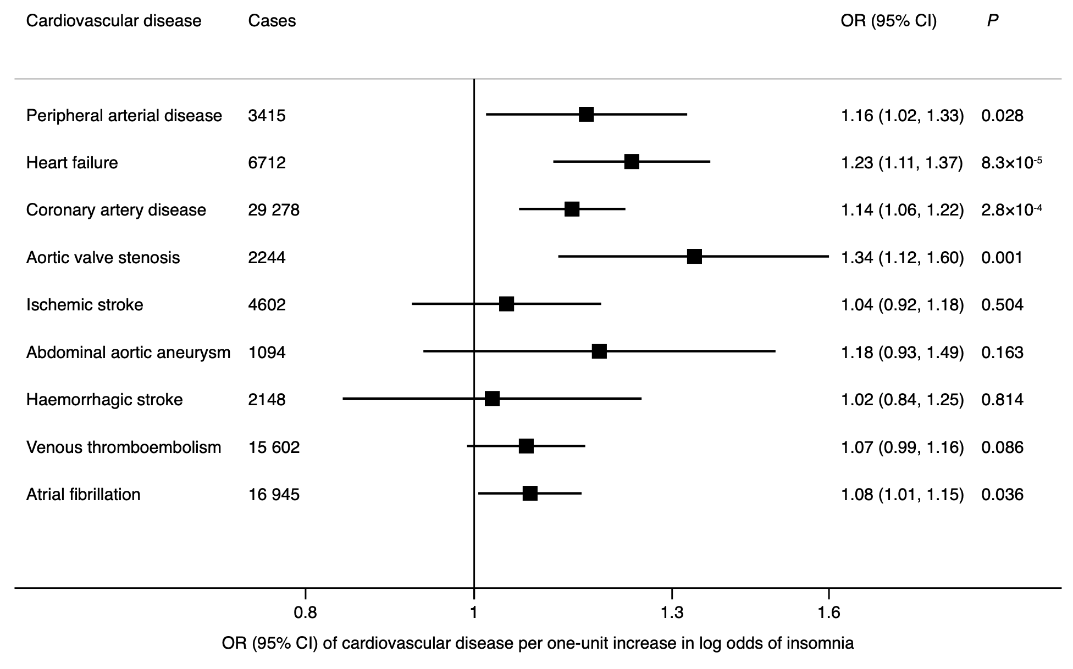

CI indicates confidence interval; OR, odds ratio.
Odds ratios are expressed per genetically predicted 1-unit-higher log-odds of liability to insomnia. Estimates are from the multivariable multiplicative random-effects inverse variance-weighted method.
Supplementary Figure 3. Associations of genetically predicted liability to insomnia with 9 individual cardiovascular diseases after adjusting for sleep duration in UK Biobank

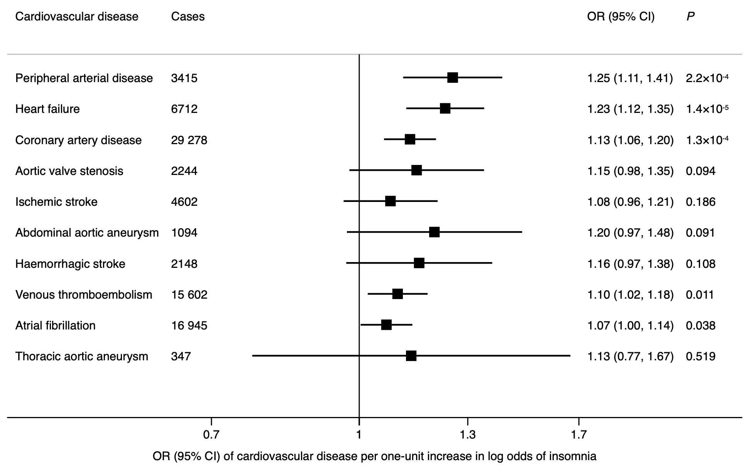

CI, confidence interval; OR, odds ratio.
Odds ratios are expressed per genetically predicted 1-unit-higher log-odds of liability to insomnia. Estimates are from the multivariable multiplicative random-effects inverse variance-weighted method.
Supplementary Figure 4. Associations of genetically predicted liability to insomnia with body mass index, smoking, alcohol drinking and type 2 diabetes mellitus
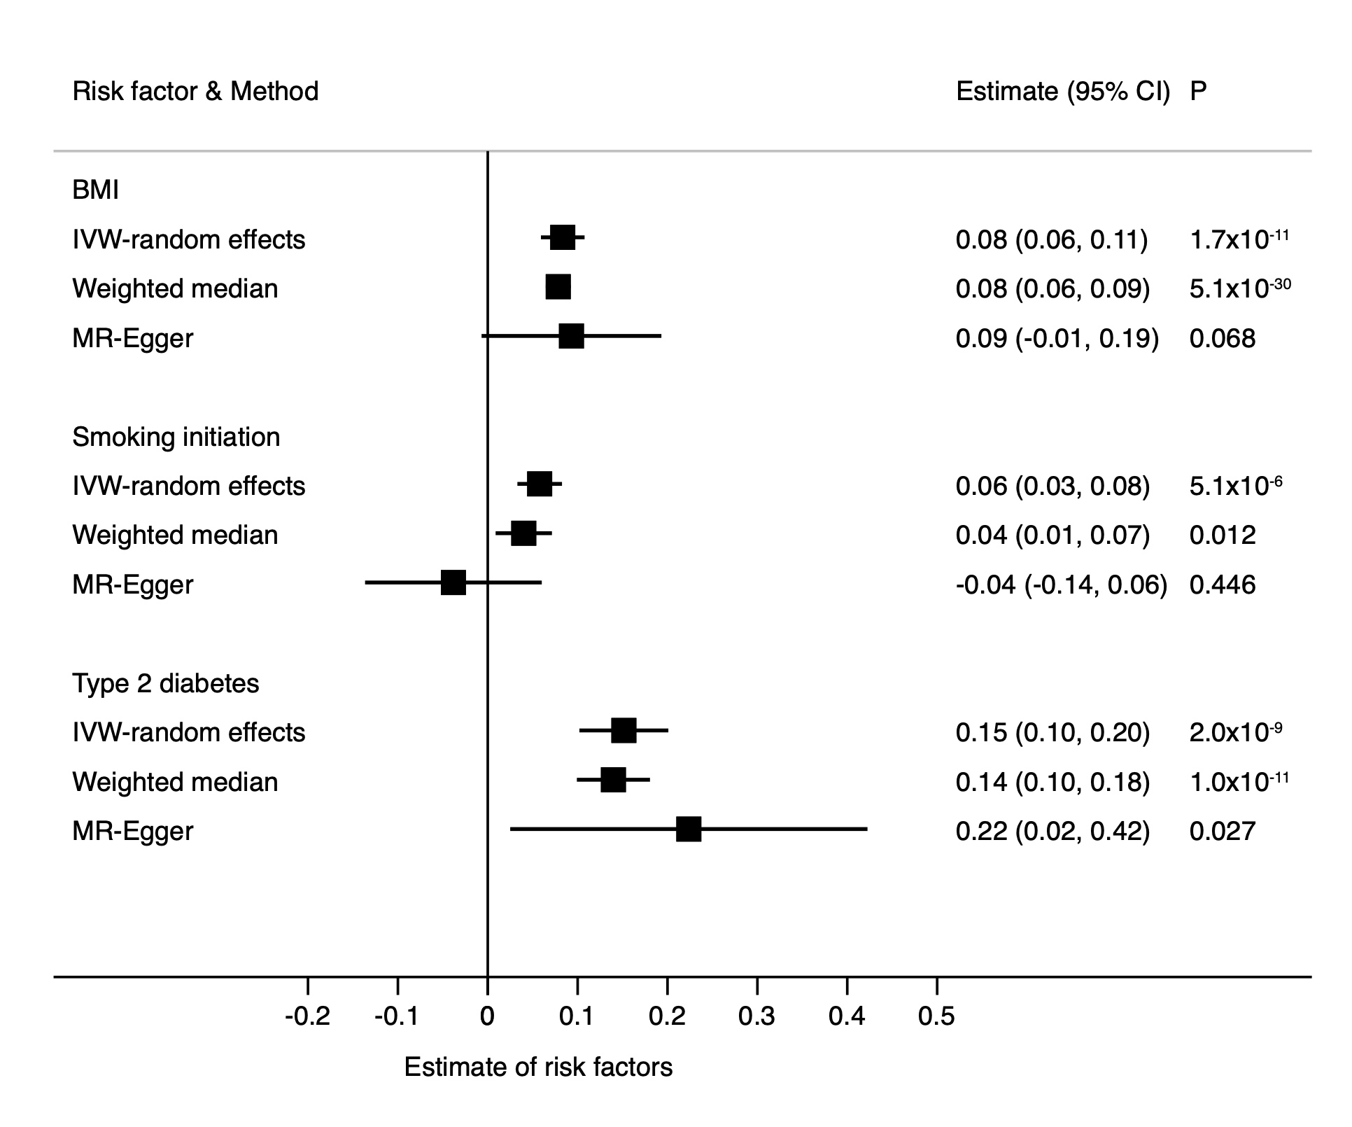

CI indicates confidence interval; OR, odds ratio.
Odds ratios are expressed per genetically predicted 1-unit-higher log-odds of liability to insomnia. Estimates are from the multiplicative random-effects inverse variance-weighted method.
Supplementary Figure 5. Associations of genetically predicted liability to insomnia with 9 individual cardiovascular diseases after adjusting for body mass index, smoking and type 2 diabetes mellitus in UK Biobank

BMI indicates body mass index; CI, confidence interval; OR, odds ratio; T2DM, type 2 diabetes.
Odds ratios are expressed per genetically predicted 1-unit-higher log-odds of liability to insomnia. Estimates are from the multivariable multiplicative random-effects inverse variance-weighted method.

