SUPPLEMENTARY DATA
9294 participants in 3-City Study baseline sample

858 excluded (did not provide blood sample and/or did not complete self-administered questionnaire on leisure and physical activities)

8436 individuals available for study
906 had dementia and/or history of cardiovascular disease leading to hospitalization at baseline

358 missing information on ≥1 cardiovascular health metrics or covariates

7172

546 excluded (no follow-up for incident dementia)

6626
19 missing information on occupation

359 missing information on income

6252
5895
- excluded during the IPW calculation
- 257 missing information for covariates
- 57 with extreme values for IPW

305 coronary diseases at baseline

5570 participants included in analysis for income exposure
(11 missing information on living alone)

5581 participants included in analysis for education and occupation exposure

Figure S1: Flow chart
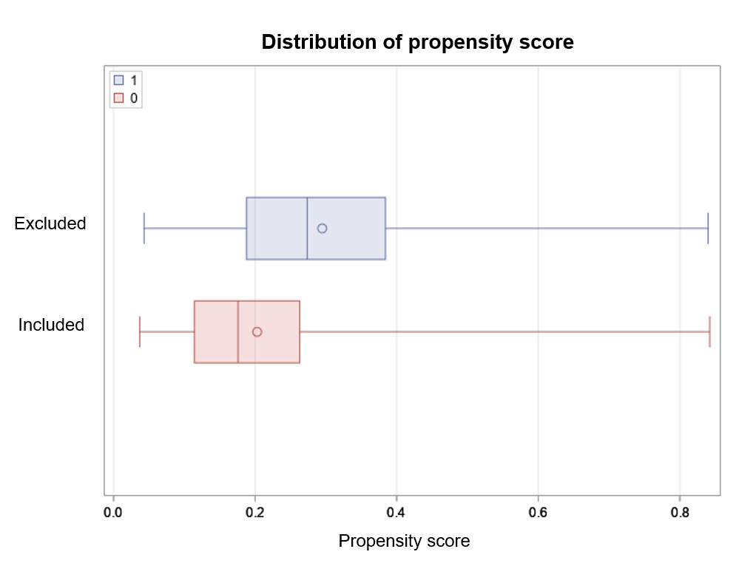
Figure S2. Propensity score distribution of participants excluded or included from the analytical sample at baseline

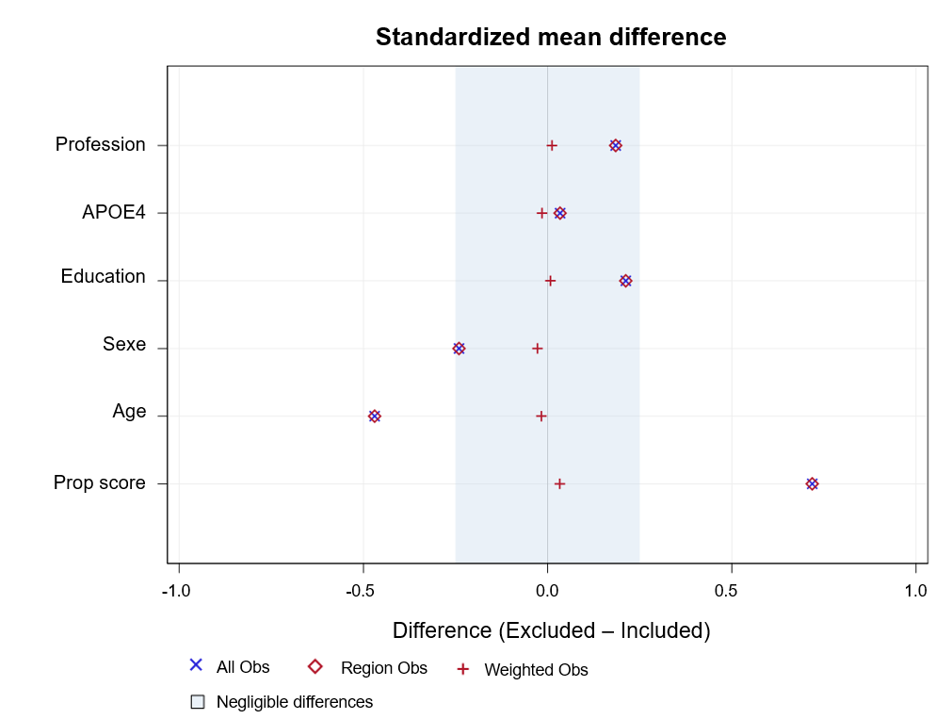
Figure S3. Standardized mean differences

