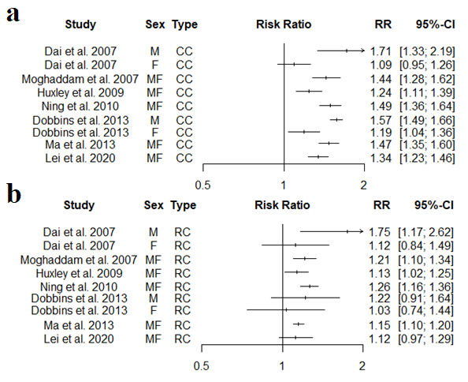
Supplementary Fig S1 Forest plot of the summary estimates from the reviews with meta-analyses in the umbrella review of the association between obesity (BMI ≥30 kg/m² and a) CC risk; b) RC risk
Abbreviations: BMI = body-mass index, CC = colon cancer, CI = confidence interval, CRC = colorectal cancer, F = female, M = male, RC = rectal cancer, RR = relative risk.

