Supplements- Circulating lipoprotein (a) and all-cause and cause-specific mortality: A systematic review and dose-response meta-analysis

Supplementary Table-1 Search strategy.
embase | ('lipoprotein A'/de OR (lipoprotein-A OR lipoproteinA OR lp-a OR lp-ai OR lp-aii OR lpa-i OR lpa-ii OR (lpa AND lipoprotein*)):ab,ti) AND ('mortality'/exp OR 'death'/exp OR 'mortality risk'/de OR 'mortality risk score'/de OR 'survival'/exp OR 'survivor'/exp OR (mortalit* OR death* OR fatal* OR surviv*):ab,ti) NOT [conference abstract]/lim NOT ([animals]/lim NOT [humans]/lim) NOT (juvenile/exp NOT adults/exp) NOT ('case report'/de OR case-report:ti)
Medline ALL Ovid | ("Lipoprotein(a)"/ OR (lipoprotein-A OR lipoproteinA OR lp-a OR lp-ai OR lp-aii OR lpa-i OR lpa-ii OR (lpa AND lipoprotein*)).ab,ti.) AND (exp Mortality/ OR Mortality.fs. OR exp Death/ OR exp Survival/ OR Survivors/ OR (mortalit* OR death* OR fatal* OR surviv*).ab,ti.) NOT (exp animals/ NOT humans/) NOT ((exp infant/ OR exp child/) NOT adult/) NOT (case reports/ OR case-report.ti.)
Web of science Core Collection | TS=(((lipoprotein-A OR lipoproteinA OR lp-a OR lp-ai OR lp-aii OR lpa-i OR lpa-ii OR (lpa AND lipoprotein*))) AND ((mortalit* OR death* OR fatal* OR surviv*))) NOT TI=(case-report*) AND DT=(article)
Cochrane Central register or trials | ((lipoprotein-A OR lipoproteinA OR lp-a OR lp-ai OR lp-aii OR lpa-i OR lpa-ii OR (lpa AND lipoprotein*)):ab,ti) AND ((mortalit* OR death* OR fatal* OR surviv*):ab,ti)

Supplementary Table-2 Characteristics of the included studies in the meta-analysis.
Study characteristics |  |  |  | Participants’ characteristics |  |  |  | Exposure and outcomes
 |  |  |  |  |  |  |  |  | No. of death
Author, year | Country | Design | Follow-up¹ | Sex | Age² | Health status | No. of Participants | Lp(a) assessment method | All-cause | CVD | Non-CVD | Adjustments
Perez-Cornago, 2020 [1] | UK | Prospective cohort | 8.7 | Male | 56.53±8.2 | General population | 163,808 | ITA | - | - | 240 | Age (underlying time variable), Townsend deprivation score, ethnicity, lives with a wife or partner, BMI, smoking, PA, alcohol, history of DM.
Welsh, 2020 [2] | UK | Prospective cohort | 8.9 | Both | 37-73 | Participants without baseline CVD and not taking a statin | 340,333 | ITA | - | 1,627 | - | Classical risk factors.
Welsh, 2020 [2] | UK | Prospective cohort | 8.9 | Both | 37-73 | Participants with baseline CVD and/or taking a statin | 73,391 | ITA | - | 1,620 | - | Classical risk factors.
Zhang, 2020 [3] | China | Prospective cohort | 3.02 | Both | 82.86 | AMI | 1,008 | ITA | - | 287 | - | Age, sex, BMI, current smoking, history of HTN/ DM, LDL, heart rate, DBP, left ventricular ejection fraction, eGFR, fasting glucose, hsCRP, revascularization during admission, baseline statin use.
Cao, 2020 [4] | China | Prospective cohort | 4.1 | Both | 61.7±16.1 | MI | 3,864 | ITA | - | 241 | - | Age, sex, BMI, family history of CAD, HTN, smoking, history of DM, prerevascularization, Gensini Score, corrected LDL, TG, FBS, hypersensitive, C-reactive protein, baseline statin use.
Heinrich, 2020 [5] | Denmark | Prospective cohort | 6.1 | Both | 58.7±8.6 | T2DM with microalbuminuria and no CVD | 198 | Denka Seiken developed Roche second generation | 26 | - | - | Age, sex, smoking, LDL, HbA1c, SBP, creatinine, urinary albumin excretion rate
Golledge, 2020 [6] | Australia | Prospective cohort | 2.4 | Both | NM | PAD | 1,472 | Automated latex-enhanced immunoassay | 368 | - | - | Age, sex, smoking, LDL, eGFR, history of DM/ HTN/ CHD, statin prescription
Arsenault, 2020 [7] | UK | Prospective cohort | 20 | Both | 45-79 | General population | 18,720 | ITA | 5,686 | 2,412 | - | Age, sex, smoking, BMI, SBP, history of DM, eGFR
Liu, 2020 [8] | China | Prospective cohort | 5 | Both | 57.3±10.8 | CAD | 7,562 | ITA | - | 251 | - | Age, sex, smoking, TG, LDL, hs-CRP, HbA1C, history of DM/ HTN, left ventricular ejection fraction, revascularization (percutaneous coronary intervention/coronary artery bypass grafting), baseline statin use
Roth, 2020 [9] | Austria | Prospective cohort | 5 | Both | 60.75 | Underwent coronary angiography  for acute coronary syndromes | 1,245 | Isoform-insensitive INA | 195 | 113 | - | Age, sex, BMI, LDL, TG, history of DM/ HTN, presence of  Multi-vessel disease and type of event (ST-segment elevation MI, Non-ST-segment elevation MI or unstable angina)
Xu, 2020 [10] | China | Prospective cohort | 6.2 | Both | 61.01±10.06 | Three-Vessel  CAD | 5,130 | ITA | 804 | - | - | Age, sex, LDL, left ventricular ejection fraction, BMI, creatinine clearance, statin treatment, presentation, previous MI, PAD, history of DM/CKD/HTN, SYNTAX Score, treatments
Zhang, 2020 [11] | China | Prospective cohort | 3.3 | Both | 58.54±10.47 | T2DM with prior cardiovascular events | 2,284 | ITA | - | 68 | - | Age, sex, smoking, LDL,  FBS, BMI, history of HTN/dyslipidemia, family history of CAD, diseased vessels,  statin and anti-diabetes drugs use
Gencer, 2019 [12] | Switzerland | Prospective cohort | 1 | Both | NM | Acute coronary syndromes | 1,711 | INA | 85 | 69 | - | Smoking, LDL, HDL, TG,  BMI, history of HTN/DM.
O’Donoghue, 2019 [13]³ | 49 countries | Prospective phase  (Clinical trial) | 2.2 | Both | 40-85 | Established atherosclerotic CV disease | 25,096 | Isoform-independent ITA | - | NM | - | Age, sex, smoking, LDL, race, region, prior MI, history of stroke/ PAD/ HTN/ DM, high-intensity statin use, ezetimibe use
Langsted, 2019 [14] | Denmark  (2 cohorts) | Prospective cohort | 3-26 | Both | 59.2 | General population | 69,761 | Automated turbidimetric assay, ITA, Isoform insensitive assay | 10,180 | - | - | Age, sex, smoking, BMI, HTN, TG, HDL, CRP, eGFR, ALA, TSH, history of DM, menopausal status and HRT  (women only), Lp(a) corrected total  cholesterol
Akinyemiju, 2018 [15] | US | Prospective cohort | 5-9 | Both | ≥ 45 | No active treatment for cancer | 1,764 | INA | - | - | 88 | Age, sex, education, income, site, race, PA, BMI, smoking, alcohol use, comorbidity score
Feng, 2017 [16] | China | Prospective cohort | 1.95 | Both | 63.3±10.6 | Undergoing CAG or PCI | 1,684 | Sandwich ELISA | 56 | - | - | Age, sex, LDL, Lp(a) (high), history of HTN/DM, anemia, eGFR, Left ventricular ejection fraction, lesion vessels
Bajaj, 2017 [17] | US | Prospective cohort | 7.5 | Both | 58 | Chronic kidney disease | 3,744 | Latex-enhanced ITA | 822 | - | - | Age, sex, race/ethnicity, clinical site, education, tobacco use, SBP, BMI, statin use, TC, LDL, HDL, TG, history of DM/ prior CVD
Zewinger, 2017 (original study) [18] | Germany | Prospective cohort | 9.9 | Both | 62.7±10.6 | Established CHD | 3,313 | Photometric assay | 994 | 621 | - | Age, sex, smoking, LDL, DM, SBP, BMI, eGFR, lipid-lowering therapy
Zewinger, 2017 (validation study 1)⁴ [18] | Norway | Prospective phase  (Clinical trial) | 10.3 | Both | 61.8±10.4 | Underwent coronary angiography | 4,162 | Particle-enhanced ITA | - | 416 | - | Age, sex, smoking, LDL, DM, SBP, BMI, eGFR, lipid-lowering therapy
Zewinger, 2017 (validation study 2)⁵ [18] | Scotland, Ireland, The Netherlands | Prospective phase  (Clinical trial) | 3.2 | Both | 75.6±3.4 | Preexisting vascular disease or an increased risk for vascular disease | 1,860 | Latex agglutination assay | - | 130 | - | Age, sex, smoking, LDL, DM, SBP, BMI, eGFR, lipid-lowering therapy
Zewinger, 2017 (validation study 3)⁶ [18] | Germany | Prospective cohort | 4.7 | Both | 61.9±10.1 | Underwent coronary angiography | 2,614 | Particle-enhanced ITA | - | 231 | - | Age, sex, smoking, LDL, DM, SBP, BMI, eGFR, lipid-lowering therapy
Waldeyer, 2017 [19] | 5 European countries  (7 cohorts) | Prospective cohort | 9.2 | Both | 42.1-62 | General population | 52,131 | Particle-enhanced ITA | 3,978 | - | - | Age, sex, smoking, LDL, DM, SBP, BMI, eGFR, lipid-lowering therapy
Katzke, 2017 [20] | Germany | Case-cohort | 15.6 | Both | 35-66 | General population | 2,739 | NM | - | 381 | 761 | Height, waist, BMI, lifetime alcohol consumption, red meat intake, fiber intake, smoking, socioeconomic  status, PA, history of DM/ HTN, use of lipid-lowering drugs
Onat, 2016 [21] | Turkey | Prospective cohort | 5.2 | Both | 59.3±10.65 | General population | 1,274 | INA | 121 | - | - | Age, sex, smoking, HDL, SBP
Séguro, 2016 [22] | France | Prospective cohort | 8.6 | Both | 52±10 | General population | 4,930 | NM | 123 | 31 | - | Age, sex, tobacco use, history of HTN/ DM, LDL, statin therapy
Zhao, 2016 [23] | US | Prospective cohort | 8.4 | Both | 73.8 | Prior CVD,  Diabetes,  10-year Framingham CVD risk >20% | 3,251 | Monoclonal antibody–based ELISA | 2,928 | - | - | Age, sex, smoking, TG, HDL, SBP, DBP, HTN medication, lipid medication, history of DM, BMI, family history of CHD
Nomikos, 2015 [24] | Greece | Prospective cohort | 8.41 | Both | 45±14 | Without any chronic disease | 2,583 | Latex-enhanced ITA | 99 | - | - | Smoking, PA, BMI, history of HTN/DM/ hypercholesterolemia, family history of CVD
Patterson, 2015 [25] | UK | Prospective cohort | 15.4 | Male | 45-59 | General population | 1,773 | IRMA | - | 363 | 571 | Age, smoking, DM, SBP, TC, TG, BMI, history of CVD and family history of CHD before 55 years of age
Sawabe, 2012 [26] | Japan | Prospective cohort | 12.5 | Both | 55±11.7 | Healthy individuals | 10,413 | ELISA | 830 | 202 | 316 | Age, sex, smoking, BMI, habitual drinking histories
Qi, 2012 [27] | US  (2 cohorts) | Prospective cohort | 12-16 | Both | 30-75 | T2DM | 1,686 | Latex-enhanced ITA | - | 156 | - | Age, smoking, BMI, LDL, HDL, TG, HbA1C, alcohol intake, PA, duration of DM, insulin use, aspirin use, cholesterol-lowering medication use, family history of MI, fasting status, history of HTN,  HRT (women only)
The Emerging Risk Factors Collaboration, 2009 [28] | Multiple countries  (24-25 studies) | Prospective cohorts/ Nested case-cohorts | 9.3 | Both | 57±8 | General population | 126,634 | - | - | 2,159 | 7,268 | Age, usual levels of SBP, smoking status, history of DM, BMI, TC.  Were stratified where appropriate, by sex and study group
Solfrizzi, 2009 [29] | Italy | Prospective cohort | 6.3 | Both | 73.7 ± 5.6 | Elderly individuals | 372 | ELISA | 154 | - | - | Age, sex, number of drinks, geriatric depression scale score, HTN status, smoking, non-HDL, Apo B to Apo A-I ratio, level of fibrinogen, BMI, T2DM, and vascular events at baseline (CAD, stroke, and PAD)
Chien, 2008 [30] | China | Prospective cohort | 13.8 | Both | 35-97 | Free of CVD history | 3,484 | Isoform-independent ELISA | 781 | - | - | Age, sex, smoking, current alcohol drinking, HDL, LDL, BMI, marital status, education, occupation, PA, family history of CHD, history of HTN/ DM
D’Angelo, 2006 [31] | Italy | Prospective cohort | 6.3 | Both | 65-87 | With or without history of vascular disease | 559 | ELISA | 107 | 33 | - | Age, sex
Hernandez, 2005 [32] | Spain | Prospective cohort | 10 | Both | 59.1±11 | T2DM | 100 | ELISA | - | 23 | - | Age, sex, BMI, smoking, HbA1c, LDL, HDL, TG, creatinine, albumin excretion rate, and the presence of HTN, macroangiopathy, retinopathy
Ariyo, 2003 [33] | US | Prospective cohort | 7.4 | Female | 72.2±5.4 | Without vascular disease | 2,375 | Monoclonal antibody–based ELISA | NM | - | - | Age, sex, TC, LDL, TG, smoking, history of DM/HTN, BMI, carotid-wall thickness, estrogen use or nonuse, other traditional risk factors
Ariyo, 2003 [33] | US | Prospective cohort | 7.4 | Male | 73.2±5.8 | Without vascular disease | 1,597 | Monoclonal antibody–based ELISA | NM | - | - | Age, sex, TC, LDL, TG, BMI, carotid-wall thickness, smoking, history of DM/ HTN, other traditional risk factors
Ahlbeck glader, 2002 [34] | Sweden | Prospective cohort | 6.7 | Both | 59.4±8.1 | Stable effort angina | 1,216 | In-house ELISA | 200 | 152 | - | Age, sex, smoking, LDL, TC, HDL, TG, fibrinogen, BMI, Myocardial coronary obstruction scores, Left ventricular motion scores, previous AMI, HTN, history of stroke/claudication/DM, AT III and SR
Iliescu, 2002 [35] | Canada | Prospective cohort | 2 | Both | 58.1±15.9 | Peritoneal dialysis | 54 | ELISA | 24 | - | - | Age
Zairis, 2002 [36] | Greece, New York | Prospective cohort | 1.84 | Both | 59.3±10 | Stable or unstable coronary syndromes (after successful coronary stenting) | 483 | Immunoassay method | - | 21 | - | Other univariate predictors of the event
Lundstam, 2002 [37] | Sweden | Prospective cohort | 11.7 | Both | 17-78 | CHD patients who underwent coronary angiography | 964 | ELISA | 363 | - | - | Age, sex
Cheng, 2001 [38] | China | Prospective cohort | 3.6 | Both | 37-87 | Lower limb arterial occlusive disease (intermittent claudication, critical ischemia) | 441 | ITA | 144 | - | - | For the effects of all other confounding variables
Gerdes, 2000 [39]⁷ | Denmark | Prospective phase  (Clinical trial) | 5.5 | Both | 35-70 | MI survivors | 966 | IRMA | 54 | 38 | - | Age, sex, smoking, HDL, LDL, TG, Apo A-I, Apo B, Lp(a), ꞓ4-carrier status, nationality, angina pectoris, history of DM/ HTN/claudication
Shlipak, 2000 [40]⁸ | US | Prospective phase  (Clinical trial) | 4.1 | Female | 66.7 | Postmenopausal women with CAD | 1,383 | ELISA | - | 59 | - | Race/ethnicity, history of DM, WHR, tobacco use, HDL, LDL, TG, and use of lipid-lowering agents, aspirin, and calcium channel blockers
Koda, 1999 [41] | Japan | Prospective cohort | 2.3 | Both | 56.6±14.1 | Hemodialysis | 390 | Latex-enhanced ITA | 49 | 18 | - | Age, history of DM, albumin
Ohashi, 1999 [42] | Japan | Prospective cohort | 5 | Both | 26-73 | Hemodialysis | 268 | ELISA |  | 70 | - | NM
Stubbs, 1998 [43] | UK | Prospective cohort | 3 | Both | 63 | MI | 266 | ELISA | - | 57 | - | Age, previous MI, infarct size, HTN
Stubbs, 1998 [43] | UK | Prospective cohort | 3 | Both | 60.8 | Unstable angina | 197 | ELISA | - | 31 | - | Conventional risk factors, accelerated angina
¹ Follow-up is presented as median, or mean, or min and max of years. ²Age is reported as Mean ± SD, Median (range), or min-max.³ Results of placebo group of FOURIER Trial (prospective phase) are presented. ⁴The prospective phase of the clinical trial study (The Western Norway B Vitamin Interventional Trial and The Bergen Coronary Angiography Cohort (WENBIT/BECAC cohort)) was included. ⁵The prospective phase of the clinical trial study (The PROspective Study of Pravastatin in the Elderly at Risk (PROSPER)) was included. ⁶ The ATHEROGENE study which is a prospective study on patients underwent coronary angiography was reported. ⁷ Results of placebo group of Scandinavian Simvastatin Survival Study (prospective phase) were included. ⁸ The results of the prospective phase of the clinical trial for the placebo group are reported. NM: Not mentioned; AMI: acute myocardial infarction; Apo: Apolipoprotein; ALA: Alanine aminotransferase; BMI: Body mass index; CAD: Coronary artery diseases; CVD: Cardiovascular diseases; CAG: Coronary angiography; CHD: Coronary heart diseases; CKD: chronic kidney disease; DM: Diabetes mellitus; ELISA: Enzyme-linked immunosorbent assay; eGFR: estimated glomerular filtration rate; FBS: fasting blood sugar; HTN; Hypertension; HDL: High-density lipoprotein cholesterol; HbA1c: Hemoglobin A1C; HRT: Hormone replacement therapy; ITA: Immunoturbidimetric assay; INA: Immunonephelometric assay; IRMA: Immunoradiometric assay; Lp(a): Lipoprotein (a); LDL: Low-density lipoprotein cholesterol; MI: myocardial infarction; PA: Physical activity; PAD: Peripheral artery disease; PCI: Percutaneous coronary intervention; SBP: Systolic blood pressure; TG: Triglyceride; TSH: thyroid stimulating hormone; T2DM: Type 2 diabetes; WHR: waist-to-hip ratio.

Supplementary Table-3 Quality of the included studies in the systematic review using the Newcastle Ottawa Scale.
Author, year | Selection |  |  |  | Comparability | Outcome/ Exposure |  |  | Total Score
Author, year | 1 | 2 | 3 | 4 | 1 | 1 | 2 | 3 | 9
Perez-Cornago, 2020 [1] | * | * | * | * | ** | * | * | * | 9
Welsh, 2020 [2] | * | * | * | * | ** | * | * | * | 9
Zhang, 2020 [3] | - | * | * | - | ** | * | - | * | 6
Cao, 2020 [4] | - | * | * | - | ** | * | - | * | 6
Heinrich, 2020 [5] | - | * | * | - | ** | - | * | * | 6
Golledge, 2020 [6] | - | * | * | - | ** | * | - | * | 6
Arsenault, 2020 [7] | * | * | * | * | ** | * | * | * | 9
Liu, 2020 [8] | - | * | * | - | ** | - | * | * | 6
Roth, 2020 [9] | - | * | * | - | ** | * | * | * | 7
XU, 2020 [10] | - | * | * | - | ** | * | * | * | 7
Zhang, 2020 [11] | - | * | * | - | ** | * | - | * | 6
Gencer, 2019 [12] | - | * | * | - | ** | * | - | * | 6
O’Donoghue, 2019 [13] | - | * | * | - | ** | * | - | * | 6
Langsted, 2019 [14] | * | * | * | * | ** | * | * | * | 9
Akinyemiju, 2018 [15] | * | * | * | * | ** | * | * | * | 9
Feng, 2017 [16] | - | * | * | - | ** | - | - | * | 5
Bajaj, 2017 [17] | - | * | * | - | ** | * | * | * | 7
Zewinger, 2017 (original study) [18] | - | * | * | - | ** | * | * | * | 7
Zewinger, 2017 (validation study 1)¹ [18] | - | * | * | - | ** | * | * | * | 7
Zewinger, 2017 (validation study 2)² [18] | - | * | * | - | ** | * | - | * | 6
Zewinger, 2017 (validation study 3)³ [18] | - | * | * | - | ** | * | - | * | 6
Waldeyer , 2017 [19] | * | * | * | * | ** | - | * | * | 8
Katzke, 2017 [20] | * | * | - | * | ** | * | * | * | 8
Onat, 2016 [21] | * | * | * | * | ** | * | * | * | 9
Séguro, 2016 [22] | * | * | - | * | ** | * | * | * | 8
Zhao, 2016 [23] | - | * | * | - | ** | * | * | * | 7
Nomikos, 2015 [24] | * | * | * | * | ** | - | * | * | 8
Patterson, 2015 [25] | * | * | * | * | ** | * | * | * | 9
Sawabe, 2012 [26] | * | * | * | * | ** | * | * | * | 9
Qi, 2012 [27] | - | * | * | - | ** | * | * | * | 7
Solfrizzi, 2009 [29] | * | * | * | * | ** | * | * | * | 9
The Emerging Risk Factors Collaboration, 2009 [28] | * | * | * | * | ** | * | * | * | 9
Chien, 2008 [30] | * | * | * | * | ** | * | * | * | 9
D’Angelo, 2006 [31] | * | * | * | * | * | * | * | * | 8
Hernandez, 2005 [32] | - | * | * | - | ** | - | * | * | 6
Ariyo, 2003 [33] | * | * | * | * | ** | * | * | * | 9
Ahlbeck glader, 2002 [34] | - | * | * | - | ** | * | * | * | 7
Iliescu, 2002 [35] | - | * | * | - | * | * | - | * | 5
Zairis, 2002 [36] | - | * | * | - | ** | * | * | * | 7
Lundstam, 2002 [37] | - | * | * | - | * | * | * | * | 6
Cheng, 2001 [38] | - | * | * | - | ** | * | - | * | 6
Gerdes, 2000 [39] | - | * | * | - | ** | - | * | * | 6
Shlipak, 2000 [40] | - | * | * | - | ** | * | - | * | 6
Koda,1999 [41] | - | * | * | - | * | * | - | * | 5
Ohashi,1999 [42] | - | * | * | - | * | - | * | * | 5
Stubbs, 1998 [43] | - | * | * | - | ** | * | - | * | 5

Supplementary Table-4 Summary of the included studies in the systematic review, reporting the death number/percent in low/high level of Lp(a).
Study characteristics |  |  |  | Participants’ characteristics |  |  |  |  | Exposure and results
Author, year | Country | Design | Follow-up¹ | Sex | Age² |  | Health status | No. of participants/ low Lp(a) group | Lp(a) assessment method | Lp(a) classification | Summary of results
 |  |  |  |  | Low Lp(a) | High Lp(a)
Bigazzi, 2021 [44] | Italy | Prospective cohort | 2 | Both | 66.3 ± 12.3 | 66.3 ± 12.5 | Coronary ischemia | 2374/ 1576 | Rate nephelometry | ≤30, >30–50, ≥50 mg/dL | 21 deaths were observed in the lowest and 2 in the highest levels of Lp(a). Among population with Lp(a) concentration between 30-50 mg/dL, 7 deaths were reported.
Hishikari, 2020 [45] | Japan | Prospective cohort | 2 | Both | 70.6 ± 8.3 | 71.2 ± 9.9 | Hemodialysis | 410/ 297 | Latex agglutination immunoassay | <40, ≥40 mg/dL | No significant differences were observed in cardiac death between two levels of Lp(a)  (Low Lp(a): 18 (6.1%) vs. high Lp(a): 13 (11.5%), p = 0.092)
Matsushita, 2020 [46] | Japan | Prospective phase  (Clinical trial) | 0.83 | Both | 63±10 | 67±11 | Acute coronary syndrome | 76/ 49 | Latex agglutination immunoassays | ≤ 20, > 20 mg/dL | No significant differences were observed between two levels of Lp(a) (Low Lp(a): 6 vs. high Lp(a): 0, p = 0.55).
Dewa Gde Dwi Sumarjaya, 2020 [47] | Indonesia | Prospective cohort | NM | Both | 56.45±9.48 | 61.69±10.47 | Hospitalized-acute MI | 66/ 31 | ITA | < 10.25, ≥ 10.25 mg/dL | 3.2 % (Low Lp(a) group) and 11.4 % (High Lp(a) group) CVD mortality were observed.
Xu, 2020 [48] | China | Prospective cohort | 2.4 | Both | 57.6±10.3 | 58.5±10 | Patients underwent PCI | 6714/ 2238 | latex turbidimetric method | ≤ 10.59 or 10.59-30.55 or ≥ 30.55 mg/dL | No significant differences were observed in different levels of Lp(a) for cardiovascular death (tertile 1: 7 (0.3 %), tertile 2: 6 (0.3 %), tertile 3: 8 (0.4 %), and all-cause death tertile 1: 26 (1.2 %), tertile 2: 15 (0.7 %), tertile 3: 15 (0.7 %)).
Shitara, 2019 [49] | Japan | Prospective cohort | 5.1 | Both | 65.2±12 | 65.3±11.5 | Coronary artery disease and Left  ventricular systolic dysfunction | 369/ 184 | Latex agglutination immunoassays | < 21.6 or ≥ 21.6 mg/dL | 36 (23.8 5) and 44 (29.1 %) all-cause death and 13 (8.6 %) 22 (14.6 %) cardiovascular death were observed in low Lp(a) and high Lp(a) groups, respectively.
Sanchez Munoz-Torrero, 2018 [50] | Spain | Prospective cohort | 3 | Both | 67±11 | 66±11 | Stable outpatients with symptomatic artery  disease | 1503/ 814 | Kinetic nephelometric | < 30 or  30-50 or ≥ 50 mg/dL | No significant differences were observed in different levels of Lp(a) for cardiovascular death (Lp < 30: 20 (2.5 %), Lp: 30-50: 4 (1.3 %), Lp ≥ 50: 13 (3.5 %), non-cardiovascular death (Lp < 30: 24 (2.9 %), Lp = 30-50: 8 (2.5 %), Lp ≥ 50: 16 (4.3 %) and all-cause death (Lp < 30: 44 (5.4 %), Lp: 30-50: 12 (3.8 %), Lp ≥ 50: 29 (7.8 %))
Fogacci, 2017 [51] | Italy | Prospective cohort | 25 | Both | NM | NM | Without history of CHD | 1215 | ELISA | Stratified into quartiles | Subjects at high and intermediate CV risk aged 56–69 years (regardless of gender) and women aged 40–55 years with a low CV risk profile who had lower Lp(a) levels showed a significant benefit on CV mortality (p < 0.05).
Xie, 2017 [52] | China | Prospective cohort | 2.6 | Both | 57±10 | 60±8 | Patients with non-obstructive CAD | 451/ 150 | Latex agglutination immunoassays | 0.2-10.6 or 10.9-23.4 or 23.8-124 mg/dL | Significant differences were observed across different levels of Lp(a) and cardiovascular death (tertile 1: 2 (1%), tertile 2: 4 (3%), and tertile 3: 9 (6 %)).
Konishi, 2016 [53] | Japan | Prospective cohort | 4.7 | Both | 70.1±9.2 | 69.9±9.4 | CKD | 904/ 454 | Latex agglutination immunoassays | According to median levels of Lp(a) | The difference in cardiac death was significant between two levels of Lp(a) (Low Lp(a): 38 (8.4%) vs. high Lp(a): 67 (14.8%), p < 0.01).  No considerable differences were observed in Non-cardiac death (Low Lp(a): 52 (11.6%) vs. high Lp(a): 54 (11.9%), p = 0.88)
Mitsuda, 2016 [54] | Japan | Prospective cohort | 3 | Both | 64±12.4 | 66±12.8 | STEMI patients after primary percutaneous coronary intervention | 176/ 88 | Latex agglutination immunoassays | < 16.5 or >16.5 mg/dL | 0 (0%) death in low Lp(a) group and 1 (1.1%) death in high Lp(a) group were observed.
Konishi, 2015 [55] | Japan | Prospective cohort | 4.7 | Both | 67.8±10.4 | 67±10.7 | CAD | 411/ 292 | Latex agglutination immunoassays | < 30 or ≥ 30 mg/dL | 34 deaths in low Lp(a) group and 19 deaths in high Lp(a) group were observed.
Cai, 2013 [56] | China | Prospective phase  (Clinical trial) | 1 | Both | 62.2±10.3 | 62.3±11.1 | CAD, eligible for stent placement | 832/ 552 | Sandwich ELISA | < 30 or > 30  mg/dL | In both subgroups of baseline LDL-C ( ≥ 1.8 and <18 mmol/L), no significant differences were observed in CVD mortality between two groups of Lp(a).  (LDL < 18 mmol/L, low Lp(a): 6 (2.1%) vs. high Lp(a): 2 (2.2%)  LDL ≥ 1.8, low Lp(a): 15 (5.7%) vs. high Lp(a): 10 (5.3%))
Zhou, 2012 [57] | China | Prospective cohort | 2.5 | Both | NM | NM | Acute coronary syndrome | 713/ 178 | Immune turbidimetric assay | < 9 or 9-< 15.2 or 15.2 < 31.3 or ≥ 31.3 mg/dL | Number of cardiovascular death events were 1, 4, 5, 4 for quartiles 1 to 4, respectively.
Ikenaga, 2011 [58] | Japan | Prospective cohort | 5 | Both | 63±12 | 64±11 | Acute MI | 410/ 315 | Turbidimetric immunoassay system | ≤ 40 or > 40 mg/dL | The difference in cardiac death was significant between two levels of Lp(a)  (Low Lp(a): 5 (1.6%) vs. high Lp(a): 5 (5.3%), p = 0.06)
Boras, 2010 [59] | Croatia | Prospective cohort | 4 | Both | 63 (45-69) | 64 (46-70) | T2DM | 146/ 60 | Automated ITA | ≤ 30 or > 30  mg/dL | There were no significant differences in CVD or stroke death between two Lp(a) groups.
Nicholls, 2010 [60] | US | Prospective cohort | 3 | Both | 63.9±10.9 | 63±10.7 | Patients underwent coronary angiography | 2769/ 1720 | Automated latex enhanced  immunoassay | < 30 or ≥ 30 mg/dL | The rate of death did not significantly differ between patients in low Lp(a) (10.5 %) and high Lp(a) (12.2 %) levels (p = 0.20)
Igarashi, 2003 [61] | Japan | Prospective cohort | 2.9 | Both | 67±7 | 64±8 | Acute MI | 127/ 96 | Latex-enhanced turbidimetric immunoassay | < 47 or ≥ 47  mg/dL | 2.1 % cardiac death were accrued in participants with low Lp(a) level although no cardiac mortality was observed in the other group (p > 0.05). Two and one fatal MI were observed in high and low Lp(a) group (p > 0.05).
Longenecker, 2002 [62] | US | Prospective cohort | 2.8 | Both | NM | NM | Dialysis patients | 864/ 433 | ELISA | < 53 or ≥ 53 nmol/L | 187 and 158 deaths were occurred in low and high Lp(a) groups, respectively.
Cristóbal, 1999 [63] | Spain | Prospective cohort | > 3 | NM | 43 | 48 | Cardiac transplant recipients | 166/ 108 | ELISA | < 30 or > 30  mg/dL | Three-year global mortality was not significantly different between Lp(a) groups. Significant CVD mortality (Low Lp(a): 12% vs. high Lp(a): 3%) and sudden death (Low Lp(a): 4% vs. high Lp(a): 0%) were observed.
Skinner, 1997 [64] | UK | Prospective cohort | 5 | Both | NM | NM | patients underwent first time CABG for stable angina | 353/ 116 | Enzyme-linked immunosorbent assay | < 123 or 123-331 or 331-1411 mg/l | Late cardiac death was 5, 8, 2 events in tertiles 1 to 3 of Lp(a) levels. Thus, serum Lp(a) concentration did not predict late cardiac death.
Goldwasser, 1993 [65] | US | Prospective cohort | 1 | Both | 60±16 | 61±13 | Hemodialysis | 125/ 84 | ITA | < 57 or ~ 57  mg/dL | Lower Lp(a) level was associated with a survival of 78% compared with 83.7% for Lp(a) ~ 57 mg/dL  (p = 0.23 by log-rank test).
¹ Follow-up is presented as median, mean, min and max of years. ² Age is reported as Mean ± SD, Median (range), or min and max. NM: Not mentioned; T2DM: Type 2 diabetes mellitus; CAD: Coronary artery disease; MI: Myocardial infarction; CHD: Coronary heart diseases; CKD: Chronic kidney disease; CABG: Coronary artery bypass graft surgery; PCI: Percutaneous coronary intervention; ITA: Immunoturbidimetric assay; ELISA: Enzyme-linked immunosorbent assay.

Supplementary Table-5 Summary of the included studies in the systematic review, reporting level of Lp(a) in survivors/non-survivors.
Study characteristics |  |  |  | Participants’ characteristics |  |  |  |  | Exposure and results
Author, year | Country | Design | Follow-up | Gender | Age¹ |  | Health status | No. of participants/ Survivors | Lp(a) assessment method | Lp(a) level |  | Summary of results
 |  |  |  |  | Survivor | Non-survivor | Health status | No. of participants/ Survivors | Lp(a) assessment method | Survivors | Non- survivors | Summary of results
Schwaiger, 2006 [66] | Austria | Prospective cohort | 13 | Both | 43 ± 10.9 | 59 ± 10.7 | Hemodialysis  patients | 165/ 70 | ELISA | 20.6 ± 27.3  mg/dL | 30.1 ± 30.7  mg/dL | Significant difference was observed  (p = 0.025)
Hocher, 2003 [67] | Germany | Prospective cohort | 2 | Both | 63.5 ± 5.8 | 70.4 ± 9.8 | Hemodialysis  patients | 245/ 172 | Standardized autoanalyzer methods | 29.5 ± 33.2 mg/dL | 29.3 ± 32.5 mg/dL | No significant difference was observed.
Zimmermann, 1999 [68] | Germany | Prospective cohort | 2 | Both | NM | NM | Hemodialysis  patients | 280/ 208 | Nephelometric immunoassay | 9.2 mg/dL | 13.6 mg/dL | After 4 years of follow-up, 42 cardiovascular deaths and 72 all-cause deaths were reported
Koch, 1997 [69] | Germany | Prospective cohort | 9 | Both | 53 ± 15 | 61 ± 12 | Diabetic patients with ESRD | 412/ 232 | Electroimmuno-diffusion | 22.6 ± 22  mg/dL | 24.1 ± 21.4  mg/dL | No significant difference was observed  (p = 0.9)
Cressman, 1994 [70] ² | US | Prospective cohort | 4 | Both | 57 ± 12 | 64 ± 11 | Patients with ESRD | 129/ 62 | Double-antibody radioimmunoassay | 3.33 ± 1.08  (log Lp(a), mg/dL) | 3.72 ±0.9  (log Lp(a), mg/dL) | Significant difference was observed  (p < 0.005)
Cressman, 1992 [71] ² | US | Prospective cohort | 4 | Both | 58 ± 14 | 58 ± 14 | Hemodialysis Patients | 129/ 60 | Double-antibody radioimmunoassay | 37.7 mg/dL | 46.7 mg/dL | After 4 years of follow-up, 11 non-cardiovascular deaths and 13 uncertain deaths were reported
Haffner, 1992 [72] | US | Nested case-control | 4 | Both | NM | NM | Patients with diabetes | 70/ 35 | Monoclonal anti-Lp(a) antibody | Older-onset:  12.7 ± 3.7  Younger-onset:  18.5 ± 6.6  (mg/dL) | Older-onset:  15.4 ± 3.9  Younger-onset:  16.8 ± 6.6  (mg/dL) | No significant difference was observed  (older-onset: p = 0.60,  younger-onset: p = 0.86)
¹Age is reported as Mean or Median of years. ² These studies are derived from a same population but reported different study outcomes. NM: Not mentioned; NS: Non-significant; ESRD: End-stage renal disease; ELISA: Enzyme-linked immunosorbent assay.

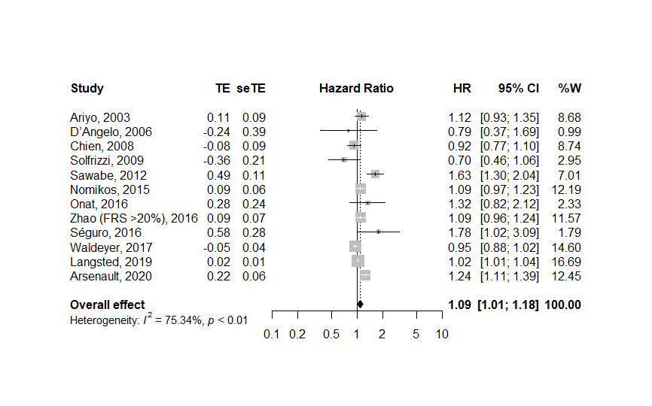
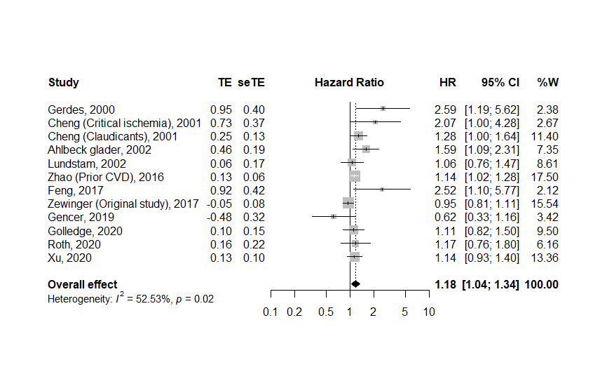
Supplementary Figure-1 Summary hazard ratios of all-cause mortality for top versus bottom third of Lp(a) levels in general population.
Supplementary Figure-2 Summary hazard ratios of all-cause mortality for top versus bottom third of Lp(a) levels in patients with CVD.

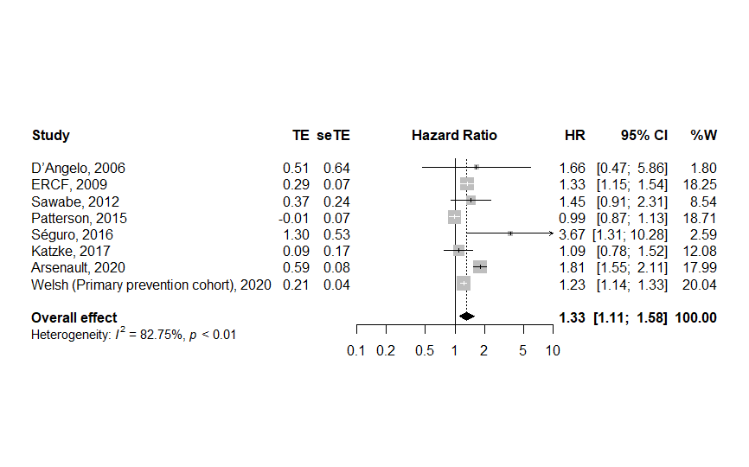
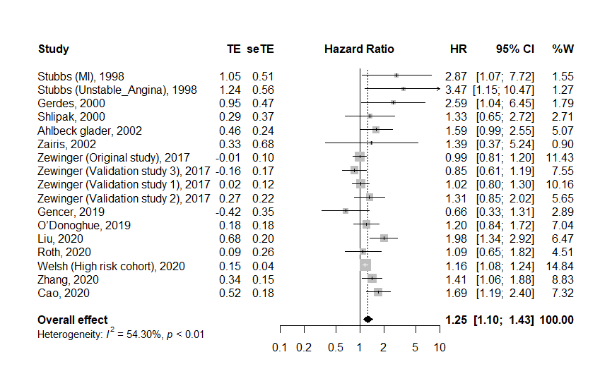
Supplementary Figure-3 Summary hazard ratios of CVD-death for top versus bottom third of Lp(a) levels in general population.
Supplementary Figure-4 Summary hazard ratios of CVD-death for top versus bottom third of Lp(a) levels in patients with CVD.

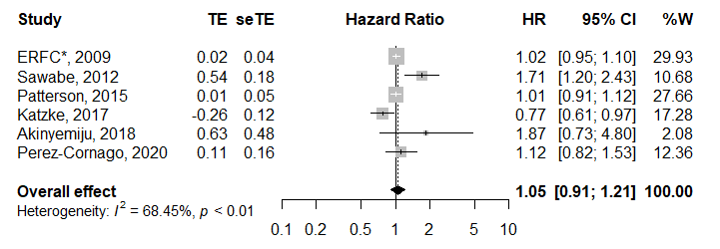
Supplementary Figure-5 Summary hazard ratios of non-CVD-death for top versus bottom third of Lp(a) levels in general population. *ERFC: The emerging risk factor collaboration.

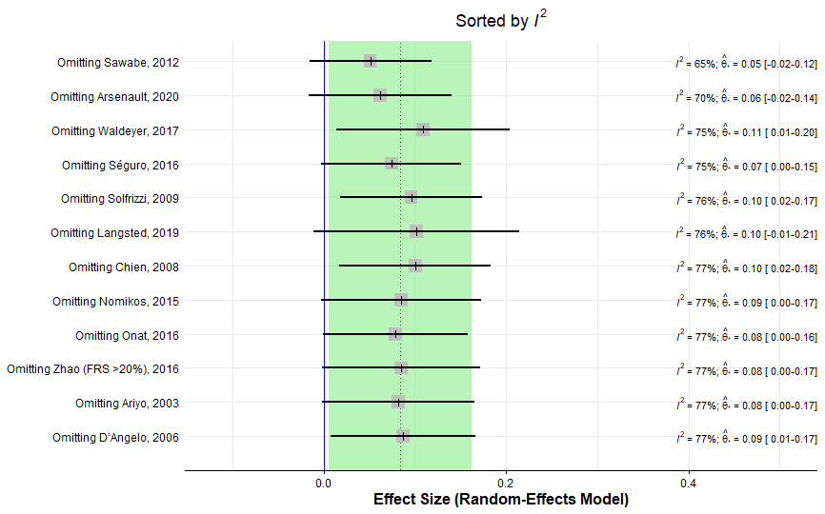
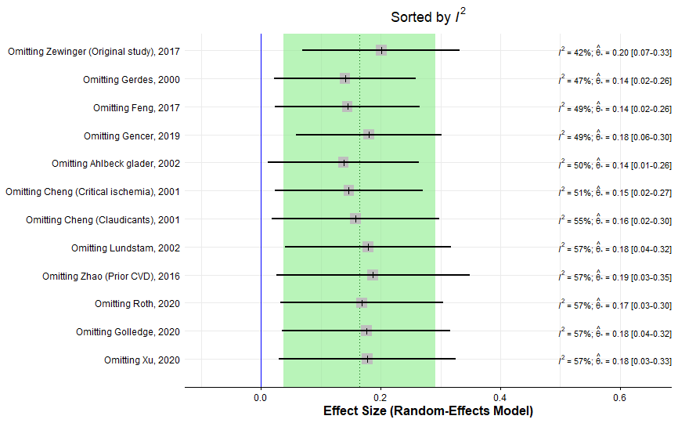
A
B

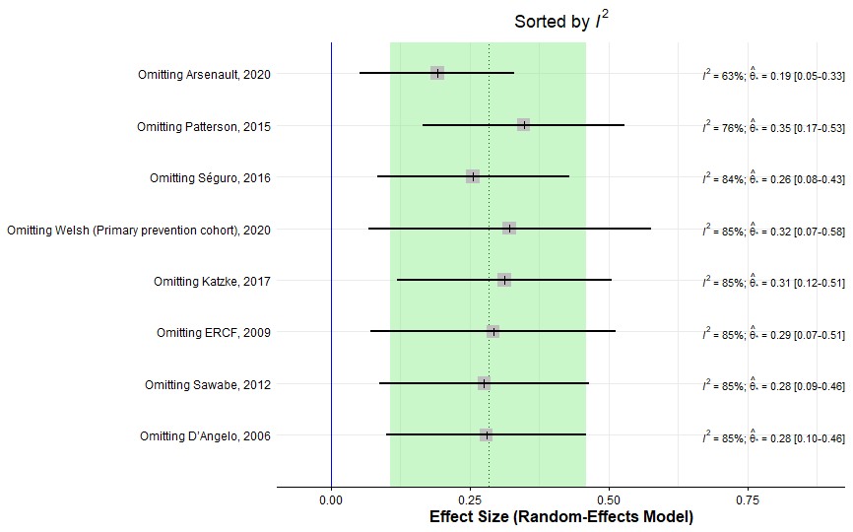
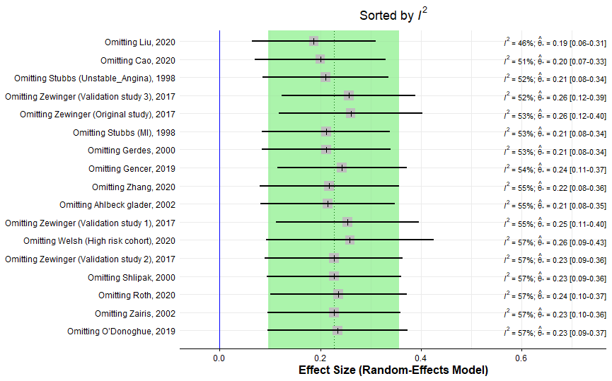
C
D

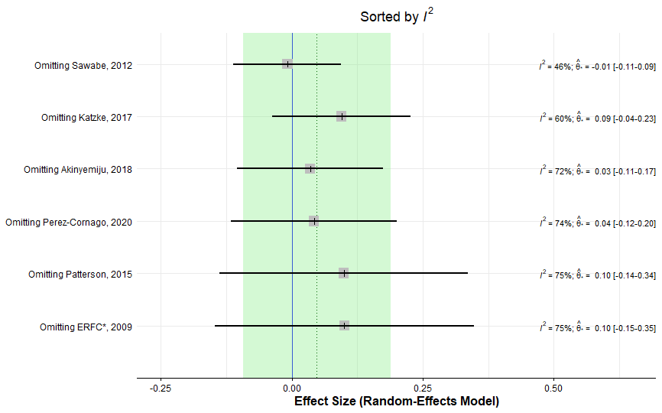
E
Supplementary Figure-6 Leave-one-out forest plots of the included studies in meta-analysis of A) All-cause mortality in general population, B) All-cause mortality in patients with CVD, C) CVD- death in general population, D) CVD-death in patients with CVD, E) Non-CVD-death in general population. Effects sizes are sorted by I².

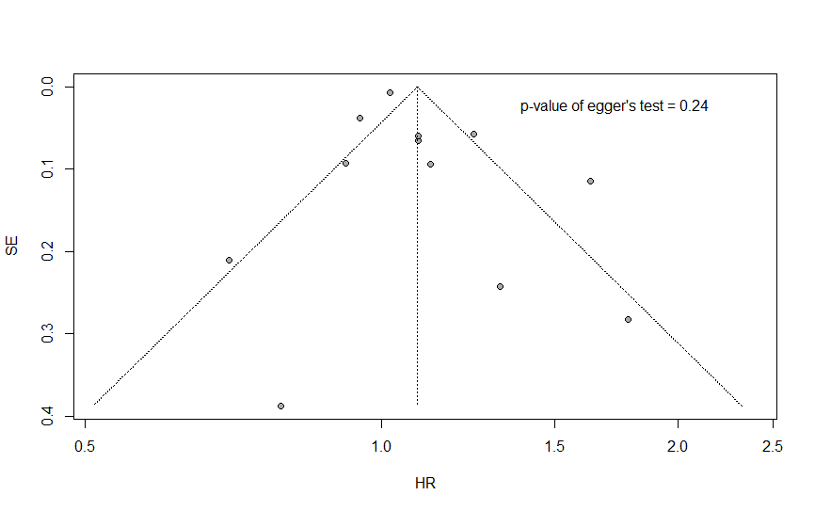
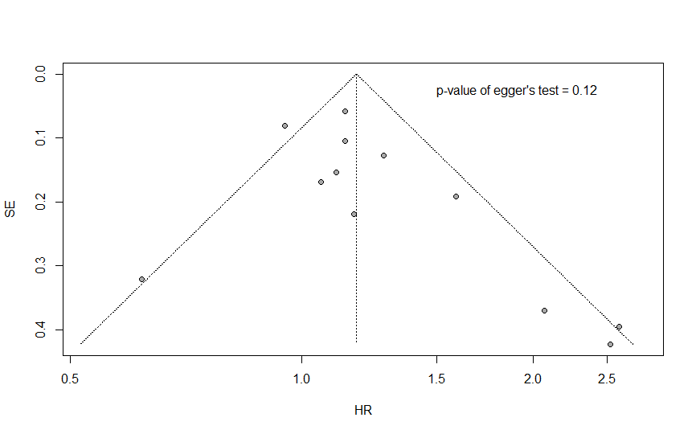
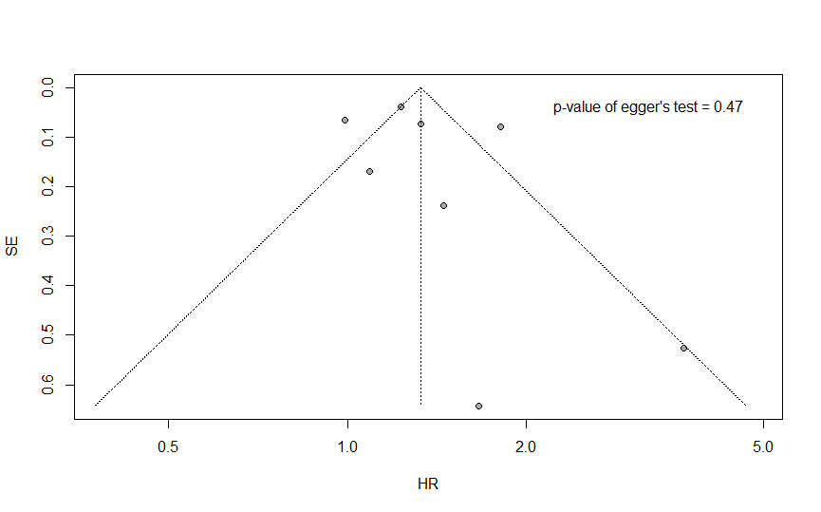
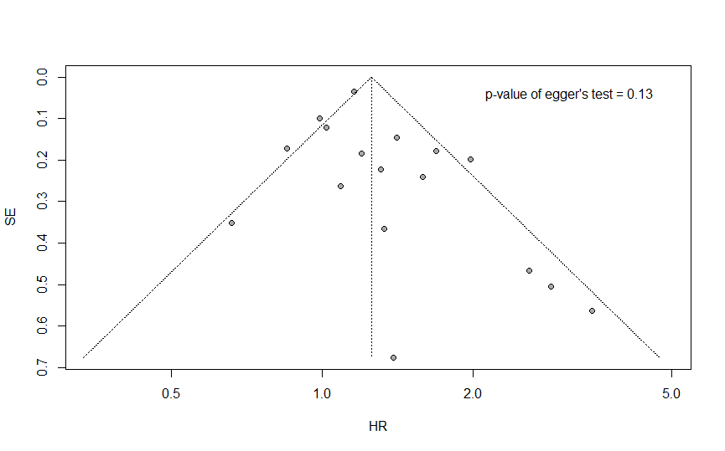
A
B
C
D

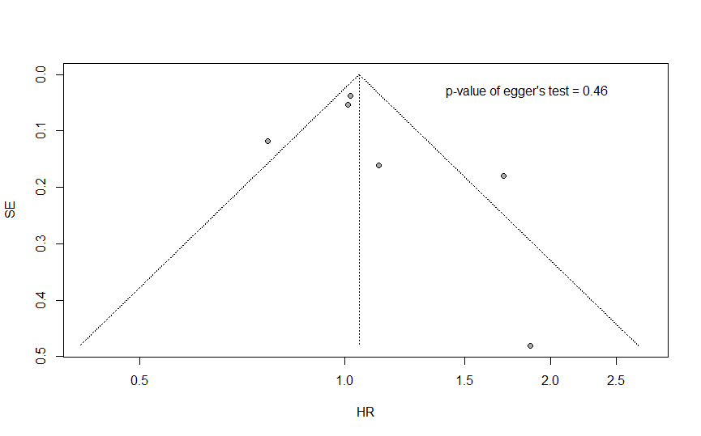
E
Supplementary Figure-7 Funnel plots of the hazard ratios of the included studies in meta-analysis of A) All-cause mortality in general population, B) All-cause mortality in patients with CVD, C) CVD- death in general population, D) CVD-death in patients with CVD, E) Non-CVD-death in general population. X and Y- axes represent the HR and SE, respectively.

A
B
C
D

E
Supplementary Figure-8 Non-linear dose response analysis. A) All-cause mortality in general population, B) All-cause mortality in patients with CVD, C) CVD- death in general population, D) CVD-death in patients with CVD, E) Non-CVD-death in general population. X and Y- axes represent the Lp(a) concentration in mg/dl and HR, respectively.

Supplementary Table-6 Table of HRs from nonlinear dose-response analyses.
 | All-cause mortality |  | CVD-death |  | Non-CVD-death
Lp(a) | General population | CVD patients | General population | CVD patients | General population
mg/dl | HR (95% CI) | HR (95% CI) | HR (95% CI) | HR (95% CI) | HR (95% CI)
0 | 1.00 | 1.00 (3.25 mg/dl) | 1.00 (1.45 mg/dl) | 1.00 (3.25 mg/dl) | 1.00 (1.45 mg/dl)
10 | 1.00 (0.91-1.10) | 1.00 (0.94-1.06) | 1.02 (0.83-1.24) | 1.07 (0.99-1.15) | 0.95 (0.87-1.04)
20 | 1.01 (0.84-1.20) | 0.99 (0.87-1.12) | 1.05 (0.77-1.44) | 1.16 (0.98-1.36) | 0.90 (0.76-1.08)
30 | 1.02 (0.82-1.28) | 0.98 (0.83-1.15) | 1.13 (0.80-1.60) | 1.21 (0.98-1.51) | 0.87 (0.69-1.11)
40 | 1.05 (0.81-1.35) | 0.96 (0.81-1.14) | 1.26 (0.69-2.28) | 1.24 (0.97-1.58) | 0.86 (0.66-1.12)
50 | 1.07 (0.81-1.42) | 0.94 (0.78-1.13) | 1.42 (0.46-4.38) | 1.24 (0.97-1.59) | 0.87 (0.68-1.11)
60 | 1.10 (0.82-1.49) | 0.92 (0.72-1.17) | 1.65 (0.27-10.11) | 1.23 (0.96-1.57) | 0.90 (0.73-1.11)
70 | 1.14 (0.82-1.57) | 0.90 (0.65-1.25) | 1.92 (0.14-26.42) | 1.21 (0.95-1.54) | 0.94 (0.79-1.11)
80 | 1.17 (0.83-1.65) | 0.89 (0.61-1.30) | 2.26 (0.07-72.53) | 1.19 (0.93-1.52) | 0.99 (0.84-1.17)
p_{nonlinearity} | 0.58 | 0.86 | 0.79 | 0.10 | 0.27

REFRENCES

1. Perez-Cornago, A., et al., Examination of potential novel biochemical factors in relation to prostate cancer incidence and mortality in UK Biobank. Br J Cancer, 2020. 123(12): p. 1808-1817.
2. Welsh, P., et al., Lipoprotein(a) and cardiovascular disease: prediction, attributable risk fraction, and estimating benefits from novel interventions. Eur J Prev Cardiol, 2020.
3. Zhang, M., et al., Lipoprotein(a) and cardiovascular death in oldest-old (≥80 years) patients with acute myocardial infarction: A prospective cohort study. Atherosclerosis, 2020. 312: p. 54-59.
4. Cao, Y.X., et al., Lipoprotein(a) and Cardiovascular Outcomes in Patients with Previous Myocardial Infarction: A Prospective Cohort Study. Thromb Haemost, 2021.
5. Heinrich, N.S., et al., Lipoprotein(a)and renal function decline, cardiovascular disease and mortality in type 2 diabetes and microalbuminuria. J Diabetes Complications, 2020.
6. Golledge, J., et al., Association of Serum Lipoprotein (a) With the Requirement for a Peripheral Artery Operation and the Incidence of Major Adverse Cardiovascular Events in People With Peripheral Artery Disease. J Am Heart Assoc, 2020. 9(6): p. e015355.
7. Arsenault, B.J., et al., Association of Long-term Exposure to Elevated Lipoprotein(a) Levels with Parental Life Span, Chronic Disease-Free Survival, and Mortality Risk: A Mendelian Randomization Analysis. JAMA Netw Open, 2020.
8. Liu, H.H., et al., Association of lipoprotein(a) levels with recurrent events in patients with coronary artery disease. Heart, 2020. 106(16): p. 1228-1235.
9. Roth, C., et al., Lipoprotein(a) plasma levels are not associated with survival after acute coronary syndromes: An observational cohort study. PLoS ONE, 2020. 15(1).
10. Xu, N., et al., Impact of Lipoprotein(a) on Long-Term (Mean 6.2 Years) Outcomes in Patients With Three-Vessel Coronary Artery Disease. Am J Cardiol, 2020. 125(4): p. 528-533.
11. Zhang, Y., et al., Lipoprotein (a) predicts recurrent worse outcomes in type 2 diabetes mellitus patients with prior cardiovascular events: A prospective, observational cohort study. Cardiovasc Diabetol, 2020. 19(1).
12. Gencer, B., et al., Prognostic value of elevated lipoprotein(a) in patients with acute coronary syndromes. Eur J Clin Invest, 2019. 49(7).
13. O’Donoghue, M.L., et al., Lipoprotein(a), PCSK9 inhibition, and cardiovascular risk insights from the FOURIER trial. Circulation, 2019. 139(12): p. 1483-1492.
14. Langsted, A., P.R. Kamstrup, and B.G. Nordestgaard, High lipoprotein(a) and high risk of mortality. Eur Heart J, 2019. 40(33): p. 2760-2770.
15. Akinyemiju, T., et al., Pre-diagnostic biomarkers of metabolic dysregulation and cancer mortality. Oncotarget, 2018. 9(22): p. 16099-16109.
16. Feng, Z., et al., Association of lipoprotein(a) with long-term mortality following coronary angiography or percutaneous coronary intervention. Clin Cardiol, 2017. 40(9): p. 674-678.
17. Bajaj, A., et al., Lipoprotein(a) and risk of myocardial infarction and death in chronic kidney disease findings from the CRIC study (Chronic renal insufficiency cohort). Arterioscler Thromb Vasc Biol, 2017. 37(10): p. 1971-1978.
18. Zewinger, S., et al., Relations between lipoprotein(a) concentrations, LPA genetic variants, and the risk of mortality in patients with established coronary heart disease: a molecular and genetic association study. Lancet Diabetes Endocrinol, 2017. 5(7): p. 534-543.
19. Waldeyer, C., et al., Lipoprotein(a) and the risk of cardiovascular disease in the European population: Results from the BiomarCaRE consortium. Eur Heart J, 2017. 38(32): p. 2490-2498.
20. Katzke, V.A., et al., Blood lipids and lipoproteins in relation to incidence and mortality risks for CVD and cancer in the prospective EPIC-Heidelberg cohort. BMC Med, 2017. 15(1).
21. Onat, A., et al., Lipoprotein(a) level and MIF gene variant predict incident metabolic syndrome and mortality. J Invest Med, 2016. 64(2): p. 392-399.
22. Séguro, F., et al., Real life validation of the European Atherosclerosis Society Consensus Panel lipoprotein(a) threshold of 50 mg/dL. Int J Cardiol, 2016. 221: p. 537-538.
23. Zhao, Y., et al., Cardiovascular Disease, Mortality Risk, and Healthcare Costs by Lipoprotein(a) Levels According to Low-density Lipoprotein Cholesterol Levels in Older High-risk Adults. Clin Cardiol, 2016. 39(7): p. 413-420.
24. Nomikos, T., et al., Hierarchical modelling of blood lipids' profile and 10-year (2002-2012) all cause mortality and incidence of cardiovascular disease: The ATTICA study. Lipids Health Dis, 2015. 14(1).
25. Patterson, C.C., et al., Which biomarkers are predictive specifically for cardiovascular or for non-cardiovascular mortality in men? Evidence from the Caerphilly Prospective Study (CaPS). Int J Cardiol, 2015. 201: p. 113-118.
26. Sawabe, M., et al., Low lipoprotein(a) concentration is associated with cancer and all-cause deaths: A population-based cohort study (the jms cohort study). PLoS ONE, 2012. 7(4).
27. Qi, Q., et al., Genetic variants, plasma lipoprotein(a) levels, and risk of cardiovascular morbidity and mortality among two prospective cohorts of type 2 diabetes. Eur Heart J, 2012. 33(3): p. 325-34.
28. Collaboration, E.R.F., Lipoprotein (a) concentration and the risk of coronary heart disease, stroke, and nonvascular mortality. 2009.
29. Solfrizzi, V., et al., All-cause mortality and competing risks of fatal and nonfatal vascular events in the Italian longitudinal study on aging: impact of lipoprotein(a). Rejuvenation Res, 2009. 12(6): p. 395-402.
30. Chien, K.L., et al., Lipoprotein(a) and cardiovascular disease in ethnic Chinese: The Chin-Shan community cardiovascular cohort study. Clin Chem, 2008. 54(2): p. 285-291.
31. D'Angelo, A., et al., Lipoprotein(a), fibrinogen and vascular mortality in an elderly northern Italian population. Haematologica, 2006. 91(12): p. 1613-1620.
32. Hernández, C., et al., Lipoprotein(a) as a risk factor for cardiovascular mortality in type 2 diabetic patients: A 10-year follow-up study. Diabetes Care, 2005. 28(4): p. 931-933.
33. Ariyo, A.A., C. Thach, and R. Tracy, Lp(a) Lipoprotein, Vascular Disease, and Mortality in the Elderly. New Engl J Med, 2003. 349(22): p. 2108-2115.
34. Ahlbeckglader, C., et al., Is lipoprotein(a) a predictor for survival in patients with established coronary artery disease? Results from a prospective patient cohort study in northern Sweden. J Intern Med (GBR), 2002. 252(1): p. 27-35.
35. Iliescu, E.A., et al., Apolipoprotein(a) phenotype and lipoprotein(a) level predict peritoneal dialysis patient mortality. Peritoneal Dial Int, 2002. 22(4): p. 492-499.
36. Zairis, M.N., et al., The impact of plasma levels of C-reactive protein, lipoprotein (a) and homocysteine on the long-term prognosis after successful coronary stenting: The global evaluation of new events and restenosis after stent implantation study. J Am Coll Cardiol, 2002. 40(8): p. 1375-1382.
37. Lundstam, U., et al., Serum lipids, lipoprotein(a) level, and apolipoprotein(a) isoforms as prognostic markers in patients with coronary heart disease. J Intern Med (GBR), 2002. 251(2): p. 111-118.
38. Cheng, S.W.K. and A.C.W. Ting, Lipoprotein (a) level and mortality in patients with critical lower limb ischaemia. Eur J Vasc Endovasc Surg, 2001. 22(2): p. 124-129.
39. Gerdes, L.U., et al., The apolipoprotein ε4 allele determines prognosis and the effect on prognosis of simvastatin in survivors of myocardial infarction: A substudy of the Scandinavian Simvastatin Survival Study. Circulation, 2000. 101(12): p. 1366-1371.
40. Shlipak, M.G., et al., Estrogen and progestin, lipoprotein (a), and the risk of recurrent coronary heart disease events after menopause. Jama, 2000. 283(14): p. 1845-1852.
41. Koda, Y., et al., Lipoprotein(a) is a predictor for cardiovascular mortality of hemodialysis patients. Kidney Int Suppl, 1999. 56(71): p. S251-S253.
42. Ohashi, H., et al., Lipoprotein(a) as a risk factor for coronary artery disease in hemodialysis patients. Kidney Int Suppl, 1999. 56(71): p. S242-S244.
43. Stubbs, P.J., et al., Lipoprotein(a) as a risk predictor for cardiac mortality in patients with acute coronary syndromes. Eur Heart J, 1998. 19(9): p. 1355-1364.
44. Bigazzi, F., et al., Gender difference in lipoprotein(a) concentration as a predictor of coronary revascularization in patients with known coronary artery disease. Biochim Biophys Acta Mol Cell Biol Lipids, 2021. 1866(3).
45. Hishikari, K., et al., Usefulness of Lipoprotein (a) for Predicting Outcomes After Percutaneous Coronary Intervention for Stable Angina Pectoris in Patients on Hemodialysis. Am J Cardiol, 2020. 136: p. 32-37.
46. Matsushita, K., et al., Impact of serum lipoprotein (a) level on coronary plaque progression and cardiovascular events in statin-treated patients with acute coronary syndrome: a yokohama-acs substudy. J Cardiol, 2020. 76(1): p. 66-72.
47. Dewa Gde Dwi Sumarjaya, I., I. Ketut Badjra Nadha, and A.A.W. Lestari, High lipoprotein(a) levels as a predictor of major adverse cardiovascular events inhospitalized-acute myocardial infarction patients. Vasc Health Risk Manage, 2020. 16: p. 125-132.
48. Xu, N., et al., Lipoprotein(a) levels are associated with coronary severity but not with outcomes in Chinese patients underwent percutaneous coronary intervention. Nutr Metab Cardiovasc Dis, 2020. 30(2): p. 265-273.
49. Shitara, J., et al., Impact of lipoprotein (a) levels on long-term outcomes in patients with coronary artery disease and left ventricular systolic dysfunction. Circ J, 2019. 83(5): p. 1047-1053.
50. Sanchez Munoz-Torrero, J.F., et al., Lipoprotein (a) levels and outcomes in stable outpatients with symptomatic artery disease. Atherosclerosis, 2018. 276: p. 10-14.
51. Fogacci, F., et al., Serum lipoprotein(a) level as long-term predictor of cardiovascular mortality in a large sample of subjects in primary cardiovascular prevention: data from the Brisighella Heart Study. Eur J Intern Med, 2017. 37: p. 49-55.
52. Xie, H., et al., Long-Term Prognostic Value of Lipoprotein(a) in Symptomatic Patients With Nonobstructive Coronary Artery Disease. Am J Cardiol, 2017. 119(7): p. 945-950.
53. Konishi, H., et al., Plasma lipoprotein(a) predicts major cardiovascular events in patients with chronic kidney disease who undergo percutaneous coronary intervention. Int J Cardiol, 2016. 205: p. 50-53.
54. Mitsuda, T., et al., Lipoprotein (a) levels predict adverse vascular events after acute myocardial infarction. Heart and vessels, 2016. 31(12): p. 1923-1929.
55. Konishi, H., et al., Impact of Lipoprotein(a) as residual risk on long-term outcomes in patients after percutaneous coronary intervention. Am J Cardiol, 2015. 115(2): p. 157-160.
56. Cai, A., et al., Baseline LDL-C and Lp(a) elevations portend a high risk of coronary revascularization in patients after stent placement. Dis Markers, 2013. 35(6): p. 857-862.
57. Zhou, J., et al., Association between Lipoprotein (a) level on admission and the incidence of subsequent cardiovascular events in patients with acute coronary syndrome. Int J Cardiol, 2012. 158(3): p. 464-6.
58. Ikenaga, H., et al., Usefulness of lipoprotein (a) for predicting progression of non-culprit coronary lesions after acute myocardial infarction. Circ J, 2011. 75(12): p. 2847-2852.
59. Boras, J., et al., Lipoprotein(a) predicts progression of carotid artery intima-media thickening in patients with type 2 diabetes: A four-year follow-up. Wien Klin Wochenschr, 2010. 122(5-6): p. 159-164.
60. Nicholls, S.J., et al., Lipoprotein(a) levels and long-term cardiovascular risk in the contemporary era of statin therapy. J Lipid Res, 2010. 51(10): p. 3055-3061.
61. Igarashi, Y., et al., Predictors of adverse long-term outcome in acute myocardial infarction patients undergoing primary percutaneous transluminal coronary angioplasty - With special reference to the admission concentration of lipoprotein (a). Circ J, 2003. 67(7): p. 605-611.
62. Longenecker, J.C., et al., Small apolipoprotein(a) size predicts mortality in end-stage renal disease: The CHOICE study. Circulation, 2002. 106(22): p. 2812-2818.
63. Cristóbal, C., et al., Levels of lipoprotein(a) in cardiac transplant recipients. Transplant Proc, 1999. 31(6): p. 2552-2553.
64. Skinner, J.S., et al., Serum Lp (a) lipoprotein concentration is not associated with clinical and angiographic outcome five years after coronary artery bypass graft surgery. Heart, 1997. 78(2): p. 131-135.
65. Goldwasser, P., et al., Prealbumin and lipoprotein(a) in hemodialysis: Relationships with patient and vascular access survival. AM J KIDNEY DIS, 1993. 22(1): p. 215-225.
66. Schwaiger, J.P., et al., Carotid plaques and their predictive value for cardiovascular disease and all-cause mortality in hemodialysis patients considering renal transplantation: A decade follow-up. Am. J. Kidney Dis., 2006. 47(5): p. 888-897.
67. Hocher, B., et al., Different impact of biomarkers as mortality predictors among diabetic and nondiabetic patients undergoing hemodialysis. J Am Soc Nephrol, 2003. 14(9): p. 2329-2337.
68. Zimmermann, J., et al., Inflammation enhances cardiovascular risk and mortality in hemodialysis patients. Kidney international, 1999. 55(2): p. 648-658.
69. Koch, M., et al., Apolipoprotein A, fibrinogen, age, and history of stroke are predictors of death in dialysed diabetic patients: A prospective study in 412 subjects. NEPHROL DIAL TRANSPLANT, 1997. 12(12): p. 2603-2611.
70. Cressman, M.D., et al., Lp (a) and premature mortality during chronic hemodialysis treatment. Chemistry and physics of lipids, 1994. 67: p. 419-427.
71. Cressman, M.D., et al., Lipoprotein(a) Is an Independent Risk Factor for Cardiovascular-Disease in Hemodialysis-Patients. Circulation, 1992. 86(2): p. 475-482.
72. Haffner, S.M., et al., Lack of association between lipoprotein (a) concentrations and coronary heart disease mortality in diabetes: The Wisconsin Epidemiologic Study of Diabetic Retinopathy. METAB CLIN EXP, 1992. 41(2): p. 194-197.

