Supplementary material
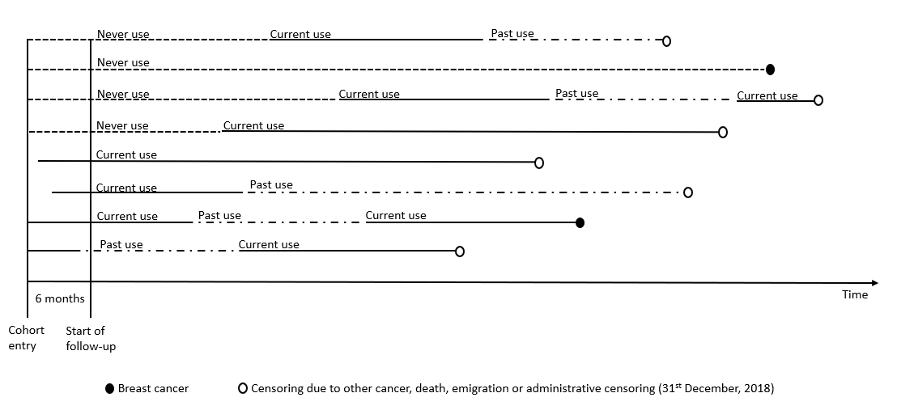
Supplementary Figure 1 Follow-up definition of study participants

Supplementary Table 1 Medications and corresponding Anatomical Therapeutic Chemical (ATC) codes
Medications | ATC code
Low-dose aspirin | B01AC06, B01AC56
Other anti-platelets | B01AC01-05, B01AC7-30
β-blockers | C07
Angiotensin-converting enzyme inhibitors | C09A, C09B
Angiotensin receptor blockers | C09C, C09D
Calcium channel blockers | C08, C09BB, C09DB
Diuretics | C03, C07B, C09BA, C09DA
Statins | C10AA, C10BA02, C10BA05, C10BA06
Antidiabetics | A10
Non-steroidal anti-inflammatory drugs | M01A
Menopausal hormone therapy | G03C, G03F

Supplementary Table 2 Baseline characteristics in the different study populations used for the different analyses, Norway 2004-2018
 | Full cohort (N=1,083,629) | BMI cohort (N=450,080) | NCC population ª (N=196,799)
Age (years) at the start of follow-up
Median (Q1, Q3) | 52.7 (50.0, 62.7) | 50.9 (50.0, 57.6) | 57.0 (50.9, 64.4)
Highest education level
None/primary school | 310,357 (28.6%) | 101,973 (22.7%) | 57,790 (29.4%)
Secondary school | 464,285 (42.8%) | 213,198 (47.4%) | 90,085 (45.8%)
University | 274,830 (25.4%) | 132,412 (29.4%) | 44,036 (22.4%)
Missing | 34,157 (3.2%) | 2,497 (0.6%) | 4,888 (2.5%)
Income (Norwegian kroner)
Q1 (<154,000) | 266,058 (24.6%) | 71,949 (16.0%) | 56,499 (28.7%)
Q2 (154,000–258,000) | 266,057 (24.6%) | 114,359 (25.4%) | 57,878 (29.4%)
Q3 (258,001–385,000) | 266,057 (24.6%) | 147,398 (32.7%) | 51,584 (26.2%)
Q4 (>385,000) | 266,057 (24.6%) | 116,172 (25.8%) | 27,290 (13.9%)
Missing | 19,400 (1.8%) | 202 (0.0%) | 3,548 (1.8%)
Marital status
Married/partnered | 418,097 (38.6%) | 143,118 (31.8%) | 68,757 (34.9%)
Not married/partnered | 640,675 (59.1%) | 305,171 (67.8%) | 123,793 (62.9%)
Missing | 24,857 (2.3%) | 1,791 (0.4%) | 4,249 (2.2%)
Country of origin
Norway | 950,796 (87.7%) | 408,188 (90.7%) | 179,429 (91.2%)
Other Nordic countries ^{b} | 34,571 (3.2%) | 13,611 (3.0%) | 5,420 (2.8%)
Rest of the world | 98,262 (9.1%) | 28,281 (6.3%) | 11,950 (6.1%)
Children
0 | 139,859 (12.9%) | 40,345 (9.0%) | 22,481 (11.4%)
1 | 142,211 (13.1%) | 54,129 (12.0%) | 24,305 (12.4%)
2 | 408,880 (37.7%) | 191,364 (42.5%) | 75,823 (38.5%)
≥3 | 392,679 (36.2%) | 164,242 (36.5%) | 74,190 (37.7%)
BMI (kg/ m²)
<25 | 217,882 (20.1%) | 217,882 (48.4%) | 46,333 (23.5%)
≥25 | 232,198 (21.4%) | 232,198 (51.6%) | 50,105 (25.5%)
Missing | 633,549 (58.5%) | - | 100,361 (51.0%)
Ever use of drugs
Low-dose aspirin | 257,442 (23.8%) | 94,518 (21.0%) | 59,449 (30.2%)
Other anti-platelets | 70,911 (6.5%) | 24,291 (5.4%) | 16,721 (8.5%)
Beta-blockers | 271,931 (25.1%) | 100,711 (22.4%) | 61,150 (31.1%)
Calcium channel blockers | 216,6711 (20.0%) | 81,279 (18.1%) | 49,565 (25.2%)
Angiotensin-converting enzyme inhibitors | 130,627 (12.1%) | 45,446 (10.1%) | 29,260 (14.9%)
Angiotensin receptor blockers | 280,389 (25.9%) | 118,027 (26.2%) | 62,862 (31.9%)
Diuretics | 331,431 (30.6%) | 121,763 (27.1%) | 73,890 (37.5%)
Statins | 343,267 (31.7%) | 147,759 (32.8%) | 78,340 (39.8%)
Antidiabetics | 86,617 (7.9%) | 31,215 (6.9%) | 17,726 (9.0%)
Non-steroidal anti-inflammatory drugs | 770,446 (71.1%) | 365,770 (81.3%) | 156,405 (79.5%)
Menopausal hormone therapy | 418,224 (37.6%) | 226,594 (50.3%) | 91,419 (46.5%)
Abbreviations: Quartile (Q), Body mass index (BMI), Nested case-control (NCC)
ª Some individuals in the NCC study were included both as a case and as a control, in this table they are included only once
^{b} Includes Denmark, Finland, Iceland, and Sweden

Supplementary Table 3 Characteristics at index for breast cancer cases and matched controls, Norway 2004-2018
 | Controls (N=205,230) | BC cases (N=20,523)
Age (years) at index
Median (Q1, Q3) | 66.0 (60.3, 73.6) | 66.0 (60.3, 73.6)
Highest education level
None/primary school only | 59,841 (29.2%) | 5,301 (25.8%)
Secondary school | 93,629 (45.6%) | 9,982 (48.6%)
University | 45,669 (22.3%) | 5,081 (24.8%)
Missing | 6,091 (3.0%) | 159 (0.8%)
Income (Norwegian kroner)
Q1 (<154,000) | 50,194 (24.5%) | 4,538 (22.1%)
Q2 (154,000–258,000) | 49,933 (24.3%) | 4,799 (23.4%)
Q3 (258,001–385,000) | 49,609 (24.2%) | 5,123 (25.0%)
Q4 (>385,000) | 49,207 (24.0%) | 5,525 (26.9%)
Missing | 6,287 (3.1%) | 538 (2.6%)
Marital status
Married/partnered | 87,696 (42.7%) | 9,077 (44.2%)
Not married/partnered | 117,534 (57.3%) | 11,446 (55.8%)
Country of origin
Norway | 187,179 (91.2%) | 18,861 (91.9%)
Other Nordic countriesª | 5,627 (2.7%) | 555 (2.7%)
Rest of the world | 12,424 (6.1%) | 1,107 (5.4%)
Children
0 | 23,479 (11.4%) | 2,239 (10.9%)
1 | 25,013 (12.2%) | 2,901 (14.1%)
2 | 78,708 (38.4%) | 8,317 (40.5%)
≥3 | 78,030 (38.0%) | 7,066 (34.4%)
BMI (kg/ m²)
<25 | 45,920 (22.4%) | 4,552 (22.2%)
≥25 | 55,877 (27.2%) | 5,588 (27.3%)
Missing | 103,433 (50.4%) | 10,383 (50.5%)
Ever use of other drugs
Low-dose aspirin | 49,364 (24.1%) | 4,953 (24.1%)
Other anti-platelets | 11,020 (5.4%) | 1,013 (4.9%)
Beta-blockers | 51,106 (24.9%) | 5,344 (26.0%)
Calcium channel blockers | 37,460 (18.3%) | 4,002 (19.5%)
Angiotensin-converting enzyme inhibitors | 23,110 (11.1%) | 2,344 (11.4%)
Angiotensin receptor blockers | 51,569 (25.1%) | 5,596 (27.3%)
Diuretics | 64,701 (31.5%) | 7,021 (34.2%)
Statins | 66,084 (32.5%) | 6,462 (31.5%)
Antidiabetics | 14,566 (7.1%) | 1,505 (7.3%)
Non-steroidal anti-inflammatory drugs | 148,903 (72.6%) | 15,505 (75.5%)
Menopausal hormone therapy | 81,328 (39.6%) | 9,529 (46.4%)
Abbreviations: Quartile (Q), Body mass index (BMI)
ª Includes Denmark, Finland, Iceland, and Sweden

