Excluded: Women with delivery at gestational week <22 (n=1 884)

Excluding women with a first stillborn child (n=4 336)
n= 649 764

Women with at least two singleton deliveries 1970-2019 and first delivery <2010 at gestational week >=22, excluding pregnancies after in vitro fertilization
n=655 436

,
n=
n= 226 101
1967 - 2014
n= 1 353 979

Final study sample:
Women with at least two singleton deliveries 1970-2019, with first delivery <2010 at gestational week >=22 and with information about offspring birthweight excluding pregnancies after in vitro fertilization
n= 654 100

Final
Women with at least two singleton deliveries
1970-2019 and first delivery <2010, with
information about gestational age, excluding pregnancies after in vitro fertilization
n= 657 320
Excluded: Women with pregnancies after in vitro fertilization (n=8 066)

Excluded: Women without information about gestational age at delivery (n=66 226)

Eligible: Women with at least two consecutive singleton deliveries reported to the Medical Birth Registry of Norway, 1970-2019. First delivery <2010
n=731 612

n=
n= 226 101
1967 - 2014
n= 1 353 979

Women with at least two deliveries 1970-2019 and first delivery <2010, excluding pregnancies after in vitro fertilization
n= 723 546

n=
n= 226 101
1967 - 2014
n= 1 353 979

Supplemental Fig. 1 Flow chart of the study sample

Excluded: Women with missing information about offspring birthweight (n=1 336)

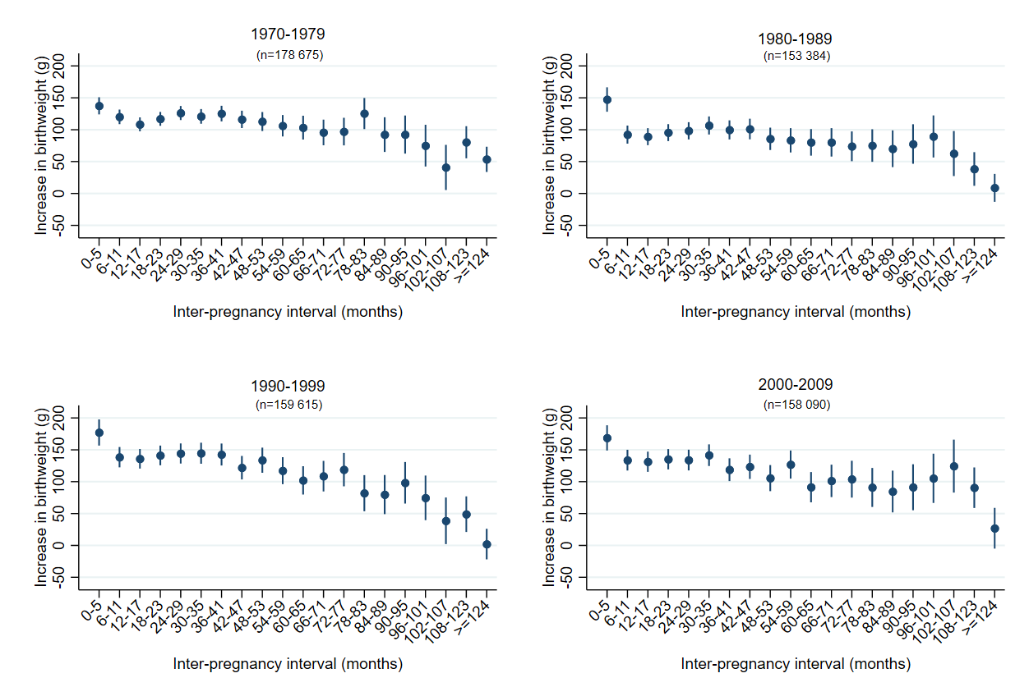

Supplemental Fig. 2 Increase in mean birthweight in grams according to inter-pregnancy interval and decade of first delivery. First stillbirth excluded
Adjusted estimates. All women in Norway with their first and second singleton delivery during the period 1970-2019 and first delivery <2010.
NOTE: Adjusted estimates: Include fixed effect for year of first delivery in five periods with equal number of women (quintiles), women's age at the first delivery, diabetes in first or second pregnancy, hypertension in first or second pregnancy, sex of child in first and second pregnancy, a new father to the second pregnancy and whether the woman was born in Norway

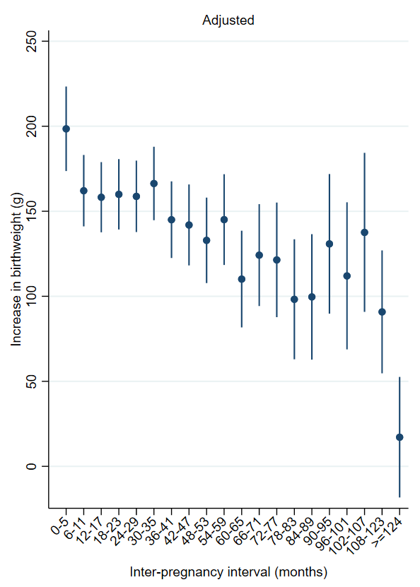

Supplemental Fig. 3 Increase in mean birthweight in grams according to inter-pregnancy interval. First stillbirth excluded
Adjusted for daily smoking in first trimester in first or second pregnancy. Deliveries during 1999-2019 (n=123 177)
NOTE: Adjusted estimates: Include smoking, fixed effect for year of first delivery in five periods with equal number of women (quintiles), women's age at the first delivery, diabetes in first or second pregnancy, hypertension in first or second pregnancy, sex of child in first and second pregnancy, a new father to the second pregnancy and whether the woman was born in Norway
Final study sample:
Number of women with at least two singleton births 1970-2019, excluding pregnancies after in vitro fertilization, with pregnancies reported to last ≥ 28 weeks and with information about offspring birthweight
n= 764 203

Final
Excluded: Women with missing information about offspring birthweight (n=1 267)

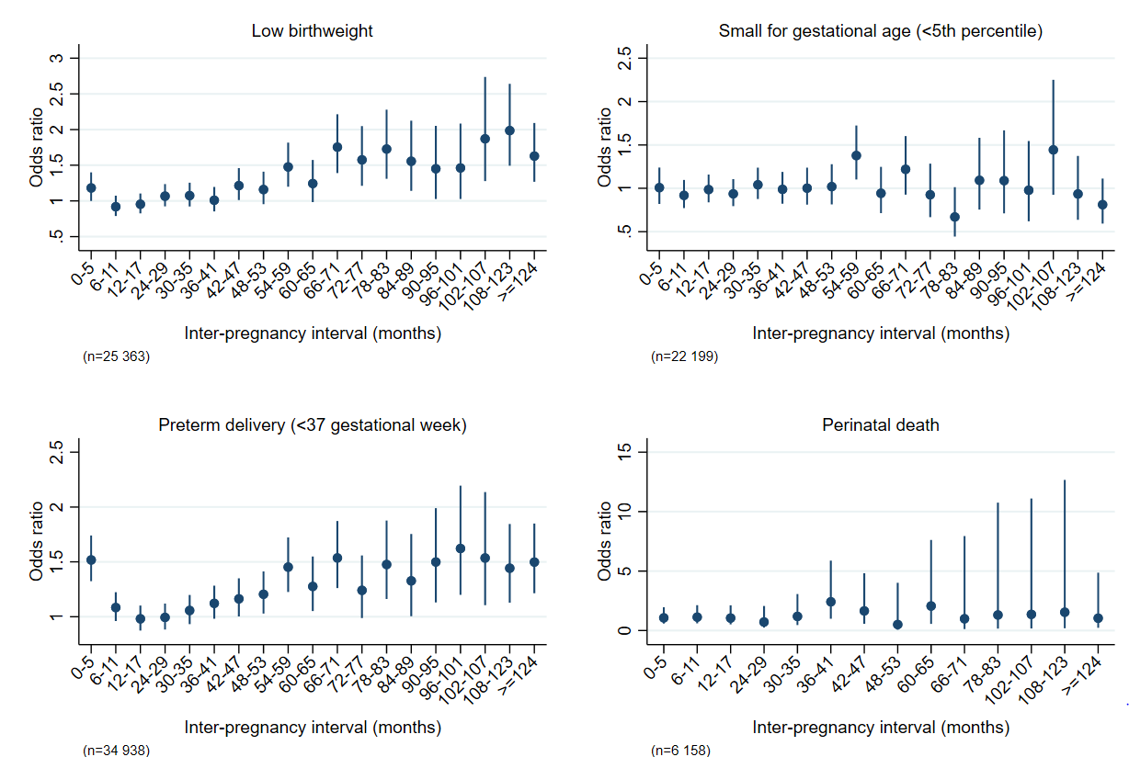

Supplemental Fig. 4 Adjusted odds ratios for recurrence according to inter-pregnancy interval. Reference category: inter-pregnancy interval 18-23 months
First and second singleton delivery during the period 1970-2019 and first delivery <2010. First child live born, except in the analyses of recurrence of perinatal death.
NOTE: Adjusted estimates: Include fixed effect for year of first delivery in five periods with equal number of women (quintiles), women's age at the first delivery, diabetes in first or second pregnancy, hypertension in first or second pregnancy, sex of child in first and second pregnancy, a new father to the second pregnancy and whether the woman was born in Norway

Final study sample:
Number of women with at least two singleton births 1970-2019, excluding pregnancies after in vitro fertilization, with pregnancies reported to last ≥ 28 weeks and with information about offspring birthweight
n= 764 203

Final
Excluded: Women with missing information about offspring birthweight (n=1 267)

