Supplementary Material

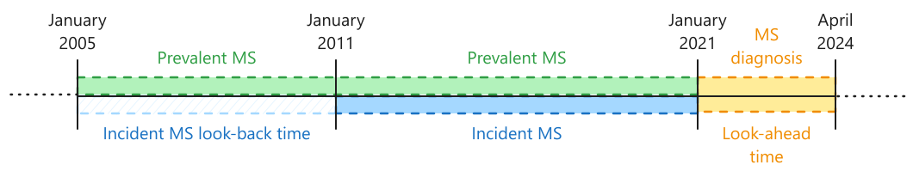
Figure S1: Timeline for the definitions of MS diagnosis, prevalent MS, and incident MS.

