Cohort Profile: The West-China Hospital Alliance Longitudinal Epidemiology Wellness (WHALE) Study

Supplementary Materials

Supplementary Table 1. The timeline of data integrating in the WHALE Database
Supplementary Figure 1. Quality control process of data collection
Supplementary Table 2 The Number of New Participants in Different Years and Their Frequency of Health Check-ups by November 5, 2024
Supplementary Table 3. List of characteristics measured among health check-up in the WHALE
Supplementary Table 4. Health Examination Equipment Information
Supplementary Table 5. Measurement tools in questionnaires
Supplementary Figure 2. The volume range of plasma in each sample tube
Supplementary Figure 3. Flowchart of data clean
Supplementary Table 6. Comparative summary table contrasting WHALE with other major cohorts

Supplementary Table 1. The timeline of data integrating in the WHALE Database (As of Jan 15, 2025)
Order | Hospitals in WHALE database | Enrollment Time | Integration  Sequence | Participants | Location | Hospital Level
1 | West China Hospital, Sichuan University | 2010.01 | Tier-1 | 571294 | Chengdu, Sichuan | Tertiary
2 | West China Hospital of Sichuan University (Wenjiang campus) | 2013.07 | Tier-1 | 311096 | Chengdu, Sichuan | Tertiary
3 | Shang Jin Hospital of West China Hospital, Sichuan University | 2016.03 | Tier-1 | 63714 | Chengdu, Sichuan | Tertiary
4 | Wuhou Health Examination Center of West China Hospital | 2019.10 | Tier-1 | 149554 | Chengdu, Sichuan | Health Management Center
5 | Tian Fu Hospital of West China Hospital, Sichuan University | 2021.10 | Tier-1 | 98932 | Chengdu, Sichuan | Tertiary
6 | The First People’s Hospital of Shuangliu District, Chengdu | 2024.01 | Tier-2 | 29484 | Chengdu, Sichuan | Tertiary
7 | Meishan People's Hospital, Meishan | 2024.04 | Tier-2 | 2331 | Meishan, Sichuan | Tertiary
8 | Mianzhu People's Hospital, Mianzhu | 2024.04 | Tier-2 | 125997 | Mianzhu, Sichuan | Tertiary
9 | Jintang County First People's Hospital, Chengdu | 2024.05 | Tier-2 | 87832 | Chengdu, Sichuan | Tertiary
10 | Wangjiang Hospital, Sichuan University | 2024.05 | Tier-2 | 168778 | Chengdu, Sichuan | Secondary
11 | West China Hospital, Sichuan University (Jinjiang campus) | 2025.02 | Tier-1 | Opening in 2025.02 | Chengdu, Sichuan | Tertiary

Supplementary Figure 1. Quality control process of data collection
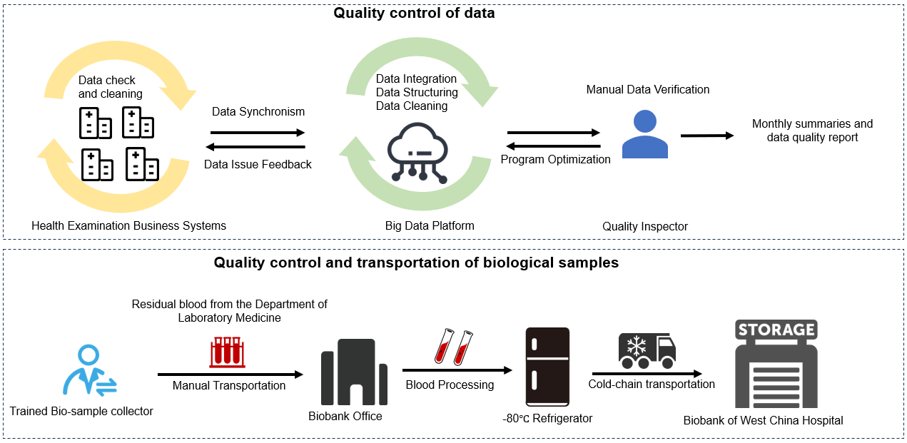

Supplementary Table 2. The number of new participants in different years and their frequency of health check-ups by January 15th, 2025
Year | New participants | The Number of Individuals with Different Frequencies of Health Check-ups as of January 15th, 2025
Year | New participants | 1 | 2 | 3 | 4 | 5 | 6 | 7 | 8 | 9 | ≥10
2010 | 70,485 | 22,932 | 7,120 | 4,198 | 3,689 | 2,873 | 3,089 | 3,123 | 2,540 | 1,952 | 18,969
2011 | 53,877 | 20,392 | 6,572 | 3,559 | 2,816 | 2,931 | 2,766 | 2,693 | 1,721 | 1,467 | 8,960
2012 | 51,605 | 23,965 | 5,686 | 3,181 | 2,933 | 2,656 | 1,632 | 1,098 | 1,120 | 1,228 | 8,106
2013 | 54,819 | 24,246 | 6,918 | 4,926 | 5,230 | 2,833 | 1,919 | 1,851 | 1,201 | 1,234 | 4,461
2014 | 75,904 | 33,377 | 10,643 | 7,532 | 3,919 | 3,269 | 2,804 | 2,574 | 2,418 | 2,409 | 6,959
2015 | 64,698 | 30,287 | 10,346 | 5,440 | 3,905 | 2,929 | 2,336 | 2,017 | 2,009 | 2,565 | 2,864
2016 | 71,125 | 39,122 | 9,493 | 5,260 | 3,820 | 2,570 | 2,089 | 1,924 | 2,687 | 4,002 | 158
2017 | 86,650 | 46,557 | 12,081 | 8,096 | 3,938 | 3,687 | 3,497 | 3,854 | 4,677 | 211 | 52
2018 | 106,286 | 61,068 | 16,376 | 7,757 | 5,335 | 4,506 | 5,848 | 4,945 | 255 | 149 | 47
2019 | 118,777 | 77,582 | 17,244 | 7,089 | 4,830 | 6,201 | 5,580 | 194 | 26 | 11 | 20
2020 | 143,534 | 87,669 | 19,881 | 11,629 | 1,5934 | 8,148 | 205 | 35 | 13 | 12 | 8
2021 | 163,095 | 103,661 | 23,756 | 23,782 | 1,1513 | 320 | 46 | 11 | 3 | 1 | 2
2022 | 176,317 | 112,717 | 43,875 | 19,294 | 358 | 53 | 11 | 2 | 3 | 2 | 2
2023 | 205,188 | 173,449 | 30,733 | 931 | 56 | 9 | 4 | 3 | 2 |  | 1
2024 | 83354 | 82,683 | 640 | 24 | 5 | 1 |  |  | 1
2025 | 972 | 972
Total | 1,526,686 | 940,679 | 221,364 | 112,698 | 68,281 | 42,986 | 31,826 | 24,324 | 18,676 | 15,243 | 50,609

Supplementary Table 3. List of characteristics measured among health check-up in the WHALE.
 | Categories | Available information
Demographics | Demographics | National ID number, Unique ID, Birthdate, Gender, Marital Status, Ethnic Group, Education, Occupation, Corporate Name, Contact Information, Physical Examination Organization
Face-to-Face interview | Health related information | Smoking Status, Alcohol Consumption, Diseases History, Family History, Surgical History, Drug Allergy History
Physical examination | Anthropometry | Body Weight, Body Height, Waist Circumference, Hip Circumference, Body Mass Index (BMI)
Physical examination | Specialist examination | Internal Checkup: Liver, Kidney, Spleen, Lung, Heart; External Checkup: Skin, Lymph Gland, Spine, Breast, Thyroid, Apparatus Urogenitalis; Ophthalmic Testing: Eye Ground, Eyesight, Intraocular Pressure, Eyeball, Pupil, Eyelid; Otorhinolaryngology Examination: Aural Region, Nose, Oropharynx, Tonsil, Laryngeal; Oral, Gynecologic Examination: Vagina, Uterine Neck, Vulva, Uterus, Secreta
Physical examination | Other Specialist examination | Bone Density Test, Bone Metabolism Test, Fatty Liver and Liver Fibrosis Assessment, Body Composition Analysis, Pulmonary Function Test，Electrocardiogram (ECG)
Laboratory tests | Hematology | Hematocrit, Red Blood Cell Distribution Width - Standard Deviation (RDW-SD), Mean Corpuscular Hemoglobin (MCH), Mean Corpuscular Hemoglobin Concentration (MCHC), Mean Corpuscular Volume (MCV), White Blood Cell Count (WBC), Hemoglobin (Hb), Red Blood Cell Count (RBC), Platelet Count, Red Blood Cell Distribution Width - Coefficient of Variation (RDW-CV), Neutrophil Percentage, Lymphocyte Percentage, Lymphocyte Absolute Count, Neutrophil Absolute Count, Monocyte Percentage, Monocyte Absolute Count, Eosinophil Percentage, Eosinophil Absolute Count, Basophil Percentage, Basophil Absolute Count
Laboratory tests | Urine Test | Urine color, Urine turbidity, Urine glucose, Qualitative urine bilirubin, Qualitative ketone bodies, Nitrite, Urine occult blood, Urine white blood cells, Percentage of lysed red blood cells, Absolute count of lysed red blood cells, Amorphous phosphate crystals, Calcium oxalate crystals, Urobilinogen Qualitative Test, Specific Gravity, pH Value, Casts, Bacteria, Urine Protein Qualitative Test, Urine Microalbumin
Laboratory tests | Stool Test | Consistency, Color, Occult Blood, Microscopic White Blood Cells, Red Blood Cells., Phagocytes, Starch Granules, Fat Droplets, Yeast-Like Organisms
Laboratory tests | Liver Function Tests | Aspartate Aminotransferase (AST), Alanine Aminotransferase (ALT), AST/ALT Ratio, Indirect Bilirubin, Total Bilirubin, Alkaline Phosphatase (ALP), Albumin/Globulin Ratio, Total Protein, Direct Bilirubin, Globulin, Albumin, Gamma-Glutamyl Transferase (GGT)
Laboratory tests | Kidney Function | Creatinine, Estimated Glomerular Filtration Rate (eGFR), Urea, Uric Acid, blood urea nitrogen, Cystatin C
Laboratory tests | Glucose Metabolism | Glucose, Hemoglobin A1c (HbA1c), Glycated Albumin, Fasting Insulin, Fasting C-Peptide
Laboratory tests | Thyroid function Tests | Triiodothyronine, Free Thyroxine, Free Triiodothyronine, Thyroid Stimulating Hormone Receptor Antibodies, Thyroglobulin Antibodies, Thyroglobulin, Thyroxine, Thyroid Stimulating Hormone, Reverse Triiodothyronine, Thyroid Peroxidase Antibodies, Parathyroid Hormone, Sensitive Thyroid Stimulating Hormone
Laboratory tests | Tumor Markers | Carcinoembryonic Antigen (CEA), Alpha-Fetoprotein (AFP), Prostate-Specific Antigen (PSA), Carbohydrate Antigen 19-9, Carbohydrate Antigen 15-3, Cancer Antigen 125, CYFRA21-1
Laboratory tests | Lipid Profile | Triglycerides, Total Cholesterol, High-Density Lipoprotein (HDL), Low-Density Lipoprotein (LDL)
Laboratory tests | Infectious Diseases | Human papilloma virus (HPV), SARS-CoV-2 ORF1ab Gene Nucleic Acid, SARS-CoV-2 N Gene Nucleic Acid, Hepatitis C Virus Antibody, Hepatitis B Surface Antigen (HBsAg), Hepatitis B e-Antigen (HBeAg), Hepatitis B Core Antibody (HBcAb), Hepatitis B Surface Antibody (HBsAb), Cytomegalovirus Antibody IgG, Cytomegalovirus Antibody IgM, HIV Antibodies (I/II)
Laboratory tests | Inflammation and Immunology | C-Reactive Protein (CRP), Erythrocyte Sedimentation Rate (ESR), Anti-Nuclear Antibody (ANA), Rheumatoid Factor (RF), Immunoglobulin M (IgM), Immunoglobulin G (IgG), Immunoglobulin A (IgA), Immunoglobulin E (IgE)
Laboratory tests | Hormones | Testosterone, Estradiol, Progesterone, Follicle Stimulating Hormone (FSH), Luteinizing Hormone (LH), Prolactin (PRL), Gonadotropins, Prolactin, Insulin, Insulin-like Growth Factor 1 (IGF-1), Dopamine, Norepinephrine, Growth Hormone (GH)
Laboratory tests | Gastrointestinal System | Pepsinogen I (PG I), Pepsinogen II (PG II), Pepsinogen I/II Ratio, Gastrin, Helicobacter pylori Urease Antibody, Amylase, Lipase
Laboratory tests | Electrolytes and Minerals | Sodium, Potassium, Carbon Dioxide Combining Power, Phosphorus, Chloride, Anion Gap, Calcium, Phosphorus, Magnesium
Laboratory tests | Other Biochemical Tests | Lactate Dehydrogenase (LDH), Hydroxybutyrate Dehydrogenase (HBDH), Creatine Kinase (CK), 25-Hydroxy Vitamin D
Laboratory tests | Gynecologic examination | Candida in Vaginal Discharge, Cleanliness of Vaginal Discharge, Leukocyte Esterase, Hydrogen Peroxide, Fungi, Lactobacillus, Candida, Proline Aminopeptidase, pH of Vaginal Discharge
Image tests | CT | Chest, Whole Abdomen, Upper Abdomen, Head, Neck, Pelvis, Spine
Image tests | X-ray | Cervical Spine, Thoracic Spine, Lumbar Spine, Extremity Bones, Chest, Abdominal Plain Film, Gastrointestinal Series
Image tests | Ultrasonography | Liver, Gallbladder, Pancreas, Spleen, Kidney, Adrenal Gland, Thyroid Gland, Breast, Lymph Node

Supplementary Table 4. Health examination equipment information
health check-up type | Examination items | Equipment Model and Version | Company
Physical examination | Blood Pressure | ABP-1000(F-version） | Chioy, China
Physical examination | Standing Height/ Weight | SG-1001SC | Chioy, China
Physical examination | Standing Height/ Weight | SK-V7 | Sonka, China
Physical examination | Bone density measurements | MetriScan | Miles Medical LLC, China
Physical examination | Pulmonary function testing | MasterScreen SeS | Jaeger, Germany
Physical examination | Body composition analysis | InBody570 | InBody, Korea
Physical examination | Liver Fibrosis Determination | FibroScan 502 Touch | ECHOSENS, France
Physical examination | Liver Fibrosis Determination | FT-C | , China
Physical examination | Liver Fibrosis Determination | Hepatus 6 | Mindray, China
Physical examination | Slit-lamp Microscope | SL-2G/DKT-18 | TOPCON, Japan
Physical examination | Slit-lamp Microscope | YZ5J | 66 Vision-Tech
Physical examination | Slit-lamp Microscope | SLM-5E | KANGHUA, China
Physical examination | Fundus Camera | CR-2 AF | Canon, Japan
Laboratory tests | Hematology | XE-2100 and XE-5000 | Sysmex, Japan
Laboratory tests | Hematology | Alifax Test 1 | ALIFAX, Italy
Laboratory tests | Urine Test | UF5000 | Sysmex, Japan
Laboratory tests | Urine Test | UC3500 | Sysmex, Japan
Laboratory tests | Stool Test | FA160 | Orienter, China
Laboratory tests | Liver Function Tests | cobas C702 | Roche, Switzerland
Laboratory tests | Kidney Function Test | cobas C702 | Roche, Switzerland
Laboratory tests | Glucose Metabolism | cobas C702 | Roche, Switzerland
Laboratory tests | Glucose Metabolism | HLC-723G8 | TOSOH, China
Laboratory tests | Glucose Metabolism | ADAMS A1C HA-8190V | аrKгау, Japan
Laboratory tests | Glucose Metabolism | capillarys 3 | sebia, France
Laboratory tests | Tumor Markers | cobas 8000 e801 | Roche, Switzerland
Laboratory tests | Lipid Profile | cobas C702 | Roche, Switzerland
Laboratory tests | Inflammation and Immunology | IMMAGE 800 | BECKMAN COULTER, USA
Laboratory tests | Inflammation and Immunology | FACSCantoⅡ | Becton Dickinson, USA
Laboratory tests | Inflammation and Immunology | FACSCantoplus | Becton Dickinson, USA
Laboratory tests | Infectious Diseases | SLAN-96 Real-time PCR Instrument | HONGSHI, China
Laboratory tests | Infectious Diseases | Luminex-200 Multiplex Flow Cytometer | Luminex, USA
Laboratory tests | Infectious Diseases | CL-8000i | Mindray, China
Laboratory tests | Infectious Diseases | cobas e 801 | Roche, Switzerland
Laboratory tests | Hormones | cobas C702 | Roche, Switzerland
Laboratory tests | Hormones | cobas 8000 e 801 | Roche, Switzerland
Laboratory tests | Gastrointestinal System | URANUS AE 115 | AIKANG, China
Laboratory tests | Electrolytes and Minerals | cobas C702 | Roche, Switzerland
Laboratory tests | Thyroid function Tests | cobas 8000 e 801 | Roche, Switzerland
Laboratory tests | Other Biochemical Tests | cobas 8000 c702 | Roche, Switzerland
Laboratory tests | Other Biochemical Tests | cobas e 602 | Roche, Switzerland
Laboratory tests | Other Biochemical Tests | cobas 8000 e801 | Roche, Switzerland
Imaging tests | Supersonic inspection | EPIQ5 | PHILLIPS, USA
Imaging tests | Computed Tomography | SOMATOM Definition AS 128 | Siemens, Germany
Imaging tests | Computed Tomography | uCT960+ | United-Imaging, China
Imaging tests | Computed Tomography | Somatom Definition Flash | Siemens, Germany
Imaging tests | Computed Tomography | Revolution CT ES | GE, USA
Imaging tests | X-ray examination | uDR780i | United-Imaging, China
Imaging tests | Electrocardiogram | iMAC120 | ZONCARE, China
Imaging tests | Electrocardiogram | SE-1026 | EDAN, China

Supplementary Table 5. Measurement tools in questionnaires
Interested factors or aspects | Measurement tool
 | In the WHALE Database | In the WHALE Health Trajectory Cohort (prospectively)
Demographics | 8 questions: age, gender, nation, marriage status, education level, family income, residence, occupation
Lifestyle
Smoking | 5 questions: current cigarette smoking status, daily and annual cigarette consumption, frequency of passive smoking, and exposure to kitchen fumes | 8 questions: current cigarette smoking status, the age at smoking starting both for current smokers and past smokers, daily cigarette consumption both for current smokers and past smokers, passive smoking status, frequency and duration of passive smoking
Alcohol drinking | 3 questions: current drinking status, the average amount of alcohol consumed per occasion, and the duration of drinking history | 4 questions: current drinking status, frequency of alcohol drinking, the average amount of alcohol consumed per day, the types of alcohol consumed
Diet | 7 questions: the extent of salt, oil, and spicy ingredients used in their diet, the primary types of meat consumed and their quantities, the frequency of smoked foods consumption, the frequency of pickles consumption, the frequency of tea consumption | 7 questions: meat and vegetable balance in the diet, dietary preferences regarding the taste profile, frequency of spicy food consumption in the past month, preference for spiciness level, ingredients for spiciness, frequency of numbing food that contain Sichuan pepper consumption, ingredients for numbness
Physical activity and sedentary bahevior | 6 questions: working hours, sedentary time, exercise frequency, duration of physical activity, the intensity levels of work and exercise | International Physical Activity Questionnaire (IPAQ) short form (16 items): four dimensions: vigorous physical activity, moderate physical activity, walking, and sedentary time
Psychological conditions
Sleep quality | 1 question: subjective sleep quality  Pittsburgh Sleep Quality Index (PSQI) (19 items): further evaluation on subjective sleep quality, sleep latency, sleep duration, habitual sleep efficiency, sleep disturbances, use of sleep mediations, and daytime dysfunction during the past week
Anxiety | The Self-Rating Anxiety Scale (SAS) (20 items) | the Patient Health Questionnaire-9 (PHQ-9) (9 items)
Depression | the Self-Rating Depression Scale (SDS) (20 items) | the Generalized Anxiety Disorder Scale (GAD-7) (7 items)
Health assessment
Medical and family history of chronic diseases | including hypertension, diabetes, coronary heart disease, stroke, gout, rheumatoid arthritis, pulmonary tuberculosis, chronic obstructive pulmonary disease, cancer, chronic hepatitis, asthma, gastritis, gallstones, non-traumatic fracture, hyperthyroidism, hypothyroidism, thyroid Nodules
Medication use history | covering 3 types of medication | duration, starting year, adherence of medication use covering 6 categories

Supplementary Figure 2. The volume range of plasma in each sample tube
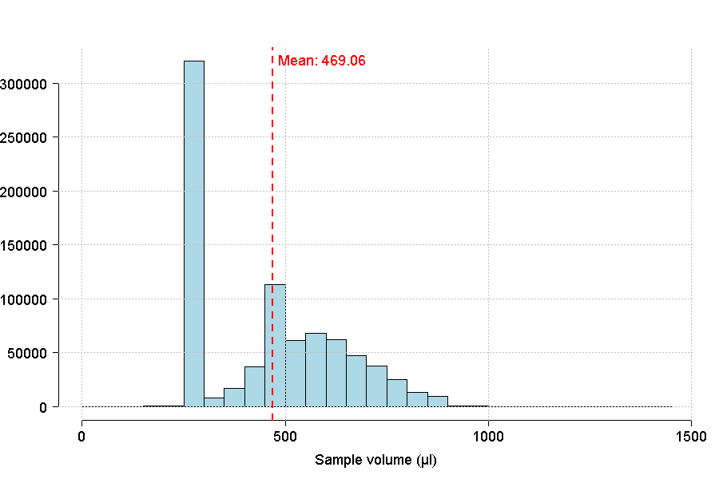

Supplementary Figure 3. Flowchart of data clean
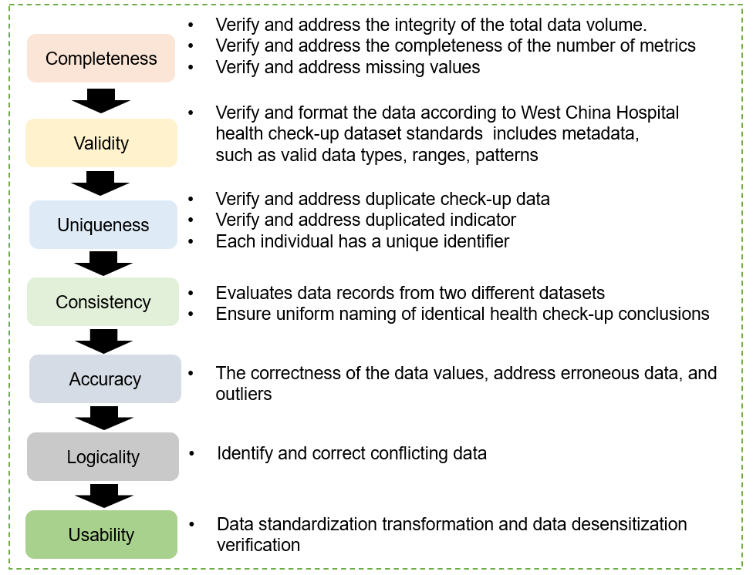

Supplementary Table 6. Comparative summary table contrasting WHALE with other major cohorts
Cohort | Geographic | Ethnic Diversity | Sample Size | Types of Data Collected | Follow-up Design and Frequency | Distinctive features of WHALE Study
WHALE Study | Sichuan Province, China (strategically positioned between eastern and western China, one of China’s most populous provinces) | 85.6% Han, 14.4% others | 1,526,686 (WHALE Database,); 273,628 (Health Trajectory Cohort,) | Health checkup data (body measurement, sociodemographic, laboratory tests, imaging); EHR data, questionnaires (lifestyle, health status), biological samples, genomic data | Ambispective cohort; biennial active follow-up; passive via healthcare/admin database linkage | NA
Our Future Health | UK-wide (England, Scotland, Wales; Northern Ireland from 2025) | Diverse UK population, ethnicity not specified | 2 million consented (1.4 million questionnaires, 1.1 million blood samples) | Questionnaires (demographics, lifestyle), physical measures, blood (plasma, DNA), genomic data, linked health records | Continuous passive follow-up via health record linkage; active re-contact studies planned for 2025 | WHALE Study 's active biennial follow-ups and multimodal data collection (biospecimens, imaging, clinical records) provide deeper insights into health trajectories.
All of Us | US-wide, >340 sites | 51% non-white, 80% underrepresented groups | 230,000 total, 175,000 core (biosamples, measures, EHR) by Jul 2019 | EHRs (billing, labs, meds), questionnaires, physical measures, biosamples (blood/saliva), genomic data, Fitbit | Passive follow-up via EHR and linked data (death index, pharmacy, claims); optional surveys and biospecimen collections, no fixed schedule | WHALE Study offers structured biennial active follow-ups, standardized extensive imaging data, and detailed physical examination records.
MVP | US-wide, ~50 VA medical facilities | 77.2% White, 13.5% African American, 7.6% Other, 1.6% not reported | 397,104 enrolled by Aug 2015 | Questionnaires (baseline, lifestyle), VA EHRs, blood for genetic/other assays | Passive follow-up via VA EHRs for health events, mortality; active via surveys or re-contact as needed | WHALE Study includes diverse Chinese ethnic populations, routine collection of comprehensive physical and laboratory data, and structured biennial follow-ups.
UK Biobank | UK-wide, 22 assessment centres | 94.2% White, 1.9% Asian, 1.6% Black, 2.3% Other/Unknown | 500,000 (2006-2010). | Questionnaires (sociodemographic, lifestyle, health), physical measures, biosamples (blood, urine, saliva), accelerometry, multimodal imaging, genome-wide genotyping | Passive follow-up via health record linkage; active via repeat imaging, seasonal monitoring for some. No fixed schedule. | WHALE Study emphasizes repeated longitudinal health check-ups (up to >10 visits for ~3% participants) integrated within a hospital network, providing richer temporal data.
China Kadoorie Biobank (CKB) | 10 regions (5 urban, 5 rural) across China | Primarily Han Chinese, specific ethnic diversity not detailed | ~512,891 (2004-2008) | Questionnaires (sociodemographic, lifestyle, medical history), physical measurements, blood samples (plasma, DNA), linked health records | Continuous passive follow-up via linkage with mortality/morbidity registries and national health insurance databases; active re-survey of ~25,000 participants | WHALE Study incorporates active follow-ups combined with passive linkage, extensive imaging and repeated clinical/laboratory assessments across hospital settings(alliance network).
Kailuan Study | Tangshan, Hebei Province | Primarily Han Chinese, specific ethnic diversity not detailed | ~100,000 (2006-2007) | Physical exams, laboratory tests, questionnaires (lifestyle, occupational health), limited biospecimens | Biennial health check-ups; passive linkage to health records | WHALE Study offers greater sample diversity, broader disease scope, more comprehensive biological sample collections, and longitudinal imaging data.
Taizhou Longitudinal Study | Taizhou, Jiangsu, China (3 districts) | Primarily Han Chinese, specific ethnic diversity not detailed | ~200,000 (baseline 2007) | Questionnaires (socioeconomic, lifestyle, diet, medical history), physical measurements, biological samples (buccal cells, fasting blood) | Active follow-up every 3 years with nested case-control approach; passive monitoring via chronic disease registry | WHALE Study's biennial active follow-up, extensive multimodal data, and frequent repeated measurements provide more detailed longitudinal health trajectories.
EHR = Electronic Health Records; MVP = Million Veteran Program; VA = Veterans Affairs; CKB = China Kadoorie Biobank.

