Supplemental material to ”Does tattoo exposure increase the risk of cutaneous melanoma? A population-based case-control study”

Emelie Rietz Liljedahl^{1, PhD}, Kari Nielsen^{3,4, PhD}, Malin Engfeldt^{1,2, PhD}, Anna Jöud^{1,5, PhD}, and Christel Nielsen^{1,6, PhD}
¹Division of Occupational and Environmental Medicine, Department of Laboratory Medicine, Lund University, Lund, Sweden
²Department of Occupational and Environmental Medicine, Region Skåne, Lund, Sweden
³Department of Dermatology, Skåne University Hospital, Lund, Sweden
⁴Dermatology, Department of Clinical Sciences, Lund University, Lund, Sweden
⁵ Department of Clinical Sciences, Lund University, Lund, Sweden
⁶Clinical Pharmacology, Pharmacy and Environmental Medicine, Institute of Public Health, University of Southern Denmark, Odense, Denmark

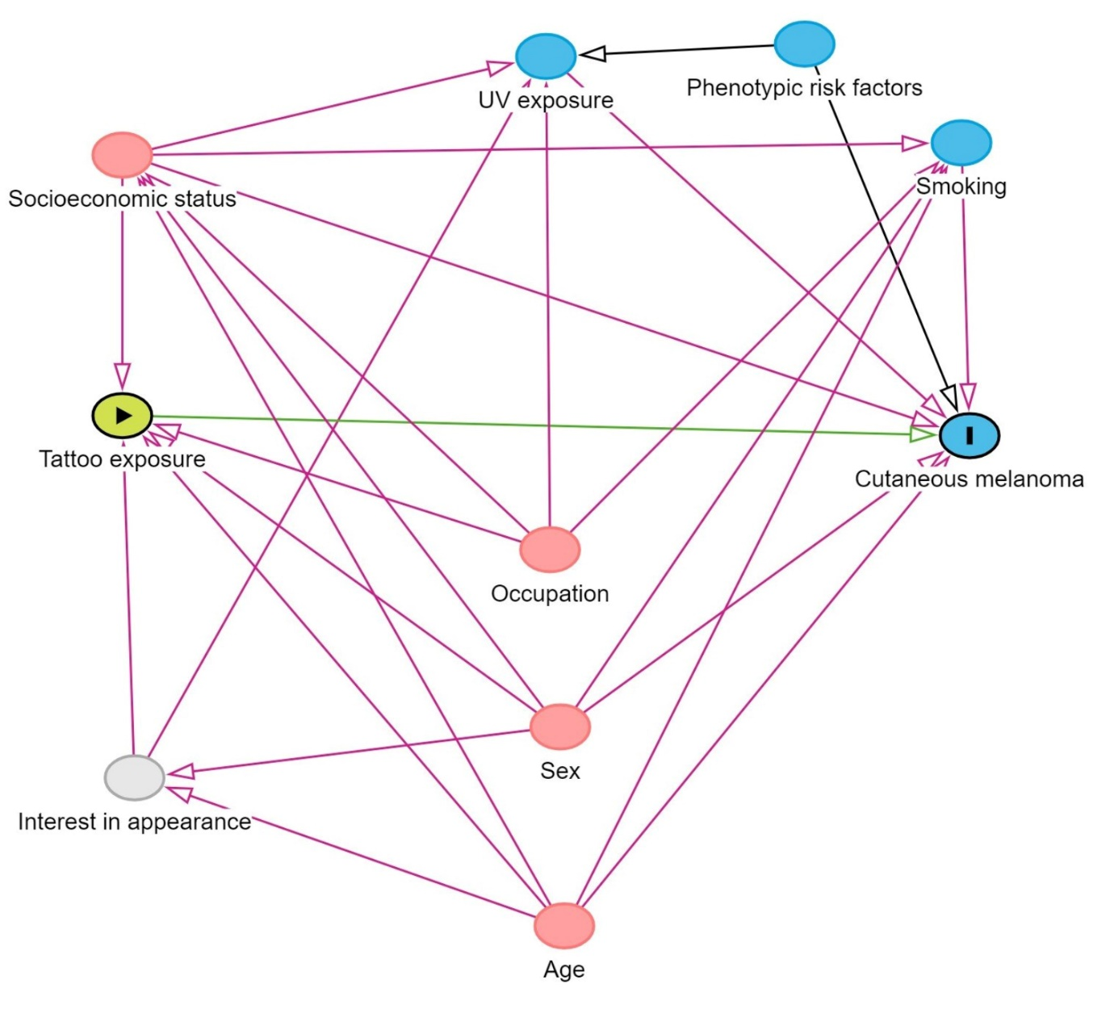
Figure S1. The directed acyclic graph visualizing the underlying associations between tattoos and cutaneous melanoma, and potential measurable and unmeasurable confounders related to tattoo exposure and/or melanoma.

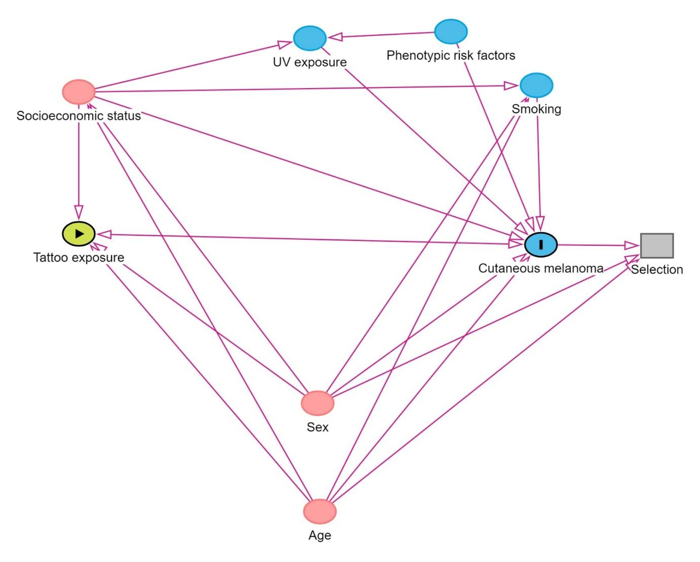
Figure S2.The directed acyclic graph used to inform the statistical analyses.

Table S1. Descriptive drop-out analysis of cases and controls, displayed as n (%) at the time of the survey.
 | Casesª |  | Controls
 | Respondents | Non-respondents | Respondents | Non-respondents
Sex
Male | 658 (53) | 586 (47) | 1640 (43) | 2172 (57)
Female | 940 (57) | 710 (43) | 2458 (49) | 2602 (51)
Age
20-29 | 28 (42) | 38 (58) | 62 (30) | 142 (70)
30-39 | 135 (40) | 199 (60) | 349 (34) | 676 (66)
40-49 | 333 (49) | 342 (51) | 830 (40) | 1220 (60)
50-59 | 658 (57) | 506 (43) | 1745 (49) | 1806 (51)
60-69 | 444 (68) | 211 (32) | 1112 (54) | 930 (46)
Educational attainment
Primary and lower secondary | 75 (41) | 110 (59) | 273 (28) | 694 (72)
Upper secondary | 618 (50) | 628 (50) | 1738 (42) | 2361 (58)
Post-secondary | 903 (62) | 553 (38) | 2081 (56) | 1631 (44)
Missing | 2 (33) | 4 (67) | 6 (6) | 88 (95)
Country of birth
Sweden | 1529 (56) | 1209 (44) | 3545 (51) | 3390 (49)
Other | 69 (44) | 87 (56) | 553 (29) | 1384 (72)
Marital status
Married | 945 (62) | 582 (38) | 2270 (52) | 2101 (48)
Unmarried | 431 (46) | 509 (54) | 1231 (41) | 1769 (59)
Divorced | 209 (52) | 190 (48) | 551 (40) | 841 (60)
Widowed | 13 (46) | 15 (54) | 46 (42) | 63 (58)
Disposable income (SEK²)
None (0) | 13 (36) | 23 (64) | 82 (22) | 287 (78)
1 – 124,999 | 67 (44) | 84 (56) | 198 (29) | 477 (71)
125,000 – 199,999 | 72 (45) | 88 (55) | 241 (36) | 427 (64)
200,000 – 279,999 | 135 (47) | 150 (53) | 423 (41) | 607 (59)
280,000 – 369,999 | 324 (52) | 296 (48) | 905 (45) | 1094 (55)
≥370,000 | 987 (60) | 655 (40) | 2249 (54) | 1882 (46)
ªNot including deceased cases.

Matched analysisª |  |  |  | Unmatched analysis^{b}
Interaction | Cases (n) | Controls (n) | IRR (95% CI) | Cases (n) | Controls (n) | IRR (95% CI)
High UV, tattooed | 159 | 202 | 1.94 (1.5-2.5) | 196 | 380 | 1.79 (1.46-2.20)
High UV, non-tattooed | 459 | 646 | 1.41 (1.12-1.67) | 538 | 1144 | 1.40 (1.22-1.61)
Low-medium UV, tattooed | 125 | 230 | 1.24 (0.95-1.62) | 157 | 429 | 1.23 (1.00-1.52)
Low-medium UV, non-tattooed | 585 | 1165 | 1.00 | 701 | 2026 | 1.00

ªEstimates obtained from conditional logistic regression adjusted for age, sex, educational attainment, household disposable income, marital status, phenotypic risk index, UV-exposure index, and smoking.
^{b}Estimates obtained from unconditional logistic regression adjusted for age, sex, educational attainment, household disposable income, marital status, phenotypic risk index, UV-exposure index, and smoking.
Table S2. Adjusted incidence rate ratios of cutaneous melanoma in tattooed and non-tattooed individuals with different degrees of sun exposure, expressed in relation to non-tattooed individuals with low UV exposure from interaction analysis.

Table S3. Exploratory subgroup analyses of the association between a) tattoo exposure status, and b) tattoo exposure duration, and melanoma subtypes.
 |  | Matched analysis |  |  | Unmatched analysis |  |  |  | Unmatched analysis
 |  | Full adjustmentª |  |  | Full adjustment^{b} |  |  |  | Full adjustment^{b}
 | Exposure status | Cases (n) | Controls (n) | IRR^{c}  (95 % CI) | Cases (n) | Controls (n) | IRR  (95 % CI) | Exposure duration | Cases (n) | Controls (n) | IRR (95 % CI)
Invasive melanoma^{d} | Tattooed | 145 | 432 | 1.25 (0.95-1.64) | 182 | 809 | 1.29 (1.06-1.56) | 0-5 | 19 | 97 | 1.12 (0.66-1.88)
 |  |  |  |  |  |  |  | 5-10 | 27 | 125 | 1.31 (0.84-2.05)
 |  |  |  |  |  |  |  | 10-15 | 31 | 110 | 1.59 (1.04-2.43)
 |  |  |  |  |  |  |  | >15 | 105 | 477 | 1.25 (0.98.1.58)
 | Non-tattooed | 521 | 1811 | 1.00 | 617 | 3170 | 1.00 | Non-tattooed | 617 | 3170 | 1.00
Superficial spreading melanoma | Tattooed | 122 | 432 | 1.40 (1.03-1.90) | 149 | 809 | 1.25 (1.02-1.53) | 0-5 | 16 | 97 | 1.20 (0.69-2.08)
 |  |  |  |  |  |  |  | 5-10 | 20 | 125 | 1.26 (0.77-2.08)
 |  |  |  |  |  |  |  | 10-15 | 25 | 110 | 1.66 (1.05-2.62)
 |  |  |  |  |  |  |  | >15 | 88 | 477 | 1.36 (1.05-1.76)
 | Non-tattooed | 405 | 1811 | 1.00 | 476 | 3170 | 1.00 | Non-tattooed | 476 | 3170 | 1.00
In situ melanoma^{e} | Tattooed | 139 | 432 | 1.33 (1.02-1.75) | 171 | 809 | 1.18 (0.97-1.45) | 0-5 | 26 | 97 | 1.38 (0.86-2.21)
 |  |  |  |  |  |  |  | 5-10 | 27 | 125 | 1.26 (0.80-1.97)
 |  |  |  |  |  |  |  | 10-15 | 31 | 110 | 1.59 (1.04-2.43)
 |  |  |  |  |  |  |  | >15 | 87 | 477 | 1.04 (0.80-1.34)
 | Non-tattooed | 523 | 1811 | 1.00 | 622 | 3170 | 1.00 | Non-tattooed | 622 | 3170 | 1.00
Melanocytic nevus | Tattooed | 126 | 432 | 1.39 (1.05-1.85) | 156 | 809 | 1.18 (0.96-1.45) | 0-5 | 25 | 97 | 1.47 (0.91-2.36)
 |  |  |  |  |  |  |  | 5-10 | 23 | 125 | 1.15 (0.71-1.19)
 |  |  |  |  |  |  |  | 10-15 | 28 | 110 | 1.51 (0.97-2.35)
 |  |  |  |  |  |  |  | >15 | 80 | 477 | 1.04 (0.80-1.36)
 | Non-tattooed | 469 | 1811 | 1.00 | 559 | 3170 | 1.00 | Non-tattooed | 559 | 3170 | 1.00

ªEstimates obtained from conditional logistic regression adjusted for age, sex, educational attainment, household disposable income, marital status, phenotypic risk index, UV-exposure index, and smoking.

^{b}Estimates obtained from unconditional logistic regression adjusted for age, sex, educational attainment, household disposable income, marital status, phenotypic risk index, UV-exposure index, and smoking.

Exposure duration was not analyzed with conditional logistic regression due to small sample size.
^{c}Incidence rate ratio.

^{d}Includes nevoid melanoma and melanoma not otherwise specified, nodular melanoma, lentigo maligna melanoma, superficial spreading melanoma, acral lentiginous melanoma, and mixed epithelioid, and spindle cell melanoma.

^{e}Includes melanocytic nevus with severe atypia, lentigo maligna in situ, acral lentiginous melanoma in situ, and atypical Spitz’s nevus.

Table S4. Incidence rate ratios (IRR) of cutaneous melanoma in tattooed individuals relative to non-tattooed individuals.

 | Matched analysis |  |  |  |  |  | Unmatched analysis
 | Basic adjustmentª |  |  | Full adjustment^{b} |  |  | Basic adjustment^{c} |  |  | Full adjustment^{d}
 | Cases (n) | Controls (n) | IRR^{e} (95 % CI) | Cases (n) | Controls (n) | IRR (95 % CI) | Cases (n) | Controls (n) | IRR (95 % CI) | Cases (n) | Controls (n) | IRR (95 % CI)
First time melanoma | 1173 | 1982 |  | 1168 | 1955 |  | 1416 | 4018 |  | 1410 | 3979
Tattooed | 249 | 390 | 1.07 (0.89-1.29) | 248 | 386 | 1.23 (1.01-1.51) | 314 | 815 | 1.11 (0.96-1.29) | 313 | 809 | 1.21 (1.03-1.41)
Non-tattooed | 924 | 1592 |  | 920 | 1569 |  | 1102 | 3203 |  | 1097 | 3170
Immunosuppressive meds excl. | 1285 | 2217 |  | 1280 | 2190 |  | 1544 | 3928 |  | 1538 | 3890
Tattooed | 279 | 424 | 1.17 (0.98-1.40) | 278 | 419 | 1.32 (1.10-1.62) | 346 | 796 | 1.15 (0.99-1.33) | 345 | 790 | 1.25 (1.07-1.46)
Non-tattooed | 1006 | 1793 | 1.00 | 1002 | 1771 | 1.00 | 1198 | 3132 | 1.00 | 1193 | 3100 | 1.00
Risk occupation excl | 1324 | 2261 |  | 1319 | 2234 |  | 1587 | 3989 |  | 1581 | 3951
Tattooed | 283 | 434 | 1.12 (0.94-1.33) | 282 | 1037 | 1.29 (1.06-1.55) | 352 | 807 | 1.13 (0.98-1.31) | 351 | 801 | 1.24 (1.07-1.45)
Non-tattooed | 1041 | 1827 | 1.00 | 429 | 1805 | 1.00 | 1235 | 3182 | 1.00 | 1230 | 3150 | 1.00
ªEstimates obtained from conditional logistic regression adjusted for sex and age.

^{b}Estimates obtained from conditional logistic regression adjusted for age, sex, educational attainment, household disposable income, marital status, phenotypic risk index, UV-exposure index, and smoking.
^{c}Estimates obtained from unconditional logistic regression adjusted for sex and age.

^{d}Estimates obtained from unconditional logistic regression adjusted for age, sex, educational attainment, household disposable income, marital status, phenotypic risk index, UV-exposure index, and smoking.
^{e}Incidence rate ratio.

 | Basic adjustmentª |  |  | Full adjustment^{b}
 | Cases (n) | Controls (n) | IRR^{c} (95 % CI) | Cases (n) | Controls (n) | IRR (95 % CI)
Tattoo status | 1609 | 4097 |  | 1602 | 4044
Tattooed | 354 | 826 | 1.12 (0.97-1.29) | 353 | 821 | 1.20 (1.03-1.40)
Non-tattooed | 1255 | 3271 | 1.00 | 1249 | 3223 | 1.00

All estimates were obtained from unconditional logistic regression due to small groups of next-of-kin.
ªEstimates obtained from unconditional logistic regression adjusted for sex and age.

^{b}Estimates obtained from unconditional logistic regression adjusted for age, sex, educational attainment, household disposable income, marital status, UV-exposure index, and smoking.
^{c}Incidence rate ratio.

Table S5. Incidence rate ratios (IRR) of cutaneous melanoma in tattooed individuals relative to non-tattooed individuals, including deceased cases’ next-of-kin (n=11).

