COVID-19 vaccination and short-term mortality risk: a nationwide self-controlled case series study in The Netherlands
Isabel AL Slurink, Annemarijn R de Boer, Marc JM Bonten, Miriam CJM Sturkenboom, Patricia CJL Bruijning-Verhagen

Supplemental file

Supplemental tables
Supplemental table 1. Characteristics of individuals in the general Dutch population died from any cause between 6 January 2021 and 18 November 2021, stratified by risk period in which death occurred after last COVID-19 vaccination dose received.
Characteristic | Timing of death
 | Risk period after COVID-19 vaccination |  | No registered COVID-19 vaccination
 | ≤3 weeks | >4 weeks
Total | 8,073 | 67,348 | 66,291
Mean age (SD), years | 79.15 (12.17) | 79.84 (11.72) | 75.73 (14.75)
Age group, n (%)
<29 | 32 (0.4) | 202 (0.3) | 857 (1.3)
30-39 | 41 (0.5) | 236 (0.4) | 770 (1.2)
40-49 | 117 (1.4) | 745 (1.1) | 1,719 (2.6)
50-59 | 355 (4.4) | 2790 (4.1) | 5,036 (7.6)
60-69 | 956 (11.8) | 7453 (11.1) | 9,912 (15.0)
70-79 | 2,077 (25.7) | 16,392 (24.3) | 17,576 (26.5)
80-89 | 2,937 (36.4) | 25,996 (38.6) | 20,014 (30.2)
≥90 | 1,558 (19.3) | 13,534 (20.1) | 10,407 (15.7)
Women, n (%) | 4,022 (49.8) | 34,590 (51.4) | 32,153 (48.5)
Cause of death, n (%)
Circulatory system diseases | 2,341 (29.0) | 16,158 (24.0) | 13,275 (20.0)
Neoplasms | 1,536 (19.0) | 19,127 (28.4) | 20,002 (30.2)
Respiratory system diseases | 510 (6.3) | 4,473 (6.6) | 3,488 (5.3)
Mental and neurological diseases | 1,087 (13.5) | 10,313 (15.3) | 5,578 (8.4)
Non-natural causes | 541 (6.7) | 3,781 (5.6) | 3,517 (5.3)
Other causes | 1,308 (16.2) | 10,860 (16.1) | 10,442 (15.8)
COVID-19 | 750 (9.3) | 2,636 (3.9) | 9,989 (15.1)
Number of vaccine administrations, n (%)
One dose | 4,395 (54.4) | 11,317 (16.8)
Two doses | 3,565 (44.2) | 55,927 (83.0)
Three doses | 113 (1.4) | 104 (0.2)
Vaccine type, first vaccine, n (%)
mRNA | 7,250 (89.8) | 61,123 (90.8)
non-mRNA or unknown | 823 (10.2) | 6,222 (9.2)
Vaccine type, second vaccine, n (%)
mRNA | 3,283 (40.7) | 52,260 (77.6)
non-mRNA or unknown | 396 (4.9) | 3,772 (5.6)
Vaccine type, third vaccine, n (%)
mRNA | 109 (1.4) | 55 (0.1)
non-mRNA or unknown¹ | 5 (0.0) | 50 (0.1)
Presence of chronic conditions, n (%)
No | 1,754 (21.7) | 15,422 (22.9) | 17,233 (26.0)
One | 1,440 (17.8) | 13,355 (19.8) | 12,828 (19.4)
Multiple | 4,879 (60.4) | 38,571 (57.3) | 36,230 (54.7)
Chronic condition, n (%)
Anaemia | 1,744 (21.6) | 12,979 (19.3) | 12,510 (18.9)
Asplenia² | 40 (0.1) |  | 37 (0.1)
Asthma | 277 (3.4) | 2,025 (3.0) | 2,024 (3.1)
Chronic Liver Disease | 153 (1.9) | 1,080 (1.6) | 1,367 (2.1)
Cardiovascular Disease | 3,934 (48.7) | 31,155 (46.3) | 28,398 (42.8)
Diabetes | 1,591 (19.7) | 11,926 (17.7) | 11,713 (17.7)
Hypertension | 3,045 (37.7) | 23,700 (35.2) | 21,651 (32.7)
Obesity | 261 (3.2) | 1,910 (2.8) | 2,043 (3.1)
Immunodeficiency and organ transplant | 92 (1.1) | 847 (1.3) | 820 (1.2)
Neuromuscular Disorders | 13 (0.2) | 70 (0.1) | 54 (0.1)
Renal diseases | 1,689 (20.9) | 12,548 (18.6) | 12,120 (18.3)
Dementia | 1,477 (18.3) | 9,988 (14.8) | 7,617 (11.5)
Stroke | 414 (5.1) | 2,969 (4.4) | 2,746 (4.1)
Rheumatic disorders | 237 (2.9) | 1,697 (2.5) | 1,598 (2.4)
Cancer | 2,161 (26.8) | 19,584 (29.1) | 19,934 (30.1)
Lung disease (excluding asthma) | 1,856 (23.0) | 14,132 (21.0) | 14,291 (21.6)
Tuberculosis² | 24 (0.0) |  | 39 (0.1)
Number of registered positive SARS-CoV-2 infections, n (%)
0 | 7,106 (88.0) | 60,894 (90.4) | 54,877 (82.8)
1 | 961 (11.9) | 6,383 (9.5) | 11,366 (17.1)
2 or 3 | <10 | >67 | 48 (0.1)
Type of COVID-19 test, first test³, n (%)
PCR | >956 | > 6,430 | 11,389 (99.9)
Other | <10 | < 20 | 14 (0.1)
¹ Rounded to nearest fifth due to low counts.
² Presence of chronic conditions shown for two categories combined due to low counts.
³All second and third tests were PCR.

Supplemental table 2. Characteristics of individuals in the general Dutch population who received at least one COVID-19 vaccination and died from any cause between 6 January 2021 and 30 April 2023.
Characteristic | Vaccinated |  |  | No vaccine registered
 | Total | Risk period after vaccination
 |  | ≤3 weeks | >4 weeks
Total | 299,935 | 17,991 | 281,944 | 96,830
Mean age (SD), years | 78.35 (12.27) | 79.95 (11.51) | 78.25 (12.31) | 74.78 (15.75)
Age group, n (%)
<29 | 1,341 (0.4) | 49 (0.3) | 1,293 (0.5) | 1,774 (1.8)
30-39 | 1,554 (0.5) | 68 (0.4) | 1,486 (0.5) | 1,510 (1.6)
40-49 | 4,494 (1.5) | 194 (1.1) | 4,300 (1.5) | 2,986 (3.1)
50-59 | 15,321 (5.1) | 625 (3.5) | 14,696 (5.2) | 8,003 (8.3)
60-69 | 37,511 (12.5) | 1,960 (10.9) | 35,551 (12.6) | 14,429 (14.9)
70-79 | 79,573 (26.5) | 4,583 (25.5) | 74,990 (26.6) | 24,667 (25.5)
80-89 | 110,156 (36.7) | 6,927 (38.5) | 103,229 (36.6) | 29,023 (30.0)
≥90 | 49,985 (16.7) | 3,583 (19.9) | 46,402 (16.5) | 14,438 (14.9)
Women, n (%) | 152,512 (50.8) | 9,264 (51.5) | 143,248 (50.8) | 47,332 (48.9)
Cause of death, n (%)
Circulatory system diseases | 70,305 (23.4) | 5,297 (29.4) | 65,008 (23.1) | 19,364 (20.0)
Neoplasms | 82,379 (27.5) | 3,050 (17.0) | 79,329 (28.1) | 26,930 (27.8)
Respiratory system diseases | 23,118 (7.7) | 1,406 (7.8) | 21,712 (7.7) | 5,490 (5.7)
Mental and neurological diseases | 41,235 (13.7) | 2,636 (14.7) | 38,599 (13.7) | 8,454 (8.7)
Non-natural causes | 17,557 (5.9) | 1,209 (6.7) | 1,6348 (5.8) | 5,790 (6.0)
Other causes | 50,616 (16.9) | 3,044 (16.9) | 47,572 (16.9) | 16,806 (17.4)
COVID-19 | 14,725 (4.9) | 1,349 (7.5) | 13,376 (4.7) | 13,996 (14.5)
Number of vaccinations, n (%)
One dose | 22,682 (7.6) | 4,659 (25.9) | 18,023 (6.4)
Two doses | 102,043 (34.0) | 3,886 (21.6) | 98,157 (34.8)
Three doses | 82,166 (27.4) | 4,533 (25.2) | 77,633 (27.5)
Four doses | 57,586 (19.2) | 2,928 (16.3) | 54,658 (19.4)
Five doses | 34,178 (11.4) | 1,918 (10.7) | 32,260 (11.4)
Six or seven doses | 1,280 (0.4) | 67 (0.4) | 1,213 (0.4)
Completed primary series, n (%) | 275,559 (91.9) | 275,559 (73.7) | 275,559 (93.0)
Number of booster events¹, n (%)
None | 213,467 (53.8) | 8,608 (47.8) | 108,029 (38.3)
One | 86,496 (21.8) | 4,042 (22.5) | 82,454 (29.2)
Two | 58,874 (14.8) | 3,206 (17.8) | 55,668 (19.7)
Three | 35,391 (8.9) | 1,979 (11.0) | 33,412 (11.9)
Four or five | 2,537 (0.6) | 156 (0.9) | 2,371 (0.8)
Vaccin type, first vaccine, n (%)
mRNA | 266,482 (88.8) | 16,060 (89.3) | 250,422 (88.8)
non-mRNA or unknown | 28,808 (9.6) | 1,613 (9.0) | 27,195 (9.6)
Vaccin type, second vaccine, n (%)
mRNA | 247,618 (82.6) | 11,805 (65.6) | 235,813 (83.6)
non-mRNA or unknown | 22,391 (7.5) | 1,088 (6.0) | 21,303 (7.6)
Vaccin type, third vaccine, n (%)
mRNA | 20,722 (6.9) | 991 (5.5) | 19,731 (7.0)
non-mRNA or unknown | 307 (0.1) | 15 (0.1) | 292 (0.1)
Vaccin type, first booster, n (%)
mRNA | 17,272 (57.6) | 9,432 (52.4) | 16,329 (57.9)
non-mRNA or unknown² | 5 (0.0) | 0 (0.0) | 5 (0.0)
Vaccin type, second booster, n (%)
mRNA | 89,862 (30.0) | 4,836 (26.9) | 85,026 (30.2)
non-mRNA or unknown² | 5 (0.0) | 0 (0.0) | 5 (0.0)
Vaccin type, third booster, n (%)
mRNA | 33,060 (11.0) | 1,881 (10.5) | 31,179 (11.1)
non-mRNA or unknown² | 5 (0.0) | 0 (0.0) | 5 (0.0)
Vaccin type, fourth booster, n (%)
mRNA | 183 (0.1) | 12 (0.1) | 171 (0.1)
non-mRNA or unknown | 0 (0.0) | 0 (0.0) | 0 (0.0)
Number of registered COVID-19 infections, n (%)
0 | 265,807 (88.6) | 15,719 (87.4) | 250,088 (88.7) | 80,996 (83.6)
1 | 33,720 (11.2) | 2,242 (12.5) | 31,478 (11.2) | 15,723 (16.2)
2 or 3 | 408 (0.1) | 30 (0.2) | 378 (0.1) | 111 (0.1)
¹ Booster events were defined as a booster vaccination or a registered positive SARS-CoV-2 after completion of the primary series vaccination.
² Rounded to nearest fifth due to low counts.

Supplemental table 3. Characteristics of individuals in the general Dutch who died from any cause between 1 June 2020 and 31 December 2021, stratified by risk period in which death occurred after a registered positive SARS-CoV-2 infection.
Characteristic | Timing of death
 | Risk period after registered positive SARS-CoV-2 infection |  | No registered SARS-CoV-2 infection
 | ≤3 weeks | >4 weeks
Total | 21,243 | 12,632 | 229,706
Mean age (SD), years | 80.8 (10.2) | 77.5 (13.5) | 77.5 (13.5)
Age group, n (%)
<29 | 36 (0.2) | 115 (0.9) | 1,483 (0.8)
30-39 | 43 (0.2) | 77 (0.6) | 1,859 (0.8)
40-49 | 142 (0.7) | 235 (1.9) | 4,588 (2.0)
50-59 | 540 (2.5) | 794 (6.3) | 13,844 (6.0)
60-69 | 1,834 (8.6) | 1,744 (13.8) | 30,647 (13.3)
70-79 | 5,655 (26.6) | 3,181 (25.2) | 58,885 (25.6)
80-89 | 9,084 (42.8) | 4,247 (33.6) | 79,232 (34.5)
≥90 | 3,909 (18.4) | 2,241 (17.7) | 38,821 (16.9)
Women, n (%) | 9,628 (45.3) | 6518 (51.6) | 115370 (50.2)
Cause of death, n (%)
Circulatory system diseases | 503 (2.4) | 2,316 (18.3) | 55,040 (24.0)
Neoplasms | 370 (1.7) | 2,294 (18.2) | 71,747 (31.2)
Respiratory system diseases | 111 (0.5) | 558 (4.4) | 14,339 (6.2)
Mental and neurological diseases | 214 (1.0) | 1,703 (13.5) | 29,091 (12.7)
Non-natural causes | 266 (1.3) | 691 (5.5) | 13,496 (5.9)
Other causes | 738 (3.5) | 1,775 (14.1) | 38,517 (16.8)
COVID-19 | 19,041 (89.6) | 3,295 (26.1) | 7,476 (3.3)
Number of registered positive SARS-CoV-2 infections, n (%)
1 | 21,139 (99.5) | 12,546 (99.3)
2 or 3 | 104 (0.5) | 85 (0.7)
Type of COVID-19 test, first test^{1,2}, n (%)
PCR | 21,186 (99.8) | 12,585 (99.7)
Self-test | 22 (0.1) | 21 (0.2)
Presence of chronic conditions, n (%)
No | 6,063 (28.5) | 4,152 (32.9) | 79,804 (34.7)
One | 3,965 (18.7) | 2,729 (21.6) | 53,593 (23.3)
Multiple | 11,215 (52.8) | 5,751 (45.5) | 96,309 (41.9)
Chronic condition, n (%)
Anaemia | 4,441 (20.9) | 2,304 (18.2) | 38,053 (16.6)
Asplenia³ | 18 (0.1) |  | 90 (0.0)
Asthma | 823 (3.9) | 460 (3.6) | 5,792 (2.5)
Chronic Liver Disease | 286 (1.3) | 194 (1.5) | 3,752 (1.6)
Cardiovascular Disease | 10,863 (51.1) | 5,705 (45.2) | 96,744 (42.1)
Diabetes | 5,003 (23.6) | 2,444 (19.3) | 37,251 (16.2)
Hypertension | 8,316 (39.1) | 4,444 (35.2) | 71,119 (31.0)
Obesity | 828 (3.9) | 421 (3.3) | 5,620 (2.4)
Immunodeficiency and organ transplant | 318 (1.5) | 181 (1.4) | 2,468 (1.1)
Neuromuscular Disorders | 48 (0.2) | 15 (0.1) | 192 (0.1)
Renal diseases | 4,868 (22.9) | 2,334 (18.5) | 37,733 (16.4)
Dementia | 4,243 (20.0) | 2,063 (16.3) | 26,865 (11.7)
Stroke | 1,219 (5.7) | 591 (4.7) | 8,959 (3.9)
Rheumatic disorders | 717 (3.4) | 332 (2.6) | 5,176 (2.3)
Cancer | 4,348 (20.5) | 3,132 (24.8) | 61,542 (26.8)
Lung disease (excluding asthma) | 4,967 (23.4) | 2,543 (20.1) | 43,867 (19.1)
Tuberculosis³ | 22 (0.1) |  | 92 (0.0)
Vaccine type, first vaccine, n (%)
mRNA | 5,634 (26.5) | 5,973 (47.3) | 75,209 (32.7)
non-mRNA or unknown | 329 (1.5) | 458 (3.6) | 8,219 (3.6)
Vaccine type, second vaccine, n (%)
mRNA | 4,514 (21.2) | 4,330 (34.3) | 64,438 (28.1)
non-mRNA or unknown | 263 (1.2) | 221 (1.7) | 5,335 (2.3)
Vaccine type, third vaccine, n (%)
mRNA | 129 (0.6) | 65 (0.5) | 1227 (0.5)
non-mRNA or unknown⁴ | 5 (0.0) | 5 (0.0) | 70 (0.0)
¹ Antigen and IgM tests not shown due to low counts.
² All second and third tests were PCR.
³ Presence of chronic conditions shown for two categories combined due to low counts.
⁴ Rounded to nearest fifth due to low counts.

Supplemental table 4. Sensitivity analyses of relative incidence of deaths in the 3-week risk period following basic series COVID-19 vaccination, all doses combined, or a registered positive SARS-CoV-2 infection
 | All-cause deaths | Non-COVID-19 related deaths
 | Relative incidence (95%CI) | Relative incidence (95%CI)
Sensitivity analyses for vaccination
Exclusion individuals with a registered positive SARS-CoV-2 infection in the 8 weeks before vaccination or during the exposure period (n = 2,662) | 0.52 (0.51-0.54) | 0.54 (0.53-0.56)
Calendar time adjustment with a restricted cubic spline | 0.46 (0.45-0.47) | 0.45 (0.44-0.47)
No adjustment for calendar time | 0.59 (0.57-0.60) | 0.55 (0.54-0.56)
Risk periods evaluated¹
Individual weeks
Week 1 | 0.29 (0.27-0.30) | 0.30 (0.28-0.32)
Week 2 | 0.49 (0.47-0.51) | 0.48 (0.46-0.50)
Week 3 | 0.63 (0.61-0.65) | 0.59 (0.57-0.61)
Week 4 | 0.67 (0.64-0.69) | 0.64 (0.62-0.67)
Week 5 | 0.75 (0.72-0.78) | 0.73 (0.70-0.76)
Week 6 | 0.92 (0.89-0.96) | 0.91 (0.88-0.95)
Week 7 | 0.91 (0.88-0.95) | 0.90 (0.87-0.94)
Week 8 | 0.85 (0.81-0.88) | 0.85 (0.82-0.89)
Week 9 | 0.86 (0.83-0.90) | 0.87 (0.84-0.91)
Week 10 | 0.81 (0.78-0.85) | 0.82 (0.79-0.86)
Week 11 | 0.83 (0.80-0.87) | 0.84 (0.80-0.87)
Week 12 | 0.81 (0.78-0.85) | 0.82 (0.78-0.85)
Cumulative weeks
Week 1 | 0.37 (0.35-0.40) | 0.40 (0.37-0.43)
Week 1-2 | 0.51 (0.49-0.53) | 0.51 (0.48-0.53)
Week 1-3 | 0.56 (0.54-0.57) | 0.55 (0.53-0.56)
Week 1-4 | 0.65 (0.64-0.67) | 0.62 (0.60-0.64)
Week 1-5 | 0.70 (0.69-0.72) | 0.67 (0.65-0.68)
Week 1-6 | 0.72 (0.71-0.74) | 0.69 (0.67-0.71)
Week 1-7 | 0.72 (0.71-0.74) | 0.70 (0.68-0.71)
Week 1-8 | 0.72 (0.71-0.73) | 0.70 (0.68-0.71)
Week 1-9 | 0.72 (0.70-0.73) | 0.70 (0.68-0.71)
Week 1-10 | 0.71 (0.70-0.72) | 0.70 (0.68-0.71)
Week 1-11 | 0.70 (0.69-0.71) | 0.69 (0.68-0.70)
Week 1-12 | 0.71 (0.70-0.72) | 0.71 (0.69-0.72)
Administrator
Municipal health service | 0.46 (0.44-0.48) | 0.45 (0.43-0.47)
General practitioner | 0.55 (0.52-0.59) | 0.56 (0.52-0.60)
Other (nursing homes, residential care centres, hospitals, mobile units) | 0.77 (0.74-0.80) | 0.78 (0.75-0.81)
Sensitivity analyses for infection
Calendar time adjustment with a restricted cubic spline | 13.18 (12.85-13.53) | 1.77 (1.68-1.87)
No adjustment for calendar time | 17.10 (16.68-17.53) | 2.10 (1.99-2.22)
Risk periods evaluated¹
Individual weeks
Week 1 | 25.54 (24.68-26.44) | 2.63 (2.43-2.85)
Week 2 | 34.15 (33.05-35.28) | 2.57 (2.37-2.78)
Week 3 | 15.77 (15.16-16.40) | 2.01 (1.84-2.20)
Week 4 | 7.42 (7.05-7.81) | 1.57 (1.42-1.74)
Week 5 | 4.75 (4.46-5.06) | 1.61 (1.45-1.78)
Week 6 | 3.22 (2.99-3.47) | 1.28 (1.13-1.43)
Week 7 | 2.47 (2.26-2.69) | 1.36 (1.21-1.53)
Week 8 | 1.86 (1.68-2.05) | 1.18 (1.03-1.34)
Week 9 | 1.55 (1.39-1.74) | 1.07 (0.94-1.23)
Week 10 | 1.49 (1.32-1.67) | 1.22 (1.07-1.39)
Week 11 | 1.20 (1.05-1.37) | 0.98 (0.84-1.13)
Week 12 | 1.19 (1.05-1.35) | 1.04 (0.91-1.19)
Cumulative weeks
Week 1 | 6.64 (6.42-6.86) | 2.00 (1.85-2.16)
Week 1-2 | 14.24 (13.88-14.62) | 2.18 (2.05-2.32)
Week 1-3 | 16.19 (15.78-16.60) | 2.14 (2.03-2.26)
Week 1-4 | 15.59 (15.20-15.99) | 2.03 (1.93-2.14)
Week 1-5 | 14.53 (14.17-14.91) | 1.97 (1.88-2.07)
Week 1-6 | 13.33 (12.99-13.68) | 1.87 (1.78-1.96)
Week 1-7 | 12.24 (11.92-12.56) | 1.82 (1.74-1.90)
Week 1-8 | 11.14 (10.85-11.44) | 1.74 (1.66-1.82)
Week 1-9 | 10.20 (9.93-10.48) | 1.66 (1.59-1.74)
Week 1-10 | 9.46 (9.20-9.72) | 1.63 (1.56-1.70)
Week 1-11 | 8.75 (8.52-8.99) | 1.57 (1.50-1.64)
Week 1-12 | 8.28 (8.05-8.51) | 1.54 (1.47-1.60)
Induction interval
2 days before registration date | 14.79 (14.42-15.17) | 2.05 (1.94-2.16)
4 days before registration date | 13.02 (12.70-13.36) | 1.86 (1.76-1.97)
7 days before registration date | 9.91 (9.66-10.17) | 1.59 (1.50-1.69)
14 days before registration date | 2.54 (2.46-2.62) | 0.82 (0.76-0.89)
¹ Estimates for individual weeks were derived from a single model with a total risk period of 12 weeks, divided into 12 discrete weekly risk intervals. Cumulative week estimates were obtained from separate models with a total risk interval equal to the cumulative interval shown.

Supplemental figures

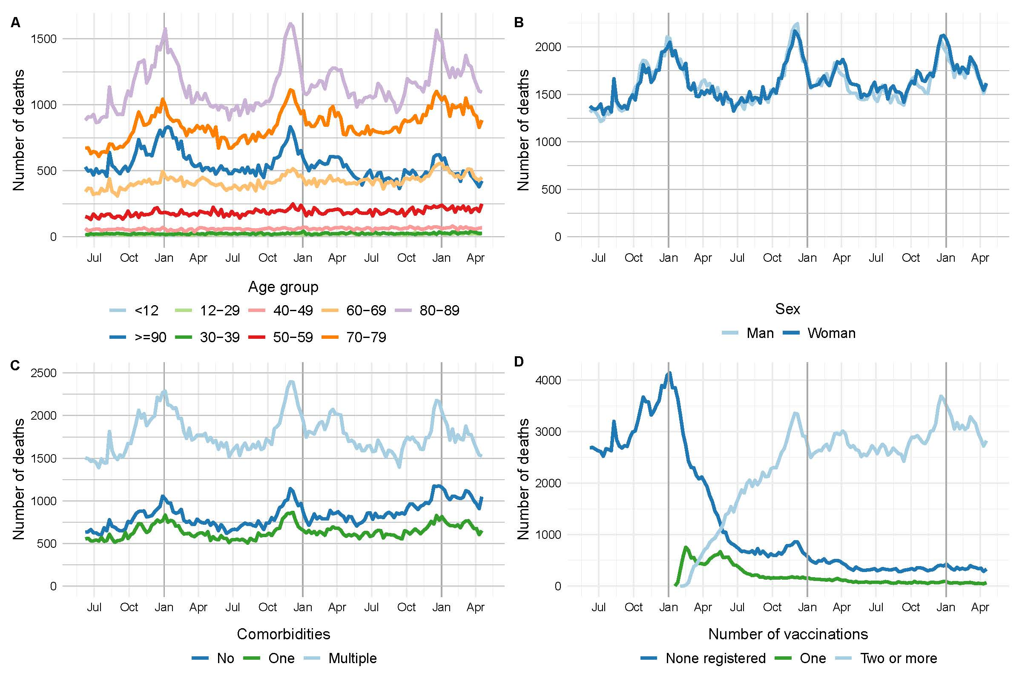
Supplemental figure 1. Number of deaths each week, among individuals who died between June 1, 2020 to April 30, 2023 (n = 493,382) by, A) by age group, B) sex, C) presence of chronic disease, and D) vaccination doses received.

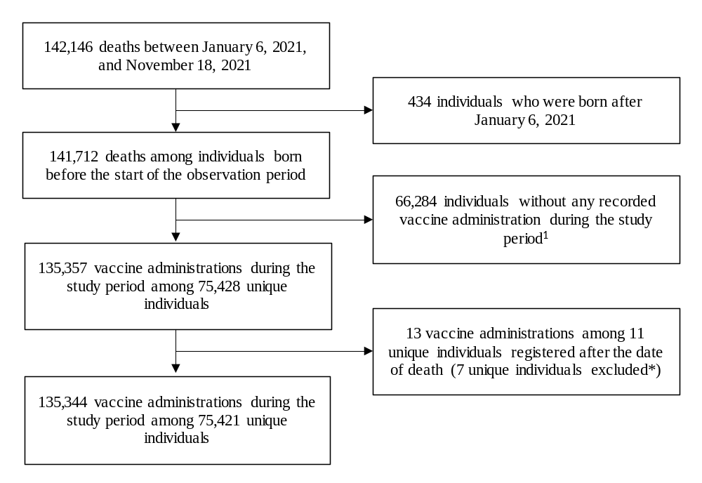
Supplemental figure 2. Flow-chart of the study population for analysis on COVID-19 vaccination and mortality.
¹ Included in the analyses to control for seasonal trends in mortality.

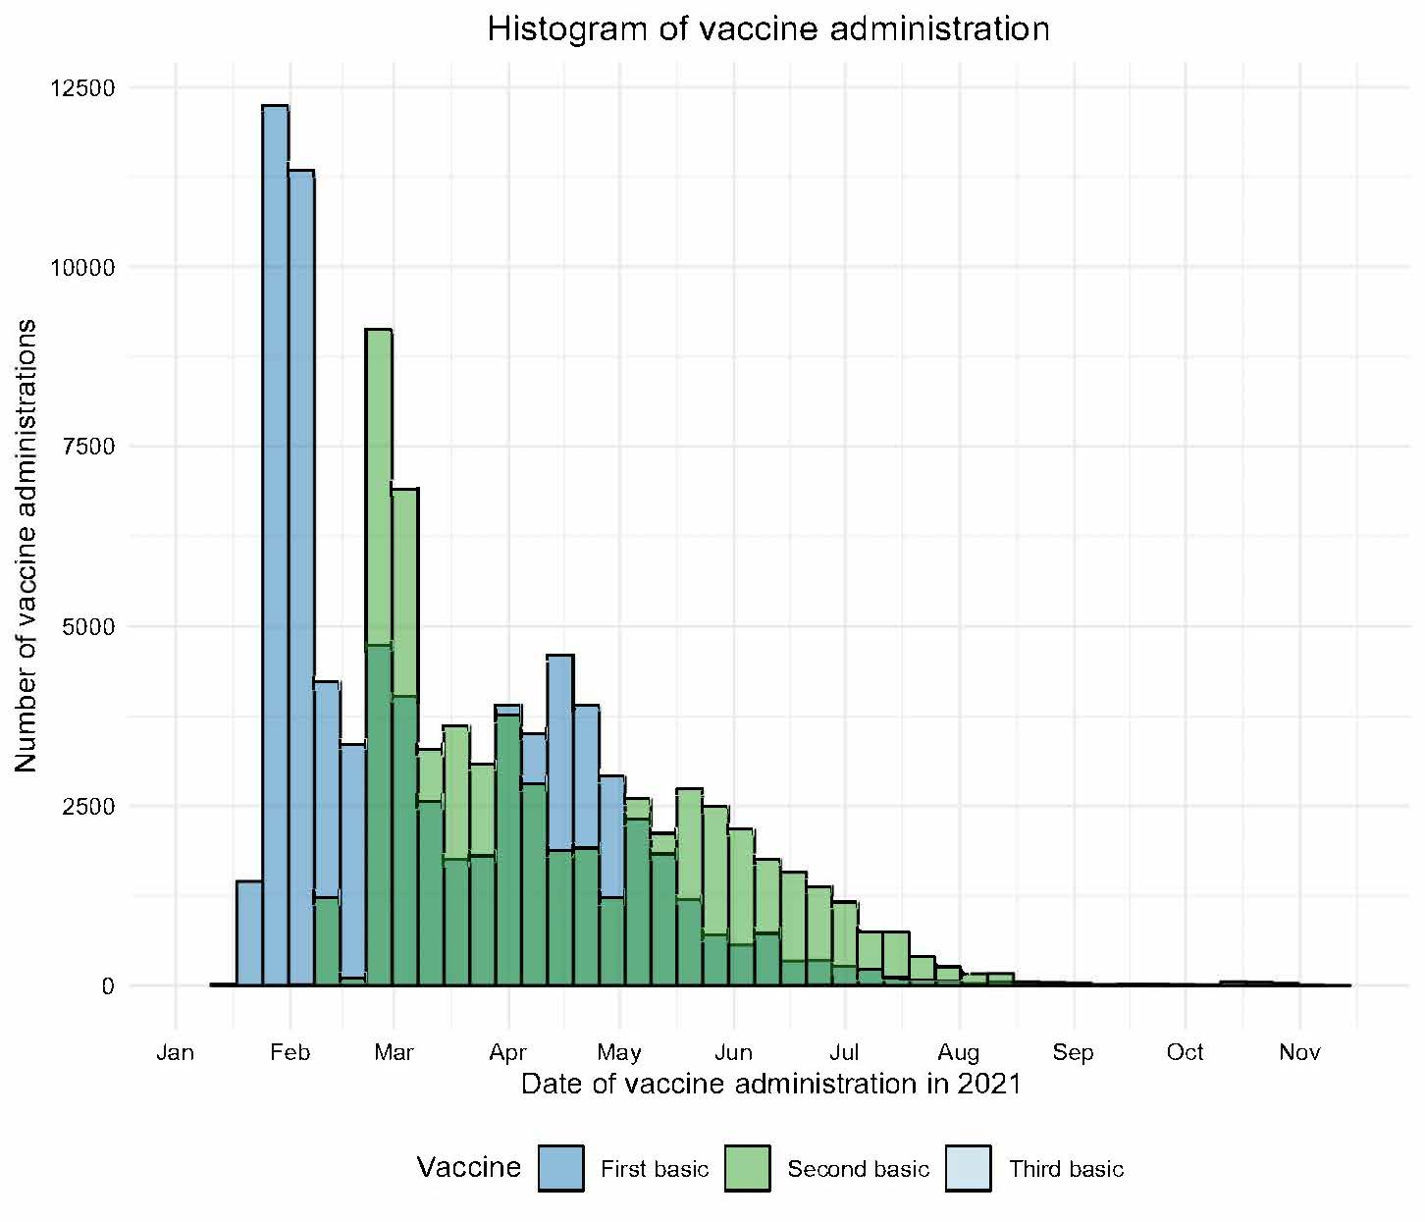
Supplemental figure 3a. Number of primary vaccine administrations from January 6, 2021 to November 18, 2021, among individuals who received the vaccine and died during this period (n = 75,421).
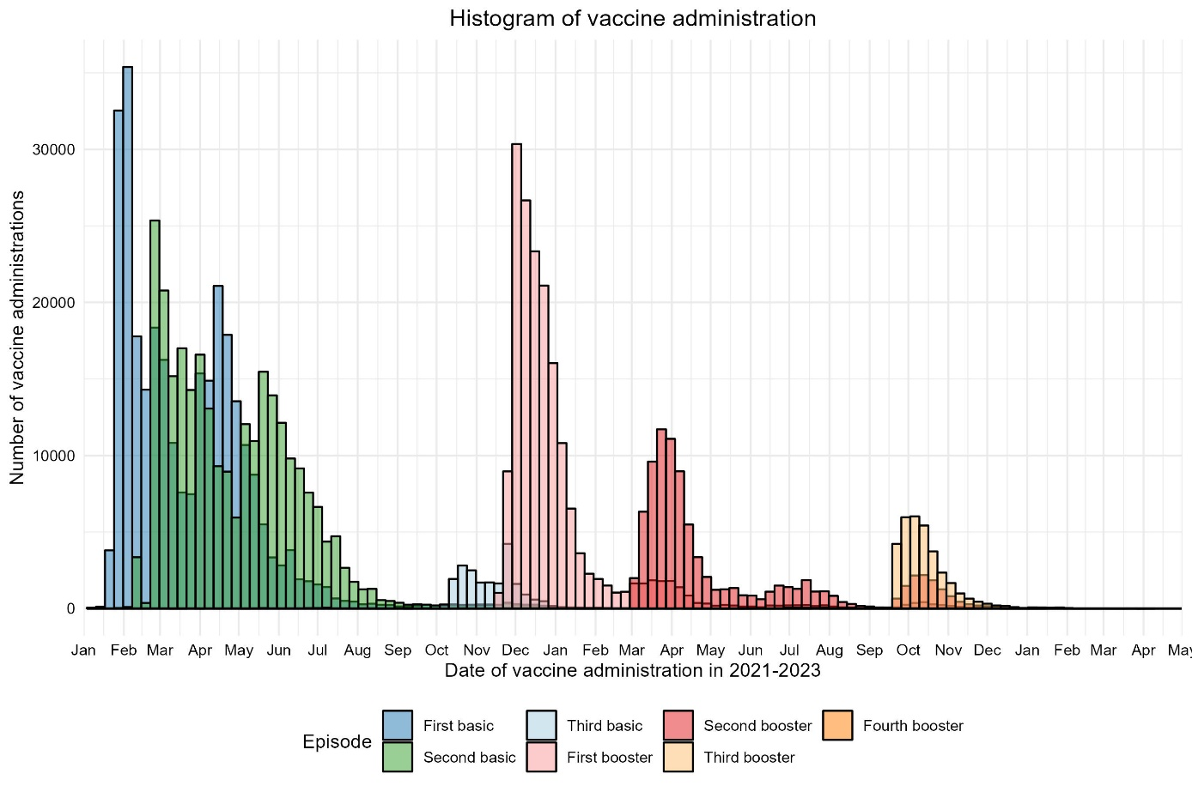
Supplemental figure 3b. Number of primary and booster vaccine administrations from January 6, 2021 to April 30, 2023, among individuals who received the vaccine and died during this period (n = 299,935).
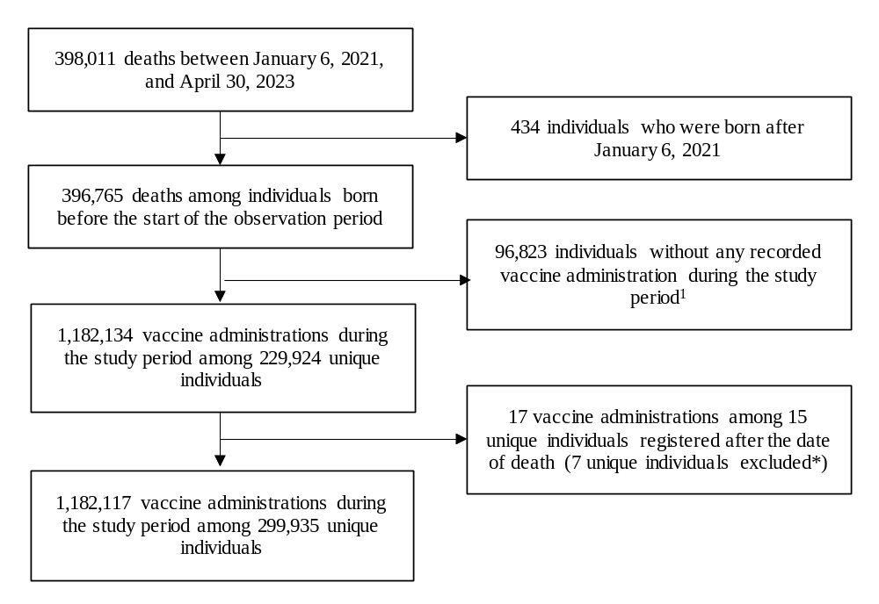
Supplemental figure 4. Flow-chart of the study population for analysis on COVID-19 basic and booster vaccination and mortality.
¹ Included in the analyses to control for seasonal trends in mortality.

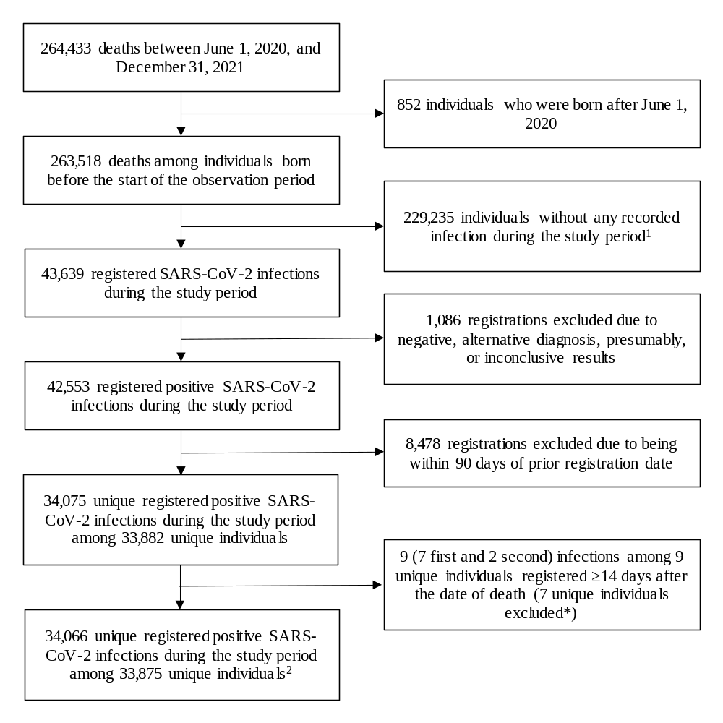
Supplemental figure 5. Flow-chart of the study population for analysis on SARS-CoV2 infection and mortality.
¹ Included in the analyses to control for seasonal trends in mortality.
² Including 240 (236 first and 4 second) infections among 240 unique individuals within 14 days after the date of death.
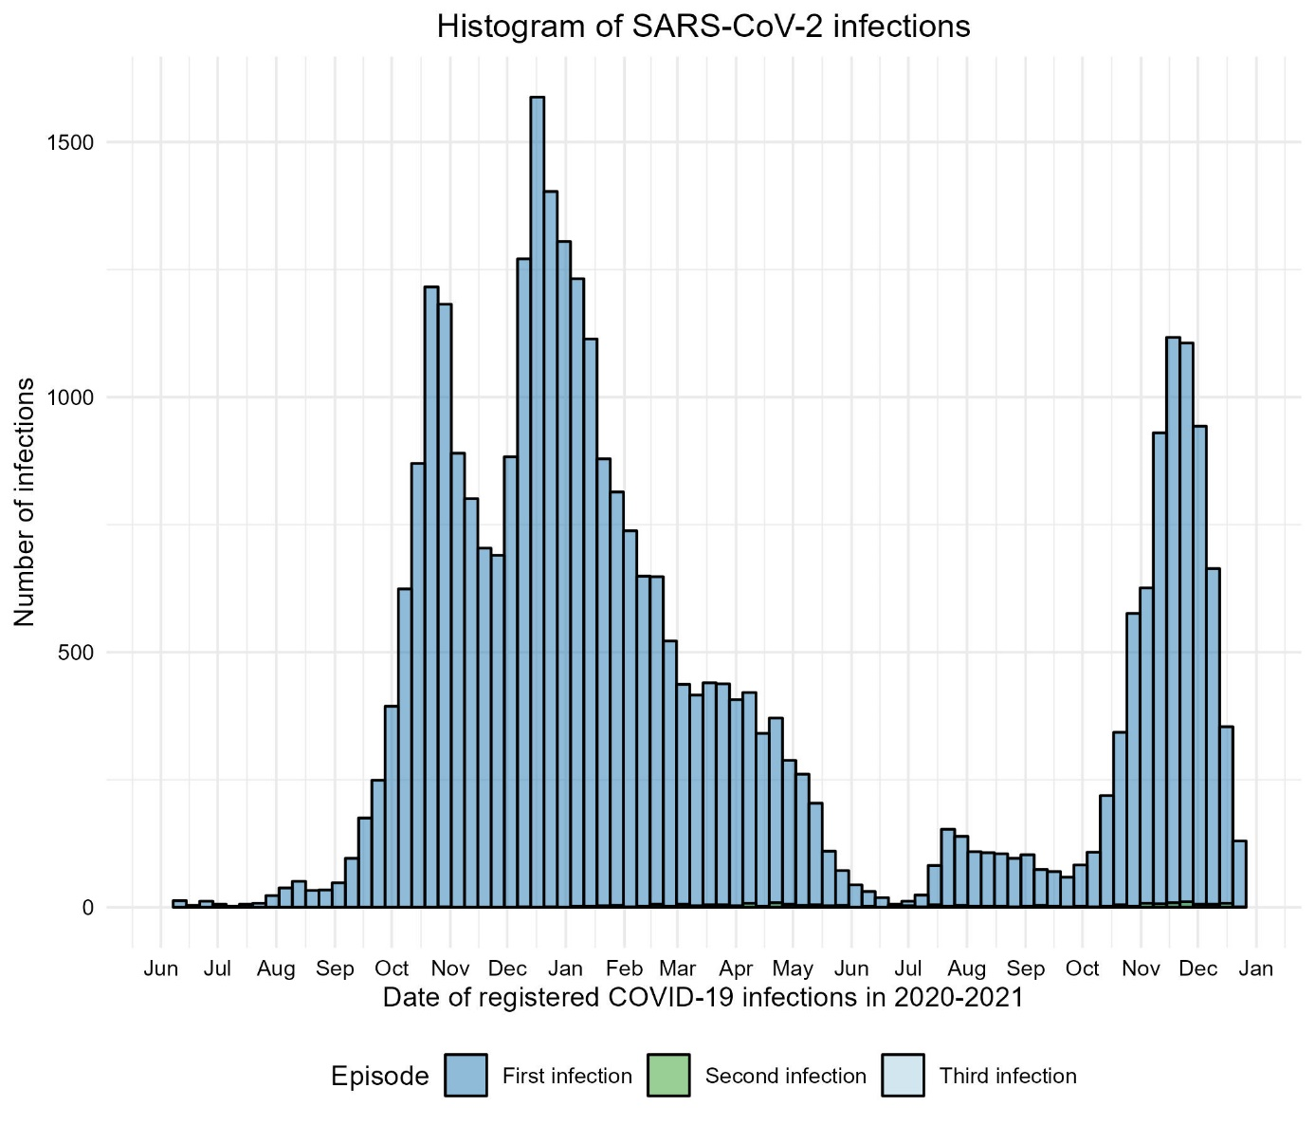
Supplemental figure 6. Number of registered positive SARS-CoV-2 infections from June 1, 2020 to December 31, 2021, among individuals who had a registered positive SARS-CoV-2 infection and died during this period (n = 33,875).

