Tables:
Table S1: ICD-10 codes used to define CKD-related endpoints and to classify CKD incidence based on first recorded diagnosis during follow-up.
Category | ICD-10 Code | Description
Diabetes-related CKD | E11.2 | Type 2 diabetes mellitus with kidney complications (diabetic nephropathy or CKD).
Hypertension-related CKD | I12.0 | Hypertensive chronic kidney disease with stage 5 CKD or end-stage renal disease (ESRD).
Hypertension-related CKD | I13.1 | Hypertensive heart and kidney disease with stage 1–4 CKD and heart failure.
Hypertension-related CKD | I13.2 | Hypertensive heart and kidney disease with stage 5 CKD or ESRD and heart failure.
Nephritic Syndrome | N03.2 | Chronic nephritic syndrome with diffuse membranous glomerulonephritis
Nephritic Syndrome | N03.3 | Chronic nephritic syndrome with diffuse mesangial proliferative glomerulonephritis
Nephritic Syndrome | N03.4 | Chronic nephritic syndrome with diffuse endocapillary proliferative glomerulonephritis
Nephritic Syndrome | N03.5 | Chronic nephritic syndrome with diffuse mesangial matrix expansion
Nephritic Syndrome | N03.6 | Chronic nephritic syndrome with dense deposit disease
Nephritic Syndrome | N03.7 | Chronic nephritic syndrome with diffuse crescentic glomerulonephritis
Nephritic Syndrome | N05.2 | Nephrotic syndrome with diffuse membranous glomerulonephritis
Nephritic Syndrome | N05.3 | Nephrotic syndrome with diffuse mesangial proliferative glomerulonephritis
Nephritic Syndrome | N05.4 | Nephrotic syndrome with diffuse endocapillary proliferative glomerulonephritis
Nephritic Syndrome | N05.5 | Nephrotic syndrome with diffuse mesangial matrix expansion
Nephritic Syndrome | N05.6 | Nephrotic syndrome with dense deposit disease
Nephritic Syndrome | N05.7 | Nephrotic syndrome with diffuse crescentic glomerulonephritis
CKD | N18.1 | Chronic kidney disease stage 1
CKD | N18.2 | Chronic kidney disease stage 2
CKD | N18.3 | Chronic kidney disease stage 3a/b
CKD | N18.4 | Chronic kidney disease stage 4
CKD | N18.5 | Chronic kidney disease stage 5
CKD | N18.6 | End-stage renal disease (requiring dialysis)
CKD | N18.9 | Chronic kidney disease, unspecified stage
CKD | N19 | Unspecified kidney failure
Other Renal Conditions | N25.0 | Renal osteodystrophy (bone disorder due to CKD).
Dialysis and Transplantation | Z49.0 | Encounter for preparation for dialysis
Dialysis and Transplantation | Z49.1 | Encounter for care involving dialysis
Dialysis and Transplantation | Z49.2 | Encounter for other dialysis-related care
Dialysis and Transplantation | Z94.0 | Kidney transplant status
Dialysis and Transplantation | Z99.2 | Dependence on renal dialysis

Table S2: Composition of the food groups
Method | Food group | Items
RRR | Alcohol | Light beer, Medium beer, Strong beer, Spirits, White wine, Red wine, Dessert wine
RRR | Beef | Minced meat, Beef
RRR | Cereals | Oatmeal, Gruel, Muesli, Bran
RRR | Coffee | Coffee
RRR | Dairy products | Light milk, Medium milk, Standard milk, Light yogurt, Natural yogurt, Cottage cheese, Cheese, Light cheese
RRR | Desserts | Cinnamon buns/cookies, Biscuits, Pastries, Chocolate, Ice-cream
RRR | Dressings | Dressings, Mayonnaise, Cream, Ketchup, Gravy
RRR | Eggs | Pancakes, Eggs,
RRR | Fish | Herring, Salmon, Cod, Caviar, Shellfish
RRR | Fruit | Orange, Apple/Pear, Banana, Berries, Other fruit
RRR | Nuts | Nuts
RRR | Other meat | Pudding, Liver, Liver paste
RRR | Pork | Pork
RRR | Poultry | Chicken
RRR | Processed meat | Sausage, Meat in sandwich
RRR | Root vegetables | Boiled potato, Fried potato, French fries, Carrots
RRR | Snacks and sweets | Chips, Sweets,
RRR | Sugar-sweetened beverages | Fruit syrup and softdrinks
RRR | Sugars | Honey, Jam, Fruit soup
RRR | Tea | Tea
RRR | Vegetables | Lettuce, Cabbage, Cauliflower, Broccoli, Tomato, Paprika, Spinach, Peas, Onion, Garlic, Vegetable mix, Vegetable soups
RRR | Refined grain | Pizza, White bread, Pasta, Rice
RRR | Whole grain | Crispbread, Ryebread
DASH diet | Low-fat diary | Light milk, Light yogurt, Cottage cheese, Light cheese
DASH diet | Fruit | Orange, Apple/Pear, Banana, Berries, Other fruit
DASH diet | Nuts and Legumes | Nuts, Vegetable soups, Peas
DASH diet | Whole grain | Crispbread, Ryebread
DASH diet | Vegetables | Lettuce, Cabbage, Cauli, Broccoli, Tomato, Paprika, Spinach, Onion, Garlic, Vegetable mix
DASH diet | Red and processed meat | Minced meat, Beef, Blood pudding, Liver, Liver paste, Pork, Sausage, Meat in sandwich
DASH diet | Sugar-sweetened beverages | Fruit syrup and softdrinks

Table S3: ICD codes used to identify and exclude prevalent cases of CKD, hypertension, and diabetes at baseline.
Disease | ICD codes
CKD | ICD-8: 581.00 – 582.09
CKD | ICD-9: 403.11, 403.91, 404.03, 404.13, 404.93,  582.0, 582.1, 582.2, 582.2, 582.2, 582.2,  583.1, 583.2, 583.2, 583.8, 583.9,  585.1, 585.2, 585.3, 585.4, 585.5, 585.6, 585.9,  586, 588  V561 - V562,  V42.0, V45.11
Hypertension | ICD-7: 441, 442, 443, 444, 445, 446, 447  ICD-8: 400, 403, 404  ICD-9: 401-405
Diabetes | ICD-7: 260  ICD-8: 249, 250  ICD-9: 250
Table S4: Tests of the proportional hazards assumption based on scaled Schoenfeld residuals, across categorical, linear, and non-linear models for each dietary pattern, stratified by sex. The table reports p-values for both the global test and the specific test for each dietary pattern.
 | Females |  |  | Males
 | Categorical model | Linear model | Non-linear model | Categorical model | Linear model | Non-linear model
DP1 | Global: 0.51;  DP1: 0.52 | Global: 0.30;  DP1: 0.44 | Global: 0.54;  DP1: 1.00 | Global: 0.42;  DP1: 0.81 | Global: 0.51;  DP1: 0.80 | Global: 0.97;  DP1: 0.87
DP2 | Global: 0.61;  DP2: 0.94 | Global: 0.79;  DP2: 0.42 | Global: 0.40;  DP2: 0.77 | Global: 0.47;  DP2: 0.90 | Global: 0.38;  DP2: 0.17 | Global: 0.92;  DP2: 1.00
DP3 | Global: 0.34;  DP3: 0.18 | Global: 0.42;  DP3: 0.37 | Global: 0.43;  DP3: 0.80 | Global: 0.47;  DP3: 0.81 | Global: 0.42;  DP3: 0.25 | Global: 0.87;  DP3: 0.93
DASH | Global: 0.27; DASH: 0.12 | Global: 0.27; DASH: 0.07 | Global: 0.42; DASH: 0.76 | Global: 0.32;  DASH: 0.16 | Global: 0.38;  DASH: 0.13 | Global: 0.85; DASH: 0.66
NNR | Global: 0.86;  NNR: 0.53 | Global: 0.71; NNR: 0.07 | Global: 0.47; NNR: 0.97 | Global: 0.04;  NNR: 0.01 | Global: 0.47;  NNR: 0.47 | Global: 0.61; NNR: 0.51

Table S5: Investigation of sex differences in the association between dietary patterns and health outcomes using multiplicative interaction terms between sex and dietary patterns in Cox regression models. Hazard ratios (HR) with 95% confidence intervals (CIs) are presented for the main effects and interaction terms.
 |  | HR (95%CI) | P-value
Main effects | DP1 | 0.92 (-0.19, 0.02) | 0.116
Main effects | Sex (M vs F) | 1.48 (0.23, 0.56) | <0.001
Interaction term | DP1 : Sex | 1.09 (-0.06, 0.24) | 0.251
Main effects | DP2 | 0.89 (-0.22, -0.02) | 0.022
Main effects | Sex (M vs F) | 1.47 (0.22, 0.55) | <0.001
Interaction term | DP2 : Sex | 1.13 (-0.03, 0.27) | 0.109
Main effects | DP3 | 1.16 (0.04, 0.26) | 0.007
Main effects | Sex (M vs F) | 1.47 (0.22, 0.55) | <0.001
Interaction term | DP3 : Sex | 0.82 (-0.36, -0.05) | 0.009
Main effects | DASH | 0.84 (-0.28, -0.07) | 0.001
Main effects | Sex (M vs F) | 1.49 (0.23, 0.56) | <0.001
Interaction term | DASH : Sex | 1.21 (0.04, 0.34) | 0.015
Main effects | NNR | 0.90 (-0.21, 0.00) | 0.042
Main effects | Sex (M vs F) | 1.44 (0.2, 0.53) | <0.001
Interaction term | NNR : Sex | 0.94 (-0.21, 0.09) | 0.447

Table S6: Descriptive analyses of dietary intake, including RRR-specific food groups (TEI-adjusted portions/week) and macro- and micronutrients used to derive the NNR. Reported are means, standard deviations (SDs) and medians.
 | Females |  |  | Males
RRR food groups (portions/day) | Mean | SD | Median | Mean | SD | Median | p-value
Beef | 2.2 | 1.2 | 2.1 | 2.4 | 1.3 | 2.2 | <0.001
Alcohol | 4.0 | 4.7 | 2.1 | 7.8 | 7.5 | 5.7 | <0.001
Cereals | 5.7 | 5.7 | 4.3 | 5.8 | 5.4 | 4.6 | 0.004
Coffee | 19.0 | 13.0 | 20.0 | 21.0 | 14.0 | 21.0 | <0.001
Dairy products | 40.0 | 16.0 | 38.0 | 43.0 | 17.0 | 42.0 | <0.001
Eggs | 1.9 | 1.2 | 1.7 | 2.0 | 1.3 | 1.7 | 0.007
Dessert | 8.4 | 5.4 | 7.2 | 9.1 | 6.1 | 7.7 | <0.001
Dressings | 4.4 | 2.7 | 3.8 | 4.5 | 3.0 | 3.9 | 0.056
Fish | 3.2 | 2.0 | 2.8 | 3.4 | 2.3 | 2.9 | <0.001
Fruit | 14.0 | 8.5 | 13.0 | 10.0 | 7.0 | 8.9 | <0.001
Nuts | 0.4 | 0.8 | 0.3 | 0.4 | 0.9 | 0.3 | <0.001
Other meat | 1.7 | 2.1 | 1.1 | 1.9 | 2.3 | 1.2 | <0.001
White grain | 9.8 | 7.6 | 8.5 | 14.0 | 11.0 | 12.0 | <0.001
Pork | 0.9 | 0.7 | 0.7 | 1.0 | 0.7 | 0.8 | <0.001
Poultry | 0.7 | 0.5 | 0.5 | 0.6 | 0.5 | 0.5 | 0.049
Processed meat | 3.6 | 2.9 | 2.8 | 4.3 | 3.4 | 3.4 | <0.001
Root vegetables | 7.7 | 3.9 | 7.2 | 7.5 | 3.5 | 6.9 | <0.001
Snacks and sweets | 1.7 | 1.7 | 1.3 | 1.7 | 1.8 | 1.3 | 0.012
Soft drinks | 0.5 | 1.8 | 0.0 | 1.1 | 3.5 | 0.2 | <0.001
Sugar | 8.1 | 13.0 | 3.7 | 15.0 | 18.0 | 8.0 | <0.001
Tea | 7.1 | 10.0 | 4.6 | 5.5 | 8.1 | 0.0 | <0.001
Vegetables | 20.0 | 11.0 | 18.0 | 16.0 | 9.6 | 14.0 | <0.001
Whole grain | 20.0 | 13.0 | 18.0 | 24.0 | 17.0 | 22.0 | <0.001
NNR macro and micronutrients | Mean | SD | Median | Mean | SD | Median
Sodium (mg/d) | 1895.0 | 258.0 | 1898.0 | 2212.0 | 287.0 | 2207.0 | <0.001
Fiber (g/d) | 21.0 | 4.4 | 20.0 | 22.0 | 4.8 | 22.0 | <0.001
Selenium (µg/d) | 28.0 | 6.6 | 27.0 | 29.0 | 7.0 | 29.0 | <0.001
Zink (mg/d) | 10.0 | 1.1 | 10.0 | 11.0 | 1.2 | 11.0 | <0.001
Iron (mg/d) | 15.0 | 2.4 | 15.0 | 18.0 | 2.9 | 18.0 | <0.001
Potassium (mg/d) | 3036.0 | 492.0 | 3004.0 | 3255.0 | 523.0 | 3226.0 | <0.001
Magnesium (mg/d) | 304.0 | 32.0 | 302.0 | 345.0 | 36.0 | 344.0 | <0.001
Phosphorus (mg/d) | 1443.0 | 223.0 | 1427.0 | 1648.0 | 270.0 | 1626.0 | <0.001
Calcium (mg/d) | 1096.0 | 281.0 | 1072.0 | 1245.0 | 351.0 | 1212.0 | <0.001
Vitamin E (mg/d) | 5.3 | 1.1 | 5.2 | 5.2 | 1.1 | 5.1 | <0.001
Vitamin D (µg/d) | 3.6 | 1.3 | 3.5 | 4.0 | 1.5 | 3.9 | <0.001
Vitamin C (mg/d) | 98.0 | 42.0 | 92.0 | 92.0 | 41.0 | 86.0 | <0.001
Vitamin B12 (µg/d) | 6.5 | 2.5 | 6.0 | 7.4 | 2.6 | 6.9 | <0.001
Folate (µg/d) | 229.0 | 42.0 | 226.0 | 247.0 | 41.0 | 245.0 | <0.001
Vitamin B6 (mg/d) | 2.0 | 0.3 | 2.0 | 2.2 | 0.3 | 2.1 | <0.001
Niacin (mg/d) | 14.0 | 2.0 | 14.0 | 16.0 | 2.2 | 16.0 | <0.001
Riboflavin (mg/d) | 2.2 | 0.5 | 2.2 | 2.6 | 0.6 | 2.5 | <0.001
Thiamine (mg/d) | 1.6 | 0.2 | 1.6 | 1.8 | 0.2 | 1.8 | <0.001
Vitamin A (mg/d) | 1287.0 | 584.0 | 1184.0 | 1284.0 | 586.0 | 1187.0 | 0.500
Protein (E%) | 76.0 | 8.8 | 76.0 | 85.0 | 10.0 | 85.0 | <0.001
Carbohydrates (E%) | 269.0 | 22.0 | 269.0 | 308.0 | 25.0 | 307.0 | <0.001
Saccarides (E%) | 32.0 | 13.0 | 29.0 | 38.0 | 17.0 | 34.0 | <0.001
Fat (E%) | 54.0 | 8.5 | 54.0 | 62.0 | 9.3 | 62.0 | <0.001
Saturated fat (E%) | 24.0 | 4.9 | 24.0 | 28.0 | 5.5 | 28.0 | <0.001
Monounsaturated fat (E%) | 18.0 | 3.2 | 18.0 | 21.0 | 3.5 | 20.0 | <0.001
Polyunsaturated fat (E%) | 7.0 | 1.2 | 6.9 | 8.0 | 1.4 | 7.9 | <0.001
Alcohol (E%) | 3.0 | 3.4 | 1.7 | 5.7 | 5.4 | 4.6 | <0.001

Table S7: Cox regression results for the association between dietary patterns and incident CKD, excluding early incident cases (<3 years from baseline assessment), with hazard ratios (HR) and 95% confidence intervals (95%CI) for linear and categorical modeling. Models were stratified by sex, and adjusted for BMI, physical activity, education, smoking, energy intake, and supplement use. Incident rates (IR, events per 10,000 person-year) are provided for adherence categories.
 |  | Females |  |  |  | Males
 |  | IR | HR (95%CI) | P-value |  | IR | HR (95%CI) | P-value
DP1 | Linear modelling |  | 0.97 (0.87, 1.08) | 0.538 |  |  | 0.98 (0.86, 1.10) | 0.687
 | Categorical modelling*
 | Low adherence | 10.8 | 1.07 (0.83, 1.38) | 0.607 |  | 19.1 | 1.41 (1.05, 1.90) | 0.022
 | Medium adherence | 10.6 | Reference |  |  | 15.1 | Reference
 | High adherence | 11.0 | 1.00 (0.77, 1.30) | 0.985 |  | 21.3 | 1.35 (1.01, 1.81) | 0.044
DP2 | Linear modelling |  | 0.90 (0.81, 1.01) | 0.065 |  |  | 0.98 (0.87, 1.1) | 0.756
 | Categorical modelling*
 | Low adherence | 10.9 | Reference |  |  | 16.4 | Reference
 | Medium adherence | 10.5 | 0.90 (0.69, 1.16) | 0.409 |  | 18.8 | 1.04 (0.78, 1.40) | 0.792
 | High adherence | 11.0 | 0.89 (0.68, 1.15) | 0.363 |  | 20.4 | 0.96 (0.71, 1.28) | 0.763
DP3 | Linear modelling |  | 1.15 (1.03, 1.29) | 0.016 |  |  | 0.96 (0.85, 1.08) | 0.476
 | Categorical modelling*
 | Low adherence | 9.9 | Reference |  |  | 23.6 | Reference
 | Medium adherence | 11.4 | 1.22 (0.94, 1.58) | 0.128 |  | 15.9 | 0.77 (0.58, 1.02) | 0.071
 | High adherence | 11.0 | 1.30 (1.00, 1.70) | 0.052 |  | 16.3 | 1.05 (0.79, 1.39) | 0.745
DASH | Linear modelling |  | 0.86 (0.77, 0.96) | 0.008 |  |  | 0.98 (0.86, 1.11) | 0.746
 | Categorical modelling*
 | Low adherence | 11.6 | Reference |  |  | 16.6 | Reference
 | Medium adherence | 11.6 | 0.92 (0.72, 1.18) | 0.500 |  | 18.3 | 0.83 (0.62, 1.12) | 0.219
 | High adherence | 8.9 | 0.69 (0.52, 0.89) | 0.006 |  | 21.3 | 0.84 (0.63, 1.12) | 0.226
NNR | Linear modelling |  | 0.93 (0.83, 1.04) | 0.187 |  |  | 0.88 (0.78, 1.00) | 0.045
 | Categorical modelling*
 | Low adherence | 12.2 | Reference |  |  | 23.3 | Reference
 | Medium adherence | 10.0 | 0.81 (0.63, 1.04) | 0.102 |  | 17.8 | 0.83 (0.63, 1.09) | 0.184
 | High adherence | 10.1 | 0.92 (0.71, 1.20) | 0.539 |  | 14.6 | 0.78 (0.57, 1.06) | 0.113
* Adherence refers to the tertile-based categorical score, with: Low adherence: T1; Medium adherence: T2; High adherence: T3.
Acronyms: IR, Incidence Rate; HR, Hazard Ratio; 95%CI: 95% Confidence Interval; DASH, Dietary Approaches to Stop Hypertension; NNR, Nordic Nutrition Recommendations

Table S8: Cox regression results for the association between dietary patterns and incident CKD excluding individuals with extreme scores levels (bottom and top 1st percentile), with hazard ratios (HR) and 95% confidence intervals (95%CI) for linear and categorical modeling. Models were stratified by sex, and adjusted for BMI, physical activity, education, smoking, energy intake, and supplement use. Incident rates (IR, events per 10,000 person-year) are provided for adherence categories.
 |  | Females |  |  | Males
 |  | IR | HR (95%CI) | P-value | IR | HR (95%CI) | P-value
DP1 | Linear modelling |  | 0.94 (0.83, 1.06) | 0.300 |  | 1.02 (0.9, 1.17) | 0.731
 | Categorical modelling*
 | Low adherence | 10.8 | 1.05 (0.82, 1.35) | 0.697 | 19.1 | 1.38 (1.03, 1.85) | 0.031
 | Medium adherence | 10.6 | Reference |  | 15.1 | Reference
 | High adherence | 11.0 | 0.96 (0.74, 1.23) | 0.743 | 21.3 | 1.42 (1.06, 1.89) | 0.017
DP2 | Linear modelling |  | 0.88 (0.78, 0.99) | 0.030 |  | 0.97 (0.86, 1.11) | 0.695
 | Categorical modelling*
 | Low adherence | 10.9 | Reference |  | 16.4 | Reference
 | Medium adherence | 10.5 | 0.85 (0.66, 1.10) | 0.212 | 18.8 | 1.07 (0.81, 1.43) | 0.631
 | High adherence | 11.0 | 0.88 (0.68, 1.13) | 0.319 | 20.4 | 0.94 (0.70, 1.26) | 0.684
DP3 | Linear modelling |  | 1.12 (1.00, 1.26) | 0.056 |  | 0.98 (0.86, 1.11) | 0.766
 | Categorical modelling*
 | Low adherence | 9.9 | Reference |  | 23.6 | Reference
 | Medium adherence | 11.4 | 1.15 (0.90, 1.49) | 0.265 | 15.9 | 0.84 (0.64, 1.10) | 0.210
 | High adherence | 11.0 | 1.24 (0.95, 1.60) | 0.110 | 16.3 | 1.12 (0.85, 1.49) | 0.415
DASH | Linear modelling |  | 0.85 (0.76, 0.95) | 0.005 |  | 0.95 (0.84, 1.08) | 0.410
 | Categorical modelling*
 | Low adherence | 11.6 | Reference |  | 16.6 | Reference
 | Medium adherence | 11.6 | 0.93 (0.73, 1.19) | 0.578 | 18.3 | 0.83 (0.63, 1.1) | 0.195
 | High adherence | 8.9 | 0.70 (0.54, 0.91) | 0.007 | 21.3 | 0.79 (0.59, 1.04) | 0.095
NNR | Linear modelling |  | 0.88 (0.78, 0.99) | 0.027 |  | 0.85 (0.75, 0.97) | 0.013
 | Categorical modelling*
 | Low adherence | 12.2 | Reference |  | 23.3 | Reference
 | Medium adherence | 10.0 | 0.77 (0.60, 0.99) | 0.044 | 17.8 | 0.77 (0.59, 1.02) | 0.064
 | High adherence | 10.1 | 0.89 (0.69, 1.15) | 0.389 | 14.6 | 0.74 (0.55, 1.00) | 0.047
* Adherence refers to the tertile-based categorical score, with: Low adherence: T1; Medium adherence: T2; High adherence: T3.
Acronyms: IR, Incidence Rate; HR, Hazard Ratio; 95%CI: 95% Confidence Interval; DASH, Dietary Approaches to Stop Hypertension; NNR, Nordic Nutrition Recommendations

Figures
Figure S1: Scree plot showing the proportion of total variance in the response variables explained by each dietary pattern derived through Reduced Rank Regression (RRR). The red line represents the cumulative variance explained, indicating that the first three dietary patterns together account for approximately 97.9% of the total variance across the four nutrients.
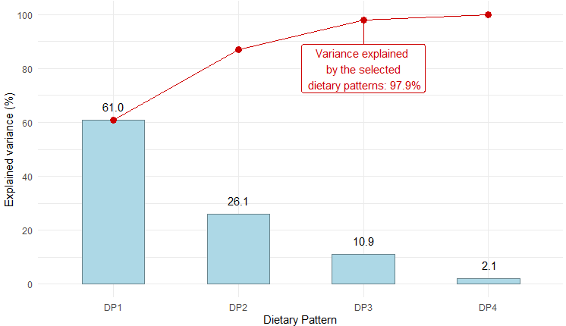
Figure S2: Directed Acyclic Graph (DAG) used to identify potential confounders in the association between dietary patterns (exposure, green circle) and CKD incidence (outcome, lightblue circle), obtained using the browser-based tool DAGitty*.
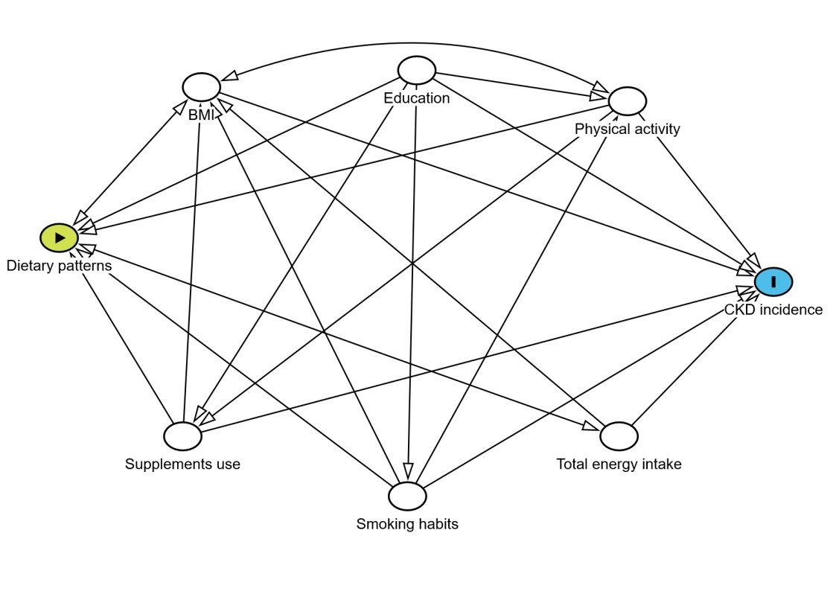
*Textor J., van der Zander B., Gilthorpe M.S., Liskiewicz M., Ellison G.T.: Robust causal inference using directed acyclic graphs: the R package “dagitty”. Int J Epidemiol 2016; 45: pp. 1887-1894.
Figure S3: Flowchart of the selection of study participants for this analysis
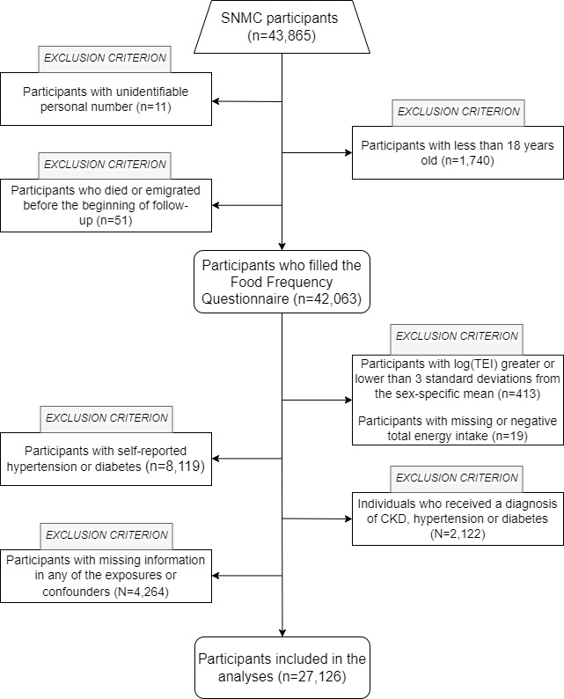

Figure S4: Heatmap of pairwise Pearson’s correlation coefficients between nutrients and RRR dietary patterns
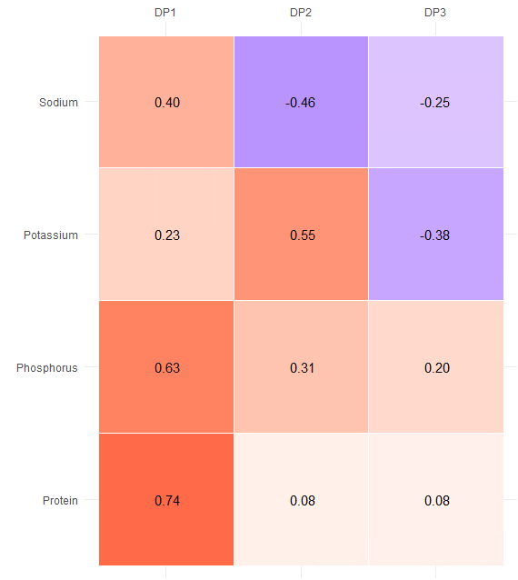

Figure S5: Predicted relative risks (log-hazard scale, red line) from models investigating non-linear associations between the dietary pattern and the log-hazard for CKD, excluding individuals with extreme score levels (bottom and top 1st percentile), with 95% confidence intervals (red shading). Histograms represent the relative distribution of the dietary patterns. The estimated degrees of freedom (edf) indicate the complexity of the non-linear function used to model the relationship. Specifically, an edf close to 1 suggests a nearly linear relationship, whereas higher edf values indicate increasing deviations from linearity.
