- Online Supplement -
Night Shift Work, Dietary Patterns, and Coronary Heart Disease
European Journal of Epidemiology

Diana A. Nôga¹, Elisa M. S. Meth¹, André P. Pacheco^{1,2,3}, Jonathan Cedernaes^{4,5},
Pei Xue¹, Christian Benedict¹

¹ Department of Pharmaceutical Biosciences, Uppsala University, Uppsala, Sweden
² Department of Research and Innovation, Division of Mental Health and Addiction, Oslo University Hospital, Oslo, Norway
³ Institute of Clinical Medicine, Faculty of Medicine, University of Oslo, Oslo, Norway
⁴ Department of Medical Sciences, Uppsala University, Uppsala, Sweden
⁵ Department of Medical Cell Biology, Uppsala University, Uppsala, Sweden

Correspondence to: Diana Nôga (diana.noga.morais@uu.se) or Christian Benedict (christian.benedict@uu.se).
Fig. S1 Final sample estimation

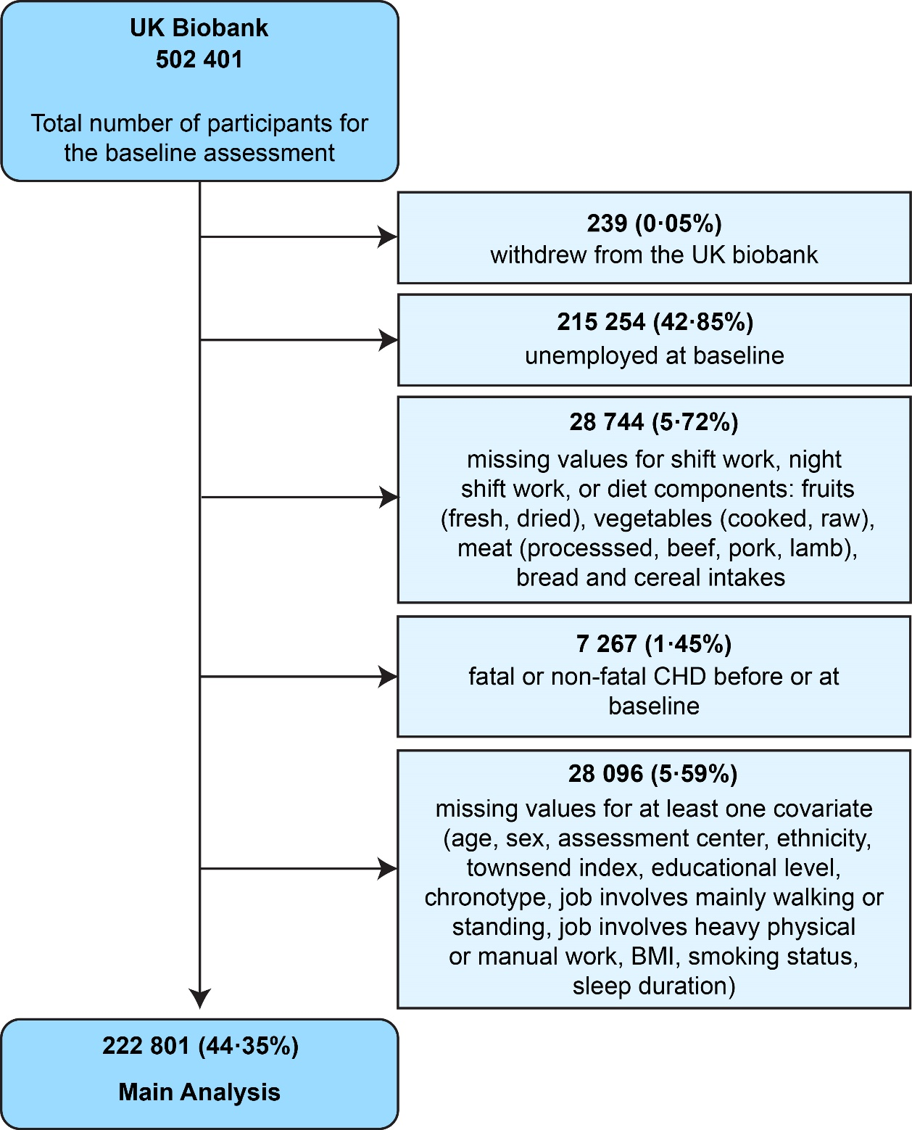

Table S1 Number of participants at risk, categorized by work schedule
Exposure group | No. at risk
 | Baseline | <2 years# | <4 years# | <6 years# | <8 years# | <10 years# | <12 years# | <14 years#
Daytime work | 186221 | 184733 | 182772 | 180485 | 177947 | 174959 | 129651 | 9088
Shift work with no or occasional night shifts | 29153 | 28883 | 28520 | 28151 | 27681 | 27175 | 19729 | 1337
Regular night shift work | 7427 | 7335 | 7245 | 7127 | 6995 | 6867 | 5084 | 316
# Time since baseline (2006-2010)

Table S2 Number of participants at risk, categorized by meat consumption status
Exposure group | No. at risk
 | Baseline | <2 years# | <4 years# | <6 years# | <8 years# | <10 years# | <12 years# | <14 years#
Meat eater | 209050 | 207264 | 204955 | 202304 | 199309 | 195843 | 145019 | 9989
Meat avoider | 13751 | 13688 | 13582 | 13459 | 13314 | 13158 | 9445 | 752
# Time since baseline (2006-2010)

Table S3 Sex-specific Cox regression estimates
Exposure of interest | Female subgroup |  | Male subgroup
 | Model A, HR [95% CI] | Model B, HR [95% CI] | Model A, HR [95% CI] | Model B, HR [95% CI]
Daytime workers | 1 | 1 | 1 | 1
Shift workers with no or occasional night shifts | 1.299 [1.187 to 1.422] | 1.056 [0.960 to 1.162] | 1.159 [1.091 to 1.231] | 0.998 [0.938 to 1.063]
Regular night shift workers | 1.600 [1.347 to 1.901] | 1.129 [0.944 to 1.350] | 1.334 [1.206 to 1.476] | 1.088 [0.981 to 1.206]
Fiber intake, gram per day | 0.984 [0.978 to 0.990] | 0.993 [0.987 to 0.998] | 0.990 [0.987 to 0.994 | 0.995 [0.991 to 0.998]
Meat eater | 1 | 1 | 1 | 1
Meat avoider | 0.829 [0.729 to 0.944] | 0.970 [0.850 to 1.107] | 0.758 [0.665 to 0.863] | 0.848 [0.742 to 0.968]
Values are presented as hazard ratios (HRs) with 95% confidence intervals (95% CIs). Models were fitted using the multiply imputed cohort. Model A included the exposure of interest and age. Model B included all exposures of interest simultaneously for mutual adjustment, as well as age, BMI, socioeconomic status, assessment center, chronotype, ethnicity, education, smoking, sleep duration, physical activity, work-related physical demands, meat and alcohol intake, statin use, and prevalent diabetes and/or hypertension.

