SUPPLEMENTARY MATERIAL

Source-specific nitrate and nitrite intake and association with gastric cancer in
the Danish Diet, Cancer and Health Cohort

Dorit W. Erichsen et al.

Version date 25 February 2026

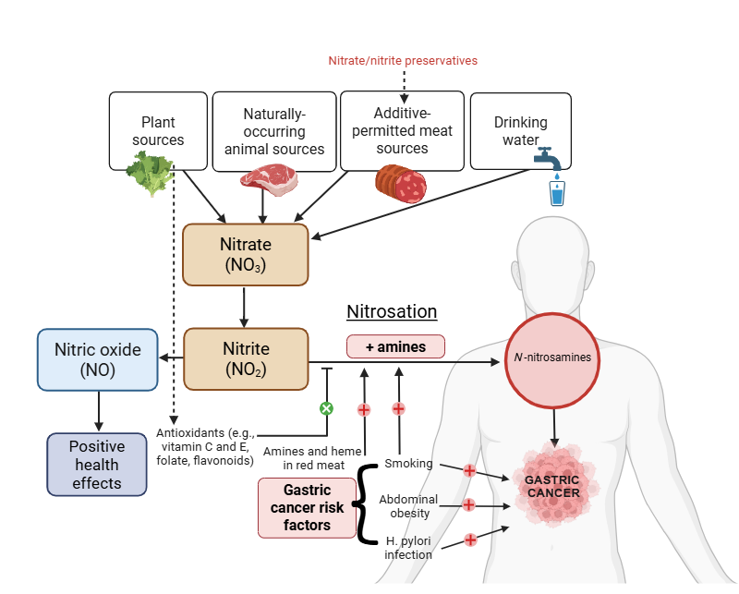
Supplementary Figure 1. Conceptual model of nitrate and nitrite sources, mechanistic pathways and dual health effects

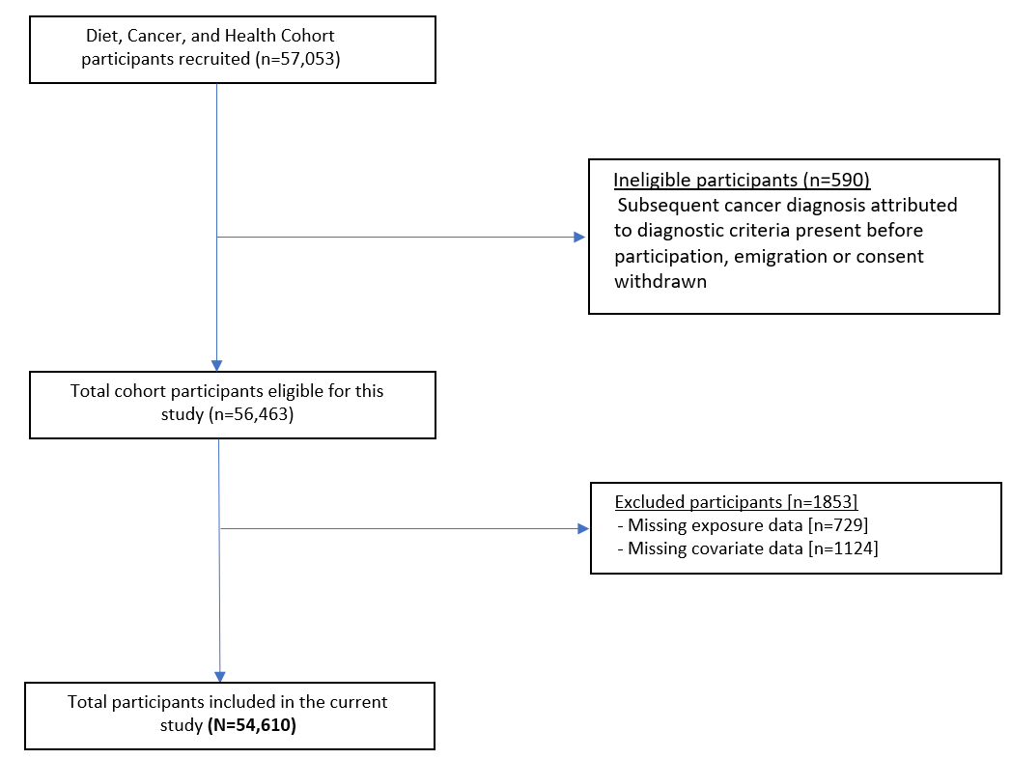

Supplementary Figure 2. CONSORT flow diagram of the Diet, Cancer and Health Cohort participants included in the present study

Supplementary Table 1. Dietary characteristics of the study population by quintile of source-specific nitrate intakes
 | Total participants | Plant-sourced nitrate |  | Naturally occurring animal-sourced nitrate |  | Additive-permitted meat-sourced nitrate |  | Tap water-sourced nitrate
 | N=54,610 | Q1 (n=10,922) | Q5 (n=10,922) | Q1 (n=10,922) | Q5 (n=10,922) | Q1 (n=10,922) | Q5 (n=10,922) | Q1 (n=10,922) | Q5 (n=10,918)
Dietary intake
Energy (kcal/d) | 2270.6 [1877.9, 2718.6] | 1946.2 [1598.2, 2338.0] | 2573.6 [2173.1, 3059.5] | 1816.9 [1537.1, 2148.6] | 2661.6 [2258.3, 3144.3] | 1916.3 [1588.6, 2283.7] | 2791.8 [2375.8, 3258.9] | 2349.2 [1952.3, 2794.8] | 2183.0 [1804.3, 2627.5]
Vegetables (g/d) | 309.9 [232.2, 403.1] | 183.2 [142.3, 222.3] | 474.7 [403.8, 564.7] | 257.0 [185.7, 344.2] | 358.4 [276.4, 457.4] | 305.0 [220.6, 407.3] | 333.6 [250.7, 428.9] | 289.3 [215.9, 377.1] | 323.8 [239.8, 425.3]
Fruits (g/d) | 169.8 [92.9, 280.0] | 86.7 [39.2, 152.7] | 283.0 [177.4, 432.2] | 140.3 [67.0, 244.9] | 219.4 [132.1, 346.5] | 196.1 [112.8, 322.6] | 148.1 [75.7, 250.9] | 131.6 [63.1, 227.7] | 196.2 [113.7, 320.4]
Wholegrains (g/d) | 121.6 [81.2, 168.9] | 103.5 [65.5, 147.0] | 152.9 [104.1, 203.9] | 112.5 [68.3, 163.0] | 135.2 [98.6, 186.3] | 115.2 [72.2, 164.3] | 152.7 [106.0, 202.9] | 116.5 [70.4, 165.2] | 124.6 [83.1, 170.2]
Refined grains (g/d) | 45.8 [29.3, 72.3] | 43.3 [26.1, 80.9] | 48.2 [31.4, 71.1] | 38.1 [23.1, 58.5] | 49.6 [32.4, 76.2] | 35.3 [22.3, 53.0] | 59.6 [38.8, 97.8] | 49.4 [31.0, 86.2] | 42.3 [26.9, 63.2]
Red meat (g/d) | 81.4 [58.6, 111.4] | 74.8 [54.6, 100.4] | 81.7 [55.9, 116.3] | 56.5 [42.5, 70.4] | 101.4 [73.4, 138.7] | 55.1 [38.5, 74.7] | 113.0 [85.0, 148.6] | 92.8 [67.8, 123.2] | 72.3 [51.7, 98.8]
Processed meat (g/d) | 21.6 [12.2, 35.5] | 22.4 [12.8, 36.6] | 19.1 [9.6, 33.0] | 15.9 [8.5, 26.4] | 24.6 [14.2, 39.4] | 6.6 [4.5, 8.7] | 52.1 [42.5, 67.4] | 26.0 [15.0, 41.3] | 18.5 [9.9, 30.6]
Poultry (g/d) | 17.9 [10.3, 27.6] | 12.5 [6.8, 19.9] | 22.8 [13.4, 35.3] | 12.9 [6.8, 21.1] | 21.0 [12.8, 32.9] | 15.4 [8.1, 25.8] | 19.6 [11.3, 30.6] | 17.1 [9.4, 26.2] | 18.3 [10.3, 29.0]
Fish (g/d) | 38.2 [25.4, 55.3] | 28.8 [18.8, 42.1] | 47.5 [31.8, 68.2] | 28.3 [18.6, 41.1] | 47.7 [32.2, 67.9] | 33.1 [21.4, 49.3] | 43.1 [28.1, 62.1] | 35.6 [23.2, 51.6] | 39.3 [26.1, 57.6]
Dairy (g/d) | 306.2 [165.7, 570.7] | 263.0 [119.6, 547.1] | 354.0 [215.1, 615.8] | 137.5 [74.6, 285.2] | 537.0 [379.6, 795.6] | 286.2 [148.3, 514.8] | 329.5 [178.7, 608.1] | 288.9 [144.7, 564.4] | 302.6 [163.1, 557.9]
Butter (g/d) | 9.2 [1.0, 20.0] | 10.5 [2.2, 19.8] | 7.5 [0.4, 20.3] | 6.1 [0.3, 16.2] | 10.3 [1.2, 21.4] | 6.0 [0.3, 16.1] | 15.1 [2.6, 25.6] | 12.2 [2.0, 22.1] | 6.8 [0.6, 17.8]
Vegetable oils (g/d) | 4.7 [1.2, 8.9] | 1.3 [0.5, 2.8] | 9.0 [4.7, 13.4] | 1.9 [0.6, 5.9] | 5.3 [1.6, 11.3] | 5.1 [1.0, 9.1] | 2.7 [1.1, 8.4] | 2.6 [0.9, 7.5] | 4.8 [1.0, 9.1]
Confectionery (g/d) | 49.0 [28.5, 81.1] | 41.8 [22.9, 72.6] | 53.3 [31.5, 87.6] | 40.7 [22.2, 70.2] | 56.3 [33.9, 92.0] | 41.6 [23.2, 71.3] | 57.5 [33.3, 98.2] | 49.4 [27.8, 84.7] | 45.5 [26.1, 76.0]
Soft drink (g/d) | 16.4 [3.3, 45.0] | 16.4 [3.3, 85.7] | 6.6 [0.0, 28.6] | 6.6 [0.0, 28.6] | 16.4 [3.3, 57.2] | 6.6 [0.0, 16.4] | 28.6 [6.6, 85.7] | 16.4 [3.3, 85.7] | 9.9 [0.0, 28.6]
Alcohol (g/d) | 12.9 [5.9, 31.1] | 12.1 [3.6, 32.3] | 12.7 [6.0, 29.3] | 11.0 [3.3, 26.9] | 13.3 [6.3, 30.5] | 10.3 [3.2, 21.0] | 16.5 [7.4, 36.8] | 16.0 [7.0, 36.6] | 11.2 [3.9, 23.0]
Water (l/d) | 1.7 [1.3, 2.1] | 1.6 [1.1, 2.0] | 1.8 [1.4, 2.3] | 1.7 [1.3, 2.2] | 1.8 [1.3, 2.2] | 1.8 [1.3, 2.2] | 1.6 [1.2, 2.1] | 1.3 [0.9, 1.6] | 2.2 [1.8, 2.6]
Tea (g/d) | 85.7 [3.3, 500.0] | 16.4 [0.0, 200.0] | 200.0 [16.4, 500.0] | 85.7 [3.3, 500.0] | 157.1 [16.4, 500.0] | 200.0 [16.4, 500.0] | 16.4 [3.3, 200.0] | 16.4 [3.3, 500.0] | 85.7 [6.6, 500.0]
Coffee (g/d) | 900.0 [500.0, 1300.0] | 900.0 [500.0, 1300.0] | 500.0 [500.0, 900.0] | 900.0 [500.0, 1300.0] | 900.0 [500.0, 1300.0] | 500.0 [500.0, 900.0] | 900.0 [500.0, 1300.0] | 900.0 [500.0, 1300.0] | 900.0 [500.0, 900.0]
Polyphenols (mg/d) | 1606.0 [1264.4, 1947.9] | 1425.9 [1088.4, 1764.7] | 1767.9 [1431.1, 2152.9] | 1521.4 [1165.3, 1863.1] | 1679.3 [1343.0, 2051.6] | 1543.5 [1194.4, 1913.2] | 1680.9 [1332.4, 2005.1] | 1631.0 [1270.5, 1951.8] | 1591.5 [1233.4, 1964.4]
Folic acid (µg/d) | 367.1 [289.1, 462.0] | 272.4 [218.1, 348.6] | 473.1 [398.1, 567.7] | 299.7 [234.1, 385.9] | 444.5 [362.3, 542.0] | 354.4 [272.9, 453.7] | 394.9 [315.4, 489.5] | 342.9 [269.5, 431.7] | 382.6 [298.3, 485.2]
Vitamin C (mg/d) | 125.1 [86.4, 183.8] | 74.2 [52.2, 115.5] | 184.6 [140.6, 259.6] | 108.0 [70.3, 165.0] | 151.5 [108.7, 215.5] | 137.4 [92.3, 214.4] | 118.5 [83.7, 168.3] | 104.9 [72.6, 152.5] | 140.8 [96.3, 215.7]
Vitamin E (mg α-TE/d) | 11.9 [8.3, 17.8] | 8.6 [6.0, 14.4] | 15.3 [11.2, 21.5] | 9.7 [6.5, 16.1] | 14.3 [10.2, 20.2] | 11.4 [7.4, 18.0] | 13.1 [9.3, 18.6] | 10.7 [7.6, 16.0] | 13.0 [8.6, 19.2]

