Supplement for
Aune D, Otaki Y, Mahamat-Saleh Y, Hibino M, Heath AK, Berlanga-Taylor A, Konta T, Yamagata K, Fujimoto S, Tsuruya K, Narita I, Kasahara M, Shibagaki Y, Iseki K, Moriyama T, Kondo M, Asahi K, Watanabe T, Watanabe T, Watanabe M, Janszky I. Adiposity and the risk of aortic aneurysm: results from the UK Bioban, Japan-Specific Health Check-ups Study and a systematic review and meta-analysis of cohort studies.

Supplementary text - search strategy

PubMed search:
(“body mass index” OR BMI OR overweight OR obesity OR anthropometry OR fatness OR “body fatness” OR “abdominal fatness” OR “abdominal obesity” OR “waist circumference” OR "hip circumference" OR “waist-to-hip ratio” OR adiposity OR "weight gain" OR "weight change" OR “weight loss” OR lifestyle OR life-style)
AND
aortic aneurysm

Embase search:
1) (body mass index or BMI or overweight or obesity or anthropometry or fatness or body fatness or abdominal fatness or abdominal obesity or waist circumference or hip circumference or waist-to-hip ratio or adiposity or weight gain or weight change or weight loss or lifestyle or life-style).ab,ti.
2) body mass index/ or BMI/ or overweight/ or obesity/ or anthropometry/ or fatness/ or body fatness/ or abdominal fatness/ or abdominal obesity/ or waist circumference/ or hip circumference/ or waist-to-hip ratio/ or adiposity/ or weight gain/ or weight change/ or weight loss/ or lifestyle/ or life-style/
3) aortic aneurysm/
4) aortic aneurysm.ab,ti.
5) 1 or 2
6) 3 or 4
7) 5 and 6

Supplementary Table 1. List of excluded studies and exclusion reasons.
Exclusion reasons | Reference number
Abstract | (1-6)
Case-control study | (7;8)
Cross-sectional study | (9-18)
Duplicate | (19-22)
Genetic scores | (23)
Letter | (24)
Mediation analysis | (25)
Meta-analysis | (26-30)
Modeling study/secular trend study | (31-40)
Mendelian Randomization study | (41-47)
Not relevant exposure | (48-63)
Patients | (64-67)
Review | (68-75)
Unspecific outcome | (76-78)
<3 categories of exposure | (79-83)

Reference List

1. Jahangir E, Lipworth L, Mumma MT, Edwards TL, Blot WJ, Sampson UK. Predictors of incident abdominal aortic aneurysm in the elderly: Insights from the southern community cohort study. Circulation Conference: American Heart Association 2012;20.
2. Tang W, Alonso A, Lutsey PL et al. Associations between middle-age risk factors and risk of asymptomatic abdominal aortic aneurysm: The atherosclerosis risk in communities (ARIC) study. Circulation Conference: American Heart Association's Epidemiology and Prevention/Nutrition, Physical Activity, and Metabolism 2014;25.
3. Singh R, Bodar V, Chen J et al. Healthy lifestyle factors and risk of abdominal aortic aneurysm in the physicians' health study. Cardiology (Switzerland) Conference: 23rd World Congress on Heart Disease International Academy of Cardiology Annual Scientific Sessions 2018;2018.
4. Fattahi N, Rosenblad A, Kragsterman B, Hultgren R. Risk Factors in 50-year-old Men Predicting Development of Abdominal Aortic Aneurysm - A prospective Cohort Study with 15 Years of Follow-up. European Journal of Vascular and Endovascular Surgery Conference: The European Society for Vascular Surgery 33rd Annual Meeting 2019;01.
5. Nielsen SN, Djekic DD, Robertson JR et al. Body size in adolescence and future risk of Aortic disease: A nationwide cohort study of Swedish men. European Heart Journal Conference: ESC Congress 2022;01.
6. Jung M, Yi S, An S, Kim C. Association between Body Mass Index and Aortic Aneurysm and Dissection Mortality in Koreans. Obesity Facts Conference: 31st European Congress on Obesity, ECO 2024;01.
7. Cronin O, Liu D, Bradshaw B et al. Visceral adiposity is not associated with abdominal aortic aneurysm presence and growth. Vasc Med 2014;19:272-80.
8. Zhang Y, Xu G, Wang P. Smoking, Hypertension, and GG Genotype of the IL-6 rs1800796 Polymorphism are Independent Risk Factors for Abdominal Aortic Aneurysm in Han Population. Pharmgenomics Pers Med 2021;14:1115-21.
9. Jamrozik K, Norman PE, Spencer CA et al. Screening for abdominal aortic aneurysm: lessons from a population-based study. Med J Aust 2000;173:345-50.
10. Golledge J, Clancy P, Jamrozik K, Norman PE. Obesity, adipokines, and abdominal aortic aneurysm: Health in Men study. Circulation 2007;116:2275-9.
11. Kent KC, Zwolak RM, Egorova NN et al. Analysis of risk factors for abdominal aortic aneurysm in a cohort of more than 3 million individuals. J Vasc Surg 2010;52:539-48.
12. Chun KC, Teng KY, Chavez LA et al. Risk factors associated with the diagnosis of abdominal aortic aneurysm in patients screened at a regional Veterans Affairs health care system. Ann Vasc Surg 2014;28:87-92.
13. Mahamid M, Khoury T, Mahamid B, Sbeit W, Mari A, Nseir W. The interplay between abdominal aortic aneurysm, metabolic syndrome and fatty liver disease: a retrospective case-control study. Diabetes Metab Syndr Obes 2019;12:1743-9.
14. Apoloni RC, Zerati AE, Wolosker N et al. Analysis of the Correlation Between Central Obesity and Abdominal Aortic Diseases. Annals of Vascular Surgery 54(pp 176-184), 2019;01.
15. Carter JL, Morris DR, Sherliker P et al. Sex-Specific Associations of Vascular Risk Factors With Abdominal Aortic Aneurysm: Findings From 1.5Million Women and 0.8Million Men in the United States and United Kingdom. J Am Heart Assoc 2020;9:e014748.
16. Rabben T, Mansoor SM, Bay D, Sundhagen JO, Guevara C, Jorgensen JJ. Screening for Abdominal Aortic Aneurysms and Risk Factors in 65-Year-Old Men in Oslo, Norway. Vasc Health Risk Manag 2021;17:561-70.
17. Kim H, Cho S, Sakalihasan N, Hultgren R, Joh JH. Prevalence and Risk Factors of Abdominal Aortic Aneurysms Detected with Ultrasound in Korea and Belgium. Journal of Clinical Medicine 12(2) (no pagination), 2023;484.
18. Behrendt C-A, Thomalla G, Rimmele DL et al. Prevalence of Peripheral Arterial Disease, Abdominal Aortic Aneurysm, and Risk Factors in the Hamburg City Health Study: A Cross Sectional Analysis. Journal of Vascular Surgery Conference: 2023;01.
19. Stackelberg O, Wolk A, Eliasson K et al. Lifestyle and Risk of Screening-Detected Abdominal Aortic Aneurysm in Men. J Am Heart Assoc 2017;6.
20. Acosta S, Fatemi S, Melander O, Engstrom G, Gottsater A. Prospective Comparison of Plasma Biomarker and Traditional Risk Factor Profiles for Incident Isolated Atherosclerotic Disease and Incident Isolated Abdominal Aortic Aneurysm. Front Cardiovasc Med 2021;8:818656.
21. Otaki Y, Watanabe T, Konta T et al. A Body Shape Index and Aortic Disease-Related Mortality in Japanese General Population. J Atheroscler Thromb 2023;30:754-66.
22. Ma Y, Wang J, Tang L et al. Differential Risk Profiles of Incident Abdominal Aortic Aneurysms in Specific Subgroups: A Large Cohort-based Study. Ann Surg 2025.
23. Van't Hof FNG, Vaucher J, Holmes MV et al. Genetic variants associated with type 2 diabetes and adiposity and risk of intracranial and abdominal aortic aneurysms. European Journal of Human Genetics 25(6) (pp 758-762), 2017;05.
24. Schooling CM. Smoking, sex, risk factors and abdominal aortic aneurysm: is it all down to testosterone? J Epidemiol Community Health 2015;69:495.
25. Zeng Y, Yuan X, Zi J et al. Telomere length mediates the causal effects of excess adiposity on cardiovascular risk: A two-step Mendelian randomization study. Nutr Metab Cardiovasc Dis 2025;103904.
26. Takagi H, Umemoto T. A meta-analysis of the association of obesity with abdominal aortic aneurysm presence. Int Angiol 2015;34:383-91.
27. Takagi H, Umemoto T. The association between body mass index and abdominal aortic aneurysm growth: a systematic review. Vasa 2016;45:119-24.
28. Zhang P, Liu C, Li J et al. Risk factors for abdominal aortic aneurysm in general populations: A systematic review and meta-analysis. PLoS One 2025;20:e0329500.
29. Sheng C, Liu T, Chen S, Liao M, Yang P. The neglected association between central obesity markers and abdominal aortic aneurysm presence: A systematic review and meta-analysis. Front Cardiovasc Med 2023;10:1044560.
30. Wu Y, Zhang H, Jiang D et al. Body mass index and the risk of abdominal aortic aneurysm presence and postoperative mortality: a systematic review and dose-response meta-analysis. Int J Surg 2024;110:2396-410.
31. Wang Z, You Y, Yin Z et al. Burden of Aortic Aneurysm and Its Attributable Risk Factors from 1990 to 2019: An Analysis of the Global Burden of Disease Study 2019. Frontiers in Cardiovascular Medicine 9(no pagination), 2022;901225.
32. Sajeev K, Kochhar G, John J et al. Evolving Burden of Cardiovascular Disease Attributable to High Body Mass Index in the United States and its Trend from 1990-2021: A Comparative and Consistent Analysis. Circulation Conference: American Heart Association's 2024;01.
33. Jing T, Liu Q, Chen D et al. Burden of aortic aneurysm and its attributable risk factors in 204 countries and territories, 1990-2021 results from the Global Burden of Disease Study 2021. medRxiv (no pagination), 2025;22.
34. Imtiaz H, Vempati R, Adedara VO et al. Trends and Impacts of High Body Mass Index on Global Aortic Aneurysm Burden from 1990-2021: Insight from Global Burden of Disease Study 2021. Arteriosclerosis, Thrombosis, and Vascular Biology Conference: American Heart Association's Vascular Discovery: From Genes to Medicine 2025;01.
35. Casu RM, Metz L, Freiholtz D, Zheng X, Bjorck HM, Zheng X. Global trends and risk factors of aortic aneurysm mortality from 1990 to 2021: An analysis of the Global Burden of Disease Study 2021. Asian Heart J 2025;1:18-37.
36. Zhou X, Ruan W, Pu J et al. Worldwide trends in mortality for aortic aneurysm from 1990 to 2021 and projections to 2036: a systematic analysis of data from the Global Burden of Disease Study 2021. BMJ Open 2025;15:e101159.
37. Li C, Chen J, Yang F et al. Burden of aortic aneurysm in China from 1990 to 2021: A comparative analysis with G20 countries based on the Global Burden of Disease Study 2021. Public Health 2025;247:105883.
38. Wang W, Shi Y, Li X, Gu T, Shi E. Global, regional, and national trends in the epidemiology of aortic aneurysms among women of childbearing age, 1990-2021, with predictions through 2036. BMC Public Health 2025;25:2224.
39. Li C, Qiu S, Huang X et al. Aortic aneurysm trends attributable to high body mass index over the period 1990-2021 and projections up to 2040. J Diabetes Metab Disord 2025;24:157.
40. Jing J, Xie M, Han Y et al. Global, regional, and national burden of aortic aneurysm attributable to body mass index from 1990 to 2021 and prediction to 2040: a cross-sectional study. Int J Surg 2025;111:5941-58.
41. Wade KH, Carslake D, Sattar N, Davey SG, Timpson NJ. BMI and Mortality in UK Biobank: Revised Estimates Using Mendelian Randomization. Obesity (Silver Spring) 2018;26:1796-806.
42. Larsson SC, BÃ¤ck M, Rees JMB, Mason AM, Burgess S. Body mass index and body composition in relation to 14 cardiovascular conditions in UK Biobank: a Mendelian randomization study. Eur Heart J 2020;41:221-6.
43. Zhou J, Lin J, Zheng Y. Association of cardiovascular risk factors and lifestyle behaviors with aortic aneurysm: A Mendelian randomization study. Front Genet 2022;13:925874.
44. Liu C, Peng J, Liu Y, Peng Y, Ma Q. Genetic evidence for lifestyle and cardiometabolic factors on the risk of aortic aneurysms: A comprehensive Mendelian randomization study. Atherosclerosis 2024;397:118572.
45. Wang X, Wang S, Sun J, Gu J, Lu X. Causal association between modifiable risk factors and aortic aneurysm and aortic dissection: A comprehensive Mendelian randomization study. Medicine (Baltimore) 2025;104:e43134.
46. Luo C, Zhao Y, Zhang J, Ma Q. The association of metabolic syndrome with aortic aneurysm: a two-sample Mendelian randomization study. Eur J Med Res 2025;30:815.
47. Wu Z, Luo S, Cai D et al. The causal relationship between metabolic syndrome and its components and cardiovascular disease: A mendelian randomization study. Diabetes Res Clin Pract 2024;211:111679.
48. Hammond EC, Garfinkel L. Coronary heart disease, roke, and aortic aneurysm. Factors in the etiology. Arch Environ Health 1969;19:167-82.
49. Hammond EC, Garfinkel L. Coronary heart disease, stroke, and aortic aneurysm. Arch Environ Health 1969;19:167-82.
50. Alcorn HG, Wolfson SK, Jr., Sutton-Tyrrell K, Kuller LH, O'Leary D. Risk factors for abdominal aortic aneurysms in older adults enrolled in The Cardiovascular Health Study. Arterioscler Thromb Vasc Biol 1996;16:963-70.
51. Lindblad B, Borner G, Gottsater A. Factors associated with development of large abdominal aortic aneurysm in middle-aged men. Eur J Vasc Endovasc Surg 2005;30:346-52.
52. Iribarren C, Darbinian JA, Go AS, Fireman BH, Lee CD, Grey DP. Traditional and novel risk factors for clinically diagnosed abdominal aortic aneurysm: the Kaiser multiphasic health checkup cohort study. Ann Epidemiol 2007;17:669-78.
53. Dua MM, Dalman RL. Identifying abdominal aortic aneurysm risk factors in postmenopausal women. Women's Health 5(1) (pp 33-37), 2009;2009.
54. Kent C. Are we looking in the wrong place? An analysis of 3.1 million patients screened for AAA with the proposal of a new system for identifying who should be screened for AAA disease. Vascular Conference: 8th Western Vascular Institute Symposium, WVI 2010;June.
55. Zuo S, Wei Y, Chen F et al. A matched case-control study of risk factors in abdominal aortic aneurysm. [Chinese]. Beijing da xue xue bao Yi xue ban = Journal of Peking University Health sciences 46(3) (pp 412-416), 2014;18.
56. Tang W, Yao L, Roetker NS et al. Lifetime Risk and Risk Factors for Abdominal Aortic Aneurysm in a 24-Year Prospective Study: The ARIC Study (Atherosclerosis Risk in Communities). Arterioscler Thromb Vasc Biol 2016;36:2468-77.
57. Yuan H-F, Han X-W, Jiao D-C, Zhou P-L. A case-control study of risk factors of abdominal aortic aneurysm. Heart Surgery Forum 2019;01.
58. Cuyler HE, Garfinkel L. Coronary heart disease, stroke, and aortic aneurysm. Factors in the etiology. Arch Environm Hlth 2019;1949.
59. Cuyler HE, Garfinkel L. Coronary heart disease, stroke, and aortic aneurysm. Factors in the etiology. Archives of Environmental Health 2019;1969.
60. Welsh P, Welsh CE, Jhund PS et al. Derivation and Validation of a 10-Year Risk Score for Symptomatic Abdominal Aortic Aneurysm: Cohort Study of Nearly 500 000 Individuals. Circulation 144(8) (pp 604-614), 2021;24.
61. Chen S, Huang Z, Guo D et al. Association between life's essential 8 score and the risk of abdominal aortic aneurysm: a prospective cohort study from UK Biobank data. BMC Public Health 2025;25:2456.
62. Liu X, Zhang X, Gong C et al. Association of Shift Work and Lifestyle With Aortic Aneurysm Incidence: A Large Prospective Cohort Study in the UK Biobank. Journal of the American Heart Association 14(12) (pp 1-9), 2025;e040481.
63. Lee SJ, Ahn JH, Cho EA, Jeon S, Oh EJ, Shim JG. Predicting risk of ascending thoracic aortic aneurysm in asymptomatic adults using machine learning. PLoS One 2026;21:e0342482.
64. Brown LC, Powell JT. Risk factors for aneurysm rupture in patients kept under ultrasound surveillance. UK Small Aneurysm Trial Participants. Ann Surg 1999;230:289-96.
65. Powell JT, Brown LC. The natural history of abdominal aortic aneurysms and their risk of rupture. Acta Chir Belg 2001;101:11-6.
66. Cho IY, Han K, Lee KN et al. Risk Factors for Abdominal Aortic Aneurysm in Patients With Diabetes. J Vasc Surg 2024.
67. Lim SK, Han K, Lee JH et al. Risk factors for thoracic aortic aneurysm and dissection among diabetic patients: a nationwide population-based study. Frontiers in Cardiovascular Medicine 12(no pagination), 2025;1569886.
68. Cronin O, Walker PJ, Golledge J. The association of obesity with abdominal aortic aneurysm presence and growth. Atherosclerosis 2013;226:321-7.
69. Eckstein H-H, Maegdefessel L. Linking obesity with abdominal aortic aneurysm development. European Heart Journal 41(26) (pp 2469-2471), 2020;01.
70. Hingorani AD, Finan C, Floriaan SA. Obesity causes cardiovascular diseases: Adding to the weight of evidence. European Heart Journal 41(2) (pp 227-230), 2020;01.
71. Flessenkamper I, Sollner H, Eckstein H-H. Clinical risk indicators for formation of abdominal aortic aneurysms: English version. Gefasschirurgie 2020;2015.
72. Okrzeja J, Karwowska A, Blachnio-Zabielska A. The Role of Obesity, Inflammation and Sphingolipids in the Development of an Abdominal Aortic Aneurysm. Nutrients 14(12) (no pagination), 2022;2438.
73. Kano HD, Sun W. Risk Factors for Aortic Dissection. US Cardiology Review 17(no pagination), 2023;e17.
74. Lu F, Lin Y, Zhou J et al. Obesity and the obesity paradox in abdominal aortic aneurysm. Front Endocrinol (Lausanne) 2024;15:1410369.
75. Musto L, Smith A, Pepper C, Bujkiewicz S, Bown M. Risk factor-targeted abdominal aortic aneurysm screening: systematic review of risk prediction for abdominal aortic aneurysm. British Journal of Surgery 111(9) (no pagination), 2024;znae239.
76. Twig G, Ben-Ami SD, Furer A et al. Adolescent body mass index and cardiovascular disease-specific mortality by midlife. Journal of Clinical Endocrinology and Metabolism 102(8) (pp 3011-3020), 2017;01.
77. Strachan DP. Predictors of death from aortic aneurysm among middle-aged men: the Whitehall study. Br J Surg 1991;78:401-4.
78. Joshy G, Korda RJ, Attia J, Liu B, Bauman AE, Banks E. Body mass index and incident hospitalisation for cardiovascular disease in 158 546 participants from the 45 and Up Study. Int J Obes (Lond) 2014;38:848-56.
79. Watt HC, Law MR, Wald NJ, Craig WY, Ledue TB, Haddow JE. Serum triglyceride: a possible risk factor for ruptured abdominal aortic aneurysm. Int J Epidemiol 1998;27:949-52.
80. Jahangir E, Lipworth L, Edwards TL et al. Smoking, sex, risk factors and abdominal aortic aneurysms: a prospective study of 18 782 persons aged above 65 years in the Southern Community Cohort Study. J Epidemiol Community Health 2015;69:481-8.
81. Cho IY, Koo HY, Han K et al. Metabolic syndrome and the risk of abdominal aortic aneurysm: A nationwide cohort study. Atherosclerosis 2023;386:117329.
82. Orozco-Ruiz X, Kostev K. Sex and Body Mass Index differences in the incidence of vascular and cardiometabolic diseases: A retrospective cohort study including 233â€‰730 patients in Germany. Diabetes Obes Metab 2025;27:7052-61.
83. Cho HJ, Kim MH, Ko KJ, Jun KW, Han KD, Hwang JK. Development and validation of a risk prediction model for abdominal aortic aneurysm: a nationwide population-based cohort study. Sci Rep 2025;15:26417.

Supplementary Table 2. BMI and aortic aneurysm in the UK Biobank
 | BMI, kg/m²
Cut-offs | <18.5 | 18.5-<25.0 | 25.0-<30.0 | 30.0-<35.0 | 35.0-<40.0 | ≥40.0 | P_{trend} | Per 5 kg/m²
Median | 17.88 | 23.14 | 27.20 | 31.78 | 36.75 | 42.65 | P_{trend} | Per 5 kg/m²
Participants | 2609 | 161346 | 210483 | 86690 | 24710 | 9600 |  | 495438
Person-years (incidence) | 31032.7 | 1991815.4 | 2588847.4 | 1058747.6 | 300181.2 | 115834.5 |  | 6086458.8
Person-years (mortality) | 31079.0 | 1994650.8 | 2594942.3 | 1062011.6 | 300944.8 | 116033.5 |  | 6099662.0
Cases, AA (main analysis) | 14 | 747 | 1590 | 840 | 194 | 62 |  | 3447
HR (95% CI), model 1 | 1.35 (0.79-2.29) | 1.00 | 1.19 (1.09-1.29) | 1.54 (1.39-1.70) | 1.49 (1.27-1.75) | 1.61 (1.24-2.09) | <0.001 | 1.18 (1.13-1.22)
HR (95% CI), model 2 | 1.32 (0.78-2.24) | 1.00 | 1.18 (1.08-1.29) | 1.51 (1.36-1.67) | 1.45 (1.23-1.70) | 1.56 (1.20-2.02) | <0.001 | 1.16 (1.12-1.21)
HR (95% CI), model 3 | 1.14 (0.61-2.13) | 1.00 | 1.20 (1.09-1.32) | 1.55 (1.39-1.72) | 1.45 (1.22-1.74) | 1.64 (1.23-2.19) | <0.001 | 1.18 (1.13-1.23)
Cases, AA (excl. first 5 years) | 13 | 566 | 1208 | 635 | 127 | 46 |  | 2595
HR (95% CI) | 1.63 (0.94-2.83) | 1.00 | 1.19 (1.08-1.32) | 1.52 (1.35-1.70) | 1.30 (1.07-1.57) | 1.65 (1.23-2.21) | <0.001 | 1.16 (1.11-1.21)
Cases, AA, men | 5 | 501 | 1326 | 707 | 152 | 45 |  | 2736
HR (95% CI) | 0.94 (0.39-2.28) | 1.00 | 1.27 (1.15-1.41) | 1.65 (1.47-1.85) | 1.61 (1.34-1.94) | 1.80 (1.33-2.46) | <0.001 | 1.21 (1.16-1.27)
Cases, AA, women | 9 | 246 | 264 | 133 | 42 | 17 |  | 711
HR (95% CI) | 1.47 (0.75-2.86) | 1.00 | 0.96 (0.80-1.14) | 1.12 (0.90-1.39) | 1.08 (0.77-1.51) | 1.10 (0.67-1.81) | 0.47 | 1.03 (0.96-1.11)
Cases, AA, never smokers | - | 253 | 461 | 207 | 37 | - |  | 980
HR (95% CI) | 1.05 (0.34-3.29) | 1.00 | 1.23 (1.06-1.44) | 1.58 (1.31-1.90) | 1.19 (0.84-1.69) | 1.91 (1.19-3.06) | <0.001 | 1.18 (1.10-1.27)
Cases, AA, former smokers | - | 238 | 753 | 455 | 121 | - |  | 1605
HR (95% CI) | 2.26 (0.84-6.09) | 1.00 | 1.31 (1.13-1.52) | 1.71 (1.46-2.01) | 1.88 (1.50-2.35) | 1.88 (1.30-2.70) | <0.001 | 1.22 (1.16-1.29)
Cases, AA, current smokers | 7 | 256 | 376 | 178 | 36 | 9 |  | 862
HR (95% CI) | 1.06 (0.50-2.24) | 1.00 | 1.01 (0.86-1.18) | 1.20 (0.99-1.46) | 1.03 (0.72-1.46) | 0.84 (0.43-1.64) | 0.35 | 1.05 (0.97-1.13)
Cases, TAA | - | 199 | 349 | 172 | 38 | - |  | 795
HR (95% CI) | 1.53 (0.57-4.12) | 1.00 | 1.14 (0.96-1.36) | 1.48 (1.21-1.83) | 1.46 (1.04-2.04) | 1.76 (1.05-2.96) | <0.001 | 1.17 (1.08-1.26)
Cases, AAA | 9 | 410 | 985 | 528 | 126 | 38 |  | 2096
HR (95% CI) | 1.49 (0.77-2.89) | 1.00 | 1.25 (1.11-1.40) | 1.56 (1.37-1.79) | 1.57 (1.28-1.92) | 1.66 (1.19-2.32) | <0.001 | 1.18 (1.13-1.24)
Cases, UAA | - | 127 | 235 | 134 | 25 | - |  | 529
HR (95% CI) | 0.58 (0.08-4.16) | 1.00 | 1.09 (0.88-1.36) | 1.54 (1.20-1.97) | 1.18 (0.76-1.82) | 1.07 (0.50-2.31) | 0.014 | 1.14 (1.04-1.26)
Cases, ruptured AA | 0 | 44 | 101 | 49 | 10 | 5 |  | 209
HR (95% CI) | - | 1.00 | 1.31 (0.92-1.88) | 1.57 (1.03-2.38) | 1.35 (0.67-2.71) | 2.38 (0.93-6.09) | 0.019 | 1.20 (1.04-1.40)
Cases, nonruptured AA | 14 | 703 | 1489 | 791 | 184 | 57 |  | 3238
HR (95% CI) | 1.42 (0.84-2.42) | 1.00 | 1.17 (1.07-1.28) | 1.50 (1.35-1.67) | 1.45 (1.23-1.72) | 1.51 (1.15-1.99) | <0.001 | 1.16 (1.12-1.21)
AA deaths | 0 | 44 | 79 | 40 | 12 | 8 |  | 183
HR (95% CI) | - | 1.00 | 0.99 (0.68-1.44) | 1.17 (0.76-1.82) | 1.44 (0.75-2.75) | 3.27 (1.51-7.08) | 0.009 | 1.18 (1.01-1.38)
AA, aortic aneurysm; AAA, abdominal aortic aneurysm; TAA, thoracic aortic aneurysm; UAA; unspecified site aortic aneurysm. The number of cases has been suppressed when n<5 and for some additional cells.
Model 1 (similar to J-SHC model): Adjusted for age, sex, region, smoking status, time since quitting smoking, cigarettes/day, and alcohol consumption
Model 2 (main analysis and all subgroup analyses): Adjusted for age, sex, region, ethnicity, Townsend deprivation index, education, smoking status, time since quitting smoking and cigarettes/day, alcohol consumption, frequency of physical activity, height
Model 3: same adjustments as model 2, but using complete case analysis (n=444,667 participants and 2972 cases)
BMI * Sex interaction, p<0.0001
BMI * smoking interaction, p=0.04

Supplementary Table 3. Waist circumference and aortic aneurysm in the UK Biobank
 | Waist circumference, cm
Median (all/women/men) | 73.0/71.0/83.0 | 80.0/78.0/91.0 | 86.0/83.0/96.0 | 94.0/90.0/102.0 | 107.0/101.0/111.0 | p_{trend} | Per 10 cm
Participants | 102616 | 101267 | 95067 | 96681 | 99807 |  | 495438
Person-years (incidence) | 1269014.7 | 1251729.7 | 1171096.0 | 1185333.7 | 1209284.7 |  | 6086458.8
Person-years (mortality) | 1270627.5 | 1253795.6 | 1173695.4 | 1188312.5 | 1213231.0 |  | 6099662.0
Cases, AA (main analysis) | 423 | 559 | 663 | 792 | 1010 |  | 3447
HR (95% CI), model 1 | 1.00 | 1.13 (1.00-1.29) | 1.34 (1.19-1.52) | 1.45 (1.29-1.64) | 1.82 (1.62-2.04) | <0.001 | 1.19 (1.16-1.22)
HR (95% CI), model 2 | 1.00 | 1.11 (0.98-1.26) | 1.29 (1.14-1.46) | 1.37 (1.21-1.54) | 1.66 (1.48-1.87) | <0.001 | 1.16 (1.13-1.19)
HR (95% CI), model 3 | 1.00 | 1.10 (0.96-1.26) | 1.31 (1.15-1.49) | 1.38 (1.22-1.57) | 1.68 (1.48-1.90) | <0.001 | 1.17 (1.14-1.21)
Cases, AA (excl. first 5 years) | 326 | 447 | 513 | 620 | 759 |  | 2665
HR (95% CI) | 1.00 | 1.16 (1.01-1.34) | 1.32 (1.14-1.51) | 1.42 (1.24-1.63) | 1.68 (1.47-1.92) | <0.001 | 1.15 (1.12-1.19)
Cases, AA, men | 301 | 444 | 534 | 639 | 818 |  | 2736
HR (95% CI) | 1.00 | 1.20 (1.03-1.39) | 1.43 (1.24-1.65) | 1.50 (1.30-1.72) | 1.85 (1.61-2.12) | <0.001 | 1.19 (1.15-1.23)
Cases, AA, women | 122 | 115 | 129 | 153 | 192 |  | 711
HR (95% CI) | 1.00 | 0.88 (0.68-1.14) | 0.92 (0.71-1.17) | 1.02 (0.80-1.30) | 1.15 (0.91-1.45) | 0.06 | 1.07 (1.00-1.13)
Cases, AA, never smokers | 136 | 199 | 199 | 222 | 224 |  | 980
HR (95% CI) | 1.00 | 1.39 (1.12-1.73) | 1.50 (1.21-1.87) | 1.68 (1.36-2.09) | 1.87 (1.50-2.32) | <0.001 | 1.17 (1.11-1.24)
Cases, AA, former smokers | 141 | 218 | 305 | 377 | 564 |  | 1605
HR (95% CI) | 1.00 | 1.06 (0.86-1.31) | 1.34 (1.09-1.64) | 1.37 (1.12-1.66) | 1.82 (1.50-2.19) | <0.001 | 1.21 (1.16-1.26)
Cases, AA, current smokers | 146 | 142 | 159 | 193 | 222 |  | 862
HR (95% CI) | 1.00 | 0.92 (0.73-1.16) | 1.04 (0.83-1.30) | 1.11 (0.89-1.38) | 1.20 (0.97-1.49) | 0.022 | 1.07 (1.01-1.13)
Cases, TAA | 120 | 146 | 161 | 170 | 198 |  | 795
HR (95% CI) | 1.00 | 1.10 (0.86-1.40) | 1.25 (0.99-1.59) | 1.25 (0.99-1.59) | 1.47 (1.17-1.87) | 0.001 | 1.14 (1.07-1.21)
Cases, AAA | 236 | 308 | 380 | 512 | 660 |  | 2096
HR (95% CI) | 1.00 | 1.06 (0.89-1.25) | 1.25 (1.06-1.48) | 1.46 (1.25-1.70) | 1.75 (1.50-2.04) | <0.001 | 1.19 (1.15-1.23)
Cases, UAA | 66 | 96 | 114 | 106 | 147 |  | 529
HR (95% CI) | 1.00 | 1.26 (0.92-1.72) | 1.50 (1.11-2.04) | 1.27 (0.93-1.73) | 1.70 (1.26-2.30) | 0.001 | 1.11 (1.03-1.19)
Cases, ruptured AA | 23 | 29 | 33 | 56 | 68 |  | 209
HR (95% CI) | 1.00 | 1.06 (0.61-1.84) | 1.18 (0.69-2.01) | 1.75 (1.07-2.86) | 2.03 (1.25-3.30) | <0.001 | 1.29 (1.15-1.44)
Cases, nonruptured AA | 400 | 530 | 630 | 736 | 942 |  | 3238
HR (95% CI) | 1.00 | 1.11 (0.98-1.27) | 1.30 (1.14-1.47) | 1.35 (1.19-1.52) | 1.64 (1.45-1.85) | <0.001 | 1.15 (1.12-1.19)
AA deaths | 29 | 26 | 26 | 42 | 60 |  |  | 183
HR (95% CI) | 1.00 | 0.74 (0.44-1.26) | 0.71 (0.42-1.21) | 0.96 (0.59-1.56) | 1.23 (0.78-1.96) | 0.086 |  | 1.25 (1.11-1.41)
AA, aortic aneurysm; AAA, abdominal aortic aneurysm; TAA, thoracic aortic aneurysm; UAA; unspecified site aortic aneurysm
Model 1 (similar to J-SHC model): Adjusted for age, sex, region, smoking status, time since quitting smoking, cigarettes/day, and alcohol consumption
Model 2 (main analysis and all subgroup analyses): Adjusted for age, sex, region, ethnicity, Townsend deprivation index, education, smoking status, time since quitting smoking and cigarettes/day, alcohol consumption, frequency of physical activity, height
Model 3: same adjustments as model 2, but using complete case analysis (n=444,667 participants and 2972 cases)
WC * sex interaction, p<0.0001
WC * smoking interaction, p=0.08
Supplementary Table 4. Hip circumference and aortic aneurysm in the UK Biobank
 | Hip circumference, cm
Median (all/women/men) | 93/92/95 | 99/98/100 | 102/102/103 | 107/107/107 | 115/117/113 | p_{trend} | Per 10 cm
Participants | 103518 | 97894 | 101148 | 98917 | 93961 |  | 495438
Person-years (incidence) | 1264682.6 | 1204429.7 | 1248803.9 | 1218358.8 | 1150183.8 |  | 6086458.8
Person-years (mortality) | 1267031.1 | 1206919.8 | 1251207.6 | 1221245.4 | 1153258 |  | 6099662.0
Cases, AA (main analysis) | 609 | 661 | 647 | 749 | 781 |  | 3447
HR (95% CI), model 1 | 1.00 | 1.07 (0.96-1.20) | 1.19 (1.07-1.33) | 1.24 (1.11-1.38) | 1.54 (1.38-1.72) | <0.001 | 1.17 (1.13-1.22)
HR (95% CI), model 2 | 1.00 | 1.03 (0.92-1.15) | 1.12 (1.00-1.25) | 1.13 (1.01-1.26) | 1.37 (1.22-1.53) | <0.001 | 1.12 (1.07-1.16)
HR (95% CI), model 3 | 1.00 | 1.05 (0.93-1.18) | 1.17 (1.03-1.32) | 1.14 (1.01-1.29) | 1.43 (1.26-1.61) | <0.001 | 1.14 (1.09-1.19)
Cases, AA (excl. first 5 years) | 456 | 519 | 514 | 583 | 593 |  | 2665
HR (95% CI) | 1.00 | 1.08 (0.95-1.23) | 1.18 (1.04-1.34) | 1.18 (1.04-1.34) | 1.40 (1.23-1.59) | <0.001 | 1.13 (1.08-1.19)
Cases, AA, men | 461 | 552 | 499 | 602 | 622 |  | 2736
HR (95% CI) | 1.00 | 1.08 (0.96-1.23) | 1.19 (1.04-1.35) | 1.15 (1.02-1.31) | 1.47 (1.30-1.68) | <0.001 | 1.16 (1.11-1.22)
Cases, AA, women | 148 | 109 | 148 | 147 | 159 |  | 711
HR (95% CI) | 1.00 | 0.87 (0.68-1.11) | 0.90 (0.72-1.14) | 1.06 (0.84-1.34) | 1.04 (0.82-1.31) | 0.36 | 1.03 (0.95-1.11)
Cases, AA, never smokers | 169 | 187 | 189 | 218 | 217 |  | 980
HR (95% CI) | 1.00 | 1.04 (0.84-1.28) | 1.14 (0.92-1.40) | 1.25 (1.01-1.53) | 1.55 (1.26-1.91) | <0.001 | 1.17 (1.09-1.26)
Cases, AA, former smokers | 222 | 272 | 307 | 381 | 423 |  | 1605
HR (95% CI) | 1.00 | 0.96 (0.81-1.15) | 1.15 (0.96-1.37) | 1.16 (0.98-1.37) | 1.42 (1.20-1.68) | <0.001 | 1.17 (1.10-1.24)
Cases, AA, current smokers | 218 | 202 | 151 | 150 | 141 |  | 862
HR (95% CI) | 1.00 | 1.15 (0.94-1.39) | 1.04 (0.84-1.29) | 0.95 (0.76-1.17) | 1.06 (0.85-1.33) | 0.67 | 0.98 (0.90-1.07)
Cases, TAA | 140 | 147 | 142 | 194 | 172 |  | 795
HR (95% CI) | 1.00 | 0.99 (0.78-1.25) | 1.00 (0.79-1.26) | 1.26 (1.01-1.58) | 1.31 (1.04-1.65) | 0.005 | 1.11 (1.02-1.20)
Cases, AAA | 381 | 418 | 392 | 426 | 479 |  | 2096
HR (95% CI) | 1.00 | 1.06 (0.92-1.22) | 1.13 (0.98-1.31) | 1.05 (0.91-1.21) | 1.37 (1.19-1.58) | <0.001 | 1.12 (1.06-1.18)
Cases, UAA | 83 | 91 | 105 | 123 | 127 |  | 529
HR (95% CI) | 1.00 | 1.02 (0.76-1.38) | 1.27 (0.95-1.70) | 1.32 (0.99-1.76) | 1.57 (1.17-2.09) | <0.001 | 1.17 (1.06-1.29)
Cases, ruptured AA | 36 | 46 | 36 | 42 | 49 |  | 209
HR (95% CI) | 1.00 | 1.31 (0.84-2.03) | 1.15 (0.71-1.84) | 1.18 (0.74-1.86) | 1.60 (1.01-2.51) | 0.06 | 1.16 (0.99-1.36)
Cases, nonruptured AA | 573 | 615 | 611 | 707 | 732 |  | 3238
HR (95% CI) | 1.00 | 1.02 (0.91-1.14) | 1.11 (0.99-1.25) | 1.13 (1.01-1.26) | 1.35 (1.21-1.52) | <0.001 | 1.12 (1.07-1.16)
AA deaths | 37 | 40 | 28 | 31 | 47 |  |  | 183
HR (95% CI) | 1.00 | 1.08 (0.68-1.69) | 0.84 (0.51-1.39) | 0.79 (0.48-1.30) | 1.38 (0.87-2.17) | 0.33 |  | 1.14 (0.96-1.35)
AA, aortic aneurysm; AAA, abdominal aortic aneurysm; TAA, thoracic aortic aneurysm; UAA; unspecified site aortic aneurysm
Model 1 (similar to J-SHC model): Adjusted for age, sex, region, smoking status, time since quitting smoking, cigarettes/day, and alcohol consumption
Model 2 (main analysis and all subgroup analyses): Adjusted for age, sex, region, ethnicity, Townsend deprivation index, education, smoking status, time since quitting smoking and cigarettes/day, alcohol consumption, frequency of physical activity, height
Model 3: same adjustments as model 2, but using complete case analysis (n=444,667 participants and 2972 cases)
HC * sex interaction, p<0.0001
HC * smoking interaction, p=0.09
Supplementary Table 5. Waist-to-hip ratio and aortic aneurysm in the UK Biobank
 | Waist-to-hip ratio
Median (all/women/men) | 0.753/0.731/0.854 | 0.792/0.777/0.901 | 0.829/0.813/0.934 | 0.872/0.853/0.968 | 0.981/0.910/1.019 | p_{trend} | Per 0.1 unit
Participants | 98129 | 99826 | 100213 | 98261 | 99009 |  | 495438
Person-years (incidence) | 1221211.0 | 1238170.8 | 1235210.1 | 1201866.3 | 1190000.6 |  | 6086458.8
Person-years (mortality) | 1222679.8 | 1240027.5 | 1237653.1 | 1205215.9 | 1194086.7 |  | 6099662.0
Cases, AA (main analysis) | 379 | 509 | 645 | 848 | 1066 |  | 3447
HR (95% CI), model 1 | 1.00 | 1.11 (0.97-1.27) | 1.25 (1.10-1.42) | 1.54 (1.36-1.74) | 1.72 (1.53-1.94) | <0.001 | 1.35 (1.28-1.41)
HR (95% CI), model 2 | 1.00 | 1.11 (0.97-1.27) | 1.24 (1.09-1.41) | 1.51 (1.34-1.71) | 1.67 (1.48-1.89) | <0.001 | 1.33 (1.26-1.40)
HR (95% CI), model 3 | 1.00 | 1.09 (0.95-1.26) | 1.25 (1.09-1.43) | 1.52 (1.33-1.73) | 1.68 (1.48-1.91) | <0.001 | 1.33 (1.26-1.41)
Cases, AA (excl. first 5 years) | 301 | 411 | 509 | 654 | 790 |  | 2665
HR (95% CI) | 1.00 | 1.14 (0.98-1.32) | 1.26 (1.09-1.45) | 1.51 (1.32-1.74) | 1.63 (1.43-1.87) | <0.001 | 1.28 (1.21-1.36)
Cases, AA, men | 285 | 400 | 506 | 680 | 865 |  | 2736
HR (95% CI) | 1.00 | 1.15 (0.99-1.34) | 1.28 (1.11-1.49) | 1.60 (1.39-1.85) | 1.79 (1.56-2.05) | <0.001 | 1.38 (1.30-1.46)
Cases, AA, women | 94 | 109 | 139 | 168 | 201 |  | 711
HR (95% CI) | 1.00 | 0.96 (0.73-1.26) | 1.07 (0.82-1.39) | 1.19 (0.92-1.53) | 1.26 (0.98-1.62) | 0.012 | 1.15 (1.03-1.28)
Cases, AA, never smokers | 160 | 160 | 225 | 226 | 209 |  | 980
HR (95% CI) | 1.00 | 1.00 (0.80-1.24) | 1.41 (1.15-1.73) | 1.51 (1.23-1.86) | 1.47 (1.19-1.82) | <0.001 | 1.28 (1.17-1.41)
Cases, AA, former smokers | 130 | 224 | 274 | 400 | 577 |  | 1605
HR (95% CI) | 1.00 | 1.24 (1.00-1.54) | 1.26 (1.02-1.55) | 1.60 (1.31-1.95) | 1.95 (1.61-2.37) | <0.001 | 1.40 (1.30-1.51)
Cases, AA, current smokers | 89 | 125 | 146 | 222 | 280 |  | 862
HR (95% CI) | 1.00 | 1.12 (0.85-1.46) | 1.08 (0.83-1.41) | 1.45 (1.13-1.86) | 1.44 (1.13-1.83) | <0.001 | 1.23 (1.11-1.36)
Cases, TAA | 129 | 141 | 149 | 179 | 197 |  | 795
HR (95% CI) | 1.00 | 1.01 (0.80-1.28) | 1.02 (0.81-1.30) | 1.23 (0.98-1.55) | 1.32 (1.05-1.66) | 0.004 | 1.22 (1.09-1.35)
Cases, AAA | 168 | 279 | 394 | 526 | 729 |  | 2096
HR (95% CI) | 1.00 | 1.29 (1.07-1.57) | 1.55 (1.29-1.85) | 1.84 (1.54-2.19) | 2.14 (1.80-2.53) | <0.001 | 1.44 (1.35-1.54)
Cases, UAA | 80 | 81 | 99 | 135 | 134 |  | 529
HR (95% CI) | 1.00 | 0.89 (0.65-1.21) | 1.00 (0.74-1.35) | 1.31 (0.99-1.74) | 1.20 (0.90-1.60) | 0.028 | 1.11 (0.97-1.27)
Cases, ruptured AA | 14 | 21 | 44 | 54 | 76 |  | 209
HR (95% CI) | 1.00 | 1.20 (0.61-2.36) | 2.14 (1.17-3.91) | 2.38 (1.32-4.30) | 2.84 (1.59-5.07) | <0.001 | 1.71 (1.41-2.08)
Cases, nonruptured AA | 365 | 488 | 601 | 794 | 990 |  | 3238
HR (95% CI) | 1.00 | 1.11 (0.97-1.27) | 1.21 (1.06-1.37) | 1.48 (1.30-1.68) | 1.63 (1.44-1.84) | <0.001 | 1.30 (1.24-1.37)
AA deaths | 13 | 27 | 36 | 41 | 66 |  |  | 183
HR (95% CI) | 1.00 | 1.64 (0.85-3.19) | 1.84 (0.98-3.48) | 1.85 (0.99-3.47) | 2.45 (1.34-4.49) | 0.002 |  | 1.64 (1.33-2.03)
AA, aortic aneurysm; AAA, abdominal aortic aneurysm; TAA, thoracic aortic aneurysm; UAA; unspecified site aortic aneurysm
Model 1 (similar to J-SHC model): Adjusted for age, sex, region, smoking status, time since quitting smoking, cigarettes/day, and alcohol consumption
Model 2 (main analysis and all subgroup analyses): Adjusted for age, sex, region, ethnicity, Townsend deprivation index, education, smoking status, time since quitting smoking and cigarettes/day, alcohol consumption, frequency of physical activity, height
Model 3: same adjustments as model 2, but using complete case analysis (n=444,667 participants and 2972 cases)
WHR * sex interaction, p<0.0001
WHR * smoking interaction, p=0.008
Supplementary Table 6. Waist-to-height ratio and aortic aneurysm in the UK Biobank
 | Waist-to-height ratio
Median (all/women/men) | 0.445/0.429/0.477 | 0.487/0.473/0.517 | 0.529/0.512/0.546 | 0.569/0.556/0.580 | 0.633/0.630/0.636 | p_{trend} | Per 0.1 unit
Participants | 102173 | 96046 | 98861 | 99299 | 99059 |  | 495438
Person-years (incidence) | 1264064.0 | 1188152.9 | 1218610.1 | 1217434.6 | 1198197.2 |  | 6086458.8
Person-years (mortality) | 1265697.1 | 1190134.9 | 1221197.3 | 1220612.2 | 1202020.3 |  | 6099662.0
Cases, AA (main analysis) | 433 | 529 | 661 | 815 | 1009 |  | 3447
HR (95% CI), model 1 | 1.00 | 1.16 (1.02-1.32) | 1.24 (1.09-1.39) | 1.38 (1.23-1.56) | 1.64 (1.47-1.84) | <0.001 | 1.25 (1.20-1.32)
HR (95% CI), model 2 | 1.00 | 1.18 (1.04-1.34) | 1.26 (1.11-1.42) | 1.42 (1.26-1.60) | 1.70 (1.51-1.91) | <0.001 | 1.27 (1.21-1.34)
HR (95% CI), model 3 | 1.00 | 1.19 (1.04-1.37) | 1.29 (1.14-1.47) | 1.47 (1.30-1.67) | 1.74 (1.53-1.97) | <0.001 | 1.29 (1.23-1.37)
Cases, AA (excl. first 5 years) | 341 | 425 | 505 | 632 | 762 |  | 2665
HR (95% CI) | 1.00 | 1.21 (1.05-1.40) | 1.24 (1.08-1.43) | 1.43 (1.25-1.64) | 1.69 (1.48-1.93) | <0.001 | 1.26 (1.19-1.33)
Cases, AA, men | 328 | 403 | 529 | 658 | 818 |  | 2736
HR (95% CI) | 1.00 | 1.23 (1.06-1.42) | 1.36 (1.19-1.57) | 1.55 (1.35-1.77) | 1.85 (1.62-2.11) | <0.001 | 1.34 (1.26-1.42)
Cases, AA, women | 105 | 126 | 132 | 157 | 191 |  | 711
HR (95% CI) | 1.00 | 0.98 (0.76-1.27) | 0.91 (0.70-1.18) | 0.99 (0.77-1.28) | 1.18 (0.92-1.52) | 0.09 | 1.10 (1.00-1.21)
Cases, AA, never smokers | 164 | 176 | 189 | 241 | 210 |  | 980
HR (95% CI) | 1.00 | 1.19 (0.96-1.47) | 1.25 (1.01-1.55) | 1.65 (1.35-2.02) | 1.61 (1.30-1.99) | <0.001 | 1.30 (1.18-1.42)
Cases, AA, former smokers | 134 | 217 | 304 | 385 | 565 |  | 1605
HR (95% CI) | 1.00 | 1.31 (1.06-1.63) | 1.43 (1.16-1.75) | 1.53 (1.26-1.87) | 2.04 (1.68-2.48) | <0.001 | 1.36 (1.26-1.46)
Cases, AA, current smokers | 135 | 136 | 168 | 189 | 234 |  | 862
HR (95% CI) | 1.00 | 1.06 (0.84-1.35) | 1.11 (0.88-1.39) | 1.14 (0.91-1.42) | 1.33 (1.07-1.65) | 0.09 | 1.10 (1.00-1.22)
Cases, TAA | 130 | 147 | 149 | 180 | 189 |  | 795
HR (95% CI) | 1.00 | 1.19 (0.94-1.50) | 1.12 (0.88-1.43) | 1.34 (1.06-1.69) | 1.48 (1.17-1.87) | 0.001 | 1.23 (1.11-1.36)
Cases, AAA | 219 | 287 | 401 | 513 | 676 |  | 2096
HR (95% CI) | 1.00 | 1.22 (1.02-1.45) | 1.39 (1.18-1.64) | 1.57 (1.33-1.84) | 1.92 (1.64-2.24) | <0.001 | 1.33 (1.24-1.41)
Cases, UAA | 83 | 87 | 101 | 119 | 139 |  | 529
HR (95% CI) | 1.00 | 1.06 (0.79-1.44) | 1.11 (0.83-1.49) | 1.24 (0.93-1.65) | 1.45 (1.09-1.92) | 0.006 | 1.20 (1.05-1.36)
Cases, ruptured AA | 20 | 27 | 45 | 46 | 71 |  | 209
HR (95% CI) | 1.00 | 1.29 (0.72-2.31) | 1.81 (1.06-3.08) | 1.66 (0.98-2.83) | 2.47 (1.48-4.11) | <0.001 | 1.52 (1.25-1.85)
Cases, nonruptured AA | 413 | 502 | 616 | 769 | 938 |  | 3238
HR (95% CI) | 1.00 | 1.17 (1.03-1.34) | 1.23 (1.09-1.40) | 1.41 (1.25-1.59) | 1.66 (1.47-1.87) | <0.001 | 1.26 (1.19-1.32)
AA deaths | 23 | 30 | 34 | 33 | 63 |  |  | 183
HR (95% CI) | 1.00 | 1.24 (0.72-2.15) | 1.15 (0.67-1.96) | 0.97 (0.56-1.66) | 1.67 (1.01-2.74) | 0.047 |  | 1.42 (1.15-1.75)
AA, aortic aneurysm; AAA, abdominal aortic aneurysm; TAA, thoracic aortic aneurysm; UAA; unspecified site aortic aneurysm
Model 1 (similar to J-SHC model): Adjusted for age, sex, region, smoking status, time since quitting smoking, cigarettes/day, and alcohol consumption
Model 2 (main analysis and all subgroup analyses): Adjusted for age, sex, region, ethnicity, Townsend deprivation index, education, smoking status, time since quitting smoking and cigarettes/day, alcohol consumption, frequency of physical activity, height
Model 3: same adjustments as model 2, but using complete case analysis (n=444,667 participants and 2972 cases)
WHtR * sex interaction, p<0.0001
WHtR * smoking interaction, p=0.04
Supplementary Table 7. Fat mass and aortic aneurysm in the UK Biobank
 | Fat mass, kg
Median (all/women/men) | 14.3/15.8/13.1 | 19.3/20.9/17.8 | 23.5/25.2/21.3 | 28.1/30.5/25.2 | 37.2/40.1/32.6 | p_{trend} | Per 10 kg
Participants | 97160 | 97247 | 96526 | 98205 | 98339 |  | 487477
Person-years (incidence) | 1199421.2 | 1200713.8 | 1189874.9 | 1206465.8 | 1196465.4 |  | 5992941.2
Person-years (mortality) | 1201043.0 | 1202986.1 | 1192378.3 | 1209296.8 | 1200078.6 |  | 6005782.7
Cases, AA (main analysis) | 431 | 587 | 643 | 766 | 925 |  | 3352
HR (95% CI), model 1 | 1.00 | 1.25 (1.10-1.41) | 1.34 (1.18-1.51) | 1.45 (1.29-1.63) | 1.79 (1.60-2.01) | <0.001 | 1.21 (1.16-1.25)
HR (95% CI), model 2 | 1.00 | 1.23 (1.08-1.39) | 1.29 (1.14-1.45) | 1.37 (1.21-1.54) | 1.62 (1.44-1.83) | <0.001 | 1.16 (1.11-1.21)
HR (95% CI), model 3 | 1.00 | 1.29 (1.13-1.48) | 1.34 (1.18-1.53) | 1.41 (1.24-1.61) | 1.72 (1.51-1.95) | <0.001 | 1.17 (1.12-1.22)
Cases, AA (excl. first 5 years) | 331 | 462 | 491 | 610 | 696 |  | 2590
HR (95% CI) | 1.00 | 1.26 (1.10-1.45) | 1.29 (1.12-1.49) | 1.44 (1.26-1.65) | 1.64 (1.43-1.87) | <0.001 | 1.15 (1.10-1.21)
Cases, AA, men | 314 | 463 | 496 | 624 | 761 |  | 2658
HR (95% CI) | 1.00 | 1.34 (1.16-1.54) | 1.40 (1.21-1.61) | 1.54 (1.34-1.76) | 1.82 (1.59-2.08) | <0.001 | 1.21 (1.16-1.27)
Cases, AA, women | 117 | 124 | 147 | 142 | 164 |  | 694
HR (95% CI) | 1.00 | 0.92 (0.71-1.19) | 0.96 (0.75-1.23) | 0.89 (0.69-1.14) | 1.07 (0.84-1.37) | 0.48 | 1.01 (0.94-1.10)
Cases, AA, never smokers | 131 | 215 | 186 | 202 | 216 |  | 950
HR (95% CI) | 1.00 | 1.58 (1.27-1.96) | 1.43 (1.14-1.79) | 1.55 (1.24-1.94) | 1.85 (1.48-2.31) | <0.001 | 1.17 (1.09-1.26)
Cases, AA, former smokers | 143 | 217 | 292 | 390 | 521 |  | 1563
HR (95% CI) | 1.00 | 1.10 (0.89-1.36) | 1.29 (1.05-1.57) | 1.42 (1.17-1.73) | 1.71 (1.41-2.07) | <0.001 | 1.20 (1.14-1.27)
Cases, AA, current smokers | 157 | 155 | 165 | 174 | 188 |  | 839
HR (95% CI) | 1.00 | 1.09 (0.87-1.36) | 1.16 (0.93-1.45) | 1.10 (0.88-1.37) | 1.25 (1.01-1.56) | 0.10 | 1.06 (0.98-1.15)
Cases, TAA | 125 | 163 | 134 | 171 | 180 |  | 773
HR (95% CI) | 1.00 | 1.22 (0.97-1.55) | 1.00 (0.78-1.28) | 1.21 (0.96-1.53) | 1.33 (1.05-1.68) | 0.039 | 1.11 (1.02-1.20)
Cases, AAA | 224 | 335 | 405 | 471 | 601 |  | 2036
HR (95% CI) | 1.00 | 1.32 (1.12-1.57) | 1.51 (1.28-1.78) | 1.51 (1.29-1.78) | 1.87 (1.60-2.19) | <0.001 | 1.20 (1.14-1.26)
Cases, UAA | 78 | 84 | 95 | 119 | 140 |  | 516
HR (95% CI) | 1.00 | 0.98 (0.72-1.33) | 1.07 (0.79-1.45) | 1.23 (0.92-1.64) | 1.42 (1.07-1.90) | 0.003 | 1.12 (1.02-1.24)
Cases, ruptured AA | 22 | 36 | 33 | 55 | 59 |  | 205
HR (95% CI) | 1.00 | 1.50 (0.88-2.56) | 1.31 (0.76-2.26) | 1.92 (1.16-3.17) | 2.07 (1.25-3.42) | 0.003 | 1.28 (1.10-1.49)
Cases, nonruptured AA | 409 | 551 | 610 | 711 | 866 |  | 3147
HR (95% CI) | 1.00 | 1.21 (1.07-1.38) | 1.29 (1.13-1.46) | 1.34 (1.18-1.51) | 1.60 (1.42-1.81) | <0.001 | 1.15 (1.11-1.20)
AA deaths | 26 | 30 | 31 | 37 | 55 |  | 179
HR (95% CI) | 1.00 | 1.06 (0.62-1.79) | 1.03 (0.61-1.74) | 1.04 (0.63-1.74) | 1.46 (0.90-2.38) | 0.10 | 1.27 (1.08-1.49)
AA, aortic aneurysm; AAA, abdominal aortic aneurysm; TAA, thoracic aortic aneurysm; UAA; unspecified site aortic aneurysm
Model 1 (similar to J-SHC model): Adjusted for age, sex, region, smoking status, time since quitting smoking, cigarettes/day, and alcohol consumption
Model 2 (main analysis and all subgroup analyses): Adjusted for age, sex, region, ethnicity, Townsend deprivation index, education, smoking status, time since quitting smoking and cigarettes/day, alcohol consumption, frequency of physical activity, height
Model 3: same adjustments as model 2, but using complete case analysis (n=437,820 participants and 2888 cases)
Fat mass * sex interaction, p<0.0001
Fat mass * smoking interaction, p=0.06
Supplementary Table 8. Fat percentage and aortic aneurysm in the UK Biobank
 | Fat percentage, %
Median (all/women/men) | 21.4/27.6/17.8 | 31.2/33.1/22.5 | 35.3/36.8/25.4 | 38.9/40.4/28.3 | 43.0/45.3/32.5 | p_{trend} | Per 10 kg
Participants | 97788 | 98861 | 97577 | 97046 | 96768 |  | 488040
Person-years (incidence) | 1209499.8 | 1222158.9 | 1202306.2 | 1191644.0 | 1173875.9 |  | 5999484.9
Person-years (mortality) | 1211159.5 | 1224304.9 | 1204967.4 | 1194385.3 | 1177528.6 |  | 6012345.6
Cases, AA (main analysis) | 424 | 573 | 673 | 747 | 938 |  | 3355
HR (95% CI), model 1 | 1.00 | 1.17 (1.03-1.32) | 1.26 (1.11-1.42) | 1.30 (1.15-1.46) | 1.50 (1.33-1.69) | <0.001 | 1.22 (1.15-1.30)
HR (95% CI), model 2 | 1.00 | 1.16 (1.02-1.31) | 1.24 (1.10-1.41) | 1.27 (1.12-1.43) | 1.45 (1.28-1.63) | <0.001 | 1.20 (1.13-1.27)
HR (95% CI), model 3 | 1.00 | 1.18 (1.03-1.34) | 1.29 (1.14-1.47) | 1.30 (1.15-1.48) | 1.48 (1.30-1.68) | <0.001 | 1.22 (1.14-1.30)
Cases, AA (excl. first 5 years) | 323 | 462 | 524 | 584 | 698 |  | 2591
HR (95% CI) | 1.00 | 1.24 (1.07-1.42) | 1.29 (1.12-1.49) | 1.33 (1.16-1.53) | 1.47 (1.28-1.68) | <0.001 | 1.19 (1.11-1.28)
Cases, AA, men | 309 | 440 | 532 | 605 | 774 |  | 2660
HR (95% CI) | 1.00 | 1.23 (1.06-1.42) | 1.37 (1.19-1.58) | 1.43 (1.24-1.64) | 1.61 (1.40-1.85) | <0.001 | 1.30 (1.22-1.40)
Cases, AA, women | 115 | 133 | 141 | 142 | 164 |  | 695
HR (95% CI) | 1.00 | 0.95 (0.74-1.23) | 0.90 (0.70-1.15) | 0.83 (0.65-1.07) | 0.99 (0.78-1.27) | 0.72 | 0.94 (0.83-1.06)
Cases, AA, never smokers | 129 | 211 | 210 | 193 | 207 |  | 950
HR (95% CI) | 1.00 | 1.53 (1.23-1.91) | 1.56 (1.25-1.94) | 1.49 (1.19-1.87) | 1.71 (1.36-2.14) | <0.001 | 1.23 (1.10-1.37)
Cases, AA, former smokers | 160 | 210 | 295 | 368 | 531 |  | 1564
HR (95% CI) | 1.00 | 0.93 (0.75-1.14) | 1.08 (0.89-1.31) | 1.15 (0.95-1.38) | 1.36 (1.13-1.63) | <0.001 | 1.24 (1.13-1.37)
Cases, AA, current smokers | 135 | 152 | 168 | 186 | 200 |  | 841
HR (95% CI) | 1.00 | 1.13 (0.90-1.43) | 1.17 (0.93-1.47) | 1.18 (0.94-1.48) | 1.20 (0.96-1.50) | 0.14 | 1.08 (0.96-1.21)
Cases, TAA | 130 | 174 | 150 | 155 | 164 |  | 773
HR (95% CI) | 1.00 | 1.23 (0.98-1.54) | 1.04 (0.82-1.32) | 1.06 (0.84-1.35) | 1.13 (0.89-1.44) | 0.72 | 1.03 (0.91-1.17)
Cases, AAA | 208 | 306 | 425 | 472 | 628 |  | 2039
HR (95% CI) | 1.00 | 1.22 (1.02-1.46) | 1.49 (1.26-1.76) | 1.46 (1.24-1.73) | 1.68 (1.43-1.97) | <0.001 | 1.31 (1.21-1.42)
Cases, UAA | 80 | 89 | 91 | 114 | 142 |  | 516
HR (95% CI) | 1.00 | 0.98 (0.73-1.33) | 0.95 (0.70-1.29) | 1.14 (0.85-1.52) | 1.34 (1.01-1.79) | 0.02 | 1.16 (1.00-1.35)
Cases, ruptured AA | 19 | 33 | 43 | 44 | 66 |  | 205
HR (95% CI) | 1.00 | 1.48 (0.84-2.60) | 1.72 (1.00-2.97) | 1.57 (0.91-2.70) | 2.10 (1.24-3.54) | 0.007 | 1.46 (1.14-1.87)
Cases, nonruptured AA | 405 | 540 | 630 | 703 | 872 |  | 3150
HR (95% CI) | 1.00 | 1.14 (1.01-1.30) | 1.22 (1.08-1.38) | 1.25 (1.11-1.42) | 1.42 (1.25-1.60) | <0.001 | 1.18 (1.11-1.26)
AA deaths | 22 | 25 | 41 | 33 | 58 |  |  | 179
HR (95% CI) | 1.00 | 0.97 (0.55-1.72) | 1.40 (0.83-2.37) | 0.98 (0.57-1.69) | 1.45 (0.87-2.41) | 0.16 |  | 1.34 (1.03-1.74)
AA, aortic aneurysm; AAA, abdominal aortic aneurysm; TAA, thoracic aortic aneurysm; UAA; unspecified site aortic aneurysm
Model 1 (similar to J-SHC model): Adjusted for age, sex, region, smoking status, time since quitting smoking, cigarettes/day, and alcohol consumption
Model 2 (main analysis and all subgroup analyses): Adjusted for age, sex, region, ethnicity, Townsend deprivation index, education, smoking status, time since quitting smoking and cigarettes/day, alcohol consumption, frequency of physical activity, height
Model 3: same adjustments as model 2, but using complete case analysis (n=438,303 participants and 2890 cases)
Fat percentage * sex interaction, p<0.0001
Fat percentage * smoking interaction, p=0.047
Supplementary Table 9: BMI and aortic aneurysm mortality in the Japan-Specific Health Check-ups Study
BMI
Cut-offs | <21.8 | 21.8-<24.5 | ≥24.5 | P_{trend} | Per 5 kg/m²
Median (all/women/men) | 20.2/20.5/20.1 | 23.1/23.1/23.0 | 26.4/26.3/26.5 | - | -
Participants | 205,551 | 209,178 | 216,112 | - | 630,841
Person-years | 774,582 | 786,111 | 778,696 | - | 2,339,389
AA deaths | 10 | 20 | 21 | - | 51
HR (95% CI) | 1.00 | 1.66 (0.79-3.72) | 1.79 (0.86-4.00) | 0.15 | 1.24 (0.84-1.85)
AA deaths, men | 6 | 16 | 14 | - | 36
HR (95% CI) | 1.00 | 1.87 (0.77-5.22) | 1.65 (0.66-4.69) | 0.41 | 1.22 (0.74-1.99)
AA deaths, women | - | - | 7 | - | 15
HR (95% CI) | 1.00 | 1.16 (0.27-4.91) | 2.19 (0.66-8.38) | 0.19 | 1.31 (0.67-2.55)
AA deaths, never smokers | 5 | 13 | 18 | - | 36
HR (95% CI) | 1.00 | 2.10 (0.79-6.58) | 3.03 (1.20-9.24) | 0.025 | 1.46 (1.09-1.96)
AA deaths, ever smokers | 5 | 7 | 3 | - | 15
HR (95% CI) | 1.00 | 1.21 (0.39-4.09) | 0.52 (0.11-2.14) | 0.38 | 0.59 (0.25-1.38)
Deaths, TAA | 5 | 8 | 10 | - | 23
HR (95% CI) | 1.00 | 1.32 (0.44-4.40) | 1.66 (0.58-5.38) | 0.35 | 1.33 (0.79-2.27)
Deaths, AAA | - | 9 | - | - | 21
HR (95% CI) | 1.00 | 1.96 (0.63-7.27) | 1.87 (0.58-7.05) | 0.36 | 1.14 (0.59-2.19)
Deaths, ruptured AA | 9 | 18 | 20 | - | 47
HR (95% CI) | 1.00 | 1.65 (0.76-3.89) | 1.89 (0.88-4.41) | 0.13 | 1.29 (0.87-1.91)
AA, aortic aneurysm; AAA, abdominal aortic aneurysm, TAA, thoracic aortic aneurysm; UAA, unspecified site aortic aneurysm,
Adjusted for age, sex, smoking, alcohol, region
NB! Too few deaths for analyses of unspecified aortic aneurysm and non-ruptured aortic aneurysm.
Number of deaths have been suppressed when n<5 and for some additional cells.
BMI * sex interaction, p=0.84
BMI * smoking interaction, p=0.08

Supplementary Table 10: Waist circumference and aortic aneurysm mortality in the Japan-Specific Health Check-ups Study
Waist circumference
Cut-offs Men  Women | <79  <74.5 | 79-<83.5  74.5-<80 | 83.5-<87.5  80-<85 | 87.5-<92  85-<90.8 | ≥92  ≥90.8 | P_{trend} | Per 10 cm
Median (all/women/men) | 72/75/70 | 79/81/77 | 84/85/82 | 88.4/89.4/87.5 | 95.5/96/99.5 | - | -
Participants | 123,576 | 120,381 | 129,191 | 126,242 | 131,451 | - | 630,841
Person-years | 462,596 | 453,303 | 485,614 | 469,277 | 468,599 | - | 2,339,389
AA deaths | - | - | 14 | 16 | 13 | - | 51
HR (95% CI) | 1.00 | 0.99 (0.23-4.19) | 3.31 (1.18-11.67) | 4.05 (1.48-14.14) | 3.12 (1.10-11.11) | 0.006 | 1.54 (1.15-2.05)
AA deaths, men | - | - | - | 11 | - | - | 36
HR (95% CI) | 1.00 | 0.49 (0.07-2.51) | 2.44 (0.82-8.92) | 3.09 (1.06-11.17) | 2.29 (0.75-8.47) | 0.03 | 1.59 (1.12-2.27)
AA deaths, women | 0 | - | - | 5 | - | - | 15
HR (95% CI) | - | 1.00 | 1.68 (0.31-9.12) | 1.93 (0.37-9.97) | 1.66 (0.30-9.16) | 0.10 | 1.44 (0.88-2.38)
AA deaths, never smokers | - | - | - | - | - | - | 36
HR (95% CI) | 1.00 | 1.81 (0.17-38.89) | 8.20 (1.57-150.5) | 10.24 (2.02-186.7) | 9.54 (1.85-174.4) | 0.002 | 1.77 (1.27-2.47)
AA deaths, ever smokers | - | - | - | - | - | - | 15
HR (95% CI) | 1.00 | 0.76 (0.10-4.61) | 1.59 (0.35-8.06) | 1.82 (0.40-9.23) | 0.75 (0.10-4.51) | 0.89 | 1.07 (0.60-1.89)
Deaths, TAA | - | - | 5 | 9 | 6 | - | 23
HR (95% CI) | 1.00 | 0.49 (0.02-5.11) | 2.32 (0.50-16.23) | 4.47 (1.15-29.40) | 2.83 (0.65-19.34) | 0.04 | 1.65 (1.09-2.50)
Deaths, AAA | - | - | 7 | - | 6 | - | 21
HR (95% CI) | 1.00 | 1.01 (0.12-8.42) | 3.41 (0.82-22.94) | 2.08 (0.41-15.07) | 3.05 (0.70-20.83) | 0.12 | 1.45 (0.92-2.29)
Deaths, ruptured AA | - | - | 14 | 14 | 12 | - | 47
HR (95% CI) | 1.00 | 1.31 (0.29-6.66) | 4.37 (1.42-18.97) | 4.69 (1.53-20.36) | 3.84 (1.22-16.89) | 0.007 | 1.54 (1.14-2.08)
AA, aortic aneurysm; AAA, abdominal aortic aneurysm, TAA, thoracic aortic aneurysm; UAA, unspecified site aortic aneurysm,
Adjusted for age, sex, smoking, alcohol, region
Number of deaths have been suppressed when n<5 and for some additional cells.
Waist circumference * sex interaction, p=0.74
Waist circumference * smoking interaction, p=0.20

Supplementary Table 11: Waist-to-height ratio and aortic aneurysm mortality in the Japan-Specific Health Check-ups Study
Waist-to-height ratio
Cut-offs Men  Women | <0.479  <0.486 | 0.479-<0.507  0.486-<0.525 | 0.507-<0.531  0.525-<0.560 | 0.531-<0.561  0.560-<0.601 | ≥0.561  ≥0.601 | P_{trend} | Per 0.1 unit
Median (all/women/men) | 0.457/0.456/0.458 | 0.500/0.494/0.507 | 0.530/0.519/0.542 | 0.564/0.545/0.578 | 0.616/0.586/0.633 | - | -
Participants | 126,101 | 126,203 | 125,869 | 126,326 | 126,342 | - | 630,841
Person-years | 473,097 | 478,437 | 473,728 | 468,688 | 445,439 | - | 2,339,389
AA deaths | 5 | 6 | 14 | 8 | 18 |  | 51
HR (95% CI) | 1.00 | 1.10 (0.33-3.60) | 2.46 (0.88-6.83) | 1.36 (0.44-4.16) | 3.18 (1.17-8.64) | 0.01 | 1.75 (1.10-2.79)
AA deaths, men | - | - | - | - | - |  | 36
HR (95% CI) | 1.00 | 0.56 (0.13-2.36) | 2.04 (0.71-5.87) | 0.55 (0.13-2.29) | 2.73 (0.98-7.63) | 0.03 | 1.84 (1.00-3.41)
AA deaths, women | 0 | - | - | - | - |  | 15
HR (95% CI) | - | 1.00 | 1.68 (0.31-9.12) | 1.93 (0.37-9.97) | 1.66 (0.30-9.16) | 0.18 | 1.17 (1.03-1.34)
AA deaths, never smokers | - | - | - | - | - |  | 36
HR (95% CI) | 1.00 | 3.38 (0.38-30.25) | 8.69 (1.12-67.36) | 4.56 (0.55-37.99) | 11.28 (1.48-86.25) | 0.004 | 2.13 (1.27-3.57)
AA deaths, ever smokers | - | - | - | - | - |  | 15
HR (95% CI) | 1.00 | 0.53 (0.10-2.92) | 0.82 (0.18-3.69) | 0.54 (0.10-2.96) | 1.10 (0.27-4.43) | 0.0001 | 0.98 (0.37-2.59)
Deaths, TAA | - | - | 7 | - | 10 |  | 23
HR (95% CI) | 1.00 | 0.91 (0.13-6.45) | 3.03 (0.63-14.68) | 0.84 (0.12-6.00) | 4.39 (0.95-20.24) | 0.03 | 2.13 (1.11-4.10)
Deaths, AAA | - | - | 6 | - | - |  | 21
HR (95% CI) | 1.00 | 0.93 (0.19-4.61) | 1.80 (0.45-7.25) | 0.88 (0.17-4.40) | 1.86 (0.46-7.55) | 0.40 | 1.51 (0.72-3.15)
Deaths, ruptured AA | - | - | 14 | 7 | 16 |  | 47
HR (95% CI) | 1.00 | 1.37 (0.39-4.84) | 3.05 (1.00-9.29) | 1.48 (0.43-5.08) | 3.55 (1.18-10.71) | 0.02 | 1.72 (1.06-2.81)
AA, aortic aneurysm; AAA, abdominal aortic aneurysm, TAA, thoracic aortic aneurysm; UAA, unspecified site aortic aneurysm,
Adjusted for age, sex, smoking, alcohol, region
Number of deaths have been suppressed when n<5 and for some additional cells.
Waist-to-height ratio * sex interaction, p=0.74
Waist-to-height ratio * smoking interaction, p=0.20

Supplementary Table 12. Cohort studies of body fatness and aortic aneurysm
First author, publication year, country | Study name or description | Study period | Number of participants, number of cases | Assessment of anthropometric measures | Adiposity measure, subgroup | Comparison | Relative risk (95% confidence interval) | Adjustment for confounders
Goldberg RJ et al, 1995, USA | Honolulu Heart Program | 1965-1968 - 1988, 23 years follow-up | 2710 Japanese American men, age 55-64 years:  119 aortic aneurysm cases | Measured | BMI | <21.3  21.3-23.4  23.5-25.4  ≥25.5 | 1.00  0.92 (0.39-2.18)  1.04 (0.44-2.44)  1.05 (0.45-2.48) | Age, ventricular rate, exercise, SBP, serum cholesterol, serum triglycerides, serum glucose, serum uric acid, hematocrit, forced expiratory volume, cigarettes per day, alcohol
Tornwall ME et al, 2001, Finland | Alpha-Tocopherol, Beta-Carotene Cancer Prevention Study | 1985-1988 - 1993, 5.8 years follow-up | 29133 male smokers, age 50-69 years: 181 abdominal aortic aneurysm cases | Measured | BMI | 25.0  >25.0-27.0  >27.0 | 1.00  0.84 (0.57-1.26)  0.78 (0.55-1.11) | Age, cigarettes per day, years of smoking, leisure-time exercise, SBP, DBP, total cholesterol, HDL cholesterol, diabetes mellitus, education, exercise, alpha-tocopherol and beta-carotene supplementation group
Wong DR et al, 2007, USA | Health Professionals Follow-up Study | 1986-2002, 16 years follow-up | 39352 men, age 40-75 years: 376 abdominal aortic aneurysm cases | Self-reported (validated) | BMI | 12.9-23.0  23.1-24.3  24.4-25.7  25.8-27.4  27.5-91.7 | 1.00  0.82 (0.55-1.21)  1.15 (0.82-1.61)  1.24 (0.88-1.73) 1.25 (0.89-1.75) | Age, smoking, hypertension, diabetes, hypercholesterolemia, physical activity
Stackelberg O et al, 2013, Sweden | Cohort of Swedish Men | 1998-2009, 12 years follow-up | 33996 men, age 46-84 years: 492 abdominal aortic aneurysm cases | Self-reported | Waist circumference  BMI | 89 cm  97  106  23.0  26.8  31.6 | 1.00  1.28 (1.02-1.61)  1.18 (0.89-1.57)  1.00  0.86 (0.69-1.07)  0.88 (0.60-1.28) | Age, education, smoking status and pack-years, alcohol, diabetes, hypertension, hypercholesterolemia, history of angina, MI, ischemic stroke or heart failure, mutual adjustment between BMI and waist circumference
Stackelberg O et al, 2013, Sweden | Swedish Mammography Cohort | 1998-2009, 12 years follow-up | 29659 women, age 46-84 years: 105 abdominal aortic aneurysm cases | Self-reported | Waist circumference  BMI | 75 cm  83  93  23.0  26.8  31.6 | 1.00  1.40 (0.83-2.39)  1.61 (0.87-2.96)  1.00  0.81 (0.50-1.33)  0.71 (0.33-1.55) | Age, education, smoking status and pack-years, alcohol, diabetes, hypertension, hypercholesterolemia, history of angina, MI, ischemic stroke or heart failure, mutual adjustment between BMI and waist circumference
Wang L et al, 2017, USA | Physicians’ Health Study 1 and 2 | 1996 – 2012, 10.4 years follow-up | 25554 men, age 50 years: 471 abdominal aortic aneurysm cases | Self-reported | BMI, all  BMI, never smokers  BMI, ever smokers | <25.0  25.0-<30.0  ≥30.0  <25.0  25.0-<30.0  ≥30.0  <25.0  25.0-<30.0  ≥30.0 | 1.00  1.30 (1.06-1.59)  1.69 (1.24-2.30)  1.00  1.30 (0.89-1.91)  1.44 (0.71-2.90)  1.00  1.25 (0.99-1.58)  1.64 (1.16-2.32) | Age, race, randomized assignment (aspirin, beta-carotene, vitamin E, vitamin C, multivitamin), smoking status, alcohol, vigorous exercise, hypertension, hypercholesterolemia, cardiovascular disease, diabetes
Nordkvist S et al, 2018, Sweden | Malmö Diet and Cancer Study | 1991-1996 - NA, 20.7 years follow-up | 26133 men and women, mean age 57.3 years: 353 abdominal aortic aneurysm cases | Measured | BMI | Per 4.83 kg/m² | 1.12 (1.00-1.25) | Age, sex
Bhaskaran K et al, 2018, United Kingdom | UK Clinical Practice Research Database | 1998-2016, ~7.2 years follow-up | 3632674 men and women, age ≥16 years: 4239 aortic aneurysm deaths | Not reported | BMI, all participants  BMI, all participants  BMI, never smokers  BMI, never smokers | <18.5  18.5-<25.0  25.0-<30.0  ≥30.0  <18.5  18.5-19.9  20.0-22.4  22.5-24.9  25.0-27.4  27.5-29.9  30.0-34.9  35.0-39.9  ≥40.0  <18.5  18.5-<25.0  25.0-<30.0  ≥30.0  <18.5  18.5-19.9  20.0-22.4  22.5-24.9  25.0-27.4  27.5-29.9  30.0-34.9  35.0-39.9  ≥40.0 | 1.08 (0.85-1.38)  1.00  1.23 (1.14-1.32)  1.33 (1.21-1.46)  1.02 (0.80-1.30)  0.89 (0.73-1.09)  0.85 (0.76-0.95)  1.00  1.16 (1.06-1.26)  1.16 (1.05-1.28)  1.25 (1.12-1.39)  1.27 (1.04-1.55)  1.42 (0.99-2.05)  0.93 (0.55-1.55)  1.00  1.29 (1.14-1.44)  1.25 (1.06-1.48)  0.86 (0.51-1.45)  0.80 (0.55-1.17)  0.84 (0.69-1.02)  1.00  1.20 (1.04-1.38)  1.22 (1.04-1.44)  1.17 (0.97-1.41)  1.22 (0.85-1.76)  1.15 (0.54-2.43) | Age, sex, deprivation, calendar year, diabetes, alcohol status, smoking status
Oyenuga AO et al, 2019, USA | The Atherosclerosis Risk in Communities (ARIC) study | 1987-1989 - 2011, 22.6 years follow-up | 14375 men and women, age 45-64 years: 545 abdominal aortic aneurysm cases | Measured | BMI | <25.0  25.0-<30.0  ≥30.0 | 0.86 (0.67-1.10)  0.94 (0.76-1.17)  1.00 | Age, sex, race, education, income, smoking status, blood pressure, total cholesterol, blood glucose, healthy diet, physical activity
Nyrønning LÅ et al, 2019, Norway | Nord-Trøndelag Health Study 2 & 3 (HUNT 2 & 3) | 1995-1997, 2006-2008 - 2014, 13 years follow-up | 59136 men and women, age 50-106 years: 742 abdominal aortic aneurysm cases | Measured | BMI | <25  25-29  30-34  ≥35 | 1.00  0.96 (0.80-1.16)  1.10 (0.87-1.41)  1.19 (0.77-1.84) | Age, sex, diabetes mellitus, coronary heart disease, hypertension, total cholesterol, smoking
Nyrønning LÅ et al, 2020, Norway | Tromsø Study 4 | 1994 - 2001, 7 years follow-up | 4161 men and women, age 25-82 years: 124 abdominal aortic aneurysm cases | Measured | BMI | Per 10 kg/m² | 1.24 (1.17-1.33) | Age, sex, hypertension, smoking
Fattahi N et al, 2020, Sweden | Westmannia Cardiovascular Risk Factors Study (WICTORY) | 1990-1999 - 2007, 15 years follow-up | 5817 men, age 50 years: 153 abdominal aortic aneurysm cases | Measured | Waist circumference | Per 1 cm | 1.019 (1.002-1.037) | Age, smoking status, blood pressure treatment, prior myocardial infarction, systolic blood pressure, total cholesterol
Xiao J et al, 2021, Sweden | Malmo Diet and Cancer Study | 1991-1996 - 2016, 19.8 years follow-up | 26688 men and women, age 45-73 years: 447 abdominal aortic aneurysm cases | Measured | Waist circumference | Per 1 SD (14.3505 cm) | 1.06 (0.94-1.20) | Age, sex, marriage status, education, smoking, diabetes, systolic blood pressure, antihypertensive medication, ApoB/ApoA1 ratio, antilipid medication, white blood cell count
Takada M et al, 2021, Japan | Japan Collaborative Cohort Study | 1988-1989 – 2009, 18.8 years follow-up | 103972 men and women, age 40-79 years: 139 aortic aneurysm deaths | Self-reported | BMI, total aortic aneurysm, men  BMI, thoracic aortic aneurysm, men  BMI, abdominal aortic aneurysm, men  BMI, total aortic aneurysm, women  BMI, thoracic aortic aneurysm, women  BMI, abdominal aortic aneurysm, women | <20.3  20.3-21.9  21.9-23.3  23.3-25.1  ≥25.1  <20.3  20.3-21.9  21.9-23.3  23.3-25.1  ≥25.1  <20.3  20.3-21.9  21.9-23.3  23.3-25.1  ≥25.1  <20.3  20.3-21.9  21.9-23.3  23.3-25.1  ≥25.1  <20.3  20.3-21.9  21.9-23.3  23.3-25.1  ≥25.1  <20.3  20.3-21.9  21.9-23.3  23.3-25.1  ≥25.1 | 1.00  2.52 (1.18-5.35)  2.75 (1.28-5.88)  3.71 (1.77-7.80)  4.48 (2.10-9.58)  1.00  2.73 (0.52-14.24)  5.55 (1.16-26.51)  7.77 (1.67-36.06)  6.52 (1.33-33.02)  1.00  2.80 (1.08-7.29)  2.49 (0.92-6.70)  3.27 (1.23-8.72)  3.81 (1.39-10.49)  1.00  0.59 (0.22-1.60)  0.59 (0.22-1.61)  0.29 (0.08-1.05)  0.96 (0.42-2.19)  1.00  0.64 (0.15-2.73)  0.43 (0.08-2.28)  0.23 (0.03-1.98)  1.56 (0.49-4.99)  1.00  0.43 (0.08-2.25)  0.76 (0.18-3.24)  0.37 (0.07-1.97)  0.58 (0.15-2.24) | Age, alcohol, cigarette smoking status, perceived mental stress, walking, sports, education, fresh fish, employment status
Koba A et al, 2023, Japan | Ibaraki Prefectural Health Study | 1993 - 2019, 26 years follow-up | 95723 men and women, age 40-79 years: 190 aortic aneurysm deaths | Measured | BMI | <21  21-<23  23-<25  25-<30  30  Per 3.15 | 1.19 (0.75-1.88)  0.87 (0.56-1.36)  1.00  1.11 (0.76-1.62)  1.39 (0.65-2.97)  1.02 (0.87-1.20) | Age, sex, systolic blood pressure, diastolic blood pressure, antihypertensive medication, HDL cholesterol, non-HDL cholesterol, triglycerides, lipid-lowering medication, serum glucose, smoking status and cigarettes/day, alcohol
Current study, 2024, United Kingdom | UK Biobank | 2006-2010, 12.3 years follow-up | 495438 men and women, age 38-73 years: 3447 aortic aneurysm cases | Measured | BMI  Waist circumference  Hip circumference  Waist-to-hip ratio  Waist-to-height ratio  Fat mass  Fat percentage | <18.5  18.5-<25.0  25-<30  30-<35  35-<40  ≥40  Per 5 kg/m²  73 cm  80  86  94  107  Per 10 cm  93 cm  99  102  1007  115  Per 10 cm  0.752  0.790  0.826  0.869  0.982  Per 0.1 unit  0.442  0.487  0.526  0.566  0.629  Per 0.1 unit  14.2 kg  19.2  23.4  27.9  36.8  Per 10 kg  21.4  31.2  35.3  38.9  43.0  Per 10% | 1.32 (0.78-2.24)  1.00  1.18 (1.08-1.29)  1.51 (1.36-1.67)  1.45 (1.23-1.70)  1.56 (1.20-2.02)  1.16 (1.12-1.21)  1.00  1.11 (0.98-1.26)  1.29 (1.14-1.46)  1.37 (1.21-1.54)  1.66 (1.48-1.87)  1.16 (1.13-1.19)  1.00  1.03 (0.92-1.15)  1.12 (1.00-1.25)  1.13 (1.01-1.26)  1.37 (1.22-1.53)  1.12 (1.07-1.16)  1.00  1.11 (0.97-1.27)  1.24 (1.09-1.41)  1.51 (1.34-1.71)  1.67 (1.48-1.89)  1.33 (1.26-1.40)  1.00  1.18 (1.04-1.34)  1.26 (1.11-1.42)  1.42 (1.26-1.60)  1.70 (1.51-1.91)  1.27 (1.21-1.34)  1.00  1.23 (1.08-1.54)  1.29 (1.14-1.45)  1.35 (1.20-1.53)  1.62 (1.44-1.83)  1.16 (1.11-1.21)  1.00  1.16 (1.02-1.31)  1.24 (1.10-1.41)  1.27 (1.12-1.43)  1.45 (1.28-1.63)  1.20 (1.13-1.27) | Age, sex, ethnicity, Townsend deprivation index, education, smoking status, time since quitting smoking and cigarettes/day, BMI categories, frequency of physical activity, height
Current study, 2024, Japan | Japan-Specific Health Check-Ups | 2008-2010 - 2012, 4.0 years follow-up | 630841 men and women, age 40-74 years: 51 aortic aneurysm deaths | Measured | BMI  Waist circumference  Waist-to-height ratio | 20.2  23.1  26.4  Per 5 kg/m²  72 cm  79  84  88.4  95.5  Per 10 cm  0.456  0.500  0.530  0.564  0.616  Per 0.1 unit | 1.00  1.66 (0.79-3.72)  1.79 (0.86-4.00)  1.24 (0.84-1.85)  1.00  0.99 (0.23-4.19)  3.31 (1.18-11.67)  4.05 (1.48-14.14)  3.12 (1.10-11.11)  1.54 (1.15-2.05)  1.00  1.10 (0.33-3.60)  2.46 (0.88-6.83)  1.36 (0.44-4.16)  3.18 (1.17-8.64)  1.75 (1.10-2.79) | Age, sex, smoking, alcohol, region
ACE=angiotensin converting enzyme-inhibitor, AD=aortic dissection, BMI =Body mass index, DBP=diastolic blood pressure, HDL=High-density lipoprotein, MI=myocardial infarction, NSAID=non-steroidal anti-inflammatory drugs, SBP=systolic blood pressure

Supplementary Table 13. Table of HRs (95% CIs) from the nonlinear dose-response meta-analysis of BMI and aortic aneurysm

 | Aortic aneurysm (n=5) | Thoracic aortic aneurysm (n=3) | Abdominal aortic aneurysm (n=10)
BMI | RR (95% CI) | RR (95% CI) | RR (95% CI)
16.7 | 1.02 (0.91-1.16) | 0.65 (0.47-0.91) | 0.88 (0.81-0.96)
17.5 | 1.00 (0.92-1.08) | 0.74 (0.59-0.93) | 0.91 (0.86-0.97)
20.0 | 1.00 | 1.00 | 1.00
22.5 | 1.07 (1.04-1.10) | 1.24 (1.08-1.43) | 1.09 (1.04-1.14)
25.0 | 1.19 (1.15-1.23) | 1.45 (1.16-1.80) | 1.17 (1.07-1.28)
27.5 | 1.32 (1.28-1.36) | 1.63 (1.25-2.11) | 1.25 (1.12-1.39)
30.0 | 1.48 (1.43-1.52) | 1.78 (1.35-2.34) | 1.32 (1.16-1.49)
32.5 | 1.64 (1.58-1.71) | 1.91 (1.46-2.51) | 1.38 (1.21-1.58)
35.0 | 1.82 (1.73-1.92) | 2.04 (1.58-2.63) | 1.43 (1.25-1.64)
37.5 | 2.01 (1.87-2.16) | 2.14 (1.69-2.71) | 1.47 (1.27-1.69)
40.0 | 2.20 (2.00-2.42) | 2.24 (1.81-2.78) | 1.49 (1.26-1.76)
42.5 | 2.39 (2.12-2.70) | 2.33 (1.90-2.85) | 1.50 (1.21-1.86)
45.0 | 2.58 (2.23-2.99) | 2.42 (1.97-2.97) | 1.50 (1.12-2.00)
P_{nonlinearity} | 0.04 | 0.11 | 0.02

Supplementary Table 14. Table of HRs (95% CIs) from the nonlinear dose-response meta-analysis of waist circumference and aortic aneurysm

 | Thoracic aortic aneurysm (n=2) | Abdominal aortic aneurysm (n=5)
Waist circumference | RR (95% CI) | RR (95% CI)
72.1 | 1.00 | 1.00
80.0 | 1.15 (0.98-1.35) | 1.19 (1.09-1.30)
85.0 | 1.23 (0.99-1.52) | 1.32 (1.17-1.49)
90.0 | 1.30 (1.03-1.65) | 1.45 (1.25-1.68)
95.0 | 1.37 (1.08-1.74) | 1.58 (1.35-1.84)
100.0 | 1.43 (1.13-1.80) | 1.71 (1.47-1.98)
105.0 | 1.48 (1.19-1.86) | 1.82 (1.58-2.09)
110.0 | 1.54 (1.21-1.95) | 1.91 (1.65-2.21)
P_{nonlinearity} | 0.54 | 0.32

Supplementary Table 15. Table of HRs (95% CIs) from the nonlinear dose-response meta-analysis of waist-to-height ratio and aortic aneurysm

 | Aortic aneurysm (n=2) | Thoracic aortic aneurysm (n=2) | Abdominal aortic aneurysm (n=2)
Waist-to-height ratio | RR (95% CI) | RR (95% CI) | RR (95% CI)
0.44 | 1.00 | 1.00 | 1.00
0.50 | 1.17 (1.07-1.29) | 1.16 (0.92-1.47) | 1.25 (1.11-1.40)
0.55 | 1.35 (1.19-1.52) | 1.31 (0.93-1.85) | 1.48 (1.28-1.72)
0.60 | 1.54 (1.36-1.75) | 1.48 (0.98-2.23) | 1.72 (1.50-1.99)
0.65 | 1.78 (1.54-2.05) | 1.67 (1.03-2.69) | 2.00 (1.72-2.32)
0.70 | 2.07 (1.68-2.54) | 1.89 (1.04-3.45) | 2.31 (1.81-2.93)
P_{nonlinearity} | 0.99 | 0.99 | 0.51

Supplementary Table 16. Subgroup analyses of body mass index and aortic aneurysm, per 5 kg/m²
 |  | Body mass index and aortic aneurysm |  |  |  |  | Body mass index and abdominal aortic aneurysm |  |  |  |  |  |  |  |  |  | Waist circumference and abdominal aortic aneurysm
 |  | n | RR (95% CI) | I² (%) | P_{h}¹ | P_{h}² | n | RR (95% CI) | I² (%) |  | P_{h}¹ |  |  |  | P_{h}² |  | n | RR (95% CI) |  | I² (%) | P_{h}¹ | P_{h}²
All studies |  | 6 | 1.17 (1.13-1.21) | 0 | 0.53 |  | 12 | 1.11 (1.05-1.17) | 55.4 |  | 0.01 |  |  |  |  |  | 6 | 1.15 (1.07-1.24) |  | 48.6 | 0.08
Gender
Men |  | 4 | 1.33 (1.06-1.66) | 53.9 | 0.09 | 0.31/ 0.16³ | 5 | 1.12 (0.90-1.39) | 74.4 |  | 0.004 |  |  |  | 0.92/ 0.22³ |  | 2 | 1.16 (1.03-1.31) |  | 0 | 0.55 | 0.76/ 0.66³
Women |  | 3 | 1.03 (0.96-1.11) | 0 | 0.76 | 0.31/ 0.16³ | 2 | 0.78 (0.56-1.10) | 0 |  | 0.84 |  |  |  |  |  | 1 | 1.30 (0.92-1.82) |  |  |  | 0.76/ 0.66³
Men and women |  | 2 | 1.17 (1.11-1.24) | 0 | 0.43 | 0.31/ 0.16³ | 6 | 1.12 (1.08-1.16) | 35.3 |  | 0.17 |  |  |  |  |  | 3 | 1.14 (1.01-1.29) |  | 77.8 | 0.01 | 0.76/ 0.66³
Follow-up
<10 years |  | 1 | 1.24 (0.84-1.85) |  |  | 0.79 | 3 | 1.02 (0.79-1.31) | 42.3 |  | 0.18 |  |  |  | 0.67 |  | 1 | 1.45 (0.92-2.29) |  |  |  | 0.38
≥10 years |  | 5 | 1.17 (1.13-1.21) | 0 | 0.40 | 0.79 | 9 | 1.11 (1.04-1.20) | 60.0 |  | 0.01 |  |  |  |  |  | 5 | 1.14 (1.06-1.23) |  | 54.9 | 0.06 | 0.38
Outcome
Incidence |  | 2 | 1.16 (1.12-1.21) | 0 | 0.79 | 0.51 | 10 | 1.11 (1.05-1.17) | 62.8 |  | 0.004 |  |  |  | 0.59 |  | 5 | 1.14 (1.06-1.23) |  | 54.9 | 0.06 | 0.38
Mortality |  | 5 | 1.19 (1.13-1.25) | 0 | 0.47 | 0.51 | 2 | 1.23 (0.91-1.67) | 0 |  | 0.79 |  |  |  |  |  | 1 | 1.45 (0.92-2.29) |  |  |  | 0.38
Assessment of weight/height
Measured |  | 4 | 1.16 (1.12-1.20) | 0 | 0.88 | 0.62 | 7 | 1.11 (1.06-1.16) | 47.2 |  | 0.08 |  |  |  | 0.97 |  | 3 | 1.14 (1.01-1.29) |  | 77.8 | 0.01 | 0.64
Self-reported (validated) |  | 0 |  |  |  | 0.62 | 1 | 1.31 (1.01-1.70) |  |  |  |  |  |  |  |  | 0 |  |  |  |  | 0.64
Self-reported |  | 1 | 1.45 (1.14-1.85) |  |  | 0.62 | 4 | 1.05 (0.83-1.34) | 74.9 |  | 0.007 |  |  |  |  |  | 2 | 1.16 (1.00-1.34) |  | 0 | 0.46 | 0.64
Unclear |  | 1 | 1.18 (1.12-1.24) |  |  | 0.62 | 0 |  |  |  |  |  |  |  |  |  | 1 | 1.21 (1.02-1.44) |  |  |  | 0.64
Geographic location
Europe |  | 2 | 1.17 (1.13-1.20) | 0 | 0.64 | 0.43 | 7 | 1.08 (1.01-1.15) | 68.0 |  | 0.005 |  |  |  | 0.19 |  | 5 | 1.14 (1.06-1.23) |  | 54.9 | 0.06 | 0.38
America |  | 1 | 1.06 (0.56-2.03) |  |  | 0.43 | 3 | 1.19 (1.04-1.36) | 56.1 |  | 0.10 |  |  |  |  |  | 0 |  |  |  |  | 0.38
Asia |  | 3 | 1.25 (1.02-1.54) | 33.1 | 0.22 | 0.43 | 2 | 1.23 (0.91-1.67) | 0 |  | 0.79 |  |  |  |  |  | 1 | 1.45 (0.92-2.29) |  |  |  | 0.38
Number of cases
Cases <250 |  | 4 | 1.24 (1.05-1.48) | 7.5 | 0.36 | 0.46 | 5 | 1.03 (0.87-1.23) | 39.3 |  | 0.16 |  |  |  | 0.75 |  | 3 | 1.25 (1.08-1.44) |  | 0 | 0.75 | 0.75
Cases 250-<500 |  | 0 |  |  |  | 0.46 | 4 | 1.13 (0.98-1.32) | 69.4 |  | 0.02 |  |  |  |  |  | 2 | 1.06 (0.98-1.14) |  | 0 | 0.42 | 0.75
Cases ≥500 |  | 2 | 1.17 (1.13-1.20) | 0 | 0.64 | 0.46 | 3 | 1.11 (1.01-1.21) | 70.5 |  | 0.03 |  |  |  |  |  | 1 | 1.19 (1.15-1.23) |  |  |  | 0.75
Study quality
0-<3 stars |  | 0 |  |  |  | 0.17 | 0 |  |  |  |  |  |  |  | 0.65 |  | 0 |  |  |  |  | 0.38
4-<6 stars |  | 2 | 1.39 (1.13-1.71) | 0 | 0.50 | 0.17 | 3 | 1.14 (1.02-1.27) | 0 |  | 0.82 |  |  |  |  |  | 1 | 1.45 (0.92-2.29) |  |  |  | 0.38
6-8 stars |  | 4 | 1.16 (1.13-1.20) | 0 | 0.84 | 0.17 | 9 | 1.10 (1.04-1.17) | 67.0 |  | 0.002 |  |  |  |  |  | 5 | 1.14 (1.06-1.23) |  | 54.9 | 0.06 | 0.38
Adjustment for confounding factors³
Age | Yes | 6 | 1.17 (1.13-1.21) | 0 | 0.53 | NC | 12 | 1.11 (1.05-1.17) | 55.4 |  |  |  | 0.01 |  | NC |  | 6 | 1.15 (1.07-1.24) |  | 48.6 | 0.08 | NC
Age | No | 0 |  |  |  | NC | 0 |  |  |  |  |  |  |  |  |  | 0 |  |  |  |  | NC
Education | Yes | 2 | 1.26 (1.02-1.55) | 69.7 | 0.07 | 0.62 | 6 | 1.03 (0.90-1.18) | 69.8 |  |  |  | 0.005 |  | 0.28 |  | 4 | 1.13 (1.04-1.24) |  | 65.6 | 0.03 | 0.43
Education | No | 4 | 1.17 (1.11-1.24) | 0 | 0.85 | 0.62 | 6 | 1.13 (1.07-1.19) | 31.6 |  |  |  | 0.20 |  |  |  | 2 | 1.24 (1.05-1.45) |  | 0 | 0.47 | 0.43
Alcohol | Yes | 6 | 1.17 (1.13-1.21) | 0 | 0.53 | NC | 6 | 1.11 (0.98-1.26) | 60.7 |  |  |  | 0.03 |  | 0.48 |  | 3 | 1.18 (1.03-1.36) |  | 0 | 0.50 | 0.64
Alcohol | No | 0 |  |  |  | NC | 6 | 1.10 (1.04-1.15) | 29.5 |  |  |  | 0.21 |  |  |  | 3 | 1.14 (1.03-1.26) |  | 75.9 | 0.02 | 0.64
Smoking | Yes | 6 | 1.17 (1.13-1.21) | 0 | 0.53 | NC | 10 | 1.10 (1.04-1.17) | 61.4 |  |  |  | 0.005 |  | 0.48 |  | 6 | 1.15 (1.07-1.24) |  | 48.6 | 0.08 | NC
Smoking | No | 0 |  |  |  | NC | 2 | 1.16 (1.03-1.30) | 8.9 |  |  |  | 0.30 |  |  |  | 0 |  |  |  |  | NC
Waist circumference | Yes | 0 |  |  |  | NC | 2 | 0.87 (0.73-1.04) | 0 |  |  |  | 0.63 |  | 0.03 |  | - |  |  |  |  | -
Waist circumference | No | 6 | 1.17 (1.13-1.21) | 0 | 0.53 | NC | 10 | 1.13 (1.08-1.18) | 44.8 |  |  |  | 0.06 |  |  |  | - |  |  |  |  | -
Physical activity | Yes | 3 | 1.23 (1.05-1.44) | 40.7 | 0.19 | 0.70 | 6 | 1.17 (1.07-1.27) | 45.7 |  |  |  | 0.10 |  | 0.14 |  | 1 | 1.19 (1.15-1.23) |  |  |  | 0.53
Physical activity | No | 3 | 1.17 (1.11-1.24) | 0 | 0.70 | 0.70 | 6 | 1.06 (0.99-1.14) | 43.6 |  |  |  | 0.12 |  |  |  | 5 | 1.12 (1.03-1.22) |  | 21.8 | 0.28 | 0.53
Adjustment for potential intermediate factors
Diabetes | Yes | 3 | 1.17 (1.11-1.24) | 0 | 0.70 | 0.56 | 7 | 1.05 (0.94-1.18) |  | 65.6 |  | 0.008 |  |  | 0.31 |  | 3 | 1.07 (0.99-1.15) |  | 0 | 0.38 | 0.06
Diabetes | No | 3 | 1.23 (1.07-1.42) | 41.0 | 0.18 | 0.56 | 5 | 1.14 (1.10-1.17) |  | 10.0 |  | 0.35 |  |  |  |  | 3 | 1.19 (1.15-1.23) |  | 0 | 0.69 | 0.06
Hypertension | Yes | 1 | 1.05 (0.79-1.39) |  |  | 0.49 | 6 | 1.09 (1.00-1.20) |  | 66.3 |  | 0.01 |  |  | 0.75 |  | 4 | 1.10 (1.02-1.20) |  | 17.5 | 0.30 | 0.31
Hypertension | No | 5 | 1.17 (1.13-1.21) | 0 | 0.47 | 0.49 | 6 | 1.13 (1.06-1.21) |  | 29.5 |  | 0.21 |  |  |  |  | 2 | 1.19 (1.15-1.23) |  | 0 | 0.40 | 0.31
Systolic blood pressure | Yes | 2 | 1.05 (0.81-1.36) | 0 | 0.97 | NC | 2 | 0.94 (0.66-1.34) |  | 62.7 |  | 0.10 |  |  | 0.38 |  | 2 | 1.10 (0.96-1.27) |  | 57.2 | 0.13 | 0.07
Systolic blood pressure | No | 4 | 1.17 (1.13-1.22) | 13.6 | 0.33 | NC | 10 | 1.12 (1.06-1.19) |  | 55.5 |  | 0.02 |  |  |  |  | 4 | 1.19 (1.15-1.23) |  | 0 | 0.70 | 0.07
Diastolic blood pressure | Yes | 1 | 1.05 (0.79-1.39) |  |  | 0.49 | 2 | 0.94 (0.66-1.34) | 62.7 |  | 0.10 |  |  | 0.38 |  | 0 |  |  |  |  |  | NC
Diastolic blood pressure | No | 5 | 1.17 (1.13-1.21) | 0 | 0.47 | 0.49 | 10 | 1.12 (1.06-1.19) | 55.5 |  | 0.02 |  |  |  |  | 6 |  | 1.15 (1.07-1.24) | 48.6 |  | 0.08 | NC
Serum cholesterol | Yes | 2 | 1.05 (0.81-1.36) | 0 | 0.97 | NC | 3 | 1.04 (0.95-1.14) | 25.5 |  | 0.26 |  |  | 0.17 |  | 1 |  | 1.21 (1.02-1.44) |  |  |  | 0.65
Serum cholesterol | No | 4 | 1.17 (1.13-1.22) | 13.6 | 0.33 | NC | 9 | 1.14 (1.07-1.21) | 53.6 |  | 0.03 |  |  |  |  | 5 |  | 1.14 (1.05-1.25) | 58.3 |  | 0.05 | 0.65
Hypercholesterolemia or dyslipidemia | Yes | 1 | 1.06 (0.56-2.03) |  |  | 0.78 | 6 | 1.06 (0.90-1.23) | 69.7 |  | 0.006 |  |  | 0.77 |  | 2 |  | 1.16 (1.00-1.34) | 0 |  | 0.46 | 0.90
Hypercholesterolemia or dyslipidemia | No | 5 | 1.17 (1.13-1.21) | 1.3 | 0.40 | 0.78 | 6 | 1.12 (1.07-1.17) | 38.7 |  | 0.15 |  |  |  |  | 4 |  | 1.15 (1.04-1.27) | 67.2 |  | 0.03 | 0.90
Cardiovascular disease, CHD or stroke | Yes | 0 |  |  |  | NC | 4 | 1.03 (0.87-1.22) | 75.6 |  | 0.006 |  |  | 0.40 |  | 3 |  | 1.18 (1.05-1.32) | 0 |  | 0.71 | 0.67
Cardiovascular disease, CHD or stroke | No | 6 | 1.17 (1.13-1.21) | 0 | 0.53 | NC | 8 | 1.13 (1.09-1.18) | 32.4 |  | 0.17 |  |  |  |  | 3 |  | 1.14 (1.01-1.29) | 77.8 |  | 0.01 | 0.67
n denotes the number of studies
¹P for heterogeneity within each subgroup
² P for heterogeneity between subgroups with meta-regression analysis
³ P for heterogeneity between men and women, excluding studies with both men and women combined
NC, not calculable because no studies were present in one of the subgroups or no convergence.

Supplementary Table 17: Study quality using modified Newcastle-Ottawa scale

First author, publication year, country | Selection of non-exposed cohort | Exposure ascertainment | Demonstration of outcome not present at start | Adjustment for confounders | Outcome assessment | Long enough follow-up | Adequacy of follow-up | Total
Goldberg RJ et al, 1995, USA | 1 | 1 | 1 | 2 | 1 | 1 | 0 | 7
Tornwall ME et al, 2001, Finland | 1 | 1 | 0 | 2 | 1 | 1 | 0 | 6
Wong DR et al, 2007, USA | 1 | 1 | 1 | 1.5 | 1 | 1 | 0 | 6.5
Stackelberg O et al, 2013, Sweden | 1 | 1 | 1 | 2 | 1 | 1 | 0 | 7
Stackelberg O et al, 2013, Sweden | 1 | 1 | 1 | 2 | 1 | 1 | 0 | 7
Wang L et al, 2017, USA | 1 | 0 | 1 | 2 | 1 | 1 | 0 | 6
Nordkvist S et al, 2018, Sweden | 1 | 1 | 1 | 0.5 | 1 | 1 | 0 | 5.5
Bhaskaran K et al, 2018, United Kingdom | 1 | 1 | 1 | 1.75 | 1 | 1 | 0 | 6.75
Oyenuga AO et al, 2019, USA | 1 | 1 | 1 | 2 | 1 | 1 | 0 | 7
Nyrønning LÅ et al, 2019, Norway | 1 | 1 | 1 | 1.75 | 1 | 1 | 0 | 6.75
Nyrønning LÅ et al, 2020, Norway | 1 | 1 | 1 | 1 | 1 | 1 | 1 | 7
Fattahi N et al, 2020, Sweden | 1 | 1 | 1 | 1.5 | 1 | 1 | 0 | 6.5
Xiao J et al, 2021, Sweden | 1 | 1 | 1 | 2 | 1 | 1 | 0 | 7
Takada M et al, 2021, Japan | 1 | 0 | 0 | 2 | 1 | 1 | 0 | 5
Koba A et al, 2023, Japan | 1 | 1 | 0 | 2 | 1 | 1 | 0 | 6
Current study, 2024, United Kingdom | 1 | 1 | 1 | 2 | 1 | 1 | 1 | 8
Current study, 2024, Japan | 1 | 0 | 0 | 1.25 | 1 | 1 | 0 | 4.25

Supplementary Table 18. World Cancer Research Fund grading criteria
Grading | Criteria
Convincing | A convincing relationship should be robust enough to be highly unlikely to be modified in the foreseeable future as new evidence accumulates. All of the following are generally required:  - Evidence from more than one study type  - Evidence from at least two independent cohort studies  - No substantial unexplained heterogeneity within or between study types or in different populations relating to the presence or absence of an association, or direction of effect  - Good quality studies to exclude with confidence the possibility that the observed association results from random or systematic error, including confounding, measurement error, and selection bias  - Presence of a plausible biological gradient in the association. Such a gradient need not be linear or even in the same direction across different levels of exposure, so long as this can be explained plausibly  - Strong and plausible experimental evidence, either from human studies or relevant animal models, that typical human exposures can lead to relevant outcomes
Probable | All of the following are generally required:  - Evidence from at least two independent cohort studies, or at least five case-control studies  - No substantial unexplained heterogeneity within or between study types or in different populations relating to the presence or absence of an association, or direction of effect  - Good quality studies to exclude with confidence the possibility that the observed association results from random or systematic error, including confounding, measurement error, and selection bias  - Evidence for biological plausibility
Limited - suggestive | All of the following are generally required:  - Evidence from at least two independent cohort studies, or at least five case-control studies  - The direction of effect is generally consistent though some unexplained heterogeneity may be present  - Evidence for biological plausibility
Limited - no conclusion | Evidence is so limited that no firm conclusion can be made, but this does not mean that there is evidence of no relationship. The evidence might be graded "limited - no conclusion" for several reasons:  - limited number of studies  - inconsistency of direction of effect  - poor quality of studies (e.g. lack of adjustment for known confounders)  - or any combination of these factors
Substantial effect on risk unlikely | All of the following are generally required:  - Evidence from more than one study type  - Evidence from at least two independent cohort studies  - Summary estimate of effect close to 1.0 for comparison of high versus low exposure categories  - No substantial unexplained heterogeneity within or between study types or in different populations  - Good quality studies to exclude with confidence the possibility that the absence of association results from random or systematic error, including inadequate power, imprecision or error in exposure measurement, inadequate range of exposure, confounding, and selection bias  - Absence of a demonstrable biological gradient (dose response)  - Absence of strong and plausible experimental evidence, either from human studies or relevant animal models, that typical human exposures lead to relevant outcomes
Specific upgrading factors:
1) Presence of a plausible biological gradient (dose response) in the association. Such a gradient need not be linear or even in the same direction across the different levels of exposure, so long as this can be explained plausibly.
2) A particularly large summary effect size (an odds ratio or relative risk of 2.0 or more, depending on the unit of exposure) after appropriate control for confounders.
3) Evidence from randomised trials in humans.
4) Evidence from appropriately controlled experiments demonstrating one or more plausible and specific mechanisms actually operating in humans.
5) Robust and reproducible evidence from experimental studies in appropriate animal models showing that typical human exposures can lead to relevant health outcomes.

Supplementary Table 19. Evidence grading for adiposity measures and aortic aneurysm
 | Reduced risk | Increased risk
Convincing | - | -
Probable | - | BMI and aortic aneurysm  BMI and abdominal aortic aneurysm  Waist circumference and abdominal aortic aneurysm
Limited-suggestive | - | BMI and thoracic aortic aneurysm  Waist-to-height ratio and aortic aneurysm and abdominal aortic aneurysm
Limited - no conclusion | Waist circumference and aortic aneurysm and thoracic aortic aneurysm  Waist-to-height ratio and thoracic aortic aneurysm

Supplementary Table 20. Justification for evidence grading of adiposity measures and aortic aneurysm
Requirements for grading of convincing | BMI | Waist circumference | Waist-to-height ratio
Statistically significant and robust association | Statistically significant association for AA, TAA and AAA in linear and nonlinear dose-response analyses | Statistically significant association for AAA in linear and nonlinear analyses.  No significant association for AA or TAA. | Statistically significant associations for AA and AAA, but not for TAA.
Evidence from at least two independent cohort studies | AA (n=6)  TAA (n=3)  AAA (n=12) | AA (n=2)  TAA(n=2)  AAA (n=6) | AA (n=2)  TAA (n=2)  AAA (n=2)
No substantial unexplained heterogeneity within or between study types or in different populations relating to the presence or absence of an association, or direction of effect | AA: 0%  TAA: 33%  AAA: 55%  Moderately low heterogeneity for TAA, moderate heterogeneity for AAA, however, the majority of studies report positive associations. | AA: 73%  TAA: 67%  AAA: 49%  Moderate heterogeneity for AAA, but high heterogeneity for TAA and AAA, however, all studies reported studies in the direction of a positive association. | AA: 45%  TAA: 62%  AAA: 0%  Low to moderate heterogeneity for AA and AAA, but high heterogeneity for TAA, however, the heterogeneity was mainly driven by differences in the strength of the association.
Good quality studies to exclude with confidence the possibility that the observed association results from random or systematic error, including confounding, measurement error, and selection bias | Most studies excluded prevalent cases at baseline, and most studies adjusted for important confounding factors. Most studies did not report on loss to follow-up. Overall the studies scored had relatively high quality scores. | Most studies excluded prevalent cases at baseline (for AAA only), while for AA and TAA one of two studies made such exclusions. Most studies adjusted for important confounding factors. Most studies did not report on loss to follow-up. Overall the studies scored had relatively high quality scores. | One of two studies excluded prevalent cases at baseline and reported low loss to follow-up, while both studies adjusted for important confounding factors. One study had a high quality score and the second had a moderate score.
Presence of a plausible biological gradient in the association. Such a gradient need not be linear or even in the same direction across different levels of exposure, so long as this can be explained plausibly | Clear positive associations in nonlinear dose-response analyses across all outcomes. | Clear positive associations in nonlinear dose-response analyses for TAA and AAA. | Clear positive associations in nonlinear dose-response analyses for AA and AAA, while the association was imprecise for TAA.
Strong and plausible experimental evidence, either from human studies or relevant animal models, that typical human exposures can lead to relevant outcomes | There is strong evidence that adiposity increases blood pressure /hypertension risk | There is strong evidence that adiposity increases blood pressure /hypertension risk | There is strong evidence that adiposity increases blood pressure /hypertension risk
Final grading and justification for overall assessment. | Probably causal relationship between higher BMI and aortic aneurysm and abdominal aortic aneurysm, primarily based on a moderate to high number of cohort studies, as well as plausible mechanisms through higher blood pressure and lipid levels.  Limited-suggestive evidence for thoracic aortic aneurysm, primarily based on non-statistically significant association in linear dose-response analysis and small number of studies. | Probably causal relationship between higher waist circumference and AAA, primarily based on an moderate number of cohort studies, as well as plausible mechanisms through higher blood pressure and lipid levels.  Limited no conclusion for AA and TAA. | Limited-suggestive evidence of a causal relationship for waist-to-height ratio for AA and AAA and limited no conclusion for TAA, mainly due to the low number of studies available.
AA, aortic aneurysm; AAA, abdominal aortic aneurysm; TAA, thoracic aortic aneurysm.

Supplementary Figure 1. Influence analysis of BMI and aortic aneurysm

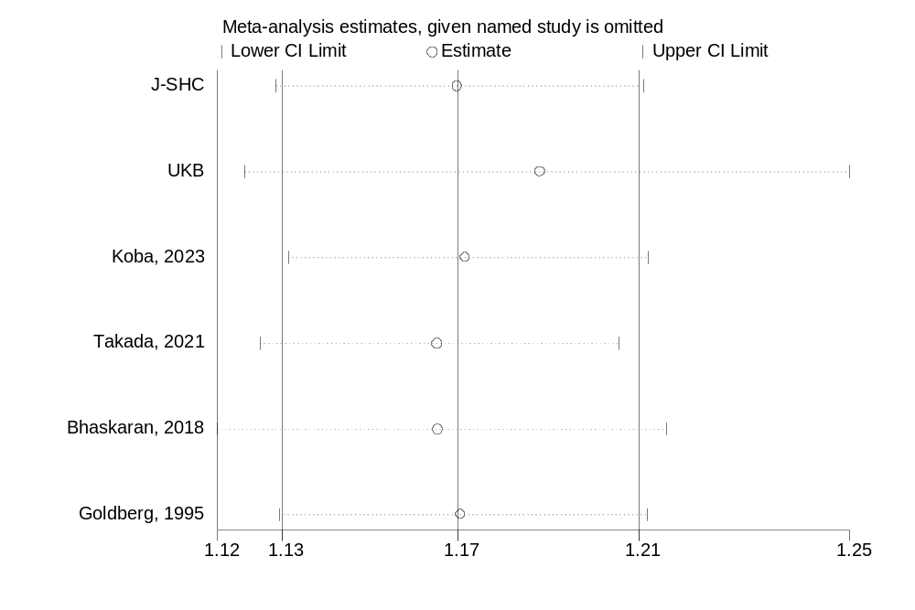

------------------------------------------------------------------------------
Study omitted | Estimate [95% Conf. Interval]
-------------------+----------------------------------------------------------
J-SHC | 1.1689917 1.1323375 1.2068323
UKB | 1.1857424 1.1259973 1.2486575
Koba, 2023 | 1.1707085 1.1348143 1.2077383
Takada, 2021 | 1.1648859 1.129088 1.2018186
Bhaskaran, 2018 | 1.1650612 1.1203741 1.2115309
Goldberg, 1995 | 1.1697221 1.1330675 1.2075623
-------------------+----------------------------------------------------------
Combined | 1.1691628 1.1335272 1.2059187
------------------------------------------------------------------------------

Supplementary Figure 2. Influence analysis of BMI and abdominal aortic aneurysm

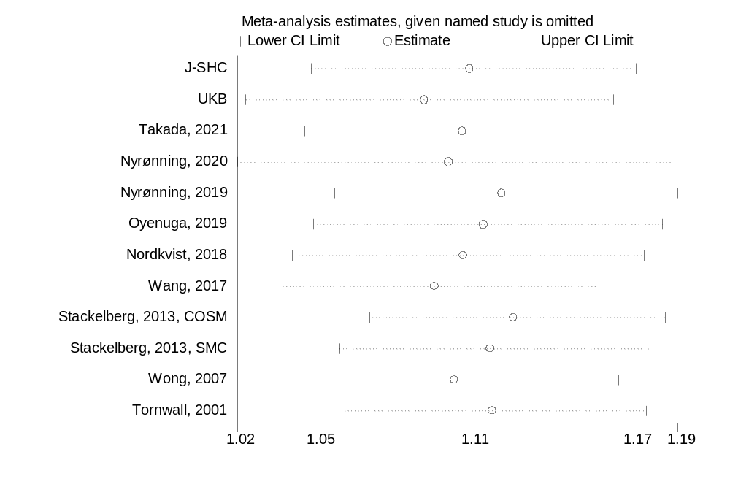

------------------------------------------------------------------------------
Study omitted | Estimate [95% Conf. Interval]
-------------------+----------------------------------------------------------
J-SHC | 1.1096203 1.0519181 1.1704878
UKB | 1.0929927 1.0279084 1.1621978
Takada, 2021 | 1.1068792 1.0492764 1.1676445
Nyrønning, 2020 | 1.1017724 1.0247858 1.1845427
Nyrønning, 2019 | 1.1212498 1.0603082 1.185694
Oyenuga, 2019 | 1.114445 1.0525556 1.1799732
Nordkvist, 2018 | 1.1071877 1.0448463 1.1732489
Wang, 2017 | 1.0964881 1.0402664 1.1557485
Stackelberg, 2013, COSM| 1.1256309 1.0729561 1.1808914
Stackelberg, 2013, SMC| 1.1170094 1.0621021 1.1747552
Wong, 2007 | 1.10403 1.0471698 1.1639776
Tornwall, 2001 | 1.1176678 1.0639794 1.1740652
-------------------+----------------------------------------------------------
Combined | 1.1104169 1.0540791 1.1697657
------------------------------------------------------------------------------

Supplementary Figure 3. Funnel plot for BMI and aortic aneurysm

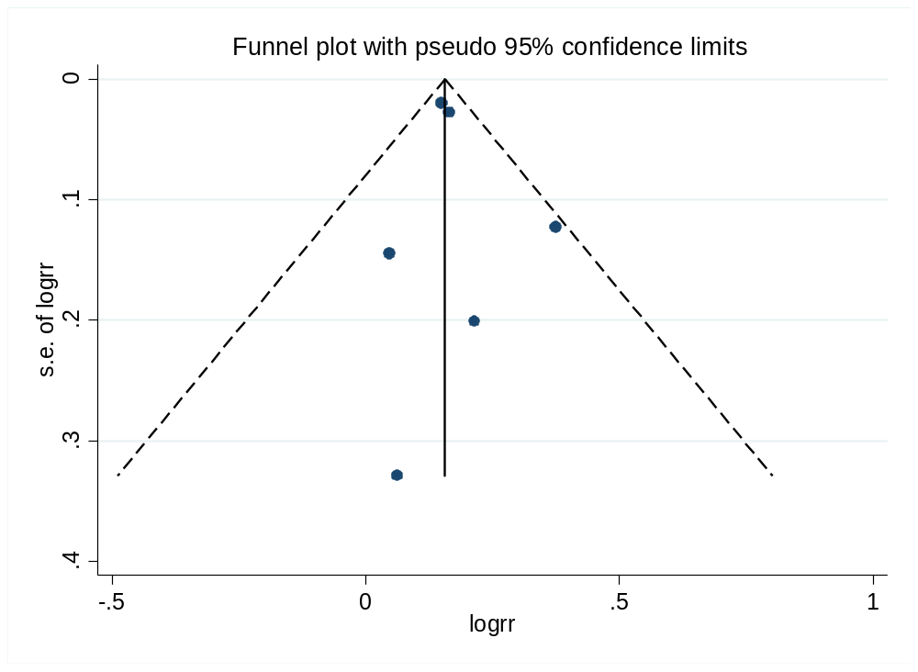

Supplementary Figure 4. Funnel plot for BMI and abdominal aortic aneurysm

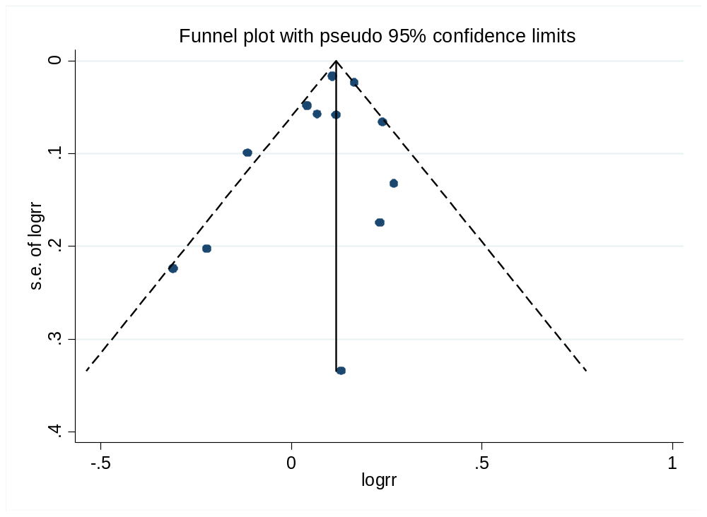

Supplementary Figure 5. BMI and ruptured aortic aneurysm

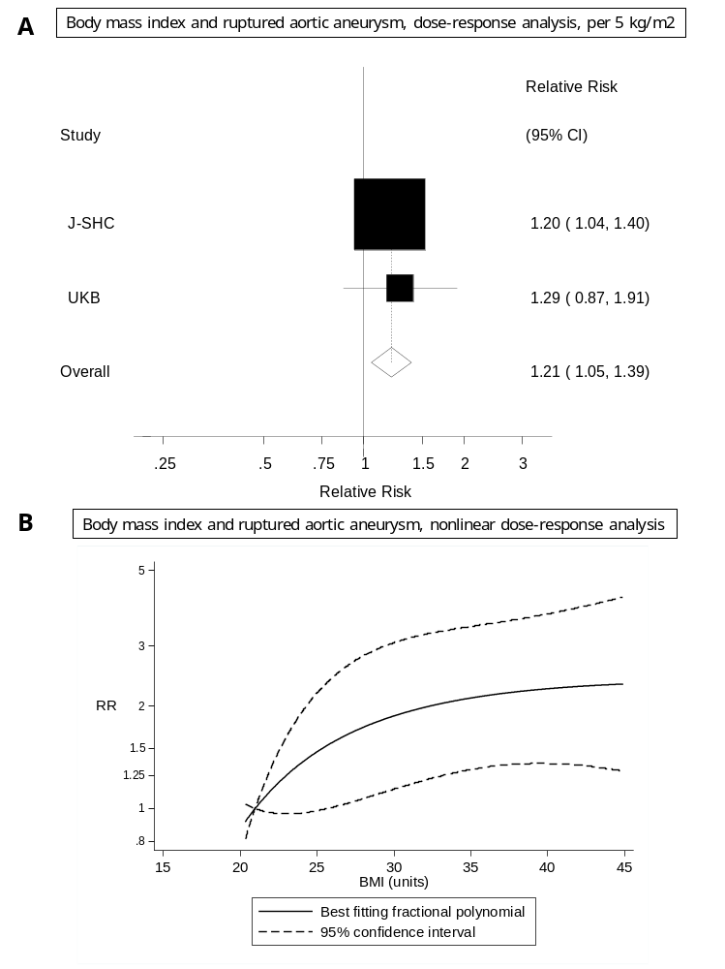
Supplementary Figure 6. BMI and aortic aneurysm incidence and mortality separately, linear and nonlinear dose-response analysis
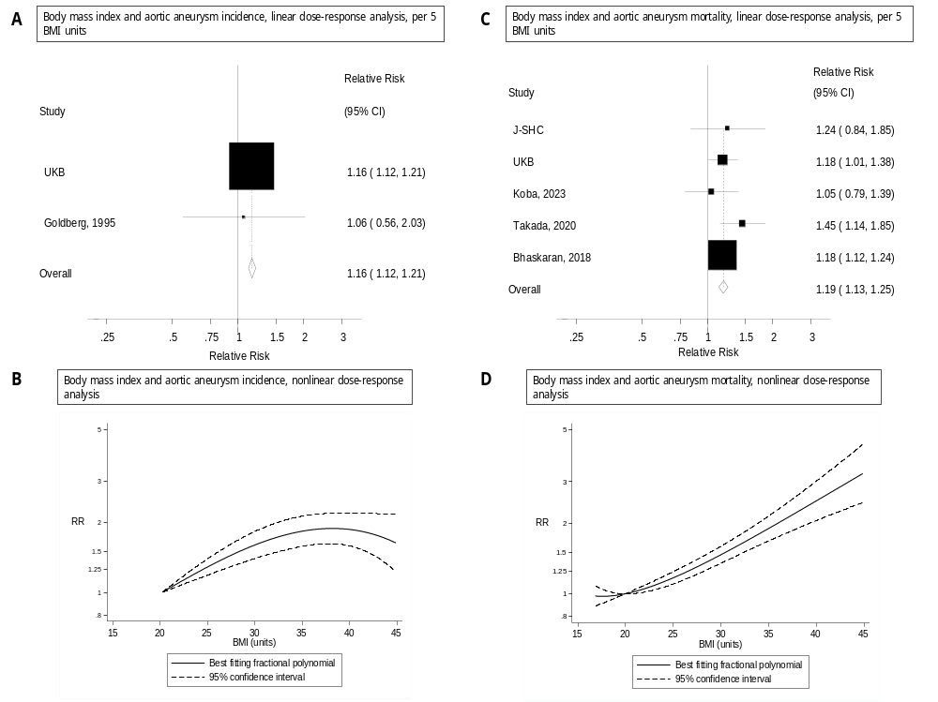

Supplementary Figure 7. Waist circumference and aortic aneurysm, dose-response per 10 cm increment

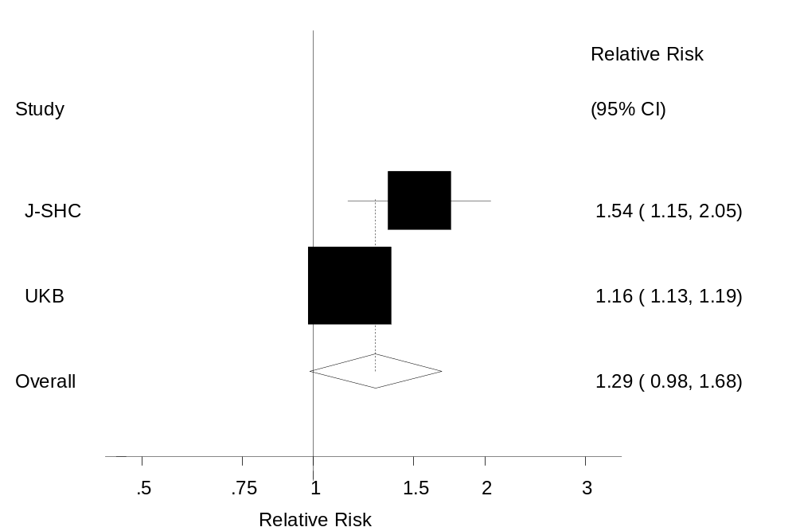

Supplementary Figure 8. Influence analysis of waist circumference and abdominal aortic aneurysm

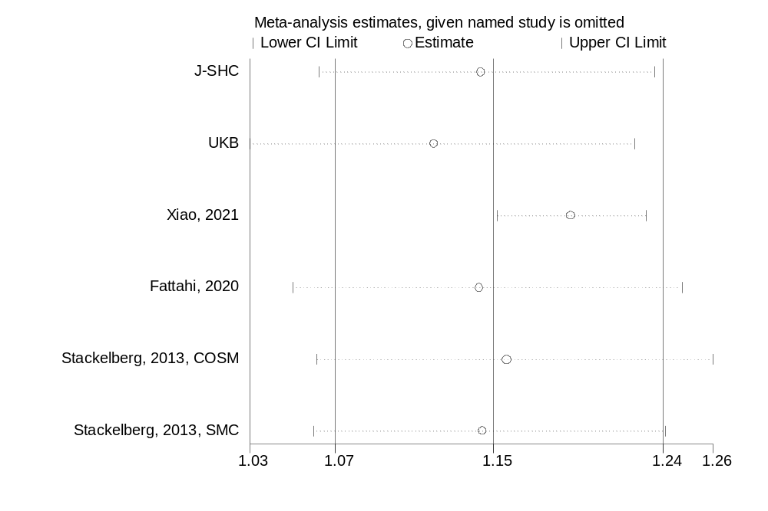

------------------------------------------------------------------------------
Study omitted | Estimate [95% Conf. Interval]
-------------------+----------------------------------------------------------
J-SHC | 1.1440058 1.060758 1.2337868
UKB | 1.1198452 1.0250053 1.2234602
Xiao, 2021 | 1.1902064 1.1525632 1.229079
Fattahi, 2020 | 1.1431986 1.0471746 1.2480279
Stackelberg, 2013, COSM| 1.1573274 1.0597175 1.2639281
Stackelberg, 2013, SMC| 1.1449032 1.0576961 1.2393006
-------------------+----------------------------------------------------------
Combined | 1.150641 1.0692218 1.2382601
------------------------------------------------------------------------------

Supplementary Figure 9. Funnel plot of waist circumference and abdominal aortic aneurysm

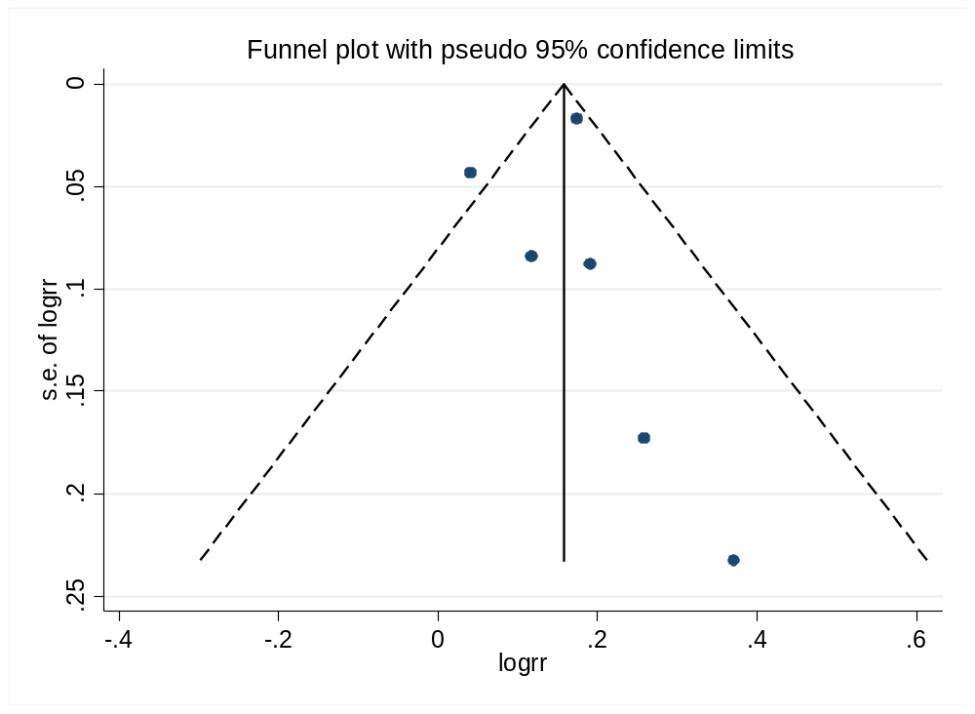

Supplementary Figure 10. Waist circumference and ruptured aortic aneurysm, dose-response per 10 cm increment
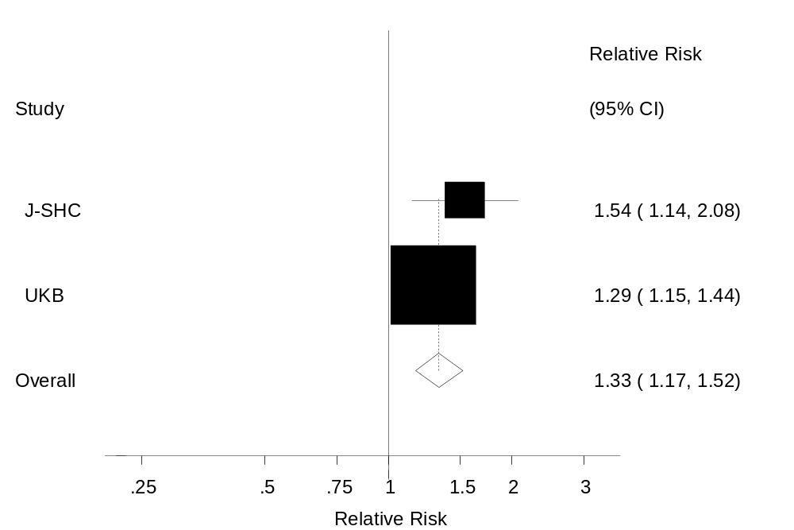

Supplementary Figure 11. Waist circumference and aortic aneurysm mortality, dose-response per 10 cm increment
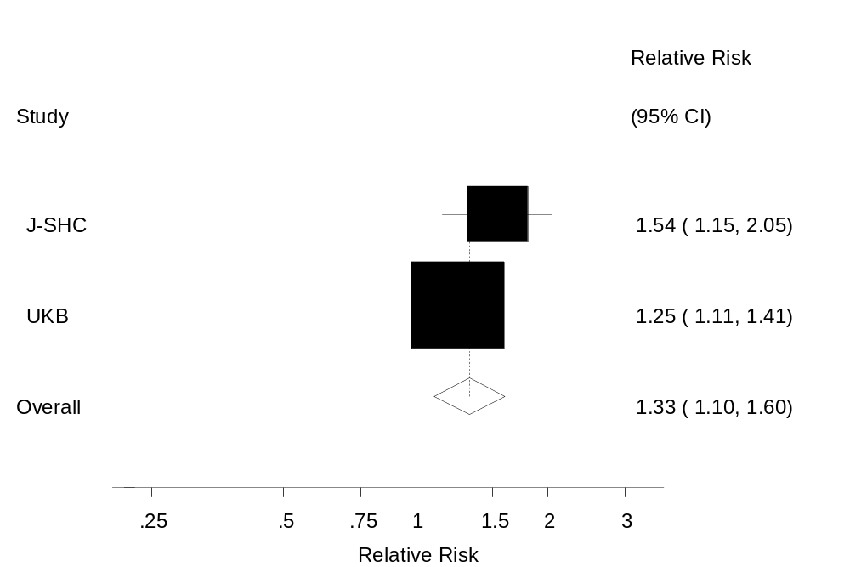

Supplementary Figure 12. Waist-to-height ratio and ruptured aortic aneurysm, linear and nonlinear dose-response analysis

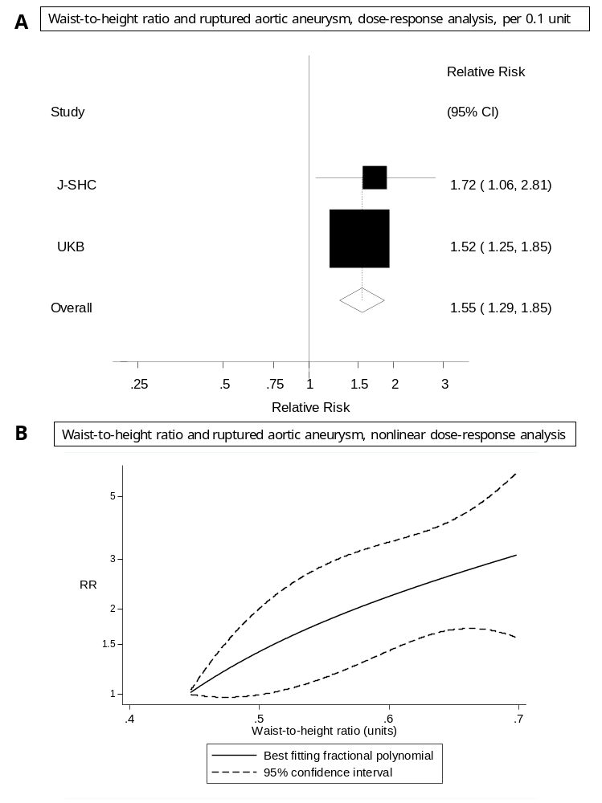

Supplementary Figure 13. Waist-to-height ratio and aortic aneurysm mortality, linear and nonlinear dose-response analysis
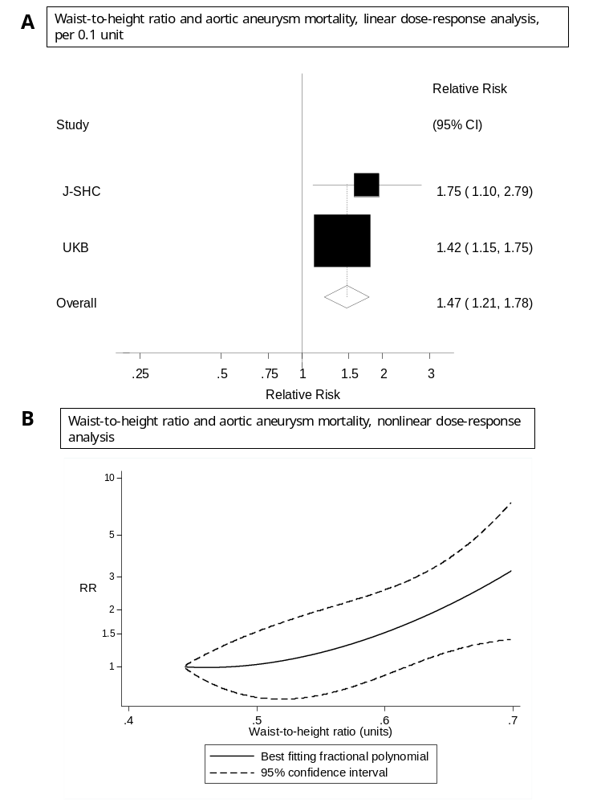

Supplementary Figure 14. BMI and aortic aneurysm, sensitivity analyses including two additional studies reporting on aortic aneurysm and aortic dissection combined

