Electronic supplementary material
Journal: European Journal of Epidemiology

Increasing incidence of type 1 diabetes in children and adolescents from 2012 to 2021 in Germany: Trends before and during the COVID-19 pandemic

Carolin T. Lehner¹, Ivona Anastasova^{1,2,3}, Gunther Schauberger¹, Marian Eberl¹, Florian Schederecker¹, Martin Tauscher⁴, Roman Gerlach ⁴, Stefanie J. Klug¹
1 Technical University of Munich, TUM School of Medicine and Health, Chair of Epidemiology, Munich, Germany
2 Institute for Medical Information Processing, Biometry and Epidemiology (IBE), LMU Munich, Germany
3 Pettenkofer School of Public Health, Munich, Germany
4 Bavarian Association of Statutory Health Insurance Physicians, Munich, Germany

Correspondence address:
Carolin Lehner
Technical University of Munich, TUM School of Medicine and Health, Chair of Epidemiology
Am Olympiapark 11
80809 Munich, Germany
carolin.lehner@tum.de

Supplementary Table S1 Age-standardized incidence rates (ASIR) of type 1 diabetes (T1D) per 100,000 person-years (py) by calendar quarter and sex (European Standard Population 2013)

Sex | Quarter | 2012 | 2013 | 2014 | 2015 | 2016 | 2017 | 2018 | 2019 | 2020 | 2021
female | Q1 | 26.5 | 22.6 | 18.3 | 22.7 | 27.7 | 25.1 | 24.6 | 26.0 | 29.4 | 33.6
female | Q2 | 25.9 | 24.8 | 31.2 | 26.5 | 30.9 | 26.3 | 23.8 | 20.3 | 33.8 | 30.6
female | Q3 | 16.2 | 28.7 | 29.6 | 27.8 | 34.4 | 29.3 | 27.5 | 22.6 | 33.6 | 30.1
female | Q4 | 25.2 | 22.3 | 29.1 | 33.8 | 27.4 | 23.4 | 31.3 | 38.0 | 36.0 | 35.8
male | Q1 | 21.7 | 22.3 | 21.3 | 31.2 | 37.5 | 30.5 | 26.7 | 23.6 | 27.1 | 37.7
male | Q2 | 21.1 | 21.9 | 24.0 | 36.9 | 35.7 | 40.2 | 32.7 | 35.4 | 38.1 | 38.6
male | Q3 | 25.8 | 31.8 | 34.8 | 41.0 | 28.2 | 30.4 | 35.8 | 30.7 | 42.6 | 39.5
male | Q4 | 32.1 | 24.5 | 39.7 | 32.3 | 31.2 | 34.1 | 32.6 | 42.8 | 37.2 | 39.8

Supplementary Table S2 Overall crude incidence rates (CIR) of type 1 diabetes (T1D) per 100,000 person-years (py) and average annual changes in % by age group, sex, and time period

 |  | CIR per 100,000 py |  | Average annual change (%)
Sex | Age group | 2012-2019 | 2012-2021 | 2012-2019 | 2012-2021
female | 0-4 | 16.8 | 17.5 | 6.7 | 4.0
female | 5-9 | 30.1 | 32.5 | -2.8 | 3.8
female | 10-14 | 38.1 | 38.5 | -1.1 | 1.1
female | 15-19 | 20.3 | 22.2 | 9.8 | 8.5
male | 0-4 | 18.1 | 19.9 | 8.6 | 12.4
male | 5-9 | 30.9 | 32.8 | 3.7 | 5.6
male | 10-14 | 46.8 | 46.8 | 1.5 | 0.6
male | 15-19 | 26.7 | 28.8 | 6.5 | 7.6

Supplementary Table S3 Time series regression model 1 of quarterly age-standardized incidence rates (ASIR) of type 1 diabetes (T1D) per 100,000 person-years (py) and factors of time by sex

 | Outcome: Quarterly ASIR of T1D (model 1)
 | Females  Coefficient (95% CI) | Males  Coefficient (95% CI)
Constant | 27.27*** (23.31, 31.23) | 27.90*** (23.04, 32.77)
Pre-pandemic time trend | 0.10 (-0.06, 0.25) | 0.30*** (0.10, 0.49)
Quarter 1 | -4.45** (-8.28, -0.61) | -5.62** (-10.33, -0.91)
Quarter 2 | -2.73 (-6.50, 1.05) | -1.46 (-6.10, 3.18)
Quarter 3 | -2.20 (-5.94, 1.54) | -0.22 (-4.82, 4.38)
Level change | 5.46 (-1.82, 12.75) | -0.56 (-9.51, 8.39)
Slope change | -0.25 (-1.58, 1.07) | 0.28 (-1.35, 1.91)
Observations | 40 | 40
R² | 0.41 | 0.49
Adjusted R² | 0.30 | 0.40
Residual Standard Error (df = 33) | 4.10 | 5.04
F Statistic (df = 6; 33) | 3.85*** | 5.26***
 | *p<0.1; **p<0.05; ***p<0.01

Supplementary Table S4 Time series regression model 3 of quarterly age-standardized incidence rates (ASIR) of type 1 diabetes (T1D) per 100,000 person-years (py) and factors of time by sex

 | Outcome: Quarterly ASIR of T1D (model 3)
 | Females  Coefficient (95% CI) | Males  Coefficient (95% CI)
Constant | 24.97*** (20.39, 29.55) | 22.61*** (17.00, 28.21)
Trend | 0.37** (0.04, 0.70) | 0.97*** (0.49, 1.45)
Slope change following Q2 2015 | - | -1.09*** (-1.82, -0.36)
Slope change following Q1 2016 | -0.57* (-1.18, 0.05) | -
Quarter 1 | -4.48** (-8.19, -0.78) | -5.53** (-9.75, -1.31)
Quarter 2 | -2.75 (-6.40, 0.90) | -1.47 (-5.62, 2.68)
Quarter 3 | -2.21 (-5.83, 1.40) | -0.23 (-4.34, 3.89)
Level change | 7.66** (0.23, 15.09) | 2.80 (-5.51, 11.11)
Slope change following pandemic onset | 0.04 (-1.28, 1.36) | 0.71 (-0.78, 2.19)
Observations | 40 | 40
R² | 0.47 | 0.60
Adjusted R² | 0.35 | 0.52
Residual Standard Error (df = 32) | 3.96 | 4.50
F Statistic (df = 7; 32) | 4.04*** | 6.98***
 | *p<0.1; **p<0.05; ***p<0.01

Supplementary Table S5 Time series regression model 1 of quarterly crude incidence rates (CIR) of type 1 diabetes (T1D) per 100,000 person-years (py) and factors of time by sex and age-groups

 | Males |  | Females
 | Coefficient  (95% CI) |  | Coefficient  (95% CI)
Age groups | Slope change | Level change | Slope change | Level change
0-4 years | 1.80*  ( -0.26, 3.86) | -4.56  (-15.88, 6.76) | -1.41*  (-3.05, 0.24) | 4.87  (-4.18, 13.92)
5-9 years | 0.89  (-2.21,3.99) | -0.59  (-17.63, 16.46) | -0.71  (-3.25, 1.83) | 14.25**  (0.29, 28.21)
10-14 years | -0.73  (-4.50, 3.04) | -0.87  (-21.59, 19.85) | 0.48  (-3.44, 4.40) | 3.56  (-17.97, 25.08)
15-19 years | -0.17  (-2.22,1.88) | 2.41  (-8.86, 13.67) | 0.80  (-1.08, 2.68) | -1.39  (-11.74, 8.95)
 |  | *p<0.1; **p<0.05; ***p<0.01

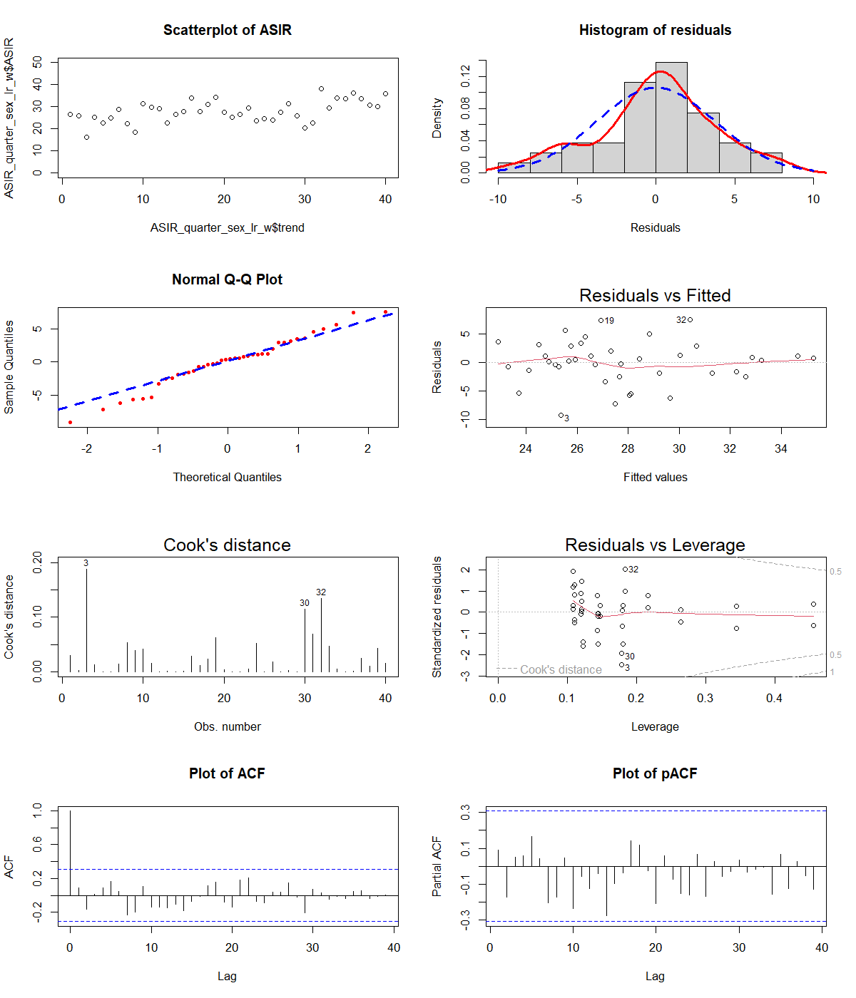
Supplementary Figure S1 Assumptions of ordinary least squares regression analysis of model 1– diagnostic plots, females

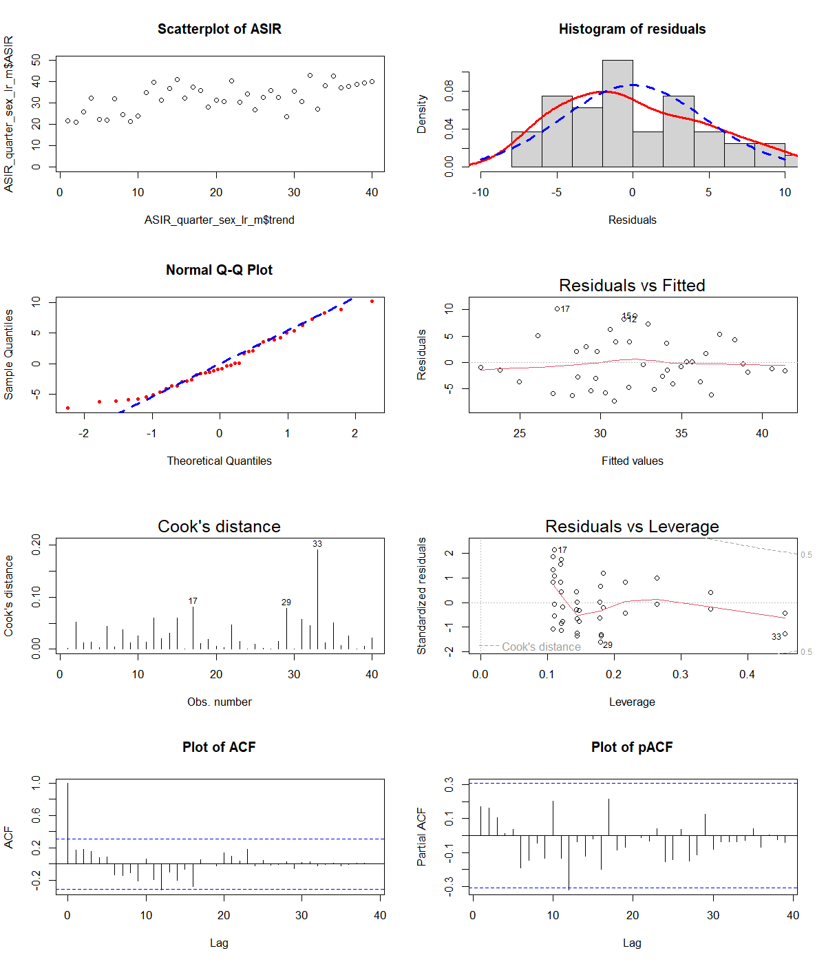
Supplementary Figure S2 Assumptions of ordinary least squares regression analysis of model 1 – diagnostic plots, males

