Supplemental material: Developing a microsimulation model of Alzheimer’s Disease for the evaluation of disease modifying therapies

Methodological appendix

Imputation
Missing data on CSF and MRI were imputed using Multiple Imputation by Chained Equations (MICE) with predictive mean matching in twenty imputed datasets.¹ Variables used to identify data donors were selected based on a minimum correlation of 0.05 with the variable being imputed. Outcome information was used in all donor selections. Parameter estimates were pooled across the imputation sets. The distribution of imputed values and convergence were assessed visually.

Statistical models
The transition from MCI to dementia was described by a joint model with endpoints MMSE and time to dementia (model 1; represented in formula (1) and (2)). The hazard of the time-to-event model was described by a piecewise constant spline function. Model 1 was fitted to data of participants with MCI at baseline. Non-converters were censored at their last visit date. The transition from dementia to institutionalisation or death outside an institution was described by a joint model with endpoints MMSE, time to institutionalisation and time to death (model 2; formulas (3-5)). The two time-to-event endpoints were described by a competing risk model and the hazards were described by piecewise constant spline functions. Model 2 was fitted to data of the first four years of follow-up of participants with dementia at baseline. Because sufficient MMSE data was only available for the first four years of follow-up, the transition from dementia to institutionalisation or death outside an institution after four years of follow-up was described by a Weibull competing risk survival model (model 3). Model 3 was fitted to data of participants who were alive and not institutionalised at four years of follow-up. Time was reset to zero at four years of follow-up.² In model 2 and 3, participants who were alive and not institutionalised on December 31st 2022, were censored at this date. The transition from institution to death was also described by a Weibull model (model 4).

The baseline hazards of the joint models were fitted with piecewise constant splines. The optimal number of knots was chosen based on AIC. This resulted in two knots for the MCI joint model and four knots for the dementia joint model. To adjust for interval censoring in the conversion from MCI to dementia, the observed conversion time was corrected by taking the midpoint the date of conversion and the prior visit date.

In all statistical models, included variables were pre-selected based on the literature. Age and sex were included in all models. For the MMSE trajectory in the MCI stage (model 1), variables were selected based on the Amyloid-Tau-Neuronal injury classification,³ signifying the core biomarker staging currently in use. Amyloid was represented by CSF-Aβ42, Tau by CSF pTau-181, and Neuronal injury by MRI medial temporal lobe atrophy. All variables were included as continuous variables. In the dementia stage, ATN variables were not included to inform the MMSE trajectory as this would require updating the biomarker values in the simulation at the time of conversion from MCI to dementia and these values were not collected in the Amsterdam Dementia Cohort. A variable indicating whether a patient lived together with a care partner at baseline was included in 3 and 4, and the time-to-event portion of model 2.⁴ The predicted MMSE at four years was included as a variable in model 3. The equations for model 1 are

$${Mᵢ}^{(1)}(t) = {β₀}^{(1)} +{ β₁}^{(1)}·t + {β₂}^{(1)}·t² + {β₃}^{(1)}·Ageᵢ + {β₄}^{(1)}·Sexᵢ + {β₅}^{(1)}·ABetaᵢ + {β₆}^{(1)}·pTauᵢ + {β₇}^{(1)}·MTAᵢ + {β₈}^{(1)}·Ageᵢ·t + {β₉}^{(1)}·Sexᵢ·t + {β₁₀}^{(1)}·ABetaᵢ·t + {β₁₁}^{(1)}·pTauᵢ·t + {β₁₂}^{(1)}·MTAᵢ·t + {b₀ᵢ}^{(1)} + {b₁ᵢ}^{(1)}·t + {εᵢ}^{(1)}(t)$$ | (1)
where:
- ${Mᵢ}^{(1)}(t)$: MMSE in model 1 for subject i at time t
${β₀}^{(1)}$ to ${β₁₂}^{(1)}$: fixed effects model 1
- $t$: time since MCI diagnosis in years
- ${b₀ᵢ}^{(1)}$ and ${b₁ᵢ}^{(1)}$: subject specific normally distributed random intercepts and slopes model 1
- ${εᵢ}^{(1)}∼N(0,σ^{2})$: residual error longitudinal marker model 1.
and
$${hᵢ}^{(1)}(t) = {h₀}^{(1)}(t)·exp(α^{(1)}·{mᵢ}^{(1)}(t) + {γ₁}^{(1)}·Ageᵢ + {γ₂}^{(1)}·Sexᵢ)$$ | (2)
where:
- ${hᵢ}^{(1)}(t)$: the hazard in model 1 for subject i at time t
- ${h₀}^{(1)}(t)$: the baseline hazard function modelled using splines in model 1
- $α^{(1)}$: the association coefficient linking MMSE to the hazard in model 1
- ${mᵢ}^{(1)}(t)$: the latent MMSE (ignoring the error term) for subject i at moment t from the longitudinal marker part of model 1
- ${γ₁}^{(1)}$ and ${γ₂}^{(1)}$: the coefficients of age and sex.

The equations of model 2 are
$${Mᵢ}^{(2)}(t) = {β₀}^{(2)} +{ β₁}^{(2)}·t + {β₂}^{(2)}·t² + {β₃}^{(2)}·Ageᵢ + {β₄}^{(2)}·Sexᵢ + {β₅}^{(2)}·Ageᵢ·t + {β₆}^{(2)}·Sexᵢ·t + {b₀ᵢ}^{(2)} + {b₁ᵢ}^{(2)}·t + {εᵢ}^{(2)}(t)$$ | (3)
where:
- ${Mᵢ}^{(2)}(t)$: MMSE in model 2 for subject i at time t
- ${β₀}^{(2)}$ to ${β_{6}}^{(2)}$: fixed effects in model 2
- $t$: time since dementia diagnosis in years
- ${b₀ᵢ}^{(2)}$ and ${b₁ᵢ}^{(2)}$: subject specific normally distributed random intercepts and slopes model 2
- ${εᵢ}^{(2)}∼N(0,σ^{2})$: residual error longitudinal marker model 2.
and
$$hᵢ^{1;(2)}\left(t\right)= {h₀}^{1;(2)}(t)·exp({α₁}^{(2)}·{mᵢ}^{(2)}(t) + {γ₁}^{(2)}·Ageᵢ + {γ₂}^{(2)}·Sexᵢ + {γ₃}^{(2)}·Carepartnerᵢ)$$ | (4)
$${hᵢ}^{2;(2)}(t) = {h₀}^{2;(2)}(t)·exp({α₂}^{(2)}·{mᵢ}^{(2)}(t) + {γ₁}^{(2)}·Ageᵢ + {γ₂}^{(2)}·Sexᵢ + {γ₃}^{(2)}·Carepartnerᵢ)$$ | (5)
where:
- $hᵢ^{1;(2)}(t)$ and $hᵢ^{2;(2)}(t)$: the cause-specific hazards of institutionalisation and death in model 2
- ${h₀}^{1;(2)}(t)$ and ${h₀}^{2;(2)}(t)$: the cause-specific baseline hazard modelled using splines in model 2
- ${α₁}^{(2)}$ and ${α₂}^{(2)}$: the association coefficients of MMSE, specific for time-to-event endpoint in model 2.
- ${mᵢ}^{(2)}(t)$: the latent MMSE (ignoring the error term) for subject i at moment t from the longitudinal marker part of model 1
- ${γ₁}^{(2)}$ to ${γ₃}^{(2)}$: The shared coefficients of age, sex, and living with a care partner in model 2.

To adjust for potential differences between participants who converted from MCI to dementia (‘incident’ dementia) compared to those who were diagnosed with dementia at baseline (‘prevalent’ dementia), we constructed a dementia joint model pooling the participants with incident and prevalent dementia. In this model, the participants with incident dementia were clock-reset at the time of conversion and a parameter was included indicating if a participant was diagnosed with MCI or dementia at baseline in the MMSE and time-to-event parts of the joint model.

Model performance
The four statistical models were evaluated by comparing the observed and predicted marginal cumulative incidence function (CIF) and by assessing their discrimination and calibration with respect to the predicted transition probabilities.⁵ The discrimination and calibration of the models was assessed at three and six years after baseline for the transition from MCI to dementia and dementia to institutionalisation or death, and at two and four years after baseline for the transition of institutionalisation to death.⁵ The discrimination was assessed using in-sample time-dependent areas under the curve (AUC) and the calibration of the models was assessed by comparing the predicted transition probabilities with pseudo-observations of the observed risk.⁶ For the calculation of the time-dependent AUC in a competing risk setting, we defined controls as being event-free at the timepoint of interest.⁷

Simulation
In the simulation, an individual MMSE trajectory was constructed for each participant based on the linear mixed effects part of the joint model using fixed effects and sampled random effects. MMSE values above and below the bounds of the instrument (30 and 0) were truncated in the simulations. When a simulated patient transitions from MCI to dementia (model 1), continuity of the MMSE curve is ensured by aligning the simulated MMSE at conversion (${mᵢ}^{(1)}(t)$ in formula (1)) with simulated MMSE at timepoint 0 in model 2 (${mᵢ}^{(2)}(t)$ in formula (3)). To achieve this, the random intercept in model 2 was set to be the difference between the MMSE in model 2 based on the fixed effect and the simulated MMSE at conversion (${mᵢ}^{(1)}(t)$ in formula (1)). The random slope in model 2 was drawn conditional on the inferred random intercept.

Transition times were determined through inverse transformation sampling of the survival probabilities.⁸ For the time from dementia to institutionalisation or death outside an institution, the shortest time sampled for each individual determined the next stage. Simulations were performed over a lifetime horizon.

Cholinesterase inhibitor treatment simulation study
We also simulated administration of cholinesterase inhibitors as a treatment scenario. The simulation cohort started in the MCI state and cholinesterase inhibitors effects were applied after transitioning to dementia in the community with an MMSE above 20 (i.e., mild dementia), assuming a one point higher MMSE while on treatment based on a systematic review and meta-analysis of cholinesterase inhibitor randomised controlled trials.⁹ Cholinesterase inhibitors were stopped when the MMSE declined below 20 (i.e., moderate dementia) or a simulated participant left the community dementia state.

Results appendix
Joint model including newly converted dementia patients
The joint model for dementia including both participants with dementia at baseline and those who converted from MCI to dementia is presented in Supplemental Table 3. The difference in baseline MMSE between those diagnosed with dementia at baseline and those who converted to dementia from MCI trended towards statistical significance, with those diagnosed with dementia at baseline having a 1.25 lower MMSE (95%: -0.04 to 2.54). The rate of MMSE decline did not differ between the two groups. Overall, the differences between the joint model including participants who converted from MCI to dementia and the joint model presented in the main text were small. This supports the validity of the joint model presented in the main text for newly converted dementia patients. Simulations using the dementia joint model including newly converted dementia patients provided similar results to simulations using the dementia joint model only including ‘prevalent’ dementia cases (further results not shown).

Model validation
The statistical models generally showed good discrimination between the observed times in the MCI and dementia stages (models 1 to 3), with the time-dependent AUCs at three and six years ranging from 0.76 to 0.86 (Supplemental Figure 2). Only for the time from institutionalisation to death (model 4), discrimination was moderate with an AUC of 0.64 at 2 years and 0.71 at four years. The statistical models had reasonably good calibration as the calibration curves were generally close to the diagonal line of perfect calibration (Supplemental Figure 2). This indicates that the predicted transition probability for an individual was close to the observed transition probability. Some discrepancies were observed for the transition from MCI to dementia (model 1) and the transition from dementia to institutionalisation (model 2 and 3). For both transitions, the predicted risk was higher than the observed risk for individuals with low observed transition probability. Overall, the performance of the statistical models indicates that the models can satisfactorily describe the observed data.

Sex stratified simulations
Simulated natural trajectories varying the sex of the population (male, female) indicated that time from MCI to death was 1.5 years longer for women than men due to a longer time living with dementia (Supplemental Figure 4). The time in the MCI stage was 0.38 years shorter for women than for men. The time gained in MCI and mild dementia was 0.30 and 1.10 years for women, and 0.38 and 0.92 years for men, respectively.

Cholinesterase inhibitor treatment simulation study
We investigated the effect of a cholinesterase inhibitor by adding one MMSE point in the mild dementia stage. Under cholinesterase inhibitor treatment, the time with mild dementia increased by 0.28 years, while decreasing the time with moderate dementia by 0.10 years (Supplemental Figure 5). The mean time with severe dementia and in an institution remained approximately the same. Overall, the time from MCI diagnosis to death increased by 0.23 years.

Simulations after excluding APOE ε4 homozygotes from the model population
The four statistical models were refit to a population from which APOE ε4 homozygotes were excluded (Supplemental Tables 4-7). In the joint models (models 1 and 2), the presence of a single APOE ε4 allele was added as a predictor of MMSE decline, with no statistically significant effect on the rate of decline. The natural disease simulation using these adapted models had a slightly increased mean time in the MCI state of 3.6 years (Supplemental Figure 6), compared to 3.3 years using a model including APOE ε4 homozygotes (Figure 3). The duration of the other disease stages did not meaningfully change. Under ATT, the mean time in the MCI stage increased by 0.40 years. Further changes in the disease duration by stage mirrored the simulations using the models including APOE ε4 homozygotes.

Supplemental Table 1: Weibull clock-reset model for transition from dementia to institution or death outside of community fit to data more than four years after baseline
 | Coefficient (standard error)
Shape | 0.25 (0.08)
Scale intercept | 2.23 (0.82)
Institutionalisation as outcome, death in community as reference | -0.74 (0.18)
Sex, female reference | -0.53 (0.16)
Age four years after baseline, yrs | -0.01 (0.01)
Predicted MMSE at four years, | 0.06 (0.02)
Lived with care partner at baseline, living alone reference | -0.20 (0.20)
Weibull parametrisation is the same as the rweibull function in R and are presented on a log-scale.¹⁰ Reducing the scale shifts the distribution towards earlier occurrence of outcomes.

Supplemental Table 2: Weibull clock-reset model for transition from institutionalisation to death
 | Coefficient (standard error)
Shape | 0.07 (0.07)
Scale intercept | 3.46 (0.73)
Sex, female reference | -0.23 (0.16)
Age at institutionalisation, yrs | -0.02 (0.01)
Lived with care partner at baseline, living alone reference | -0.87 (0.23)
Weibull parametrisation is the same as the rweibull function in R and are presented on a log-scale.¹⁰ Reducing the scale shifts the distribution towards earlier occurrence of outcomes.

Supplemental Table 3: Joint model combining participants converted from MCI to dementia with those diagnosed with dementia at baseline
MMSE |  |  | Time to event
Variable | Coef. (se) |  | Variable | Ln(HR); (se)
Intercept | 21.59 (0.66) |  | Age at baseline, yrs | 0.04 (0.01)
Years since baseline | -1.18 (0.44) |  | Sex, female reference | 0.35 (0.14)
Years since baseline squared | -0.30 (0.08) |  | Lived with care partner at baseline, living alone reference | -0.46 (0.16)
Age at baseline, yrs† | 0.64 (0.17) |  | Baseline diagnosis, MCI as reference | 0.19 (0.27)
Sex, female reference | 1.15 (0.35) |  | Point higher MMSE for death outside institution | -0.12 (0.03)
Baseline diagnosis, MCI as reference | -1.25 (0.66) |  | Point higher MMSE for institutionalisation | -0.16 (0.05)
Interaction with years since baseline
* Age at baseline, yrs† | 0.24 (0.12)
* Sex, female reference | -0.24 (0.24)
* Baseline diagnosis, MCI as reference | -0.08 (0.40)
†Normalised. Abbreviations: MMSE = mini-mental state examination, HR = hazard ratio, CI = confidence interval

Supplemental Table 4: Joint model of the transition from MCI to dementia after excluding APOE ε4 homozygotes from the model development population
MMSE |  |  | Time to event
Variable | Coef. (se) |  | Variable | Ln(HR); (se)
Intercept | 27.01 (0.33) |  | Age at baseline, yrs | -0.004 (0.01)
Years since baseline | -0.22 (0.22) |  | Sex, female reference | -0.11 (0.18)
Years since baseline squared | -0.07 (0.02) |  | MMSE, per point lower | -0.23 (0.05)
CSF AB1-42, ng/ml† | 0.11 (0.16)
CSF pTau, log transformed ng/ml† | -0.27 (0.14)
MRI MTA | -0.08 (0.20)
APOE ε4 allele count | -0.26 (0.29)
Age at baseline, yrs† | 0.22 (0.15)
Sex, female reference | -0.19 (0.29)
Interaction with years since baseline
* CSF AB1-42, ng/ml† | -0.03 (0.09)
* CSF pTau, log transformed ng/ml† | -0.26 (0.08)
* MRI MTA | -0.29 (0.11)
* APOE ε4 allele count | -0.09 (0.17)
* Age at baseline, yrs† | 0.08 (0.09)
* Sex, female reference | 0.20 (0.17)
†Normalised. Abbreviations: MRI = magnetic resonance imaging, MTA = medial-temporal atrophy, CSF = cerebrospinal fluid, MMSE = mini-mental state examination, HR = hazard ratio, CI = confidence interval

Supplemental Table 5: Joint model of the transition from dementia to institution or death outside of institution after excluding APOE ε4 homozygotes from the model development population
MMSE |  |  | Time to event
Variable | Coef. (se) |  | Variable | Ln(HR); (se)
Intercept | 19.62 (0.38) |  | Age at baseline, yrs | 0.04 (0.01)
Years since baseline | -1.26 (0.34) |  | Sex, female reference | 0.35 (0.17)
Years since baseline squared | -0.40 (0.10) |  | Lived with care partner at baseline, living alone reference | -0.57 (0.19)
Age at baseline, yrs† | 0.83 (0.20) |  | Point higher MMSE for death outside institution | -0.15 (0.03)
Sex, female reference | 1.34 (0.43) |  | Point higher MMSE for institutionalisation | -0.16 (0.06)
APOE ε4 allele count | 0.92 (0.43)
Interaction with years since baseline
* Age at baseline, yrs† | 0.24 (0.12)
* Sex, female reference | -0.24 (0.24)
* APOE ε4 allele count | -0.20 (0.28)
†Normalised. Abbreviations: MMSE = mini-mental state examination, HR = hazard ratio, CI = confidence interval

Supplemental Table 6: Weibull clock-reset model for transition from dementia to institution or death outside of community fit to data more than four years after baseline and after excluding APOE ε4 homozygotes from the model development population
 | Coefficient (standard error)
Shape | 0.21 (0.09)
Scale intercept | 2.24 (0.94)
Institutionalisation as outcome, death in community as reference | -0.69 (0.21)
Sex, female reference | -0.54 (0.19)
Age four years after baseline, yrs | -0.01 (0.01)
Predicted MMSE at four years, | 0.06 (0.02)
Lived with care partner at baseline, living alone reference | -0.20 (0.24)
Weibull parametrisation is the same as the rweibull function in R and are presented on a log-scale.¹⁰ Reducing the scale shifts the distribution towards earlier occurrence of outcomes.

Supplemental Table 7: Weibull clock-reset model for transition from institutionalisation to death after excluding APOE ε4 homozygotes from the model development population
 | Coefficient (standard error)
Shape | 0.15 (0.07)
Scale intercept | 3.87 (0.73)
Sex, female reference | -0.20 (0.16)
Age at institutionalisation, yrs | -0.03 (0.01)
Lived with care partner at baseline, living alone reference | -0.93 (0.25)
Weibull parametrisation is the same as the rweibull function in R and are presented on a log-scale.¹⁰ Reducing the scale shifts the distribution towards earlier occurrence of outcomes.

Supplemental Figure 1: Illustration of the applied treatment effect
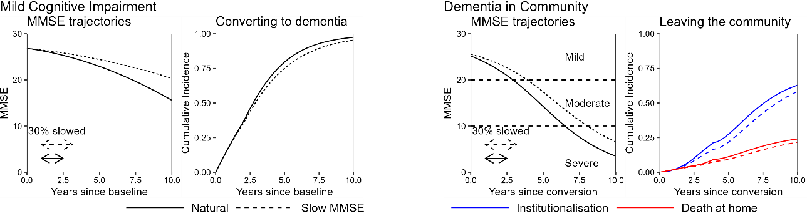
This figure illustrates a 30% slowing of MMSE in the MCI and mild dementia, and its subsequent effect on the cumulative incidence functions. The corresponding times in each stage are presented in the main text.
Supplemental Figure 2: Calibration curves of the four model transitions
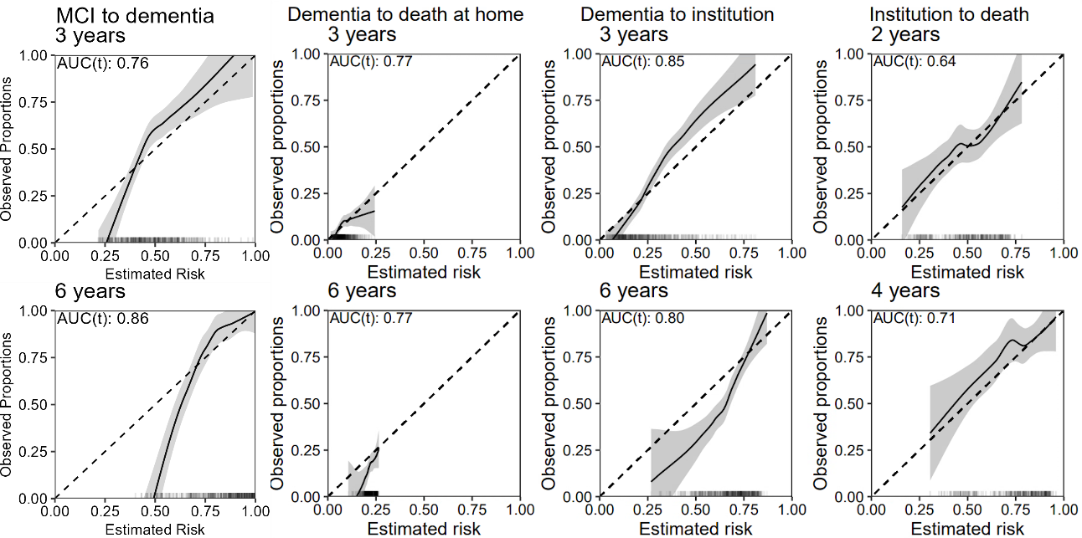
Abbreviations: AUC(t) = time-dependent AUC. The smooth curve was estimated by a linear loess smoother on the pseudo-observations with a span of 0.75. The ticks on the x-axis indicate the distribution of predicted risks. The dashed line indicates perfect calibration. If the confidence interval overlaps the dashed line, the calibration is said to be good.
Supplemental Figure 3: Natural time in clinical Alzheimer’s Disease stages
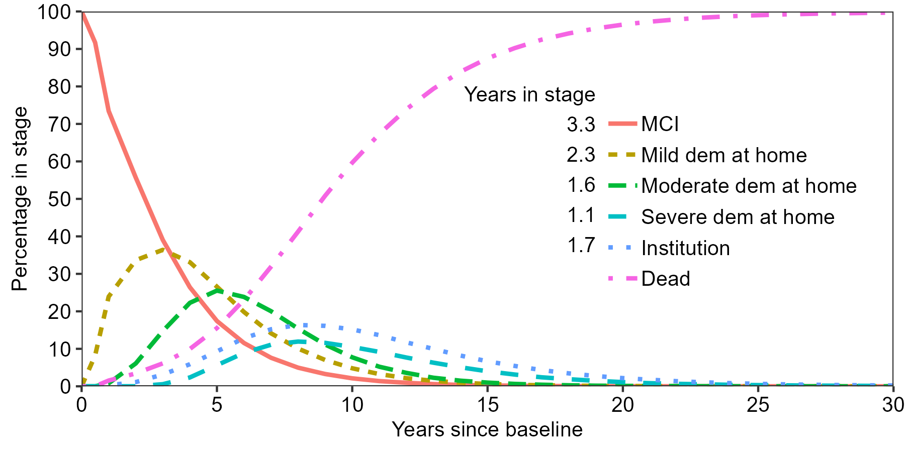
Abbreviations: MCI = mild cognitive impairment, dem. = dementia. Curves were created by applying yearly cycles, with a half-cycle correction, to the sampled event times.

Supplemental Figure 4: Time in clinical Alzheimer’s Disease stages under treatment stratified by sex
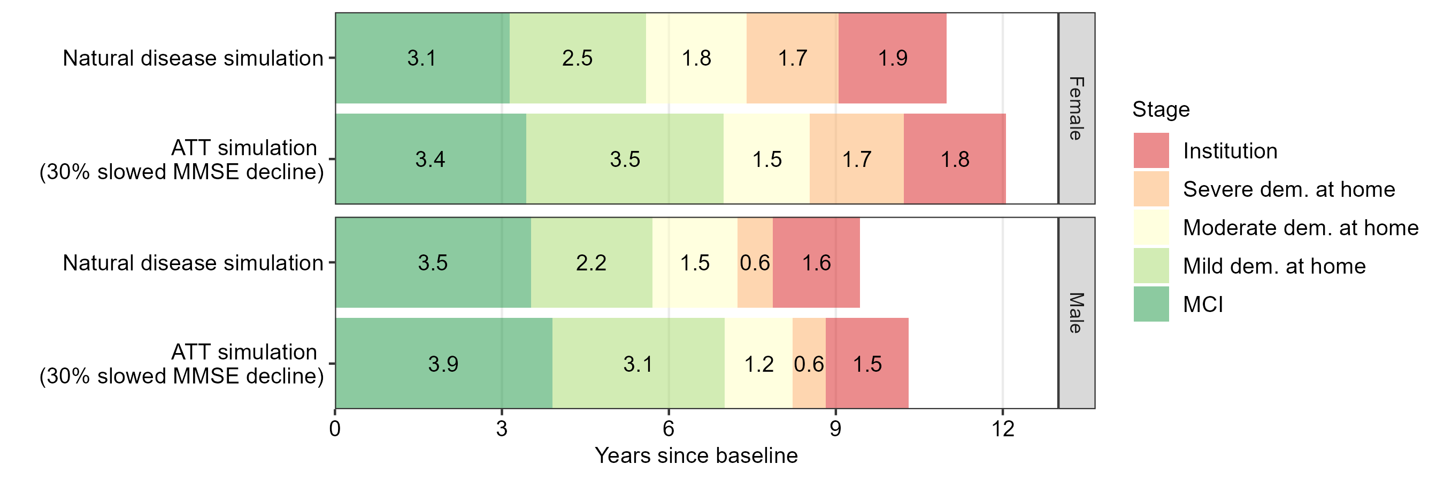
Abbreviations: MCI = mild cognitive impairment, dem. = dementia, ATT = amyloid targeting therapy, MMSE = Mini-Mental State Examination. The mean time in each stage is depicted in the bar of each stage.

Supplemental Figure 5: Time in clinical Alzheimer’s Disease stages under a cholinesterase inhibitor treatment scenario
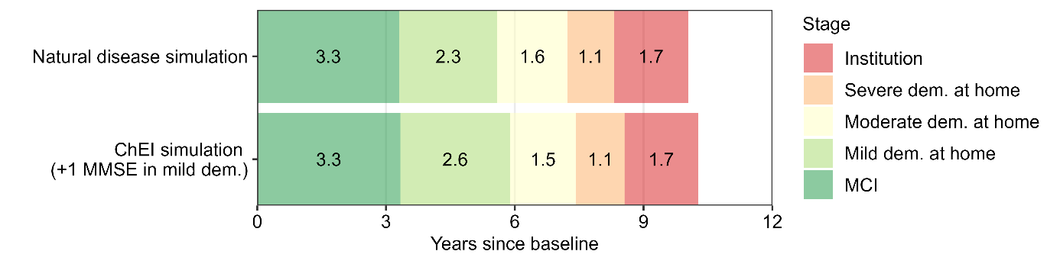
Abbreviations: MCI = mild cognitive impairment, dem. = dementia, ATT = amyloid targeting therapy, MMSE = Mini-Mental State Examination, ChEI = cholinesterase inhibitor. The mean time in each stage is depicted in the bar of each stage.

Supplemental Figure 6: Time in clinical Alzheimer’s Disease stages after excluding APOE ε4 homozygotes
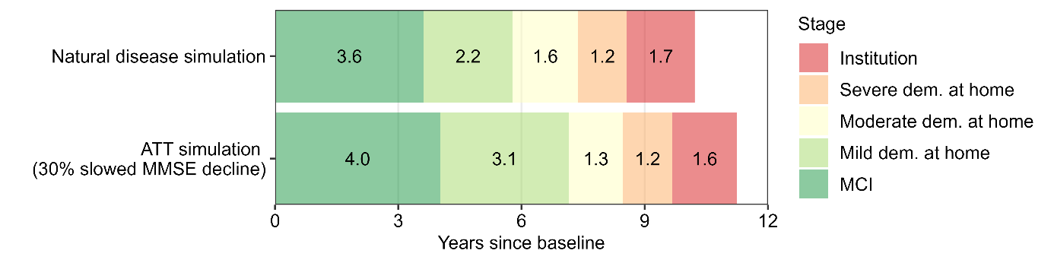
Abbreviations: MCI = mild cognitive impairment, dem. = dementia, ATT = amyloid targeting therapy, MMSE = Mini-Mental State Examination. The mean time in each stage is depicted in the bar of each stage.

References
1. Austin PC, White IR, Lee DS, van Buuren S. Missing Data in Clinical Research: A Tutorial on Multiple Imputation. Can J Cardiol. 2021;37(9):1322–31.
2. Meira-Machado L, de Una-Alvarez J, Cadarso-Suarez C, Andersen PK. Multi-state models for the analysis of time-to-event data. Stat Methods Med Res. 2009;18(2):195–222.
3. Jack CR, Jr., Andrews JS, Beach TG, Buracchio T, Dunn B, Graf A, et al. Revised criteria for diagnosis and staging of Alzheimer's disease: Alzheimer's Association Workgroup. Alzheimers Dement. 2024;20(8):5143–69.
4. Belger M, Haro JM, Reed C, Happich M, Argimon JM, Bruno G, et al. Determinants of time to institutionalisation and related healthcare and societal costs in a community-based cohort of patients with Alzheimer’s disease dementia. The European Journal of Health Economics. 2019;20:343–55.
5. Van Geloven N, Giardiello D, Bonneville EF, Teece L, Ramspek CL, Van Smeden M, et al. Validation of prediction models in the presence of competing risks: a guide through modern methods. bmj. 2022;377.
6. Andersen PK, Pohar Perme M. Pseudo-observations in survival analysis. Statistical methods in medical research. 2010;19(1):71–99.
7. Blanche P, Dartigues JF, Jacqmin‐Gadda H. Estimating and comparing time‐dependent areas under receiver operating characteristic curves for censored event times with competing risks. Statistics in medicine. 2013;32(30):5381–97.
8. R.A. Becker JC, A. R. Wilks. The New S Language: Wadsworth & Brooks/Cole; 1988.
9. Knight R, Khondoker M, Magill N, Stewart R, Landau S. A systematic review and meta-analysis of the effectiveness of acetylcholinesterase inhibitors and memantine in treating the cognitive symptoms of dementia. Dementia and geriatric cognitive disorders. 2018;45(3-4):131–51.
10. Wu H, Godfrey AJR. R: The Weibull Distribution [Available from: https://search.r-project.org/CRAN/refmans/ExtDist/html/Weibull.html.

