Supplemental material

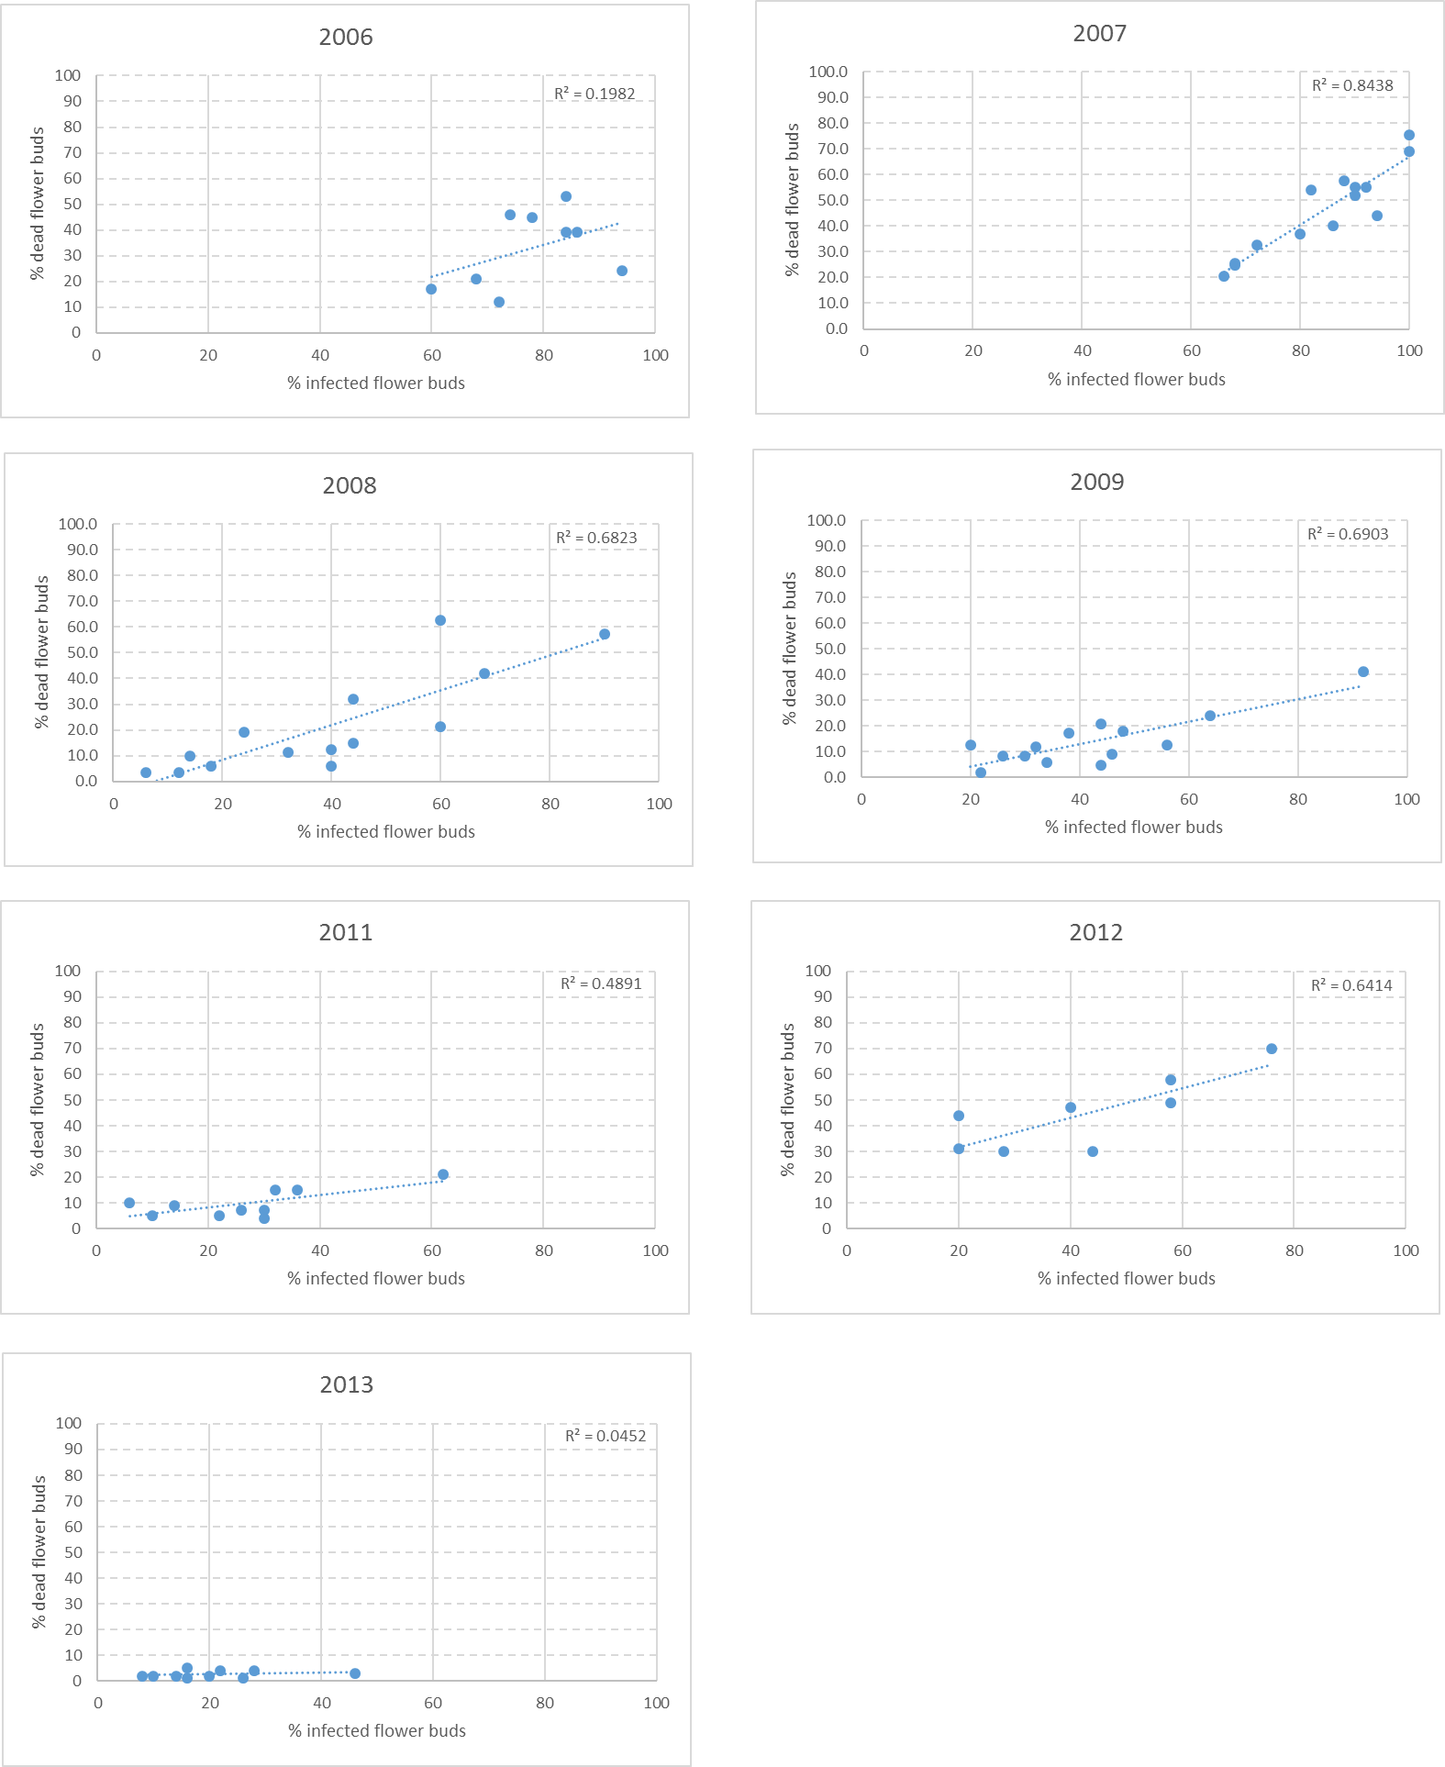

Supplementary Figure S1. Relation between dead flower buds and infection of Alternaria spp. in dormant flower buds of commercial orchards (2006 to 2009 and 2011 to 2013). Each dot represents a commercial orchard.

