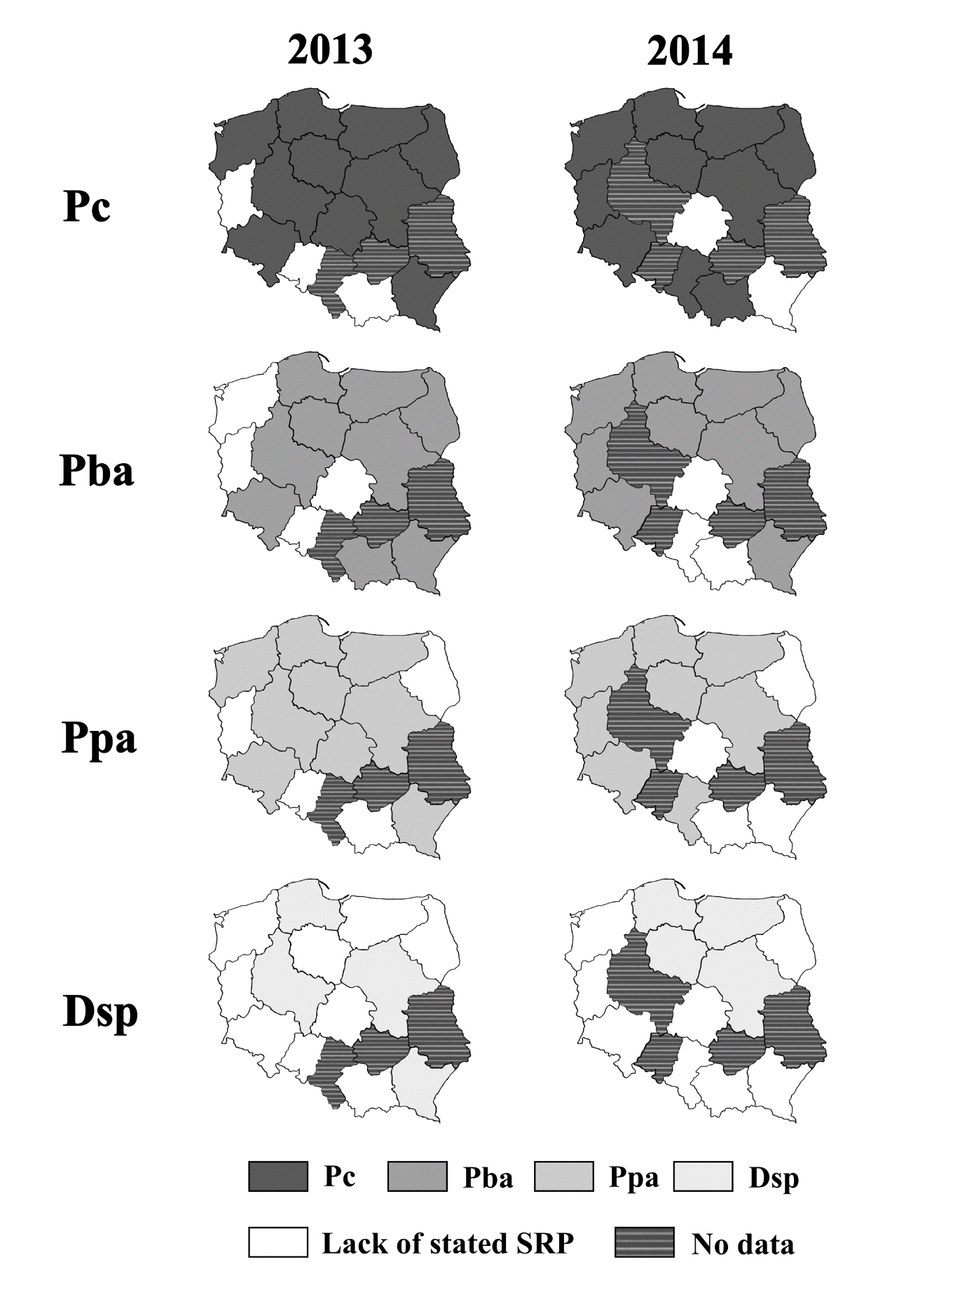
Supp. Fig. 1. Prevalence of the soft rot Pectobacteriaceae on the territory of Poland in 2013 and 2014.
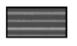
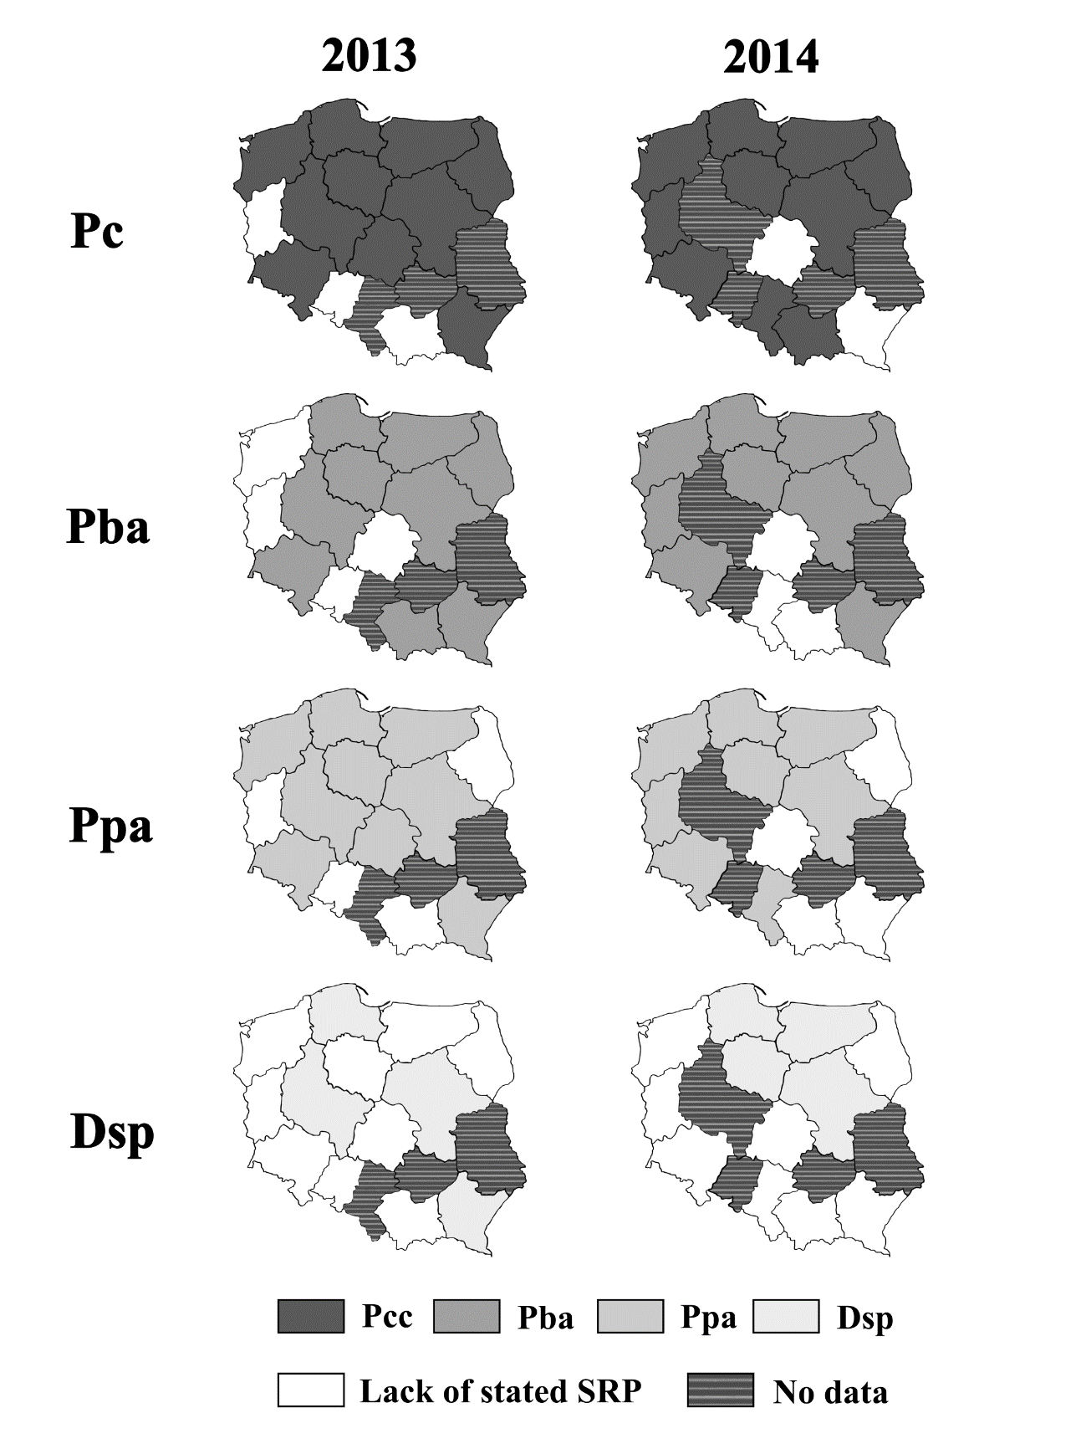
The map of Poland comprising 16 voivodeships is depicted. Regions in which the presence of the members of a certain SRP group was detected in 2013 or 2014 are coloured from the darkest tint in: for P. carotovorum (Pc), for P. atrosepticum (Pba), for P. parmentieri (Ppa) and for Dickeya spp. (Dsp). If no representatives of a stated SRP group were noted in a certain voivodeship that year, this region is shown in . Voivodeships from which we did not obtain any plant samples for testing that year are marked in .

