Supplementary Figure S1

Horizontal transmission and expression of Epichloë typhina in orchardgrass (Dactylis glomerata)
Léa Merlet ● James E. Dombrowski ● B. Shaun Bushman ● Barbara S. Gilmore ● Hannah M. Rivedal ● Ruth C. Martin.

Ruth C. Martin⁴ ()
USDA-ARS, National Forage Seed Production Research Center, 3450 SW Campus Way,
Corvallis, OR 97331-7102, USA; dombrowskijim2020@gmail.com; Barb.gilmore@usda.gov
Email: Ruth.Martin2@usda.gov; Tel: +1-541-738-4174; ORCID: 0000-0002-8242-3263
⁴Current email: martinru@oregonstate.edu

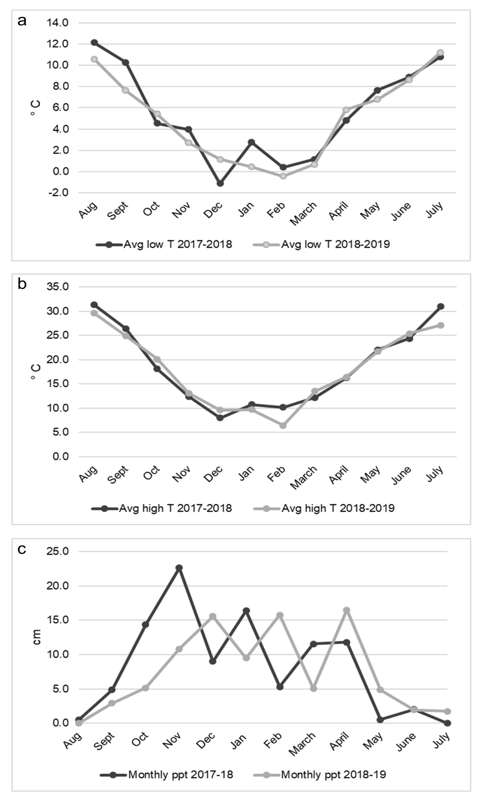

Fig. S1 Weather data comparisons between 2017 - 2018 and 2018 - 2019 growing seasons; (a) Average monthly minimum temperatures, (b) Average monthly maximum temperatures, and (c) monthly total precipitation (weather data available in Supplementary table 1)

