SUPPLEMENTARY INFORMATION
Supp. Fig. 1. The exemplary rep-PCR genomic profiles acquired with ERIC primers, which were assigned to P. atrosepticum strains isolated from potato fields and storage facilities in Poland in 2016. The ERIC-PCR profiles for the following Polish P. atrosepticum strains were shown: IFB5679, IFB5680, IFB5665, IFB5666, IFB5681, IFB5668, IFB5682, IFB5683 and IFB5684. M: molecular marker GeneRulerTM 1 kb DNA ladder (Thermo Fisher Scientific, Waltham, USA). TS: P. atrospeticum type strain LMG 2386^{TS}, K-: PCR negative control.
Supp. Fig. 2. The exemplary rep-PCR genomic profiles acquired with REP primers, which were assigned to P. atrosepticum strains isolated from potato fields and storage facilities in Poland in 2016. The REP-PCR profiles for the following Polish P. atrosepticum strains were shown: IFB5679, IFB5680, IFB5665, IFB5666, IFB5681, IFB5668, IFB5682, IFB5683 and IFB5684. M: molecular marker GeneRulerTM 1 kb DNA ladder (Thermo Fisher Scientific, Waltham, USA). TS: P. atrospeticum type strain LMG 2386^{TS}, K-: PCR negative control.
Supp. Fig. 3. Phylogenetic analysis of P. atrosepticum strains based on the sequences of recA gene. P. atrosepticum strains isolated in Poland were juxtaposed to the following Pectobacteriaceae reference strains: P. atrosepticum LMG 2386, P. brasiliense LMG 21371, P. carotovorum IPO 200, P. wasabiae CFBP 3304, P. parmentieri SCC 3193. D. solani IFB0099 was used as an outgroup. Multiple sequence alignment was performed with a ClustalW algorithm in the MEGA X software (Kumar et al. 2018). The tree was generated by application of a maximum likelihood algorithm with Tamura-Nei model also in MEGA X (Kumar et al. 2018). Bootstrap was set on the level of 1000 replicates. The lengths of the tree branches were associated with the number of substitutions per site. The year of isolation of the P. atrosepticum strains was marked with the following signs: a dot - 2013, a square - 2014 and a triangle - 2016.
Supp. Fig. 4. Phylogenetic analysis of P. atrosepticum strains based on the sequences of gyrA gene. P. atrosepticum strains isolated in Poland were juxtaposed to the following Pectobacteriaceae reference strains: P. atrosepticum LMG 2386, P. brasiliense LMG 21371, P. carotovorum IPO 200, P. wasabiae CFBP 3304, P. parmentieri SCC 3193. D. solani IFB0099 was used as an outgroup. Multiple sequence alignment was performed with a ClustalW algorithm in the MEGA X software (Kumar et al. 2018). The tree was generated by application of a maximum likelihood algorithm with Tamura-Nei model also in MEGA X (Kumar et al. 2018). Bootstrap was set on the level of 1000 replicates. The lengths of the tree branches were associated with the number of substitutions per site. The year of isolation of the P. atrosepticum strains was marked with the following signs: a dot - 2013, a square - 2014 and a triangle - 2016.
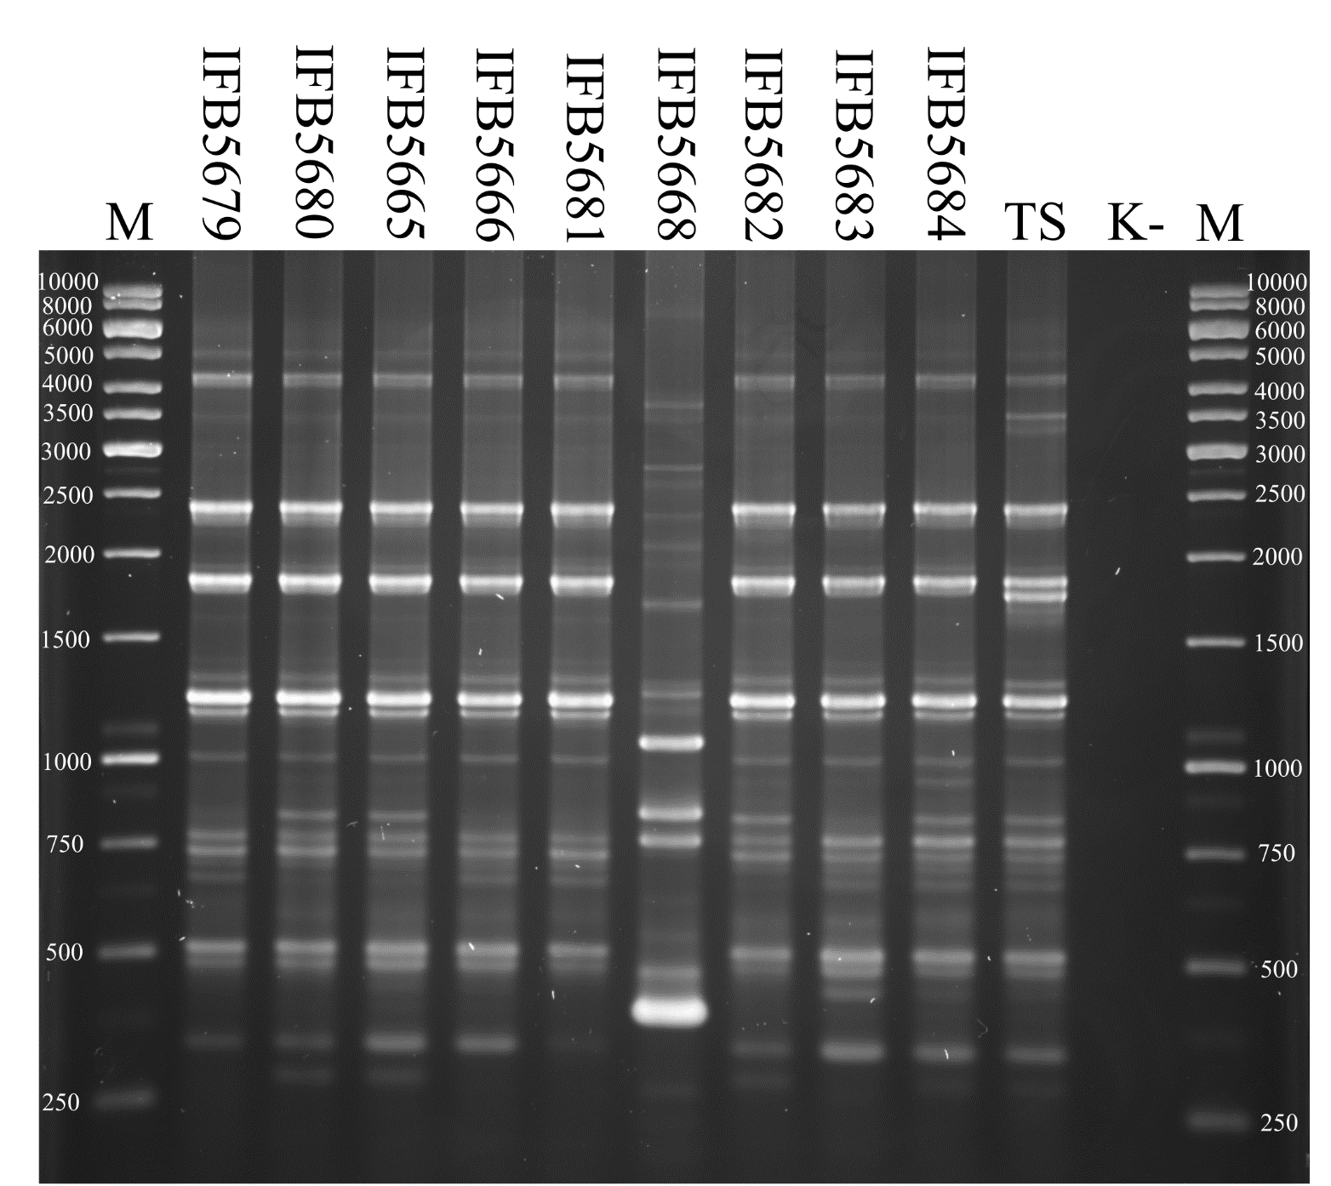
Supp. Fig. 1
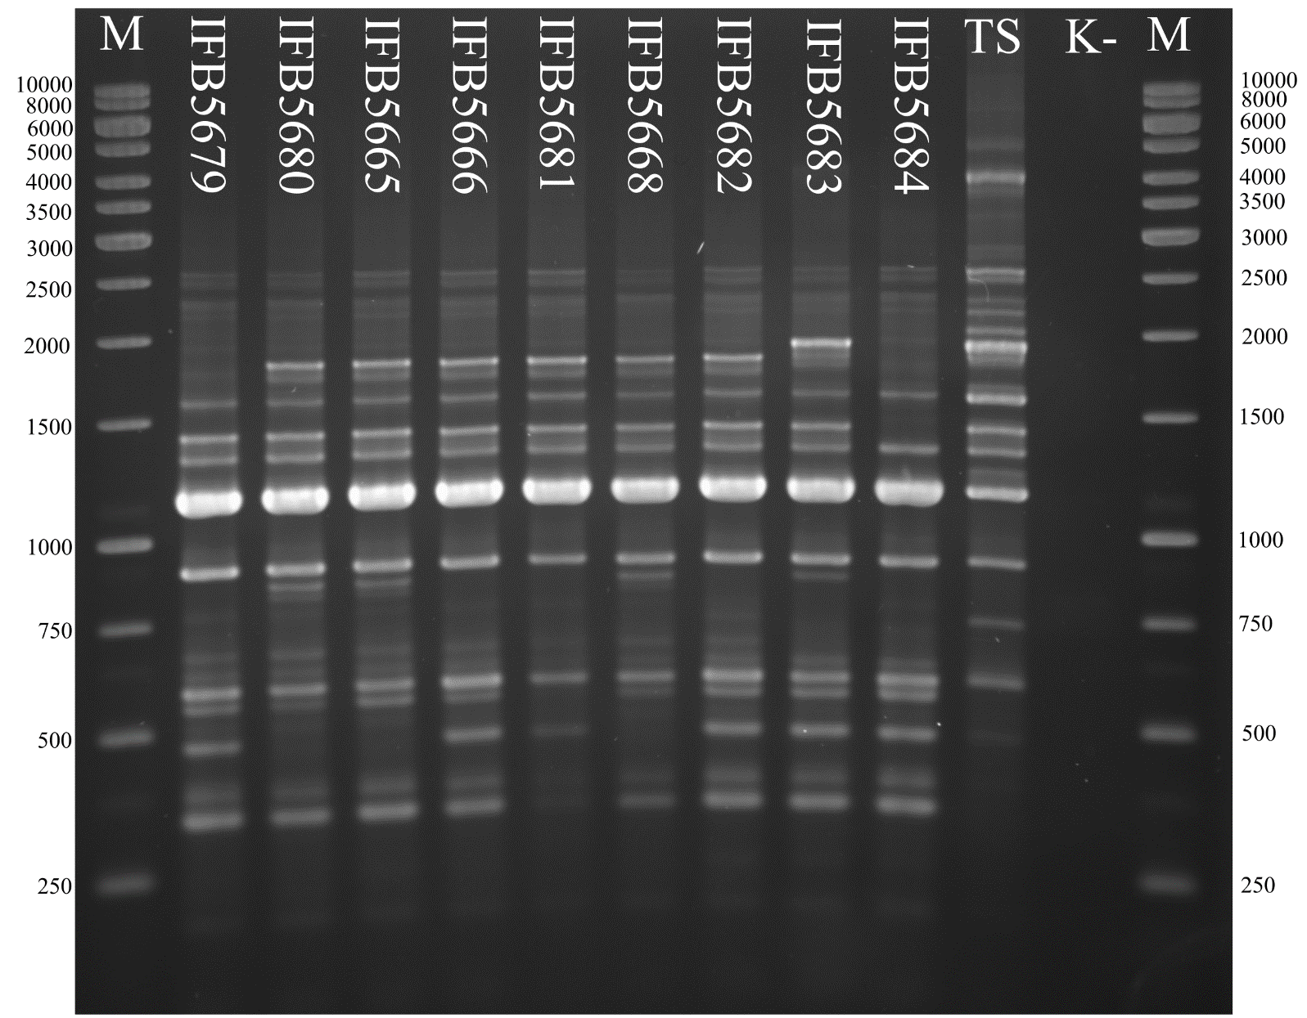
Supp. Fig. 2
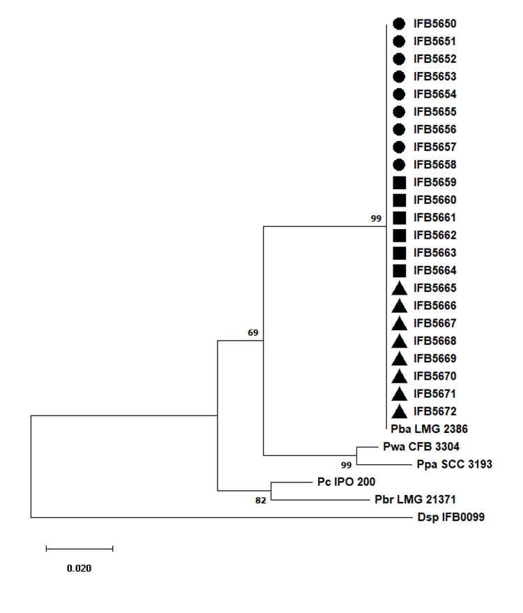
Supp. Fig. 3
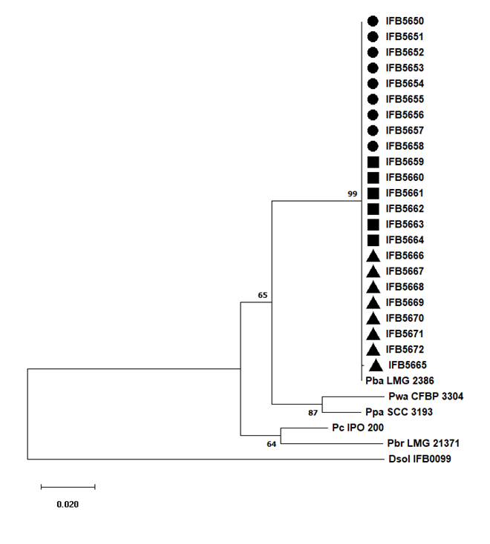
Supp. Fig. 4

