Supplementary Figure 1
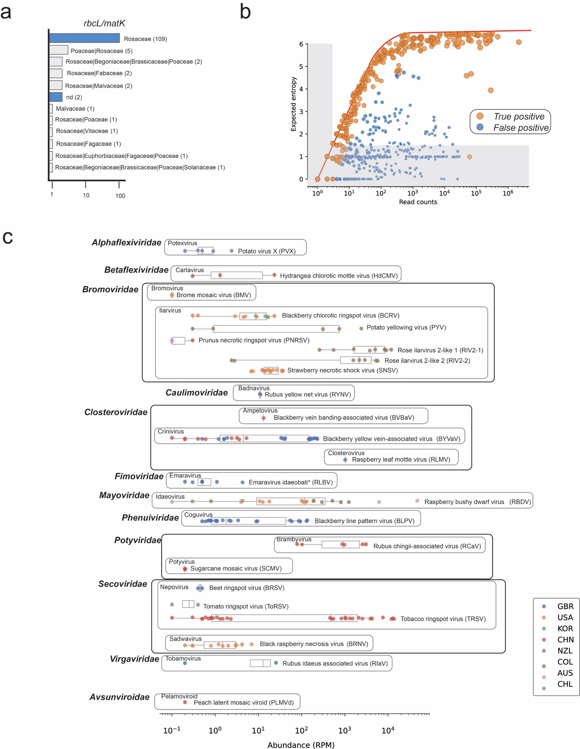
Supplementary Figure 2
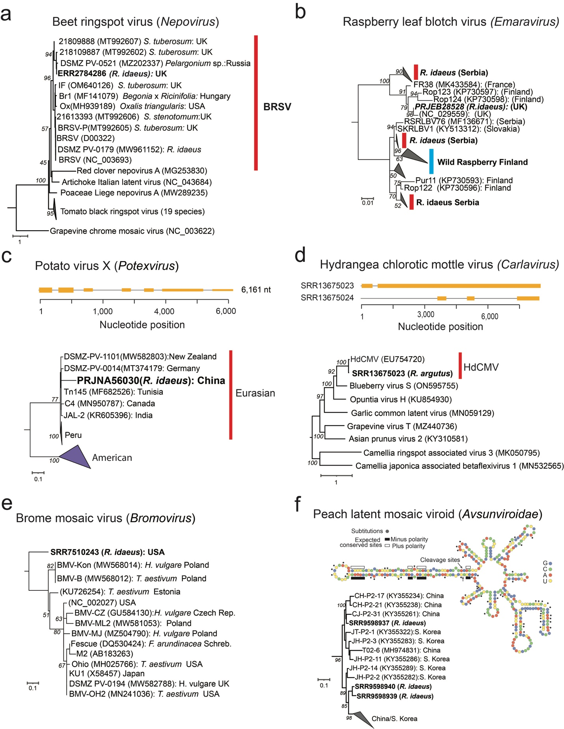
Supplementary data: available at
https://drive.google.com/drive/folders/1I-o6YumQIQsSUE2hrQtTeLk8NEr4xqbW?usp=sharing

Supplementary data 1: Assembled Rubus datasets.
Supplementary data 2: Excel file containing a detailed description of datasets, quality checks, virus counts and mapping distribution for all viruses.
Supplementary data 3: Collection of heatmaps illustrating the distribution of viral reads for each putative virus across datasets.
Supplementary data 4: GenBank files of submitted sequences derived from this work.
Supplementary data 5: Python scripts

