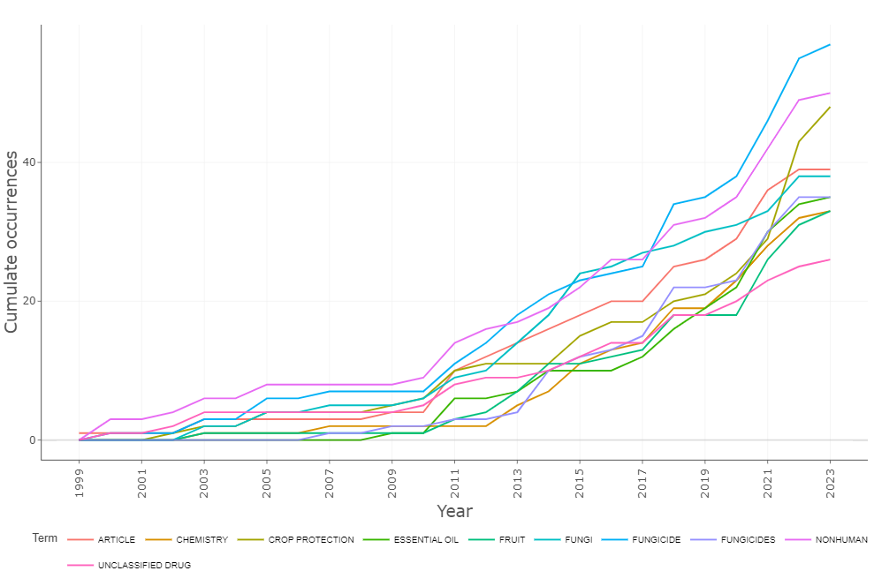
Supplementary Figure S2: Dynamics of keywords used over time in the research literature focusing on plant-based crop protection against pathogens

