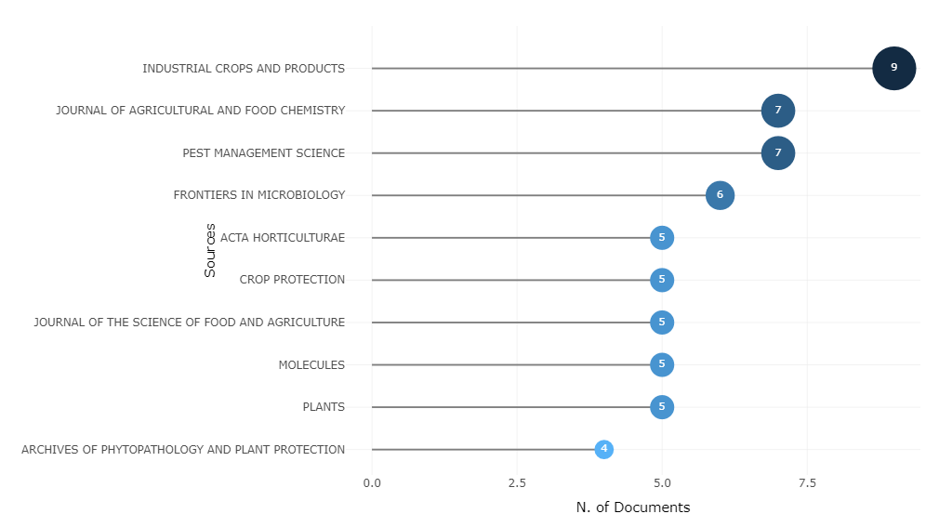
Supplementary Figure S4: The most relevant journals in the research field centered on utilising plants as biocontrol in crop protection

