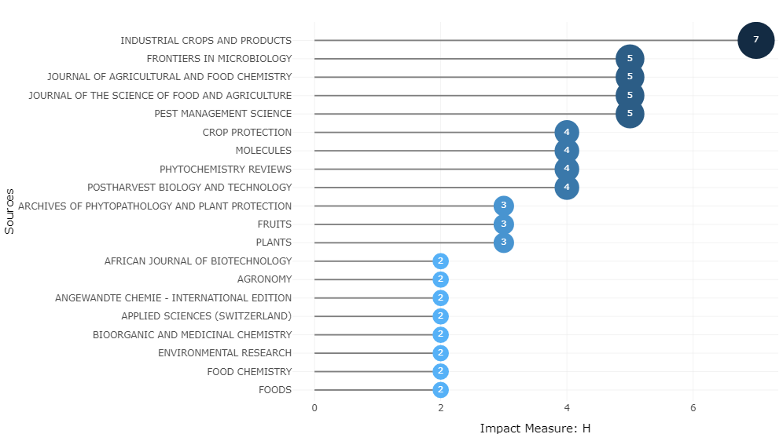
Supplementary Figure S5: The top 20 most relevant and influential journals in the research area focusing on the application of plants for biocontrol in crop protection

