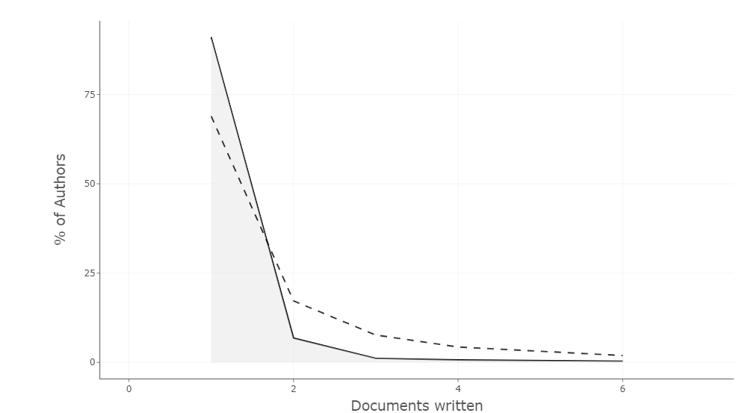
Supplementary Figure S7: Authors’ productivity through Lotka’s law in the field of study focusing on plant-based crop protection

