Supplementary figures with:

Occurrence of Phyllosticta citricarpa and Phyllosticta citriasiana in EU imported Citrus spp and its impact on diagnostics of citrus black spot on fruits

Marcel M.J.P. van Raak ● Esther J. van Veen ● Bart T.L.H. van de Vossenberg ● Marcel Westenberg ● Sietse van der Linde ()

Dutch National Plant Protection Organization, Netherlands Institute for Vectors, Invasive plants and Plant health, Geertjesweg 15, 6706 EA Wageningen, Netherlands
Corresponding author: Sietse van der Linde, s.vanderlinde@nvwa.nl

a)
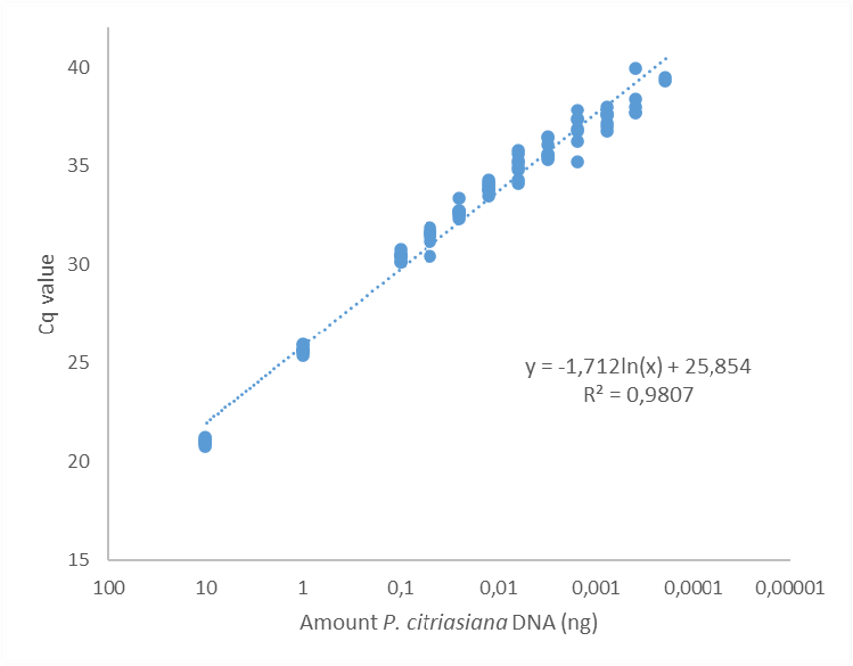
b)
Supplementary Figure S1. Analytical sensitivity of the P. citriasiana test. a) Standard curve including 8 dilution series in elution buffer prepared with a range from 10 ng to 0.195 pg . b) Logistic curve for limit of detection calculation with the intercept determined at 95% probability of detection. Dilution series were prepared from genomic DNA extracted from a P. citriasiana specimen.
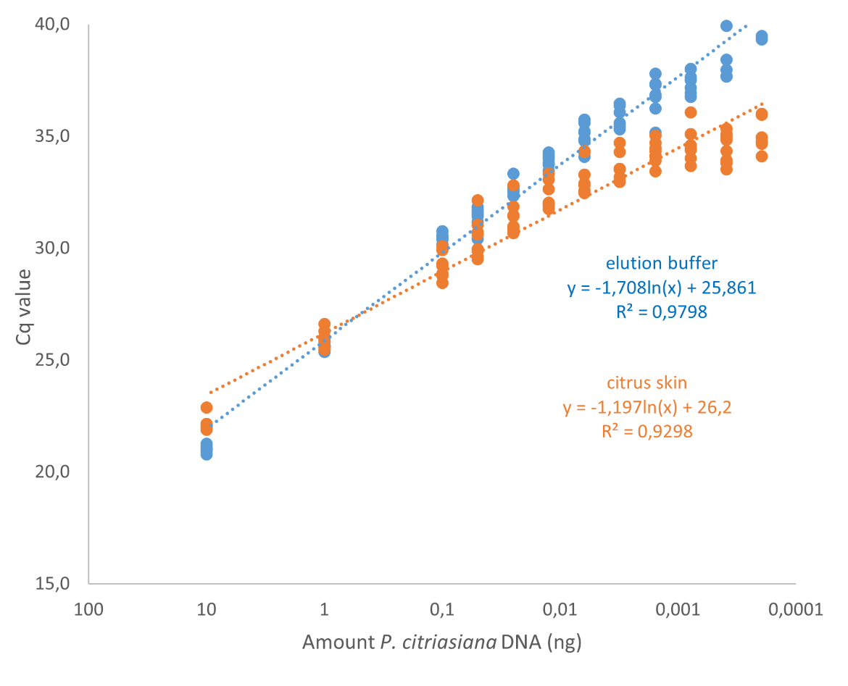
Supplementary Figure S2. Analytical selectivity of the P. citriasiana test with 8 dilution series prepared in elution buffer and 8 dilution series prepared in homogenised citrus skin, both with a range from 10 ng to 0.195 pg.

