Molecular characterization and exploration of streptomycin resistance genes in Xanthomonas campestris pv. campestris isolates from diverse agro climatic regions of Karnataka state, southern India
Beluvigi Lingaraj¹, Manjunath Krishnappa Naik^{2*#}, Kadaiah Ajithkumar³, Siddalingappa Thorebeeranahalli Yenjerappa¹, Yeli Pampanna⁴, Babu Kisan⁵, Annamalai Muthusamy⁶, and Thokur Sreepathy Murali^{7*}

Short title: Molecular characterization of Xanthomonas campestris pv. campestris isolates

¹Department of Plant Pathology, College of Agriculture, University of Agricultural Sciences Raichur, Karnataka, India.

²Department of Plant Pathology, University of Agricultural Sciences Raichur, Karnataka, India.

³AICRP on Linseed, Main Agricultural Research Station, University of Agricultural Sciences Raichur, Karnataka, India.

⁴Horticulture Unit, Main Agricultural Research Station, University of Agricultural Sciences Raichur, Karnataka, India.

⁵Department of Molecular Biology and Agricultural Biotechnology, College of Agriculture,

University of Agricultural Sciences Raichur, Karnataka, India.

⁶Department of Plant Sciences, Manipal Academy of Higher Education, Manipal, Karnataka, India.

⁷Department of Public Health Genomics, Manipal Academy of Higher Education, Manipal, Karnataka, India.

Correspondence E Mail – murali.ts@manipal.edu (ORCID: 0000-0003-1563-8077) and mk.naik@manipal.edu

#Current Address: Professor, Manipal Academy of Higher Education, Manipal, Karnataka, India.

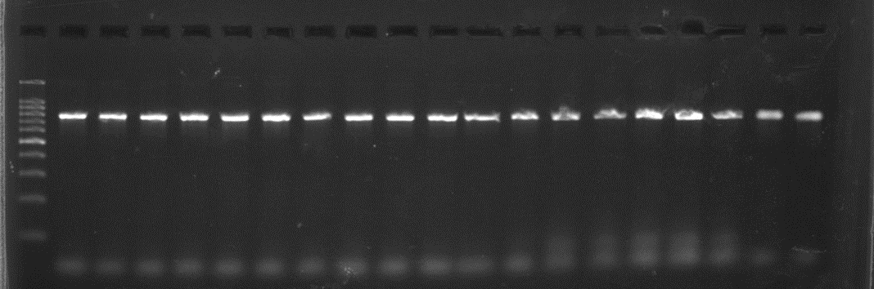
Supplementary Fig. 1 Agarose gel image showing PCR amplicons obtained with species specific and virulence primer Dhrp for X. campestris pv. campestris isolates
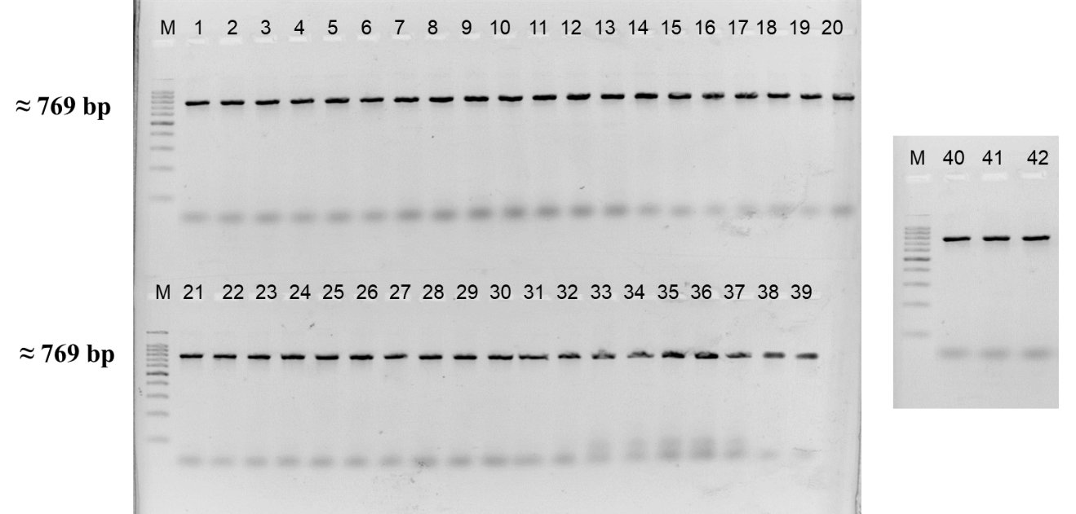

Lane: M-100 bp ladder, 1-Xcc1, 2-Xcc2, 3-Xcc3, 4-Xcc-4, 5-Xcc-5, 6-Xcc-6, 7-Xcc-7, 8-Xcc-8, 9-Xcc-9, 10-Xcc-10, 11-Xcc-11, 12-Xcc-12, 13-Xcc-13, 14-Xcc-14, 15-Xcc-15, 16-Xcc-16, 17-Xcc-17, 18-Xcc-18, 19-Xcc-19, 20-Xcc-20, 21-Xcc-21, 22-Xcc-22, 23-Xcc-23, 24-Xcc-24, 25-Xcc-25, 26-Xcc-26, 27-Xcc-27, 28-Xcc-28, 29-Xcc-29, 30-Xcc-30, 31-Xcc-31, 32-Xcc-32, 33-Xcc-33, 34-Xcc-34, 35-Xcc-35, 36-Xcc-36, 37-Xcc-37, 38-Xcc-38, 39-Xcc-39, 40-Xcc-40, 41-Xcc41 and 42-Xcc42

Supplementary Fig. 2 Agarose gel image showing PCR amplicons obtained with species specific and virulence primer (DLH) for X. campestris pv. campestris isolates
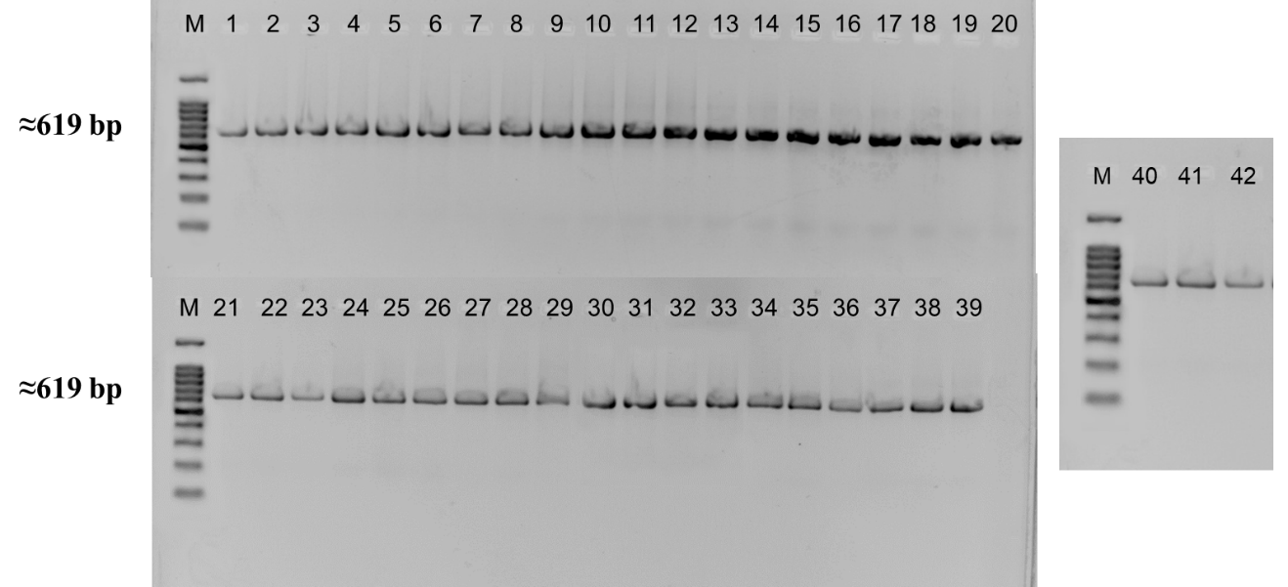
Lane: M-100 bp ladder, 1-Xcc1, 2-Xcc2, 3-Xcc3, 4-Xcc-4, 5-Xcc-5, 6-Xcc-6, 7-Xcc-7, 8-Xcc-8, 9-Xcc-9, 10-Xcc-10, 11-Xcc-11, 12-Xcc-12, 13-Xcc-13, 14-Xcc-14, 15-Xcc-15, 16-Xcc-16, 17-Xcc-17, 18-Xcc-18, 19-Xcc-19, 20-Xcc-20, 21-Xcc-21, 22-Xcc-22, 23-Xcc-23, 24-Xcc-24, 25-Xcc-25, 26-Xcc-26, 27-Xcc-27, 28-Xcc-28, 29-Xcc-29, 30-Xcc-30, 31-Xcc-31, 32-Xcc-32, 33-Xcc-33, 34-Xcc-34, 35-Xcc-35, 36-Xcc-36, 37-Xcc-37, 38-Xcc-38, 39-Xcc-39, 40-Xcc-40, 41-Xcc41 and 42-Xcc42

Supplementary Fig. 3 Agarose gel image showing PCR amplicons obtained with primers targeting streptomycin resistance gene (strA) for X. campestris pv. campestris
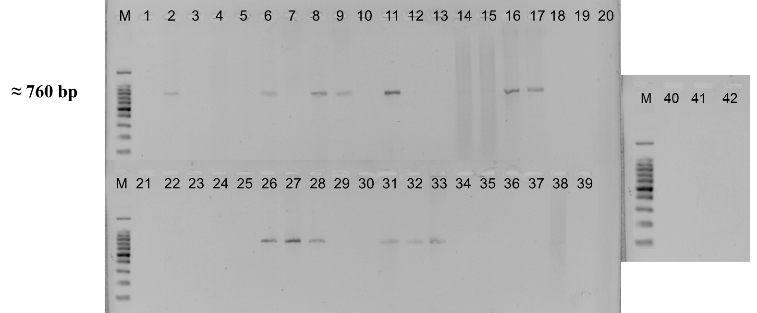
Lane: M-100 bp ladder, 1-Xcc1, 2-Xcc2, 3-Xcc3, 4-Xcc-4, 5-Xcc-5, 6-Xcc-6, 7-Xcc-7, 8-Xcc-8, 9-Xcc-9, 10-Xcc-10, 11-Xcc-11, 12-Xcc-12, 13-Xcc-13, 14-Xcc-14, 15-Xcc-15, 16-Xcc-16, 17-Xcc-17, 18-Xcc-18, 19-Xcc-19, 20-Xcc-20, 21-Xcc-21, 22-Xcc-22, 23-Xcc-23, 24-Xcc-24, 25-Xcc-25, 26-Xcc-26, 27-Xcc-27, 28-Xcc-28, 29-Xcc-29, 30-Xcc-30, 31-Xcc-31, 32-Xcc-32, 33-Xcc-33, 34-Xcc-34, 35-Xcc-35, 36-Xcc-36, 37-Xcc-37, 38-Xcc-38, 39-Xcc-39, 40-Xcc-40, 41-Xcc41 and 42-Xcc42

Supplementary Fig. 4 Agarose gel image showing PCR amplicons obtained with primers targeting streptomycin resistance gene (strB) for X. campestris pv. campestris
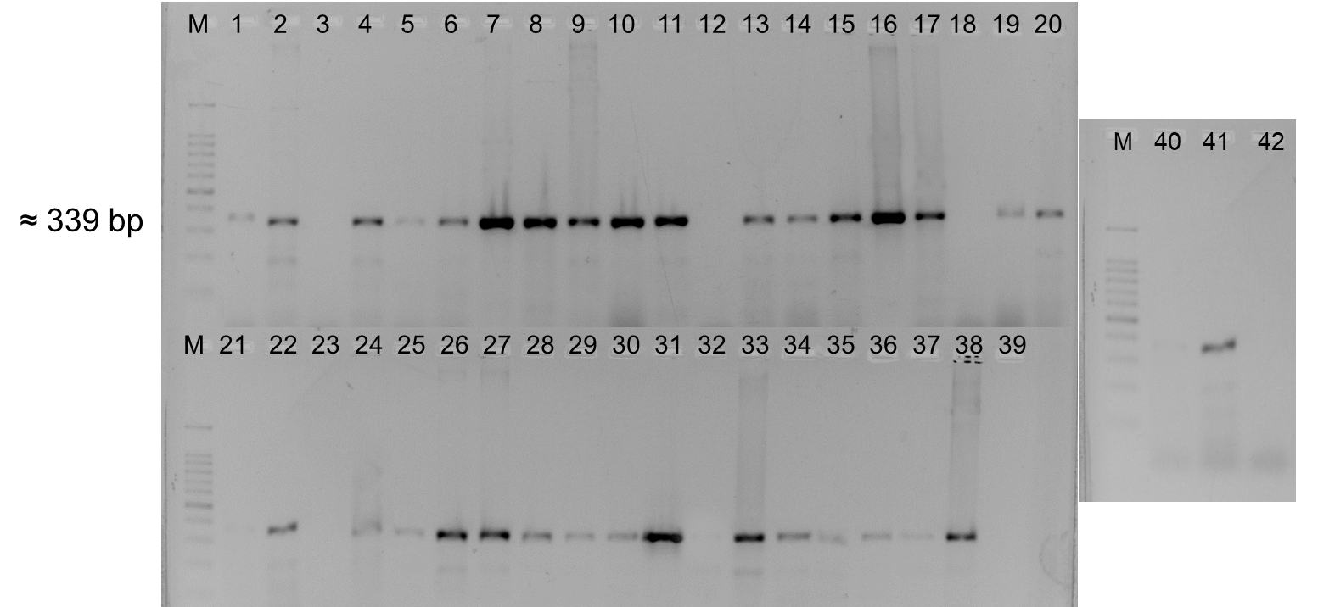
Lane: M-100 bp ladder, 1-Xcc1, 2-Xcc2, 3-Xcc3, 4-Xcc-4, 5-Xcc-5, 6-Xcc-6, 7-Xcc-7, 8-Xcc-8, 9-Xcc-9, 10-Xcc-10, 11-Xcc-11, 12-Xcc-12, 13-Xcc-13, 14-Xcc-14, 15-Xcc-15, 16-Xcc-16, 17-Xcc-17, 18-Xcc-18, 19-Xcc-19, 20-Xcc-20, 21-Xcc-21, 22-Xcc-22, 23-Xcc-23, 24-Xcc-24, 25-Xcc-25, 26-Xcc-26, 27-Xcc-27, 28-Xcc-28, 29-Xcc-29, 30-Xcc-30, 31-Xcc-31, 32-Xcc-32, 33-Xcc-33, 34-Xcc-34, 35-Xcc-35, 36-Xcc-36, 37-Xcc-37, 38-Xcc-38, 39-Xcc-39, 40-Xcc-40, 41-Xcc41 and 42-Xcc42

Supplementary Fig. 5 Agarose gel image showing PCR amplicons obtained with primers targeting streptomycin resistance gene (rpsL) for X. campestris pv. campestris
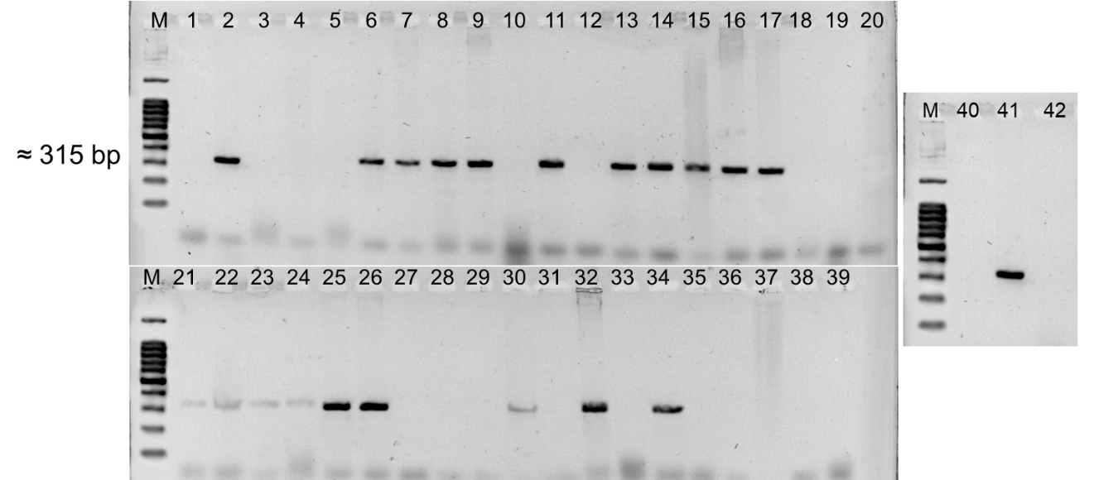
Lane: M-100 bp ladder, 1-Xcc1, 2-Xcc2, 3-Xcc3, 4-Xcc-4, 5-Xcc-5, 6-Xcc-6, 7-Xcc-7, 8-Xcc-8, 9-Xcc-9, 10-Xcc-10, 11-Xcc-11, 12-Xcc-12, 13-Xcc-13, 14-Xcc-14, 15-Xcc-15, 16-Xcc-16, 17-Xcc-17, 18-Xcc-18, 19-Xcc-19, 20-Xcc-20, 21-Xcc-21, 22-Xcc-22, 23-Xcc-23, 24-Xcc-24, 25-Xcc-25, 26-Xcc-26, 27-Xcc-27, 28-Xcc-28, 29-Xcc-29, 30-Xcc-30, 31-Xcc-31, 32-Xcc-32, 33-Xcc-33, 34-Xcc-34, 35-Xcc-35, 36-Xcc-36, 37-Xcc-37, 38-Xcc-38, 39-Xcc-39, 40-Xcc-40, 41-Xcc41 and 42-Xcc42

Supplementary Fig. 6 Agarose gel image showing PCR amplicons obtained with primers targeting copper resistance gene (copL) for X. campestris pv. campestris
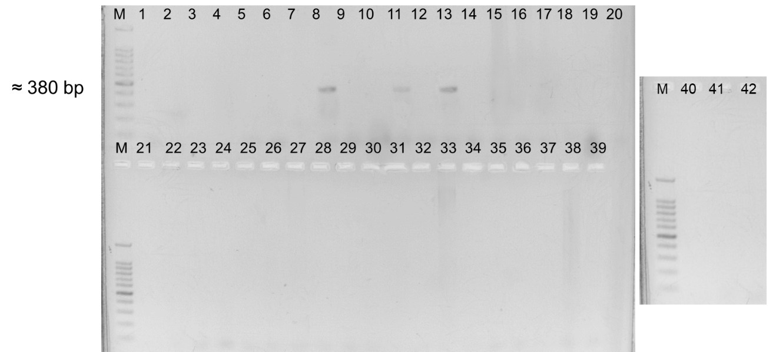
Lane: M-100 bp ladder, 1-Xcc1, 2-Xcc2, 3-Xcc3, 4-Xcc-4, 5-Xcc-5, 6-Xcc-6, 7-Xcc-7, 8-Xcc-8, 9-Xcc-9, 10-Xcc-10, 11-Xcc-11, 12-Xcc-12, 13-Xcc-13, 14-Xcc-14, 15-Xcc-15, 16-Xcc-16, 17-Xcc-17, 18-Xcc-18, 19-Xcc-19, 20-Xcc-20, 21-Xcc-21, 22-Xcc-22, 23-Xcc-23, 24-Xcc-24, 25-Xcc-25, 26-Xcc-26, 27-Xcc-27, 28-Xcc-28, 29-Xcc-29, 30-Xcc-30, 31-Xcc-31, 32-Xcc-32, 33-Xcc-33, 34-Xcc-34, 35-Xcc-35, 36-Xcc-36, 37-Xcc-37, 38-Xcc-38, 39-Xcc-39, 40-Xcc-40, 41-Xcc41 and 42-Xcc42

Supplementary Fig. 7 Agarose gel image showing PCR amplification of X. campestris pv. campestris isolates for BOX primer
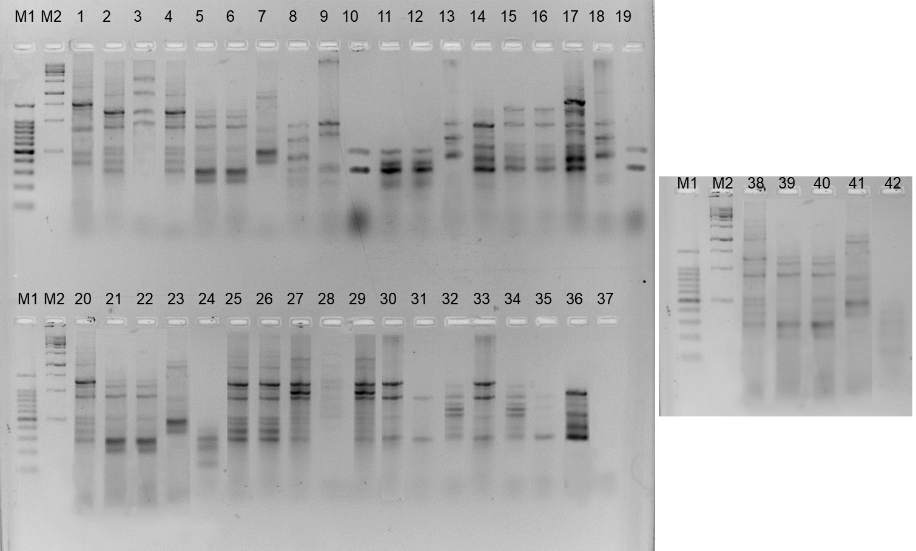
Lane: M1-100 bp ladder, M2-1 kb ladder1-Xcc1, 2-Xcc2, 3-Xcc3, 4-Xcc-4, 5-Xcc-5, 6-Xcc-6, 7-Xcc-7, 8-Xcc-8, 9-Xcc-9, 10-Xcc-10, 11-Xcc-11, 12-Xcc-12, 13-Xcc-13, 14-Xcc-14, 15-Xcc-15, 16-Xcc-16, 17-Xcc-17, 18-Xcc-18, 19-Xcc-19, 20-Xcc-20, 21-Xcc-21, 22-Xcc-22, 23-Xcc-23, 24-Xcc-24, 25-Xcc-25, 26-Xcc-26, 27-Xcc-27, 28-Xcc-28, 29-Xcc-29, 30-Xcc-30, 31-Xcc-31, 32-Xcc-32, 33-Xcc-33, 34-Xcc-34, 35-Xcc-35, 36-Xcc-36, 37-Xcc-37, 38-Xcc-38, 39-Xcc-39, 40-Xcc-40, 41-Xcc41 and 42-Xcc42

Supplementary Fig. 8 Agarose gel image showing PCR amplification of X. campestris pv. campestris isolates for ERIC primer
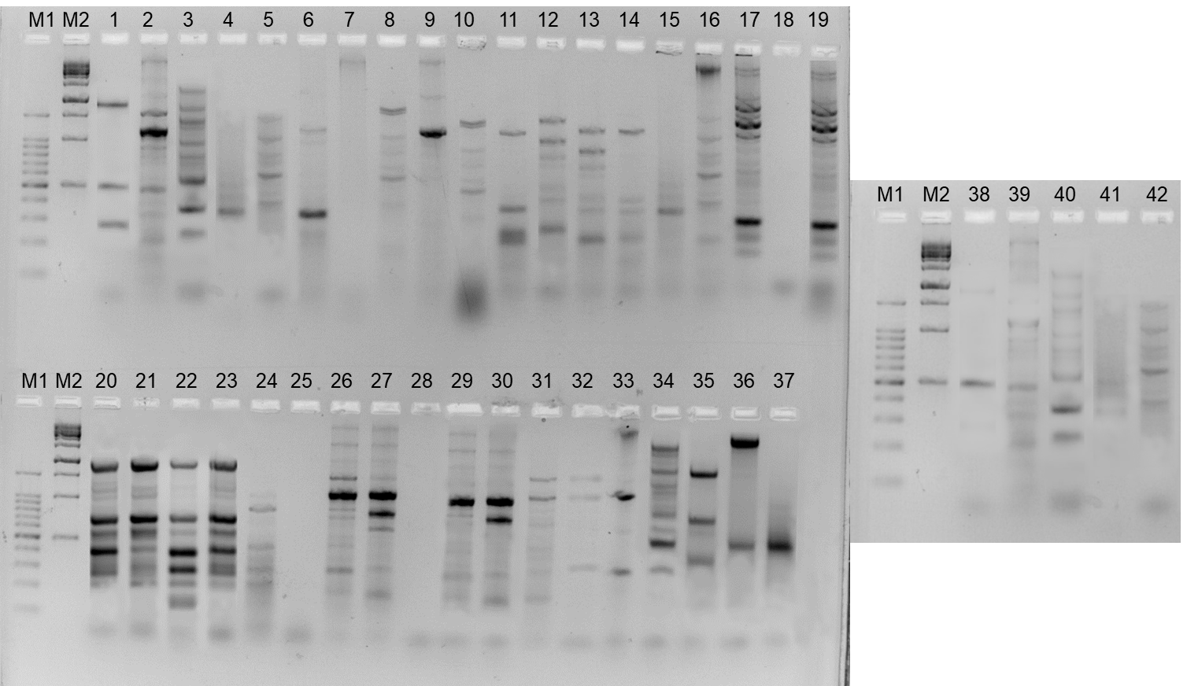
Lane: M1-100 bp ladder, M2-1 kb ladder1-Xcc1, 2-Xcc2, 3-Xcc3, 4-Xcc-4, 5-Xcc-5, 6-Xcc-6, 7-Xcc-7, 8-Xcc-8, 9-Xcc-9, 10-Xcc-10, 11-Xcc-11, 12-Xcc-12, 13-Xcc-13, 14-Xcc-14, 15-Xcc-15, 16-Xcc-16, 17-Xcc-17, 18-Xcc-18, 19-Xcc-19, 20-Xcc-20, 21-Xcc-21, 22-Xcc-22, 23-Xcc-23, 24-Xcc-24, 25-Xcc-25, 26-Xcc-26, 27-Xcc-27, 28-Xcc-28, 29-Xcc-29, 30-Xcc-30, 31-Xcc-31, 32-Xcc-32, 33-Xcc-33, 34-Xcc-34, 35-Xcc-35, 36-Xcc-36, 37-Xcc-37, 38-Xcc-38, 39-Xcc-39, 40-Xcc-40, 41-Xcc41 and 42-Xcc42

Supplementary Fig. 9 Agarose gel image showing PCR amplification of X. campestris pv. campestris isolates for REP primer
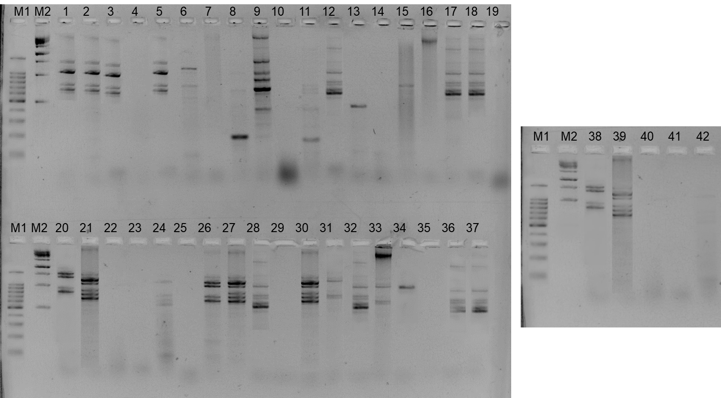
Lane: M1-100 bp ladder, M2-1 kb ladder1-Xcc1, 2-Xcc2, 3-Xcc3, 4-Xcc-4, 5-Xcc-5, 6-Xcc-6, 7-Xcc-7, 8-Xcc-8, 9-Xcc-9, 10-Xcc-10, 11-Xcc-11, 12-Xcc-12, 13-Xcc-13, 14-Xcc-14, 15-Xcc-15, 16-Xcc-16, 17-Xcc-17, 18-Xcc-18, 19-Xcc-19, 20-Xcc-20, 21-Xcc-21, 22-Xcc-22, 23-Xcc-23, 24-Xcc-24, 25-Xcc-25, 26-Xcc-26, 27-Xcc-27, 28-Xcc-28, 29-Xcc-29, 30-Xcc-30, 31-Xcc-31, 32-Xcc-32, 33-Xcc-33, 34-Xcc-34, 35-Xcc-35, 36-Xcc-36, 37-Xcc-37, 38-Xcc-38, 39-Xcc-39, 40-Xcc-40, 41-Xcc41 and 42-Xcc4

