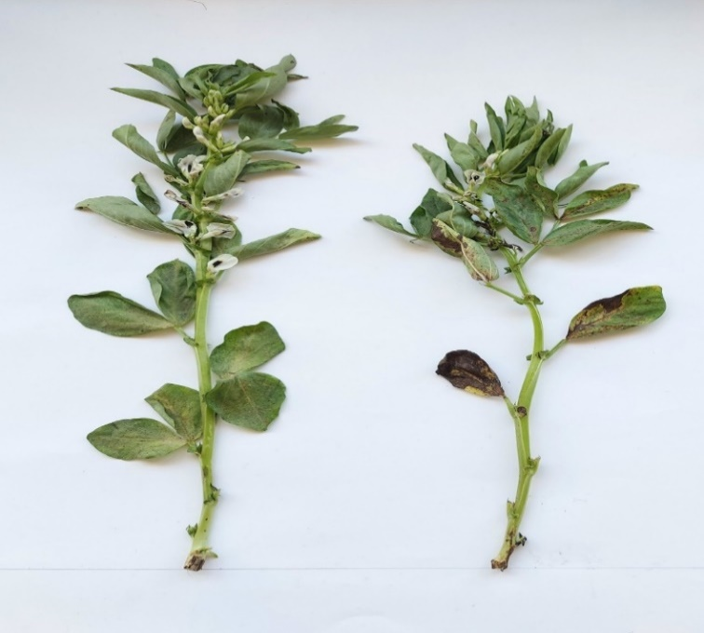 | 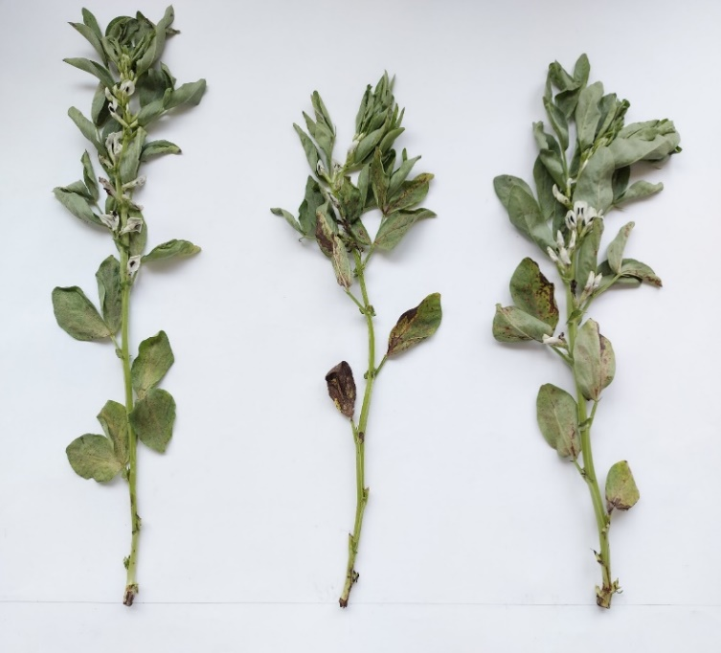 | 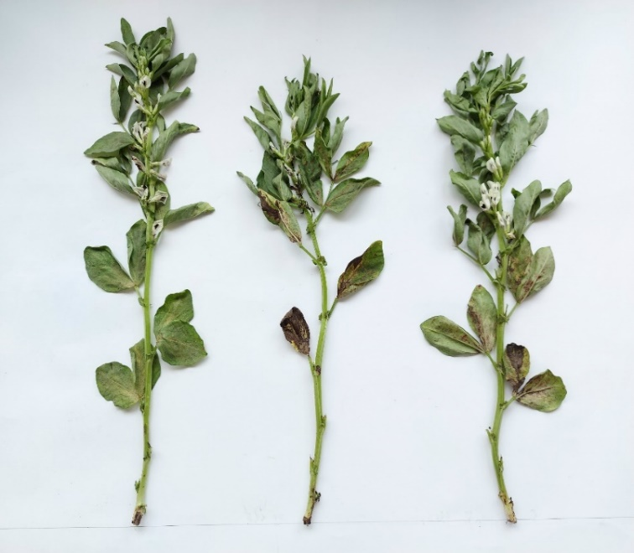
Control, B. fabae | Control, B. fabae, NYS | Control, B. fabae, FLZ
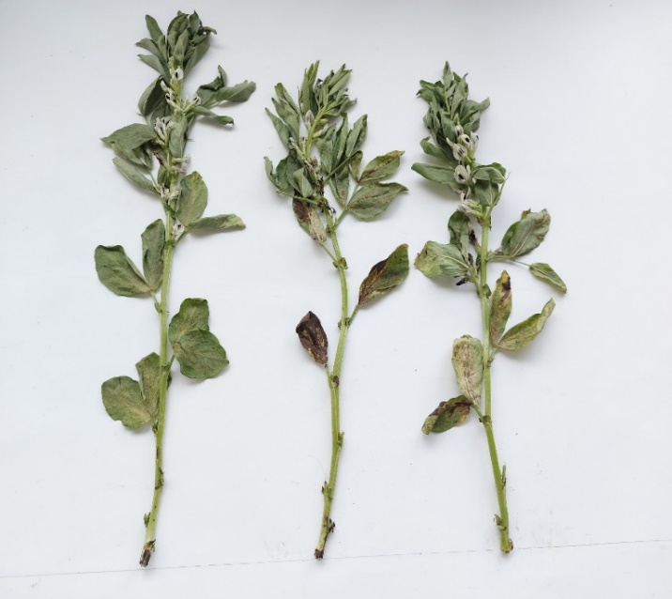 | 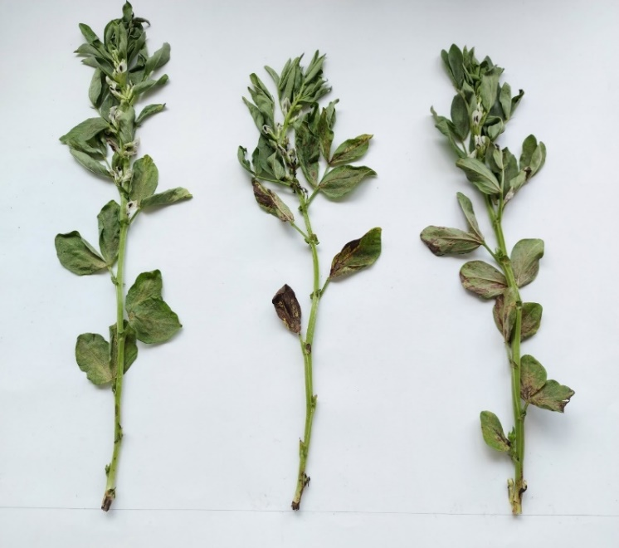 | 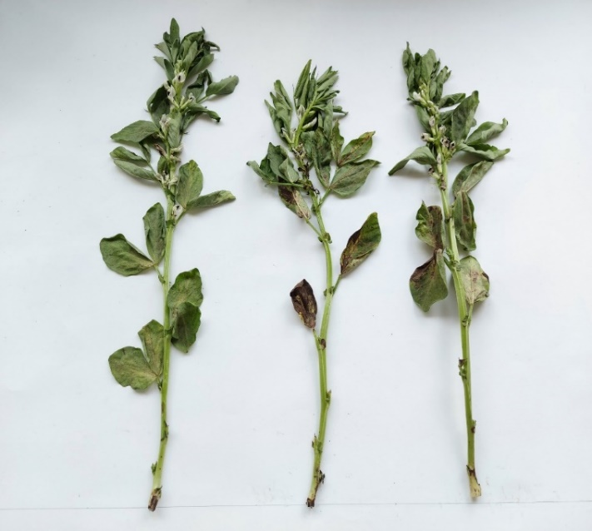
Control, B. fabae, CSNPs | Control, B. fabae, CSNPs-NYS | Control, B. fabae, CSNPs-FLZ
Fig S1: Effect of foliar application of different treatments on Vicia faba plants infected with Botrytis fabae during flowering stage.
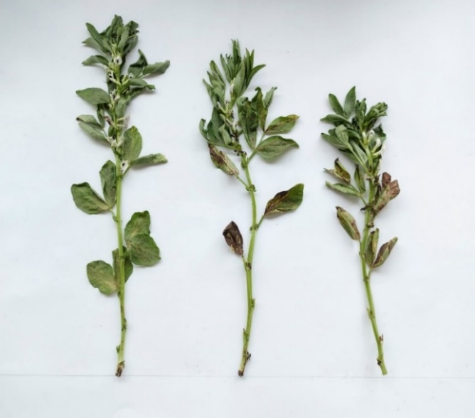 | 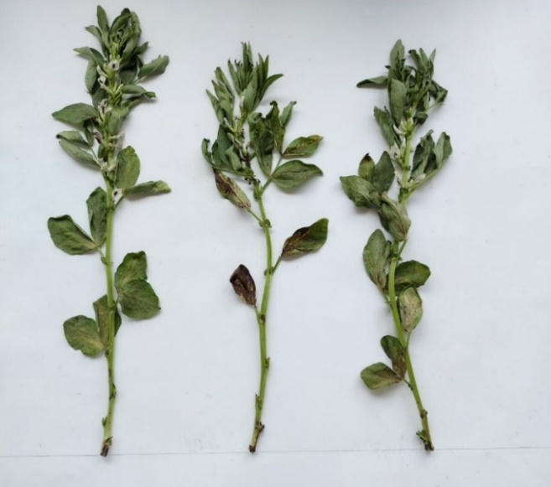 | 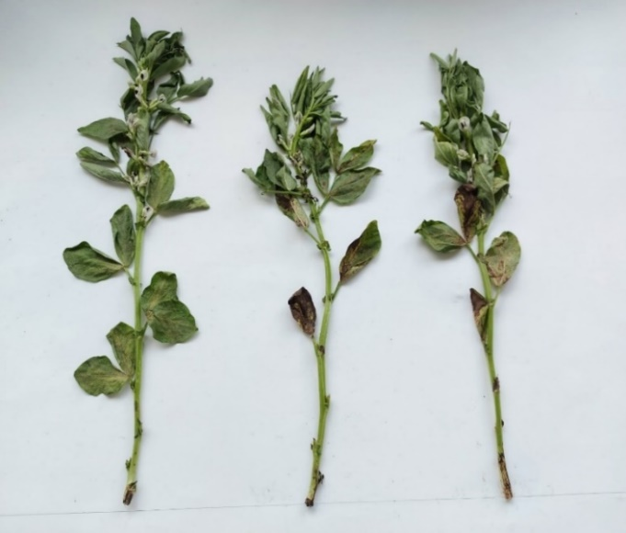
Control, B. fabae, CNTs | Control, B. fabae, CNTs-NYS | Control, B. fabae, CNTs-FLZ
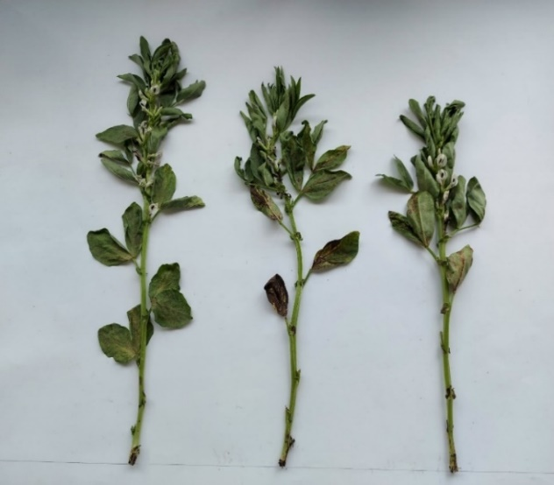 | 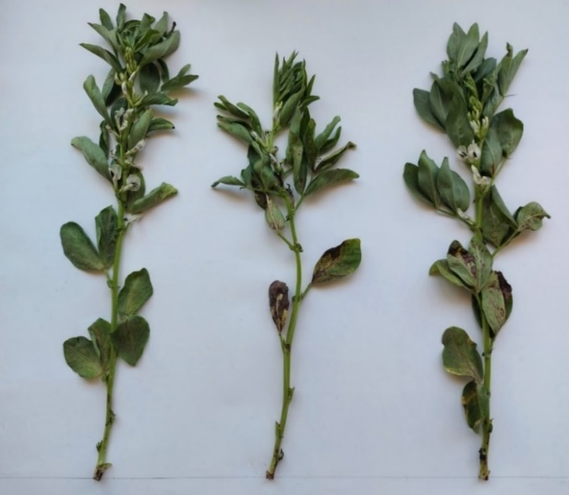 | 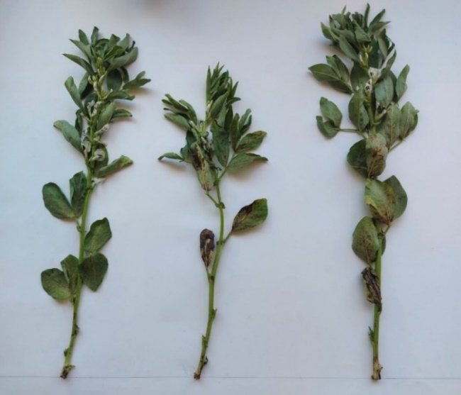
Control, B. fabae, SLNPs | Control, B. fabae, SLNPs-NYS | Control, B. fabae, SLNPs-FLZ
Fig S2: Effect of foliar application of different treatments on Vicia faba plants infected with Botrytis fabae during flowering stage.

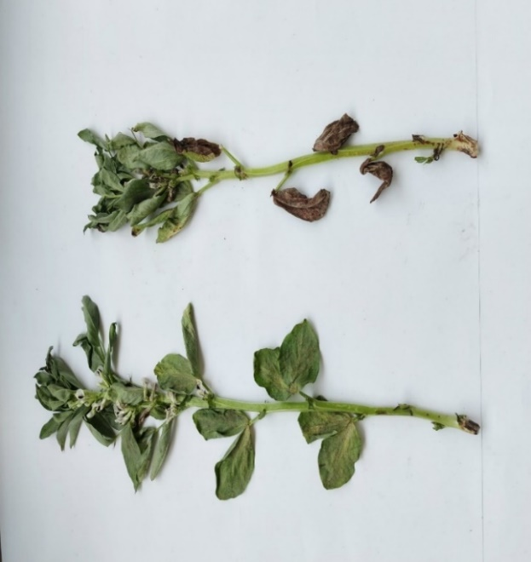 | 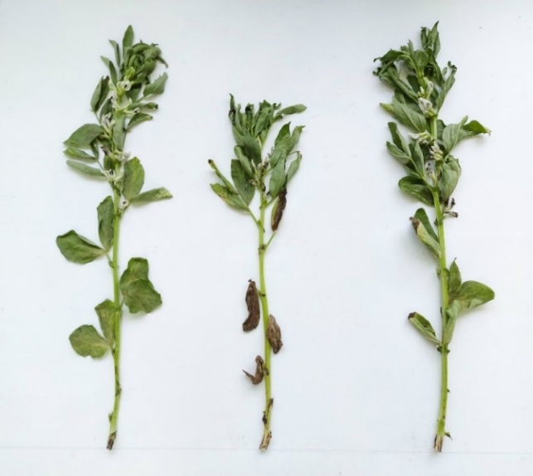 | 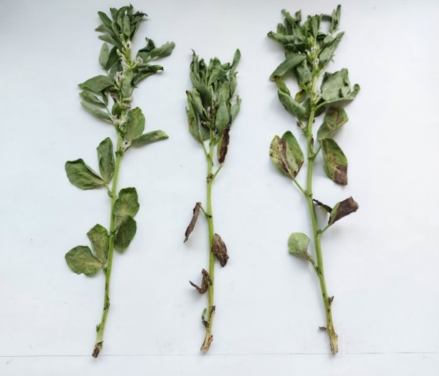
Control, A. alternata | Control, A. alternata, NYS | Control, A. alternata, FLZ
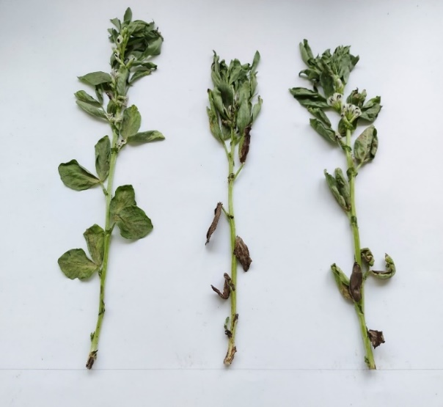 | 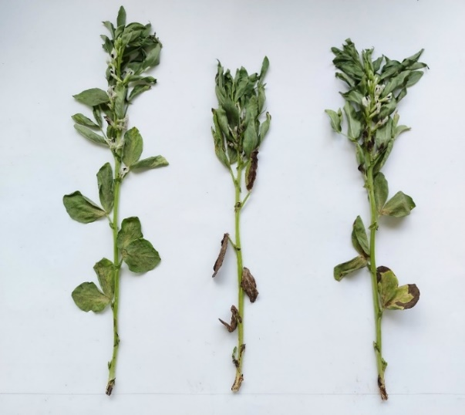 | 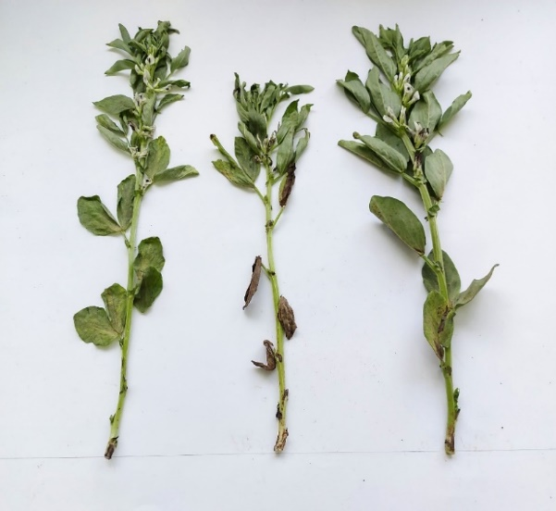
Control, A. alternata, CSNPs | Control, A. alternata, CSNPs-NYS | Control, A. alternata, CSNPs-FLZ
Fig S3: Effect of foliar application of different treatments on Vicia faba plants infected with Alternaria alternata during flowering stage.
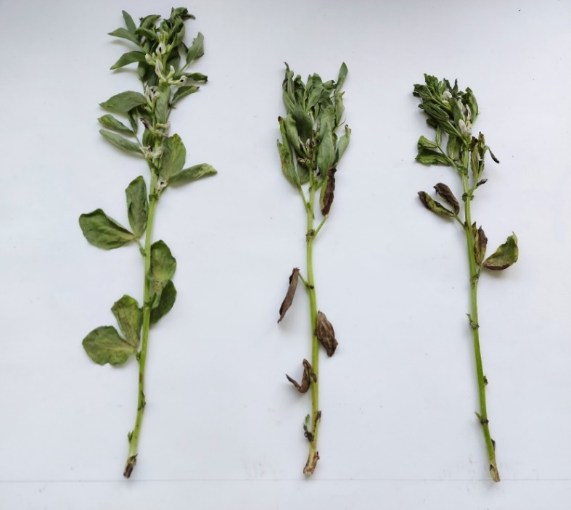 | 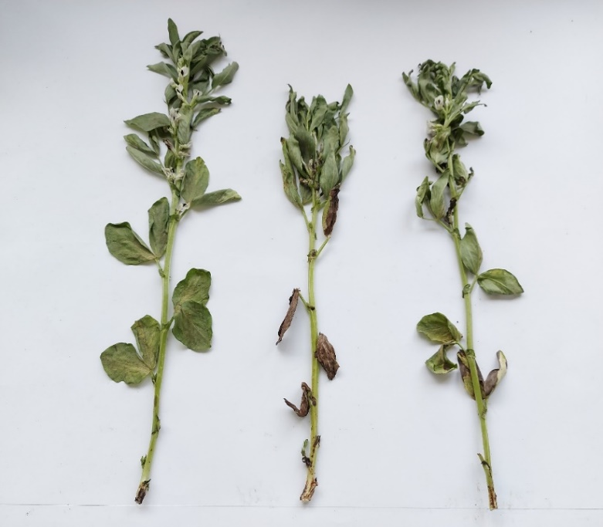 | 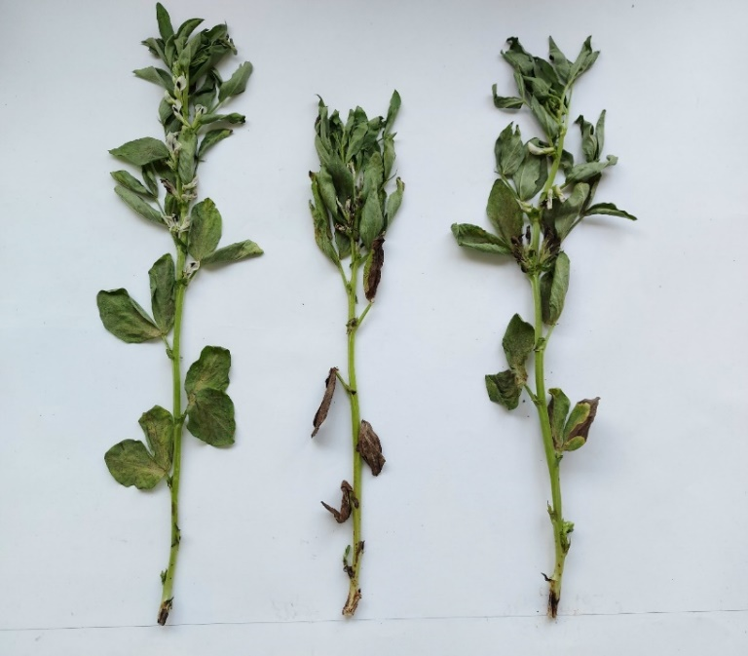
Control, A. alternata, CNTs | Control, A. alternata, CNTs-NYS | Control, A. alternata, CNTs-FLZ
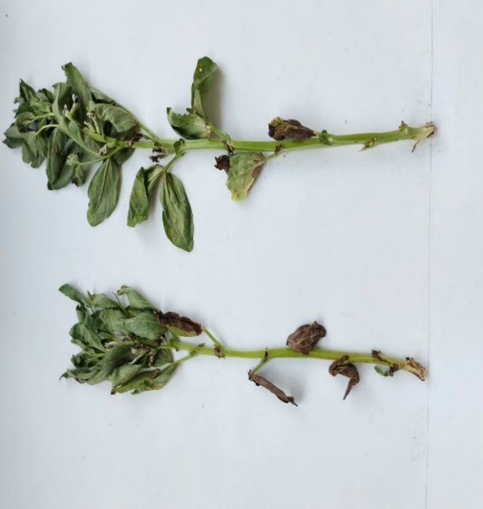 | 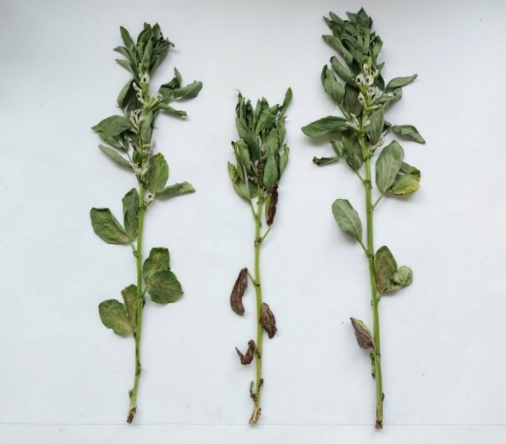 | 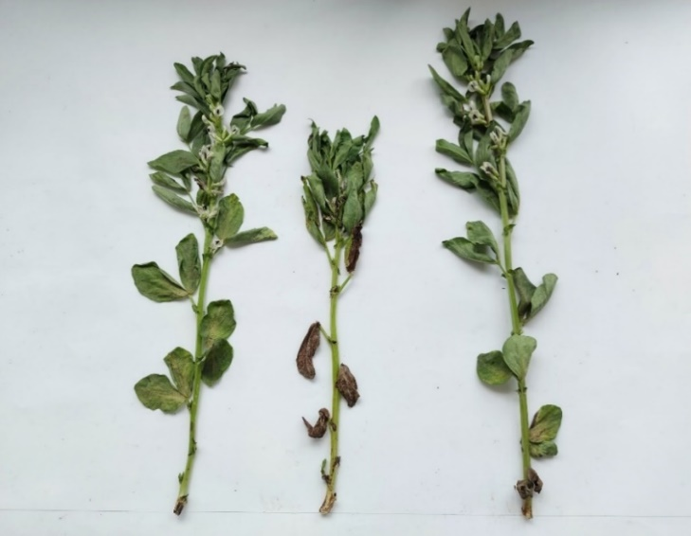
Control, A. alternata, SLNPs | Control, A. alternata, SLNPs-NYS | Control, A. alternata, SLNPs-FLZ
Fig S4: Effect of foliar application of different treatments on Vicia faba plants infected with Alternaria alternata during flowering stage

