Supplementary Table 1. Extent (10⁶ ha) of the wetland population associated with means of 12 elements measured in the uppermost soil horizon (see Table 3). $X_{↓}$ and $X_{↑}$ represent the extent for sites with heavy metal concentrations above and below the background concentration threshold, respectively. Total extent and number of probability sties for $\overline{X}$ can be found in Table 5. The full names of the elements are reported in the Methods and in Table 2. 95% CI is reported with the extent, and the number of probability sites associated with the extent is reported in parentheses. NA signifies that there were no sites with heavy metal concentrations above the background concentration threshold.
Element | 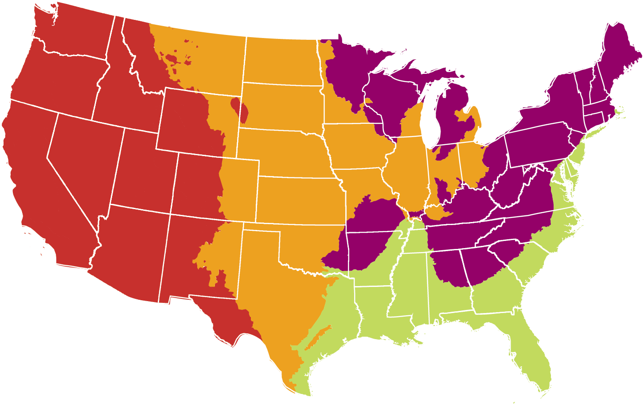  Conterminous  US | 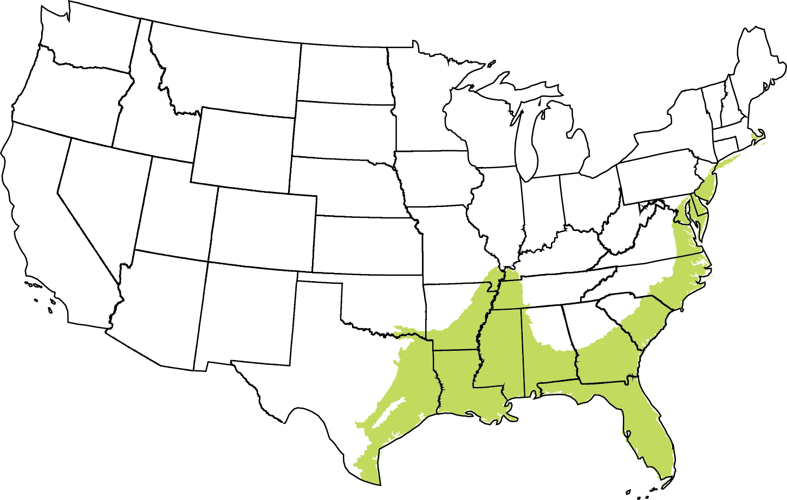  Coastal  Plains (CPL) | 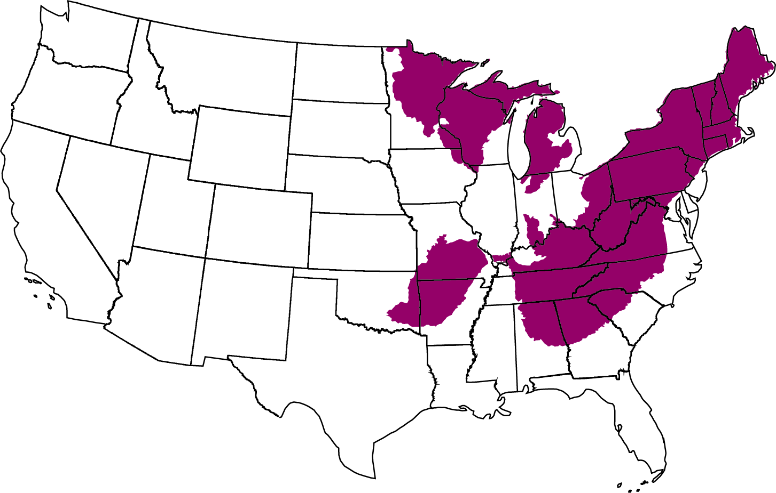  Eastern Mts & Upper Midwest (EMU) | 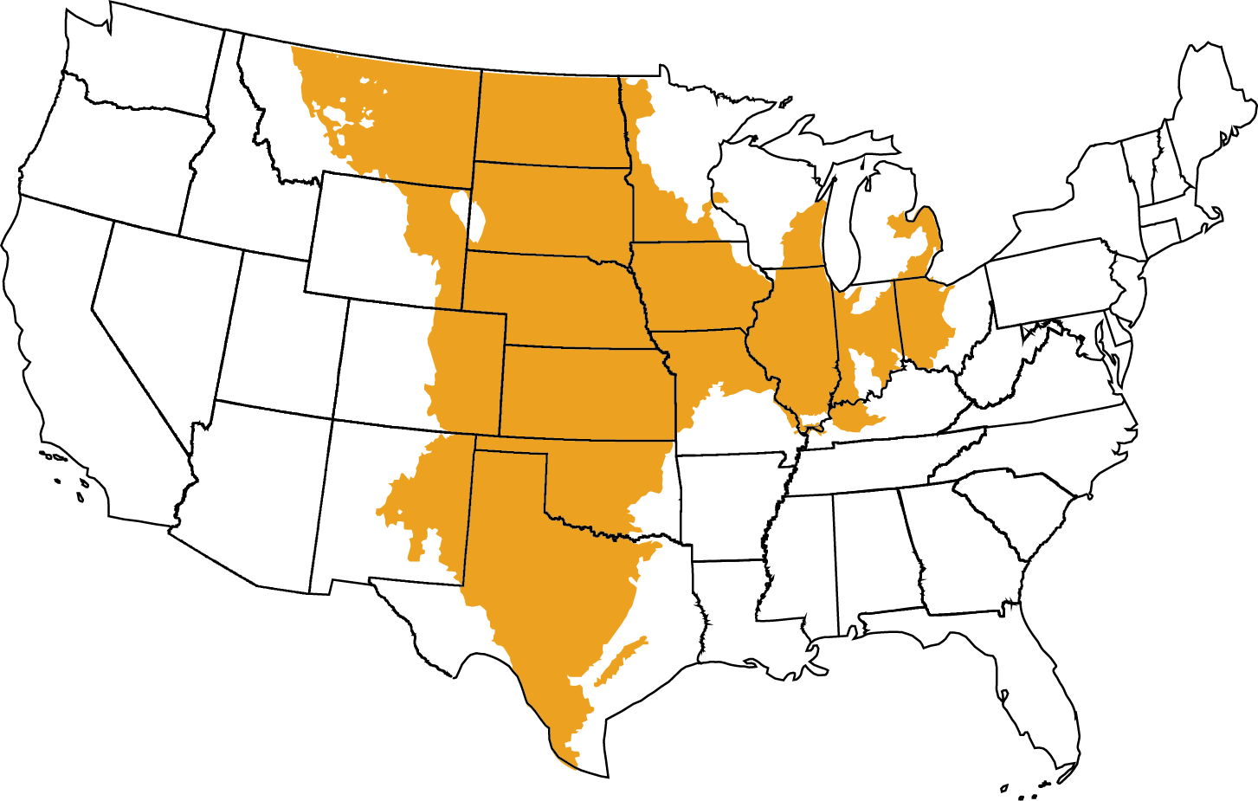  Interior  Plains (IPL) | 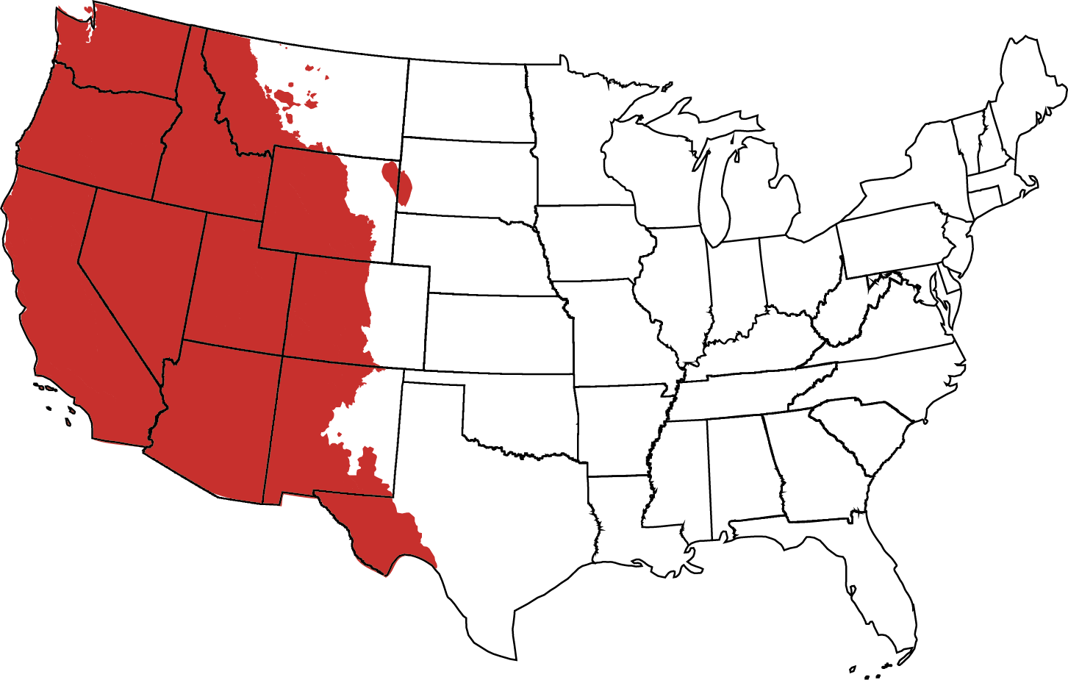  West (W)
Ag | $X_{↓}$ 23.43 ± 1.90 (867)  $X_{↑}$ 0.04 ± 0.05 (7) | $X_{↓}$ 11.66 ± 1.35 (466)  $X_{↑}$ 0.01 ± 0.01 (3) | $X_{↓}$ 7.96 ± 1.08 (149)  $X_{↑}$ 0.00 ± 0.00 (2) | $X_{↓}$ 2.38 ± 0.69 (111)  $X_{↑}$ NA | $X_{↓}$ 1.43 ± 0.34 (141)  $X_{↑}$ 0.03 ± 0.04 (2)
Cd | $X_{↓}$ 21.88 ± 1.90 (836)  $X_{↑}$ 1.60 ± 0.88 (38) | $X_{↓}$ 11.58 ± 1.35 (467)  $X_{↑}$ 0.09 ± 0.11 (2) | $X_{↓}$ 6.90 ± 1.10 (129)  $X_{↑}$ 1.06 ± 0.73 (22) | $X_{↓}$ 2.00 ± 0.64 (106)  $X_{↑}$ 0.38 ± 0.44 (5) | $X_{↓}$ 1.40 ± 0.34 (134)  $X_{↑}$ 0.06 ± 0.05 (9)
Co | $X_{↓}$ 23.17 ± 1.92 (863)  $X_{↑}$ 0.31 ± 0.35 (11) | $X_{↓}$ 11.67 ± 1.35 (468)  $X_{↑}$ 0.00 ± 0.00 (1) | $X_{↓}$ 7.67 ± 1.10 (146)  $X_{↑}$ 0.30 ± 0.34 (5) | $X_{↓}$ 2.38 ± 0.69 (111)  $X_{↑}$ NA | $X_{↓}$ 1.46 ± 0.34 (138)  $X_{↑}$ 0.01 ± 0.01 (5)
Cr | $X_{↓}$ 23.45 ± 1.91 (870)  $X_{↑}$ 0.03 ± 0.03 (4) | $X_{↓}$ 11.64 ± 1.36 (466)  $X_{↑}$ 0.03 ± 0.06 (3) | $X_{↓}$ 7.96 ± 1.08 (150)  $X_{↑}$ 0.00 ± 0.00 (1) | $X_{↓}$ 2.38 ± 0.69 (111)  $X_{↑}$ NA | $X_{↓}$ 1.46 ± 0.34 (143)  $X_{↑}$ NA
Cu | $X_{↓}$ 22.93 ± 1.92 (821)  $X_{↑}$ 0.55 ± 0.41 (53) | $X_{↓}$ 11.54 ± 1.36 (461)  $X_{↑}$ 0.13 ± 0.13 (8) | $X_{↓}$ 7.71 ± 1.10 (145)  $X_{↑}$ 0.26 ± 0.32 (6) | $X_{↓}$ 2.37 ± 0.69 (110)  $X_{↑}$ 0.01 ± 0.02 (1) | $X_{↓}$ 1.31 ± 0.34 (105)  $X_{↑}$ 0.15 ± 0.03 (38)
Ni | $X_{↓}$ 23.48 ± 1.90 (874)  $X_{↑}$ NA | $X_{↓}$ 11.67 ± 1.35 (469)  $X_{↑}$ NA | $X_{↓}$ 7.96 ± 1.08 (151)  $X_{↑}$ NA | $X_{↓}$ 2.38 ± 0.69 (111)  $X_{↑}$ NA | $X_{↓}$ 1.46 ± 0.34 (143)  $X_{↑}$ NA
Pb | $X_{↓}$ 20.82 ± 2.04 (724)  $X_{↑}$ 2.26 ± 0.79 (150) | $X_{↓}$ 11.27 ± 1.37 (407)  $X_{↑}$ 0.39 ± 0.19 (62) | $X_{↓}$ 6.06 ± 1.24 (93)  $X_{↑}$ 1.90 ± 0.72 (58) | $X_{↓}$ 2.29 ± 0.69 (104)  $X_{↑}$ 0.10 ± 0.07 (7) | $X_{↓}$ 1.20 ± 0.37 (120)  $X_{↑}$ 0.27 ± 0.24 (23)
Sb | $X_{↓}$ 22.60 ± 1.89 (839)  $X_{↑}$ 0.87 ± 0.31 (35) | $X_{↓}$ 11.48 ± 1.35 (455)  $X_{↑}$ 0.18 ± 0.14 (14) | $X_{↓}$ 7.85 ± 1.07 (145)  $X_{↑}$ 0.12 ± 0.15 (6) | $X_{↓}$ 2.38 ± 0.69 (111)  $X_{↑}$ NA | $X_{↓}$ 0.89 ± 0.27 (128)  $X_{↑}$ 0.58 ± 0.22 (15)
Sn | $X_{↓}$ 23.45 ± 1.90 (871)  $X_{↑}$ 0.03 ± 0.04 (3) | $X_{↓}$ 11.64 ± 1.35 (467)  $X_{↑}$ 0.03 ± 0.04 (2) | $X_{↓}$ 7.96 ± 1.08 (151)  $X_{↑}$ NA | $X_{↓}$ 2.38 ± 0.69 (111)  $X_{↑}$ NA | $X_{↓}$ 1.46 ± 0.34 (142)  $X_{↑}$ 0.00 ± 0.00 (1)
V | $X_{↓}$ 23.48 ± 1.90 (872)  $X_{↑}$ 0.00 ± 0.00 (2) | $X_{↓}$ 11.67 ± 1.35 (469)  $X_{↑}$ NA | $X_{↓}$ 7.96 ± 1.08 (151)  $X_{↑}$ NA | $X_{↓}$ 2.38 ± 0.69 (111)  $X_{↑}$ NA | $X_{↓}$ 1.46 ± 0.34 (141)  $X_{↑}$ 0.00 ± 0.00 (2)
W | $X_{↓}$ 23.31 ± 1.90 (858)  $X_{↑}$ 0.17 ± 0.12 (16) | $X_{↓}$ 11.53 ± 1.35 (461)  $X_{↑}$ 0.14 ± 0.11 (8) | $X_{↓}$ 7.94 ± 1.08 (144)  $X_{↑}$ 0.02 ± 0.02 (7) | $X_{↓}$ 2.38 ± 0.69 (111)  $X_{↑}$ NA | $X_{↓}$ 1.46 ± 0.34 (142)  $X_{↑}$ 0.01 ± 0.01 (1)
Zn | $X_{↓}$ 22.53 ± 1.93 (812)  $X_{↑}$ 0.95 ± 0.44 (62) | $X_{↓}$ 11.22 ± 1.35 (442)  $X_{↑}$ 0.45 ± 0.29 (27) | $X_{↓}$ 7.61 ± 1.13 (136)  $X_{↑}$ 0.35 ± 0.33 (15) | $X_{↓}$ 2.32 ± 0.70 (103)  $X_{↑}$ 0.06 ± 0.04 (8) | $X_{↓}$ 1.38 ± 0.34 (131)  $X_{↑}$ 0.08 ± 0.06 (12)

