Environmental Monitoring and Assessment, Springer, 2018
Electronic supplementary materials for:
The use of a geostatistical model supported by multivariate analysis to assess the spatial distribution of mercury in soils from historical mining areas: Karczówka Mt., Miedzianka Mt. and Rudki (south-central Poland)
Sabina Dołęgowskaª, Artur Michalik^{a*}
ªGeochemistry and the Environment Division, Institute of Chemistry, Jan Kochanowski University, 15G Świętokrzyska St., 25-406 Kielce, Poland
*Corresponding author: Artur.Michalik@ujk.edu.pl
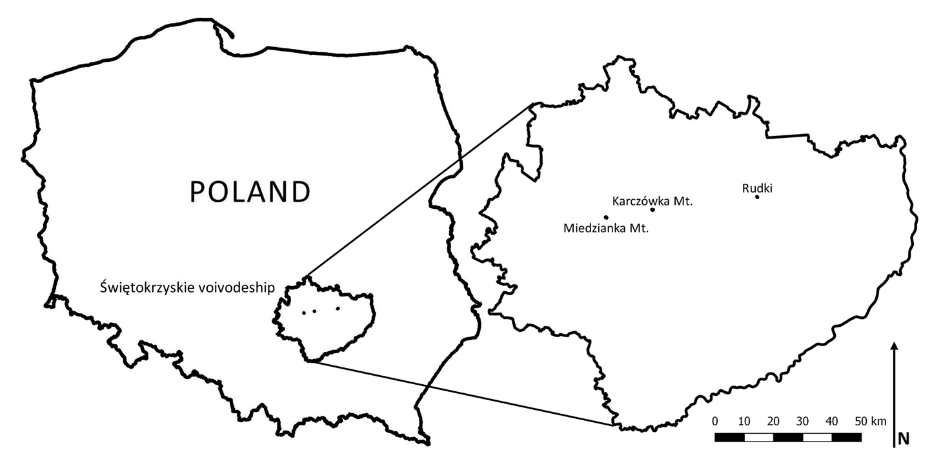
Fig. 1 Sketch map of the study areas and their localization in Świętokrzyskie voivodeship.
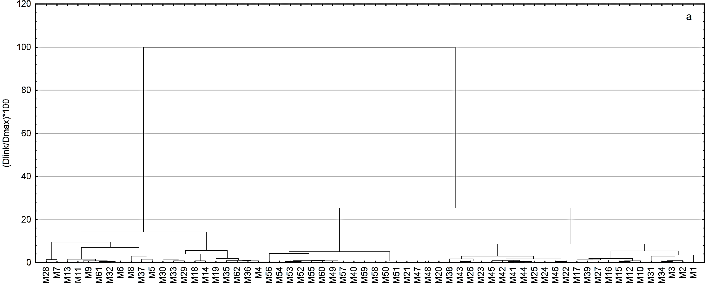
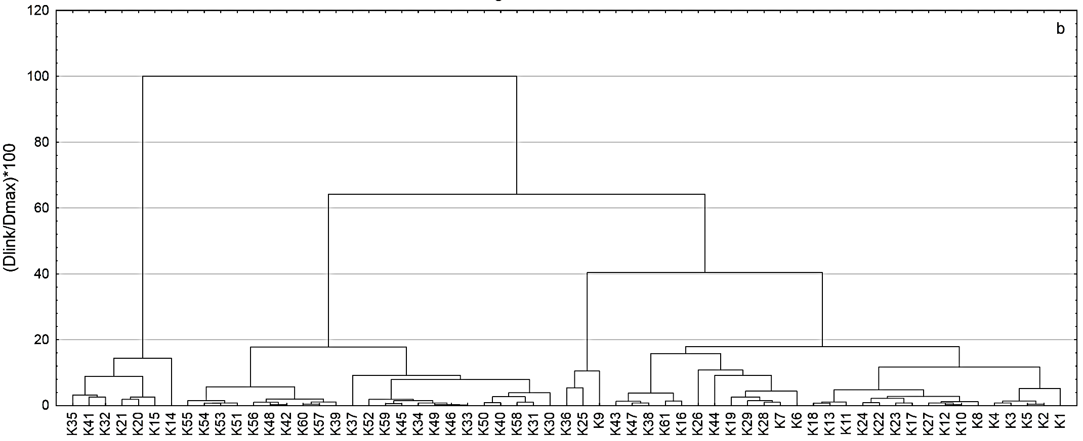
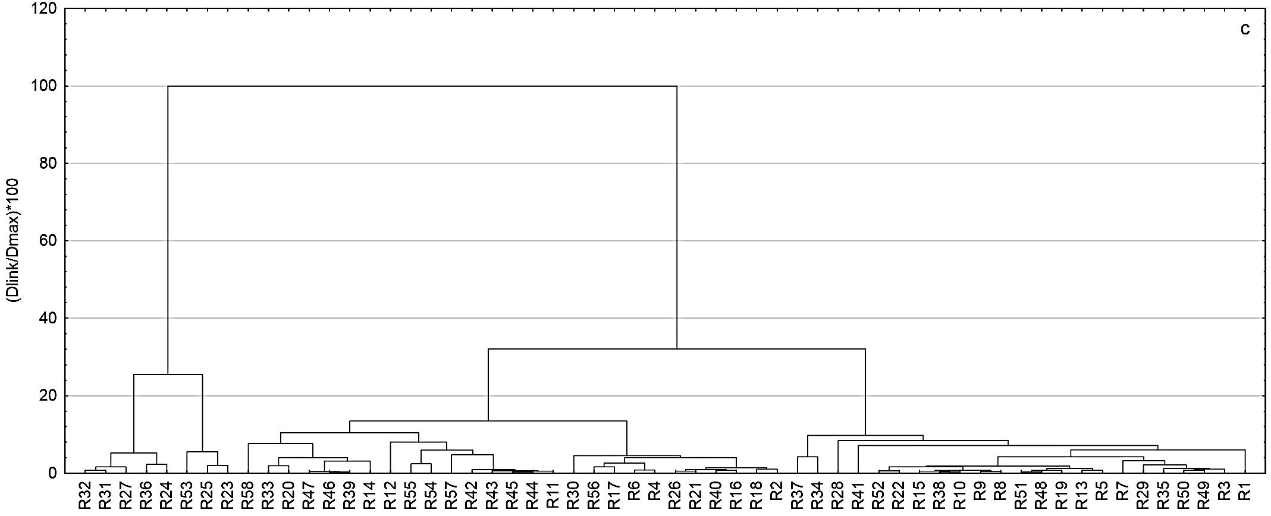

Fig. 2 Tree diagrams obtained for non-mercury biased datasets from: a – Miedzianka Mt., b – Karczówka Mt., c – Rudki.

