Table S1. Parametric parameter estimates for individual GAMM models predicting oxygen smooths, for all intercepts p<0.001.
Location | 10% |  | 50%
Estuary | Function | Intercept ± Standard Error | Function | Intercept ± Standard Error
Wheatley | Oxygen ~ s(Julian Day) + s(Temperature) | 9.53±0.426 | Oxygen ~ s(Julian Day) | 9.14 ±0.181
Mill | Oxygen ~ s(Julian Day) + s(Temperature) | 9.53±0.332 | Oxygen ~ s(Julian Day)+ s(Tidal Amplitude) | 8.96 ±0.485
Kildare | Oxygen ~ te(Julian, Temperature) | 7.61 ± 3.581. | Oxygen ~ s(Julian Day) | 8.03 ±0.323
Enmore | Oxygen ~ s(Temperature) + s(Tidal Amplitude) | 9.20 ±0.2.32 | Oxygen ~ s(Temperature) | 10.15 ±0.291
Bideford | Oxygen ~ te(Julian, Temperature, and Tidal Amplitude) | 8.65 ±1.11 | Oxygen ~ s(Julian Day) | 10.00 ±0.196
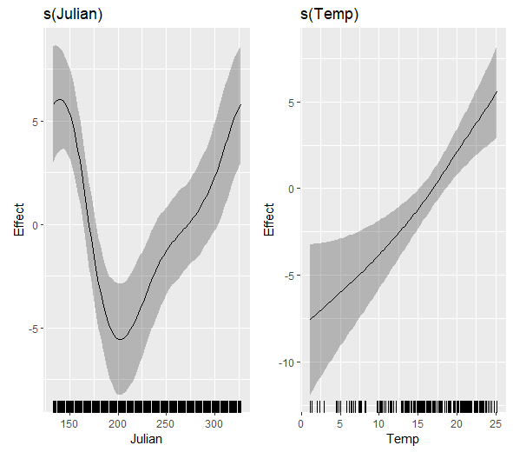
Figure S1. Fitted smooths ± 95 Confidence interval (CI) of oxygen concentration at the 10% location of the Wheatley estuary. Temp =Temperature °C, Julian =Julian Day.
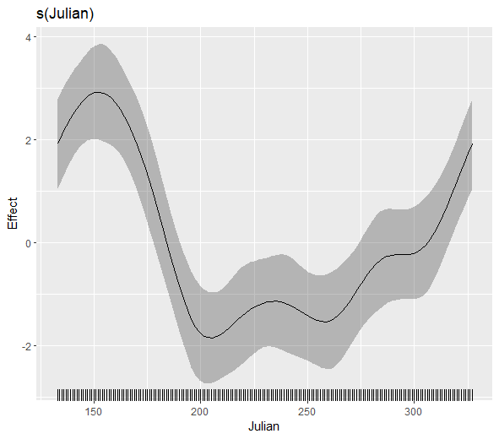
Figure S2. Fitted smooth ± 95 %CI of oxygen concentration at the 50% location of the Wheatley estuary.
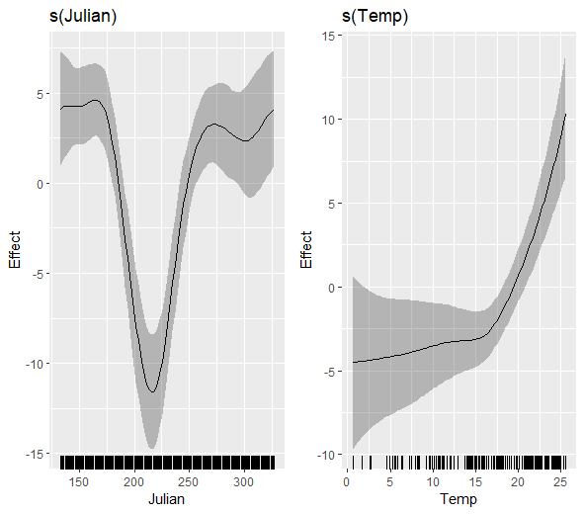
Figure S3. Fitted smooth ± 95 %CI of oxygen concentration at the 10% location of the Mill estuary.

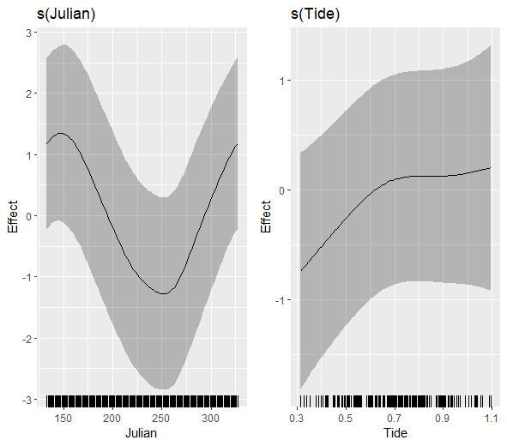
Figure S4. Fitted smooth ± 95 %CI of oxygen concentration at the 50% location of the Mill estuary. Tide = Tidal Amplitude (m).

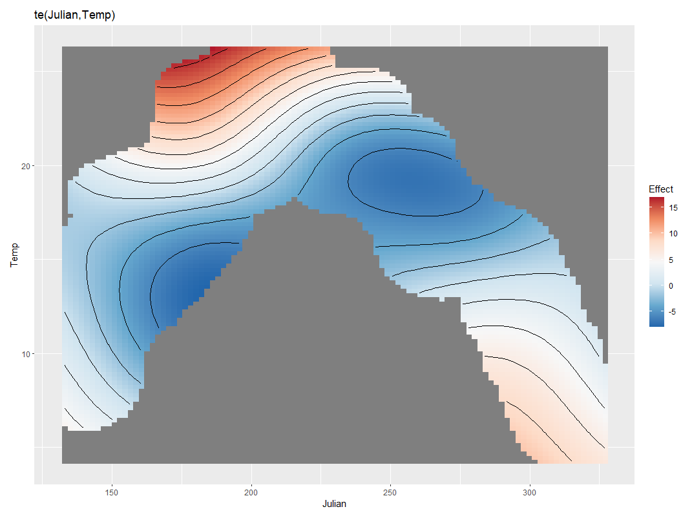
Figure S5. Fitted tensor interaction smooth of oxygen concentration at the 10% location of the Kildare estuary.

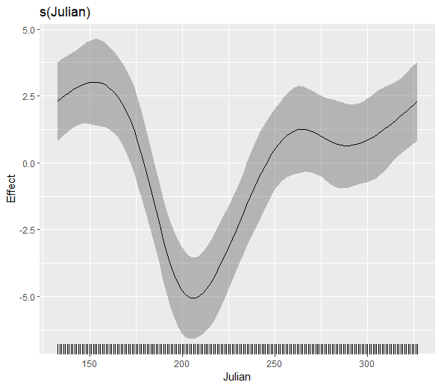
Figure S6. Fitted smooth ± 95 %CI of oxygen concentration at the 50% location of the Kildare estuary.
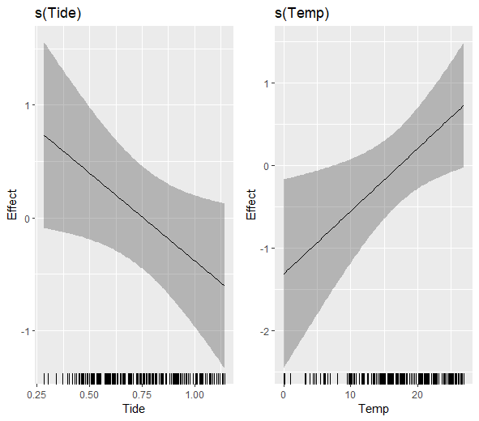
Figure S7. Fitted smooth ± 95 %CI of oxygen concentration at the 10% location of the Enmore estuary.
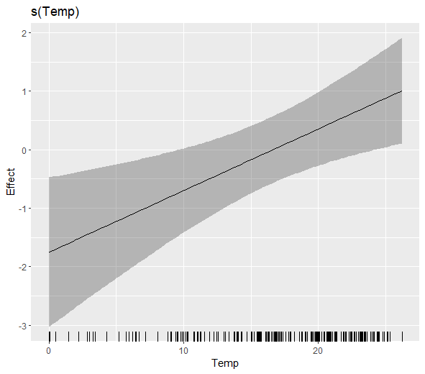
Figure S8. Fitted smooth ± 95 %CI of oxygen concentration at the 50% location of the Enmore estuary.

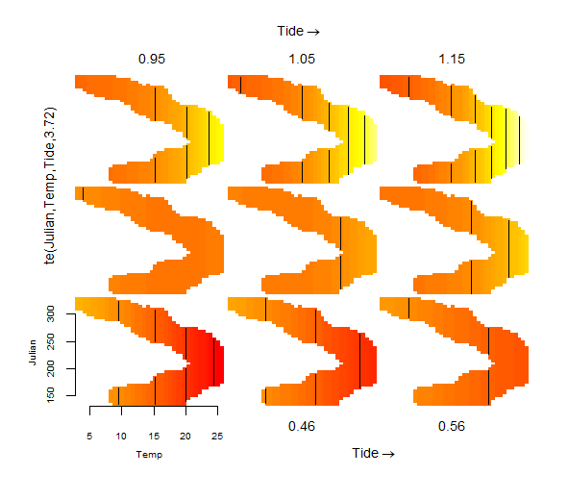
Figure S9. Fitted tensor interaction smooth of oxygen concentration at the 10% location of the Bideford estuary.

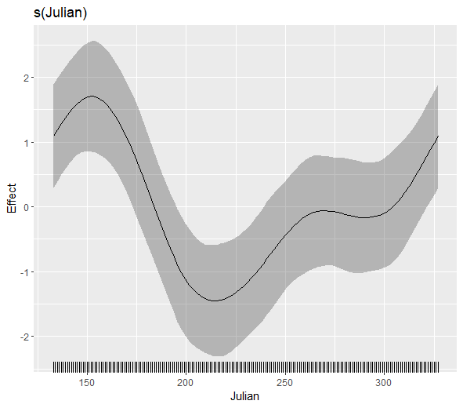
Figure S10. Fitted smooth ± 95 %CI of oxygen concentration at the 50% location of the Bideford estuary.

