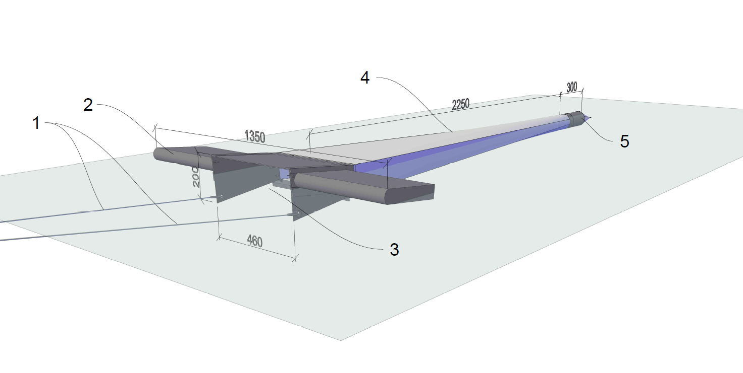

Supplementary material
Schematic drawing of the mini-manta trawl. Ropes for towing
- Wings (hollow)
- Mouth opening
- Net
- Cod end

