Supplemental Figures:
Supplemental Figure 1. Rooting zone soils (A) consist of sandy loam with high organic matter content and are underlain by silty clay to a depth of 1.6 m (B), with clay content increasing with depth. The second unit is underlain by silty sand down to 3.5 m (C), with sand content increasing with depth. Soil characterization was performed of an undisturbed 3.5 m deep soil core that was collected along the eastern edge of the Freshwater plot. A ground-penetrating radar transect was co-located along the eastern edge of the Freshwater plot and showed continuity of the sediment units from the soil core.
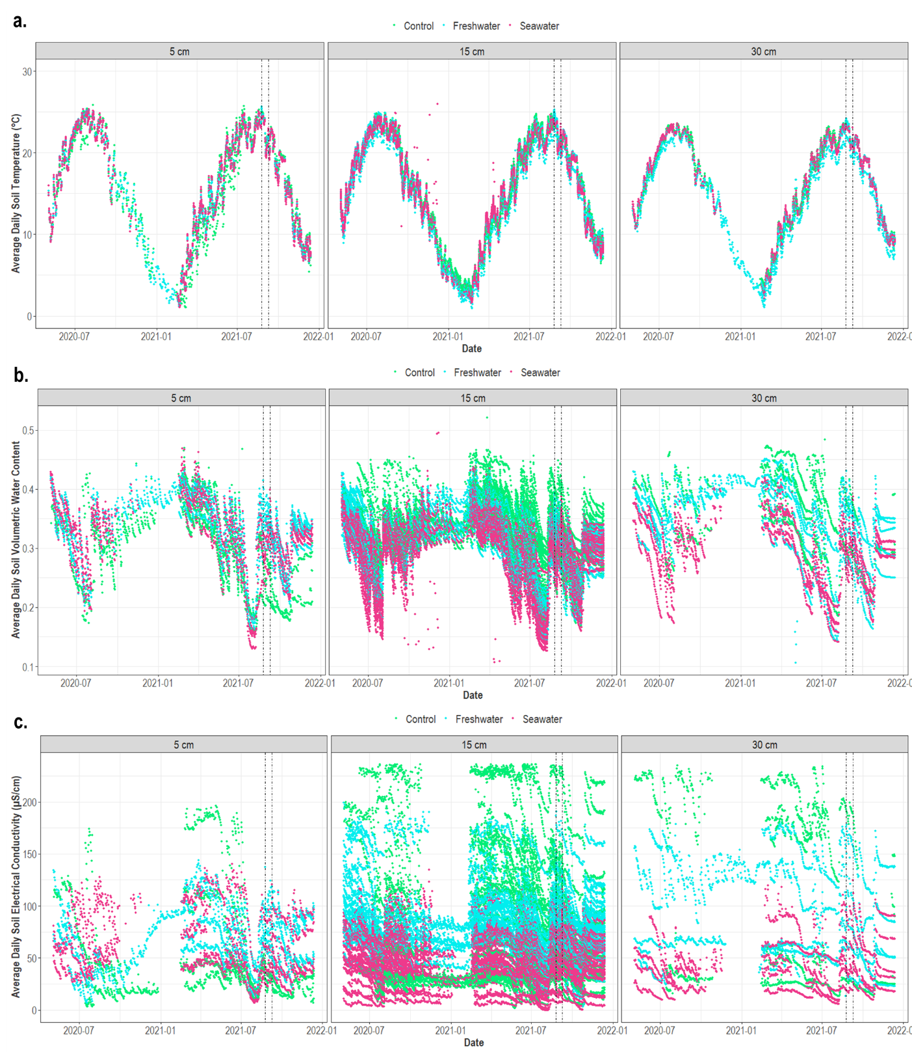
Supplemental Figure 2. Interannual variation in soil temperature (a), volumetric water content (b), and electrical conductivity (c) at three depths. Simulation events are designated with dotted lines.
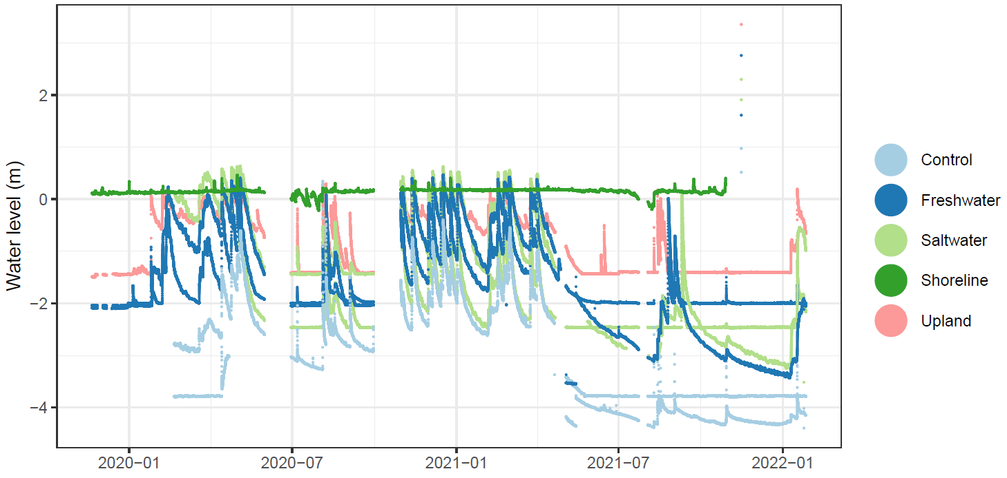
Supplemental Figure 3. Interannual variation in groundwater level.

Supplemental Figure 4. Electrical resistivity distribution at the Freshwater plot.

Supplemental Tables:

Supplemental Table 1. Characterization of forest structure within each TEMPEST experimental unit. DBH = diameter at breast height.
Plot | Number of Trees (DBH ≥ 1 cm) | DBH Range (cm) | Mean DBH  (ave ± st dev) | Number of Large Trees  (DBH ≥ 20 cm)
Control | 140 | 2.0 - 71.0 | 22.3 ± 14.6 | 60
Freshwater | 99 | 1.8 - 79.8 | 24.8 ± 19.7 | 48
Estuarine Water | 159 | 1.4 - 68.4 | 21.5 ± 16.7 | 72

Supplemental Table 2. Ambient environmental conditions. FW = Freshwater; EW = Estuarine water; NA = Not Applicable.
Variable | Plot | Soil Depth (cm) | 08/24/2021 | 08/31/2021 | 09/08/2021
 |  |  | 24 hours prior to FW plot test | 24 hours prior to Hurricane Ida | 24 hours prior to EW plot test
Mean Daily Soil Temperature ± SE (°C) | Average across all plots | 5 | 24.3 ± 0.20 | 23.8 ± 0.22 | 21.6 ± 0.22
Mean Daily Soil Temperature ± SE (°C) | Average across all plots | 15 | 23.8 ± 0.03 | 23.7 ± 0.03 | 21.5 ± 0.03
Mean Daily Soil Temperature ± SE (°C) | Average across all plots | 30 | 22.8 ± 0.14 | 23.0 ± 0.13 | 21.0 ± 0.12
Mean Daily Soil VWC ± SE (m³/m³) | Average across all plots | 5 | 0.34 ± 0.04 | 0.34 ± 0.04 | 0.34 ± 0.04
Mean Daily Soil VWC ± SE (m³/m³) | Average across all plots | 15 | 0.34 ± 0.01 | 0.34 ± 0.01 | 0.33 ± 0.01
Mean Daily Soil VWC ± SE (m³/m³) | Average across all plots | 30 | 0.36 ± 0.04 | 0.37 ± 0.04 | 0.35 ± 0.04
Mean Daily Water Table Depth ± SE (m) | Control | NA | 4.07 ± 0.01 | 4.10 ± 0.00 | 4.07 ± 0.00
Mean Daily Water Table Depth ± SE (m) | Freshwater | NA | 2.33 ± 0.02 | 1.79 ± 0.04 | 1.98 ± 0.02
Mean Daily Water Table Depth ± SE (m) | Estuarine water | NA | 2.17 ± 0.01 | 2.30 ± 0.01 | 2.25 ± 0.01

Supplemental Table 3. Time to soil saturation and duration by depth for Freshwater and Estuarine-water plot tests. Bold = saturated conditions.
 | 5 cm |  | 15 cm |  | 30 cm
Hours post-simulation initiation | Mean Hourly FW Plot Soil VWC ± SE (m³/m³) | Mean Hourly EW Plot Soil VWC ± SE (m³/m³) | Mean Hourly FW Plot Soil VWC ± SE (m³/m³) | Mean Hourly EW Plot Soil VWC ± SE (m³/m³) | Mean Hourly FW Plot Soil VWC ± SE (m³/m³) | Mean Hourly EW Plot Soil VWC ± SE (m³/m³)
1 | 0.34 ± 0.01 | 0.31 ± 0.01 | 0.32 ± 0.002 | 0.31 ± 0.003 | 0.35 ± 0.01 | 0.29 ± 0.003
2 | 0.36 ± 0.2 | 0.33 ± 0.01 | 0.35 ± 0.003 | 0.33 ± 0.003 | 0.38 ± 0.01 | 0.35 ± 0.01
3 | 0.37 ± 0.2 | 0.36 ± 0.01 | 0.36 ± 0.003 | 0.35 ± 0.003 | 0.39 ± 0.001 | 0.36 ± 0.01
4 | 0.38 ± 0.02 | 0.38 ± 0.02 | 0.37 ± 0.002 | 0.36 ± 0.002 | 0.41 ± 0.01 | 0.36 ± 0.01
5 | 0.38 ± 0.02 | 0.39 ± 0.02 | 0.38 ± 0.002 | 0.36 ± 0.002 | 0.41 ± 0.01 | 0.37 ± 0.01
6 | 0.4 ± 0.01 | 0.41 ± 0.01 | 0.39 ± 0.002 | 0.36 ± 0.001 | 0.41 ± 0.01 | 0.37 ± 0.01
7 | 0.42 ± 0.01 | 0.43 ± 0.01 | 0.39 ± 0.002 | 0.37 ± 0.002 | 0.41 ± 0.01 | 0.37 ± 0.01
8 | 0.42 ± 0.004 | 0.43 ± 0.01 | 0.39 ± 0.002 | 0.37 ± 0.002 | 0.41 ± 0.01 | 0.37 ± 0.01
9 | 0.42 ± 0.004 | 0.43 ± 0.01 | 0.39 ± 0.002 | 0.37 ± 0.002 | 0.41 ± 0.01 | 0.37 ± 0.01
10 | 0.42 ± 0.004 | 0.43 ± 0.01 | 0.39 ± 0.002 | 0.37 ± 0.002 | 0.41 ± 0.01 | 0.37 ± 0.01
11 | 0.42 ± 0.004 | 0.43 ± 0.01 | 0.39 ± 0.002 | 0.37 ± 0.002 | 0.41 ± 0.01 | 0.37 ± 0.01
12 | 0.41 ± 0.01 | 0.42 ± 0.01 | 0.39 ± 0.002 | 0.37 ± 0.002 | 0.41 ± 0.01 | 0.37 ± 0.01
13 | 0.4 ± 0.01 | 0.41 ± 0.01 | 0.38 ± 0.002 | 0.36 ± 0.002 | 0.41 ± 0.01 | 0.37 ± 0.01
14 | 0.39 ± 0.01 | 0.40 ± 0.01 | 0.37 ± 0.002 | 0.36 ± 0.002 | 0.41 ± 0.01 | 0.37 ± 0.01
15 | 0.39 ± 0.01 | 0.39 ± 0.01 | 0.37 ± 0.002 | 0.36 ± 0.002 | 0.41 ± 0.01 | 0.37 ± 0.01
16 | 0.39 ± 0.01 | 0.38 ± 0.01 | 0.37 ± 0.002 | 0.36 ± 0.002 | 0.41 ± 0.01 | 0.37 ± 0.01
17 | 0.38 ± 0.01 | 0.38 ± 0.01 | 0.36 ± 0.003 | 0.36 ± 0.002 | 0.41 ± 0.01 | 0.37 ± 0.01
18 | 0.38 ± 0.01 | 0.37 ± 0.01 | 0.36 ± 0.003 | 0.35 ± 0.002 | 0.41 ± 0.01 | 0.37 ± 0.01
19 | 0.38 ± 0.01 | 0.37 ± 0.01 | 0.36 ± 0.003 | 0.35 ± 0.002 | 0.41 ± 0.01 | 0.36 ± 0.01
20 | 0.38 ± 0.01 | 0.37 ± 0.01 | 0.36± 0.003 | 0.35 ± 0.002 | 0.41 ± 0.01 | 0.36 ± 0.01
21 | 0.37 ± 0.01 | 0.36 ± 0.01 | 0.36 ± 0.003 | 0.35 ± 0.002 | 0.41 ± 0.01 | 0.36 ± 0.01
22 | 0.37 ± 0.01 | 0.36 ± 0.01 | 0.36 ± 0.003 | 0.35 ± 0.002 | 0.41 ± 0.01 | 0.36 ± 0.01
23 | 0.37 ± 0.01 | 0.36 ± 0.01 | 0.35 ± 0.003 | 0.34 ± 0.002 | 0.41 ± 0.01 | 0.36 ± 0.01
24 | 0.37 ± 0.01 | 0.36 ± 0.01 | 0.35 ± 0.003 | 0.34 ± 0.002 | 0.39 ± 0.01 | 0.36 ± 0.01

