Distribution of microplastics and their risks to the marine ecosystem near Saint Mary’s Island, India, Southeast Arabian Sea
Rizwan Khaleelª, Gokul Valsan^{b}, Nelson Rangel-Buitrago^{c,d}, Anish Kumar Warrier^{b,e,*}
ªDepartment of Sciences, Manipal Institute of Technology, Manipal Academy of Higher Education, Manipal 576104, Karnataka, India
^{b}Department of Civil Engineering, Manipal Institute of Technology, Manipal Academy of Higher Education, Manipal 576104, Karnataka, India.
^{c}Programa de Física, Facultad de Ciencias Básicas, Universidad del Atlántico, Puerto Colombia, Atlántico, Colombia.
^{d}Programa de Biología, Facultad de Ciencias Básicas, Universidad del Atlántico, Puerto Colombia, Atlántico, Colombia.
^{e}Centre for Climate Studies, Manipal Academy of Higher Education, Manipal 576104, Karnataka, India.
Corresponding Author Email address: anish.warrier@manipal.edu

The file contains supplementary data (tables and figure) related to the manuscript.

Supplementary File Table S1. Abundance and size distribution of MPs
 | 0.1 - 0.3 mm |  |  |  |  | 0.3 - 1 mm |  |  |  |  | 1 - 5 mm
SAMPLE ID | FOAM | FILM | FIBRE | FRAGMENT | TOTAL | FOAM | FILM | FIBRE | FRAGMENT | TOTAL | FOAM | FILM | FIBRE | FRAGMENT | TOTAL
W1 | 0 | 3 | 8 | 0 | 11 | 0 | 0 | 1 | 0 | 1 | 0 | 0 | 0 | 0 | 0
W2 | 0 | 0 | 9 | 0 | 9 | 0 | 0 | 3 | 0 | 3 | 0 | 0 | 1 | 0 | 1
W3 | 1 | 2 | 6 | 4 | 13 | 37 | 0 | 8 | 3 | 48 | 34 | 1 | 6 | 21 | 62
W4 | 0 | 0 | 8 | 0 | 8 | 0 | 0 | 7 | 0 | 7 | 0 | 0 | 4 | 0 | 4
W5 | 0 | 0 | 5 | 1 | 6 | 0 | 0 | 5 | 0 | 5 | 0 | 0 | 2 | 0 | 2
W6 | 0 | 0 | 9 | 1 | 10 | 0 | 0 | 4 | 0 | 4 | 0 | 0 | 3 | 0 | 3
W7 | 0 | 0 | 2 | 0 | 2 | 0 | 0 | 1 | 0 | 1 | 0 | 0 | 0 | 0 | 0
W8 | 0 | 0 | 9 | 0 | 9 | 0 | 0 | 5 | 2 | 7 | 1 | 0 | 0 | 1 | 2
W9 | 0 | 0 | 3 | 0 | 3 | 0 | 0 | 0 | 0 | 0 | 0 | 0 | 0 | 0 | 0
W10 | 0 | 0 | 1 | 0 | 1 | 0 | 0 | 0 | 0 | 0 | 0 | 0 | 0 | 0 | 0
W11 | 0 | 0 | 13 | 9 | 22 | 1 | 0 | 1 | 4 | 6 | 0 | 0 | 0 | 2 | 2
W12 | 0 | 0 | 4 | 0 | 4 | 0 | 0 | 3 | 0 | 3 | 0 | 0 | 1 | 2 | 3

Supplementary File Table S2. Colour of MPs
LOCATION | White | Blue | Transparent | Black | Green | Red | Yellow | Brown | Orange | Violet | Pink | Total
W1 | 4 | 1 | 0 | 3 | 0 | 1 | 1 | 2 | 0 | 0 | 0 | 12
W2 | 4 | 0 | 6 | 1 | 1 | 0 | 0 | 1 | 0 | 0 | 0 | 13
W3 | 78 | 19 | 3 | 5 | 13 | 4 | 0 | 0 | 0 | 0 | 1 | 123
W4 | 5 | 4 | 6 | 1 | 1 | 2 | 0 | 0 | 0 | 0 | 0 | 19
W5 | 0 | 6 | 2 | 0 | 1 | 2 | 1 | 0 | 1 | 0 | 0 | 13
W6 | 3 | 2 | 7 | 1 | 1 | 2 | 0 | 1 | 0 | 0 | 0 | 17
W7 | 2 | 0 | 0 | 1 | 0 | 0 | 0 | 0 | 0 | 0 | 0 | 3
W8 | 9 | 1 | 0 | 4 | 0 | 1 | 2 | 0 | 1 | 0 | 0 | 18
W9 | 2 | 0 | 0 | 0 | 0 | 1 | 0 | 0 | 0 | 0 | 0 | 3
W10 | 0 | 0 | 0 | 0 | 0 | 0 | 0 | 0 | 0 | 1 | 0 | 1
W11 | 2 | 22 | 1 | 0 | 0 | 3 | 1 | 0 | 0 | 1 | 0 | 30
W12 | 4 | 2 | 0 | 2 | 0 | 0 | 0 | 0 | 2 | 0 | 0 | 10
TOTAL | 113 | 57 | 25 | 18 | 17 | 16 | 5 | 4 | 4 | 2 | 1 | 262

Supplementary File Table S3. Risk Assessment Studies: CMPI
Sample ID | CMPI-FOAM | CMPI-FOAM Type | CMPI-FILM | CMPI-FILM Type | CMPI-FIBRE | CMPI-FIBRE Type | CMPI-FRAGMENT | CMPI-FRAGMENT Type
W1 | 0 | MINIMUM | 0.25 | AVERAGE | 0.75 | EXTREME | 0 | MINIMUM
W2 | 0 | MINIMUM | 0 | MINIMUM | 1 | MAXIMUM | 0 | MINIMUM
W3 | 0.59 | MAXIMUM | 0.02 | MINIMUM | 0.16 | EXTREME | 0.23 | AVERAGE
W4 | 0 | MINIMUM | 0 | MINIMUM | 1 | EXTREME | 0 | MINIMUM
W5 | 0 | MINIMUM | 0 | MINIMUM | 0.92 | AVERAGE | 0.08 | MINIMUM
W6 | 0 | MINIMUM | 0 | MINIMUM | 0.94 | MAXIMUM | 0.06 | MINIMUM
W7 | 0 | MINIMUM | 0 | MINIMUM | 1 | EXTREME | 0 | MINIMUM
W8 | 0.06 | MINIMUM | 0 | MINIMUM | 0.78 | MAXIMUM | 0.17 | AVERAGE
W9 | 0 | MINIMUM | 0 | MINIMUM | 1 | EXTREME | 0 | MINIMUM
W10 | 0 | MINIMUM | 0 | MINIMUM | 1 | EXTREME | 0 | MINIMUM
W11 | 0.03 | MINIMUM | 0 | MINIMUM | 0.47 | AVERAGE | 0.5 | AVERAGE
W12 | 0 | MINIMUM | 0 | MINIMUM | 0.8 | MAXIMUM | 0.2 | AVERAGE

Supplementary File Table S4. Polymer composition of MPs
LOCATION | HDPE | LDPE | PP | PE | PS | PA | Others | Total
W1 | 1 | 3 | 0 | 1 | 0 | 5 | 2 | 12
W2 | 3 | 1 | 0 | 0 | 0 | 4 | 5 | 13
W3 | 10 | 7 | 14 | 11 | 72 | 4 | 5 | 123
W4 | 5 | 2 | 0 | 0 | 0 | 5 | 7 | 19
W5 | 7 | 0 | 1 | 1 | 0 | 4 | 0 | 13
W6 | 3 | 1 | 0 | 0 | 0 | 7 | 6 | 17
W7 | 0 | 1 | 0 | 0 | 0 | 2 | 0 | 3
W8 | 7 | 1 | 0 | 4 | 1 | 2 | 3 | 18
W9 | 1 | 0 | 0 | 0 | 0 | 2 | 0 | 3
W10 | 0 | 0 | 0 | 1 | 0 | 0 | 0 | 1
W11 | 9 | 0 | 2 | 13 | 1 | 4 | 1 | 30
W12 | 4 | 1 | 1 | 0 | 0 | 1 | 3 | 10
TOTAL | 50 | 17 | 18 | 31 | 74 | 40 | 32 | 262

Supplementary File Table S5. Results of the risk assessment analysis: PHI and PERI
Sample ID | PHI | PHI Type | PERI | PERI Type
W1 | 2416.67 | Hazard level V | 241.67 | MEDIUM
W2 | 1784.62 | Hazard level V | 178.46 | MEDIUM
W3 | 2170.73 | Hazard level V | 217.07 | MEDIUM
W4 | 1642.11 | Hazard level V | 164.21 | MEDIUM
W5 | 2130.77 | Hazard level V | 213.08 | MEDIUM
W6 | 2194.12 | Hazard level V | 219.41 | MEDIUM
W7 | 3500 | Hazard level V | 350 | HIGH
W8 | 1422.22 | Hazard level V | 142.22 | MINOR
W9 | 3500 | Hazard level V | 350 | HIGH
W10 | 1100 | Hazard level V | 110 | MINOR
W11 | 1540 | Hazard level V | 154 | MEDIUM
W12 | 1030 | Hazard level V | 103 | MINOR

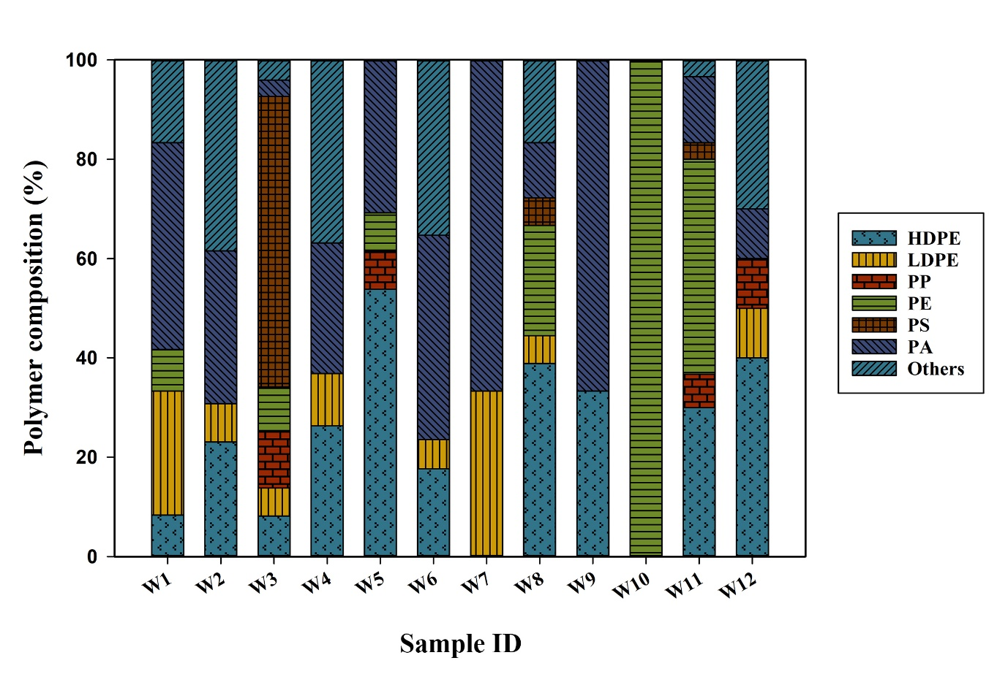
Supplementary Fig. S1. Polymer proportion of MPs

