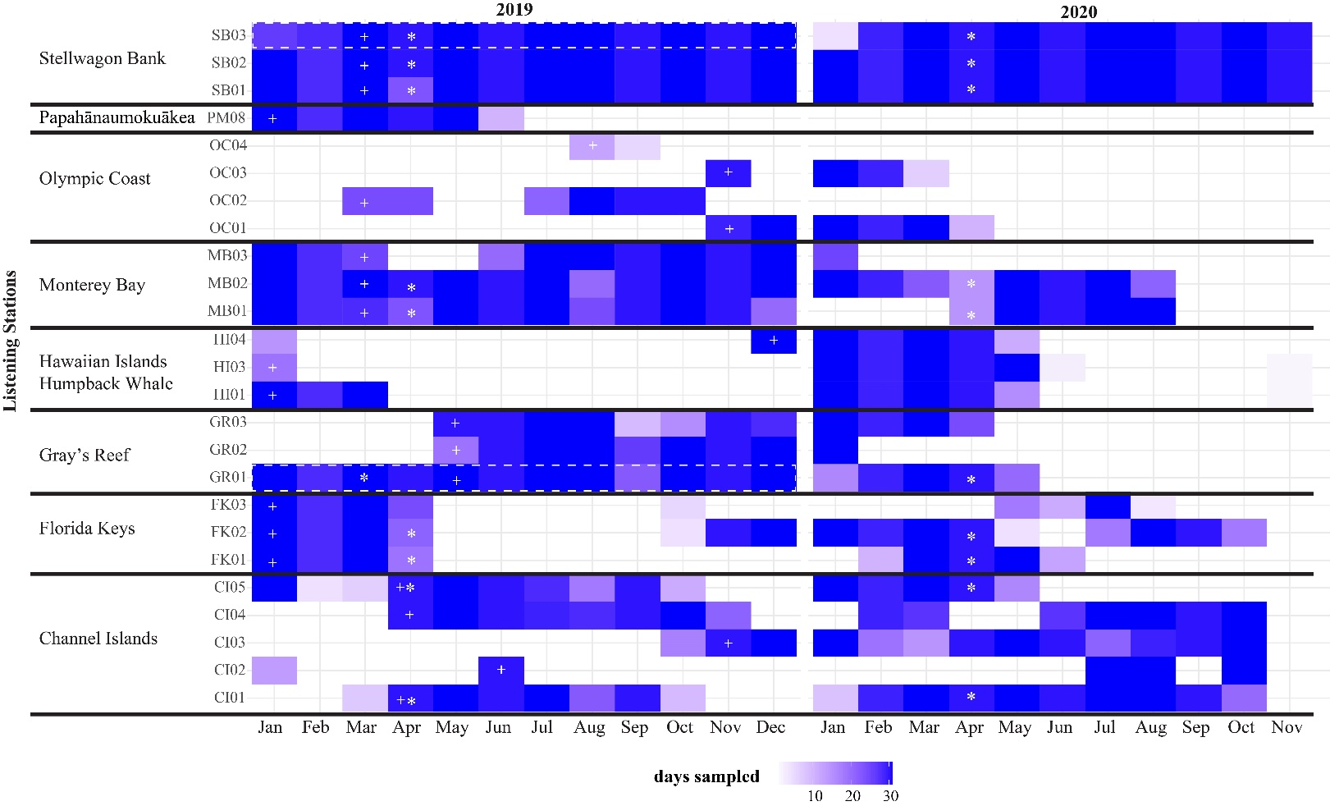
Figure S1: Passive acoustic monitoring data from each listening station used in the vessel noise analysis (n=25 locations). Plus signs in boxes (+) indicate station-months used in all the 2019 analyses (Figures 2-3). Listening stations used in seasonal comparison are marked with white dashed boxes (Figure 4). Months used in the early COVID-19 pandemic comparison are marked with an asterisk (*) (Figure 5). Shading represents days with data for a given month that was available at the time of analysis (https://sanctsound.portal.axds.co/). There was missing data (blank months) because of equipment loss, equipment failure, seasonal recording schedule, or data quality issues.

Table S1: Vessel Noise Detector settings
Sanctuary | Summary of vessel noise detector settings. Detector requires MATLAB 2016b or newer and signal processing and statistics toolboxes  https://github.com/MarineBioAcousticsRC/Triton/tree/master/Remoras/Ship-Detector
Stellwagen Bank National Marine Sanctuary | Low band limit (Hz): 50-3,000, Medium band limit:3,000-10,000, High band limit: 10,000-17,000, Close passage duration threshold (s): 25, Distant passage duration threshold (s): 30, Received level threshold (%): 0.03, Time between passages (h): 0.1, Buffer time (min): 4, Window Size (h): 2, Sliding Time Overlapping Windows (h) 0.5.
Grays Reef National Marine Sanctuary | Low band limit (Hz): 100-2,000, Medium band limit: 2,000-3,000, High band limit: 3,000-4,000, Close passage duration threshold (s): 40, Distant passage duration threshold (s):45, Received level threshold (%): 0.03, Time between passages (h): 0.1, Buffer time (min): 4, Window Size (h): 1, Sliding Time Overlapping Windows (h) 0.5.
Florida Keys National Marine Sanctuary | Low band limit (Hz):100-3,000, Medium band limit: 3,000-4,000, High band limit: 4,000-5,000, Close passage duration threshold (s): 20, Distant passage duration threshold (s):25, Received level threshold (%): 0.01, Time between passages (h): 0.01, Buffer time (min): 4, Window Size (h): 1, Sliding Time Overlapping Windows (h) 0.5.
Channel Islands National Marine Sanctuary | Low Band=100-5,000 Hz, Medium Band=5,000-10,000 Hz, High Band=10,000–48,000 Hz, Close Passage Duration Threshold: 50 s, Distant Passage Duration Threshold: 150 s, Relative Threshold Level = 0.05%, Time Between Passages = 0.01 hr, Buffer Time (min): 5, Window Size (h): 2, Sliding Time Overlapping Windows (h) = 0.5
Monterey Bay National Marine Sanctuary | Low Band=100-5,000 Hz, Medium Band=5,000-10,000 Hz, High Band=10,000–48,000 Hz, Close Passage Duration Threshold: 50 s, Distant Passage Duration Threshold: 150 s, Relative Threshold Level = 0.05%, Time Between Passages = 0.01 hr, Buffer Time (min): 5, Window Size (h): 2, Sliding Time Overlapping Windows (h) = 0.5
Olympic Coast National Marine Sanctuary | Low Band=100-5,000 Hz, Medium Band=5,000-10,000 Hz, High Band=10,000–48,000 Hz, Close Passage Duration Threshold: 50 s, Distant Passage Duration Threshold: 150 s, Relative Threshold Level = 0.05%, Time Between Passages = 0.01 hr, Buffer Time (min): 5, Window Size (h): 2, Sliding Time Overlapping Windows (h) = 0.5
Hawaiian Islands Humpback Whale Marine Sanctuary HI01 | Low band limit (Hz): 100-3,000, Medium band limit: 3,000-4,000, High band limit: 4,000-7,500, Close passage duration threshold (s): 20, Distant passage duration threshold (s): 50, Received level threshold (%): 0.01, Time between passages (h): 0.01, Buffer time (min): 1, Window Size (h): 1, Sliding Time Overlapping Windows (h) 0.5.
Hawaiian Islands Humpback Whale Marine Sanctuary HI03 | Low band limit (Hz): 100-3,000, Medium band limit: 3,000-5,000, High band limit: 5,000-7,5000, Close passage duration threshold (s): 40, Distant passage duration threshold (s): 45, Received level threshold (%): 0.01, Time between passages (h): 0.1, Buffer time (min): 0.083, Window Size (h): 1, Sliding Time Overlapping Windows (h) 0.05.
Hawaiian Islands Humpback Whale Marine Sanctuary HI04 | Low band limit (Hz): 100-5,000, Medium band limit: 5,000-7,000, High band limit: 7,000-15,000, Close passage duration threshold (s): 40, Distant passage duration threshold (s): 45, Received level threshold (%): 0.1, Time between passages (h): 0.1, Buffer time (min): 5, Window Size (h): 1, Sliding Time Overlapping Windows (h) 0.5.
Hawaiian Islands Humpback Whale Marine Sanctuary HI05 | Low band limit (Hz): 100-3,000, Medium band limit: 3,000-4,000, High band limit: 4,000-7,500, Close passage duration threshold (s): 20, Distant passage duration threshold (s): 50, Received level threshold (%): 0.01, Time between passages (h): 0.01, Buffer time (min): 1, Window Size (h): 1, Sliding Time Overlapping Windows (h) 0.5.
Hawaiian Islands Humpback Whale Marine Sanctuary HI06 | Low band limit (Hz): 100-3,000, Medium band limit: 3,000-7,500, High band limit: 7,500-15,000, Close passage duration threshold (s) 40: , Distant passage duration threshold (s): 45, Received level threshold (%): 0.05, Time between passages (h): 0.1, Buffer time (min): 1, Window Size (h): 1, Sliding Time Overlapping Windows (h) 0.3.
Papahānaumokuākea Marine National Monument  PM08 | Low band limit (Hz): 100-1,000, Medium band limit: 1,000-3,000, High band limit: 3,000-5,000, Close passage duration threshold (s): 100, Distant passage duration threshold (s): 200, Received level threshold (%): 0.1, Time between passages (h): 0.25, Buffer time (min): 5, Window Size (h): 2, Sliding Time Overlapping Windows (h) 1.

Table S2: Additional vessel noise metrics
Description | Figure | Interpretation
A sum of the durations of all AIS vessel tracks within a 10 km buffer. Metric is calculated as an average of all days in a month. | Not shown | Higher values indicate vessels are nearby for a higher percentage of the time and likely overlapping vessels present within the 10 km buffer.
Total of all unique vessels equipped with AIS within a 10 km buffer around a listening station. Metric is calculated as both an average and standard deviation of each day of a month. | Not shown | Higher values indicate listening stations with predictable routes nearby with a diversity of transiting vessels (e.g., commercial shipping routes). Higher variation indicates vessel activity related to day of the week, weather, or time of the month.
Total of all vessel dominant periods in the acoustic data. Metric is calculated as both an average and standard deviation of each day of a month. | Not shown | Higher values indicate listening stations with predictable routes nearby either by a mix of vessels or routine vessel traffic. Higher variation indicates vessel activity related to day of the week, weather, or time of the month.

