Supplementary Information
Supplementary Table 1 Descriptive statistics of PM_{2.5}, PM₁₀, TSP, CO, NO₂ and SO₂ in Summer, Autumn, Winter, and Spring along the sample transect of Faisalabad’s roads.
Seasons | Pollutants | Units | Mean | St. Dev | CV  prop | Skewness | Kurtosis | Min | Max
Summer | PM_{2.5} | µg m⁻³ | 378.13 | 149.51 | 0.4 | -0.7 | -0.79 | 98 | 572
Summer | PM₁₀ | µg m⁻³ | 502.70 | 187.16 | 0.37 | -0.35 | -1.23 | 183 | 776
Summer | TSP | µg m⁻³ | 1005.73 | 310.21 | 0.31 | -0.52 | -1.01 | 465 | 1453
Summer | CO | mg m⁻³ | 27.18 | 17.72 | 0.65 | 0.49 | -1.06 | 3.25 | 57.68
Summer | NO₂ | µg m⁻³ | 71.98 | 36.56 | 0.51 | 0.39 | -0.94 | 25.22 | 141.21
Summer | SO₂ | µg m⁻³ | 64.70 | 43.00 | 0.66 | 0.95 | 0.75 | 5.62 | 168.21
Autumn | PM_{2.5} | µg m⁻³ | 321.33 | 144.62 | 0.45 | -0.57 | -1.04 | 63 | 514
Autumn | PM₁₀ | µg m⁻³ | 468.63 | 193.05 | 0.41 | -0.26 | -1.22 | 149 | 747
Autumn | TSP | µg m⁻³ | 926.03 | 273.36 | 0.3 | -0.65 | -0.84 | 396 | 1330
Autumn | CO | mg m⁻³ | 21.66 | 13.66 | 0.63 | 0.87 | -0.51 | 3.23 | 52.57
Autumn | NO₂ | µg m⁻³ | 53.65 | 29.9 | 0.56 | 0.27 | -1.48 | 13.87 | 98.21
Autumn | SO₂ | µg m⁻³ | 42.07 | 26.33 | 0.63 | -0.11 | -1.53 | 3.13 | 79.36
Winter | PM_{2.5} | µg m⁻³ | 345.93 | 152.69 | 0.44 | 2-0.48 | -0.59 | 59 | 602
Winter | PM₁₀ | µg m⁻³ | 403.3 | 185.07 | 0.46 | -0.32 | -1.13 | 93 | 674
Winter | TSP | µg m⁻³ | 871.3 | 311.14 | 0.36 | -0.68 | -0.91 | 234 | 1256
Winter | CO | mg m⁻³ | 26.64 | 14.75 | 0.55 | 0.38 | -0.9 | 2.21 | 54.04
Winter | NO₂ | µg m⁻³ | 57.04 | 31.92 | 0.56 | 0.03 | -1.23 | 6.57 | 110.21
Winter | SO₂ | µg m⁻³ | 50.82 | 33.03 | 0.65 | 0.04 | -1.51 | 4.29 | 99.24
Spring | PM_{2.5} | µg m⁻³ | 352.2 | 140.64 | 0.4 | -0.55 | -0.76 | 105 | 597
Spring | PM₁₀ | µg m⁻³ | 469.87 | 186.53 | 0.4 | -0.31 | -0.92 | 110 | 781
Spring | TSP | µg m⁻³ | 964.07 | 276.89 | 0.29 | -0.8 | -1.02 | 454 | 1255
Spring | CO | mg m⁻³ | 15.93 | 11.06 | 0.69 | 1.34 | 1.27 | 4.74 | 47.81
Spring | NO₂ | µg m⁻³ | 35.02 | 17.36 | 0.5 | 0.33 | -0.87 | 8.54 | 68.27
Spring | SO₂ | µg m⁻³ | 39.28 | 26.39 | 0.67 | 0.6 | -0.61 | 3.21 | 92.29
Supplementary Table 2 Questions asked from each individuals
Survey Questions | Scale
Survey Questions | 1 | 2 | 3 | 4 | 5
Q 1. Major source of air pollution
- Industrial (chemical, textile, oil refinery) Exhaust | 0 | 1 | 2 | 3 | 14
- Vehicular Exhaust | 0 | 3 | 0 | 7 | 10
- Crop Burning | 0 | 3 | 0 | 7 | 10
- Use of Chemicals in Agriculture | 0 | 0 | 1 | 8 | 11
- Domestic fossil fuel burning | 4 | 5 | 1 | 0 | 10
- Brick kiln | 0 | 0 | 0 | 0 | 20
Q 2. Effect of air pollution
- Difficulty in Breathing | 0 | 0 | 0 | 0 | 20
- Respiratory diseases | 10 | 0 | 0 | 0 | 10
- Skin Allergy | 1 | 7 | 7 | 0 | 5
- Emphysema | 0 | 0 | 0 | 5 | 15
- Lung Cancer | 0 | 1 | 10 | 4 | 5
- Poor Visibility | 0 | 0 | 6 | 7 | 7
- Eye Irritation | 3 | 4 | 2 | 5 | 6
- Asthma Indices | 0 | 1 | 9 | 6 | 4
Q 3. Is Air pollution injurious for following natural resources?
- Atmosphere | 0 | 0 | 0 | 7 | 13
- Water (River, Lakes, Canals etc) | 0 | 0 | 6 | 12 | 2
- Land/Agricultural Soil | 0 | 0 | 9 | 9 | 2
- Humans | 0 | 1 | 5 | 7 | 7
Q 4. Suggestions to improve air
- Individual level cleaning practices according to Islam? | 0 | 0 | 0 | 0 | 20
- Keep your surrounding clean without waiting for government? | 0 | 0 | 0 | 0 | 20
- Should Energy efficient technologies be used? | 0 | 0 | 0 | 0 | 20
- Polluter pay principle should be implemented | 4 | 0 | 0 | 0 | 16
- Public transport should be used instead of private vehicles? | 0 | 0 | 0 | 0 | 20
- Enforcement of air pollution control laws with strict fines? | 0 | 0 | 0 | 0 | 20

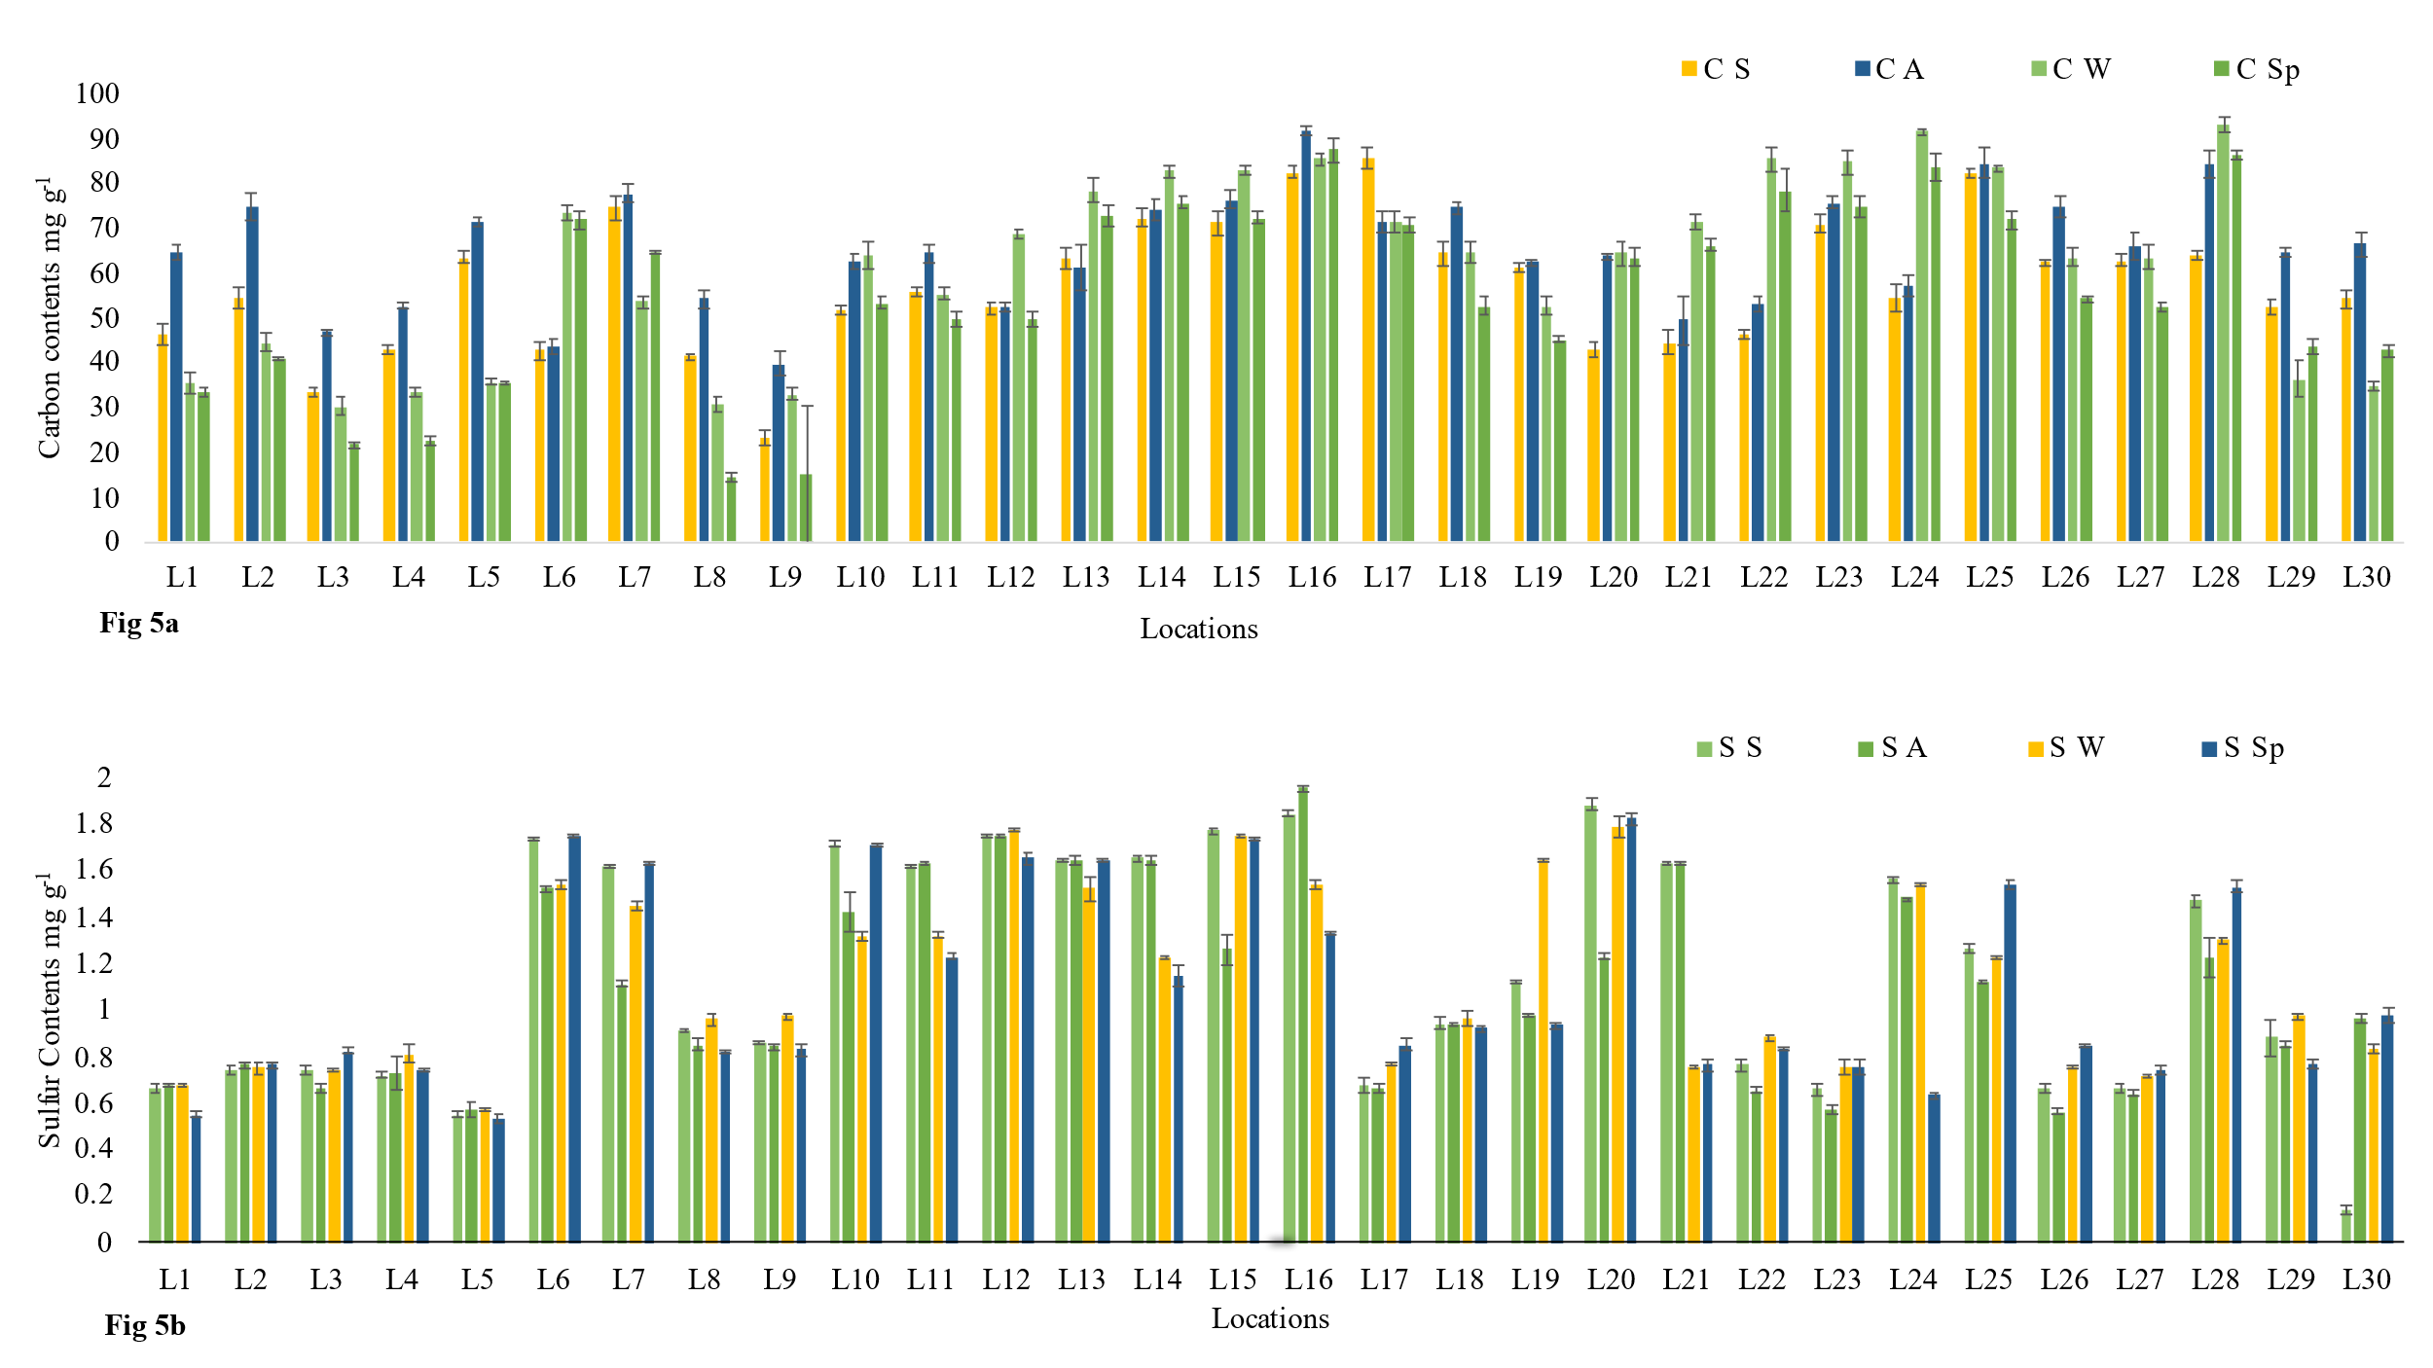
Carbon and Sulfur contents in collected dust samples from each location in mg g⁻¹. Individual location data as used for Figs 5a and 5b. Site means and SE are shown CS and SS are Summer values for carbon and sulfur, CA and SA are Autumn values, CW and SW are Winter values and CSp and SSp are Spring values.

