Surface water monitoring of chemicals associated with animal husbandry in an agricultural region in the Netherlands using passive sampling
Nikola Rakonjac ^{a *}, Erwin Roex ^{b}, Henry Beeltje ^{c}
* Corresponding author: nikola.rakonjac@wur.nl
Address: Droevendaalsesteeg 3, 6708PB Wageningen, The Netherlands
ª Soil Physics and Land Management Group, Wageningen University, Wageningen, the Netherlands
^{b} National Institute for Public Health and the Environment (RIVM), the Netherlands
^{c} AQUON, the Netherlands
Supplementary Material

SM1. Targeted compounds, quantified amounts, with LOD and LOQ values
SM2. Recovery rates
SM3. Time integrative Uptake Coefficient (TUC)
SM4. Additional details on the methods and instrument settings
SM5. Daily precipitation
SM6. Internal standards used for extraction procedure

SM1. Targeted compounds, quantified amounts, with LOD and LOQ values

Locations 1, 6, and 2, detection technique, LOD and LOQ values
Locations 5, 8, 3, 4, and 7

SM2. Recovery rates

Tv_{r} – average recovery of the 8 recovery tests
S_{r} – standard deviation among the 8 recovery tests
vc_{r} – coefficient of variation, computed as given below.
U_{r} – precision, computed as given below.
Ue_{r} – Measurement uncertainty, computed as given below.
Equations:
vc_{r} = (S_{r})/(Tv_{r}) * 100
U_{r} = (Tv_{r}) – 100
Ue_{r} = sqrt [(vc_{r})² + (U_{r})² + U_{j}²]*2

SM3. Time integrative Uptake Coefficient (TUC)
TUC values per compound and location
 |  | TUC |  |  |  |  |  |  |  | Average TUC
 |  | Loc. 1 | Loc. 2 | Loc. 3 | Loc. 4 | Loc. 5 | Loc. 6 | Loc. 7 | Loc. 8 | per compound | excl.  Loc. 8
estrone |  | 2.86 | 2.03 | 0.83 |  | 2.15 | 1.89 | 4.50 | 7.42 | 3.10 | 2.38
fipronil sulfone |  |  |  |  |  |  |  | 0.55 |  | 0.55 | 0.55
florfenicol |  | 0.61 | 0.78 | 0.47 | 0.52 | 1.04 | 1.23 | 0.53 | 1.32 | 0.81 | 0.74
flubendazole |  | 1.39 | 1.06 | 0.91 | 1.53 | 1.44 | 1.63 | 1.06 | 2.53 | 1.44 | 1.29
flumequine |  | 1.27 | 0.92 | 0.96 | 1.05 | 1.20 | 2.18 | 1.54 | 1.52 | 1.33 | 1.30
lincomycin |  |  |  |  |  | 0.86 | 1.18 |  |  | 1.02 | 1.02
sulfadiazine |  | 0.78 | 0.90 | 0.06 | 2.18 | 1.58 | 1.77 | 0.62 | 8.00 | 1.98 | 1.13
sulfamethazine |  | 0.93 | 0.87 | 0.41 | 1.07 | 1.16 | 1.60 | 0.67 | 2.43 | 1.14 | 0.96
sulfamethoxazole |  | 0.34 |  | 0.12 |  | 0.73 | 1.40 |  | 2.28 | 0.97 | 0.65
sulfamethoxypyridazine |  | 0.67 | 0.7 | 0.25 | 0.69 | 1.25 | 1.61 |  | 2.26 | 1.06 | 0.86
sulfapyridine |  |  |  |  |  | 0.57 |  |  |  | 0.57 | 0.57
tilmicosin |  |  | 1.85 | 0.14 | 2.18 | 3.92 | 1.09 | 1.13 | 3.46 | 1.97 | 1.72
trimethoprim |  |  |  | 0.16 |  | 0.75 | 0.82 |  | 2.10 | 0.96 | 0.58
BAC-C12 |  | 96.70 | 3.34 | 0.89 | 2.42 | 2.14 | 4.23 | 1.86 | 6.36 | 14.74 | 15.94
BAC-C14 |  | 123.03 | 3.52 | 1.17 | 2.15 | 2.20 | 4.96 | 1.90 | 3.69 | 17.83 | 19.85
BAC-C16 |  | 106.64 |  |  |  | 1.51 |  |  |  | 54.08 | 54.08
BAC-C18
DDAC-C10 |  | 1.48 | 1.08 |  | 0.90 | 1.13 | 2.79 | 0.64 | 11.02 | 2.72 | 1.34
Average TUC | per location | 28.06 | 1.55 | 0.53 | 1.47 | 1.48 | 2.03 | 1.36 | 4.18
Average TUC | excl. disinfectants | 1.11 | 1.14 | 0.43 | 1.32 | 1.39 | 1.49 | 1.32 | 3.33

SM4. Additional details on the methods and instrument settings
VPs
Analysis column: GEMINI NX C18
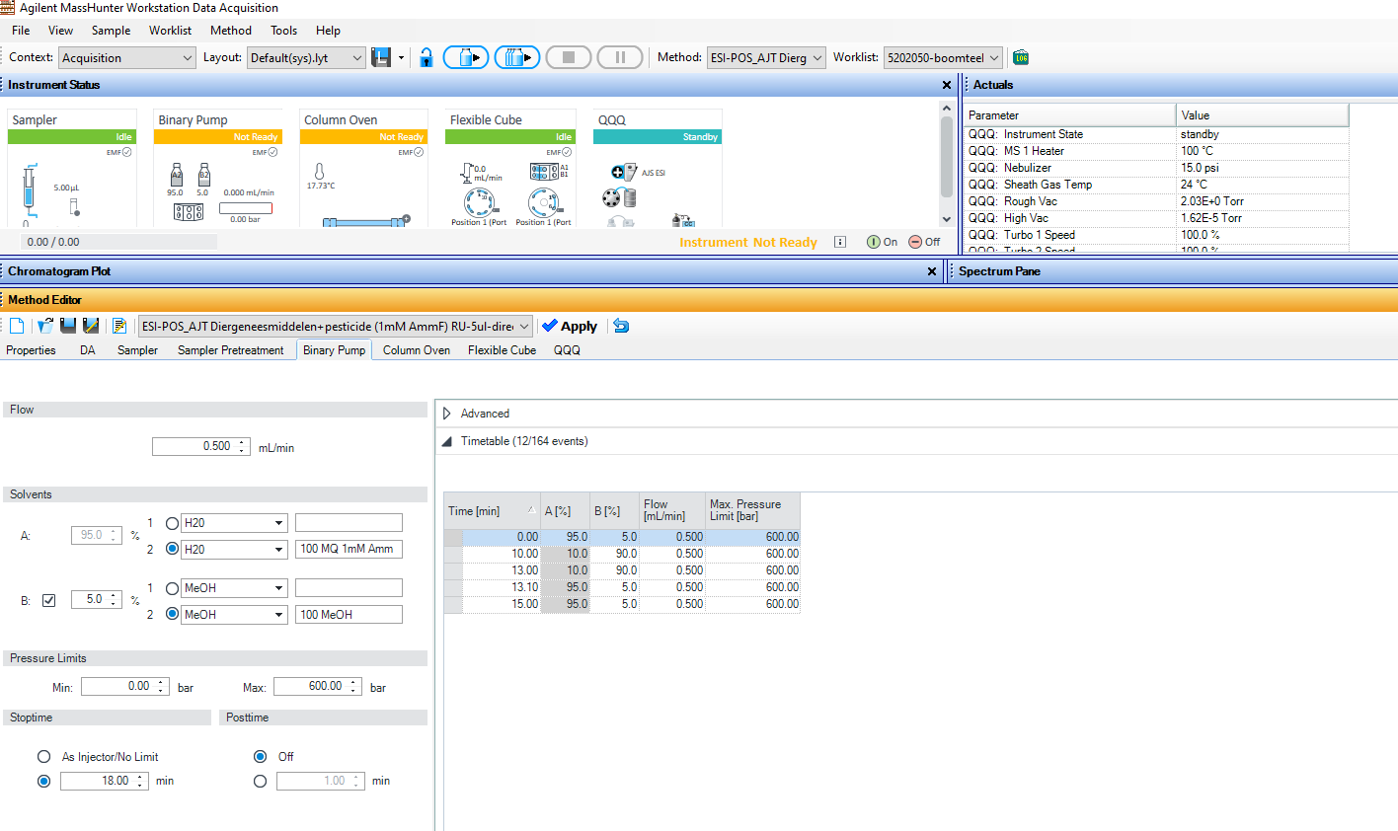
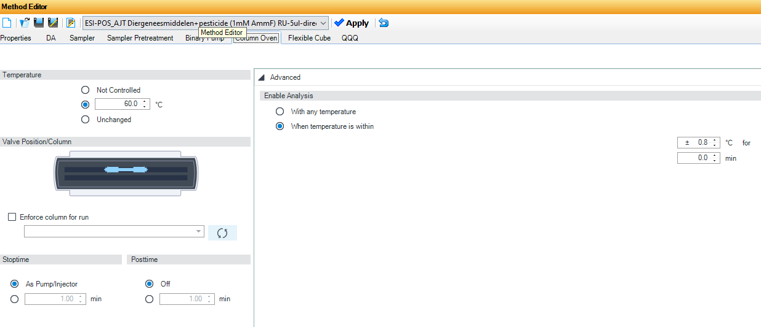
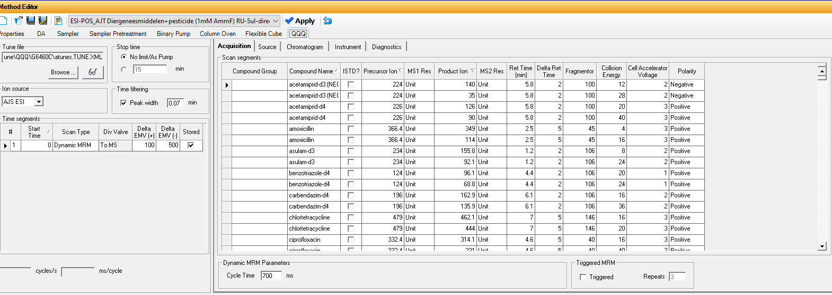
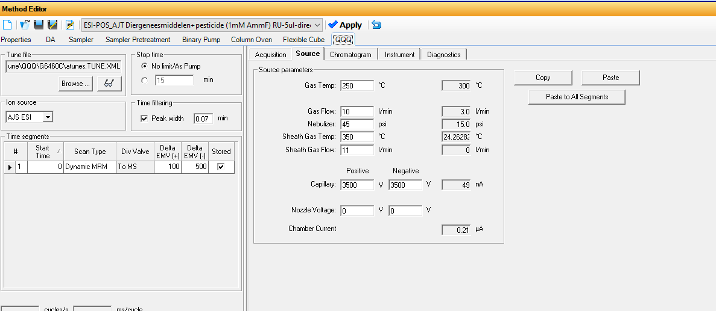

Hormones
Analysis column: Gemini NX C18

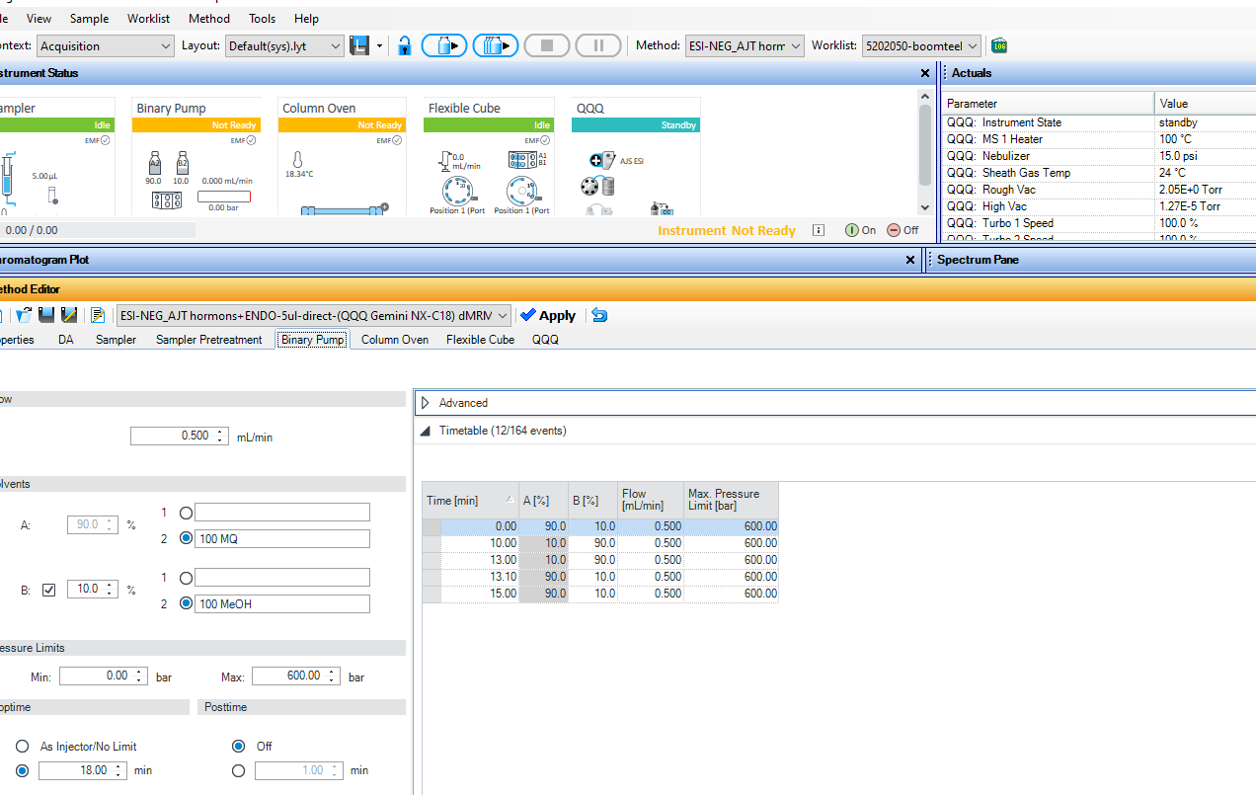

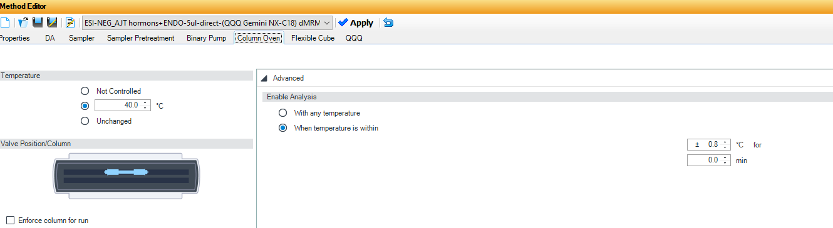

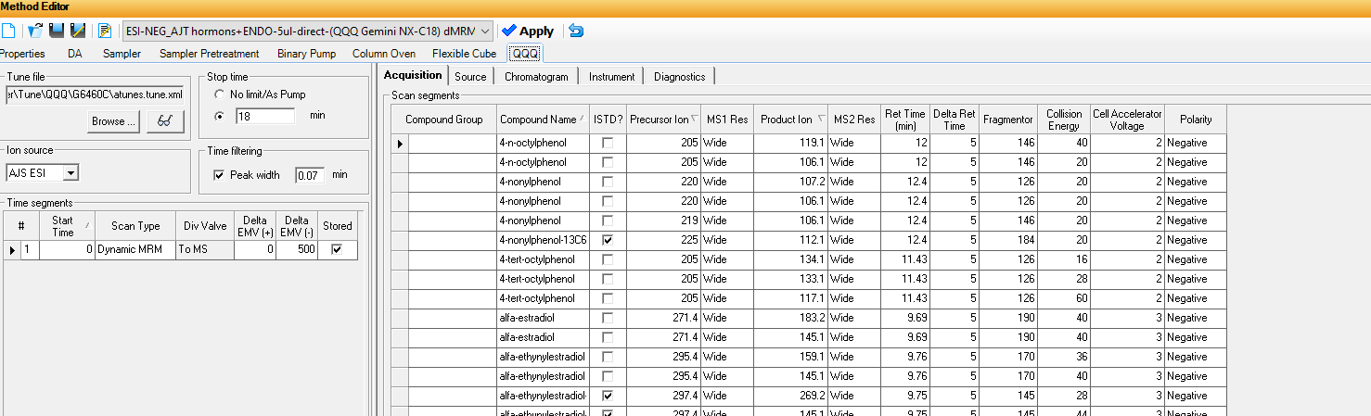
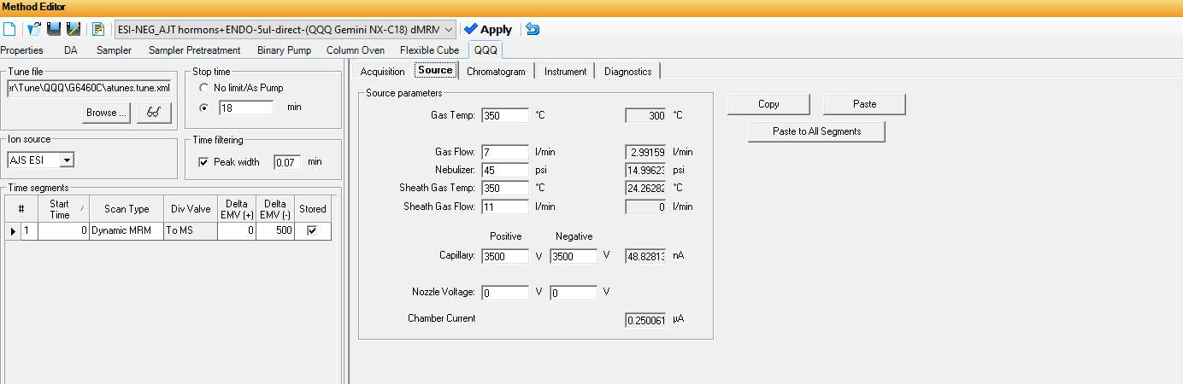

Disinfectants
Analysis: Kinetex Biphenyl

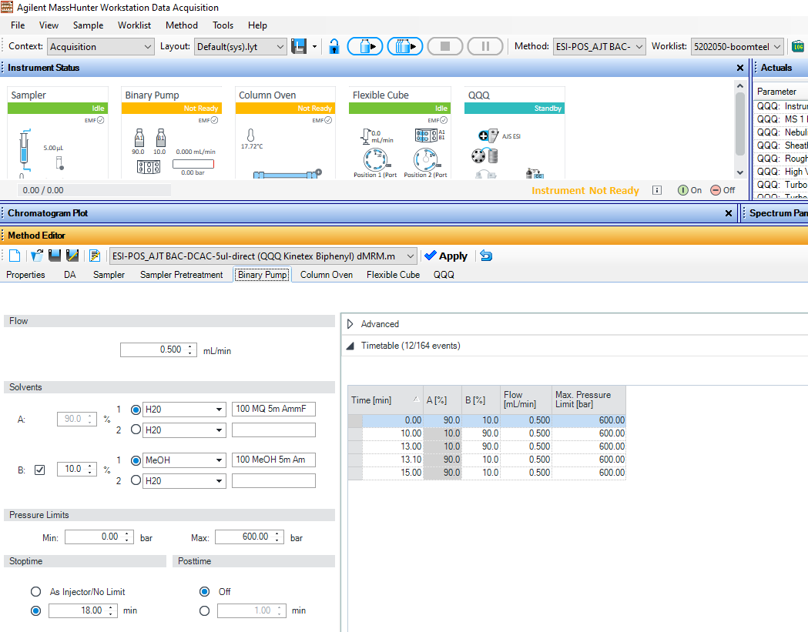
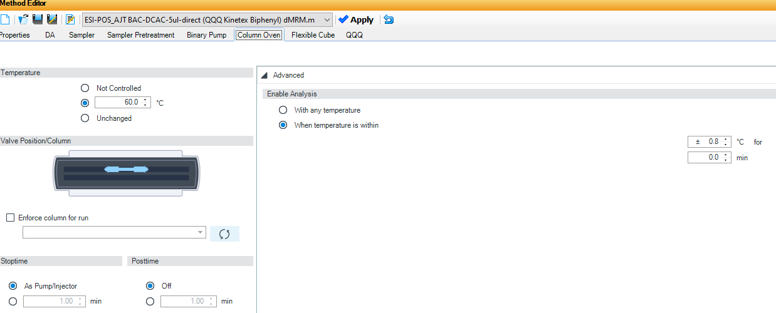
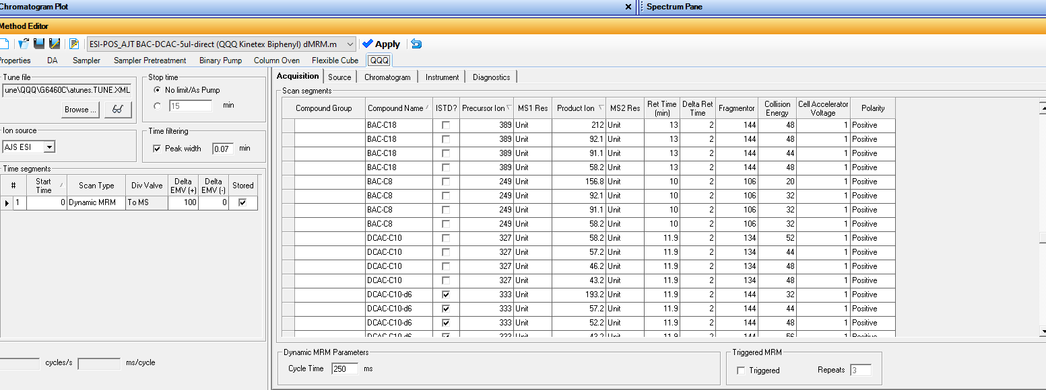
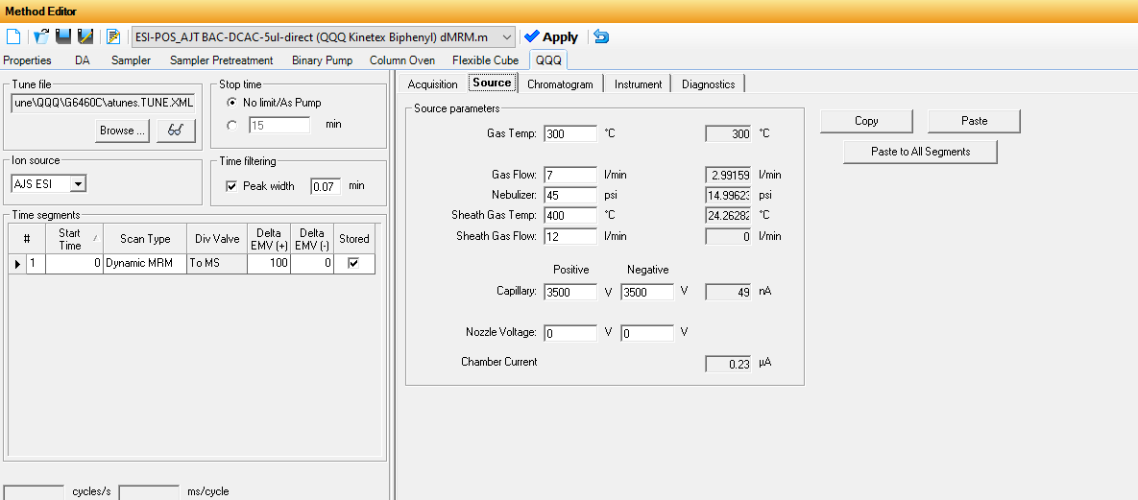

SM5. Daily precipitation
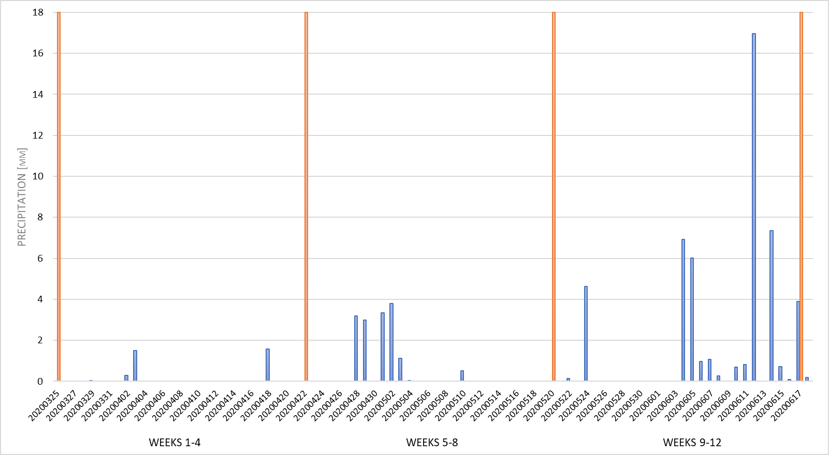
This graph depicts the precipitation trends on a daily basis within the specified region during the sampling period. Blue bars – rainfall intensity, orange bars – days when the passive samplers were installed, changed, or collected.
SM6. Internal standards used for extraction procedure

- d6-didecyldimethylammonium iodide (HPC Standards; 674541) - disinfectants
- d7-benzyldimethyltetradecylammonium chloride (HPC Standards; 674611) - disinfectants
- benzotriazole-d4 (Sigma-Aldrich; 32566) - VPs
- erythromycin-13C2 (CIL; CLM-3672-MT-S) - VPs
- flubendazole-d3 (Sigma-Aldrich; 32839) - VPs
- naproxen-13C -d3 (CIL; CLM-7665-S) – VPs
- paracetamol-13C2 (CIL; CLM-3726-S) – VPs
- sulfadiazine-13C6 (Sigma-Aldrich; 32518) – VPs
- sulfamethoxazole-13C6 (CIL; CLM-6944-S) – VPs
- alfa-ethynylestradiol-13C2 (CIL; CLM-3375-S) - hormones
- estradiol-13C2 (CIL; CLM-803-S) - hormones
- estrone-13C2 (CIL; CLM-673-S) – hormones

