LIST OF SUPPLEMENTARY TABLES
Table S1. Confusion matrix adopted in the study for assessment of performance of RegCDI
Drought indicator class  RegCDI class | Non-drought (positive) | Drought (negative)
Non-drought (positive) | True Positive (TP) | False Positive (FP)
Drought (negative) | False Negative (FN) | True Negative (TN)

Table S2. Statistical metrics used for selection of the dataset representing different drought variables. Here, $M_{n}$ and $O_{n}$are respectively the $n^{th}$ modeled and observed value in the dataset which has sample size $N$
Sl. No. | Statistic | Equation
1 | Pearson correlation coefficient (PCC) | $\frac{N*\sum{M_{n}O_{n}}-\sum{M_{n}}\sum{O_{n}}}{\sqrt{\left(N*\sum{{M_{n}}^{2}-({\sum{M_{n})}}^{2}}\right)\left(N*\sum{{O_{n}}^{2}-({\sum{O_{n})}}^{2}}\right)}}$
2 | Average bias error (Bias) | $\frac{1}{N}\sum{\left(M_{n}-O_{n}\right)}$
3 | Root-mean-square error (RMSE) | $\sqrt{{\sum{{\left(M_{n}-O_{n}\right)}^{2}}}/N}$
Table S3. Performance metrics-based evaluation of (a) land surface temperature (LST) datasets versus GLDAS_VIC model dataset and (b) soil moisture datasets versus NRSC VIC model dataset. Average bias, coefficient of determination (R²) and root mean square error (RMSE) are used for evaluating the performance, and in the absence of field observations, the GLDAS_VIC and NRSC VIC datasets are adopted for ground-truthing.
(a) LST
 | MOD11C3 V006 versus GLDAS_VIC | FLDAS_NOAH01_C_GL_MV001 versus  GLDAS_VIC |  | GLDAS NOAH10_M V2.1 versus  GLDAS_VIC
Average Bias | -3.52 | 1.40 |  | 0.57
R² | 0.42 | 0.97 |  | 0.99
RMSE | 5.74 | 1.87 |  | 0.98
(b) Soil moisture
 | Bias corrected GLDAS_NOAH10_M 2.1 versus  NRSC VIC |  | Bias corrected FLDAS_NOAH01_C_GL_M 001 versus  NRSC VIC
Average Bias | -0.02 |  | -0.02
R² | 0.70 |  | 0.49
RMSE | 0.07 |  | 0.08
Table S4. Datasets selected in the study for agricultural drought monitoring
Drought indicator | Source | Spatial resolution | Time period
Precipitation | IMD | 0.25°, 1° | 2001-2019
Soil moisture | GLDAS_NOAH10_M V2.1 | 0.25°, 1° | 2001-2019
LST | GLDAS_NOAH10_M V2.1 | 0.25°, 1° | 2001-2019
Surface reflectance | MOD09GA | 500 m | 2001-2019

Table S5. Table showing correlation between the yield of Kharif paddy crop and drought severity based on indices of (a) soil moisture deficit, (b) vegetation health condition, and (c) crop-based water stress at different grid points at 1° resolution across the study area (along with the grid location). (Table form of Fig 5).
Grid No. | LAT | LON | SMCI | SMDI | SWDI-1 | SWDI-2 | VCI | TCI | NDWI | SIWSI-1 | SIWSI-2
1 | 20.5 | 82.5 | 0.70 | 0.27 | 0.06 | - | -0.36 | 0.85 | 0.65 | 0.10 | -0.11
2 | 19.5 | 82.5 | 0.84 | 0.13 | 0.63 | - | 0.07 | 0.70 | 0.30 | 0.09 | 0.10
3 | 22.5 | 83.5 | 0.24 | 0.26 | 0.54 | 0.59 | -0.01 | -0.11 | -0.22 | -0.17 | 0.10
4 | 21.5 | 83.5 | 0.48 | 0.01 | 0.29 | 0.53 | -0.63 | 0.74 | 0.33 | -0.01 | 0.16
5 | 20.5 | 83.5 | 0.61 | 0.29 | 0.22 | 0.13 | -0.56 | 0.54 | -0.20 | -0.17 | -0.46
6 | 19.5 | 83.5 | 0.53 | 0.33 | 0.37 | -0.05 | -0.07 | 0.17 | -0.06 | -0.19 | -0.49
7 | 22.5 | 84.5 | 0.29 | -0.16 | 0.43 | 0.40 | -0.04 | 0.65 | -0.07 | 0.11 | -0.11
8 | 21.5 | 84.5 | -0.05 | -0.19 | -0.18 | -0.29 | 0.33 | 0.24 | 0.47 | 0.56 | 0.59
9 | 20.5 | 84.5 | 0.28 | 0.33 | 0.26 | 0.47 | 0.62 | 0.31 | -0.01 | 0.16 | -0.32
10 | 19.5 | 84.5 | -0.17 | 0.08 | -0.37 | -0.40 | -0.20 | 0.54 | 0.25 | 0.31 | 0.00
11 | 22.5 | 85.5 | 0.00 | 0.01 | -0.37 | 0.06 | 0.39 | 0.66 | 0.41 | 0.46 | 0.58
12 | 21.5 | 85.5 | -0.63 | -0.44 | -0.62 | -0.61 | 0.71 | 0.56 | 0.66 | 0.57 | 0.46
13 | 20.5 | 85.5 | 0.29 | 0.40 | 0.43 | 0.45 | -0.17 | 0.76 | -0.38 | 0.29 | 0.02
14 | 22.5 | 86.5 | 0.53 | 0.43 | 0.35 | 0.08 | 0.01 | 0.72 | 0.40 | 0.16 | -0.08
15 | 21.5 | 86.5 | 0.23 | 0.24 | 0.41 | 0.48 | 0.39 | 0.75 | 0.54 | 0.16 | -0.02
16 | 20.5 | 86.5 | 0.78 | 0.31 | 0.46 | 0.26 | -0.03 | 0.39 | -0.19 | -0.25 | -0.24
17 | 18.5 | 82.5 | 0.53 | -0.02 | 0.34 | 0.03 | 0.14 | 0.28 | 0.63 | 0.45 | 0.55
18 | 18.5 | 81.5 | 0.27 | -0.27 | -0.19 | - | -0.50 | 0.02 | 0.03 | 0.04 | -0.42

Table S6. Table showing correlation between the standardized yield of Kharif paddy crop and drought severity based on indices of (a) soil moisture deficit, (b) vegetation health condition, and (c) crop-based water stress at different grid points at 1° resolution across the study area. (Table form of Figure 6)
Grid No. | LAT | LON | SMCI | SMDI | SWDI-1 | SWDI-2 | VCI | TCI | NDWI | SIWSI-1 | SIWSI-2
1 | 20.5 | 82.5 | 0.69 | 0.22 | 0.05 | - | -0.33 | 0.86 | 0.63 | 0.16 | -0.03
2 | 19.5 | 82.5 | 0.80 | 0.05 | 0.66 | - | 0.06 | 0.72 | 0.20 | 0.01 | 0.01
3 | 22.5 | 83.5 | 0.27 | 0.13 | 0.60 | 0.67 | -0.03 | -0.03 | -0.39 | -0.36 | -0.08
4 | 21.5 | 83.5 | 0.33 | 0.00 | 0.42 | 0.59 | -0.59 | 0.74 | 0.39 | -0.03 | 0.02
5 | 20.5 | 83.5 | 0.77 | 0.37 | 0.52 | - | -0.57 | 0.57 | -0.30 | -0.24 | -0.44
6 | 19.5 | 83.5 | 0.48 | 0.26 | 0.38 | -0.06 | -0.03 | 0.35 | 0.06 | -0.02 | -0.34
7 | 22.5 | 84.5 | 0.28 | -0.10 | 0.44 | 0.35 | 0.07 | 0.77 | -0.12 | -0.06 | -0.16
8 | 21.5 | 84.5 | 0.05 | -0.18 | -0.26 | -0.36 | 0.26 | 0.33 | 0.41 | 0.52 | 0.58
9 | 20.5 | 84.5 | 0.25 | 0.32 | 0.22 | 0.49 | 0.51 | 0.44 | -0.17 | 0.02 | -0.40
10 | 19.5 | 84.5 | -0.16 | 0.01 | -0.45 | -0.48 | -0.13 | 0.67 | 0.13 | 0.18 | -0.12
11 | 22.5 | 85.5 | -0.11 | -0.08 | -0.52 | -0.11 | 0.52 | 0.80 | 0.54 | 0.54 | 0.66
12 | 21.5 | 85.5 | -0.59 | -0.44 | -0.69 | -0.65 | 0.69 | 0.51 | 0.66 | 0.56 | 0.44
13 | 20.5 | 85.5 | 0.29 | 0.40 | 0.43 | 0.45 | -0.17 | 0.76 | -0.38 | 0.29 | 0.02
14 | 22.5 | 86.5 | 0.51 | 0.40 | 0.35 | 0.07 | 0.01 | 0.70 | 0.37 | 0.12 | -0.11
15 | 21.5 | 86.5 | 0.23 | 0.24 | 0.41 | 0.48 | 0.39 | 0.75 | 0.54 | 0.16 | -0.02
16 | 20.5 | 86.5 | 0.42 | 0.14 | 0.66 | 0.24 | 0.15 | 0.55 | 0.38 | 0.39 | 0.37
17 | 18.5 | 82.5 | 0.60 | -0.02 | 0.36 | 0.06 | 0.13 | 0.30 | 0.66 | 0.40 | 0.46
18 | 18.5 | 81.5 | 0.27 | -0.27 | -0.19 | - | -0.50 | 0.02 | 0.03 | 0.04 | -0.42

LIST OF SUPPLEMENTARY FIGURES

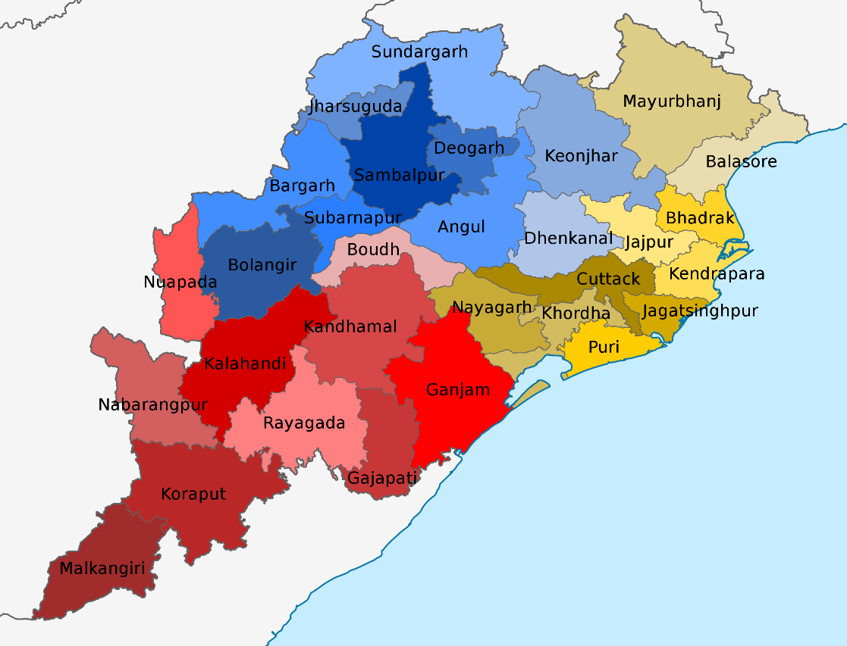
Figure S1. Map of Odisha (study area) representing all the States within it.

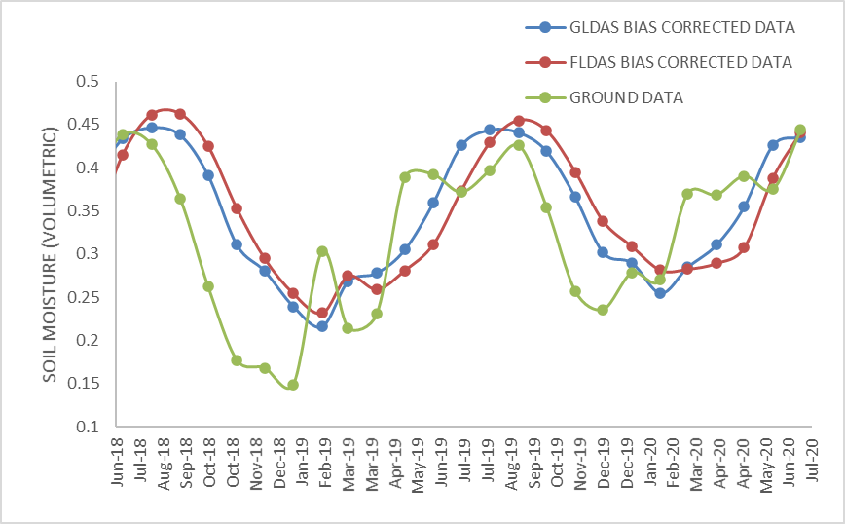
Figure S2. Time series of monthly scale soil moisture (m³/m³) datasets from different sources with bias correction applied at the sample location (21.5° N, 86.5° E).

