Supplementary Materials

Figure S1. The model impact, molecular and pathophysiological mechanisms of PM_{2.5} on cardiovascular mortality (Feng et al. 2023).

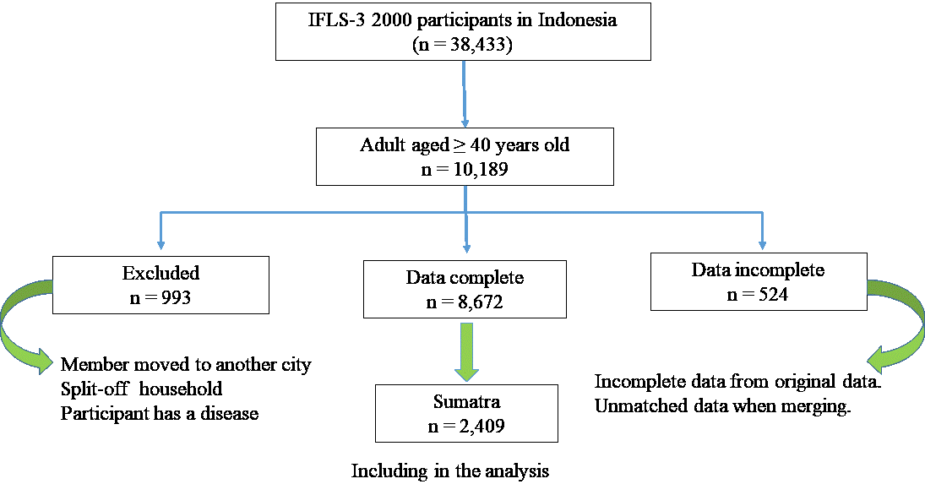
Figure S2. The selection study population in Sumatra Island, IFLS-3.

Table S1. PM_{2.5} data from QGIS software, in Sumatra Island, 2000-2014.
Years | Mean annual PM_{2.5} (µg/m³) | Maximum PM_{2.5} (µg/m³)
2000 | 8.71 | 32
2001 | 9.61 | 31
2002 | 13.81 | 33
2003 | 12.72 | 32
2004 | 14.24 | 44
2005 | 14.27 | 44
2006 | 17.48 | 60
2007 | 13.97 | 32
2008 | 13.28 | 32
2009 | 14.63 | 40
2010 | 11.94 | 31
2011 | 11.67 | 31
2012 | 14.91 | 40
2013 | 12.38 | 32
2014 | 15.59 | 40

Table S2. Hazard ratios of mortality associated with 10 µg/m³ increase in average PM_{2.5} – stratified by education level.
Cause of death | Low (<12 y) | High (≥12 y) | Interaction  p-value
All natural causes | 1.26 (1.06, 1.45)** | 1.12 (1.03, 1.22)* | 0.63
Cardiovascular | 1.32 (1.08, 1.61)** | 1.07 (1.02, 1.12)** | 0.47
Respiratory | 1.21 (1.02, 1.44)* | 1.09 (1.01, 1.18)* | 1.02
*p<0.05; **p<0.01.

