B
A
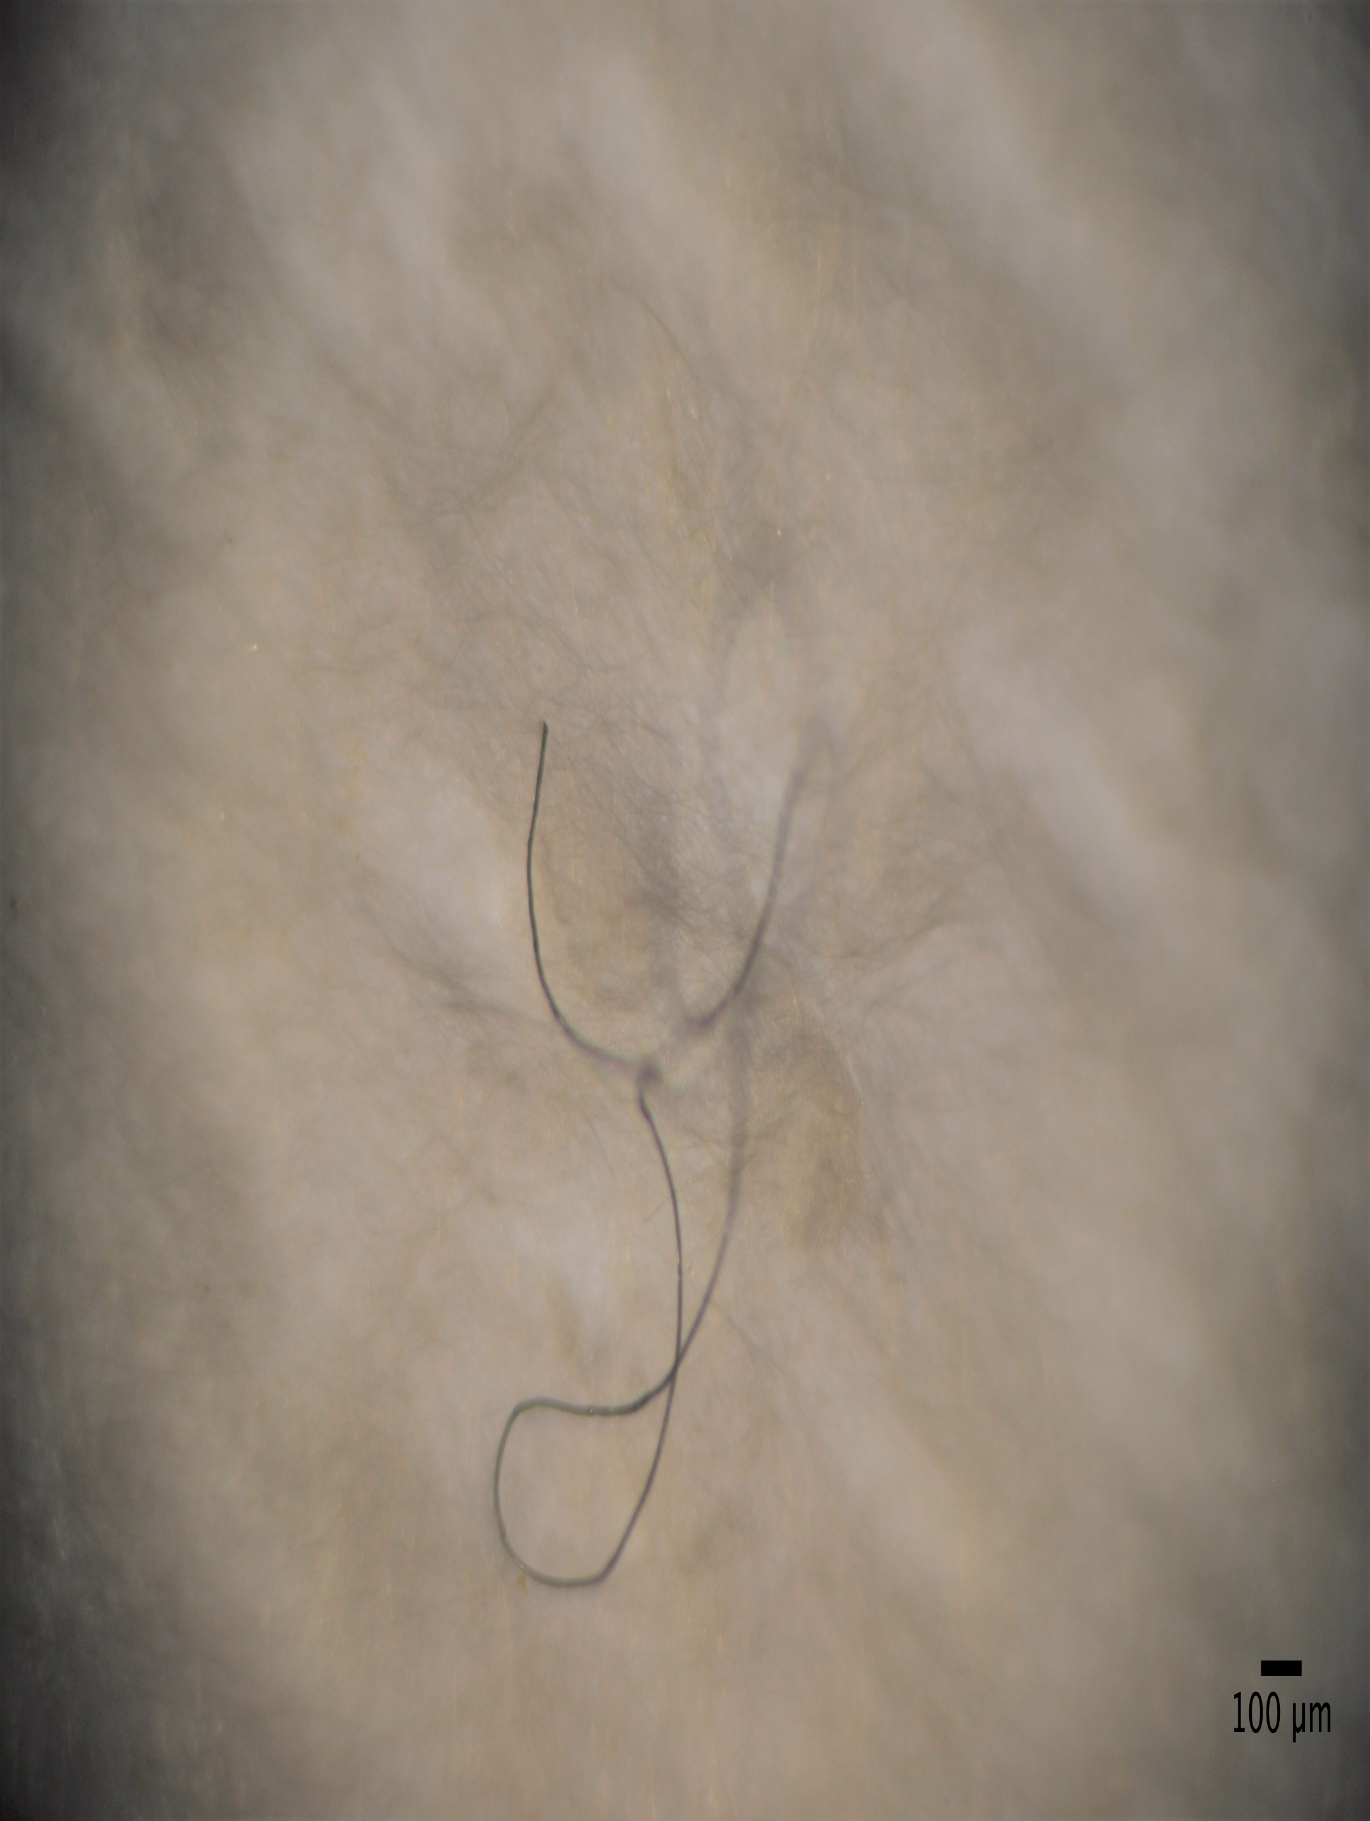
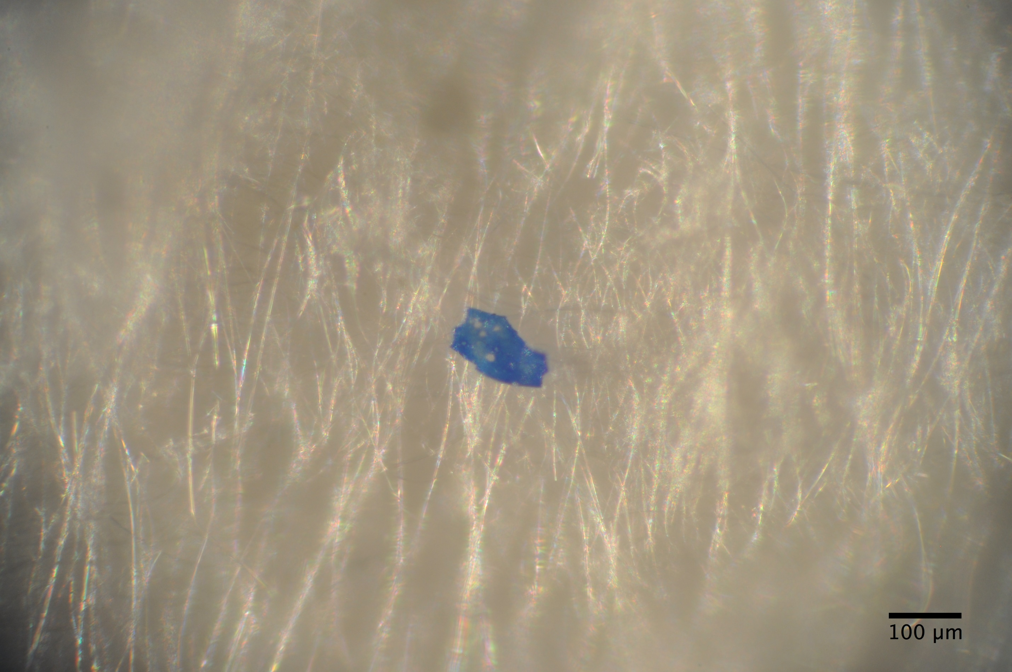
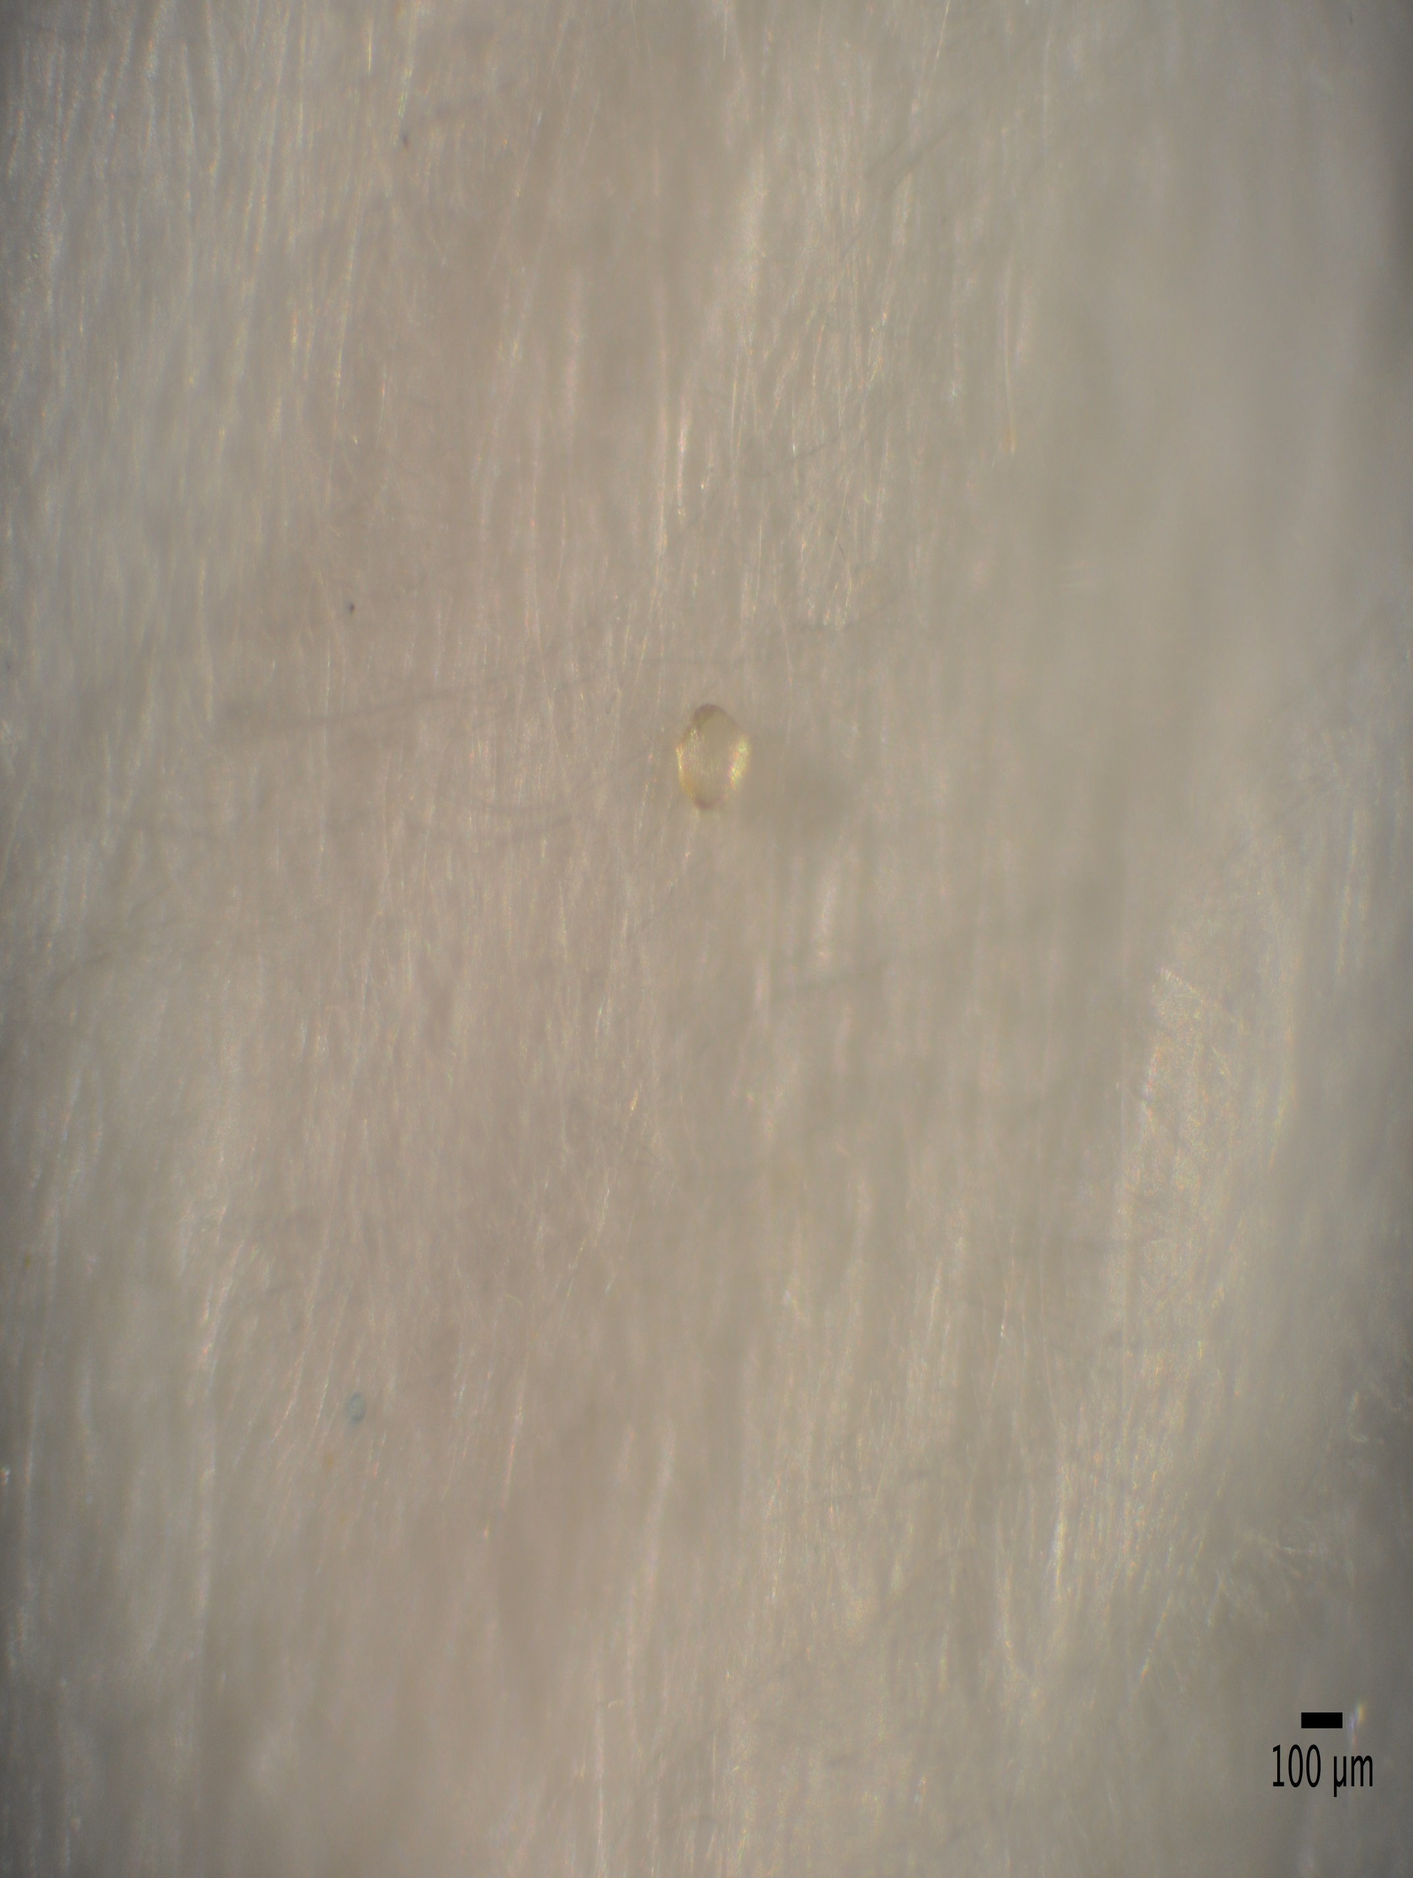
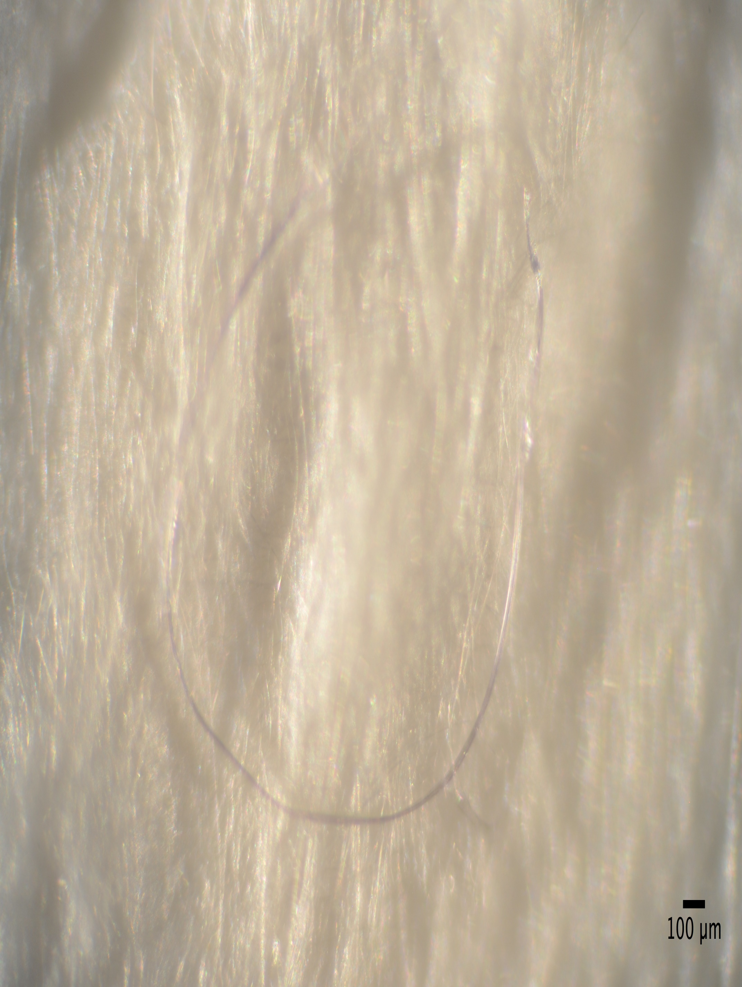

D
C

Supplement, Figure 1. Photographs showing examples of the different types of microplastics found in O. edulis tissue extracts. Examples of fibres (A, D), an irregular microplastic (B) and a round microplastic (C) are shown. All photographs (A-D) were captured directly on the filter paper. A and D also illustrate two of the most common colours of fibres observed in the O.edulis samples. Scale bar = 100μm.

