Supplementary Data
Pharmaceutical compounds | Empirical formula | Molecular structure | Molecular weight  (g mol⁻¹) | Solubility in water  (mg L⁻¹) | References | pKa | References
Trimethoprim | C₁₄H₁₈N₄O₃ | 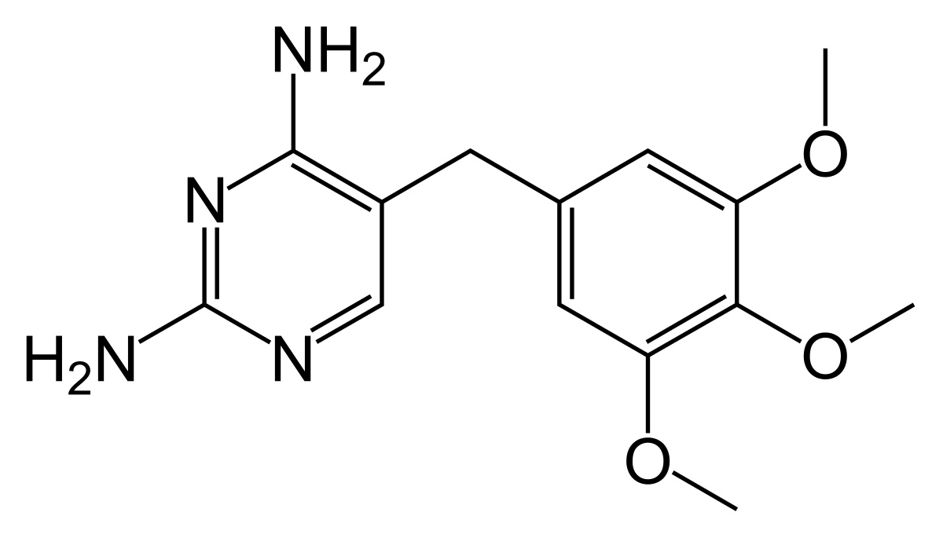 | 290.32 | 400 | Yalkowsky & Dannenfelser, 1992 | 3.23; 6.76 | Perrin, 1965
Norfloxacin | C₁₆H₁₈FN₃O₃ | 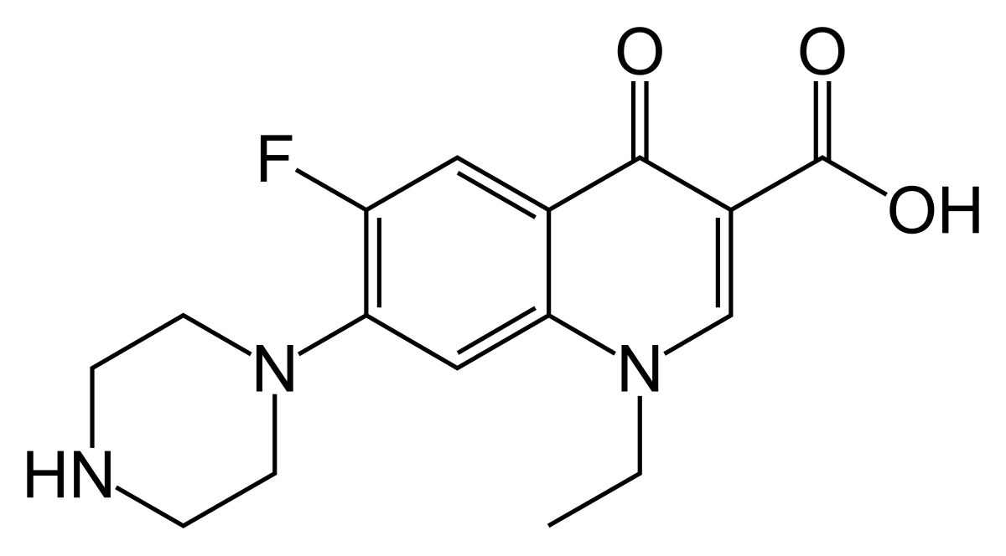 | 319.33 | 280 | O'Neil, 2006 | 6.34; 8.38 | O'Neil et. al, 2006
Ciprofloxacin | C₁₇H₁₈FN₃O₃ | 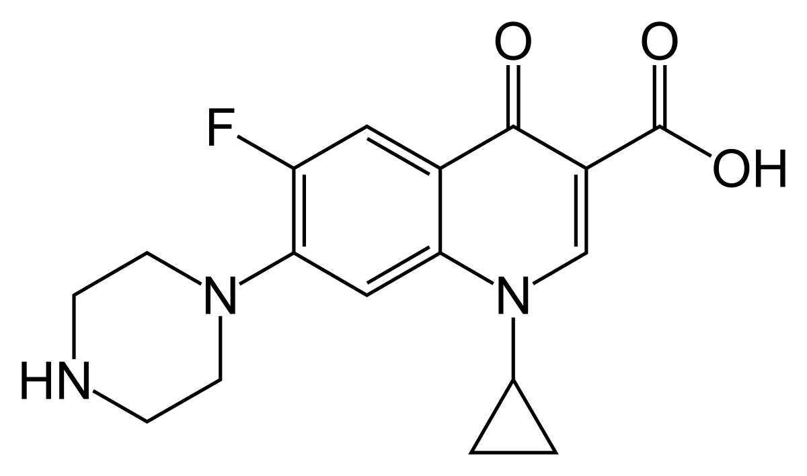 | 331.35 | 30000 | Nowara et al, 1997 | 6.09; 8.74 | Torniainen et al, 1996
Nevirapine | C₁₅H₁₄N₄O | 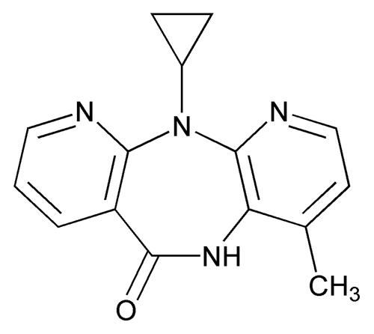 | 266.30 | 100 | Nehal et al., 2003 | 2.8 | Sarkar et al., 2008
Ofloxacin | C₁₈H₂₀FN₃O₄ | 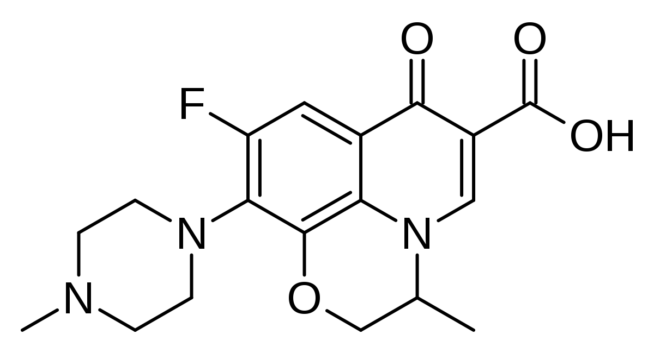 | 361.37 | 28300 | Lewis et al., 2016 | 5.97; 9.28 | Tolls, 2001
Table S1. Physicochemical properties of targeted analytical compounds

Details of the sampling sites
- The first sampling point (VRS 1, Co-ordinates: -26.9357030, 29.2653770 ) was located at the start of the town in Standerton, after the Grootdaai Dam, near a drinking water treatment plant that supplies water to the whole town.
- The second sampling point (VRS 2) was located near a wastewater treatment plant and other factories and industrial plants.
- The third sampling point (VRS 3) was located where the river finally exits Standerton town, at the townships and suburbs, near a tuberculosis (TB) clinic that may discharge its effluent into the river.
- The fourth sampling point (VRS 4) was found at the Free State-Mpumalanga border, upstream of the town of Villiers.
- The fifth sampling point (VRS 5) was located downstream of Villiers town.
- The sixth sampling point (VRS 6) was located at a small river before it joined the Vaal River. The understanding is that this tributary, called the Watervalrivier, may impact the water quality of the main river.
- The seventh sampling point (VRS 7) was located at the outflow of the Vaal Dam as the Vaal River exits the dam.
- The eighth sampling point (VRS 8) was found opposite the middle of Vanderbijlpark town, with townships and suburbs nearby.
- The ninth and final sampling point (VRS 9) was found opposite the end of Vanderbijlpark town near a recreational park.

Table S2. Physicochemical properties of water samples across all seasons.
 | pH | Conductivity  (μS/cm) | TDS  ( mg L⁻¹) | Salinity  ( g L⁻¹)
SANS | ≥ 5 - ≤ 9.7 | ≤170 | ≤1200 | -
Autumn | 7.55 - 8.79 | 151.19 – 466.85 | 75.66 – 233.35 | ND – 0.17
Winter | 8.18 - 8.79 | 176.62 – 794.44 | 95.20 – 397.09 | ND – 0.33
Spring | 7.40 – 8.52 | 174.41 – 845.28 | 91.98 – 462.04 | 0.08 – 0.46
Summer | 7.41 – 8.40 | 148.38 – 828.58 | 106.72 – 414.48 | 0.01 – 0.38

References
Lewis, K. A., Tzilivakis, J., Warner, D., & Green, A. (2016). An international database for pesticide risk assessments and management. Human and Ecological Risk Assessment: An International Journal, 22(4), 1050–1064. https://doi.org/10.1080/10807039.2015.1133242

Sarkar, M., Perumal, O. P., & Panchagnula, R. (2008). Solidstate characterization of nevirapine. Indian Journal of Pharmaceutical Sciences, 70(5), 619–630. https://doi.org/10.4103/0250-474X.45401

O’Neil, M. J., Heckelman, P. E., Koch, C. B., & Roman, K. J. (Eds.). (2006). The Merck Index: An encyclopedia of chemicals, drugs,
and biologicals (14th ed.). Hoboken, NJ: John Wiley & Sons, Inc. ISBN13 978-0-911910-001

Nowara, A., Burhenne, J., & Spiteller, M. (1997). Binding of fluoroquinolone carboxylic acid derivatives to clay minerals. Journal of Agricultural and Food Chemistry, 45(4), 1459–1463. https://doi.org/10.1021/ jf960 6138
Perrin, D. D. (1965). Dissociation constants of organic bases in aqueous solution. Butterworth.

Tolls, J. (2001). Sorption of veterinary pharmaceuticals in soils: A review. Environmental Science & Technology, 35(17), 3397–3406. https:// doi.org/10.1021/es001471r

Yalkowsky, S. H., & Dannenfelser, R. M. (1992). The AQUASOL database of aqueous solubility (Ver. 5). University of Arizona, College of Pharmacy.

Torniainen, K., Tammilehto, S., & Ulvi, V. (1996). The effect of pH, buffer type and drug concentration on the photo degradation of ciprofloxacin. International Journal of Pharmaceutics, 132(1–2), 53–61. https://doi.org/10.1016/0378- 5173(96) 04414-2

