Supplementary Materials
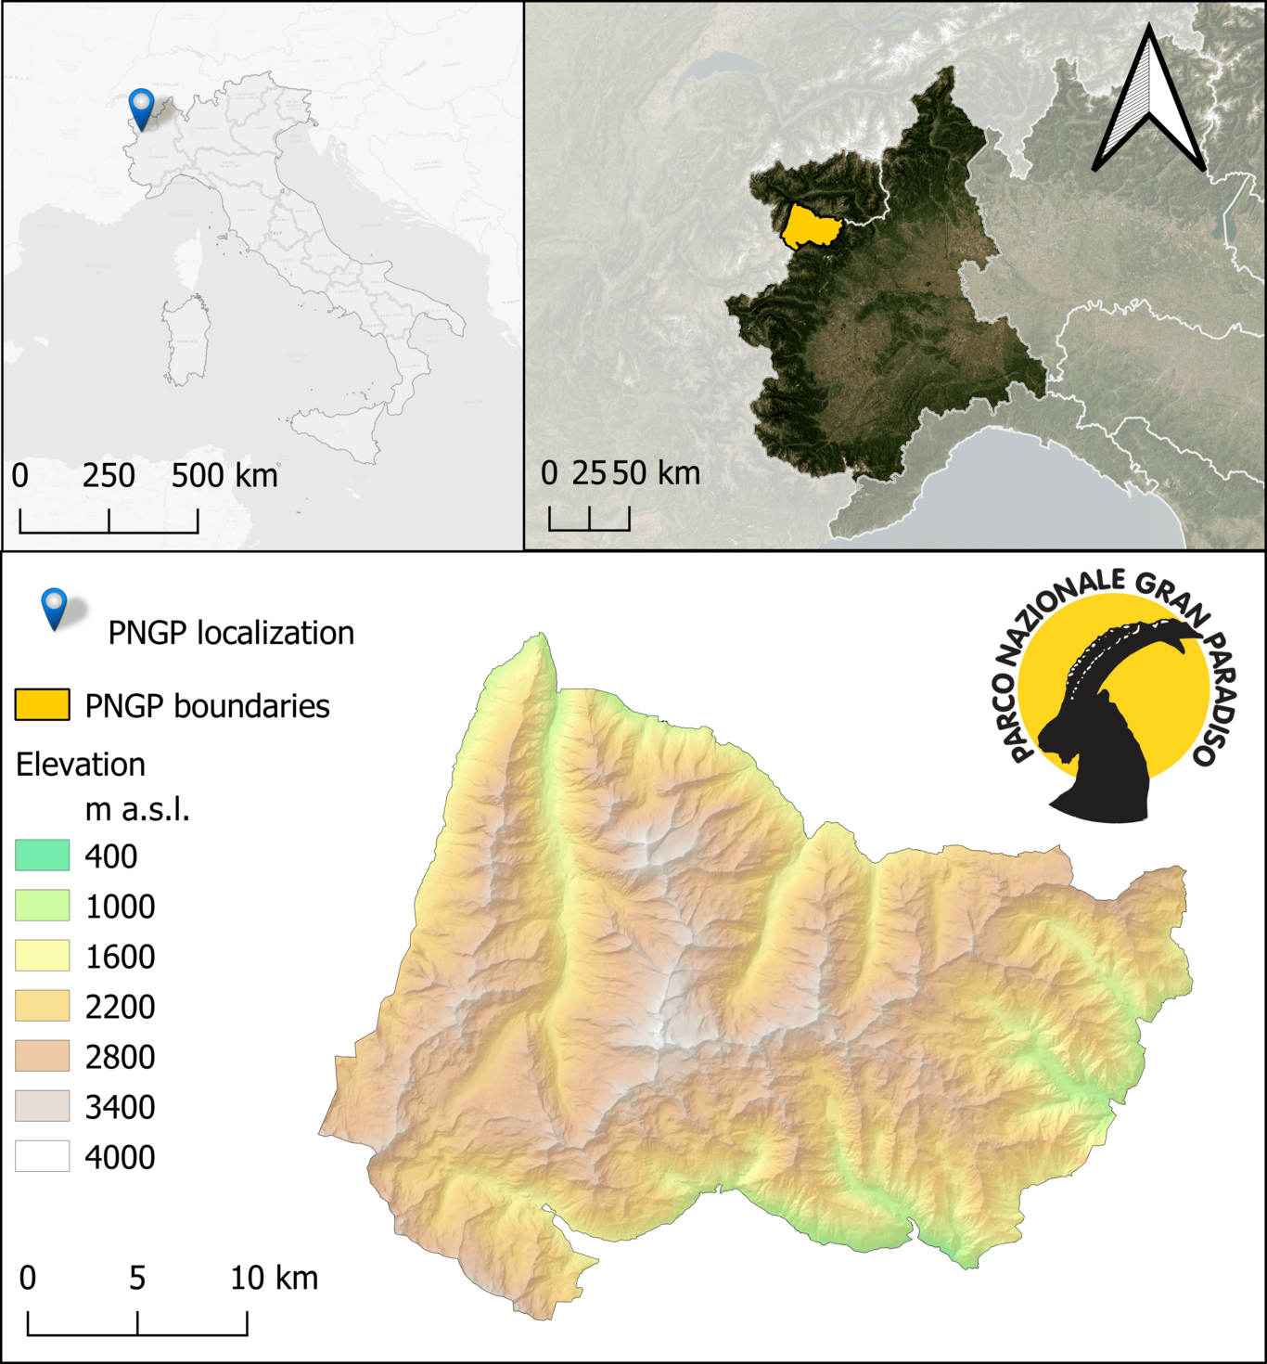
Figure S 1 Study area: the Gran Paradiso National Park (GPNP), North-West Italy. For all maps CRS: EPSG 32632.

Table S 1. Parameters used for parametric scoring for BAP images compositing.
Parameter | Description | Weight
Distance to clouds and snow | It favours pixels distant from clouds, for better radiometric quality, and from snow, to select pixels further along in phenology after snowmelt during the growing season, and pixels not yet covered by snow during the senescence season. | 1
Sensor | The aim is to avoid using Landsat 7 images collected after 31 May 2003, when the scan line corrector (SLC) failed. | 0.5
Distance to central date | The aim is to try to use the pixels of the scenes acquired as close as possible to the same date central to the season (Days Of the Year 210 and 285, respectively for the growing and the senescence seasons), in order to have uniformity in the spectral response of the vegetation classes. | 0.25
Haze-Optimized Transformation (HOT) | Has been developed to identify haze and thin clouds in Landsat imagery by Y. Zhang et al. (2002). For details, please refer to Zhu & Woodcock (2012) | 0.5
Coverage | The aim is to favour images with more valid pixel coverage, i.e. higher radiometric quality. | 0.75
Snow free area | Percentage of snow-free pixels. Newly introduced to favour the selection of image dates furthest from snow events during the senescence season and to favour pixels with the most advanced vegetative state post-snowmelt for the growing season. | 1

Table S 2. Full list of the predictors initially considered.
Spectral indices | Acronym | Formula
Chlorophyll vegetation index | CVI | NIR*(red/((green)^2))
Coloration Index | CI | (red-blue)/red
Enhanced Vegetation Index | EVI | 2.5*((NIR-red)/(NIR+6*red-7.5*blue+1))
Global Vegetation Moisture Index | GVMI | ((NIR+0.1)-(SWIR2+0.02))/((NIR+0.1)+(SWIR2+0.02))
Green leaf index | GLI | (2*green-red-blue)/(2*green+red+blue)
Modified anthocyanin reflectance index | mARI | (green^(-1)-red^(-1))*NIR
Modified Chlorophyll Absorption in Reflectance Index 1 | MCARI1 | 1.2*(2.5*(NIR-red)-1.3*(NIR-green))
Modified Soil Adjusted Vegetation Index | MSAVI | (2*NIR+1-sqrt((2*NIR+1)^2-8*(NIR-red)))/2
Normalized Difference Vegetation Index | NDVI | (NIR-red)/(NIR+red)
Normalized Difference Green NDVI | GNDVI | (NIR-green)/(NIR+green)
Normalized Difference Burn Ratio | NBR | (NIR-SWIR1)/(NIR+SWIR1)
Normalized Burn Ratio 2 | NBR2 | (SWIR1-SWIR2) / (SWIR1 + SWIR2)
Soil Adjusted Vegetation Index | SAVI | ((NIR-red)/(NIR+red+0.5))*(1+0.5)
Transformed Soil-Adjusted Vegetation Index | TSAVI | (0.7*(NIR-0.7*red-(-0.32)))/(-0.32*NIR+red-(-0.32)*0.7+1.5*(1+(0.7)^2))
Spectral Polygon Vegetation Index | SPVI | 0.4*(3.7*(NIR-red)-1.2*abs(green-red))
Tasselled Cap - brightness | SBI | 0.3037*blue+0.2793*green+0.4743*red+0.5585*NIR+0.5082*SWIR1+0.1863*SWIR2
Tasselled Cap - vegetation | GVI | -0.2848*blue-0.2435*green-0.5436*red+0.7243*NIR+0.0840*SWIR1-0.1800*SWIR2
Tasselled Cap - wetness | WET | 0.1509*blue+0.1973*green+0.3279*red+0.3406*NIR-0.7112*SWIR1-0.4572*SWIR2
Wide Dynamic Range Vegetation Index | WDRVI | (0.1*NIR-red)/(0.1*NIR+red)
Simple Ratio Drought Index | RDI | SWIR2/NIR
Normalized difference Built-up Index | NDBI | (SWIR1 - NIR)/(SWIR1 + NIR)
Moisture adjusted vegetation index | MAVI | (NIR-red)/(NIR+red+SWIR)
Atmospherically resistant vegetation index | ARVI | (NIR-red-1*(red-blue))/(NIR+red-1*(red-blue))
Normalized Difference Water Index | NDWI | (green - NIR) / (green + NIR)
Bare Soil Index | BSI | ((SWIR2+red)-(NIR+blue))/((SWIR2+red)+(NIR+blue))
Normalized Difference Moisture Index | NDMI | (NIR - SWIR2) / (NIR + SWIR2)
Normalized Difference Snow Index | NDSI | (green-SWIR1) / (green+ SWIR1)
Ancillary data | Acronym | Resolution (m)
Geology | GEO | 1:100.000
Canopy Height Model* (2008-2009) | CHM | 5
Topographic predictors | Acronym | Resolution (m)
Elevation | DTM | 5
Slope | slope | 5
Aspect | aspect | 5
Topography Roughness Index | TRI | 5
Topographic Position Index | TPI | 5
Diurnal Anisotropic Heat Index | DAHI | 5
Curvature | crv | 5
Topographic Wetness Index | TWI | 5

Table S 3. Original GPNP’s Authority LULC legend and the translation in the adopted legend. Classes that are numbered as 0 (in columns L1 or L2) have been excluded.
L1 | Land cover | L2 | Park’s LULC legend
0 | Bare soil | 0 | Disrupted environments
0 | Bare soil | 0 | Quarry
0 | Bare soil | 0 | Deposits of natural or artificial materials
0 | Built-up | 0 | Bivouacs, mountain huts
0 | Built-up | 0 | Artifacts and infrastructures
0 | Built-up | 0 | Roads and trails
0 | Built-up | 0 | Structures and facilities for skiing
0 | Built-up | 0 | Buildings
1 | Rocks, screes, debris | 0 | Calcareous and calc-scists screes
1 | Rocks, screes, debris | 0 | Calcareous and calc-scists cliffs
1 | Rocks, screes, debris | 0 | Siliceous screes
1 | Rocks, screes, debris | 0 | Siliceous cliffs
2 | Snow and glaciers | 0 | Glaciers [8340]
2 | Snow and glaciers | 0 | Glaciers covered with debris [8340]
2 | Snow and glaciers | 0 | Perennial snows
3 | Water | 0 | Lentic waters
3 | Water | 0 | Lotic waters
3 | Water | 0 | Water springs [incl. 7220*, 54.11]
3 | Water | 0 | Lentic waters with aquatic vegetation [incl. 3130]
3 | Water | 0 | Lentic waters partially buried
4 | Broadleaved | 41 | Scrubland and woods of Maple, linden and ash trees
4 | Broadleaved | 42 | Oak forest
4 | Broadleaved | 43 | Mixed broad-leaved forests
4 | Broadleaved | 44 | Mixed hygrophilous woods of broadleaved trees [incl. 91E0]
4 | Broadleaved | 45 | Chestnut groves [incl. cod.9260]
4 | Broadleaved | 46 | Beech forests [incl. 9110, 9130, 9150]
 | - | 0 | Isolated trees or in small groups of different species (20-30%)
 | - | 0 | Mixed forests of conifers and broad-leaved trees
 | - | 0 | Reforestation
 | - | 0 | Cores of standing dead trees
5 | Coniferous | 51 | Fir forests
5 | Coniferous | 52 | Larix decidua and/or Pinus cembra forests [9420]
5 | Coniferous | 53 | Mountain pine forests (Pinus uncinata) [9430]
5 | Coniferous | 54 | Mixed coniferous forests
5 | Coniferous | 55 | Sparse coniferous forests
5 | Coniferous | 56 | Spruce forests [9410]
5 | Coniferous | 57 | Scots pine forests
6 | Grassland | 61 | Subalpine and alpine acidophilic grasslands [incl. 6150, 6230*, 36.33, 36.52]
6 | Grassland | 62 | Subalpine and alpine calcicolous grasslands [incl. 6170, 36.12]
6 | Grassland | 63 | Hydrophilous tall herb communities of the Alpine plain [6430 p.p.]
6 | Grassland | 64 | Arid and thermophilic grasslands [incl. 6210, 6240*]
6 | Grassland | 65 | Montane grasslands [incl. 6520]
7 | Shrubs | 71 | Woody riparian vegetation of watercourses [incl. 3230, 3240]
7 | Shrubs | 72 | Green alder shrubs
7 | Shrubs | 73 | Shrubland (without distinction of species)
7 | Shrubs | 74 | Sub-arctic shrublands with Salix sp. [4080]
7 | Shrubs | 75 | Subalpine and alpine heaths [4060]
8 | Wetland | 0 | Pioneer herbaceous vegetation of alpine watercourses [incl. 7240*]
8 | Wetland | 0 | Herbaceous riparian vegetation of watercourses [incl. 3220]
8 | Wetland | 0 | Marshes with small acidophilic sedges [54.4]
8 | Wetland | 0 | Marshes with small basophilic sedges [7230]
8 | Wetland | 0 | Transitional peat bogs [7140]
0 | - | 0 | Parks, gardens, vegetable gardens, campsites, golf courses
0 | - | 0 | Shadows

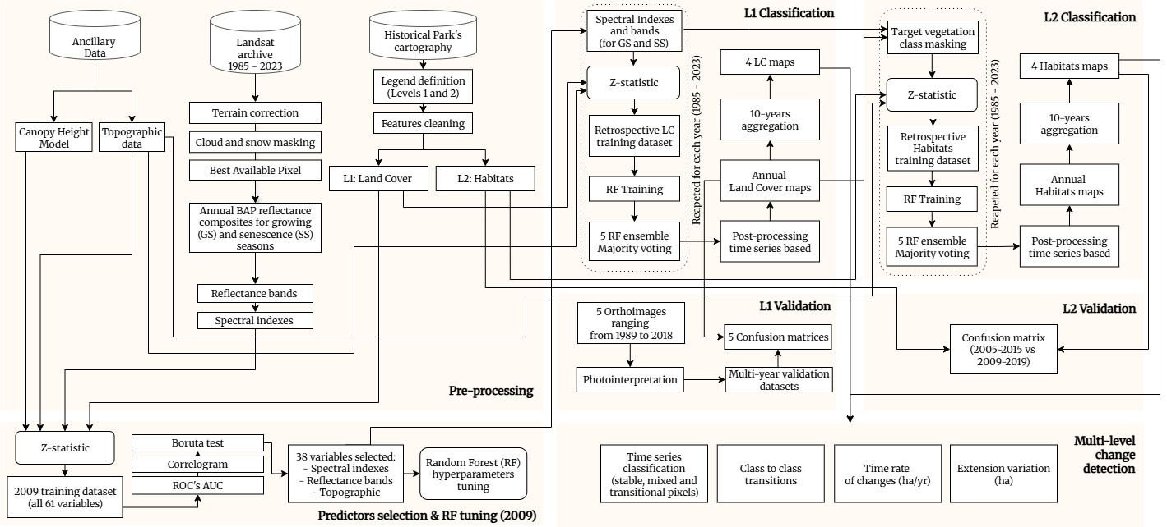
Figure S 2. Detailed flowchart of the proposed algorithm. ROC’s AUC = Receiver Operating Characteristic’s Area Under the Curve. L1 = Level 1 of the legend (Land cover classes); L2 = Level 2 of the legend (Habitats).
Z-statistic formula
The Z-statistic quantifies the multivariate distance between the pixel’s response and the expected response of the target class, as defined by Equation (S1):
$$Z_{jk}=\sqrt{\sum_{i=1}^{n}{{\left(\frac{r_{ijk}-μ_{ic_{jk}}}{σ_{ic_{jk}}}\right)}^{2}}}$$
where:
Z_{jk} is the Z-score for a pixel jk belonging of a given class
i is the predictor number
n is the number of predictors
c_{jk} is the thematic class being considered,
jk is a pixel in the class
r_{ijk} is the predictor value in i for pixel jk
μ_{icjk} is the mean value in i of all pixels in each class c_{jk}
σ_{icjk} is the standard deviation of the predictor value in band i of all pixels in class c_{jk}

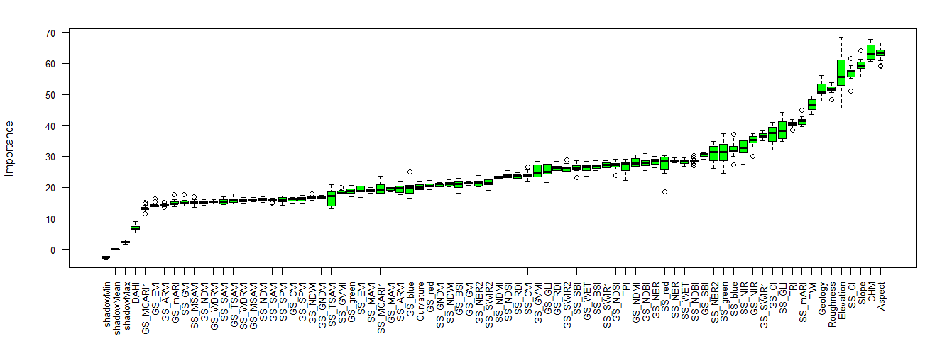
Figure S3. Predictors importance according to the Boruta test applied in 2009.
Table S4. Receiver operating characteristic’s area under the curve (ROC’s AUC).
Predictor | Rocks | Water | Snow | Broadleaved | Coniferous | Grassland | Shrubs | Wetland
GS_ARVI | 0.546 | 0.998 | 0.996 | 0.927 | 0.971 | 0.898 | 0.562 | 0.998
GS_BSI | 0.977 | 0.996 | 0.991 | 0.977 | 0.977 | 0.977 | 0.977 | 0.996
GS_CI | 0.939 | 0.939 | 0.939 | 0.939 | 0.939 | 0.939 | 0.939 | 0.701
GS_CVI | 0.932 | 0.996 | 0.986 | 0.932 | 0.955 | 0.932 | 0.932 | 0.996
GS_EVI | 0.853 | 0.990 | 0.970 | 0.928 | 0.971 | 0.876 | 0.853 | 0.990
GS_GLI | 0.874 | 0.981 | 0.978 | 0.874 | 0.912 | 0.874 | 0.874 | 0.981
GS_GNDVI | 0.960 | 0.998 | 0.995 | 0.960 | 0.963 | 0.960 | 0.960 | 0.998
GS_GVI | 0.963 | 0.992 | 0.976 | 0.963 | 0.963 | 0.963 | 0.963 | 0.992
GS_GVMI | 0.993 | 0.993 | 0.993 | 0.993 | 0.993 | 0.993 | 0.993 | 0.962
GS_mARI | 0.672 | 0.989 | 0.976 | 0.745 | 0.938 | 0.715 | 0.672 | 0.989
GS_MAVI | 0.962 | 0.999 | 0.996 | 0.962 | 0.969 | 0.962 | 0.962 | 0.999
GS_MCARI1 | 0.937 | 0.988 | 0.963 | 0.937 | 0.968 | 0.937 | 0.937 | 0.988
GS_MSAVI | 0.963 | 0.993 | 0.975 | 0.963 | 0.968 | 0.963 | 0.963 | 0.993
GS_NBR | 0.993 | 0.993 | 0.993 | 0.993 | 0.993 | 0.993 | 0.993 | 0.889
GS_NBR2 | 0.679 | 0.996 | 0.993 | 0.922 | 0.968 | 0.908 | 0.696 | 0.996
GS_NDBI | 0.993 | 0.993 | 0.993 | 0.993 | 0.993 | 0.993 | 0.993 | 0.889
GS_NDMI | 0.993 | 0.993 | 0.993 | 0.993 | 0.993 | 0.993 | 0.993 | 0.962
GS_NDSI | 0.993 | 0.993 | 0.993 | 0.993 | 0.993 | 0.993 | 0.993 | 0.962
GS_NDVI | 0.956 | 0.998 | 0.996 | 0.956 | 0.967 | 0.956 | 0.956 | 0.998
GS_NDWI | 0.960 | 0.998 | 0.995 | 0.960 | 0.963 | 0.960 | 0.960 | 0.998
GS_RDI | 0.993 | 0.993 | 0.993 | 0.993 | 0.993 | 0.993 | 0.993 | 0.962
GS_SAVI | 0.961 | 0.994 | 0.978 | 0.961 | 0.968 | 0.961 | 0.961 | 0.994
GS_SBI | 0.868 | 0.868 | 0.927 | 0.868 | 0.868 | 0.868 | 0.909 | 0.854
GS_SPVI | 0.961 | 0.986 | 0.961 | 0.961 | 0.967 | 0.961 | 0.961 | 0.986
GS_TSAVI | 0.725 | 0.983 | 0.945 | 0.923 | 0.968 | 0.857 | 0.725 | 0.983
GS_WDRVI | 0.956 | 0.998 | 0.996 | 0.956 | 0.967 | 0.956 | 0.956 | 0.998
GS_WET | 0.983 | 0.983 | 0.983 | 0.983 | 0.983 | 0.983 | 0.983 | 0.754
SS_ARVI | 0.525 | 0.882 | 0.691 | 0.541 | 0.535 | 0.674 | 0.534 | 0.882
SS_BSI | 0.515 | 0.976 | 0.754 | 0.565 | 0.667 | 0.713 | 0.530 | 0.976
SS_CI | 0.533 | 0.945 | 0.728 | 0.595 | 0.637 | 0.670 | 0.533 | 0.945
SS_CVI | 0.633 | 0.985 | 0.813 | 0.685 | 0.633 | 0.643 | 0.686 | 0.985
SS_EVI | 0.682 | 0.549 | 0.549 | 0.566 | 0.549 | 0.571 | 0.692 | 0.682
SS_GLI | 0.541 | 0.849 | 0.652 | 0.541 | 0.679 | 0.695 | 0.570 | 0.849
SS_GNDVI | 0.616 | 0.997 | 0.873 | 0.677 | 0.616 | 0.638 | 0.643 | 0.997
SS_GVI | 0.506 | 0.929 | 0.892 | 0.622 | 0.686 | 0.699 | 0.540 | 0.929
SS_GVMI | 0.600 | 0.825 | 0.895 | 0.600 | 0.628 | 0.782 | 0.605 | 0.825
SS_mARI | 0.656 | 0.757 | 0.656 | 0.684 | 0.656 | 0.667 | 0.779 | 0.757
SS_MAVI | 0.554 | 0.999 | 0.935 | 0.649 | 0.599 | 0.600 | 0.554 | 0.999
SS_MCARI1 | 0.667 | 0.754 | 0.866 | 0.617 | 0.641 | 0.763 | 0.788 | 0.754
SS_MSAVI | 0.554 | 0.825 | 0.917 | 0.636 | 0.605 | 0.554 | 0.585 | 0.825
SS_NBR | 0.637 | 0.999 | 0.951 | 0.637 | 0.650 | 0.785 | 0.670 | 0.999
SS_NBR2 | 0.532 | 0.751 | 0.657 | 0.589 | 0.542 | 0.558 | 0.527 | 0.751
SS_NDBI | 0.637 | 0.999 | 0.951 | 0.637 | 0.650 | 0.785 | 0.670 | 0.999
SS_NDMI | 0.624 | 0.997 | 0.915 | 0.624 | 0.655 | 0.771 | 0.649 | 0.997
SS_NDSI | 0.624 | 0.997 | 0.915 | 0.624 | 0.655 | 0.771 | 0.649 | 0.997
SS_NDVI | 0.558 | 0.999 | 0.932 | 0.653 | 0.598 | 0.610 | 0.558 | 0.999
SS_NDWI | 0.616 | 0.997 | 0.873 | 0.677 | 0.616 | 0.638 | 0.643 | 0.997
SS_RDI | 0.624 | 0.997 | 0.915 | 0.624 | 0.655 | 0.771 | 0.649 | 0.997
SS_SAVI | 0.564 | 0.773 | 0.900 | 0.633 | 0.588 | 0.564 | 0.575 | 0.773
SS_SBI | 0.505 | 0.898 | 0.836 | 0.601 | 0.664 | 0.692 | 0.533 | 0.898
SS_SPVI | 0.562 | 0.915 | 0.931 | 0.661 | 0.629 | 0.549 | 0.649 | 0.915
SS_TSAVI | 0.505 | 0.503 | 0.690 | 0.533 | 0.501 | 0.708 | 0.503 | 0.505
SS_WDRVI | 0.558 | 0.999 | 0.932 | 0.653 | 0.598 | 0.610 | 0.558 | 0.999
SS_WET | 0.508 | 0.929 | 0.882 | 0.595 | 0.677 | 0.723 | 0.517 | 0.929
GS_blue | 0.958 | 0.989 | 0.990 | 0.958 | 0.958 | 0.958 | 0.959 | 0.989
GS_green | 0.954 | 0.989 | 0.988 | 0.954 | 0.954 | 0.954 | 0.962 | 0.989
GS_NIR | 0.890 | 0.890 | 0.890 | 0.890 | 0.890 | 0.890 | 0.929 | 0.808
GS_red | 0.949 | 0.993 | 0.992 | 0.949 | 0.949 | 0.949 | 0.957 | 0.993
GS_SWIR1 | 0.992 | 0.992 | 0.992 | 0.992 | 0.992 | 0.992 | 0.992 | 0.770
GS_SWIR2 | 0.992 | 0.992 | 0.992 | 0.992 | 0.992 | 0.992 | 0.992 | 0.945
SS_blue | 0.513 | 0.917 | 0.870 | 0.607 | 0.691 | 0.729 | 0.561 | 0.917
SS_green | 0.533 | 0.913 | 0.858 | 0.616 | 0.662 | 0.626 | 0.565 | 0.913
SS_NIR | 0.508 | 0.887 | 0.809 | 0.588 | 0.649 | 0.678 | 0.526 | 0.887
SS_red | 0.509 | 0.913 | 0.854 | 0.601 | 0.662 | 0.665 | 0.525 | 0.913
SS_SWIR1 | 0.585 | 0.585 | 0.635 | 0.592 | 0.585 | 0.585 | 0.630 | 0.537
SS_SWIR2 | 0.592 | 0.592 | 0.592 | 0.602 | 0.592 | 0.592 | 0.627 | 0.537
Aspect | 0.591 | 0.524 | 0.521 | 0.521 | 0.582 | 0.590 | 0.606 | 0.591
CHM | 0.534 | 0.863 | 0.856 | 0.534 | 0.596 | 0.534 | 0.574 | 0.863
Curvature | 0.543 | 0.511 | 0.511 | 0.511 | 0.511 | 0.516 | 0.561 | 0.543
DAHI | 0.538 | 0.538 | 0.538 | 0.538 | 0.538 | 0.559 | 0.545 | 0.507
Elevation | 0.886 | 0.999 | 0.984 | 0.886 | 0.952 | 0.886 | 0.979 | 0.999
Roughness | 0.847 | 0.712 | 0.712 | 0.712 | 0.712 | 0.950 | 0.735 | 0.847
Slope | 0.844 | 0.713 | 0.713 | 0.713 | 0.713 | 0.949 | 0.733 | 0.844
TPI | 0.537 | 0.508 | 0.508 | 0.508 | 0.508 | 0.509 | 0.532 | 0.537
TRI | 0.836 | 0.704 | 0.704 | 0.704 | 0.704 | 0.927 | 0.712 | 0.836
TWI | 0.737 | 0.702 | 0.702 | 0.702 | 0.702 | 0.730 | 0.702 | 0.737

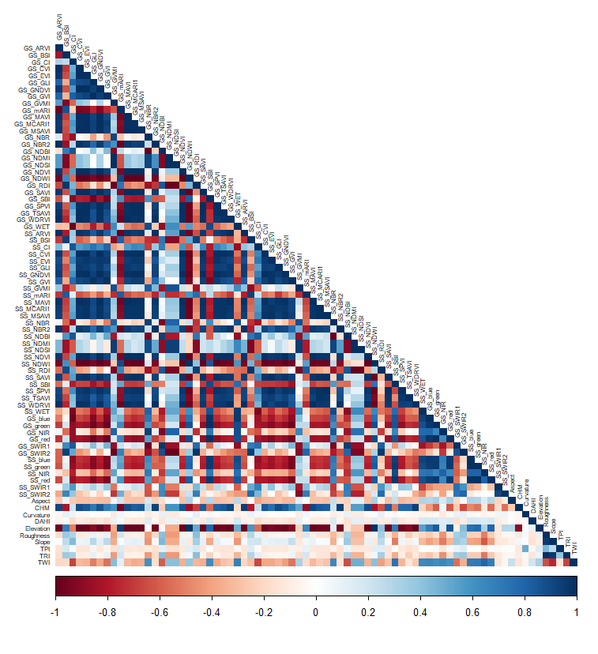
Figure S4. Correlogram of all the originally considered predictors, applied in 2009.

Table S5. Dimensions of the training dataset used to train the Level 1 RFs.
Class | Description | Average n. of pixels | SD (±)
1 | Rocks | 77697 | 3771
2 | Snow | 7083 | 406
3 | Water | 116 | 10
4 | Broadleaved | 5582 | 408
5 | Coniferous | 19393 | 1180
6 | Grassland | 39849 | 1827
7 | Shrubs | 6674 | 424
8 | Wetlands | 352 | 27

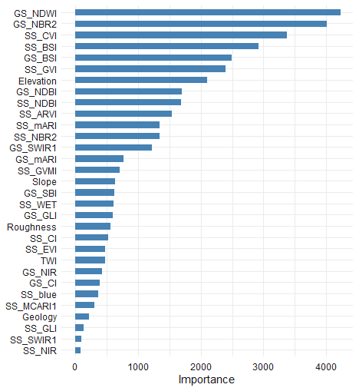
Figure S5. Variable importance plot for the RF built for 2009.

Table S 6. The 38 selected predictors: spectral indices and bands, computed both for the growing and the senescence seasons, and topographic and geological variables.
Spectral indices | Acronym | Formula | Specificity | Reference
Bare Soil Index | BSI | $$\frac{\left(SWIR2+Red\right)-(NIR+Blue)}{\left(SWIR2+Red\right)+(NIR+Blue)}$$ | Identifies bare soil areas and separates them from vegetation and urban areas. | Diek et al. (2017)
Coloration Index | CI | $$\frac{Red-Blue}{Red}$$ | Assesses the colour changes in vegetation, particularly in autumn leaves or stressed plants. | Escadafal et al. (1994)
Green Leaf Index | GLI | $$\frac{2×Green-Red-Blue}{2×Green+Red+Blue}$$ | Focuses on the green component of vegetation, indicating plant vitality. | Hunt et al. (2011)
Modified Anthocyanin Reflectance Index | mARI | $$(\frac{1}{Green}-\frac{1}{Red})×NIR$$ | Estimates anthocyanin content, which is related to stress and senescence in plants. | Gitelson et al. (2006)
Normalized Burn Ratio 2 | NBR2 | $$\frac{(SWIR1-SWIR2)}{(SWIR1+SWIR2)}$$ | Identify burned area. Modifies the Normalized Burn Ratio (NBR) to highlight water sensitivity in vegetation. | U.S. Geological Survey Earth Resources Observation and Science Center (2016b)
Normalized Difference Built-up Index | NDBI | $$\frac{(SWIR1-NIR)}{(SWIR1+NIR)}$$ | Detects urban areas and built-up land. | Zha et al. (2003)
Normalized Difference Water Index | NDWI | $$\frac{(Green-NIR)}{(Green+NIR)}$$ | Monitors water content in vegetation and water bodies. | Gao (1996)
Tasselled Cap - Brightness | SBI | $$0.3037×Blue+0.2793×Green+0.4743×Red+0.5585×NIR+0.5082×SWIR1+0.1863×SWIR2$$ | Indicates the overall brightness of the land surface. | Bannari et al. (1995)
Tasselled Cap - Vegetation | GVI | $$-0.2848×Blue-0.2435×Green-0.5436×Red+0.7243×NIR+0.084×SWIR1-0.18×SWIR2$$ | Indicates vegetation greenness as part of the Tasselled Cap transformation. | Bannari et al. (1995)
Tasselled Cap - Wetness | WET | $$0.1509×Blue+0.1973×Green+0.3279×Red+0.3406×NIR-0.7112×SWIR1-0.4572×SWIR2$$ | Measures soil moisture content and vegetation wetness. | Bannari et al. (1995)
Atmospherically Resistant Vegetation Index | ARVI | $$\frac{NIR-Red×(Red-Blue)}{NIR+Red×(Red-Blue)}$$ | Reduces atmospheric interference, particularly aerosols, in vegetation monitoring. | Kaufman & Tanre (1992)
Chlorophyll Vegetation Index | CVI | $$NIR×(\frac{Red}{{Green}^{2}})$$ | Estimates chlorophyll content in vegetation, focusing on plant health and productivity. | Glenn et al. (2010)
Enhanced Vegetation Index | EVI | $$2.5×(\frac{NIR-Red}{NIR+6×Red-7.5×Blue+1})$$ | Improves sensitivity in high biomass regions and reduces atmospheric effects. | U.S. Geological Survey Earth Resources Observation and Science Center (2016a)
Global Vegetation Moisture Index | GVMI | $$\frac{\left(NIR+0.1\right)-(SWIR2+0.02)}{\left(NIR+0.1\right)+(SWIR2+0.02)}$$ | Estimates vegetation moisture content, useful in drought monitoring. | Ceccato et al. (2002)
Modified Chlorophyll Absorption in Reflectance Index 1 | MCARI1 | $$1.2×(2.5×\left(NIR-Red\right)-1.3×\left(NIR-Green\right))$$ | Estimates chlorophyll concentration while minimizing soil background effects. | Haboudane et al. (2004)
Spectral bands | Acronym | L4-5 (TM-MSS) (µm) | L7 (TM+) (µm) | L8-9 (OLI/OLI+) (µm)
Near Infrared | NIR | 0.76– 0.90 | 0.77 – 0.90 | 0.85 – 0.88
Shortwave Infrared 1 | SWIR1 | 1.55 – 1.75 | 1.55 – 1.75 | 1.57 – 1.65
Blue | Blue | 0.45 – 0.52 | 0.45 – 0.52 | 0.45 – 0.51
Topography | Resolution | Unit | Specificity | Source
Elevation | 5 m | Meters | Altitude exerts a strong control over zonal vegetation distribution. | Derived from the DTMs distributed by the Piedmont and Aosta Valley Regions geoportals
Roughness | 5 m | Degrees | Roughness represents micro-topographical features.
Slope | 5 m | Percentage | Represents the steepness or incline of a surface.
Topographic Wetness Index (TWI) | 5 m | Dimensionless | TWI is a measure of the potential for water to accumulate in a specific area based on the surrounding terrain.
Geology | 1:100.000 | Geological units | Spatial distribution of geological features, including rock types, formations, and structural attributes, across the study area. | Geological Map of Italy scale 1:100,000, ISPRA

Table S7. Available orthoimagery used for building the independent validation dataset. BN = black & white; RGB = Red, Green, Blue.
Year | Type | Coverage | Property | Source (accessed on 04/05/2022)
1988 | BN | GPNP | Ministero dell'Ambiente e della Tutela del Territorio e del Mare - Geoportale nazionale | http://www.pcn.minambiente.it/geoportal/rest/document?id=m_amte%3A299FN3%3Aa1197b44-5b11-4a49-def8-ae45e2c5e6ae
1991 | BN | Piedmont side | Regione Piemonte | http://www.geoportale.piemonte.it/geocatalogorp/index.jsp
1994 | BN | GPNP | Agenzia per le erogazioni in agricoltura | http://www.pcn.minambiente.it/geoportal/rest/document?id=m_amte%3A299FN3%3A4dca3621-4baa-49ee-90b5-33ca42a4bb4e
2000 | RGB | GPNP | BLOM CGR S.P.A. | http://www.pcn.minambiente.it/geoportal/rest/document?id=m_amte%3A299FN3%3A2637cb18-6d0c-4508-bd6e-64804e85a550
2005 | RGB | GPNP | Arpa Piemonte | http://www.geoportale.piemonte.it/geonetworkrp/srv/ita/metadata.show?id=5862&currTab=rndt
2006 | RGB | GPNP | BLOM CGR S.P.A. | http://www.pcn.minambiente.it/geoportal/rest/document?id=m_amte%3A299FN3%3A21d09438-3f4c-4642-a9ea-064a60488b88
2010 | RGB | Piedmont side | Regione Piemonte | http://www.geoportale.piemonte.it/geonetworkrp/srv/ita/metadata.show?id=2557&currTab=rndt
2012 | RGB | GPNP | Agenzia per le erogazioni in agricoltura | http://www.pcn.minambiente.it/geoportal/rest/document?id=m_amte%3A299FN3%3Aeda6494c-b619-441a-a2d7-4097f8cde540
2015 | RGB | Piedmont side | Consorzio TeA | http://www.geoportale.piemonte.it/geonetworkrp/srv/ita/metadata.show?id=6626&currTab=rndt
2018 | RGB | Piedmont side | AGEA 2018 (c) | http://www.geoportale.piemonte.it/geonetworkrp/srv/ita/metadata.show?id=7167&currTab=rndt

Table S 8 Overall scores metrics. K = Cohen’s K coefficient; OA = Overall Accuracy; WA = Weighted Accuracy.
Year |  | OA | K | WA
1985 |  | 0.99 | 0.99 | 0.99
1990 |  | 0.99 | 0.98 | 0.99
1995 |  | 0.97 | 0.96 | 0.98
2000 |  | 0.96 | 0.95 | 0.96
2005 |  | 0.98 | 0.98 | 0.98
2010 |  | 0.95 | 0.94 | 0.95
2015 |  | 0.98 | 0.97 | 0.98
2020 |  | 0.98 | 0.97 | 0.98

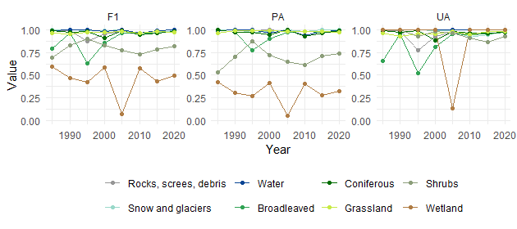
Figure S 6. Class metrics for intermediate annual maps, before applying post-processing. F1 = F-1 score; PA = Producer’s Accuracy; UA = User’s Accuracy.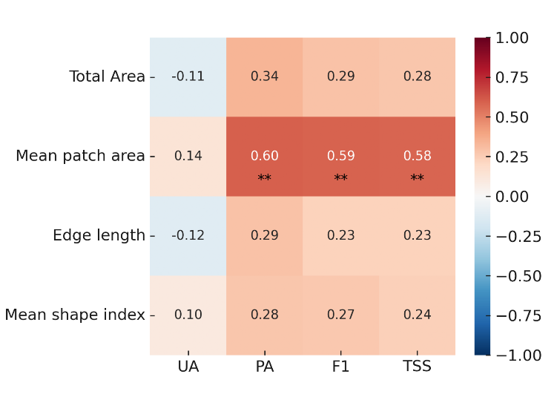
Figure S 7. Relationship between structural metrics of habitat patches and classification accuracy. Significance level ** = p < 0.01.

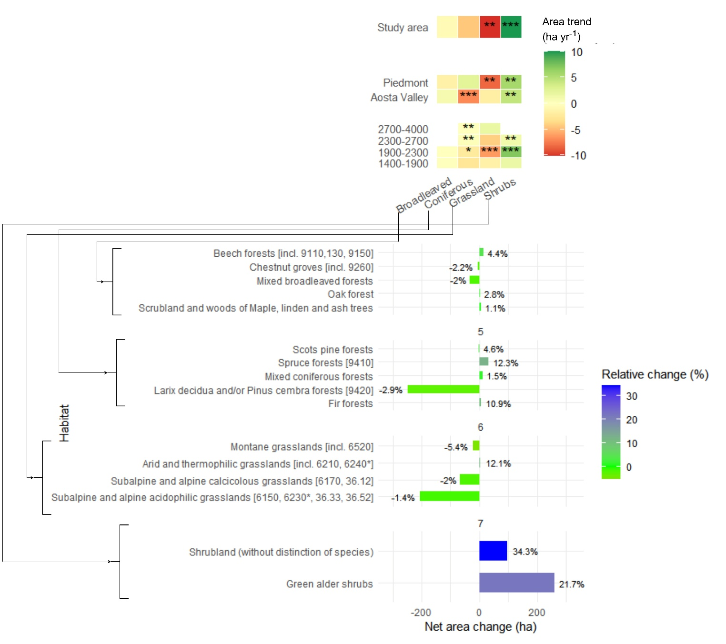
Figure S 8. Upper panel: trends of the different land cover classes, or time rate of change, in loss or gain, with significance stars (* p < 0.05, ** p < 0.01, *** p < 0.001) for the overall study area, Region and elevation (m a.s.l.). Lower panel: habitats net (total hectares of gain or loss) and relative (% of variation compared to the initial extent) change.
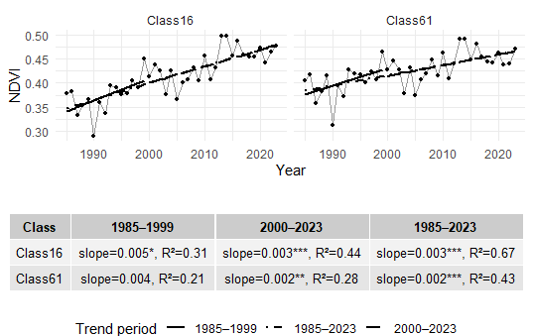
Figure S 9. NDVI trends for Rocks to Grassland (Class 16) and Grassland to Rocks (Class 61) transition pixels.

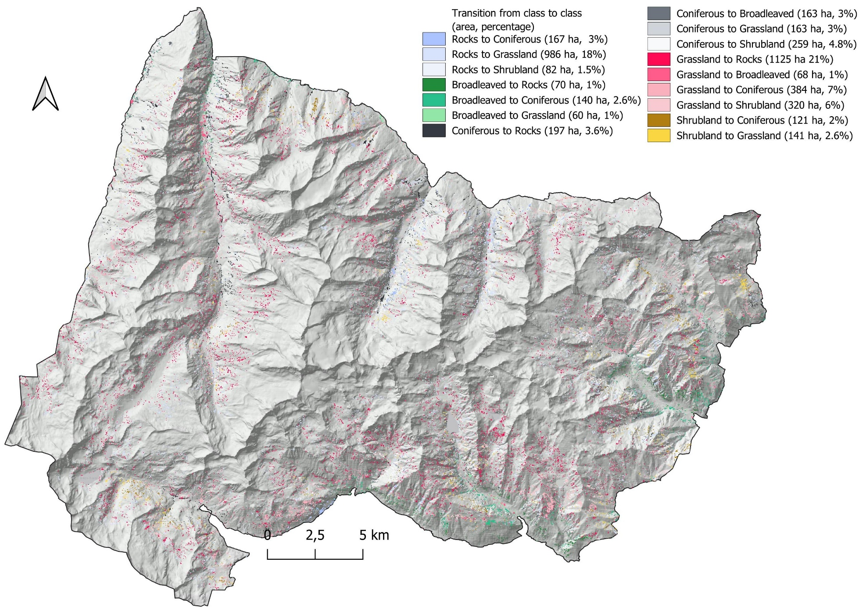
Figure S 10. Land cover transitions from 1985 to 2023. Transitions lower than 1% were excluded.

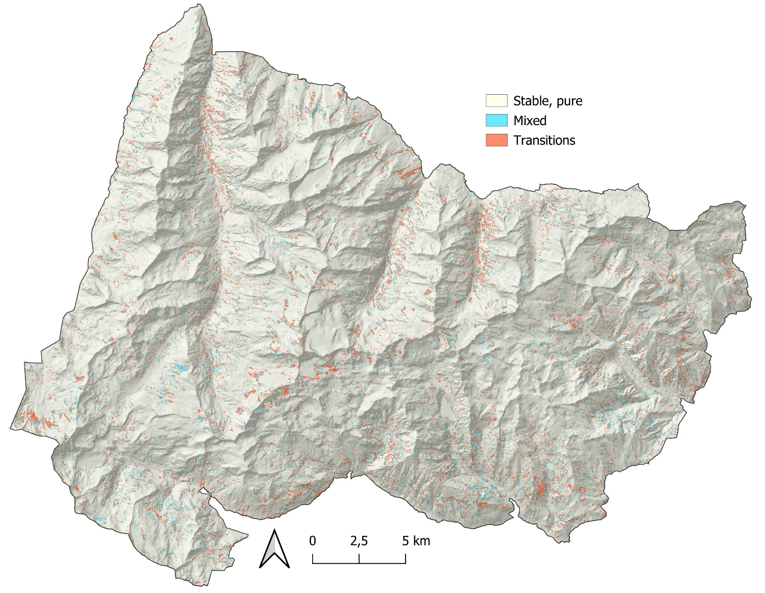
Figure S 11. Map of stable–mixed and transition areas from 1985 to 2023.
Table S 9. Full list of Landsat scene IDs used in the analysis, indicating the year and season in which they were used for the BAP compositing.
Year | Season | Scene id
1985 | GS | LT05_L2SP_195028_19850710_20200918_02_T1
1985 | GS | LT05_L2SP_195028_19850811_20200918_02_T1
1985 | GS | LT05_L2SP_195028_19850827_20200918_02_T1
1985 | SS | LT05_L2SP_195028_19851115_20200918_02_T1
1986 | GS | LT05_L2SP_195028_19860729_20200918_02_T1
1986 | GS | LT05_L2SP_195028_19860814_20200918_02_T1
1986 | SS | LT05_L2SP_195028_19861017_20200917_02_T1
1986 | SS | LT05_L2SP_195028_19861118_20200917_02_T1
1987 | GS | LT05_L2SP_195028_19870630_20201014_02_T1
1987 | GS | LT05_L2SP_195028_19870801_20201014_02_T1
1987 | GS | LT05_L2SP_195028_19870817_20201014_02_T1
1987 | SS | LT05_L2SP_195028_19870918_20211115_02_T1
1987 | SS | LT05_L2SP_195028_19871020_20201014_02_T1
1987 | SS | LT05_L2SP_195028_19871105_20201014_02_T1
1987 | SS | LT05_L2SP_195028_19871121_20201014_02_T1
1988 | GS | LT04_L2SP_195028_19880811_20201008_02_T1
1988 | GS | LT04_L2SP_195028_19880827_20200917_02_T1
1988 | GS | LT05_L2SP_195028_19880616_20211118_02_T1
1988 | GS | LT05_L2SP_195028_19880702_20200917_02_T1
1988 | GS | LT05_L2SP_195028_19880718_20200917_02_T1
1988 | GS | LT05_L2SP_195028_19880803_20200917_02_T1
1988 | SS | LT05_L2SP_195028_19880920_20211118_02_T1
1988 | SS | LT05_L2SP_195028_19881006_20200917_02_T1
1988 | SS | LT05_L2SP_195028_19881022_20211118_02_T1
1989 | GS | LT05_L2SP_195028_19890705_20200916_02_T1
1989 | GS | LT05_L2SP_195028_19890721_20200916_02_T1
1989 | GS | LT05_L2SP_195028_19890822_20200916_02_T1
1989 | SS | LT05_L2SP_195028_19891009_20200916_02_T1
1990 | GS | LT04_L2SP_195028_19900716_20200916_02_T1
1990 | GS | LT05_L2SP_195028_19900809_20211121_02_T1
1990 | GS | LT05_L2SP_195028_19900825_20200915_02_T1
1990 | SS | LT05_L2SP_195028_19900926_20200915_02_T1
1990 | SS | LT05_L2SP_195028_19901012_20200915_02_T1
1990 | SS | LT05_L2SP_195028_19901028_20200915_02_T1
1991 | GS | LT05_L2SP_195028_19910625_20200915_02_T1
1991 | GS | LT05_L2SP_195028_19910711_20200915_02_T1
1991 | GS | LT05_L2SP_195028_19910727_20200915_02_T1
1991 | GS | LT05_L2SP_195028_19910812_20200915_02_T1
1991 | SS | LT05_L2SP_195028_19911015_20200915_02_T1
1992 | GS | LT05_L2SP_195028_19920627_20200914_02_T1
1992 | GS | LT05_L2SP_195028_19920814_20200914_02_T1
1992 | GS | LT05_L2SP_195028_19920830_20200914_02_T1
1992 | SS | LT05_L2SP_195028_19920915_20200914_02_T1
1992 | SS | LT05_L2SP_195028_19921001_20200914_02_T1
1992 | SS | LT05_L2SP_195028_19921102_20200914_02_T1
1993 | GS | LT05_L2SP_195028_19930716_20200913_02_T1
1993 | GS | LT05_L2SP_195028_19930801_20200913_02_T1
1993 | GS | LT05_L2SP_195028_19930817_20200913_02_T1
1993 | SS | LT05_L2SP_195028_19931004_20200913_02_T1
1993 | SS | LT05_L2SP_195028_19931020_20200913_02_T1
1994 | GS | LT05_L2SP_195028_19940617_20200913_02_T1
1994 | GS | LT05_L2SP_195028_19940703_20200913_02_T1
1994 | GS | LT05_L2SP_195028_19940804_20200913_02_T1
1994 | GS | LT05_L2SP_195028_19940820_20200913_02_T1
1994 | SS | LT05_L2SP_195028_19941108_20200912_02_T1
1995 | GS | LT05_L2SP_195028_19950620_20200912_02_T1
1995 | GS | LT05_L2SP_195028_19950706_20200912_02_T1
1995 | GS | LT05_L2SP_195028_19950722_20200912_02_T1
1995 | SS | LT05_L2SP_195028_19951010_20211122_02_T1
1995 | SS | LT05_L2SP_195028_19951026_20200912_02_T1
1996 | GS | LT05_L2SP_195028_19960809_20200911_02_T1
1996 | GS | LT05_L2SP_195028_19960825_20200911_02_T1
1996 | SS | LT05_L2SP_195028_19960926_20200911_02_T1
1996 | SS | LT05_L2SP_195028_19961012_20211124_02_T1
1996 | SS | LT05_L2SP_195028_19961028_20211124_02_T1
1996 | SS | LT05_L2SP_195028_19961129_20211124_02_T1
1997 | GS | LT05_L2SP_195028_19970727_20200910_02_T1
1997 | GS | LT05_L2SP_195028_19970812_20200910_02_T1
1997 | SS | LT05_L2SP_195028_19970929_20200909_02_T1
1997 | SS | LT05_L2SP_195028_19971031_20211128_02_T1
1997 | SS | LT05_L2SP_195028_19971116_20211129_02_T1
1998 | GS | LT05_L2SP_195028_19980628_20200909_02_T1
1998 | GS | LT05_L2SP_195028_19980714_20200909_02_T1
1998 | GS | LT05_L2SP_195028_19980730_20200908_02_T1
1998 | GS | LT05_L2SP_195028_19980815_20200908_02_T1
1998 | GS | LT05_L2SP_195028_19980831_20200908_02_T1
1998 | SS | LT05_L2SP_195028_19980916_20200908_02_T1
1998 | SS | LT05_L2SP_195028_19981002_20211129_02_T1
1999 | GS | LE07_L2SP_195028_19990725_20200918_02_T1
1999 | GS | LE07_L2SP_195028_19990810_20200918_02_T1
1999 | GS | LT05_L2SP_195028_19990717_20200907_02_T1
1999 | GS | LT05_L2SP_195028_19990802_20211205_02_T1
1999 | SS | LE07_L2SP_195028_19991029_20211205_02_T1
1999 | SS | LE07_L2SP_195028_19991130_20200918_02_T1
1999 | SS | LT05_L2SP_195028_19991005_20200907_02_T1
2000 | GS | LE07_L2SP_195028_20000625_20200918_02_T1
2000 | GS | LE07_L2SP_195028_20000727_20200918_02_T1
2000 | GS | LE07_L2SP_195028_20000828_20211120_02_T1
2000 | GS | LT05_L2SP_195028_20000719_20200906_02_T1
2000 | GS | LT05_L2SP_195028_20000820_20200906_02_T1
2000 | SS | LE07_L2SP_195028_20000929_20200917_02_T1
2000 | SS | LE07_L2SP_195028_20001015_20211214_02_T1
2000 | SS | LT05_L2SP_195028_20000921_20200906_02_T1
2001 | GS | LE07_L2SP_195028_20010730_20200917_02_T1
2001 | GS | LE07_L2SP_195028_20010815_20211127_02_T1
2001 | GS | LT05_L2SP_195028_20010722_20200906_02_T1
2001 | GS | LT05_L2SP_195028_20010823_20200905_02_T1
2001 | SS | LE07_L2SP_195028_20010916_20200917_02_T1
2001 | SS | LE07_L2SP_195028_20011002_20200917_02_T1
2001 | SS | LE07_L2SP_195028_20011103_20200917_02_T1
2001 | SS | LE07_L2SP_195028_20011119_20200917_02_T1
2002 | GS | LE07_L2SP_195028_20020701_20211129_02_T1
2002 | GS | LE07_L2SP_195028_20020802_20200916_02_T1
2002 | GS | LE07_L2SP_195028_20020818_20200916_02_T1
2002 | GS | LT05_L2SP_195028_20020623_20200905_02_T1
2002 | SS | LE07_L2SP_195028_20021005_20200916_02_T1
2002 | SS | LE07_L2SP_195028_20021106_20200916_02_T1
2002 | SS | LE07_L2SP_195028_20021122_20211202_02_T1
2003 | GS | LE07_L2SP_195028_20030805_20200916_02_T1
2003 | GS | LT05_L2SP_195028_20030712_20200904_02_T1
2003 | GS | LT05_L2SP_195028_20030813_20200904_02_T1
2003 | SS | LE07_L2SP_195028_20031109_20200915_02_T1
2003 | SS | LE07_L2SP_195028_20031125_20200915_02_T1
2003 | SS | LT05_L2SP_195028_20030930_20200904_02_T1
2003 | SS | LT05_L2SP_195028_20031016_20200904_02_T1
2004 | GS | LE07_L2SP_195028_20040722_20200915_02_T1
2004 | GS | LE07_L2SP_195028_20040823_20200915_02_T1
2004 | GS | LT05_L2SP_195028_20040714_20201008_02_T1
2004 | GS | LT05_L2SP_195028_20040730_20201008_02_T1
2004 | GS | LT05_L2SP_195028_20040831_20200903_02_T1
2004 | SS | LE07_L2SP_195028_20041010_20200915_02_T1
2004 | SS | LT05_L2SP_195028_20041002_20200903_02_T1
2005 | GS | LE07_L2SP_195028_20050623_20200914_02_T1
2005 | GS | LE07_L2SP_195028_20050810_20200914_02_T1
2005 | GS | LT05_L2SP_195028_20050615_20200902_02_T1
2005 | GS | LT05_L2SP_195028_20050701_20200902_02_T1
2005 | GS | LT05_L2SP_195028_20050818_20200902_02_T1
2005 | SS | LE07_L2SP_195028_20051013_20200914_02_T1
2005 | SS | LE07_L2SP_195028_20051029_20200914_02_T1
2005 | SS | LE07_L2SP_195028_20051114_20200914_02_T1
2005 | SS | LT05_L2SP_195028_20051106_20200901_02_T1
2005 | SS | LT05_L2SP_195028_20051122_20201008_02_T1
2006 | GS | LE07_L2SP_195028_20060626_20200914_02_T1
2006 | GS | LE07_L2SP_195028_20060712_20200914_02_T1
2006 | GS | LT05_L2SP_195028_20060720_20200831_02_T1
2006 | GS | LT05_L2SP_195028_20060821_20200831_02_T1
2006 | SS | LE07_L2SP_195028_20061016_20200913_02_T1
2006 | SS | LE07_L2SP_195028_20061101_20200913_02_T1
2006 | SS | LT05_L2SP_195028_20060922_20200831_02_T1
2007 | GS | LE07_L2SP_195028_20070715_20200913_02_T1
2007 | GS | LE07_L2SP_195028_20070731_20200913_02_T1
2007 | GS | LT05_L2SP_195028_20070621_20211209_02_T1
2007 | GS | LT05_L2SP_195028_20070824_20200830_02_T1
2007 | SS | LE07_L2SP_195028_20071019_20200913_02_T1
2007 | SS | LE07_L2SP_195028_20071104_20200913_02_T1
2008 | GS | LE07_L2SP_195028_20080701_20200912_02_T1
2008 | GS | LE07_L2SP_195028_20080818_20200913_02_T1
2008 | GS | LT05_L2SP_195028_20080623_20200829_02_T1
2008 | GS | LT05_L2SP_195028_20080725_20200829_02_T1
2008 | GS | LT05_L2SP_195028_20080826_20200829_02_T1
2008 | SS | LE07_L2SP_195028_20080919_20200912_02_T1
2008 | SS | LE07_L2SP_195028_20081005_20200913_02_T1
2008 | SS | LE07_L2SP_195028_20081106_20200912_02_T1
2009 | GS | LE07_L2SP_195028_20090618_20200912_02_T1
2009 | GS | LE07_L2SP_195028_20090720_20200911_02_T1
2009 | GS | LT05_L2SP_195028_20090728_20200827_02_T1
2009 | GS | LT05_L2SP_195028_20090829_20200825_02_T1
2009 | SS | LE07_L2SP_195028_20090922_20200911_02_T1
2009 | SS | LT05_L2SP_195028_20090930_20200825_02_T1
2009 | SS | LT05_L2SP_195028_20091016_20200825_02_T1
2009 | SS | LT05_L2SP_195028_20091101_20201008_02_T1
2010 | GS | LE07_L2SP_195028_20100707_20200911_02_T1
2010 | GS | LE07_L2SP_195028_20100808_20200911_02_T1
2010 | GS | LT05_L2SP_195028_20100629_20200823_02_T1
2010 | GS | LT05_L2SP_195028_20100731_20200824_02_T1
2010 | SS | LE07_L2SP_195028_20101027_20200910_02_T1
2010 | SS | LT05_L2SP_195028_20101019_20200823_02_T1
2010 | SS | LT05_L2SP_195028_20101104_20200823_02_T1
2010 | SS | LT05_L2SP_195028_20101120_20200823_02_T1
2011 | GS | LE07_L2SP_195028_20110624_20200910_02_T1
2011 | GS | LE07_L2SP_195028_20110811_20200910_02_T1
2011 | GS | LE07_L2SP_195028_20110827_20200910_02_T1
2011 | GS | LT05_L2SP_195028_20110616_20200822_02_T1
2011 | GS | LT05_L2SP_195028_20110702_20200822_02_T1
2011 | SS | LE07_L2SP_195028_20110928_20200909_02_T1
2011 | SS | LE07_L2SP_195028_20111014_20200909_02_T1
2011 | SS | LE07_L2SP_195028_20111030_20200909_02_T1
2011 | SS | LE07_L2SP_195028_20111115_20200909_02_T1
2011 | SS | LT05_L2SP_195028_20110920_20200820_02_T1
2011 | SS | LT05_L2SP_195028_20111006_20200820_02_T1
2011 | SS | LT05_L2SP_195028_20111022_20200820_02_T1
2011 | SS | LT05_L2SP_195028_20111107_20200820_02_T1
2012 | GS | LE07_L2SP_195028_20120712_20200908_02_T1
2012 | SS | LE07_L2SP_195028_20121016_20200908_02_T1
2012 | SS | LE07_L2SP_195028_20121101_20200908_02_T1
2012 | SS | LE07_L2SP_195028_20121117_20200908_02_T1
2013 | GS | LC08_L2SP_195028_20130621_20200912_02_T1
2013 | GS | LC08_L2SP_195028_20130707_20200912_02_T1
2013 | GS | LC08_L2SP_195028_20130723_20200912_02_T1
2013 | GS | LC08_L2SP_195028_20130824_20200913_02_T1
2013 | GS | LE07_L2SP_195028_20130715_20200907_02_T1
2013 | GS | LE07_L2SP_195028_20130731_20200907_02_T1
2013 | GS | LE07_L2SP_195028_20130816_20200907_02_T1
2013 | SS | LC08_L2SP_195028_20130925_20200913_02_T1
2013 | SS | LC08_L2SP_195028_20131112_20200912_02_T1
2013 | SS | LC08_L2SP_195028_20131128_20200912_02_T1
2013 | SS | LE07_L2SP_195028_20131019_20200907_02_T1
2014 | GS | LC08_L2SP_195028_20140624_20200911_02_T1
2014 | GS | LC08_L2SP_195028_20140827_20200911_02_T1
2014 | GS | LE07_L2SP_195028_20140718_20200906_02_T1
2014 | SS | LC08_L2SP_195028_20140928_20200911_02_T1
2014 | SS | LC08_L2SP_195028_20141014_20200911_02_T1
2014 | SS | LC08_L2SP_195028_20141030_20200910_02_T1
2014 | SS | LE07_L2SP_195028_20141006_20200905_02_T1
2015 | GS | LC08_L2SP_195028_20150627_20200909_02_T1
2015 | GS | LC08_L2SP_195028_20150713_20200909_02_T1
2015 | GS | LC08_L2SP_195028_20150814_20200908_02_T1
2015 | GS | LC08_L2SP_195028_20150830_20200908_02_T1
2015 | GS | LE07_L2SP_195028_20150619_20200904_02_T1
2015 | GS | LE07_L2SP_195028_20150705_20200904_02_T1
2015 | GS | LE07_L2SP_195028_20150721_20200904_02_T1
2015 | GS | LE07_L2SP_195028_20150806_20200904_02_T1
2015 | GS | LE07_L2SP_195028_20150822_20200904_02_T1
2015 | SS | LC08_L2SP_195028_20150915_20200908_02_T1
2015 | SS | LC08_L2SP_195028_20151017_20200908_02_T1
2015 | SS | LC08_L2SP_195028_20151102_20210219_02_T1
2015 | SS | LC08_L2SP_195028_20151118_20200908_02_T1
2015 | SS | LE07_L2SP_195028_20150923_20200903_02_T1
2015 | SS | LE07_L2SP_195028_20151025_20200903_02_T1
2015 | SS | LE07_L2SP_195028_20151110_20200903_02_T1
2015 | SS | LE07_L2SP_195028_20151126_20200903_02_T1
2016 | GS | LC08_L2SP_195028_20160629_20200906_02_T1
2016 | GS | LC08_L2SP_195028_20160715_20200906_02_T1
2016 | GS | LC08_L2SP_195028_20160816_20200906_02_T1
2016 | GS | LE07_L2SP_195028_20160707_20200902_02_T1
2016 | GS | LE07_L2SP_195028_20160723_20200902_02_T1
2016 | GS | LE07_L2SP_195028_20160808_20200902_02_T1
2016 | GS | LE07_L2SP_195028_20160824_20200902_02_T1
2016 | SS | LC08_L2SP_195028_20161003_20200906_02_T1
2016 | SS | LC08_L2SP_195028_20161019_20200905_02_T1
2016 | SS | LC08_L2SP_195028_20161104_20200905_02_T1
2016 | SS | LC08_L2SP_195028_20161120_20200905_02_T1
2016 | SS | LE07_L2SP_195028_20160925_20200902_02_T1
2016 | SS | LE07_L2SP_195028_20161011_20200901_02_T1
2016 | SS | LE07_L2SP_195028_20161027_20200901_02_T1
2016 | SS | LE07_L2SP_195028_20161112_20200901_02_T1
2016 | SS | LE07_L2SP_195028_20161128_20200901_02_T1
2017 | GS | LC08_L2SP_195028_20170616_20200903_02_T1
2017 | GS | LC08_L2SP_195028_20170702_20200903_02_T1
2017 | GS | LC08_L2SP_195028_20170803_20200903_02_T1
2017 | GS | LC08_L2SP_195028_20170819_20200903_02_T1
2017 | GS | LE07_L2SP_195028_20170624_20200831_02_T1
2017 | GS | LE07_L2SP_195028_20170726_20200831_02_T1
2017 | GS | LE07_L2SP_195028_20170827_20200831_02_T1
2017 | SS | LC08_L2SP_195028_20170920_20200903_02_T1
2017 | SS | LC08_L2SP_195028_20171006_20200903_02_T1
2017 | SS | LC08_L2SP_195028_20171022_20200902_02_T1
2017 | SS | LC08_L2SP_195028_20171107_20200902_02_T1
2017 | SS | LC08_L2SP_195028_20171123_20200902_02_T1
2017 | SS | LE07_L2SP_195028_20170928_20200830_02_T1
2017 | SS | LE07_L2SP_195028_20171014_20200830_02_T1
2017 | SS | LE07_L2SP_195028_20171030_20200830_02_T1
2017 | SS | LE07_L2SP_195028_20171115_20200830_02_T1
2018 | GS | LC08_L2SP_195028_20180619_20200831_02_T1
2018 | GS | LC08_L2SP_195028_20180806_20200831_02_T1
2018 | GS | LE07_L2SP_195028_20180627_20200829_02_T1
2018 | GS | LE07_L2SP_195028_20180713_20200829_02_T1
2018 | GS | LE07_L2SP_195028_20180729_20200829_02_T1
2018 | GS | LE07_L2SP_195028_20180830_20200828_02_T1
2018 | SS | LC08_L2SP_195028_20180923_20200830_02_T1
2018 | SS | LC08_L2SP_195028_20181009_20200830_02_T1
2018 | SS | LC08_L2SP_195028_20181025_20200830_02_T1
2018 | SS | LC08_L2SP_195028_20181110_20200830_02_T1
2018 | SS | LE07_L2SP_195028_20180915_20200828_02_T1
2018 | SS | LE07_L2SP_195028_20181017_20200828_02_T1
2018 | SS | LE07_L2SP_195028_20181118_20200827_02_T1
2019 | GS | LC08_L2SP_195028_20190708_20200827_02_T1
2019 | GS | LC08_L2SP_195028_20190724_20200827_02_T1
2019 | GS | LC08_L2SP_195028_20190809_20200827_02_T1
2019 | GS | LC08_L2SP_195028_20190825_20200826_02_T1
2019 | GS | LE07_L2SP_195028_20190630_20200825_02_T1
2019 | GS | LE07_L2SP_195028_20190716_20200825_02_T1
2019 | GS | LE07_L2SP_195028_20190801_20200824_02_T1
2019 | SS | LC08_L2SP_195028_20190926_20200825_02_T1
2019 | SS | LC08_L2SP_195028_20191012_20200825_02_T1
2019 | SS | LC08_L2SP_195028_20191028_20200825_02_T1
2019 | SS | LC08_L2SP_195028_20191113_20200825_02_T1
2019 | SS | LC08_L2SP_195028_20191129_20200825_02_T1
2019 | SS | LE07_L2SP_195028_20190918_20200824_02_T1
2019 | SS | LE07_L2SP_195028_20191105_20200824_02_T1
2020 | GS | LC08_L2SP_195028_20200624_20200824_02_T1
2020 | GS | LC08_L2SP_195028_20200710_20200912_02_T1
2020 | GS | LC08_L2SP_195028_20200726_20200908_02_T1
2020 | GS | LC08_L2SP_195028_20200811_20200918_02_T1
2020 | GS | LC08_L2SP_195028_20200827_20200906_02_T1
2020 | GS | LE07_L2SP_195028_20200616_20200823_02_T1
2020 | GS | LE07_L2SP_195028_20200702_20200908_02_T1
2020 | GS | LE07_L2SP_195028_20200718_20200904_02_T1
2020 | GS | LE07_L2SP_195028_20200819_20200914_02_T1
2020 | SS | LC08_L2SP_195028_20200928_20201006_02_T1
2020 | SS | LC08_L2SP_195028_20201014_20201105_02_T1
2020 | SS | LC08_L2SP_195028_20201030_20201106_02_T1
2020 | SS | LC08_L2SP_195028_20201115_20210315_02_T1
2020 | SS | LE07_L2SP_195028_20201107_20201203_02_T1
2020 | SS | LE07_L2SP_195028_20201123_20201220_02_T1
2021 | GS | LC08_L2SP_195028_20210713_20210721_02_T1
2021 | GS | LC08_L2SP_195028_20210729_20210804_02_T1
2021 | GS | LC08_L2SP_195028_20210814_20210819_02_T1
2021 | GS | LC08_L2SP_195028_20210830_20210909_02_T1
2021 | GS | LE07_L2SP_195028_20210721_20210816_02_T1
2021 | GS | LE07_L2SP_195028_20210806_20210902_02_T1
2021 | GS | LE07_L2SP_195028_20210822_20210917_02_T1
2021 | SS | LC08_L2SP_195028_20210915_20210925_02_T1
2021 | SS | LC08_L2SP_195028_20211017_20211026_02_T1
2021 | SS | LC08_L2SP_195028_20211102_20211109_02_T1
2021 | SS | LC08_L2SP_195028_20211118_20211125_02_T1
2021 | SS | LC09_L2SP_195028_20211106_20220119_02_T1
2021 | SS | LC09_L2SP_195028_20211106_20230507_02_T1
2021 | SS | LE07_L2SP_195028_20210923_20211019_02_T1
2021 | SS | LE07_L2SP_195028_20211009_20211104_02_T1
2021 | SS | LE07_L2SP_195028_20211025_20211121_02_T1
2021 | SS | LE07_L2SP_195028_20211126_20211223_02_T1
2022 | GS | LC08_L2SP_195028_20220716_20220726_02_T1
2022 | GS | LC08_L2SP_195028_20220801_20220806_02_T1
2022 | GS | LC09_L2SP_195028_20220708_20220710_02_T1
2022 | GS | LC09_L2SP_195028_20220708_20230408_02_T1
2022 | GS | LC09_L2SP_195028_20220724_20220726_02_T1
2022 | GS | LC09_L2SP_195028_20220724_20230406_02_T1
2022 | GS | LC09_L2SP_195028_20220809_20220811_02_T1
2022 | GS | LC09_L2SP_195028_20220809_20230403_02_T1
2022 | GS | LC09_L2SP_195028_20220825_20220830_02_T1
2022 | GS | LC09_L2SP_195028_20220825_20230401_02_T1
2022 | GS | LE07_L2SP_195028_20220626_20220828_02_T1
2022 | GS | LE07_L2SP_195028_20220713_20220903_02_T1
2022 | GS | LE07_L2SP_195028_20220730_20220903_02_T1
2022 | GS | LE07_L2SP_195028_20220816_20220911_02_T1
2022 | SS | LC08_L2SP_195028_20220918_20220928_02_T1
2022 | SS | LC08_L2SP_195028_20221004_20221012_02_T1
2022 | SS | LC08_L2SP_195028_20221020_20221101_02_T1
2022 | SS | LC08_L2SP_195028_20221105_20221115_02_T1
2022 | SS | LC08_L2SP_195028_20221121_20221129_02_T1
2022 | SS | LC09_L2SP_195028_20220926_20220928_02_T1
2022 | SS | LC09_L2SP_195028_20221012_20221014_02_T1
2022 | SS | LC09_L2SP_195028_20221012_20230326_02_T1
2022 | SS | LC09_L2SP_195028_20221028_20221030_02_T1
2022 | SS | LC09_L2SP_195028_20221028_20230324_02_T1
2022 | SS | LE07_L2SP_195028_20220919_20221015_02_T1
2022 | SS | LE07_L2SP_195028_20221006_20221102_02_T1
2023 | GS | LC08_L2SP_195028_20230617_20230623_02_T1
2023 | GS | LC08_L2SP_195028_20230703_20230711_02_T1
2023 | GS | LC08_L2SP_195028_20230719_20230802_02_T1
2023 | GS | LC08_L2SP_195028_20230820_20230826_02_T1
2023 | GS | LC09_L2SP_195028_20230625_20230627_02_T1
2023 | GS | LC09_L2SP_195028_20230711_20230713_02_T1
2023 | GS | LC09_L2SP_195028_20230727_20230802_02_T1
2023 | GS | LC09_L2SP_195028_20230812_20230814_02_T1
2023 | GS | LE07_L2SP_195028_20230701_20230727_02_T1
2023 | GS | LE07_L2SP_195028_20230706_20230801_02_T1
2023 | GS | LE07_L2SP_195028_20230728_20230823_02_T1
2023 | GS | LE07_L2SP_195028_20230819_20230914_02_T1
2023 | GS | LE07_L2SP_195028_20230824_20231223_02_T1
2023 | SS | LC08_L2SP_195028_20231007_20231011_02_T1
2023 | SS | LC08_L2SP_195028_20231108_20231117_02_T1
2023 | SS | LC08_L2SP_195028_20231124_20231129_02_T1
2023 | SS | LC09_L2SP_195028_20230929_20231002_02_T1
2023 | SS | LC09_L2SP_195028_20231015_20231016_02_T1
2023 | SS | LE07_L2SP_195028_20230920_20231016_02_T1
2023 | SS | LE07_L2SP_195028_20231012_20231107_02_T1
2023 | SS | LE07_L2SP_195028_20231017_20231112_02_T1

