Supplementary Information

Environmental Monitoring and Assessment

Persistence of environmental and wastewater-associated antibiotic resistance in river water
Concepcion Sanchez-Cid¹, Emilie Dehon^{1,2}, Carolin Schweikart³, Timothy M. Vogel¹, Andreas Tiehm³, Claudia Stange³

¹Universite Claude Bernard Lyon 1, Laboratoire d'Ecologie Microbienne, UMR CNRS 5557, UMR INRAE 1418, VetAgro Sup, 69622 Villeurbanne, France
²CHU de Québec-Université Laval Research Center, Endocrinology and Nephrology Axis, Québec City, Québec, Canada
³TZW: DVGW-Technologiezentrum Wasser, Karlsruher Str. 84, 76139 Karlsruhe, Germany

*Corresponding author: sanchezcidtorres@gmail.com

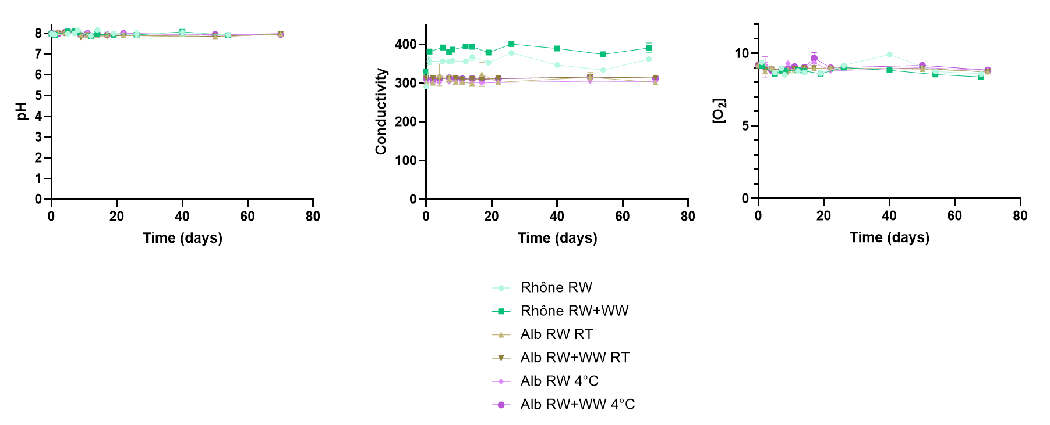
Figure S1. pH, conductivity and dissolved oxygen concentration in the Alb and the Rhône rivers over the 10-week incubation.

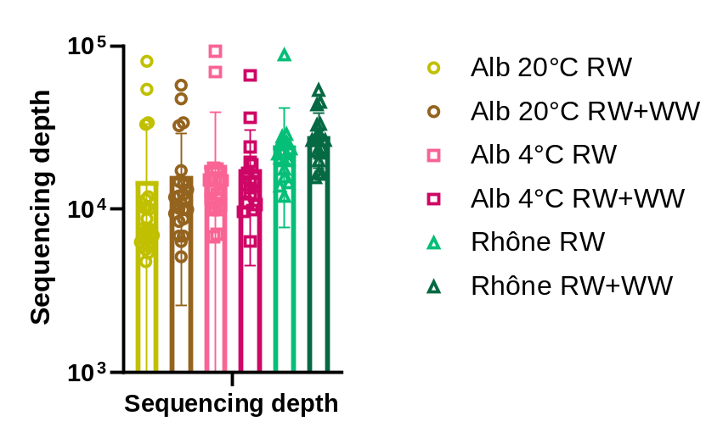
Figure S2. Sequencing depths by condition after removing samples that did not meet a plateau of ASV richness discovery due to too low sequencing depth. Alb 20°C RW n=24; Alb 20°C RW+WW n=24; Alb 4°C RW n=22; Alb 4°C RW+WW n=20; Rhône RW n=17; Rhône RW+WW n=18).
Day | MALDI-TOF-MS  identification | Genome taxonomy | Completion (%) | Redundancy (%)
35 | Janthinobacterium lividum | Janthinobacterium | 98.6 | 0
35 | Pseudomonas koreensis | Pseudomonas | 98.6 | 0
35 | Pseudomonas frederiksbergensis | Pseudomonas | 100 | 4.2
35 | Pseudomonas brennerii | Pseudomonas | 100 | 0
50 | Pseudomonas chlororaphis | Pseudomonas | 98.6 | 4.2
50 | Flavobacterium hydatis | Flavobacterium | 100 | 4.2
50 | Pseudomonas chlororaphis | Pseudomonas | 98.6 | 0
50 | Pseudomonas fluorescens | Pseudomonas | 98.6 | 4.2
50 | Pseudomonas frederiksbergensis | Pseudomonas | 100 | 0
50 | Pseudomonas koreensis | Pseudomonas | 100 | 1.4
50 | Paenibacillus amylolyticus | Pseudomonas | 100 | 1.4
50 | Pseudomonas koreensis | Pseudomonas | 100 | 2.8
50 | Pseudomonas frederiksbergensis | Pseudomonas | 100 | 0.
50 | Pseudomonas antarctica | Pseudomonas | 100 | 1.4
50 | Pseudomonas proteolytica | Pseudomonas | 100 | 0
70 | Pseudomonas jessenii | Pseudomonas | 98.6 | 0
70 | Pseudomonas corrugata | Pseudomonas | 98.6 | 2.8
70 | Pseudomonas koreensis | Pseudomonas | 100 | 1.4
Table S1. Taxonomy, completion and redundancy of the genomes sequenced from isolates from Alb river water microcosms grown on R2A medium.

