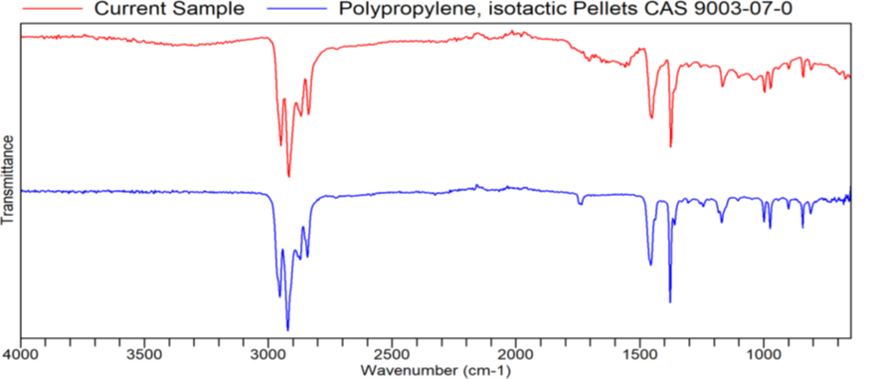
- ATR-FTIR spectre of Polypropylene. HQI : 0.88772

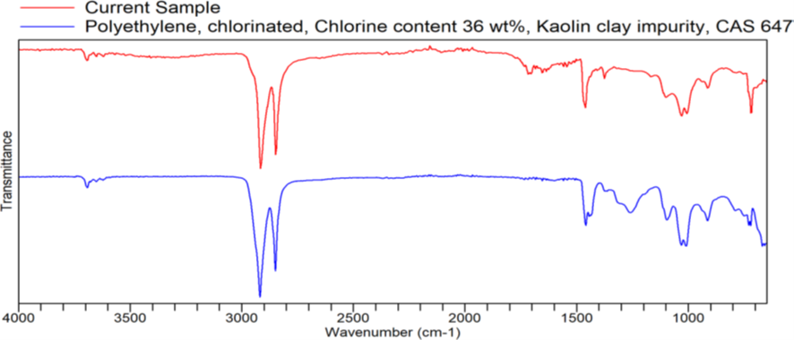
- ATR-FTIR spectre of Polyethylene. HQI: 0.80886
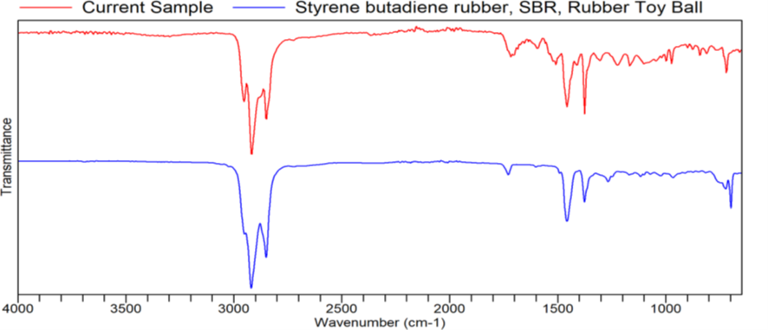

- ATR-FTIR spectre of Styrene butadiene. HQI: 0.85149
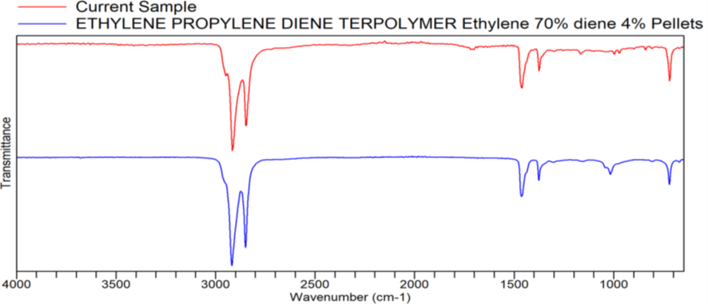
- ATR-FTIR spectre of Ethylene propylene diene. HQI: 0.93234

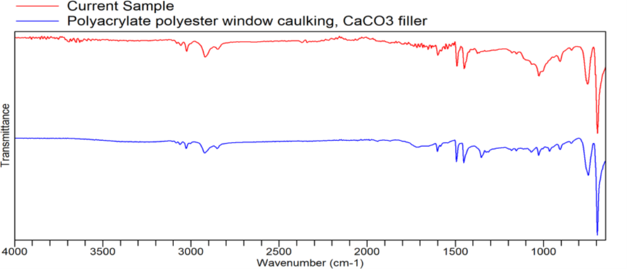
- ATR-FTIR spectre of Polyacrylate polyester. HQI: 0.85177

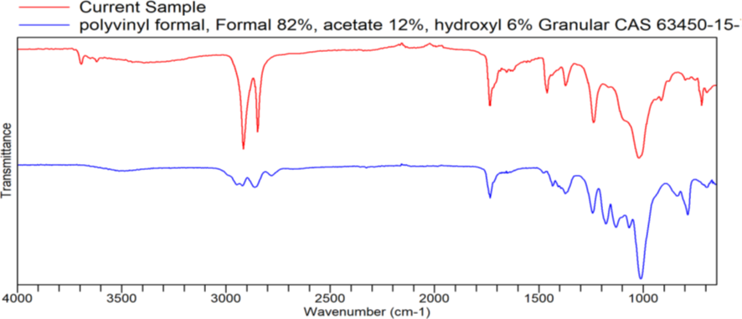
- ATR-FTIR spectre of Polyvinyl formal. HQI: 0.75197
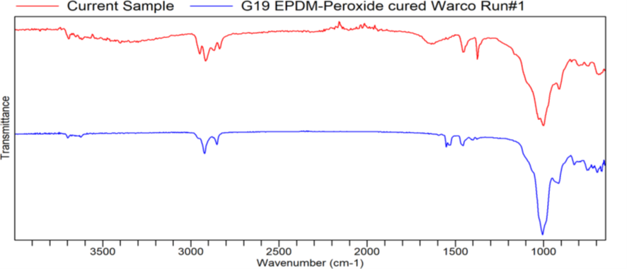
- ATR-FTIR spectre of G19 EPDM-peroxide. HQI: 0.90299

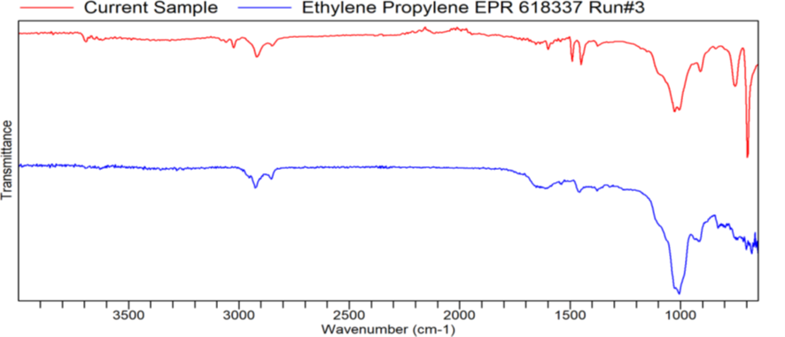
- ATR-FTIR spectre of Ethylene propylene EPR 618337. HQI: 0.77643

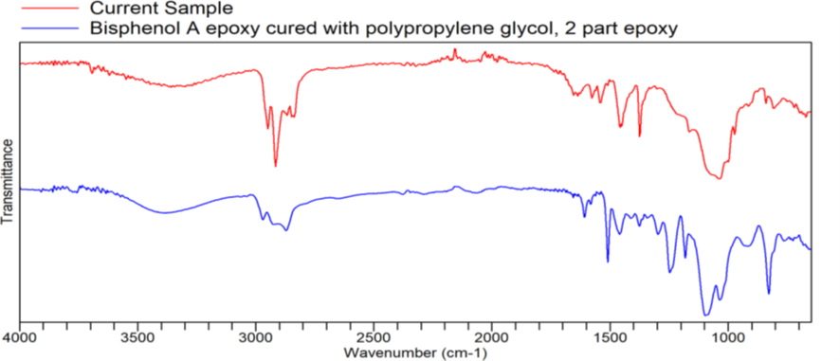
- ATR-FTIR spectre of Bisphenol A epoxy. HQI: 0.77975
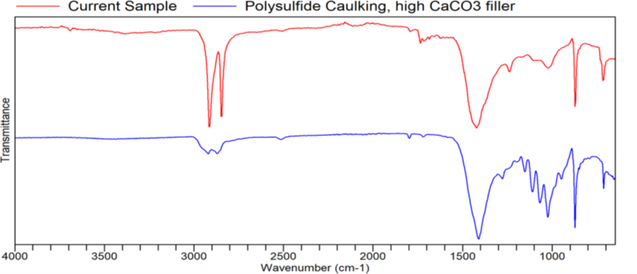
- ATR-FTIR spectre of Polysulfide Caulking. HQI : 0.72931

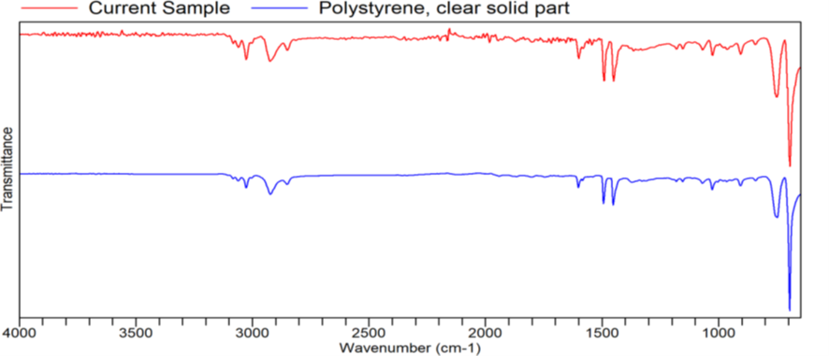
- ATR-FTIR spectre of Polystyrene. HQI: 0.92845

Fig. 8S Selected ATR-FTIR transmittance spectra of main polymers detected in the spectral range of 650 to 4000 cm

