Spatial Coexistence of Oil and Fishing Industries in the Southern Gulf of Mexico: Assessing Vulnerability and Risk of Industry Interactions on Artisanal and Industrial Fisheries
Supplementary Materials
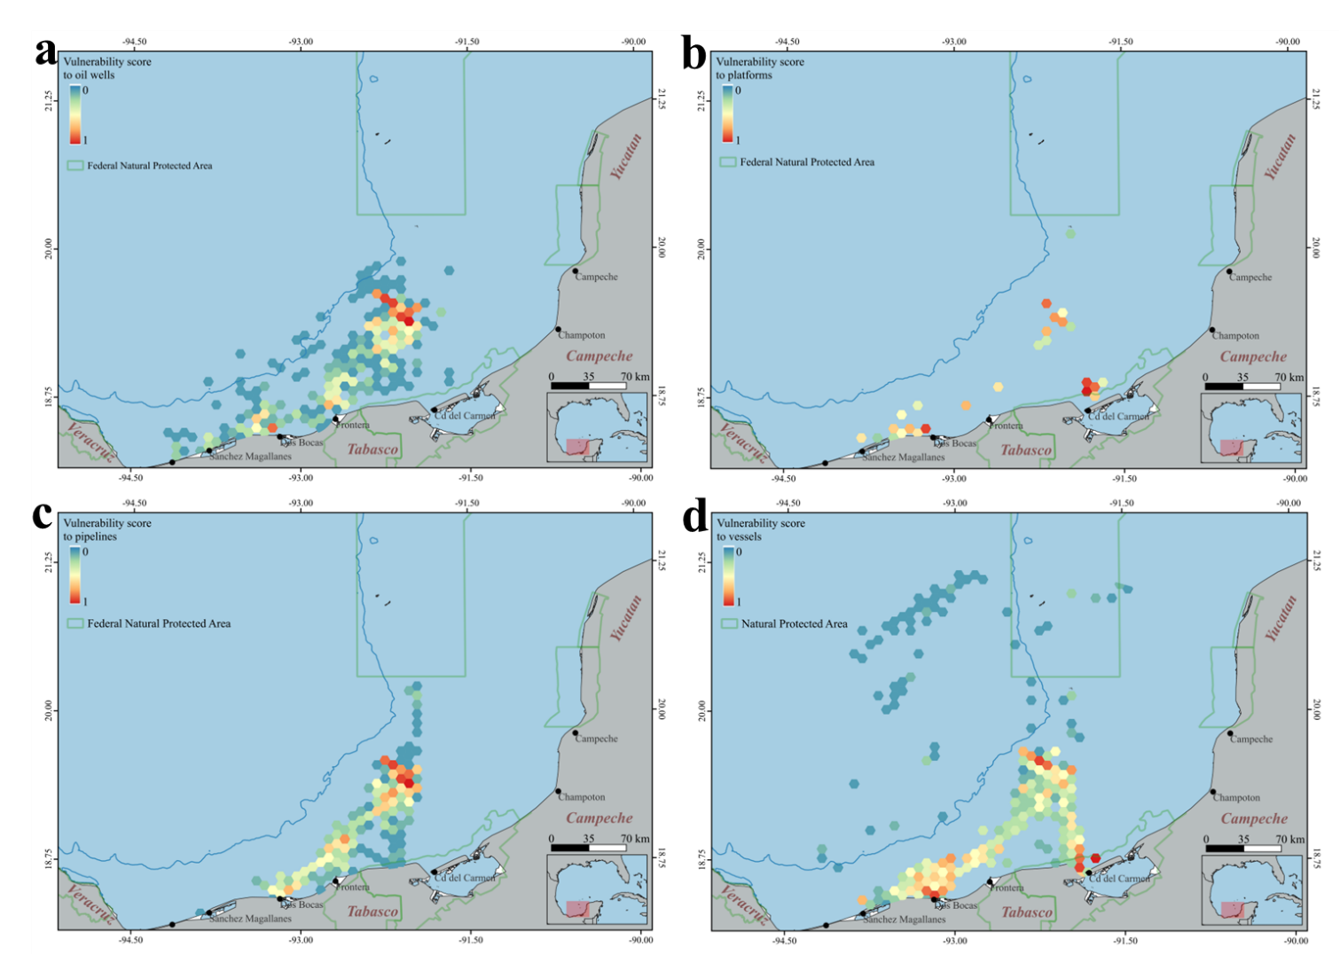
Figure S1. Individual vulnerabilities to the four elements of oil industry evaluated in this study: (a) wells, (b) platforms, (c) pipelines, and (d) vessels.

