Supporting Information:
Occurrence, Spatiotemporal Distribution, and Ecological Risks of Antibiotics in a River Basin of Eastern China
Xintong Lin^{a, *}, Jing Wang^{b}, Zhengzheng Liu^{b}, Jingqing Zhou^{b}, Qinqin Sun^{b}, Shuxin Chen^{b}, Huayu Hu^{b}
ª School of Civil and Environmental Engineering, The University of New South Wales, Sydney, NSW 2052, Australia
^{b} Ecological and Environmental Monitoring Center of Zhejiang Province, Hangzhou 310012, China
*Corresponding Author：E-mail: z5701054@ad.unsw.edu.au
Table S1. CAS Number and Limit of Quantification of Target Antibiotic
Antibiotics |  | Abbr. | CAS Number | Limit of quantification (LOQ)  (ng/L)
sulfonamides  (SAs) | Sulfadiazine | SDI | 68-35-9 | 0.4
sulfonamides  (SAs) | Sulfathiazole | STZ | 72-14-0 | 0.4
sulfonamides  (SAs) | Sulfapyridine | SPD | 144-83-2 | 0.4
sulfonamides  (SAs) | Sulfamerazine | SM | 127-79-7 | 0.8
sulfonamides  (SAs) | Sulfamethazine | SM2 | 1981-58-4 | 0.4
sulfonamides  (SAs) | Sulfamonomethoxine | SMM | 1220-83-3 | 0.4
sulfonamides  (SAs) | Sulfamethizole | SMTZ | 144-82-1 | 0.8
sulfonamides  (SAs) | Sulfameter | SMD | 651-06-9 | 0.8
sulfonamides  (SAs) | Sulfachloropyridazine | SCP | 80-32-0 | 0.8
sulfonamides  (SAs) | Sulfamethoxazole | SMZ | 723-46-6 | 0.4
fluoroquinolones  (FQs) | Enrofloxacin | ENR | 93106-60-6 | 4.0
fluoroquinolones  (FQs) | Norfloxacin | NOR | 70458-96-7 | 2.4
fluoroquinolones  (FQs) | Ciprofloxacin | CP | 85721-33-1 | 2.0
fluoroquinolones  (FQs) | Ofloxacin | OFX | 82419-36-1 | 2.0
fluoroquinolones  (FQs) | Sarafloxacin | SAR | 98105-99-8 | 2.0
fluoroquinolones  (FQs) | Enoxacin | ENX | 74011-58-8 | 2.0
fluoroquinolones  (FQs) | Lomefloxacin | LMFX | 98079-51-7 | 4.4
fluoroquinolones  (FQs) | Nalidixic acid | NA | 389-08-2 | 1.6
fluoroquinolones  (FQs) | Flumequine | FLU | 42835-25-6 | 0.8
fluoroquinolones  (FQs) | Cinoxacin | CIN | 28657-80-9 | 0.8
fluoroquinolones  (FQs) | Sparfloxacin | SPX | 110871-86-8 | 2.0
tetracyclines  (TCs) | Oxytetracycline | OTC | 79-57-2 | 2.0
tetracyclines  (TCs) | Tetracycline | TC | 60-54-8 | 4.0
tetracyclines  (TCs) | Chlortetracycline | CTC | 57-62-5 | 4.0
macrolides  (MCs) | Roxithromycin | ROX | 80214-83-1 | 0.4
macrolides  (MCs) | Erythromycin | ERY | 114-07-8 | 10.0
macrolides  (MCs) | Clarithromycin | CLR | 81103-11-9 | 3.6
macrolides  (MCs) | Azithromycin | AZM | 83905-01-5 | 3.6
lincosamides  (LINs) | Lincomycin | LIN | 154-21-2 | 0.4
lincosamides  (LINs) | Clindamycin | CLI | 21462-39-5 | 0.4
amphenicols  (AMPs) | Chloramphenicol | CAP | 56-75-7 | 0.8
amphenicols  (AMPs) | Florfenicol | FF | 73231-34-2 | 0.4
Note: LOQ was determined as the lowest point on the calibration curve with a signal-to-noise ratio ≥10 and accuracy within 80-120%.

Table S2. UPLC-MS/MS Instrumental Parameters: Gradient Program
Time (min) | Liquid Phase A (%) | Liquid Phase B (%)
0 | 90 | 10
1 | 90 | 10
6 | 70 | 30
7 | 30 | 70
9 | 15 | 85
10 | 15 | 85
10.1 | 90 | 10
12 | 90 | 10
Note: Mobile Phase A: 0.1% (v/v) formic acid in water; Mobile Phase B: methanol.

Table S3. List of LC₅₀ of the antibiotics.
Antibiotics | LC₅₀ (mg/L)
SDI | 907
STZ | 90
SPD | 246
SM2 | 62.1
SMD | 899
SCP | 391
SMZ | 267
NOR | 2010
CP | 1310
OFX | 1940
LMFX | 8670
ROX | 51.6
ERY | 68.4
LIN | 1040
CLI | 80.8
CLR | 24.2
AZM | 21.9
CAP | 2500
FF | 1100
SPX | 1240
Note: LC₅₀ values were primarily sourced from the U.S. EPA’s ECOSAR model (v2.0) or peer-reviewed ecotoxicity studies where available; Predicted No-Effect Concentration (PNEC) was calculated as: PNEC = LC₅₀ / Assessment Factor (AF). A conservative AF of 1000 was applied to extrapolate from acute laboratory data to chronic environmental protection, following standard guidelines.
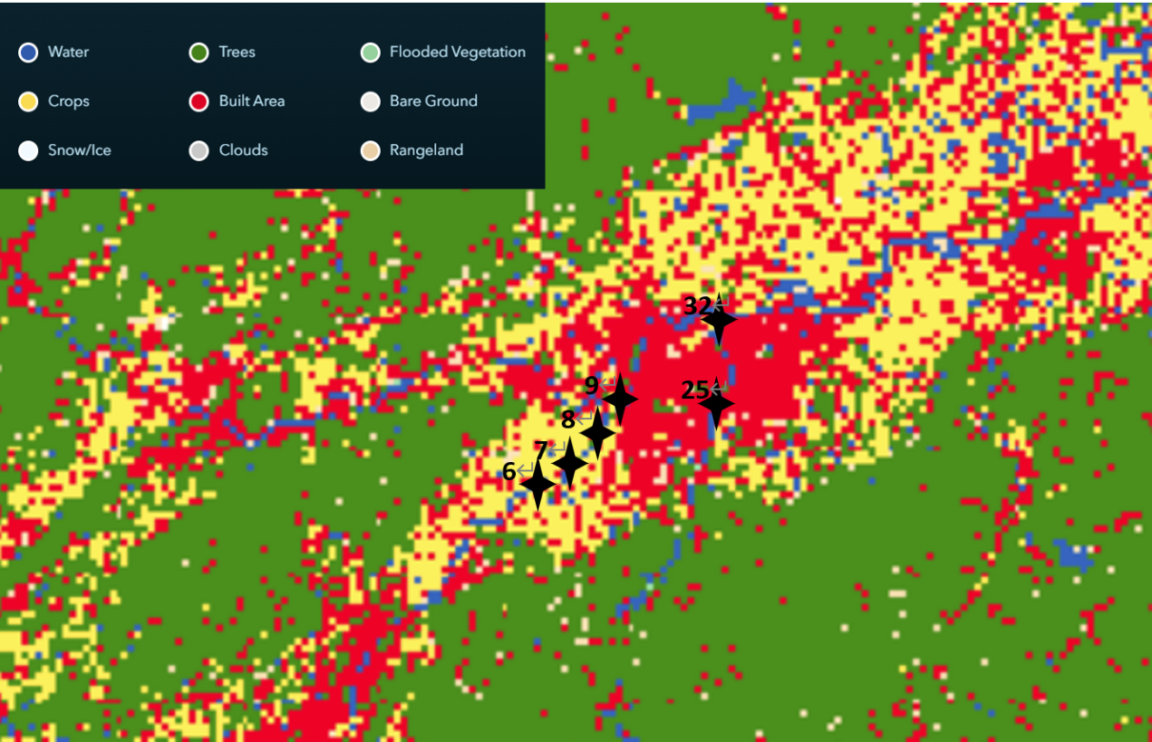
Figure S1. Map of Esri Land Cover land use type
Note: The sampling points are identified by the labels from the sampling year 2024. The area within the rectangular frame is predominantly yellow (Crops) interspersed with red (Built Area), exhibiting a mosaic pattern of cropland and construction land, which is characteristic of an agricultural region. In contrast, the area within the circular frame is almost entirely red, indicating a densely built environment, which can be inferred as a contiguous residential zone or urban-influenced area.
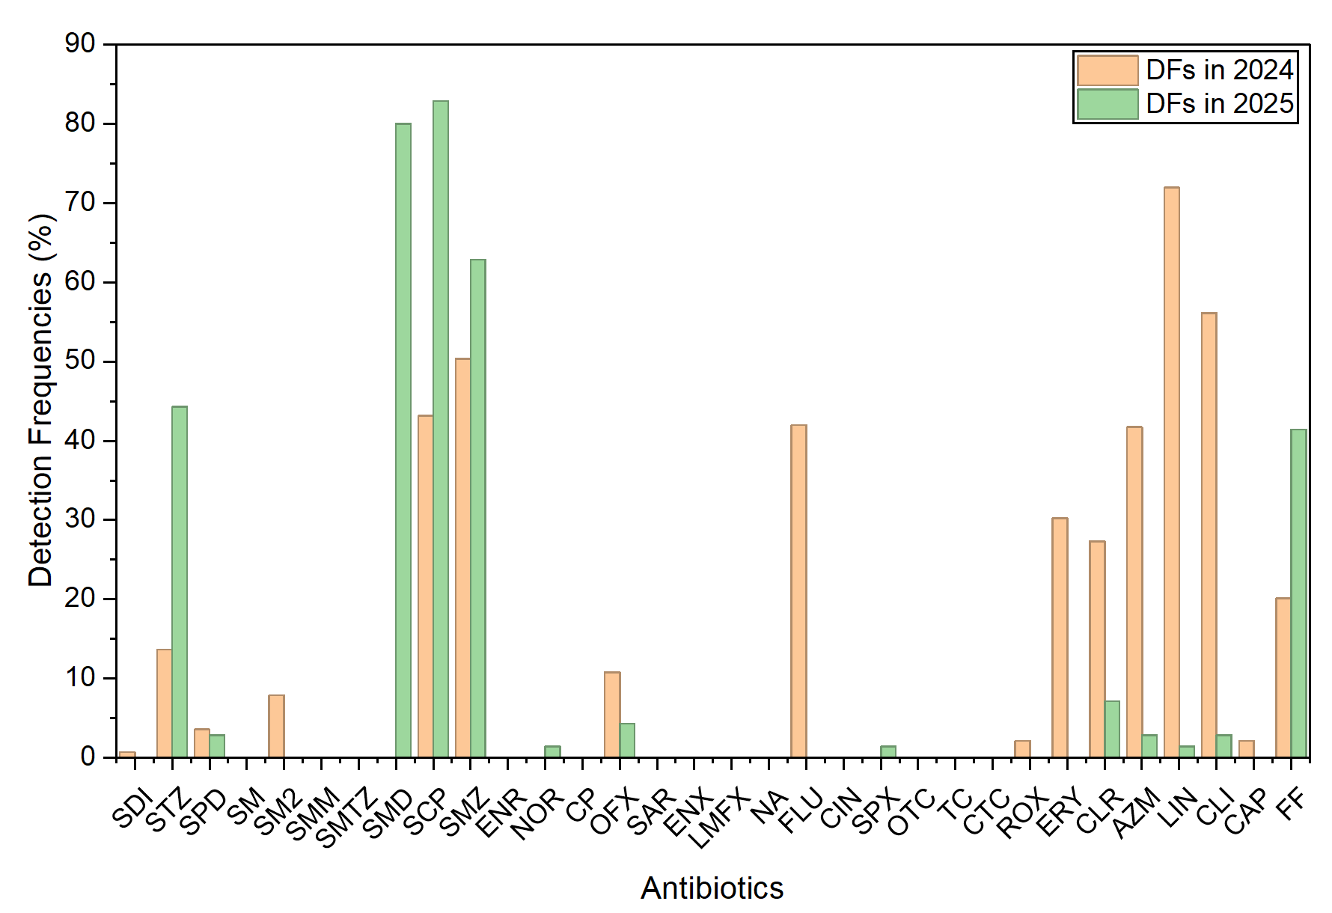
Figure S2. Detection frequencies (DFs) of the 32 antibiotics in 2024 and 2025.

