Supplementary material

In Figures 7 and 8 we present our population and GDP projections for Ethiopia. The data are taken from UN (2015) and UNDP (2017).

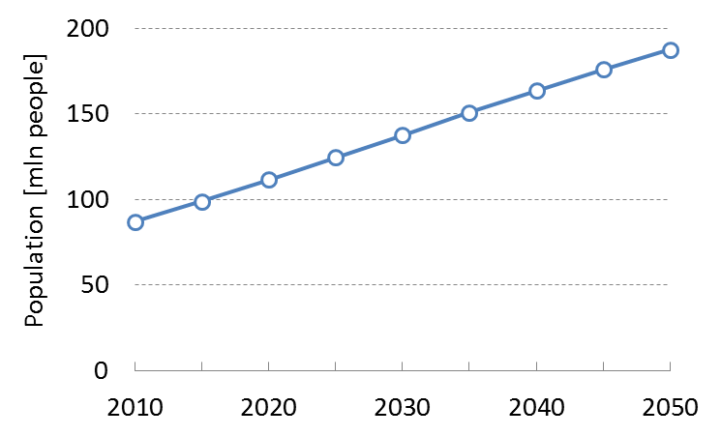
Figure 7: Population growth projection.

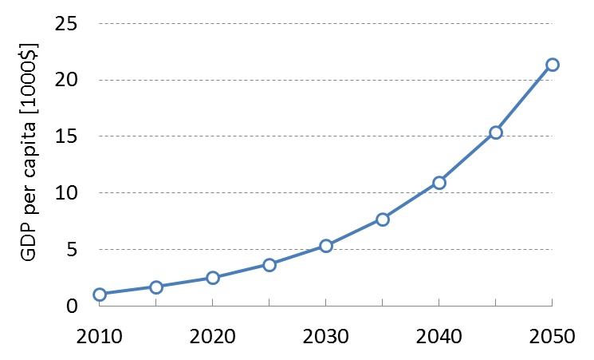
Figure 8: GDP projection.

Figure 9 depicts our willingness-to-pay projection, calculated as described in section 2 of this paper.

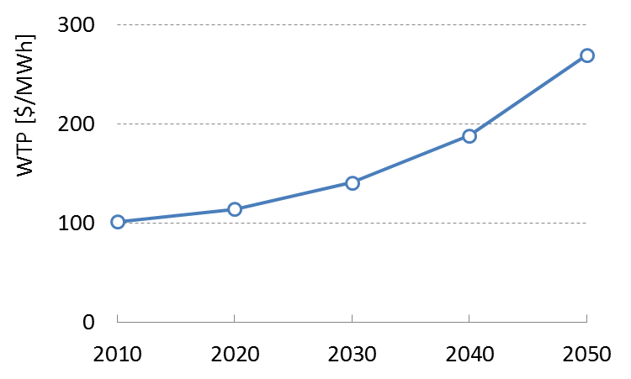
Figure 9: Willingness to pay projection.

In Figure 10 we present a large sample of electricity access data (y-axis) versus GDP (x-axis) for all countries in the world for the years between 2010 and 2015, using a logarithmic scale along the horizontal axis. The data show that, for data points where energy access is below 100%, there exists a correlation between the two variables. This correlation is lost once a country reaches 100% electrification – the GDP can keep increasing, while energy access reached its maximum. In the figure African countries are shown as blue dots, while Ethiopia is highlighted in red triangles. Other countries are plotted as grey squares.

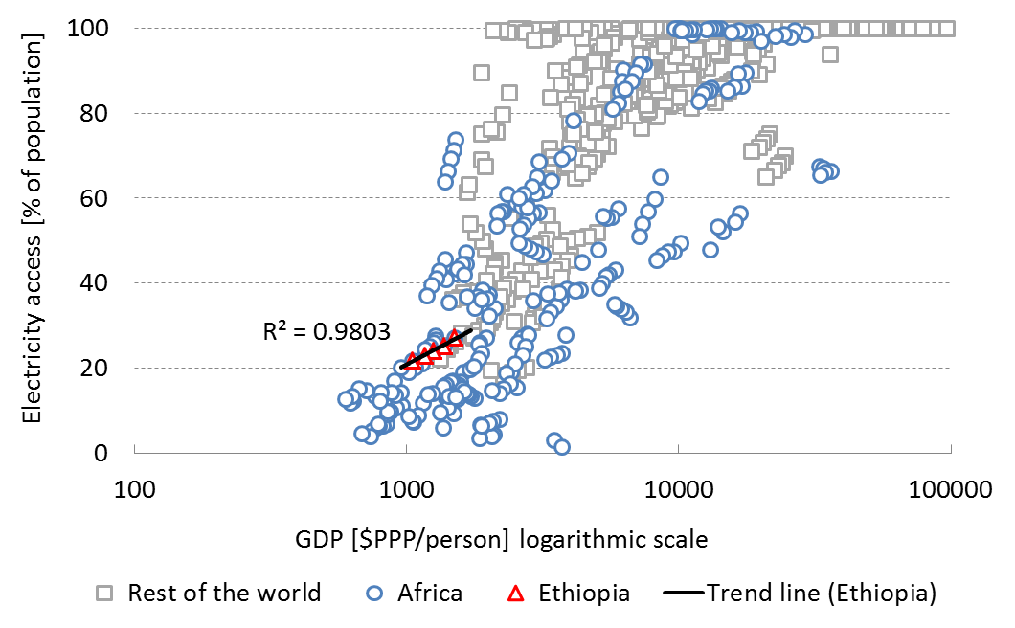
Figure 10: Correlation electricity access vs GDP (in logarithmic scale). Each data point represents a unique combination of country and year. The data span years 2010 through 2015 and include all countries in the World. African countries are plotted as blue dots, while red triangles are used to highlight Ethiopia. Other countries are presented as grey squares. The plot shows a clear (albeit weak) overall correlation between electricity access and GDP per capita. A solid black trend-line through the red data-points emphasizes that for Ethiopia itself the correlation is very good.

