Supplementary Information

This document is a compilation of data strategy applied in the paper. In particular, the authors outline the empirical procedure of data source, collecting and filtering to reach the final sample.

Data Sources

To operationalize our model, we used data compiled by Thompson Reuters Eikon DataStream for ESG and financial information. Eikon provides the world’s most complete financial historical time series data from the 1950s. The global scale data for international organizations indexed in major suppliers such as MSCI, FTSE Russell, S&P, Dow Jones and STOXX with coverage of 125 countries are collected by Eikon which accounts for 99% of worldwide market capitalization. It also offers the most complete ESG data for 6000 public companies with history back to 2002. Also, since all airline companies are publicly traded having their shares listed in stock index suppliers, they issue regular financial documents including firm’s annual reports. A company’s annual report summarizes its performance over the previous fiscal year in form of fundamental or ratio analysis, income statement, balance sheet, and future perspective. We refer to these annual reports in cases where needed observation was not available for sampled airlines.

Data Collecting

In this section we explain step-by-step the procedure to figure out how to obtain data from the sources used in this study with screenshot of each phase. Primarily, we collect the dataset related to airline companies’ performance in terms of ESG and financial variables from Eikon database. Once open the Eikon main webpage, we first clicked on “Industries” toolbar at the top of the screen, we were able to filter down to our desired industry where selected “Airlines” to get the list of all listed airline companies among the passenger transportation service companies.

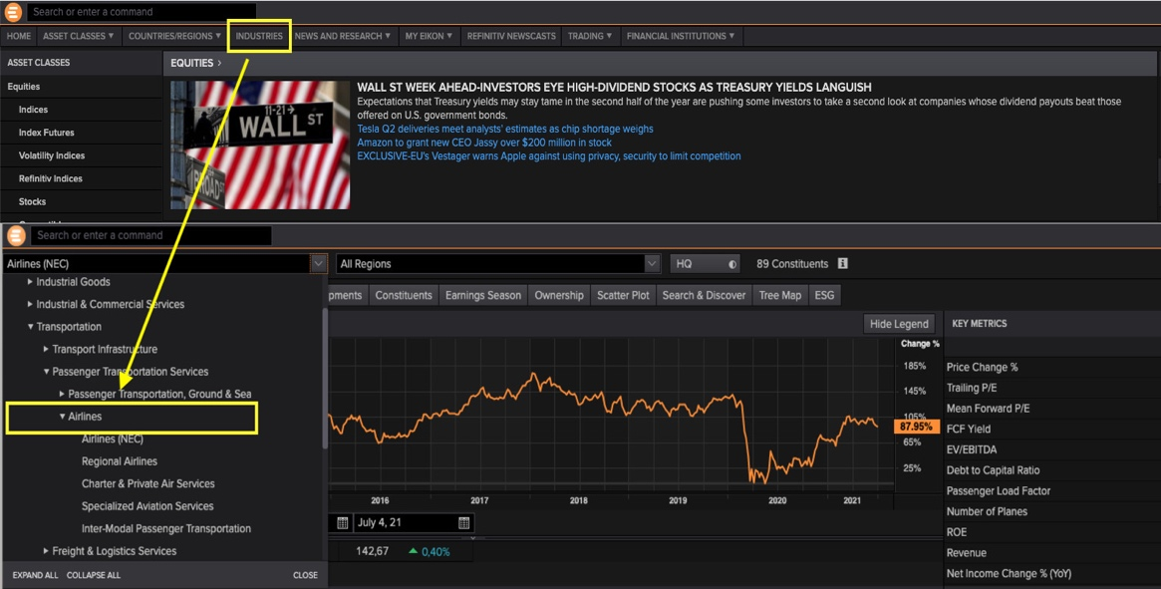

By selecting the “Airlines”, Eikon will provide with a comprehensive list of data options related with this industry. Here from the launched window, to get the ESG data we hit on “ESG” tab from the toolbar where we typed “ESG” from the search bar and adjust the time frame (last 11 years) which provided us the Excel on the screen and load the data (note that depends on the financial calendar year of these companies. We download the data for the last 12 years).

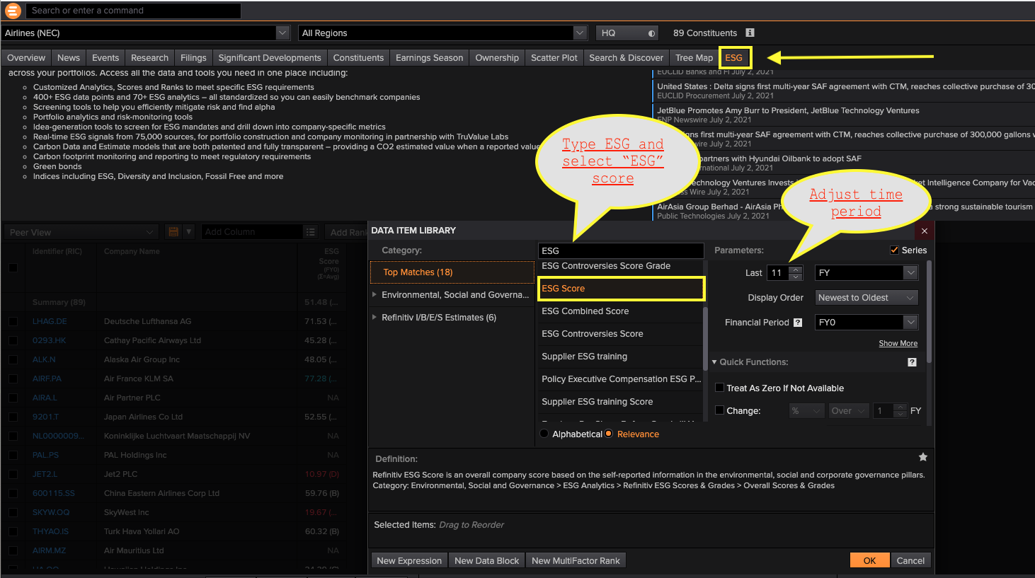

Similarly, to get the financial data, from the main menu of Eikon page for airlines, we clicked “Constituents” tab where there is the possibility to type the name of interested variable and select the suitable option (based on the definition provided when clicking on each variable) from the suggested list. Again, we added other search criteria (data range, scale, currency, display order, etc.) to filter the results and click “OK” to add the information to the report. We exported the data to Excel as values.

Example- to access the time series data of total assets of selected airlines, we typed “total assets” at the search bar then selected the “total asset, reported”. We then defined the range of last 12 years and filtered the scale to million. Note that, we measure every financial and ESG variable at the end of December 2019. After analyzing year-end financial statements for each airline, we find that 17 out of 38 airlines do not have a December fiscal year-end. Therefore, we also downloaded the data for last 12 consecutive years and compared the FY0 value with the measure for date of 31/12/2019 for these firms in order to make sure that the correct measure for the end of 2019 has been incorporated into the database. By hitting “OK” we were provided the firm-year observations for all companies in Excel as shown on the screen.

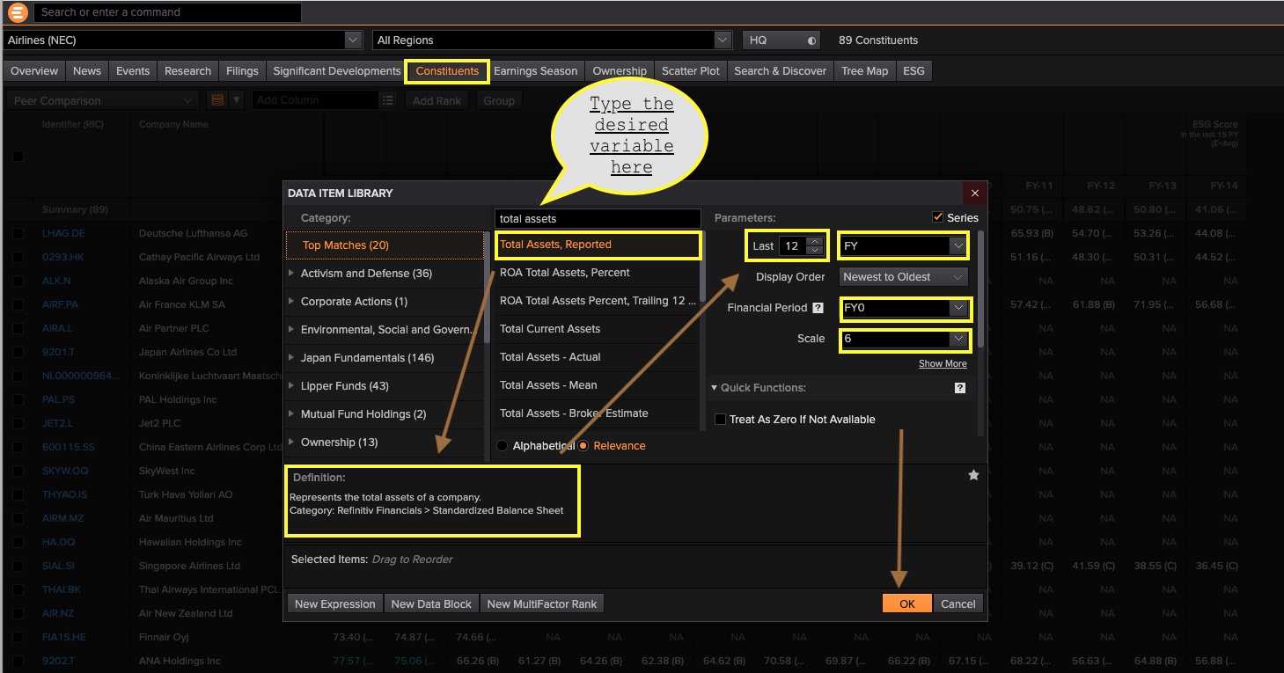

Data filtering
To construct our sample, data processing started from the full set of airline companies listed in the Eikon data base (94 airlines) over the longest possible period which is 2002-2019 (as mentioned above, it is because the Eikon started to report ESG from 2002) with firm-year observations. We discovered that not all firm-year observations were available because the Eikon does not have all ESG observations for every company and some other data were unavailable. Therefore, to minimize the missing data, we select those airlines having at least 4 years of ESG data which left us with 38 firms (the rest of 58 airlines were excluded from the sample). Additionally, due to missing data for financial variables of MB, ROA and dividend payout ratio, we referred to airlines’ official annual reports as the second data source to fill in as many missing values as possible. We find 85 observations related to these two variables and added them to the database. Finally, as a common practice in financial research, we winsorized extreme values throughout the dataset prior to estimating the regression estimation to alleviate concerns over potential problems arising from outlier values. Therefore, we checked the distribution of explanatory and control variables for normality. We detected 27 observations fall within the top and bottom (±) 3 standard error as outliers and remove them from the dataset. After removing outlier observations and filling missing values, this study obtained an unbalanced panel dataset consisted of 4297 observations for the 38 sampled airlines.

