Title

Quantifying the influence of climate variability on armed conflict in Africa, 2000-2015

Supplementary Material

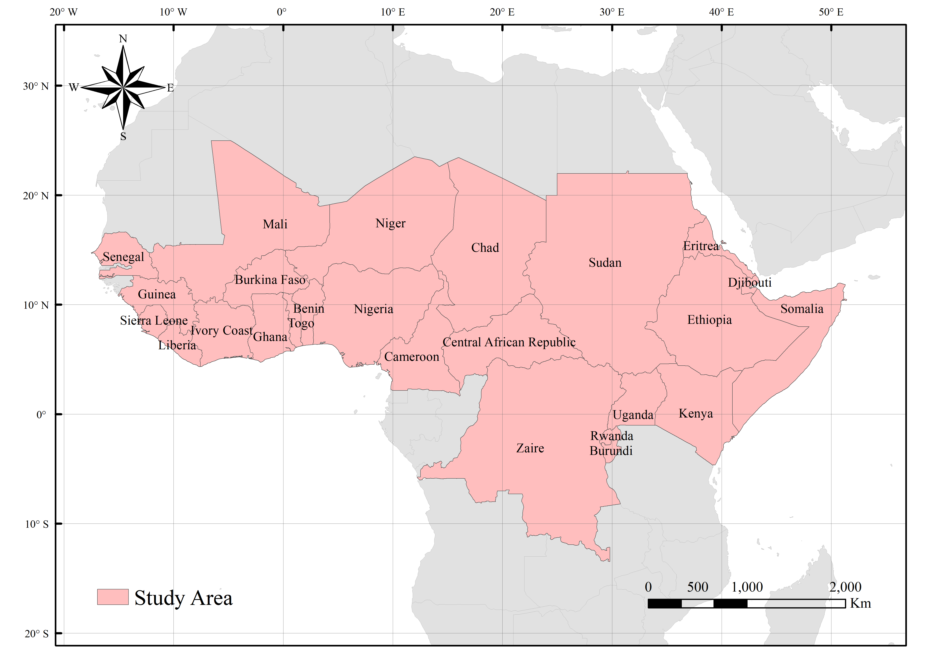
Fig. S1. The study area of the 25 countries in Africa. Study area includes Sudan, Zaire, Chad, Mali, Niger, Ethiopia, Nigeria, Somalia, Central African Republic, Kenya, Cameroon, Ivory Coast, Burkina Faso, Guinea, Uganda, Ghana, Senegal, Eritrea, Bay Republic of Nigeria, Liberia, Sierra Leone, Togo, Burundi, Rwanda and Djibouti.

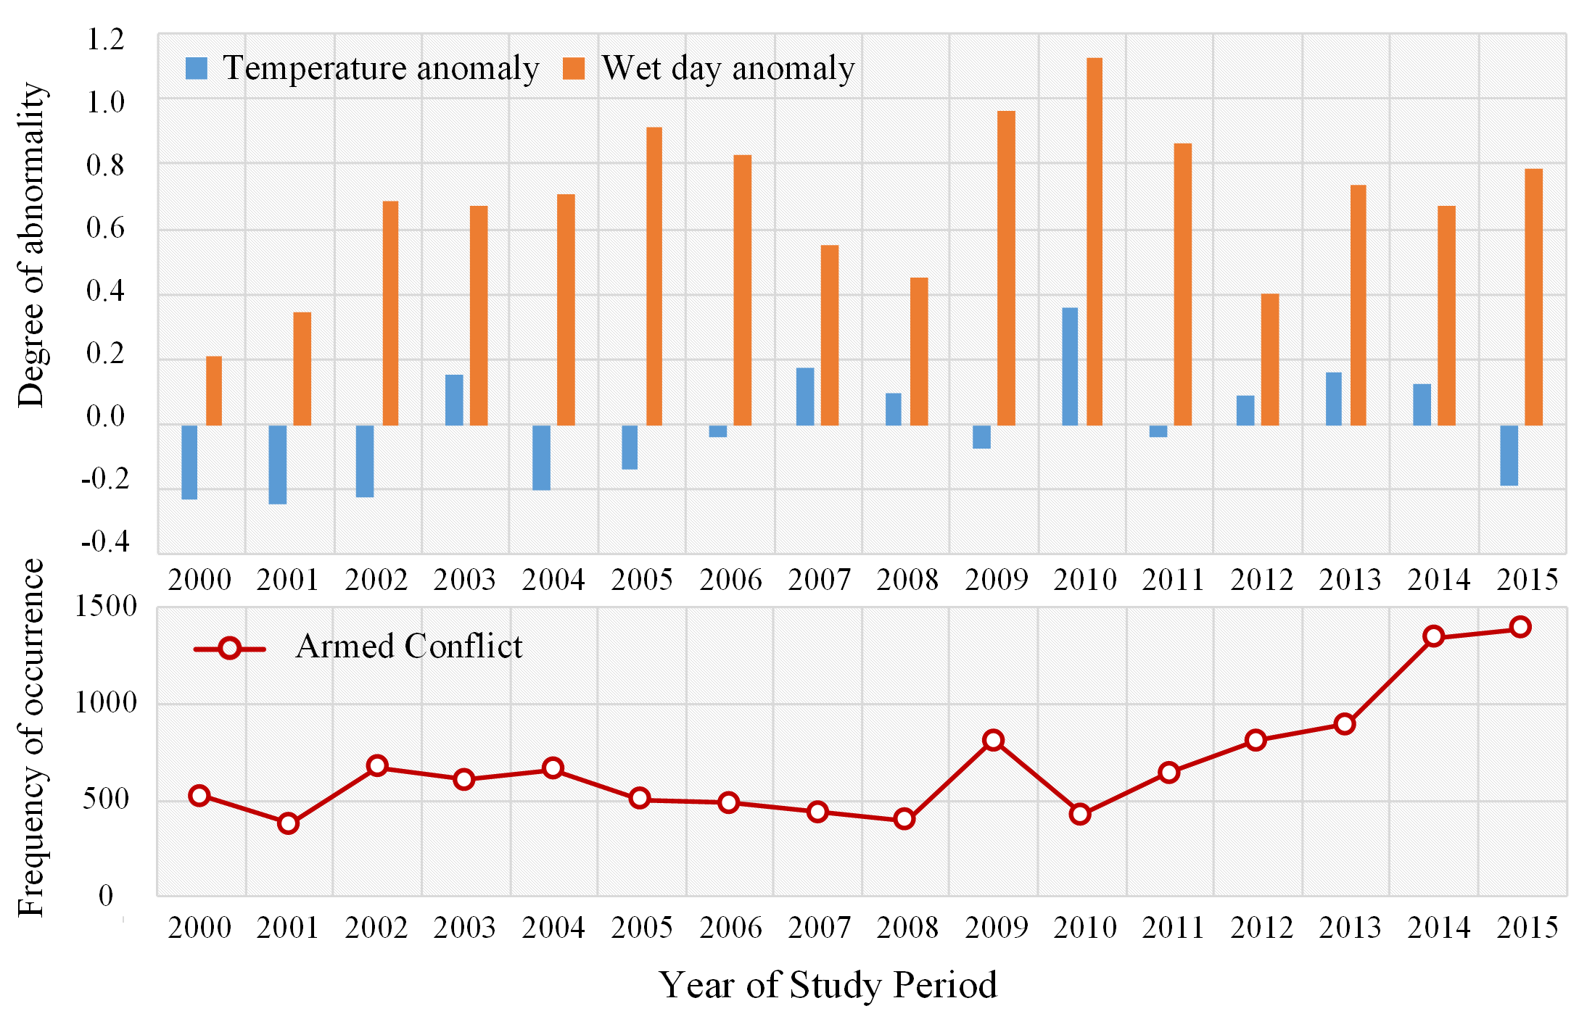
Fig. S2. Characteristics of frequency and time variation of climate variability and armed conflict in study area from 2000 to 2015. The upper part shows the time-varying characteristics of temperature anomaly and wet day anomaly from 2000 to 2015, and the lower part shows the changes of armed conflicts’ frequency during this period.

Fig.S3. Raster maps of conflict events in the study area in 2000, 2005, 2010 and 2015. The frequency of armed conflict occurrence ranges from 0 (pink) to 18 (red).
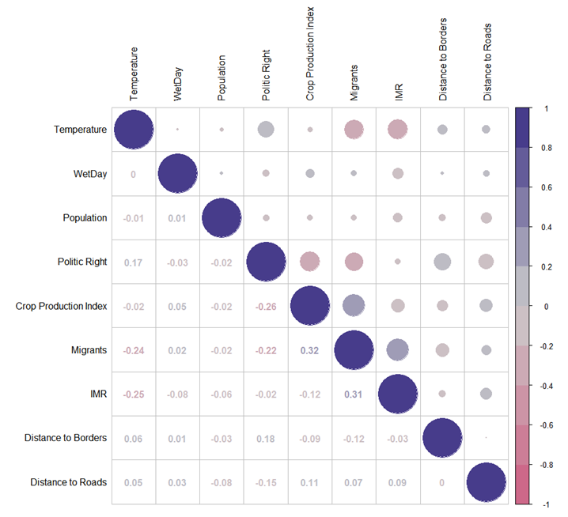
Fig. S4. Correlation between the environmental predictor variables in the final Generalized Liner Model (GLM) and Generalized Additive Model (GAM). the linear product-moment correlation coefficients tabulated in the lower triangle scaled from -1 to 1, with -1 indicating strong negative correlation and 1 indicating strong positive correlation.

Fig.S5. Raster maps of temperature anomaly in the study area in 2000, 2005, 2010 and 2015. The temperature anomaly ranges from -0.2(blue) to 2.0 (red).
Fig.S6. Raster maps of wet day anomaly in the study area in 2000, 2005, 2010 and 2015. The temperature anomaly ranges from -7(Sienna) to 6(Light Blue).

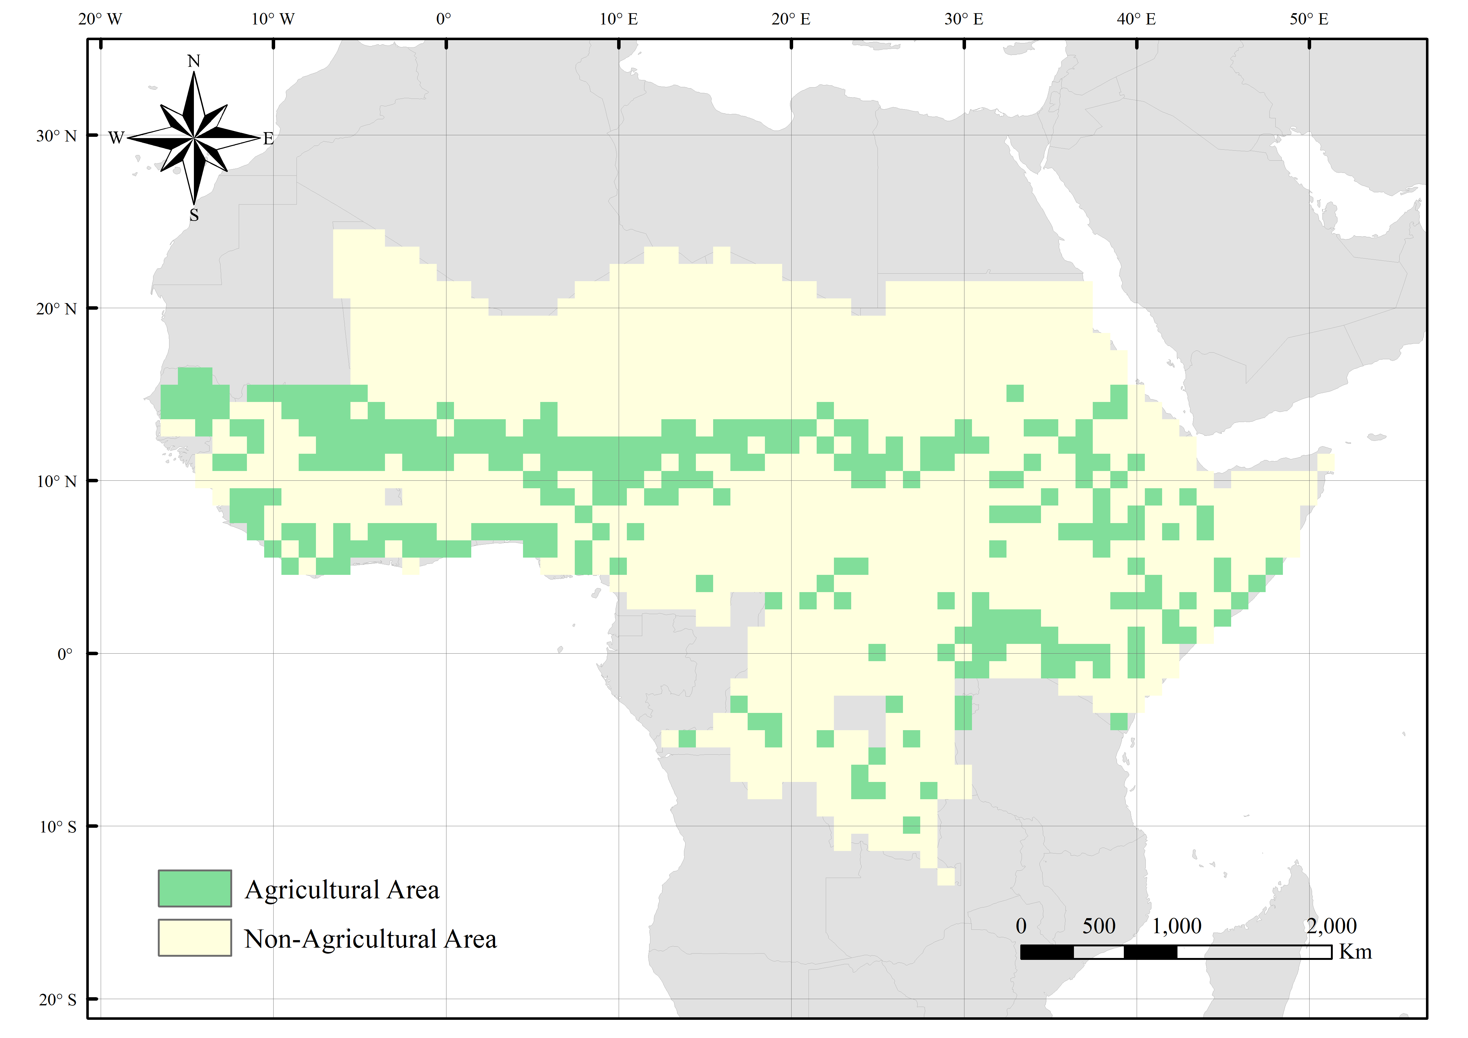
Fig.S7. Raster map of agricultural area and non-agricultural area in the study area.
Fig.S8. The coefficient estimates and 95% confidence interval over the range of temperature anomaly(a) and wet day anomaly(b) for the model in DRC.

Table S1. Data source of conflict and variables.
Factors | Parameters | Data | Source
Conflict | Violent Events | Violent Events | The Uppsala Conflict Data Program (UCDP)
Climate | Temperature anomaly | Temperature | The Climatic Research Unit TS dataset
Climate | Wet day anomaly | Wet day | The Climatic Research Unit TS dataset
Social factors | Migrants | Immigration rate | United Nations, Department of Economic and Social Affairs, Population Division (2019)
Social factors | Population | Population density | Socioeconomic Data and applications center (SEDAC) in NASA’s Earth Observing System Data and Information System(EOSDIS)
Social factors | Crop Production Index | Crop Production Index | Food and Agriculture Organization and the World Bank
Social factors | Politic Right | Politic Right | Freedom in the World
Social factors | Wellbeing | Infant Mortality Rate | Interagency Group for Child Mortality Estimation
Social factors | Ethnic diversity | The number of nations | International Conflict Research of Swiss Federal Institute of Technology Zurich
Social factors | Capital City | Capital Coordinates | Global Library Data
Basic geography | Agricultural Land | Land use Type | The Data User Element (DUE)
Basic geography | Distance to Roads | Road network | Socioeconomic Data and Applications Center (SEDAC)
Basic geography | Distance to Borders | Administrative Borders | Database of Institute of Geographical Sciences and Resources, Chinese Academy of Sciences

Table S2. Summary of conflict and variables.
Factors | Parameters | Data | Min | Max | Mean
Conflict | Violent Events | Violent Events | 0 | 39 | 0.0523
Climate | Temperature | Temperature anomaly | -2.0147 | 4.2264 | 1.0815
Climate | Wet day | Wet day anomaly | -9.0288 | 8.0725 | -0.0137
Social factors | Migrants | Immigration rate | -982.69 | 843.47 | 135.30
Social factors | Population | Population density | 0 | 4046.374 | 39.167
Social factors | Crop Production Index | Crop Production Index | 0 | 213.59 | 106.95
Social factors | Politic Right | Politic Right | 1 | 7 | 5.205
Social factors | Wellbeing | Infant Mortality Rate | 0 | 142 | 76.56
Social factors | Ethnic diversity | The number of nations | 1 | 6 | 1.722
Social factors | Capital City | Capital Coordinates | 0 | 1 | 0.0146
Basic geography | Agricultural Land | Land use Type | 0 | 1 | 0.2331
Basic geography | Distance to Roads | Road network | 0 | 2.11 | 0.0440
Basic geography | Distance to Borders | Administrative Borders | 0 | 5.6372 | 1.3085

Table S3. Summary of conflict and variables and model result in DRC
Data summary |  |  |  | GAM summary
 | Min | Max | Mean |  | estimate | z-value
Violent Events | 0 | 39 | 0.0455 | Intercept | -1.7313 | -2.4274
Temperature anomaly | -1.8216 | 4.2264 | 1.2425 | Temperature anomaly | p-value | 0.000*
Wet day anomaly | -6.6989 | 5.3603 | -0.1615 | Wet day anomaly | p-value | 0.000*
Immigration rate | -60 | 91.77 | 24.77 | Immigration rate | 0.0238 | 6.2581*
Population density | 0 | 2536.892 | 30.538 | Population density | -0.0005 | -1.9284†
Crop Production Index | 98.08 | 110.34 | 103.63 | Crop Production Index | -0.0066 | -0.6260
Politic Right | 5 | 7 | 5.938 | Politic Right | 0.1181 | 1.0183
Infant Mortality Rate | 74.1 | 107.50 | 90.62 | Infant Mortality Rate | -0.0221 | -2.1234†
Capital City | 0 | 1 | 0.0111 | Capital City | 3.4593 | 8.5378*
Distance to Roads | 0.0005 | 0.2739 | 0.0575 | Distance to Roads | -3.0858 | -3.1654*
Distance to Borders | 0 | 5.4415 | 1.7413 | Distance to Borders | -1.0076 | -16.1893*
Land use Type | 0 | 1 | 0.1215 | AIC | 7933.9678
Ethnic diversity | 1 | 4 | 1.436 | AUC | 0.8379
*p<0.01 using grid-clustered SEs
†p<0.05 using grid-clustered SEs

The effect of economic factor (crop production index) on conflict
To further explore how the economic factor affect the conflict under the climate and conflict relationship we hypothesized, we applied the smooth function of GAM to CPI to the model (1). The GAM version of this model had the following functional form:
$Y_{it}=f_{1}\left({tem}_{it}\right)+f_{2}({wet}_{it})+f_{3}({CPI}_{it})+X_{it}β+{Country}_{it}+{Year}_{it}+{Ethnic}_{it}+ε_{it}$ (2)
where i = grid; t = time (months); β is a vector of coefficients associated with the matrix of independent variables X, $f_{1}$ $f_{2 }and$ $f_{3}$are thin-plate spline functions, ${tem}_{it}$ is the temperature anomaly degree of grid i in t time and ${wet}_{it}$ is the wet day anomaly degree of grid i in t time, ${CPI}_{it}$ is the crop production index of grid I in t time, country, year and ethnic are fixed effect terms; and $ε$ is the grid month error term.
We applied the model (2) in whole study area, agricultural and non-agricultural region, respectively and found the coefficient curve of CPI and conflict as shown in Fig.S9. The chance of conflict first decreases, then increases and final drops with the CPI increases, and this pattern keeps a same shape both in agricultural and non-agricultural region.

Fig.S9. The coefficient estimates and 95% confidence interval over the range of yearly crop production index in all region (a), in agricultural region (b), and in non-agricultural region (c).

