Supplementary texts and supplementary figures for:
Integrating Space Syntax and System Dynamics for Understanding and Managing Change in Rural Housing Morphology: A Case Study of Traditional Village Houses in Düzce, Türkiye

Supplementary Text 1: Defined norms for rural housing morphology analysis
When expressed as articles, these norms are listed as follows:
- Ethnicity is kept constant in the traditional houses examined, as the study is handled in the context of understanding the underlying relationships of rural housing change and proposing a new method. Villages where people of Manav (Turkmen) ethnic origin live and traditional houses in these villages are selected in the rural areas of Düzce, which contains a wide variety of cultures. The reason for this is that the Manavs (Narin, 2018), who came to settled in Western Anatolia from Central Asia in the 13th century, are more resistant to change, in other words, their cultures are more preserved when these periods are taken into account.
- While choosing traditional houses, structures that have changed in spatial configuration and morphology are taken into account. Since there are also material changes, this dimension is included in the SD conceptual model – within the variables obtained from the interviews with residents.
- In order to examine the scale of change comparatively, newly built houses and houses with very similar features are not included in the space syntax analysis.
- In the space syntax analyses, the spaces that are not included in the living units such as byre, hayloft, woodshed, (stone) oven, poultry house, storehouse, cellar, warehouse, kuruluk (semi-open wooden structure to desiccate picked corns specially), garage and other structures within the garden of the house are not counted in the analysis.
- In the direction of digitizing the spatial configuration, the houses are evaluated as a whole. For this reason, the stair core has been added to the analysis as one unit that can be defined as a transition space or a connecting space – connecting the lower and upper floors within the house.
- In the syntactic analysis, the outside of the building (the part before the entrance door, the front garden or the road in some) is accepted as the root and the justified plan graphs are created as the starting point is root.
- Integration and depth values do not change depending on the space dimensions. Since the measurements in the spatial analyzes are made on integration and depth values, the dimensions of the housing units are not taken into account. JPGs prepared in this direction are supported by the house plans drawn according to the real dimensions, as supported by the background of the space syntax software used.
- In the formulation of the change in the SD model, to be used in the "digitization of the space", the initial construction cost of the house, as well as the costs of all material changes, are calculated and integrated into the model, and application norms on the basis of the house are determined.
Supplementary Text 2 and Supplementary Figure 1: General case study survey's results and presentation of a house’s morphological change
According to the results of the survey applied to the residents; the construction years of the buildings are in the 1950s and 1960s and the buildings continue their functions as house. The users of the houses are at least 2nd generation traditional house users, as the local craftsmen (actually residents) who built the house are not alive. Houses have been inherited from these generations. While the number of people living in the houses used to be up to 20, the number of people currently living in the houses is between 2-5. The first changes in the houses began to be made in the 1970s and 1980s. This first change period is usually 20-25 years after the date of construction. While changes (increase or decrease) were made in the number of rooms in some of the houses (Figure 1), there were changes in the use and materials of the units in some of them.
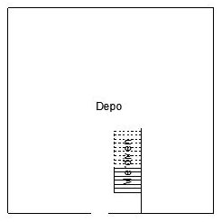  Main Building  Annex Building Building | 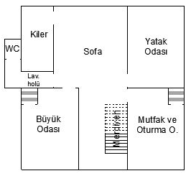 | 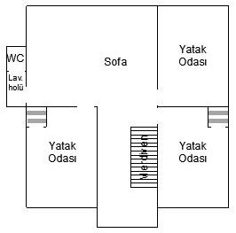
A
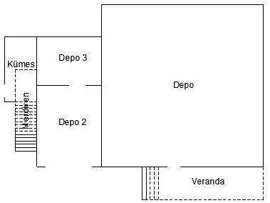 | 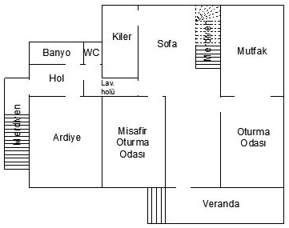 | 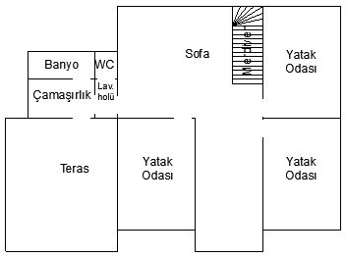
B
Figure 1: An example of the morphological change in the houses: Dadalı Village MB House diagrams consisting of floor plans before (A) and after (B) change

Supplementary Text 3: Expression of system dynamics conceptual model relations
- Qualitative and quantitative characteristics of the house originating from the spaces determine the integration and depth values. The ‘number of existing spaces’ parameter in the model affects the ‘connections between spaces’, and these connections affect the ‘existing house depth’ and ‘accessibility to the space’ in a supportive way. Increasing the ‘existing house depth’ decreases the integration value (as numerical value). Looking at this relationship, depth and integration values, in this context, are not the cause of anything, but the result.
- The ‘number of existing spaces’ and the number of spaces needed (‘number of desired/required spaces’ parameter) constitute the quantitative change, that is, the ‘space number difference’ parameter. With this parameter, the loop starts working on balancing behavior. The decrease in ‘space number difference’ increases the rate of meeting expectations in terms of the number of spaces (‘meeting expectation ratio of the house in terms of number of spaces’ parameter). The increasing rate reduces the situation of ‘making changes in the number of spaces in the house’. The decreasing effect of the parameter to change the number of spaces reduces the ‘number of existing spaces’ in the same direction. The striking point where the cycle gains its meaning comes into play here. Since the decrease in the ‘number of existing spaces’ will increase the ‘space number difference’ in the opposite direction, the cycle remains in balance without starting a new tour, with the required number of spaces with change movement being reached. And this creates one of the balancing (B) loops in the system.
- Similar to the behavior aimed at keeping the change in the number of spaces under control, the change in the space function at the top (‘desired/required space function’ parameter) in the display takes place in order to keep it in balance. When the desired change is realized in the use of space, the ‘space function difference (qualitative change)’ also changes in the same direction (increasing if increasing, decreasing if decreasing). The increase in qualitative change in terms of making a difference or moving away from the target reduces the rate of meeting expectations as a space function of the house (‘meeting expectation ratio of the house in terms of space function’ parameter). This decrease in the ratio increases the situation of ‘making space function changes in the house’, which in turn increases the functional change of the existing space (‘existing function of the space’ parameter). In order to avoid a continuous change and a reinforcing behavior, when the desired space function changes, the ‘space function difference’, which initially has an increasing effect, exhibits a decreasing behavior and the system remains in balance.
- The parameter of the ‘will to live in the existing house’, which is at the center of the other cycles in the system, is also related to the ‘inheritance of the house’ as mutually supportive. While the behavior of the ‘will to live in the existing house’ increases because the house is inherited, the desire to continue living here increases with the continuation of this desire and inheriting it from the current inhabitant because the house is lived in. This allows the cycle to be described as reinforcing (R).
- Other lateral and encompassing cycles are also reinforcing in order to increase the ‘will to live in the existing house’ as follows: if the desire to live in the existing house increases, the desire to make changes in the function or number of spaces in the house increases. If this demand increases, the function or number of existing space increases, and if the function or number increases, the difference in function or number decreases. When the difference decreases, the rate of meeting expectations in terms of space function or number of spaces increases, and when this rate increases, the ‘will to live in the existing house’ also increases. As a result, the behavior that initially developed towards maintaining the ‘will to live in the existing house’ moves in the same direction and the sustainability of the situation is ensured.
- The causal relationships on the left side of the model consist of variables (auxiliary) created according to the literature studies and survey results. These are earthquake effect, aesthetic concern, material application costs, family income level, family relations/roles, number of people living in the house, number of married daughters and sons, climate, topography, school capacity in rural area, factory capacity in rural area, number of people working outside of rural area, agricultural productivity, national productivity, production (gross domestic product), global productivity. Here, too, the variables that cause the cause are expressed as positive effect or negative effect with + and – symbols.
Supplementary Text 4 and Supplementary Figure 2, 3: Detailed explanation of system dynamics first numerical model
Based on the conceptual (qualitative) model, which consists of the parameters affecting the change of the rural housing space, the stock-flow representations and the converter factors and the numerical (quantitative) model are constructed with default values (Figure 2).
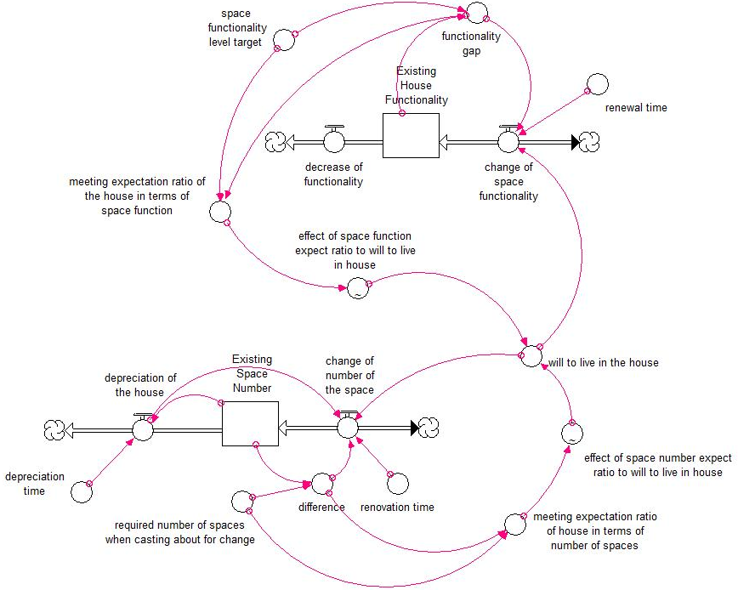
Figure 2: First setting of stock-flow diagram
It may be more appropriate to start the explanation of the first numerical model with the 'existing space number' stock, which is one of the stocks expressed with the definition of 'existing', to facilitate the understanding of the whole system. The number of existing spaces changes with flows. The model is shaped by converter variables that also affect these flows.
- When a change is requested in the house to affect the ‘existing space number’, there is a difference between the ‘required number of spaces when casting about for change’ by the residents and the initial stock (‘existing space number’). In order to close the resulting gap, there is an effect in this direction on the flow of ‘change of number of the space’. At the same time, when a change is requested, ‘required number of spaces when casting about for change’ and the ‘difference’ affect the ratio determined as the ‘meeting expectation ratio of house in terms of number of spaces’, and they participate in the cycle that foresees meeting the target. The effect of this ratio (‘effect of space number expect ratio to will to live in the house’ parameter) affects the 'will to live in the house' parameter by being determined as a graphic defined as 'S' shape, which first increases at a normal rate and then increases by slowing down. At this point, if there is a will or unwillingness to continue living in the house, this variable causes a mobility in the ‘existing space number’ through the flow of 'change of number of the space'. In a complex system, parameters do not only affect each other sequentially, but also effects on flows and stocks from different directions. Here, too, the ‘existing space number’ stock, which is affected by the ‘change of number of the space’, is exposed to an adverse effect on the ‘will to live in the house’, with the outflow called ‘depreciation of the house'. In fact, this effect is also accepted as an output that balances the input flow in the systems. The 'renovation time' parameter in the model expresses the elapsed time in case of a change in the number of spaces and this affects the flow. Likewise, ‘depreciation of the house', which is the output flow, is also affected by the ‘depreciation time’ variable since it requires a certain process. In this part of the model, which can be expressed as the below part of the model, an effect is observed from the output flow to the input flow, since a situation happens that also affects the ‘change of number of the space’ as depreciation occurs. Also, there must be a certain capacity (number) of spaces for depreciation to occur, and so there is an effect from the ‘existing space number’ stock to the ‘depreciation of the house' flow.
- When the explanation of the upper part of the model is started with the stock of 'existing house functionality', it is seen that the stock is activated with a flow of ‘change of space functionality’ (as an input) arising from the use of the space. The variable that is considered as the difference between the ‘existing house functionality’ and the ‘space functionality level target’ is shown as the 'functionality gap'. When a functionality gap occurs in the house, the system (which can also be defined as 'inhabitants') behaves towards closing this gap, affecting the flow of 'change of space functionality' together with the 'renewal time' and 'will to live in the house' parameter required to make changes in the use of the space. In case of 'decrease of functionality' appearing as a flow out of stock, the system tries to check the status in the background (with other variables and connections). Meanwhile, the ‘functionality gap’ and the ‘space functionality level target’ also affect the parameter determined as the ‘meeting expectation ratio of the house in terms of space function’. This ratio affects the ‘will to live in the house’ parameter, which is the control mechanism of the model as a whole, by being guided by another graph (‘effect of space function expect ratio to will to live in the house’ variable) equivalent to the ‘S’ shaped graph in the below part of the model in the previous expression.
- The upper and lower parts of the model are not exactly the same, but similar parts. The fact that the ‘depreciation of the house’ flow in the lower part affects the ‘change of number of the space’ does not occur as the ‘decrease of functionality’ flow in the upper part affects the ‘change of space functionality’. The reason for this situation is that there is no continuous decrease in functionality and the system does not come to the point where it will affect the ‘change of space functionality’ again, since it is in a behavior to close this decrease.
The important point in the model is how the two separate stock-flow diagrams (upper and lower parts of the model) come together. In order for the life in the house to be permanent, only the changes made on the form of the space are insufficient and after a while the demands (desired) of the residents become unfulfilled. For this reason, it is possible to continue the will to live in the house (stay in the house) based on the changes that result from the use of the house and affect the functionality at the same time. Below are some graphs that express the behavior of the system over the default values. The graphs describe the behavior of parameters such as the ‘existing space number’ stock, ‘required number of spaces when casting about for change’, the ‘existing house functionality’ stock, ‘space functionality level target’ and ‘will to live in the house’, first separately and then with a single representation (Figure 3).
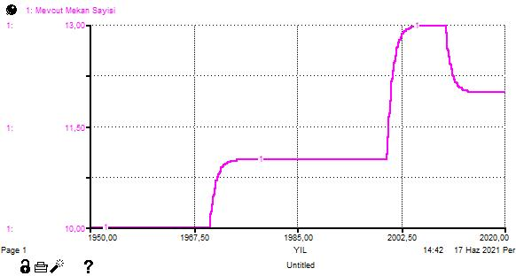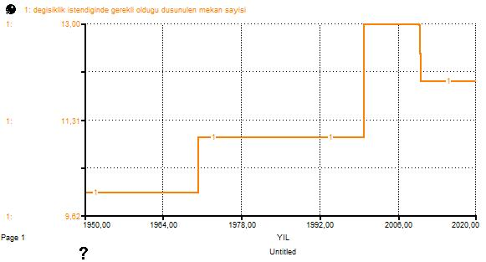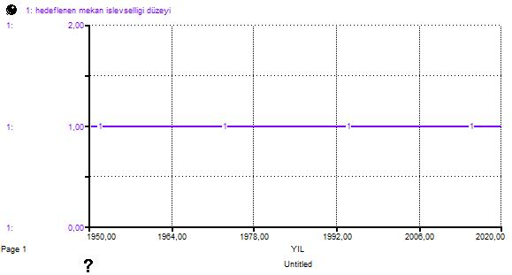
A B C
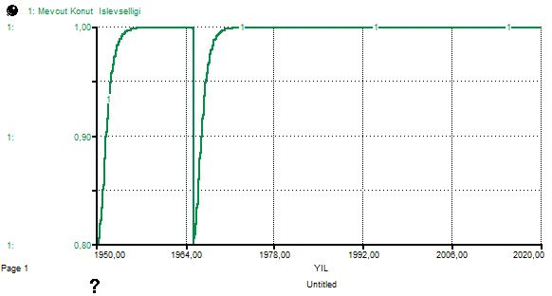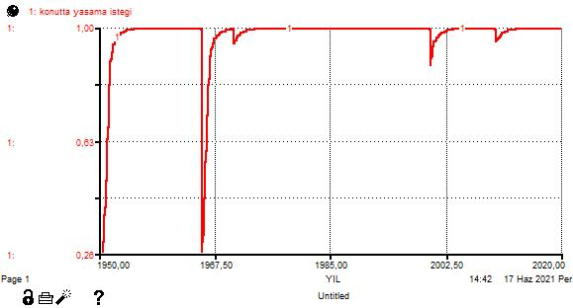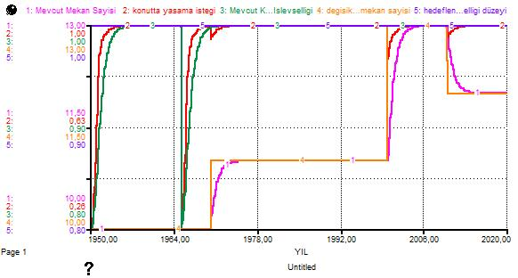
D E F
Figure 3: Graphs obtained as a result of the simulation of the spatial change model (A: Existing space number, B: Required number of spaces when casting about for change, C: Space functionality level target, D: Existing house functionality, E: Will to live in the house, F: Collective display of all charts)
In the graphs, it is observed that the 'existing space number' stock (the number 1 pink line in the graphic display), which is taken as the initial value of 10, moves in direct proportion to the variable 'required number of spaces when casting about for change', which is expressed in orange color number 4 to close the gap. The mobility here is obtained by adding 1 space in 1970 and 2 spaces in 2000 to the 10 numerically existing spaces in the house and removing 1 again in 2010, in the formulation of the required number of spaces variable (Scenarios such as adding one space by the marriage of 2 sons in the house in 2000, one son leaving the house in 2010 for reasons such as work or not being able to fit in the house can be given as an example). The ‘existing house functionality’ (stock) in green number 3 is initially considered to be 80%. The ‘effect of space number expect ratio to will to live in the house’ is taken as 50%, and the ‘effect of space function expect ratio to will to live in the house’ is 66% (in other words, when the number of spaces in the house falls below 50% and when the functional usefulness of the house falls below approximately 70%, the will to live in the house will decrease or the house will be abandoned). At the same time, it is considered that the residents have made the necessary functional changes and reached the 'space functionality level target' shown in purple number 5 (this is taken as 1, which is the level of full achievement, from 0-1). Assuming that there is a 20% loss of functionality in the use of housing in 1965, with the effect of the flow of ‘decrease of functionality’, it is seen that the stock of "existing house functionality" is also affected by this change. It is clearly observed that this effect is directly proportional to the ‘will to live in the house’, which is expressed in red color number 2. Thus, it is concluded that the life in the house can be sustained with the effect of changes made in line with the demands and expectations of the residents.

Supplementary Text 5: Space Syntax Measurement Tools
- Integration Value
Integration; describes the accessibility of the parts or areas in the space setup to one part or area. The relatively high integration value in the part indicates that the access from the specified point to the surrounding points is direct.
- Relative Asymmetry Value (RA): It is the value that shows the integration or heterogeneity of the space in the system. The RA value lies between 0 and 1. Values close to 0 indicate that the system is more integrated, and values close to 1 indicate that the system is more heterogeneous. The result acquired from the arithmetic mean of the number obtained by calculating the RA also expresses the 'mean integration value' of the system that includes all the spaces (Sanlı, 2009; Hillier and Hanson, 1984). (d_{ort}: Mean depth, n: Total number of spaces in the graph)
$$RA= {2(d}_{ort}-1)/n-2$$
- Real Relative Asymmetry Value (RRA): When comparing spatial systems of different dimensions (numbers), it is the transformed value calculated by dividing RA by the D value in the chart prepared by Hillier and Hanson (1984) for multiple spaces, which eliminates the size effect on integration. (D: The constant value according to the number of spaces, n: The total number of spaces in the graph)
$$RRA=RA/D_{n}$$
- Mean Depth Value
It is the measurement obtained by dividing the sum of the depths of all the spaces in the graph, starting from the space accepted as the root in the Justified Plan Graphs (JPGs), by the value calculated by subtracting 1 from the total number of spaces (Atak, 2009). (d_{ort}: Mean depth, n: The total number of spaces in the graph)
$$d_{ort}= the sum of the depths of all spaces/n-1$$

Supplementary Text 6 and Supplementary Figure 4, 5, 6: Second Model Process Formulated with Housing Data
The model, which is designed to understand the effect of the number of spaces and the use of space on the will to live in the house, is formulated at this stage by entering the data acquired and the calculations made into the system. In order to obtain a strong model in line with the digitization of the change, the first decision is to calculate the costs of the material changes that occur over unit prices -on m² or piece basis-. Costs have been calculated over the unit prices of the November 2021 Türkiye market and by inquiring from a single renovation company to avoid any difference. Labor charges are included in the prices. In addition, the floor heights of the houses are taken over 3 m and added to the calculations.
In the model in Figure 2, the effect of the changes in the number of spaces and the use of the space on the will to live in the house was shown and the model was explained step by step. The model in Figure 4, on the other hand, expresses the effect of material changes in the house along with the number of spaces. In addition, at this stage of the research, the mean depth values obtained from space syntax analyzes are included in the model in order to digitize the change in use in the house. The mean depth value shows the accessibility levels in the use of the space and is a necessary value for calculating the integration value. This value is taken to show the difference in syntactic measurements before and after the change, to make the model result more understandable.
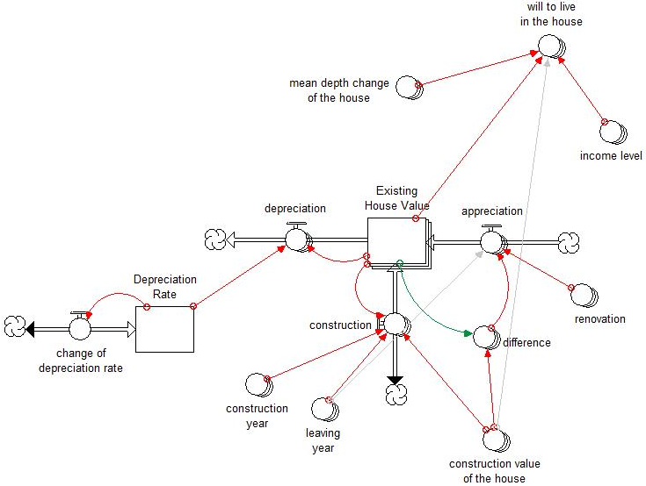
Figure 4: Stock-flow diagram formulated with spatial values
After the functions were created by entering the numerical data into the model and the model was simulated, the behavior aiming to maintain the will to live in the house have been tried to be explained with the graphs in Figures 5 and 6 over the depreciation tendency/mechanism of the house.
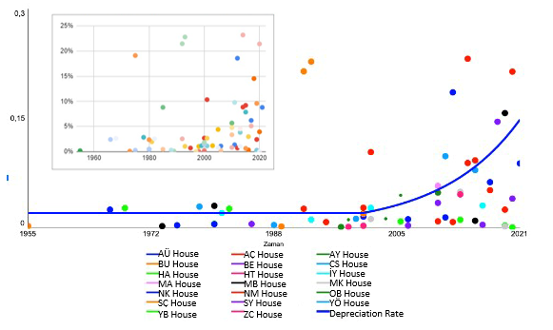
Figure 5: Annual depreciation rates of houses
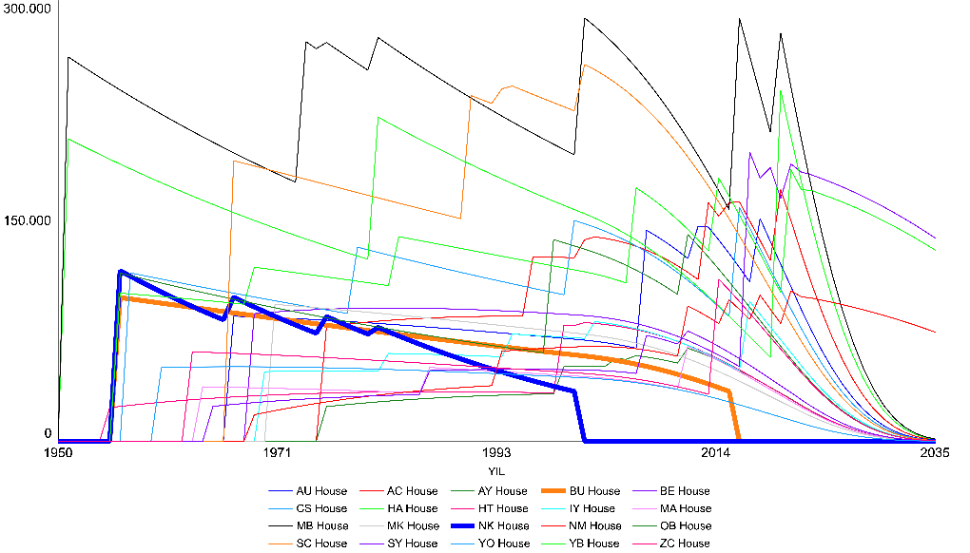
Figure 6: Existing house value graph with income level and annual mean depth change
All houses are shown in the graphics with their unique colors. In Figure 5, against the increase in the rate of depreciation of the houses, there is the goal of reaching the ideal conditions of the house when it was first built, in the current time, with the changes in Figure 6. But what if there is a time period when inhabitants no longer want to interfere with the housing in any way in the context of change? Despite the rapidly increasing depreciation value after 2021, all houses will be abandoned in about 2035, except for a few houses.

Supplementary Text 7 and Supplementary Figure 7: Third Model Process
In the third stage development model (Figure 7), which it can be described as the final version of the quantitative model, the expressions of some parameters in the model have been changed to make it more understandable. In the model developed with the aim of reaching the original value (authenticity) of the house and preserving this value, the behavior that addresses the value of the house at the time of its initial construction while ensuring the livability of the house is analyzed. The necessary data for the analyzes are obtained by adding the change states of all changed house units (rooms) to the tables where the unit prices of housing change were calculated. Overhauls (changes) are included in the calculations by giving the value '0' if the unit/element is to be completely eliminated/not conserved, '0.5' if it is partially/half replaced, and '1' if it is to be preserved or replaced with the same type of material.
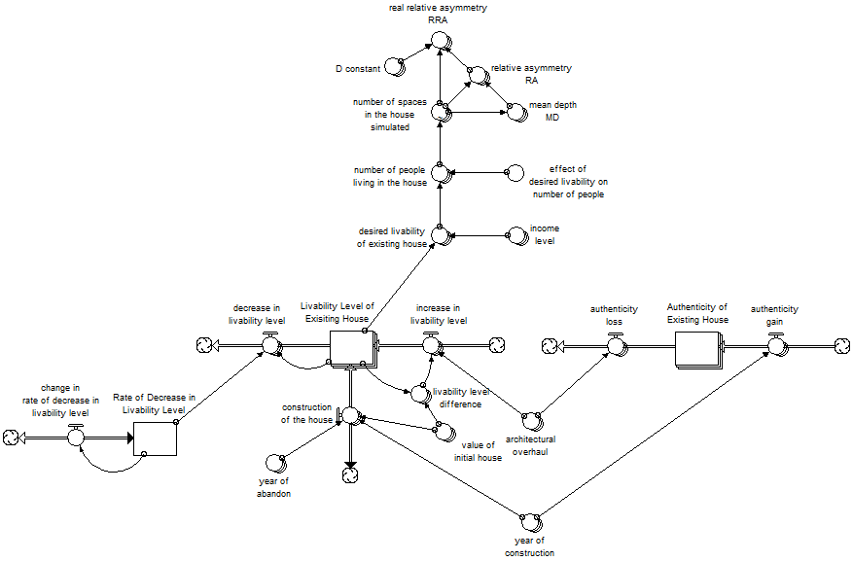
Figure 7: Third stage quantitative development model expressing the relationship between the livability and authenticity of the house
In the piece, which is located upper side, the relationship of the will to live (desired livability of existing house) parameter, which is connected with the livability level of existing house, between the spatial analysis parameters coming from the space syntax approach is visualized. In the diagram, which also includes variables such as the number of spaces in the house, the number of people living in the house, and the income level, the formulation relationship of mean depth (MD), integration (RA) and real relative asymmetry (RRA) values with each other is clearly expressed.

Supplementary Text 8 and Supplementary Figure 8: In the graphs in Figure 8, the rate of decrease in livability level by years (the need for overhaul/change according to the inhabitant's perception) is shown by marking the assumption levels. Accordingly, the first assumption is that the rate of decrease in livability level, which continued steadily until 2000, increased rapidly after 2000. The second assumption is that the rate of level loss, which progressed steadily at a certain rate until 2000, gradually increased after 2000 and continued to remain constant at a certain rate. The third assumption is that the rate of decrease in livability level, which started at a constant rate and increased after 2000, stops and decreases after a while. In order to analyze the short-term status of the model and to facilitate the understanding of the model behavior, the simulations are carried out with the target of 2050.
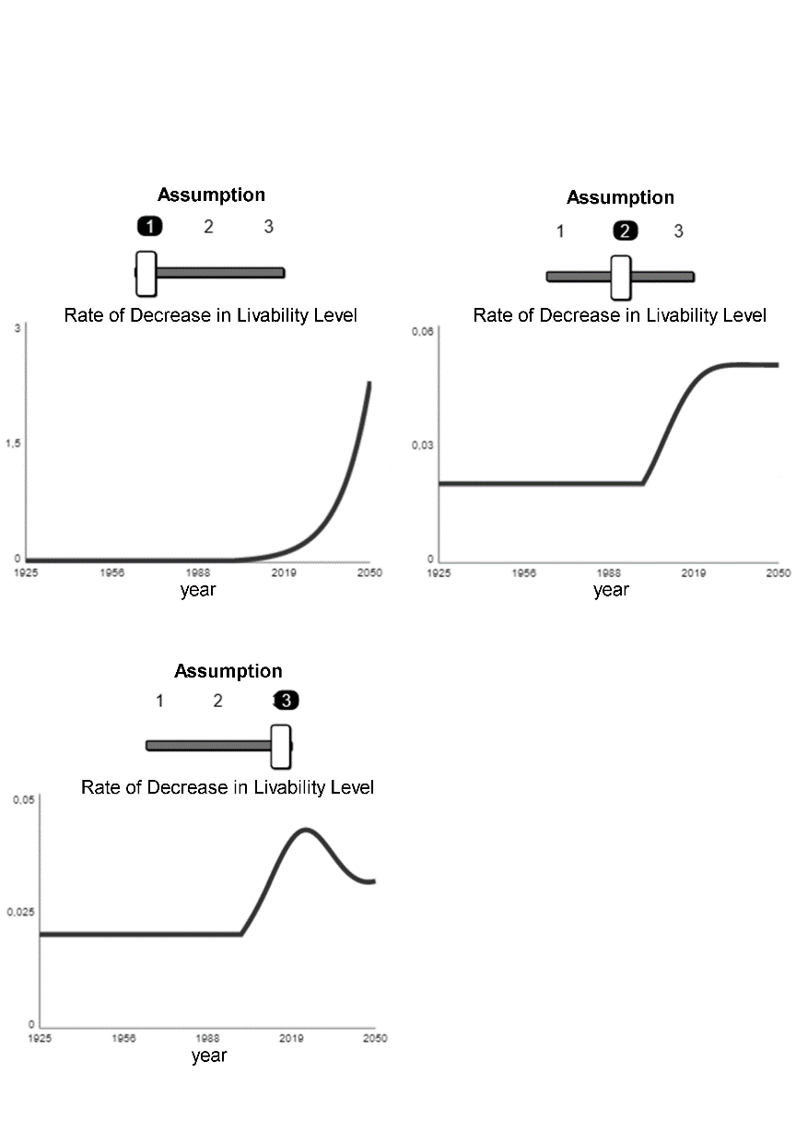
Figure 8: Assumption graphs expressing the change in the rate of decrease in livability level by years

Supplementary Text 9 and Supplementary Figure 9: With the assumptions put forward, the behavior of the change in the livability level of the house is included in the graphic representations of all the houses. The graph in Figure 9 emerges in the first assumption that the rate of decrease in livability level relative to houses increases. According to the result of the graph, if the first assumption is realized, the livability of all houses will decrease considerably by 2050.
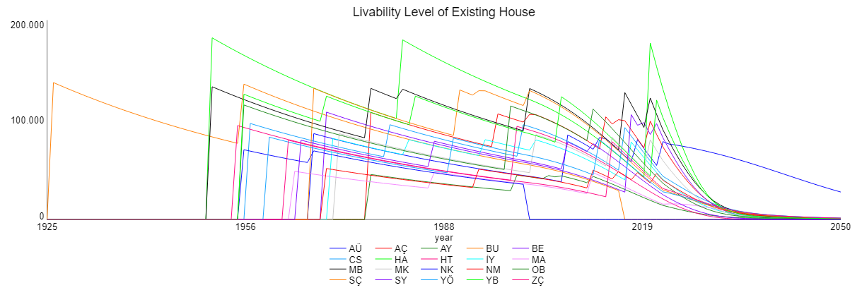
Figure 9: The livability status graph of the house, which is the result of the simulation of the first assumption

Supplementary Text 10 and Supplementary Figure 10: In the simulation realized in line with the second assumption graph in Figure 8, a more positive livability level graph emerges compared to the situation resulting from the first assumption (excluding abandoned (Aban.) houses) (Figure 10).
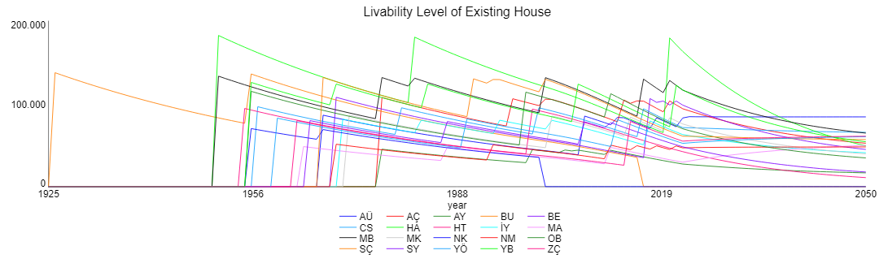
Figure 10: The livability status graph of the house, which is the result of the simulation of the second assumption

Supplementary Text 11 and Supplementary Figure 11: As a result of the simulation of the third assumption, which is considered as the only assumption that the rate of decrease in livability level decreased after 2000, according to the other two assumptions (excluding abandoned houses), it is observed that the livability level of the houses is the highest in 2050 (Figure 11).
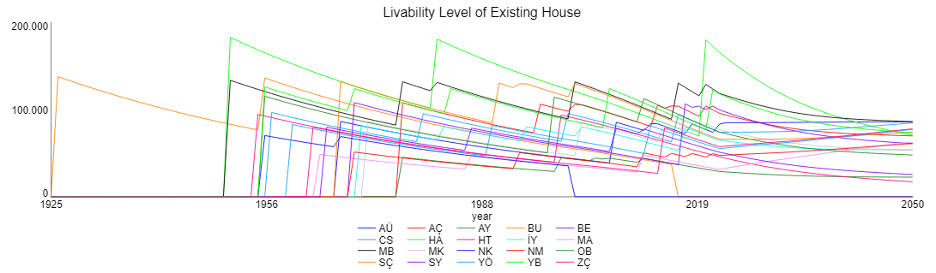
Figure 11: The livability status graph of the house, resulting from the simulation of the third assumption

References
Atak, Ö. (2009) Mekânsal Di̇zi̇m ve Görünür Alan Bağlamında Geleneksel Kayseri̇ Evleri.
Hillier, B. and Hanson, J. (1984) The Social Logic of Space. Cambridge, London: Cambridge University Press.
Narin, R. (2018) Sakarya Türkmen/Manav Tarihi-Yedi Asırlık Bir Tarih. Sakarya: Sakarya Yerel Kültür Derneği Yayınları.
Sanlı, S. (2009) Bir Mi̇mara Ai̇t Konut Tasarımlarının Mekan Sentaksı Yöntemi̇yle Anali̇zi̇.

